**API Testing Findings**

1. The assumptions made are

1. If the value is a multiple of 3 outputs the word “Fizz”

2. If the value is a multiple of 5 outputs the word “Buzz”

3. If the value is a multiple of both 3 and 5 outputs the word “FizzBuzz”

4. If the value is not numeric outputs “Invalid Item”

2. In the word "FizzBuzz" letter 'B' is in uppercase where as in the outcome from REST API , it is "Fizzbuzz" where 'b' is in lower case. Due to this all inputs which are multiples of both 3 and 5 failed.

3. For values which are multiples of 3, the outcome expected is only "Fizz" but the actual outcome is

"Fizz" and "Divided {multples of 3} by 5", which is also considered as failure.

4. For values which are multiples of 5, the outcome expected is only "Buzz" but the actual outcome is

"Buzz" and "Divided {multples of 5} by 3", which is also considered as failure.

5. When the input is empty, then the expected outcome is "Invalid Item" but the actcual outcome is

"Invalid item" which letter 'i' in lowercase which is another failures.

The failures caputred through automation are

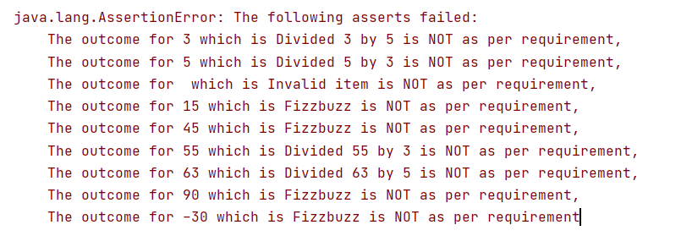

I also tested the REST endpoint manually using POSTMAN. Please find the screenshot below

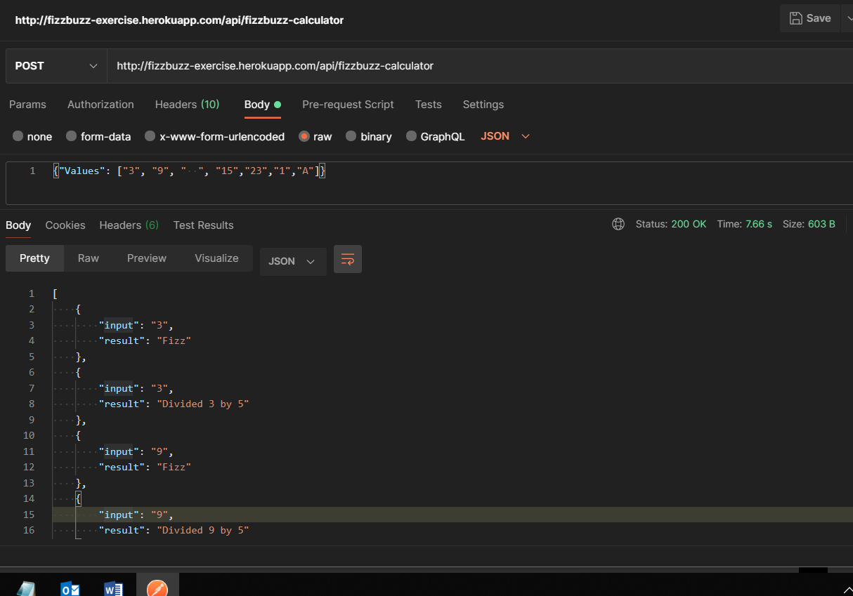

**UI Testing Findings**

I had manually tested the UI application but didnt automate it as i chose to automate REST API. In addition to the above mentioned issues, one more issue which I found was,

1. In UI, if i have to test only <empty value>(like space alone ) the outcome is not as expected. The expected outcome is “Invalid Item” but the actual outcome is “No Results”. Please find reference scrrenshots below.

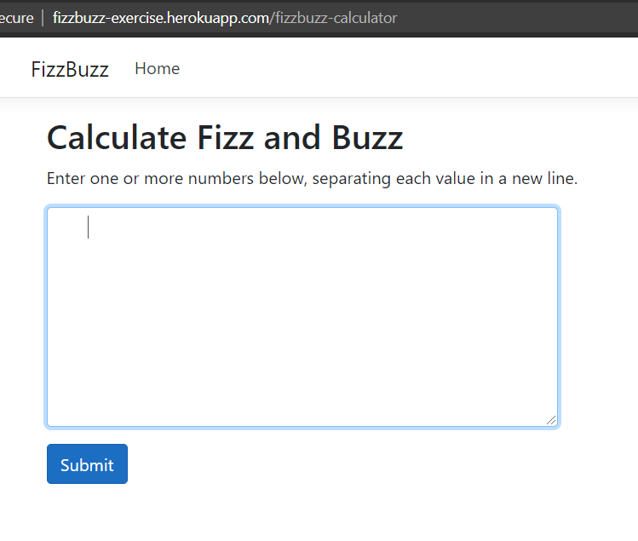

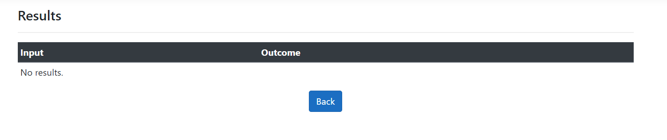

1. For automating the UI, I would have used a Test Driven framework using Maven , Selenium Webdriver, Java, TestNG .