**Student Manual**

**Liberty Robotics**

**1764**

**2009-2010**

**Table of Contents**

**Mission, Vision and Values ……………………………………………………………………………………….. 1**

**Team Organization ……………………………………………………………………………………………………. 2**

Mission, Vision and **Values**

**Mission**: To provide students with the opportunities to learn the skills necessary to be responsible and participate in an increasingly technological world, to become the leaders of the future, to serve community and society, and achieve person fulfillment.

**Vision**

**Team values:**

* Students drive the project. Mentors assist.
* Each team member, mentor and parent is equally important to the success of the team.
* Sharing knowledge among team members and developing youth is key to the longevity of the program.
* Work in coopetition with other teams in the FIRST community.
* Think safety first in all activities.
* “Gracious Professionalism” is the capstone to our program.
* Being a team means bonding together to form a family-based work organization.
* No matter your skill set, there is always a place for you on the team.
* Perseverance is key to the success of the program, team and individual
* Keep it simple.
* Don’t look back on the past and say “we should have done this.”

Team Organization

General Safety

Definitions

Personal Protective Equipment (PPE): Equipment used to protect the body from physical harm.

American National Standards Institute (ANSI): A premier source for timely, relevant, actionable information on national, regional, international standards and conformity assessment issues.

Material Safety Data Sheet (MSDS): A document that provides information about a given chemical product. It includes the name, composition (chemicals in the product), hazards, first aid measures, fire fighting measures, information regarding the proper steps to take with spills, handling and storage, personal protection to be used, physical and chemical properties, and information about stability & reactivity, toxicology, disposal, transporting, and regulatory requirements.

Sponsor: A Liberty Public Schools employee representing a class, team, organization or other group.

Work Shop Regulations

1. Every user must pass demonstrative tests, both written and practical, for each tool to be used with 100% accuracy. Students must be retested annually.
2. ANSI approved Z87 or Z87.1 safety glasses must be worn at all times during machine work related activity or at any point where physical danger is possible.
3. A sponsor will always be present while shop is in use.
4. A sponsor will be proficient with all shop systems, including, but not limited to dust collection, electric box outlet, stain room procedures and air filtration systems.
5. Sponsor and/or represented groups are responsible for all damages and incidences that occur during usage.
6. Any machine damage or unfit for use must be labeled “Do not use” and proper authorities must be notified immediately.
7. Router table, surface planer, scroll saw, surface drum sander, shaper, metal chop saw, welding equipment and lathes are not to be used without sponsor permission or supervision.
8. All consumable materials will be provided by the sponsoring group, expect with permission from other organizations or groups.
9. Sponsor will complete work shop checklist both prior and immediately following usage of area.
10. Project storage must be provided by group sponsor unless specific permission is granted.
11. All accidents should be treated and reported immediately; all parties concerned, including the nurse and principal, should be notified.
12. Any request for shop usage outside of school hours should be made through the building request usage forms.
13. Sponsor will keep all original documentation. Copies of all documentation will be provided to the Industrial Technology Department head and to others upon request.

General Shop Safety Rules

1. Do not work in shop without supervision.
2. Always wear approved eye protection (Z87 ANSI Safety Glasses) while working in the shop.
3. Immediately report all accidents and damage to the immediate sponsor. If possible, record and label machine “Broken: Do not use..”
4. Tie back long hair.
5. Remove loose clothing, jewelry and any other apparel that can be entangled or otherwise harmful.
6. Wear only closed toed shoes.
7. Never run. Only walk while in shop.
8. Learn to use proper fire extinguisher for different situations and proper use of each.
9. Wear respirator and/or turn on air vacuum system if present.
10. Keep the floor around the work space free from scrap, chips and other possible hazards.
11. Do not let other associates use tools incorrectly. Advise them to use tools with safe and proper methods.
12. Always clamp material to work area; never hold stock with hands while working.
13. When carrying tools, carry them so as to not injure yourself or others.
14. Make sure only the machine operator and helpers are within arm’s length of the machine.
15. Ask the sponsor to approve all special setups.
16. When replacing saws and cutters, make sure the tool is off at the power source.
17. Do not use a tool with frayed wire or a defective switch.
18. Arrange cords on the machine so they are not hazardous to the machine users or the helpers.
19. Never talk or distract a person who is operating a machine.
20. Examine any material for defects or objects (nails, bolts, etc) before use.
21. Acquire help while cutting oversized materials.
22. Operate machines at full speed before cutting material.
23. Give your sole attention to operating the machine and the job at hand.
24. Never make adjustments while machines are running.
25. Turn off power and wait for machine to reach a complete stop before leaving the station.
26. Clean up all spills immediately.
27. Keep hand tools sharp and properly maintained.
28. Do not feed materials into machine faster than the machine can cut.
29. Use all chemical substances within a well ventilated area.
30. Always be aware of your surroundings and any other users who may be around.
31. Use the right tool – or blade – for the job.

Tool

Safety

**Table Saws:**

**Safety Rules:**

1. During all operations, keep your fingers out of the 4 inch safety margin. Use push sticks if necessary to hold stock.
2. Never place your hands on top of the board when it is directly over the blade, even when cutting dado or rabbet.
3. Stand to the left or the right of the saw blade at an angle, never directly behind the blade, to prevent injury from kickback.
4. Set the saw blade to approximately 1/8” or 1 saw tooth above the stock being cut.
5. Check stock for defects, including warping, bending, knots, objects and other defects.
6. Never reach over the blade to pick up cut stock.
7. Never rip stock without using the rip fence. Never crosscut without using the miter gauge. Never use the miter gauge with the rip fence.
8. After using the saw, turn off the power, lower saw blade below tabletop and cover blade with fence.

**Cross cutting**

1. Keep a minimum of 6 inches of stock in contact with the miter gauge.
2. Make sure that the edge of the stock placed against the miter gauge is straight. Make sure that the face positioned against the tabletop is flat.

**Ripping Safety**

1. The shortest piece of lumber that can be ripped in 10 inches.
2. Use a push stick when ripping stock to a width of less than 6 inches.
3. Make sure that the stock edge against the rip fence is straight and the stock face positioned against the table is flat.
4. The narrowest stock that can be ripped is 3/8”.
5. Push the stock completely past the saw blade before you release it.

**Terms and parts to know**

1. Ripping
2. Crosscutting
3. Miter gauge
4. Throat plate
5. Rip Fence (Fence)
6. Height-Adjustment hand wheel
7. Tilting hand wheel
8. Base
9. Dado
10. Rabbet
11. Kickback
12. Push Stick
13. Panel Saw
14. Clamp Lever

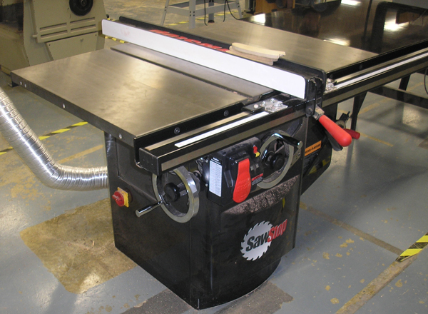

Base

Clamp Lever

Rip Fence

Table

Tilting Hand Wheel

Power

Height-Adjustment Hand Wheel

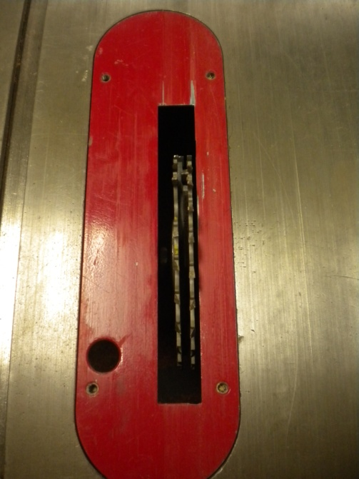

Dado Blade

Throat Plate

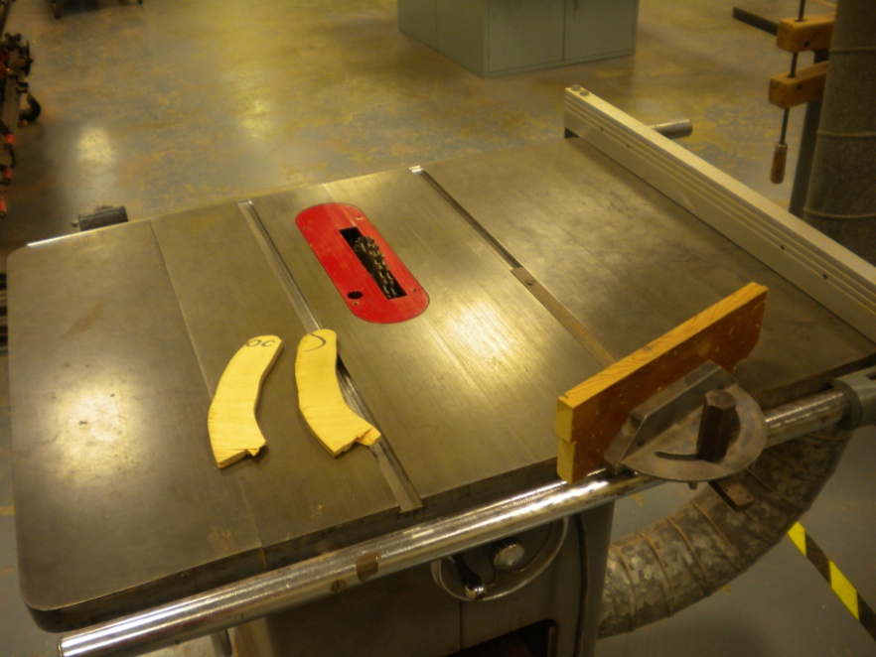

Push Sticks

Miter Gauge

Height Adjustment Wheel

**Band Saws:**

**Safety Rules:**

1. Keep your hands and fingers out of the 4 inch safety margin around the blade.
2. Keep the upper adjustable guide no more than 1/4 inch above the stock.
3. Makes sure the stock has at least one flat surface before you place it against the table.
4. Before backing out of a cut, turn off the power and allow the blade o come to a complete stop.
5. Use relief cuts when shaping curves that are narrower than the cutting capacity of the blade.
6. Cut cylindrical stock only while it is support with a “V” block and miter gauge.
7. If the bald should break while cutting a board, turn the band saw off immediately. Apply the brake if there is one. Stand away from the right of the machine and tell your instructor about the break.
8. Disconnect the power before changing or working around any cutting tool.

**Terms and parts to know**

1. Upper Door Guard
2. Table
3. Lower Guide
4. Lower Door Guard
5. Base
6. Motor
7. Movable arm and Upper Guide
8. Throat Plate
9. Safety margin
10. Relief cuts
11. “V” Block
12. Band saw tire
13. Thrust Wheel
14. Guide Pins
15. Foot Brake
16. Height Adjustment Knob
17. Belt/Saw tensioner
18. Angle Adjustment Wheel

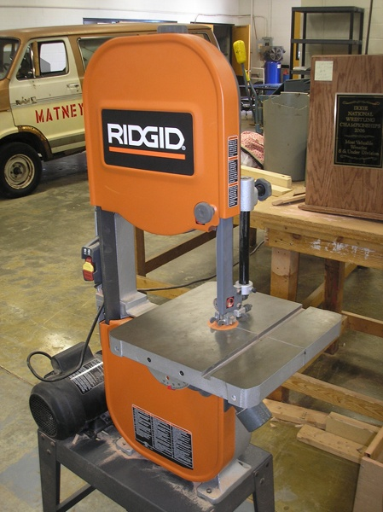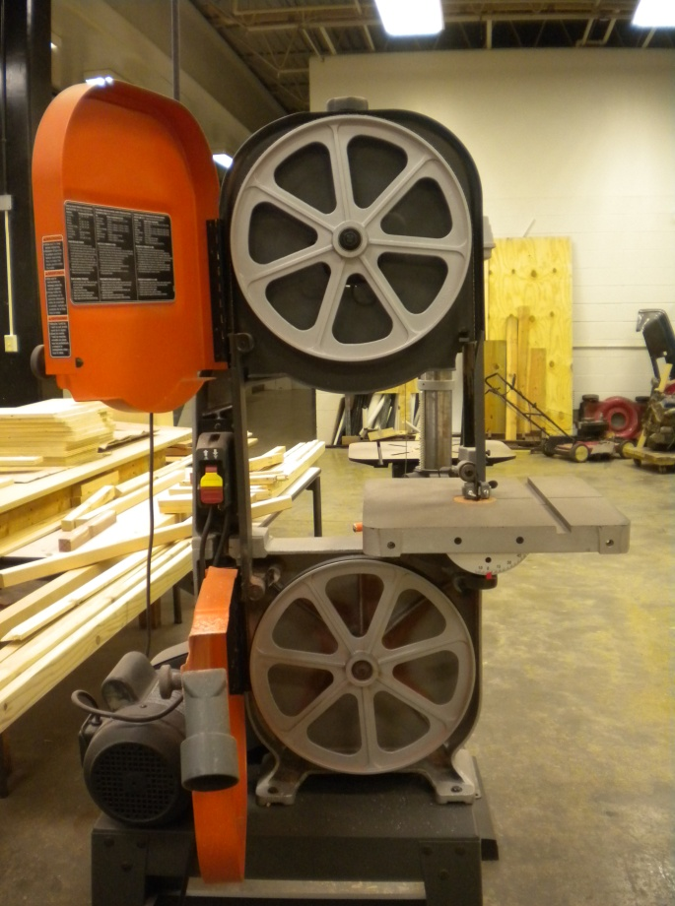

Upper Door  
Guard

Band Saw Tire

Movable Arm &  
Upper Guide

Lower Door  
Guard

Thrust Wheel

Motor

Base

Throat Plate  
(Orange Plate)

Table

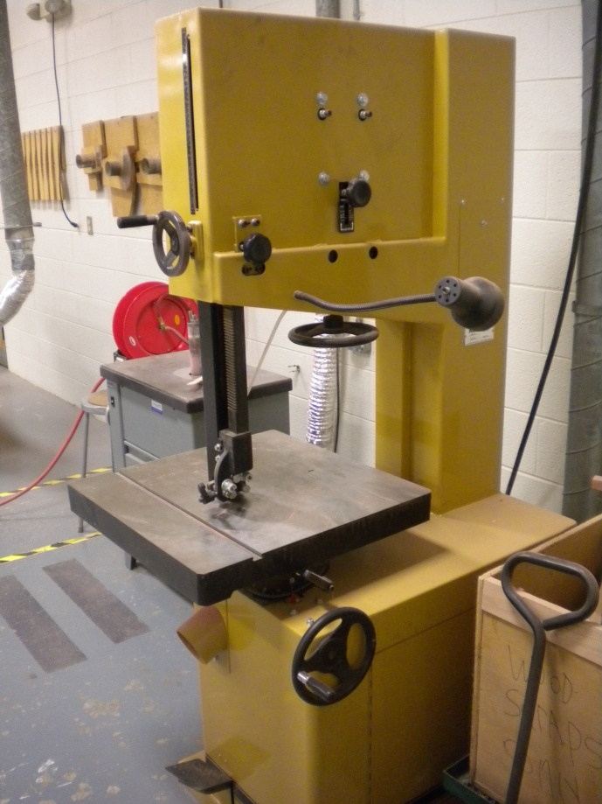

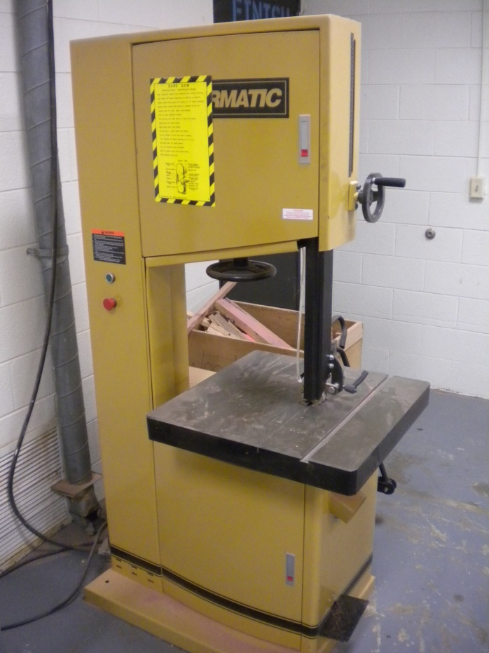

Belt/Saw Tensioner

Upper Guard Height Adjustment Wheel

Table

Angle Adjustment Wheel

Base

Upper Door Guard

Movable Arm/Upper Guide

Lower Door Guard

Foot Brake

**Radial Arm Saw**

**Safety Rules:**

1. Keep your hands at least 4 inches from the blade.
2. Always check that the guard is adjusted properly for each cut.
3. When crosscutting, hold the stock with our left hand and pull the saw with your right hand.
4. Do not cross you arms while crosscutting.
5. Be sure that surfaces placed against the fence and table are straight and flat.
6. Cut only one piece of stock at a time.
7. Do not use radial arm saw for ripping, only for crosscutting
8. Upon completing any cut, return the saw to the farthest position to the rear of the arm.
9. Disconnect the power and get permission before changing a blade or other cutters.

**Terms and parts to know:**

1. Miter scale
2. Elevating Crank
3. Arm
4. Handle
5. Motor
6. Table
7. Path of Blade
8. Sawdust Chute
9. Ring Guard
10. Column
11. Fence

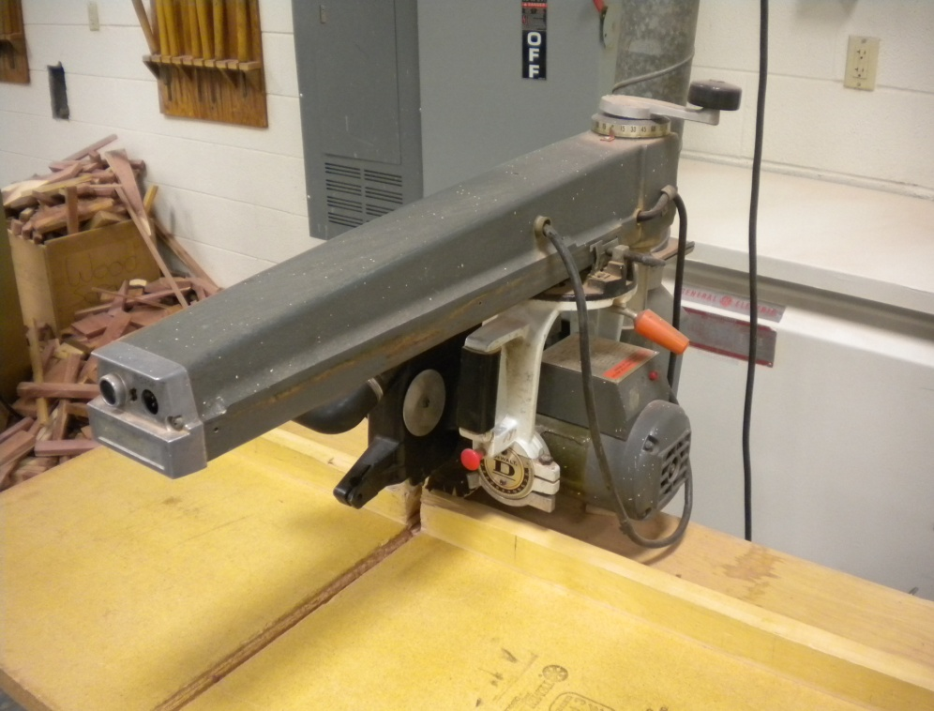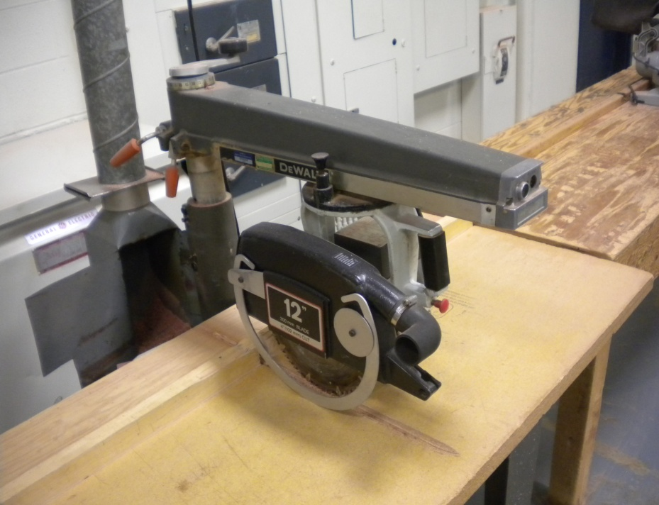

Column

Fence

Sawdust Chute

Ring Guard

Path of Blade

On/Off Switch

Arm

Elevating Crank

Handle

Miter Scale

**Drill press**

**Safety Rules**

1. Keep hands and fingers out of the 4” safety margin surrounding the boring tool
2. Clamp small work and all metal pieces to the drill press table or in a drill press vise.
3. Remove the chuck key before turning on the power.
4. Clamp cylindrical stock in a v block
5. Disconnect the power before changing or working near any cutting tool
6. Loosen table locking device before adjusting the table.
7. Ensure that the hole in the table is below the cutting tool.

**Terms and parts to know**

1. On/Off switch
2. Belt guard
3. Belt Tensioner
4. Motor
5. Feed lever
6. Table
7. Elevating crank
8. Elevating crank release
9. Column
10. Base
11. Drill chuck
12. Depth stop

Belt Guard

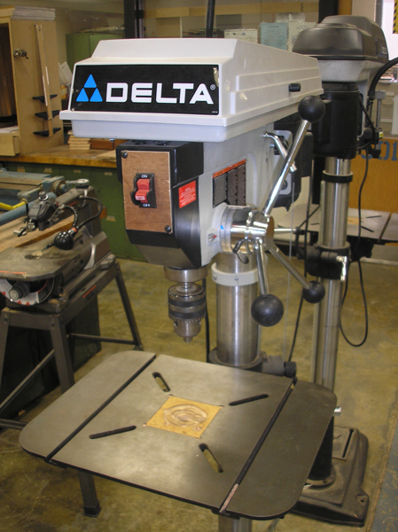

On/Off Switch

Drill Chuck

Column

Table

Feed Lever

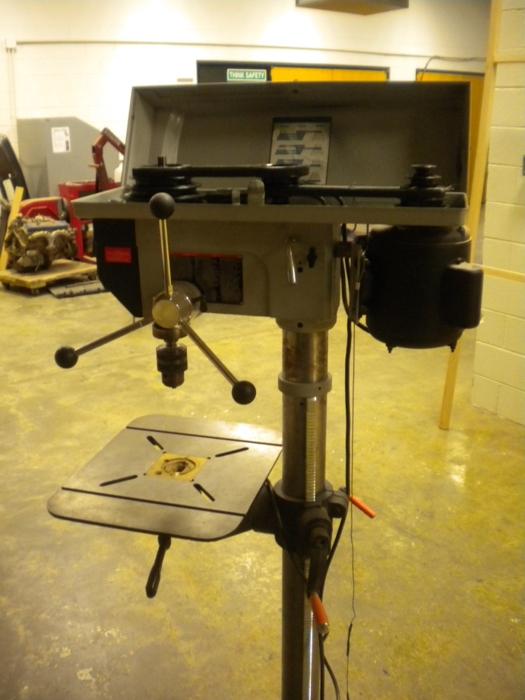

Table

Column

Elevating Crank

Elevating Crank Release

Belt Tensioner

Motor

Belt Guard (opened)

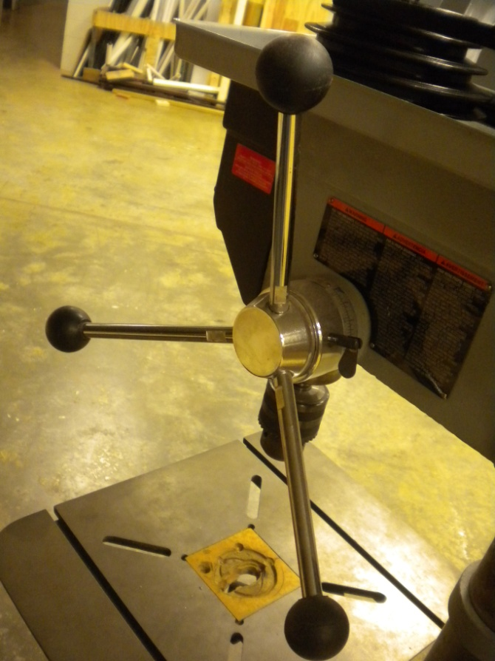

Depth Stop

Feed Lever

**Miter Saw**

**Safety Rules**

1. Be aware of kickback.
2. Always place the stock securely on the table & against the fence when making cuts.
3. Support long stock at the same height as the saw table.
4. Use clamps to secure the stock to the table and avoid injuries.
5. Never make freehand cuts. Holding the stock by only by hand and not using the fence is unstable and may lead to loss of control.
6. Never cut small pieces that would require you to put fingers within 4” of the cutting blade without a clamping device.
7. Never reach under the saw blade or perform “cross handed” operation.
8. When you start your saw, allow the blade to reach full speed before cutting; do not force the blade and always start the cut gently.
9. Don’t raise the blade from the stock until the blade has come to a complete stop.
10. Never try to remove or clamp the stock to the saw while the blade is rotating.
11. Lock the miter saw in the down position and wrap the power cord when work is complete.
12. Make sure the blade guard works properly.

**Terms to know**

1. Fixed Fence
2. Movable Fence
3. Blade Guard
4. Handle
5. Lock Down Pin
6. Miter Gauge
7. Miter Angle Release/lock
8. Compound Miter Release/Lock
9. Base Plate
10. Arm

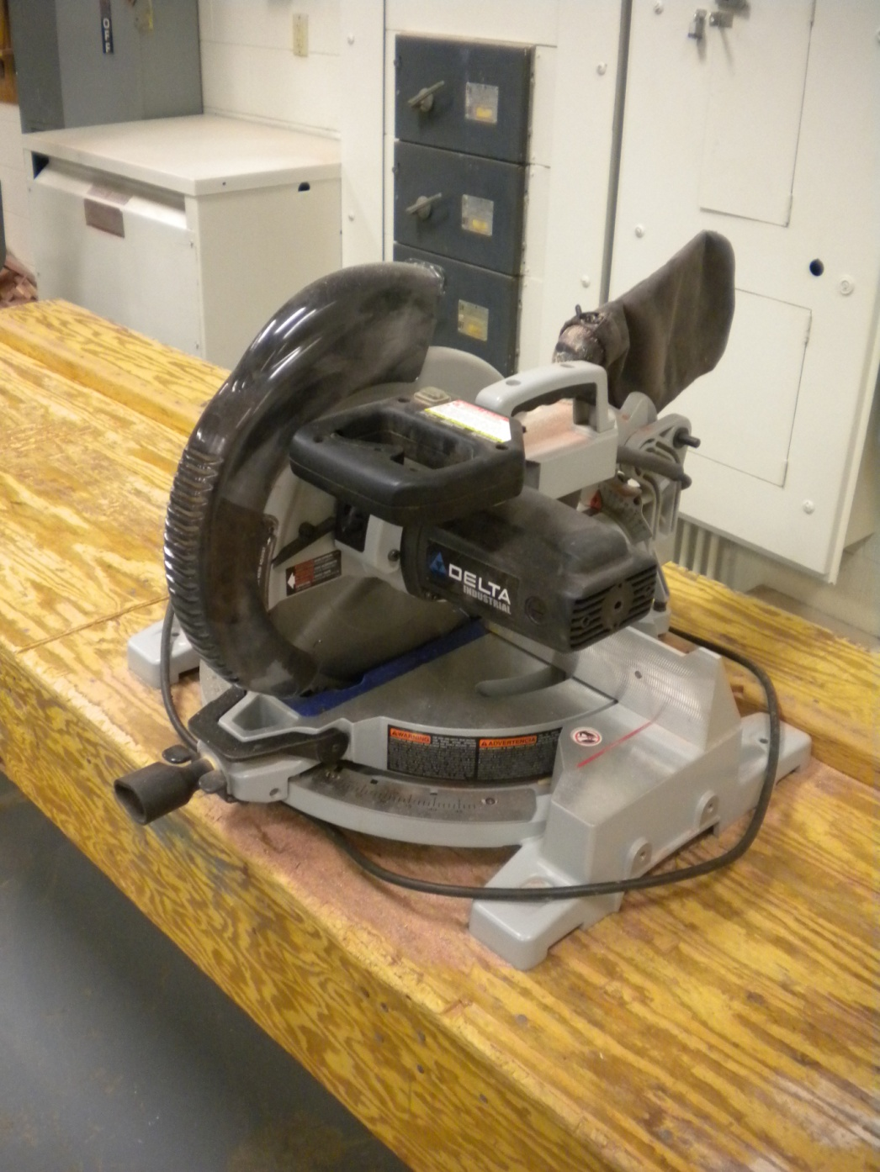

Fixed Fence

Miter Angle Release/Lock

Handle

Blade Guard

Lock Down Pin

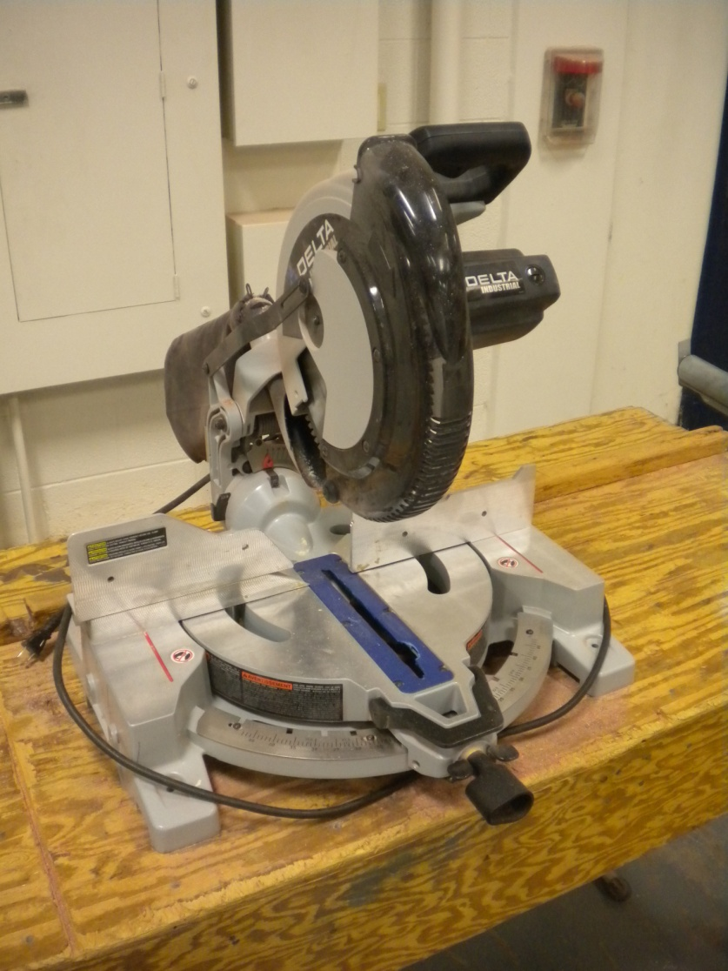

Base Plate

Miter Gauge

Movable Fence

Arm

Fixed Fence

NOTE: Students are only allowed to change the front miter gauge as necessary. The rear compound miter gauge should only be adjusted by an adult.

**Sanders**

**Safety Rules**

1. Keep fingers outside the 4” safety margin
2. Keep the stock against the table
3. Sand on side of disk sander “pulling” stock into table, not forcing stock off table
4. Do not operate the sander if the abrasive paper is loose torn or loaded.
5. Apply firm pressure on the stock. Excessive pressure will tear the abrasive material.
6. Clean out the sand paper with the rubber block regularly.
7. Do not reach into the machine or open the guard doors while the belt is turning.

**Terms and parts needed to know**

1. Table
2. Spindle
3. Tilting hand wheel
4. Different size spindles
5. Throat plate

**Reciprocating saws**

**Safety Rules**

1. Disconnect the power/battery when installing the blade.
2. Use the correct blade for the job (i.e. metal or wood blade). See T.P.I. chart for details
3. Clamp small stock before cutting.
4. Keep the cord away from the cutting area.
5. Keep hands out of the 4” safety zone.
6. Do not make a plunge cut on stock more than 1/4”
7. Hold the saw securely by the handles.
8. Do not reach under the stock during cutting.
9. Make sure that saw guide is pressed against stock while cutting

**Terms and parts needed to know**

1. Handle
2. On off switch
3. Base
4. Blade
5. Power cord/ battery pack

**Portable drills**

**Safety Rules:**

**Corded Drills**

1. Always disconnect the power form the drill before changing the bits or tightening the chuck.
2. Always remove the chuck key after installing the drill bit.
3. Clamp down small pieces of stock. Do not hold the stock by hand.
4. Grip the drill with both hands to maintain control.
5. Keep the cord clear of the bit drilling area.
6. Keep fingers and loose clothing away for the drill bit.

**Cordless Drills**

1. Clamp down small pieces of stock. Do not hold the stock by hand.
2. Grip the drill with both hands to maintain control.
3. Keep the cord clear of the bit drilling area.
4. Keep fingers and loose clothing away for the drill bit.

**Terms and parts to know**

1. Pistol grip handle
2. On off switch
3. Power lock
4. Chuck
5. Chuck keyhole
6. Forward reverse switch
7. Battery/ power cord.

**Metal Chop Saw**

**Safety Rules:**

**Corded Drills**

1. Always disconnect the power form the drill before changing the bits or tightening the chuck.
2. Always remove the chuck key after installing the drill bit.
3. Clamp down small pieces of stock. Do not hold the stock by hand.
4. Grip the drill with both hands to maintain control.
5. Keep the cord clear of the bit drilling area.
6. Keep fingers and loose clothing away for the drill bit.

**Cordless Drills**

1. Clamp down small pieces of stock. Do not hold the stock by hand.
2. Grip the drill with both hands to maintain control.
3. Keep the cord clear of the bit drilling area.
4. Keep fingers and loose clothing away for the drill bit.

**Terms and parts to know**

1. Pistol grip handle
2. On off switch
3. Power lock
4. Chuck
5. Chuck keyhole
6. Forward reverse switch
7. Battery/ power cord.

**Other Tools**

**NOTE: These tools are generally NOT used for the robotics team. If there is a need for their use, then the coaches and/or mentors will perform the necessary actions. You are NOT required to know about these tools, but you may choose to get tested on these on your own.**

**Scroll Saws:**

**Safety Rules:**

1. Keep hands away from the path of the blade.
2. Disconnect the power whenever the blade is being changed.
3. Be sure the surface placed against the table is flat.

**Terms and parts to know**

1. Overarm
2. Motor
3. Throat Plate
4. Table
5. Base
6. Speed Adjustment Crank
7. Pitarm

**Planers**

**Safety Rules**

1. Never let your fingers come within the 4” safety margin in front of the in feed of the machine.
2. Stand to one side of the machine to avoid kickbacks or flying chips.
3. Figure the maximum depth of cut as 1/16 less than the thickest portion of the stock.
4. Never surface a board across the grain or the end grain.
5. Unless special permission is given by your instructor, do not surface stock that is less than 2” longer than the distance between the center of the Infeed and the Outfeed rollers.
6. If a board becomes stuck in the planer apply forward pressure on the stock. If this does not help, turn off the power. After the cutter has come to a complete stop, lower the bed and remove the board. Notify the instructor.
7. Never look into the machine while the cutter head is turning.
8. Disconnect the power before changing or working with any cutting tool.

**Terms and parts to know**

1. Depth scale
2. Bed
3. Height adjustment hand wheel
4. Break
5. Adjustable feed wheel

**Jointers**

**Safety Rules**

1. Never let fingers come within the 4 inch safety margin.
2. Use the guard at all times unless rabbeting.
3. Never take a cut deeper than 1/16 inch without special permission from the instructor.
4. Do not joint stock less than 10 inch in length or less than 1 inch wide.
5. Use a push stock when edge jointing stock that is less that the height of the jointer fence.
6. Do not face joint stock thinner than ½ inch.
7. Do not joint material with loose knots, nails, or other foreign material.
8. Disconnect the power before changing or working around any cutting tools.

**Terms and parts to know**

1. Guard
2. Rabbeting arm
3. Outfeed table
4. Depth Gauge
5. Base
6. Infeed-depth handwheel
7. Infeed table
8. Fence

**Shapers**

**Safety Rules**

1. Disconnect the power before changing or working around any cutting tools.
2. Keep your hands and fingers outside the 4” safety margin surrounding the cutter.
3. Always use feather boards, other hold-down’s or appropriate guards.
4. Use push stick whenever possible.
5. Be certain the cutter always rotates against the direction from which the stock is fed.
6. If possible, mount the shaper knife so that the major portion of the cutting is done on the bottom surface of the stock.
7. Always allow the cutter to reach full speed before starting a cut.
8. Use stock at least 2” wide and 10” in length when edge shaping.
9. Use stock at least 10” wide when shaping end grain.
10. Never move the stock backwards. If you need a different setting, pivot the stock away from the cutter and remove it from the table.
11. Take light cuts to prevent overloading the machine.
12. Keep cutters sharp.
13. Do not use cutters that are cracked or chipped.

**Terms and parts to know**

1. Table
2. Height lock knob
3. Height adjustment hand wheel
4. Base
5. Access door

**Wood lathes**

**Safety Rules**

1. Check to see that the stock is free of cracks knots or poor glue joints.
2. Lock the tail stock tool rest and tool post securely before turning on the power.
3. After centering the stock and positioning the tool rest rotate the stock by hand
4. Position the tool rest 3/8” or less from the stock
5. Position the tool rest 1/8 above the lathe centers
6. Stand to one side of the lathe when turning on the power.
7. Rotate rough stock at the slowest possible speed.
8. Turn stock down to a cylinder before using higher speeds.
9. Hold all lathe chisels firmly with both hands.
10. Rotate large diameter turnings only at slow speeds
11. Change speed gradually to prevent the turnings form spinning of the lathe.
12. Use calipers only when the stock is not turning.
13. Remove the tool post when stock is being sanded or polished.

**Terms and parts to know**

1. Bed
2. Tool post
3. Faceplate
4. Tailstock
5. Tailstock hand wheel
6. Variable speed control
7. Lathe centers
8. Screw chuck
9. Tool rest