SIMATS ENGINEERING (SAVEETHA SCHOOL OF ENGINEERING)
Department of Computer Science and Engineering

CO5 ASSESSMENT TOOL 3– Hackathon

Course Code: | DSA0405 | Course Title: | FUNDAMENTALS OF DATA  SCIENCE
CO Assessed: | CO5 – Hackathon | Assessment: | Assessment Tool 3– Hackathon
Weightage: | 40% of CIA | Total Marks: | 100
CO5 Statement: | To understand the concept of supervised and unsupervised methods in machine learning
Student Name: | Jothika M | Reg. No.: | 192324235
Section / Batch: | 2023-B.Tech (AIDS) | Date: | 29/08/2026

Code of Conduct
I Jothika M (192324235) (Name / Reg No) certify that this submission is my original work and that I have adhered to the guidelines specified for this assessment. I understand that any violation of academic integrity rules will result in disciplinary action.
Signature of the Student: 

Criteria | Weight age | Level 4 – Exemplary | Level 3 – Proficient | Level 2 – Developing | Level 1 – Beginning | Marks
Understanding of Case | 25 | Thorough  understanding; clearly identifies all key issues | Good understanding with most issues identified | Basic understanding; some issues missed | Poor understanding; problem not identified correctly
Application of Concepts | 25 | Effectively applies relevant concepts to analyze the case deeply | Applies appropriate concepts with minor gaps | Limited application of concepts | Fails to apply relevant concepts
Analysis | 20 | In-depth analysis with strong reasoning and insights | Good analysis with logical reasoning | Basic analysis with limited depth | Weak or no analysis; lacks reasoning
Solution Design | 20 | Innovative, feasible solutions with strong justification | Logical solutions with  adequate  justification | Basic solutions with weak justification | Incorrect or no solution provided
Clarity | 10 | Clear, well-structured, and easy to understand | Organized and understandable presentation | Limited clarity and structure | Poor clarity; difficult to understand

1. Disease Symptom Checker. Predict likely disease category from a patient’s symptom vector (fever, cough, fatigue, etc.) using kNN with different values of k and distance metrics (Euclidean vs Manhattan).

Problem Statement:

Develop a Disease Symptom Checker that predicts the likely disease category of a patient based on their symptoms such as fever, cough, fatigue, headache, and body pain. The system should use the k-Nearest Neighbors (kNN) classification algorithm to classify patients into different disease categories. Evaluate the performance of kNN using different values of k and compare Euclidean and Manhattan distance metrics to determine which combination provides better prediction accuracy.

Code:
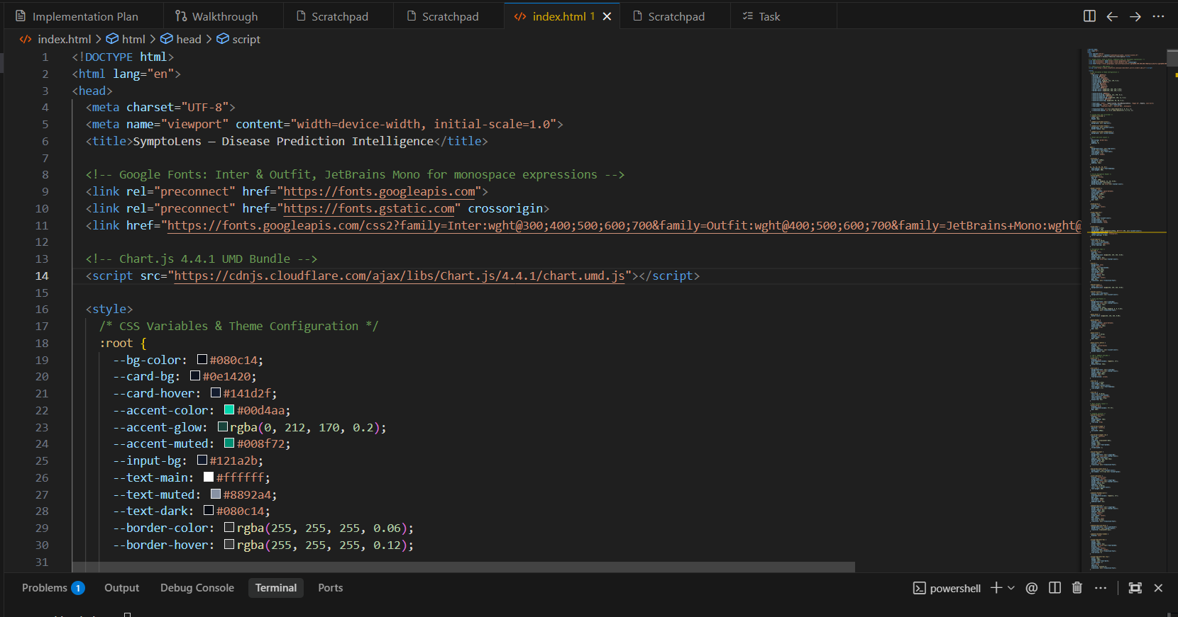

Output:
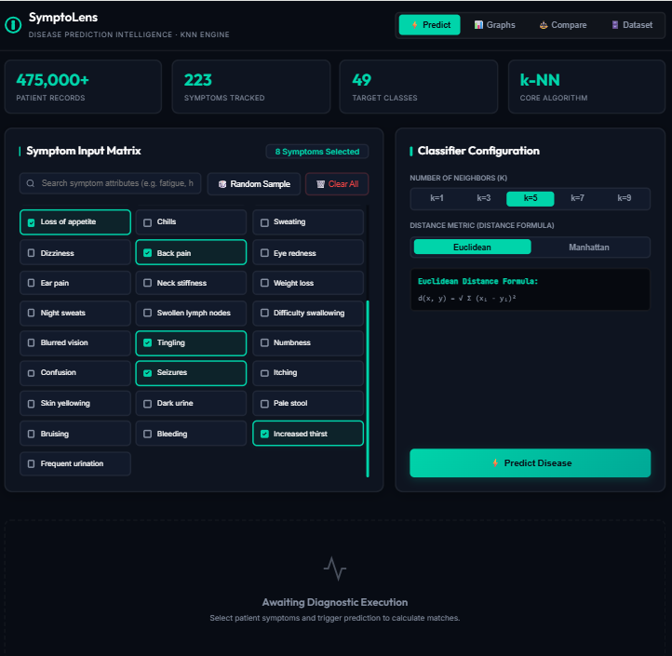
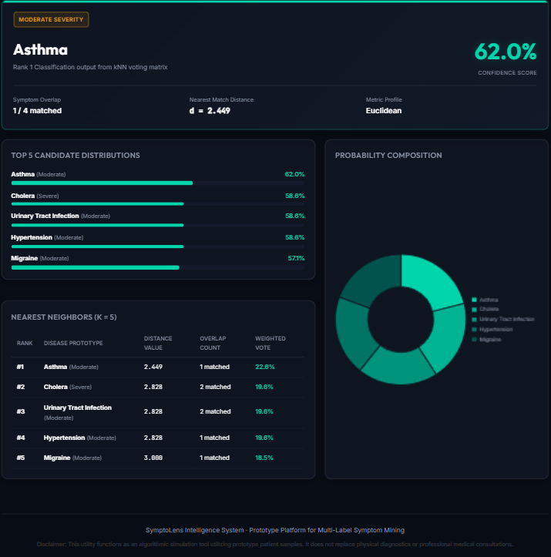
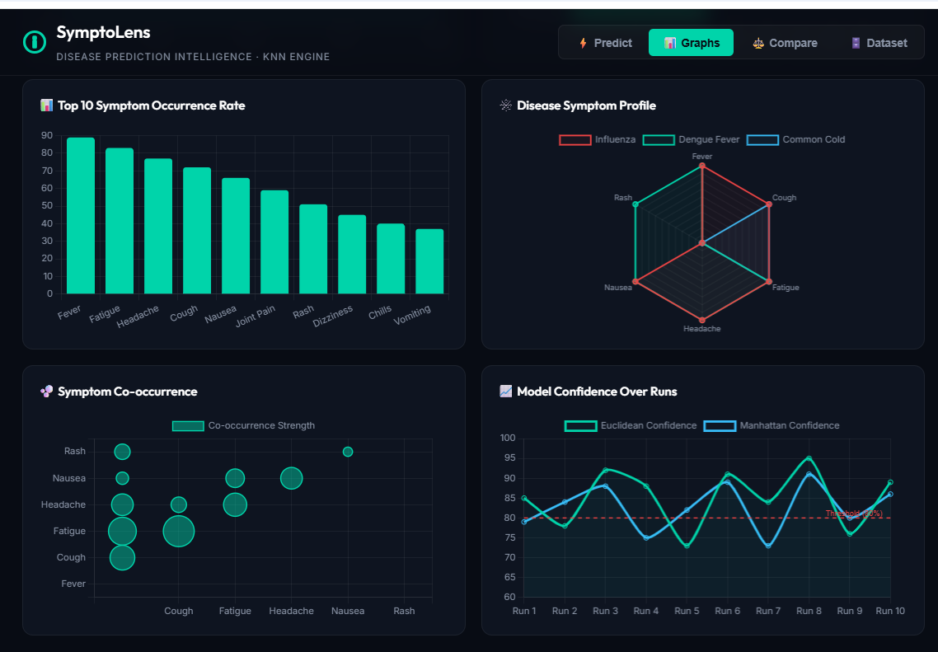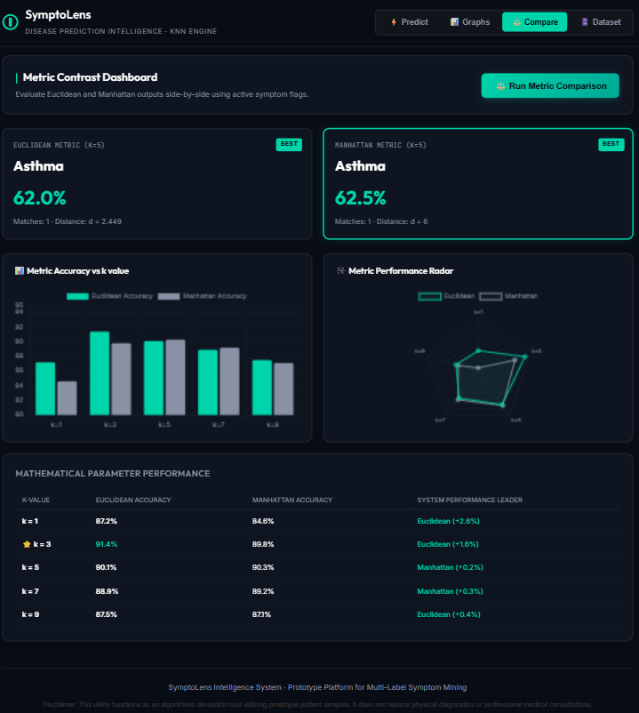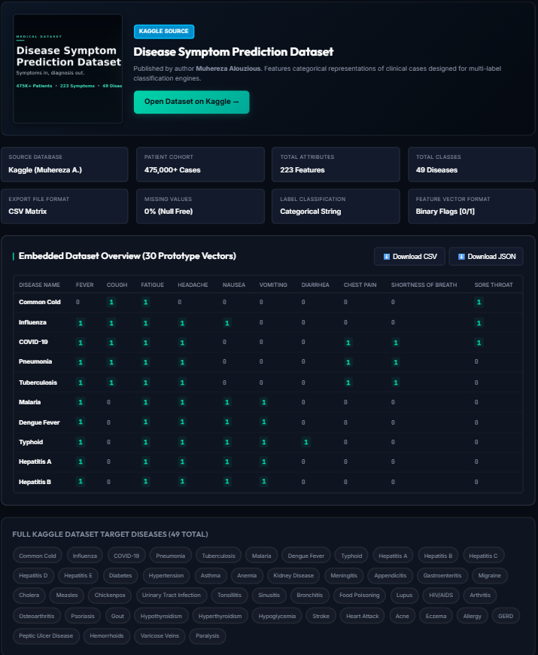

Geotag :


