[INSTITUTION NAME]
Department of [Department Name]
[University / Affiliation]
MINI PROJECT REPORT
AI26: A Multi-Camera Vehicle Analytics and
Licence-Plate Recognition System
with Evidence-Grade Auditing and Honest Uncertainty
Course: [Course Name and Code]
Academic Year: [20XX – 20XX]
Submitted by
Team details
Student Name | Roll Number | Role
[Student 1] | [Roll No.] | [e.g. Backend / ML pipeline]
[Student 2] | [Roll No.] | [e.g. Frontend / evaluation]
[Student 3] | [Roll No.] | [e.g. Testing / documentation]

Under the guidance of [Faculty Name], [Designation]

Acknowledgement and Declaration
We express our sincere gratitude to our course instructor [Faculty Name] for guidance throughout this mini project, and to the Department of [Department Name] for the facilities provided.
We declare that this report describes work carried out by our team. Third-party resources are acknowledged below and in the References. AI-based coding and writing assistants were used for assistance; the team has reviewed, run and understood the generated code, methodology, data and results reported here, and remains responsible for them.

Third-party resources used
- Ultralytics YOLOv8n pretrained weights (yolov8n.pt) for vehicle and person detection.
- Fast-ALPR 0.4.0 with the open-image-models plate detector (yolo-v9-t-384-license-plate-end2end) and the fast-plate-ocr global MobileViT-v2 OCR model.
- PyTorch (CPU), ONNX Runtime, OpenCV, NumPy, FastAPI, SQLite, React, TypeScript, Vite, Tailwind CSS/shadcn-style components, Leaflet/OpenStreetMap tiles.
- Six short recorded traffic clips bundled with the repository (CAM-01 to CAM-06) used for local demonstration and system benchmarks; CAM-07 to CAM-09 were supplied privately for plate-review experiments and are not redistributed.

List of contents
Abstract
1. Introduction
2. Problem Statement and Objectives
3. Literature Review
4. Proposed System and Methodology
5. Results and Discussion
6. Future Scope and Conclusion
References
Appendix A: Repository map and run instructions

Abstract
Urban surveillance produces far more video than people can review, yet investigators often need answers to narrow questions such as which cameras saw a given vehicle, when, and how often. This project, AI26, is a multi-camera vehicle analytics system that turns recorded or streamed camera footage into searchable, auditable evidence. A single background processor samples every camera under a fixed frame budget (2 frames per second in total). A YOLOv8n detector finds vehicles and people, an ALPR pipeline (plate detector plus MobileViT-v2 OCR) reads Indian-format registration plates, and a global-assignment tracker links detections within a camera. OCR output is normalised to Indian plate grammar and accepted as an identity only after three consistent reads on the same track; conflicting or ambiguous reads are kept as raw evidence but abstain from identity.
Results are stored in a hash-chained SQLite database and exposed through a FastAPI service and a React dashboard offering camera walls, investigations, rule-based alerts, deterministic natural-language queries, and signed, immutable evidence reports. Authentication, TOTP multi-factor login, privacy masking, model-provenance hashing and backup/restore were implemented around the AI core. In a 300-second six-camera soak test on a 12-thread CPU host the system processed 555 frames (1.86 frames per second) with no failed attempts, median process CPU of 47% and resident memory of about 532 MiB. INT8 quantisation of the detector reduced median model latency from 95.3 ms to 55.8 ms. A review of 21 plate crops showed that only 4 were human-readable and that the pipeline rejected all four disagreeing reads rather than accepting wrong plates. The report deliberately makes no accuracy claim, because no labelled held-out dataset was available; instead it documents the evaluation tooling and the exact conditions needed to produce one.
Keywords: vehicle detection, licence-plate recognition, YOLO, OCR, multi-object tracking, video analytics, evidence integrity.

1. Introduction

1.1 Background
Cities deploy thousands of CCTV cameras, but footage is usually reviewed manually after an incident. Searching hours of video from several cameras for a particular vehicle is slow, error-prone and does not scale. Computer vision can automate the first pass: detecting vehicles, reading registration plates and recording where and when each was seen, so that a human reviewer can start from a short list of candidate frames instead of raw video.

1.2 Motivation
Most academic ALPR demonstrations stop at showing a bounding box and a plate string on a clip. In a real investigation this is dangerous: an OCR error can implicate the wrong vehicle, a time-stamp from a replayed file can be mistaken for a capture time, and a report can be altered after the fact. The motivation for AI26 is therefore not only to run models, but to build a pipeline in which the system is explicit about what it knows, what it does not know, and who looked at what. This theme runs through the design: abstention over guessing, separation of raw and canonical OCR reads, provenance hashes for every model file, an append-only audit trail, and tamper-evident reports.

1.3 Relevance of Artificial Intelligence
Three AI techniques are central. First, deep object detection (YOLOv8n) finds vehicles in cluttered street scenes in real time on a CPU. Second, deep text recognition (a MobileViT-v2 sequence recogniser) reads plate characters from small, blurry crops, something rule-based image processing cannot do robustly. Third, combinatorial optimisation (minimum-cost assignment) and probabilistic voting turn frame-by-frame predictions into stable tracks and consensus identities. Classical engineering (databases, APIs, cryptographic hashing) then makes those predictions usable as evidence.

1.4 Report organisation
Section 2 states the problem and objectives. Section 3 reviews related work. Section 4 describes the architecture, data flow, models and algorithms. Section 5 presents experimental results and discusses their limits. Section 6 outlines future work and concludes.

2. Problem Statement and Objectives

2.1 Problem statement
Given recorded or live video from several fixed cameras, build a system that (i) detects and tracks vehicles, (ii) reads their registration plates, (iii) lets an investigator query where and when a plate or vehicle class was observed, (iv) proposes, but never silently asserts, cross-camera journeys, and (v) produces tamper-evident evidence reports, while running on commodity CPU hardware and clearly stating the limits of its own accuracy.

2.2 Objectives
- Build one shared inference pipeline whose cost does not grow with the number of dashboard viewers.
- Detect vehicles and persons with a pretrained YOLOv8n model and read plates with a two-stage ALPR model, all on CPU.
- Track objects within a camera using elapsed-time motion and box overlap with global assignment, and abstain when two assignments are nearly equally good.
- Normalise OCR output to Indian plate syntax and fuse repeated reads per track by consensus, preserving raw, failed and canonical reads separately.
- Persist observations, passages, reviews and audits durably, with schema migrations and verifiable audit hash chains.
- Provide a React dashboard with camera wall, investigation timeline, map, analytics, alerts, and a deterministic query interface.
- Generate immutable, hash-verified (optionally Ed25519-signed) evidence reports with frame and crop artifacts.
- Create reproducible benchmark and evaluation tooling and report all measurements with their scope and limitations.

2.3 Scope and non-goals
The project does not claim measured plate-recognition accuracy, calibrated vehicle speed, congestion estimation, appearance-based re-identification, or unique city-wide vehicle counts. Recorded clips carry replay timestamps rather than synchronised capture times, so cross-camera links remain unresolved candidates. These exclusions are deliberate and are enforced in code, for example by a clock-basis gate that refuses to infer travel time from replay clocks.

3. Literature Review
The system composes ideas from object detection, multi-object tracking, scene-text recognition, licence-plate recognition, model compression and evidence handling. Key works are summarised below and compared in Table 3.1.

3.1 Real-time object detection
Redmon et al. [1] introduced YOLO, framing detection as a single regression from image to boxes and class probabilities, which made real-time detection practical in contrast to two-stage region-based detectors such as Faster R-CNN [2], which are more accurate in some regimes but slower. Ultralytics YOLOv8 [3] refines this family with an anchor-free head and efficient backbones; its nano variant (YOLOv8n, about 3.2 million parameters) is small enough for CPU inference, which is why AI26 uses it for vehicles and persons.

3.2 Multi-object tracking
SORT [4] associates detections across frames using a Kalman-filter motion model and the Hungarian algorithm [5] for minimum-cost assignment, and DeepSORT [6] adds learned appearance embeddings to reduce identity switches. AI26 follows the assignment principle but, because sampling is sparse (a few frames per second per camera), uses elapsed-time motion, box overlap and class/shape gates rather than a Kalman filter, and returns a fresh ambiguous ID when the best two assignments are almost tied.

3.3 Licence-plate recognition
Laroca et al. [7] presented a real-time ALPR system built on YOLO detectors for vehicle, plate and character stages, reporting that detector-based pipelines outperform classical segmentation on unconstrained footage. Silva and Jung [8] studied plate detection and recognition in unconstrained scenarios, showing that oblique views and low resolution dominate failures. Shi et al. [9] proposed CRNN, an end-to-end sequence recogniser trained with CTC loss, which underlies most modern plate OCR. The OCR used in AI26 is the fast-plate-ocr global MobileViT-v2 model, built on the lightweight hybrid CNN-transformer family of Mehta and Rastegari [10].

3.4 Efficient inference
Jacob et al. [11] showed that integer-arithmetic-only inference with quantisation-aware calibration can substantially reduce latency and model size at small accuracy cost. AI26 applies static INT8 quantisation through ONNX Runtime [12] to its detector in an edge-readiness benchmark and measures speed-up and raw output drift, without claiming accuracy equivalence.

3.5 Statistical reporting
Because plate-matching experiments can have small denominators, the evaluation tooling reports Wilson score intervals [13] for rates, which behave better than the normal approximation for small samples and proportions near 0 or 1.

3.6 Existing systems and gap
Commercial ANPR products and open-source projects such as Fast-ALPR [14] provide plate detection and OCR but typically output a single string per detection and leave identity decisions, auditing and evidence integrity to the integrator. Table 3.1 summarises how the reviewed works relate to this project.
Table 3.1: Summary of reviewed literature and its role in AI26
Work | Contribution | Used in AI26 | Ref.
YOLO / YOLOv8 | Single-stage real-time detector | Vehicle and person detection (YOLOv8n) | [1],[3]
Faster R-CNN | Two-stage region-proposal detector | Contrast: accuracy vs. CPU latency | [2]
SORT / DeepSORT | Assignment-based tracking, appearance cues | Global minimum-cost assignment; no appearance model | [4]–[6]
Laroca et al. | YOLO-based real-time ALPR | Detector-then-OCR architecture | [7],[8]
CRNN | CTC sequence recognition | Basis for plate OCR family | [9],[10]
Jacob et al. | Integer quantisation | INT8 detector benchmark | [11],[12]
Fast-ALPR | Open ALPR toolkit | Plate detector and OCR runtime | [14]

The gap addressed by AI26 is the layer above recognition: converting uncertain per-frame predictions into conservative, reviewable and auditable evidence, with explicit abstention, provenance and tamper evidence, and honest reporting where no ground truth exists.

4. Proposed System and Methodology

4.1 System overview
AI26 consists of a Python backend (FastAPI, SQLite, PyTorch, ONNX Runtime, OpenCV; about 12,600 lines including evaluation tools), a React/TypeScript frontend (about 2,700 lines), 47 regression-test modules (about 7,400 lines), operations files (Docker Compose overlays, systemd units, Prometheus alerts) and documentation. Inputs are camera sources: MP4 files or RTSP streams. Outputs are annotated MJPEG streams, time-stamped observations, passage counts, alerts, candidate journeys and evidence reports.
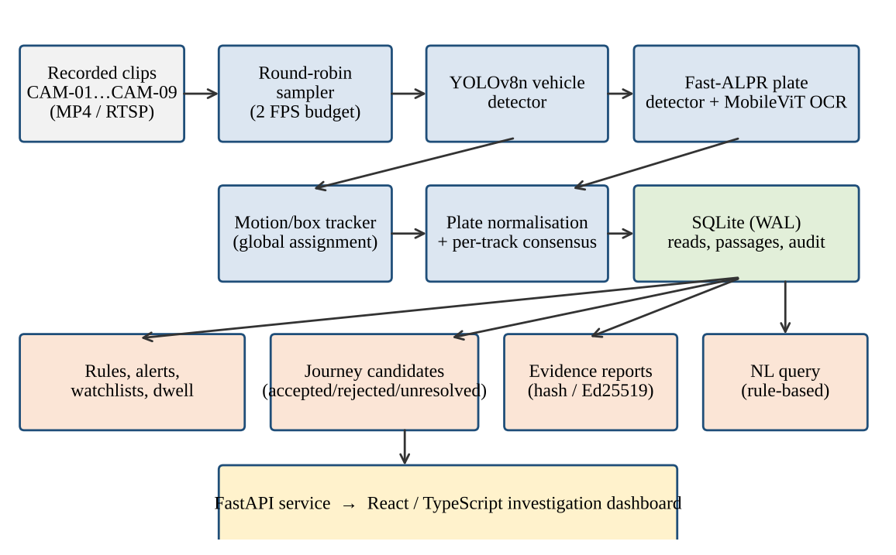
Figure 4.1: AI26 system architecture and data flow

4.2 Data sources and preprocessing
Six bundled clips (CAM-01 to CAM-06, 880–900 frames at 960×540, 25 FPS) provide local vehicle footage. Three further catalogue entries (CAM-07 to CAM-09, 1920×1080) are reserved for plate-readable footage. Sources are registered through an import workflow that preserves the original bytes, stores a SHA-256 digest, validates playback in the browser, and activates a new release only after a restart; the catalogue also records optional operator-claimed recording start time and uncertainty as unverified metadata. For recorded clips the sampler advances through verified nearby frame positions with bounded grabs and seeks only for resets or large jumps, which reduced decode cost.
Frames are processed at native resolution; the YOLO letterbox step resizes to 640×640. For OCR experiments the tool in evaluation/ can produce degraded or enhanced variants (classical contrast, optical-flow aligned burst fusion, synthetic degradation) used only offline for investigation.

4.3 Shared sampling scheduler
A single processor (processing.Processor) owns inference. It cycles over all available cameras sequentially within a global frame budget (default 2 FPS in total), so adding browser viewers never adds inference workers; streams and snapshots serve cached annotated JPEGs. A Linux advisory lock prevents a second process from owning the same data directory. Per-camera counters record attempts, failures, budget overruns, missing-source checks and retry backoff, and are exported in Prometheus format.

4.4 Vehicle detection
The pretrained YOLOv8n checkpoint (SHA-256 f59b3d83…) detects COCO classes car, motorcycle, bus and truck (and persons for privacy masking) with a configurable confidence threshold (0.4 in the benchmark). Weights are loaded lazily, their digest is recorded in every observation, and an optional canary/rollback mechanism assigns a candidate checkpoint to selected cameras only.

4.5 Plate detection and OCR
Plate reading uses Fast-ALPR: a YOLOv9-tiny 384×384 plate detector (ONNX, 7.77 MB) followed by the global MobileViT-v2 OCR model (ONNX, 4.99 MB). Both ONNX files and the OCR configuration are copied into a hashed snapshot and their digests, package versions and execution providers are written with each read, so any stored plate can be traced to exact model bytes. The branch is independently switchable by environment variables.

4.5.1 Plate normalisation
Raw OCR text is upper-cased and stripped to alphanumerics, then checked against the Indian registration grammar (two-letter state/UT code from a fixed list of 37 codes, district digits, optional series letters, four-digit number). Position-aware confusion repairs (for example O↔0, I↔1, S↔5, B↔8 in digit or letter positions) are applied, and every repair is recorded. A read that remains syntactically invalid is kept as a failed read and is never promoted.

4.5.2 Per-track consensus
Reads are accumulated in a sliding window (8 reads) per camera, session and track. An identity is supported only when at least three normalised reads agree. Conflicting reads yield status conflicting; the system may display a character-level candidate (requiring ≥75% weighted vote share and ≥0.25 margin at each position) but only as a review suggestion that never overrides the conflict. If the tracker marks the association ambiguous, the history is cleared and the read is stored as tracking_ambiguous. A contradictory identity later invalidates the passage for identity queries.

4.6 Tracking
The tracker (motion-box-assignment-v2) builds a cost matrix between existing tracks and new detections from elapsed-time-compensated centre distance, last observed velocity and IoU, with hard gates on class and box shape. A global minimum-cost assignment with an explicit option to leave a detection unmatched replaces an earlier greedy nearest-centre rule. When two assignments are nearly equal, implicated IDs are retired and fresh IDs are issued with association_status = ambiguous. Costs are heuristics, not probabilities. On 8,970 timing samples the median association time rose from 0.0038 ms to 0.0126 ms, while a constructed 64-box frame rose from 2.10 ms to 10.52 ms; both are negligible next to model inference (tens of milliseconds).

4.7 Persistence and audit
SQLite in WAL mode (schema version 15) stores users, sessions, observations, camera-local passages, alerts, rules, reports, camera-metadata revisions, journey-link decisions and a hash-chained audit log; migrations are automatic and unknown future versions are refused. Retries of the same session/frame/kind/track are idempotent. A passage is a camera-local summary and is counted once per interval, so passage counts are never presented as unique vehicles. Optionally, an operator can sign an audit chain head (checkpoint) for off-host retention. Backup and restore scripts produce verified snapshots.

4.8 Journey candidates and the clock gate
For a given plate, supported observations on different cameras form candidate links that are checked against directed camera-pair travel constraints. A link can be accepted only if the time basis is an explicit synchronised capture clock; replay or arrival clocks yield unresolved with null speed. Rejected and unresolved links are stored as decisions with reasons. This prevents the system from fabricating a trajectory from file playback timestamps.

4.9 Rule engine and natural-language query
Editable rules cover watchlists, camera zones, class filters and dwell (a single local track inside a normalised rectangle for a minimum elapsed time, at least three samples, bounded gaps). Alerts are persisted with review history and escalations. The query module (nlquery.py) is a deterministic grammar: it extracts one plate, one camera, a vehicle class and a calendar/time bound (timezone Asia/Kolkata by default) and runs bounded database queries. Unsupported requests such as colour or congestion are refused rather than guessed, and multiple dates or clock times are rejected. No large language model or fake SQL is involved.

4.10 Evidence reports and security
A report snapshot stores the matching observations, model-provenance summary, frame/crop coverage and heuristic image-review candidates, with a SHA-256 digest; an ZIP package contains the verified JPEG artifacts, and empty intervals are rejected. Report version 5 may include an Ed25519 signature verified offline against a separately trusted public key. An optional authentication overlay provides role checks, CSRF protection, per-case camera grants with purpose-logged sensitive access, TOTP multi-factor authentication with encrypted enrolment and replay protection, and key-rotation tools. A privacy mode pseudonymises plates and pixelates detected people in presented views.

4.11 Frontend
The React 19/Vite dashboard provides a camera wall with live annotated streams, a main video view, an evidence timeline, an OpenStreetMap-based map, analytics, alert queue, query chat, route-constraint and camera-settings pages, and source-upload and selection tools. Polling hooks keep views current; empty investigations show true empty states instead of demo data.

4.12 Evaluation methodology
A manifest-driven evaluation framework was written so real accuracy can be measured once labelled data exists. The manifest records each clip hash, camera/location/session, split (train, validation, test), clock and coordinate status, and manual vehicle/plate labels, and enforces that the same vehicle, camera, location and session appear in a single split. The evaluator computes: detection precision/recall using a maximum-cardinality one-to-one IoU ≥ 0.5 match; exact-plate accuracy with abstention counted separately; tracking ID switches and fragmentation; pairwise plate-matching recall and false-candidate rates with Wilson intervals; and paired ablations (raw, classical, learned and fusion variants) on identical samples. A promotion gate and model-card validator block model rollout unless required evidence exists. For this report, because no labelled dataset was available, the system was evaluated on system-level behaviour (latency, throughput, stability, tracker behaviour) and on a small human-reviewed crop audit.

4.13 Tools and libraries
Table 4.1: Technology stack
Layer | Tools
Detection / OCR | Ultralytics YOLOv8n, PyTorch 2.14 (CPU), ONNX Runtime 1.30, Fast-ALPR 0.4.0, fast-plate-ocr 1.1.0, open-image-models 0.6.0
Vision | OpenCV, NumPy
Backend | Python 3.12, FastAPI, SQLite (WAL), uv, Prometheus metrics
Frontend | React, TypeScript, Vite, Tailwind CSS, Leaflet/OpenStreetMap
Deployment | Docker Compose overlays (auth, TLS, Caddy, monitoring, RTSP), systemd, GitHub Actions
Testing | Python unittest suites (47 modules), deterministic stub-model pipeline tests

4.14 Algorithm summary
for each tick of the sampling budget:
camera <- next available camera (round-robin)
frame <- advance recorded source / grab latest RTSP frame
boxes <- YOLOv8n(frame) # vehicles, persons
tracks <- assign(prev_tracks, boxes) # min-cost, may abstain
for each vehicle track:
plate_box <- ALPR_detector(vehicle crop)
raw <- OCR(plate crop) # stored always
norm <- normalise_indian_plate(raw) # repairs recorded
status <- consensus(camera, track, norm, tracks.status)
store reads, passages, frame/crop hashes, model digests
cache annotated JPEG for streams and previews

5. Results and Discussion
All numbers below come from the validation files stored in docs/validation/ in the repository, generated by the project's own benchmark scripts. Hardware: a 12-thread x86-64 Linux desktop (12th Gen Intel Core i5-12450H class) on CPU only, under normal desktop load, so figures indicate order of magnitude rather than controlled benchmark results.

5.1 Detector latency and INT8 quantisation
The YOLOv8n detector was exported to ONNX (opset 18) and statically quantised to INT8 (QDQ on 64 weighted nodes, MinMax calibration on 60 frames from the bundled clips). Model-forward latency was measured on a 640×640 input with 2 warm-up and 10 measured runs.
Table 5.1: Detector latency by runtime and precision
Variant | Median (ms) | p95 (ms) | Images / s | Size (MB)
PyTorch FP32 | 92.8 | 98.7 | 10.8 | 6.5 (.pt)
ONNX FP32 | 95.3 | 101.2 | 10.5 | 12.8
ONNX INT8 | 55.8 | 58.3 | 17.9 | 3.6

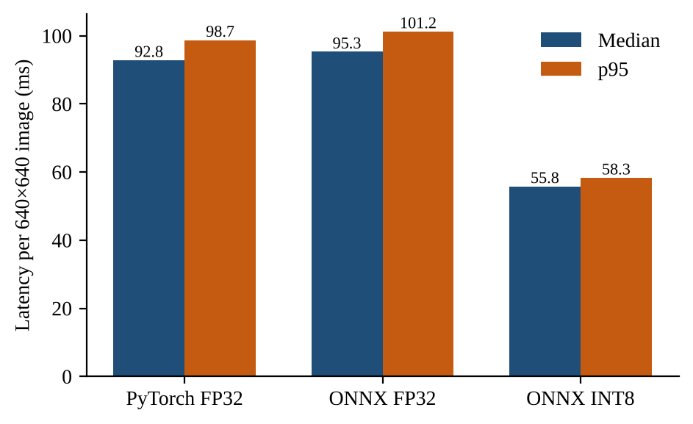
Figure 5.1: Median and p95 model-forward latency (lower is better)
INT8 quantisation cut median latency by 41% (95.3 ms to 55.8 ms) and file size by 72% (12.8 MB to 3.6 MB), a 1.7× throughput gain. FP32 ONNX output matches PyTorch almost exactly (mean absolute raw-output difference 2×10⁻⁶), validating the export. The INT8 mean absolute difference was 0.30 with a few large outliers (maximum 178.6 on raw tensors); on 60 calibration frames the INT8 model produced 15 detections that all matched the FP32 reference at IoU ≥ 0.5, while missing one of 16 reference detections. These agreement numbers are not accuracy: no ground-truth labels were used, and the calibration frames are not held out.

5.2 Effect of CPU thread count
Table 5.2: YOLO latency on one CAM-05 frame vs. thread count
Threads | Median (ms) | Max (ms)
1 | 135.4 | 160.0
2 | 77.1 | 101.1
8 | 319.4 | 985.4

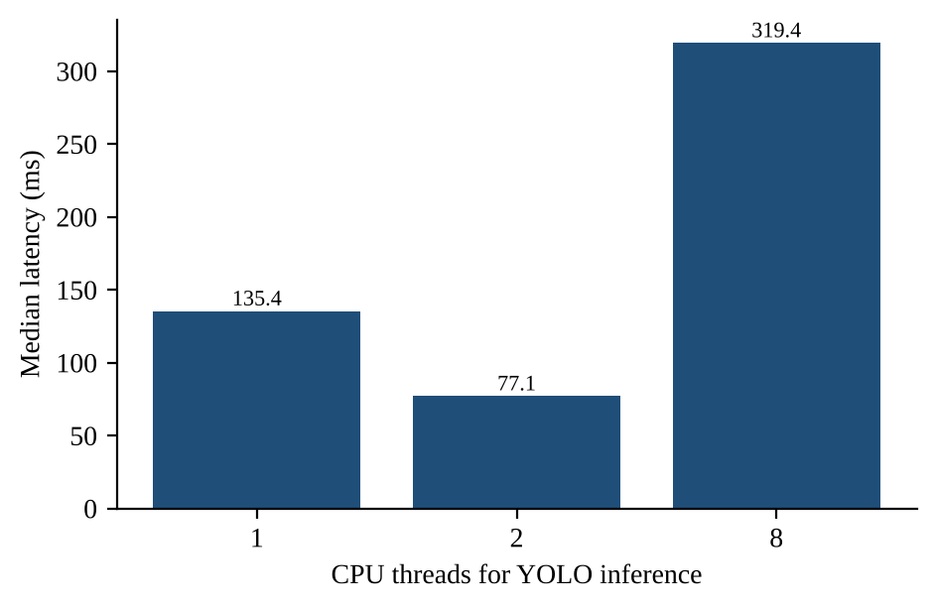
Figure 5.2: Median latency by thread count (lower is better)
Two threads were fastest; eight threads was 4× slower than two, because the API and other processes were competing for cores and thread over-subscription adds synchronisation overhead. Based on this measurement a small thread count (the AI26_CPU_THREADS setting) is the sensible choice for inference. This is a useful practical lesson: more CPU threads do not guarantee higher throughput on a shared host.

5.3 Six-camera soak test
The full backend was run for 300 seconds with the vehicle branch enabled and six cameras available, sampled every 2 seconds by the monitoring script (140 samples) at the 2 FPS shared budget.
Table 5.3: Soak-test results (300 s, 6 cameras, 2 FPS budget)
Metric | Result
Frames processed (6 cameras) | 555 in 298.0 s (1.86 FPS total)
Failed attempts / health failures | 0 / 0
Frames per camera | 92–93 each (even sharing)
Health endpoint latency | median 5.1 ms, p95 9.1 ms, max 36.0 ms
Process CPU | median 47%, p95 82%, max 106% (of one core)
Resident memory | median 532 MiB, p95 540 MiB, max 541 MiB

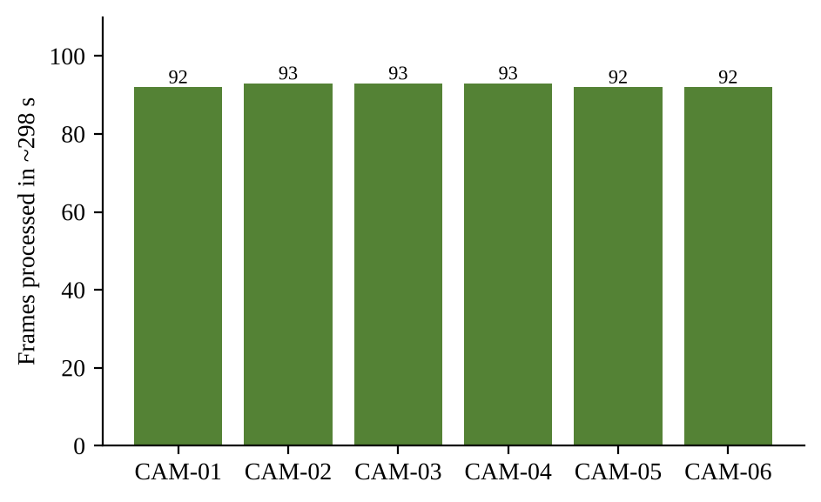
Figure 5.3: Frames processed per camera during the 298 s soak test
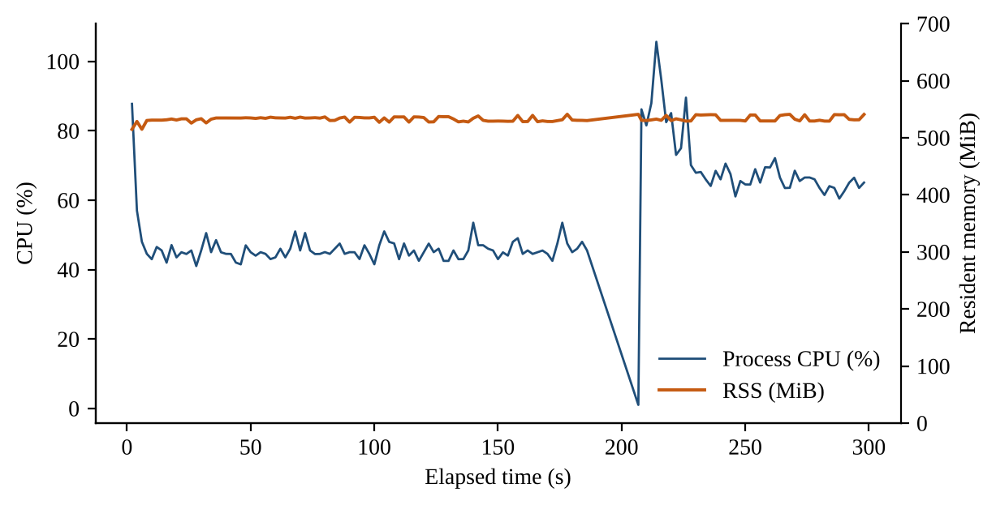
Figure 5.4: Process CPU and resident memory during the soak test
Round-robin scheduling gave each camera an equal share (92 or 93 frames) and the memory curve stayed flat, indicating no leak over the window. An earlier 30-second sample, taken before the sampling-budget change, measured 1.23 FPS in total; the budgeted scheduler skips slots for missing or retrying cameras (CAM-07 to CAM-09 were unavailable) and the later runs measured 1.86 FPS, though the runs were not frame-aligned experiments. Limitations: the test lasted only five minutes, one sampling gap reached 20.7 s (so a strict steady-state rate is not claimed), and browser rendering and real plate accuracy were not measured.

5.4 API responsiveness
Before/after profiling of common endpoints (12 samples each) showed median latencies of roughly 1.6–2.7 ms for camera and statistics routes, 6–9 ms for event and alert queries and about 1.6 ms for cached snapshots. Between the two profiling runs the median for the camera-event query moved from 10.6 ms to 8.8 ms (the runs were not controlled for load), and bounded result limits (for example limit=40) further reduced payload to 62 KB from 96 KB. Responses are cached JPEGs and SQL aggregates, so viewer count has no effect on inference.

5.5 Plate OCR review audit
Because no labelled plate dataset existed, a small human review was carried out on 21 crops sampled from CAM-07, CAM-08 and CAM-09 (1920×1080 footage). A reviewer marked each crop readable, uncertain or unreadable without seeing the prediction, then the pipeline output was compared for the readable ones.
Table 5.4: Human review of 21 plate crops (CAM-07–09)
Reviewer label | Crops | Pipeline outcome
Unreadable | 16 | Not comparable (excluded from exact-match)
Readable | 4 | 4 mismatches, all 4 rejected by the pipeline
Uncertain | 1 | Not comparable

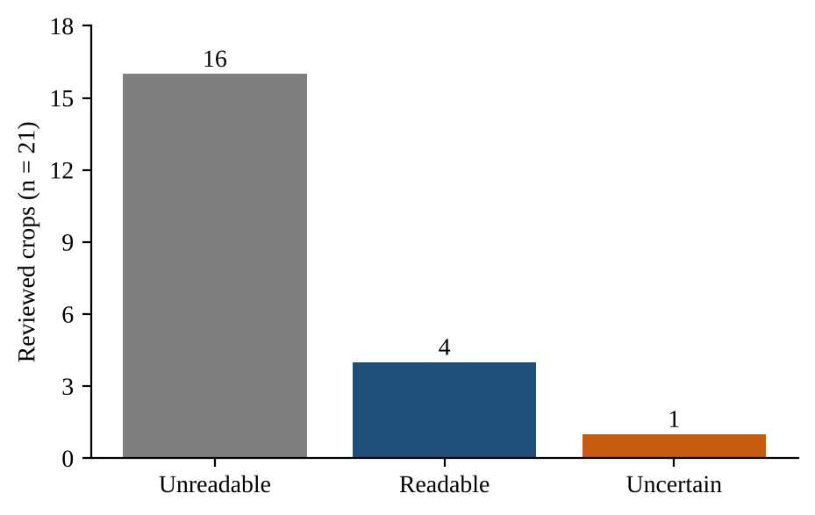
Figure 5.5: Reviewer readability labels for 21 sampled crops
Three observations follow. (1) 76% of sampled crops were unreadable even to a human, so footage quality, not just model choice, bounds ALPR performance. (2) For all four readable crops the live OCR output disagreed with the reviewer, but every mismatch was rejected by the pipeline's own gates (invalid format, low confidence or ambiguity), so none would have been accepted as a supported identity; this supports the design choice of abstaining. (3) An offline preprocessing probe on the same four readable crops found that a grayscale contrast stretch (α = 1.5, β = −25) recovered one exact match (CAM-07-02, frame 1114), and that this match also passed the format and confidence gates, whereas full-frame OCR and expanded-region OCR produced 0 exact matches. This suggests contrast enhancement is worth testing, but 1 in 4 is far too small a sample to call a result; the evaluation tool therefore sets accuracy_claim_allowed to false.

5.6 Tracker behaviour
Synthetic scenarios built to reproduce failure modes of the earlier greedy tracker (track theft, two crossing subjects, brief occlusion, expiry by elapsed time, class/shape rejection, near-tied assignments) are covered by regression tests, and the new assignment is checked against exhaustive search on small matrices. These scenarios demonstrate correctness of the design, not performance on real crowds; ID-switch and fragmentation rates on real labelled sequences remain to be measured with the provided evaluator.

5.7 Software quality
The repository contains 47 test modules covering the repository layer, authentication and MFA, report signing, source import, model provenance, tracking, reliability, backup/restore and the evaluation tools. They run deterministically with stub model outputs through the real tracking, fusion, normalisation and rendering code. A GitHub Actions workflow runs the checks. Tests verify behaviour and contracts; they are not a substitute for model accuracy evaluation.

5.8 Discussion
The measurements show that a multi-camera detection pipeline is feasible on a CPU-only workstation: about 55–95 ms per detector call, a bounded and stable memory footprint, and fair sharing across cameras. Practical findings were that a single shared inference owner scales better than per-viewer inference, that over-threading hurts, and that INT8 quantisation is a cheap latency win for edge targets.
The more important result is methodological. Plate OCR on real surveillance crops is hard: most crops were unreadable and a mainstream OCR model failed on readable ones. A system that always returns its best guess would have produced several wrong plates in this small audit; AI26 instead stored the raw read, flagged it and abstained. In an evidential setting the cost of a false identity is much larger than the cost of a missed read, so high abstention with traceable evidence is the correct operating point until a held-out evaluation justifies thresholds.

5.9 Limitations
- No held-out labelled dataset: detection precision/recall, exact-plate accuracy and calibration are not measured, and no accuracy figure in this report should be read as such.
- Benchmarks were run on a single desktop under uncontrolled load; the intended edge hardware is unconfirmed.
- Recorded clips carry replay time, so cross-camera journeys are unresolved candidates and no speed or travel time is computed.
- The tracker is heuristic and local to one camera; there is no appearance-based re-identification.
- Pretrained weights have unverified training lineage and licensing, and Indian-plate performance of the global OCR model is unmeasured.
- Passage counts are camera-local sampled counts, not unique vehicles; congestion, occupancy and colour queries are unsupported.
- A report hash detects modification; only the optional Ed25519 signature adds authenticity, and neither proves that the OCR is correct.

6. Future Scope and Conclusion

6.1 Future scope
- Labelled evaluation: annotate 500+ frames and 200+ plates from at least three camera sessions using the supplied frame-review tool and manifest, then report detection AP, exact-plate accuracy with abstention, and ID-switch rates with confidence intervals.
- Fine-tuning for Indian plates: train or fine-tune the plate detector and OCR on a licensed Indian dataset and compare against the global model with the paired ablation tool.
- Image enhancement: test the contrast enhancement, multi-frame fusion and learned super-resolution paths already scaffolded in evaluation/, using the plate-quality classifier to route crops.
- Synchronised clocks: ingest live RTSP/ONVIF cameras with NTP-synchronised capture times so that travel-time gating and cross-camera journeys can be accepted legitimately.
- Appearance re-identification: add a vehicle embedding model for plates that are unreadable, and evaluate it with the labelled-pair framework.
- Edge deployment: run the INT8 detector on a target device (for example Jetson or a CPU-only mini-PC) and measure sustained throughput, thermals and power.
- Traffic analytics: calibrated speed, occupancy and historical hour/weekday congestion baselines.
- Alert delivery: integrate external notification channels with the existing escalation queue.

6.2 Conclusion
This mini project designed and implemented AI26, an end-to-end multi-camera vehicle analytics system around a YOLOv8n detector and an ONNX-based ALPR pipeline. It demonstrates a shared, budgeted inference scheduler; global-assignment tracking with abstention; Indian plate normalisation with consensus fusion; a durable, hash-chained store; a full dashboard; and tamper-evident evidence reports. Measurements on a CPU host show stable operation across six cameras (555 frames in 298 s, no failures, ~532 MiB memory) and a 41% latency reduction from INT8 quantisation. A human review of 21 plate crops showed that real footage is frequently unreadable and that the system's conservative gates rejected all four incorrect reads of readable plates.
The project's central lesson is that applied AI in an evidential setting must be engineered for honesty as much as for accuracy: record the raw output, hash the model, abstain when unsure, and refuse to claim what has not been measured. The evaluation framework delivered with the system provides the path to turn those safeguards into quantified accuracy once labelled data is available.

References
[1] J. Redmon, S. Divvala, R. Girshick and A. Farhadi, "You Only Look Once: Unified, Real-Time Object Detection," in Proc. IEEE CVPR, 2016, pp. 779–788.
[2] S. Ren, K. He, R. Girshick and J. Sun, "Faster R-CNN: Towards Real-Time Object Detection with Region Proposal Networks," in Advances in NIPS, 2015.
[3] G. Jocher, A. Chaurasia and J. Qiu, "Ultralytics YOLOv8," 2023. [Online]. Available: https://github.com/ultralytics/ultralytics
[4] A. Bewley, Z. Ge, L. Ott, F. Ramos and B. Upcroft, "Simple Online and Realtime Tracking," in Proc. IEEE ICIP, 2016, pp. 3464–3468.
[5] H. W. Kuhn, "The Hungarian method for the assignment problem," Naval Research Logistics Quarterly, vol. 2, no. 1–2, pp. 83–97, 1955.
[6] N. Wojke, A. Bewley and D. Paulus, "Simple Online and Realtime Tracking with a Deep Association Metric," in Proc. IEEE ICIP, 2017, pp. 3645–3649.
[7] R. Laroca, E. Severo, L. A. Zanlorensi, L. S. Oliveira, G. R. Gonçalves, W. R. Schwartz and D. Menotti, "A Robust Real-Time Automatic License Plate Recognition Based on the YOLO Detector," in Proc. IJCNN, 2018.
[8] S. M. Silva and C. R. Jung, "License Plate Detection and Recognition in Unconstrained Scenarios," in Proc. ECCV, 2018, pp. 580–596.
[9] B. Shi, X. Bai and C. Yao, "An End-to-End Trainable Neural Network for Image-Based Sequence Recognition and Its Application to Scene Text Recognition," IEEE TPAMI, vol. 39, no. 11, pp. 2298–2304, 2017.
[10] S. Mehta and M. Rastegari, "MobileViT: Light-weight, General-purpose, and Mobile-friendly Vision Transformer," in Proc. ICLR, 2022.
[11] B. Jacob et al., "Quantization and Training of Neural Networks for Efficient Integer-Arithmetic-Only Inference," in Proc. IEEE CVPR, 2018, pp. 2704–2713.
[12] ONNX Runtime developers, "ONNX Runtime," Microsoft, 2024. [Online]. Available: https://onnxruntime.ai
[13] E. B. Wilson, "Probable Inference, the Law of Succession, and Statistical Inference," J. Amer. Statist. Assoc., vol. 22, no. 158, pp. 209–212, 1927.
[14] ankandrew (GitHub user), "fast-alpr, fast-plate-ocr and open-image-models," GitHub, 2024. [Online]. Available: https://github.com/ankandrew/fast-alpr
[15] S. Ramírez, "FastAPI documentation," 2024. [Online]. Available: https://fastapi.tiangolo.com
[16] AI26 project repository, docs/validation/*.json, docs/IMPLEMENTATION.md and evaluation/*.md (measurement data and design documentation used in this report).

Appendix A: Repository Map and Run Instructions
Table A.1: Repository layout
Path | Purpose
backend/ | FastAPI API, inference owner, tracker, fusion, repository, auth, reports (about 8,400 lines in the main modules)
frontend/ | React/TypeScript dashboard
evaluation/ | Dataset manifest, evaluator, ablation, promotion gate, enhancement and benchmark tools
tests/ | 47 deterministic test modules
docs/ | Implementation notes and validation JSON for each measurement
demo/ | Synthetic static walkthrough (not real data)
ops/, deploy/, compose.*.yaml | Monitoring alerts, systemd units and Docker Compose overlays

To run locally (Linux, Python 3.12, Node.js 22.12+, uv):
uv run run.py # first run installs dependencies
uv run run.py --skip-install # later runs
# UI: http://localhost:5174 API: http://127.0.0.1:8001

Evaluation entry points: evaluation/evaluate.py (metrics), evaluation/ablation.py (paired ablations), evaluation/edge_benchmark.py (ONNX/INT8 latency), evaluation/dataset_manifest.py (manifest validation).

