**UTD – Fall 2023**

**CS 6360 Database Design**

**Assignment #2 Due Date: Sunday, Sept. 17, 2023, Midnight**

For this assignment you must use a software tool to draw ERMs or EERM of the following problems. The following links provide some ER drawing tools; you may investigate them and pick one that works for you. <http://dia-installer.de/shapes/ER/index.html.en> [https://products.office.com/en-us/Visio/visio-](https://products.office.com/en-us/Visio/visio-professional-2013-free-trialflowchart-software)

[professional-2013-free-trialflowchart-software](https://products.office.com/en-us/Visio/visio-professional-2013-free-trialflowchart-software)<https://www.omnigroup.com/omnigraffle>

<https://www.gliffy.com/>

Or any software that you may find and suitable for drawing ERM Submission Instructions:

* Hand drawing ERMs are not accepted.
* All answers should be your own • Handwritten answers are not accepted.
* Images are not accepted. • All answers should be collected in only one PDF file. • Submit this file via eLearning.

# Question 1: [20 points]

Draw an Enhanced Entity-Relationship (EER) diagram that describes the following business environment. The National Association of Zoos (NAZ) wants to develop an information system to keep track of the zoos, animals, and related zoo objects and people associated with zoos in the US.

Each Zoo in the U.S. has a unique name plus an address and a size in acres. Each state may have several zoos. In addition to the unique state name, the NAZ wants to record the state's governor and capital. Each animal in each zoo has an animal number that is unique across all NAZ zoos. Each animal also has a pet name (King, Rover, Fred, etc.), a species (tiger, eagle, shark, etc.) and a country of origin.

An animal may be a bird, a mammal, a fish, or any of several other broad categories of animal, but a particular animal may be classified in only one of these broad categories. Additional data about birds include their length and wingspan. Additional data about fish include their weight and top swimming speed. Mammals are kept in enclosures that can be of one of several types (cages, fenced fields, glass enclosures, etc.).

Each enclosure in a zoo is identified by an enclosure number that is only unique within its zoo. In addition to the enclosure type, the NAZ information system must record the date the enclosure was built. It must also maintain information on the company that built the enclosure, including its unique company name, address, and phone number. Of course, a company may be responsible for building several enclosures. Assume that each enclosure is built by only one company. An enclosure may contain one or several mammals. The NAZ also wants to record the date of birth of each mammal.

The NAZ wants to keep track of the current employees of each zoo. Each zoo employee has an employee number that is only unique to the zoo that currently employs him or her. The NAZ also records each employee's name and date of birth. There are only three kinds of zoo employees: veterinarians, animal handlers, and maintenance workers. An employee can fall into more than one of these categories. For example, a veterinarian may at times be considered an animal handler, and an animal handler may at times do maintenance work. The NAZ wants to record each animal handler's date of hire and salary. For each maintenance worker, the NAZ wants to record the set of skills that they have and the number of years they have been employed by the zoo. Some maintenance workers supervise other maintenance workers. For veterinarians, the NAZ wants to record their specialties (a veterinarian can have more than one specialty), their license number, and data about their university degrees. In fact, the NAZ wants to store data about each university including its unique name, city, and state. Since a veterinarian may have received degrees from more than one university, the NAZ wants to keep track of the degrees and dates of graduation of each degree of each veterinarian.

Each zoo can have donors who help support the zoo. A donor can help support more than one zoo. The NAZ assigns each donor a unique identification number and also records their name and phone number. The NAZ also tracks each donor's contribution history, including the date and amount of each contribution to each zoo.

# Question 2: [10 points]

Map the following EER diagram into relational database schema:

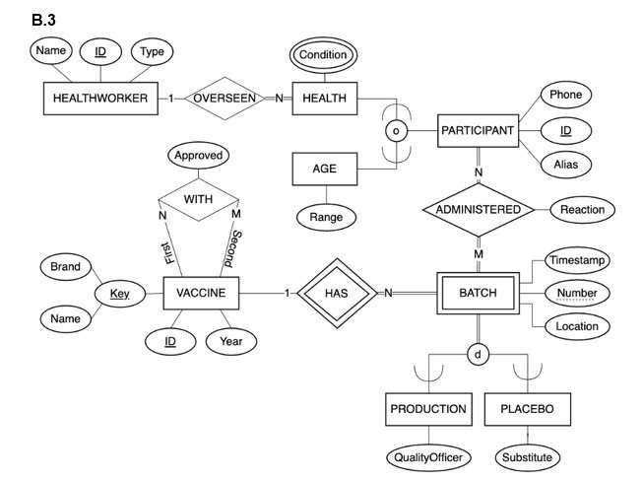

# Question 3: [10 points]

Draw an ER diagram that would be mapped into the following relational Database schema:

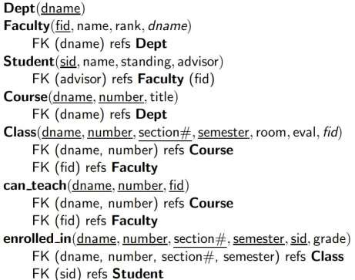

# Question 4: [10 points]

Redraw the following EERM diagram using the (min, max) notations. State clearly all assumptions you make.



