Write SQL to show the count of **new** customers transacting in the store by date.

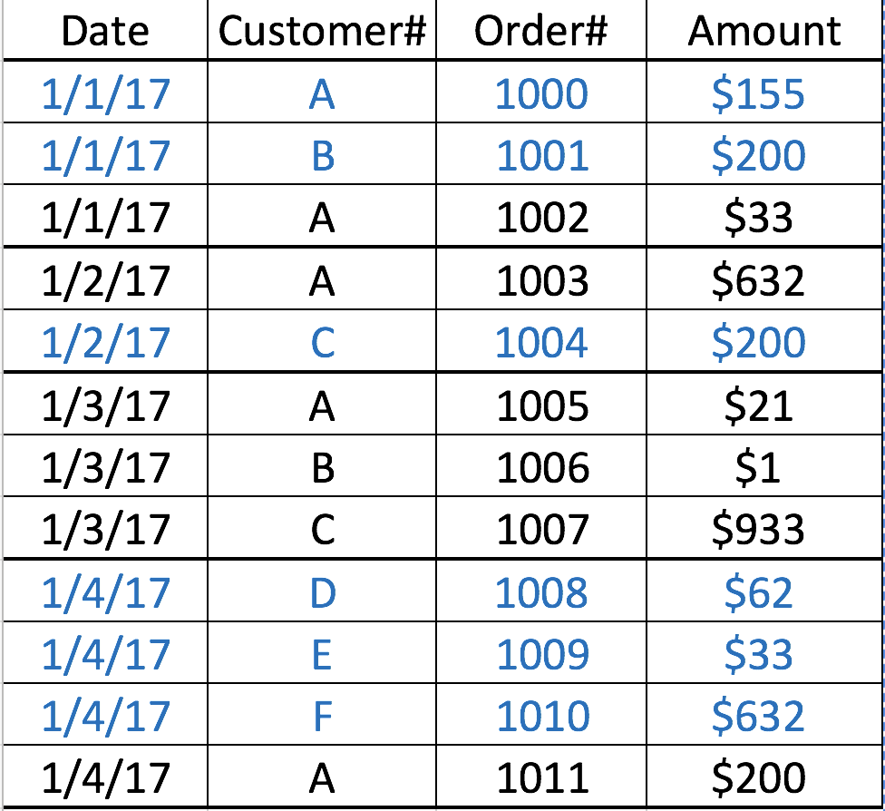

Write SQL to identify the top selling product (Product Name)

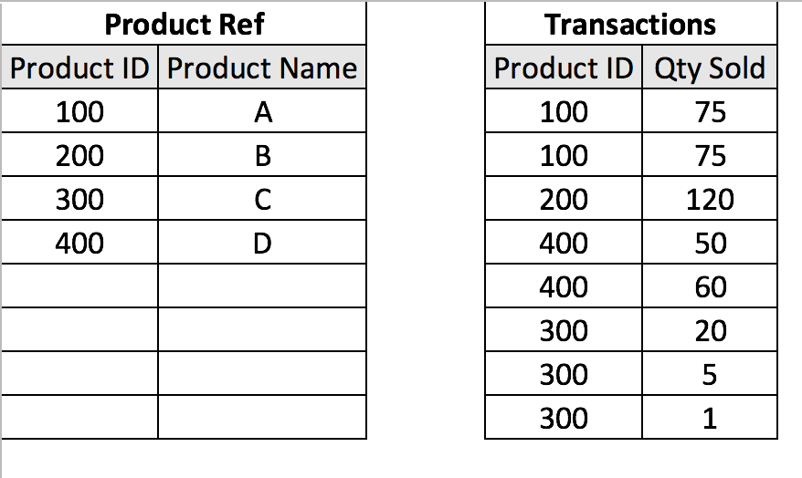

Write SQL to identify the seniority rank of the employees based on Joining date

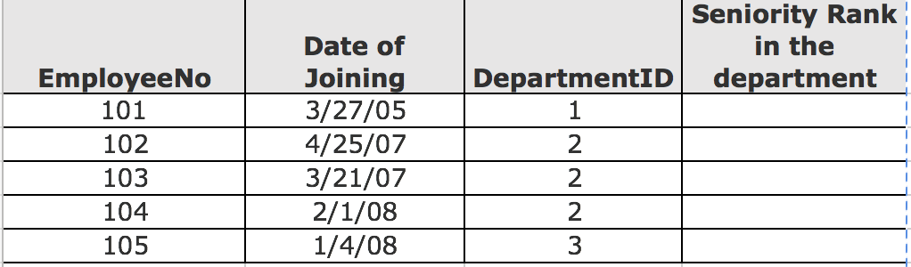

Write a SQL to find all employees that make more than their manager in terms of salary.

|  |  |  |
| --- | --- | --- |
| Emp-Id | Salary | Manager’s Emp-id |
| **5020** | $10,000 | 1000 |
| **1000** | $14,000 |  |
| 5021 | $8,000 | 5020 |
| **5050** | $11,000 | 5020 |
| **6020** | $12,000 | 1000 |
| 6021 | $8,000 | 6020 |
| 6022 | $8,000 | 6020 |
| 5501 | $8,000 | 5050 |

Re-download Data.

|  |  |  |
| --- | --- | --- |
| Customer# | App_id | Date |
| 1 | 971265422 | **2016-04-16** |
| 1 | 971265422 | **2016-05-15** |
| 1 | 971265422 | **2016-06-05** |
| 1 | 971265422 | **2016-06-05** |
| 1 | 971265422 | **2016-06-19** |

Construct **Attribution Start date and End date at person level**. Where "**Start date" is the date of re-download** and "**End date" is the date of next re-download or 29 days from the current re download date,**whichever is earlier. Ignore duplicate records, if there are multiple re downloads for the same day, consider only one of them,

|  |  |  |
| --- | --- | --- |
| Customer# | start_dt | emd_dt |
| 1 | **2016-04-16** | **2016-05-14** |
| 1 | **2016-05-15** | **2016-06-04** |
| 1 | **2016-06-05** | **2016-06-18** |
| 1 | **2016-06-19** | **2016-07-17** |

|  |  |  |  |  |
| --- | --- | --- | --- | --- |
| Session-ID | Event ID | Event | Referrer |  |
| 1234 | 1000 | Entry | Facebook |  |
| 1234 | 1001 | Add to Cart |  |  |
| 1234 | 1002 | Add to Cart |  |  |
| 1234 | 1003 | Buy |  |  |
| 30001 | 20001 | Entry |  |  |
| 8799 | 1010 | Entry | Facebook |  |
| 8799 | 10201 | Add to Cart |  |  |
| 6779 | 1293 | Entry | Facebook |  |
| 6779 | 23124 | Add to Cart |  |  |
| 6779 | 6862 | Buy |  |  |
| 8688 | 7980 | Entry | Google |  |
| 8688 |  |  |  |  |