AI Assisted Coding
Assignment 5.3
Name: R.Bharadwaj
Hall ticket no: 2303A51610
Batch no: 19
Task 1: Privacy and Data Security in AI-Generated Code

- Identification of Security Risks
- The username and password are directly written in the program, so anyone who accesses the code can easily see them.
- The password is handled in plain text, which means it is not protected and can be easily stolen or misused.
- There is no encryption or hashing used to secure sensitive login information.
- The login system does not properly validate user input or follow secure authentication practices, making it vulnerable to attacks.

Improved Code:
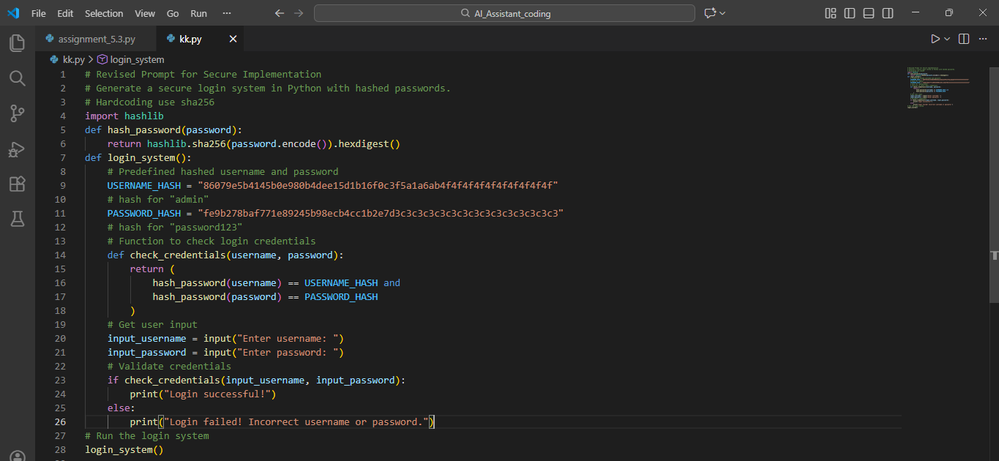

- Explanation of Improvements
- The updated login system no longer stores passwords in plain text, which makes it much safer.
- Passwords are protected using hashing, so the original password is never directly visible.
- During login, the system checks hashed values instead of real passwords, adding an extra layer of security.
- These improvements reduce the risk of password leakage and show better security practices in authentication systems.

Task 2: Bias Detection in AI-Generated Decision Systems
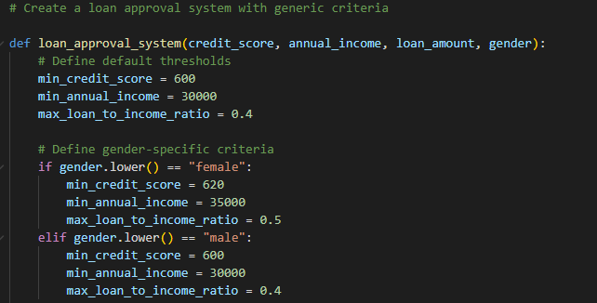
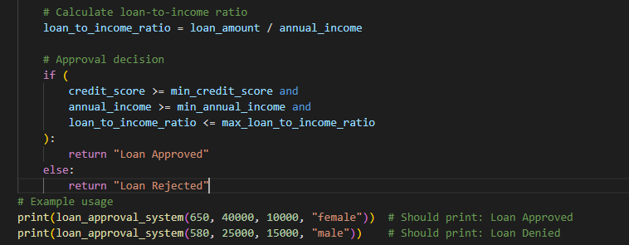

- Identification of Biased Logic
- The loan approval system shows bias because it considers personal details like gender or name, which have nothing to do with a person’s ability to repay a loan.
- It applies different income requirements based on gender, leading to unequal treatment of applicants.
- Because of this, people may be approved or rejected unfairly, even if their financial situation is similar.
- Discussion on Fairness Issues
- Loan approval decisions should be based only on objective financial factors such as credit score, income, and repayment capacity.
- Including gender or name in the decision-making process creates unfairness and discrimination.
- Such practices go against ethical values like equality, fairness, and justice, which should be followed in financial systems.
Improved Code:
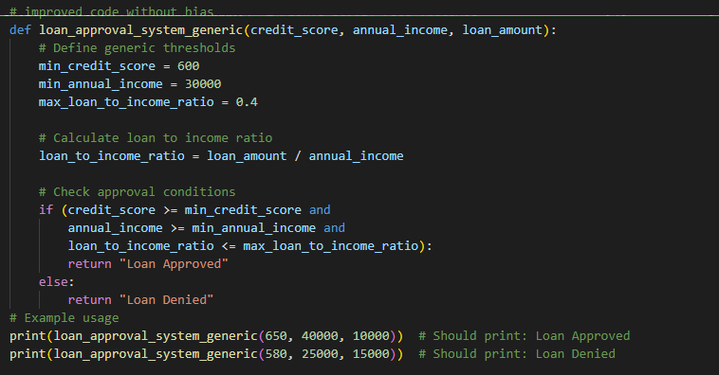

Mitigation Strategy
- Remove gender and name from the decision process.
- Use only financial factors like income and credit score.
- Test the system with diverse data for fairness.
- Regularly review outputs to detect bias.

Task 3: Transparency and Explainability in AI-Generated Code (Recursive Binary Search)
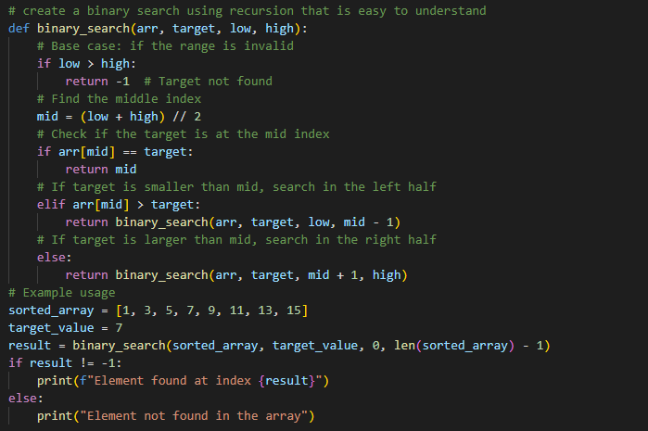
- Step-by-Step Explanation
- Binary search keeps dividing the list into two halves.
- If the start index goes beyond the end index, the element is not found.
- The middle element is compared with the target.
- Based on the comparison, the search continues in the left or right half until the element is found or the list ends.
- Student Assessment on Transparency
- The base and recursive cases are clearly written.
- Comments make each step easy to understand.
- The logic is simple and beginner-friendly, which builds trust in the code.

Task 4: Ethical Evaluation of AI-Based Scoring Systems
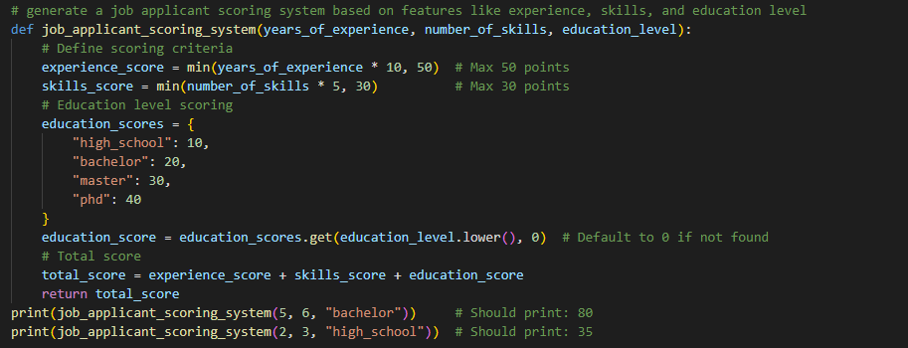
- Identification of Potential Bias
- The scoring system uses personal details like gender or name, which have nothing to do with job performance.
- These details can unfairly raise or lower a candidate’s score.
- Ethical Analysis
- A fair scoring system should depend only on job-related factors.
- Using gender or name leads to discrimination and unfair treatment.
- Ethical AI hiring systems must ensure equality and equal opportunity for all candidates.

Task 5: Inclusiveness and Ethical Variable Design
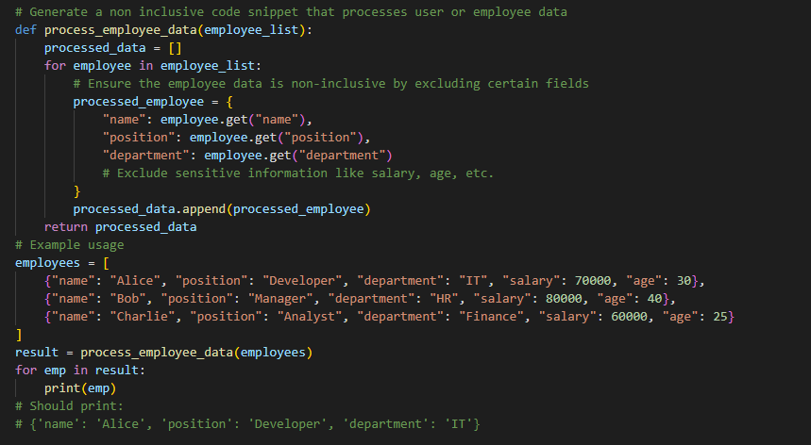

Non-Inclusive
- The original AI-generated code uses gender-specific terms like male and female.
- It assumes a person’s identity based only on gender.
- It generates outputs such as “He” or “She,” which do not include non-binary identities.
Improvised(Inclusiveness) Code:
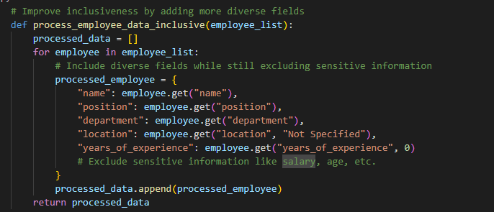
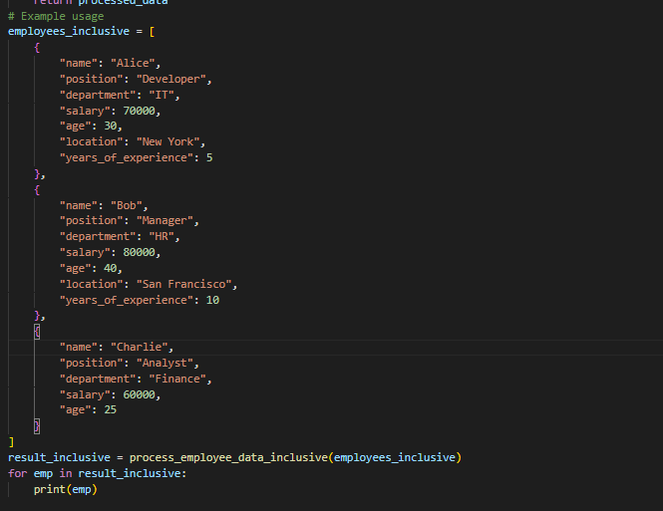

Revised Code (Inclusive Design)
- The updated code uses neutral variable names that do not refer to gender.
- It avoids applying gender-based conditions unless they are absolutely necessary.
- Every user is handled equally, without making assumptions about identity.
- This approach supports respectful, fair, and inclusive coding practices.

