1. Webcrawler Rest API test1 3

2. Logfile location 3

2.1 Logfile data 4

3. Gson utility to generate Json string request 5

3.1 Utility class 6

3.2 Json string input 7

4. WebCrawler Rest API test 2 7

4.1 LogFile 8

5. Logback.xml configuration 9

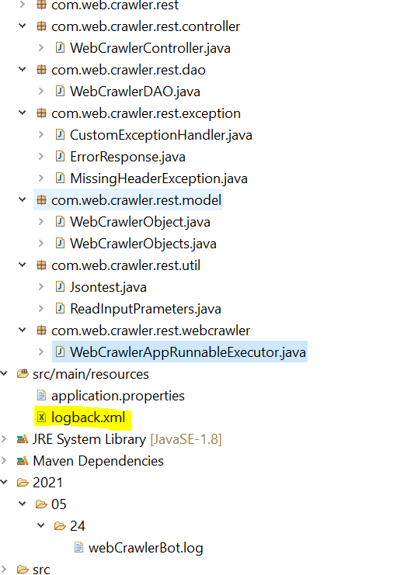 9

# Webcrawler Rest API test1

# 

# Logfile location

# 

## 2.1 Logfile data

# 

# Gson utility to generate Json string request

# 

## 3.1 Utility class

# 

## 3.2 Json string input

# {"webCrawlerList":[{"url":"https://camel.apache.org","id":1,"searchText":"Camel Spring Boot"},{"url":"https://activemq.apache.org","id":2,"searchText":"ActiveMQ Artemis"},{"url":"https://cxf.apache.org","id":3,"searchText":"Download"},{"url":"https://kafka.apache.org","id":4,"searchText":"HIGH THROUGHPUT"},{"url":"https://servicemix.apache.org","id":5,"searchText":"legacy support for the JBI"}]}

# WebCrawler Rest API test 2

# 

## 4.1 LogFile

# 

# Logback.xml configuration

# 