Hi Team,
This is with respect to ASIN B0CHR00001 which has been warned for suppression for negative feedback received from customers. We have understood this is due to customer complaints who have felt .
ASIN: B0CHR00001
Title: Wakefit Sample Ergonomic Office Chair | Demo POA
Root Cause Analysis: After reviewing all the reviews as mentioned in the “Voice of the Customer” we have identified product issues highlighted by customers, review feedback and take action to fix them.
Customer Review:
A) Product is defective/ Defective item/ doesn't work
1. Defect Identified (Root Cause):
• Inadequate incoming inspection of supplier parts.
• Variation in component quality across supplier batches.
• Lack of defined sampling standards during inward quality checks.
• Missed detection of cosmetic and functional defects during assembly.
• Insufficient in-process inspection checkpoints during production.
• Inconsistent documentation and traceability of inspected parts.
2. Corrective Actions Implemented
- Segregated suspect inventory and stopped dispatch of affected batches.
- Implemented 100% inspection for critical supplier components.
- Introduced supplier-wise quality and rejection tracking.
- Standardized inspection criteria and approved reference samples.
- Increased inspection frequency for high-risk suppliers.
- Added QC checkpoints at critical assembly stages.
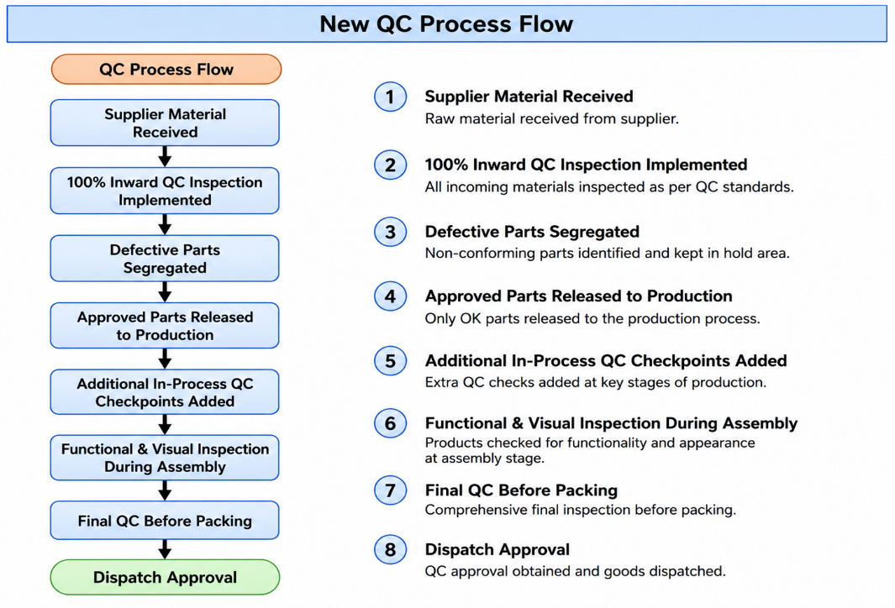
- Implemented operator self-inspection and random functional checks.
- Increased supervisor audits during production shifts.
- Trained operators and QC inspectors on defect identification.
- Reworked or rejected defective parts identified during production.
3. Preventive / Proactive Measures
- Standardized IQC checklists for all suppliers.
- Scheduled periodic supplier quality audits.
- Implemented batch traceability for incoming parts.
- Defined AQL standards for inspections.
- Conducted monthly supplier performance reviews based on rejection trends.
- Displayed SOPs at all production stations.
- Introduced layered process audits for critical operations.
- Initiated daily QC reporting and defect trend analysis.
- Implemented poka-yoke methods to reduce assembly errors.
- Strengthened final product inspection before packaging and dispatch.
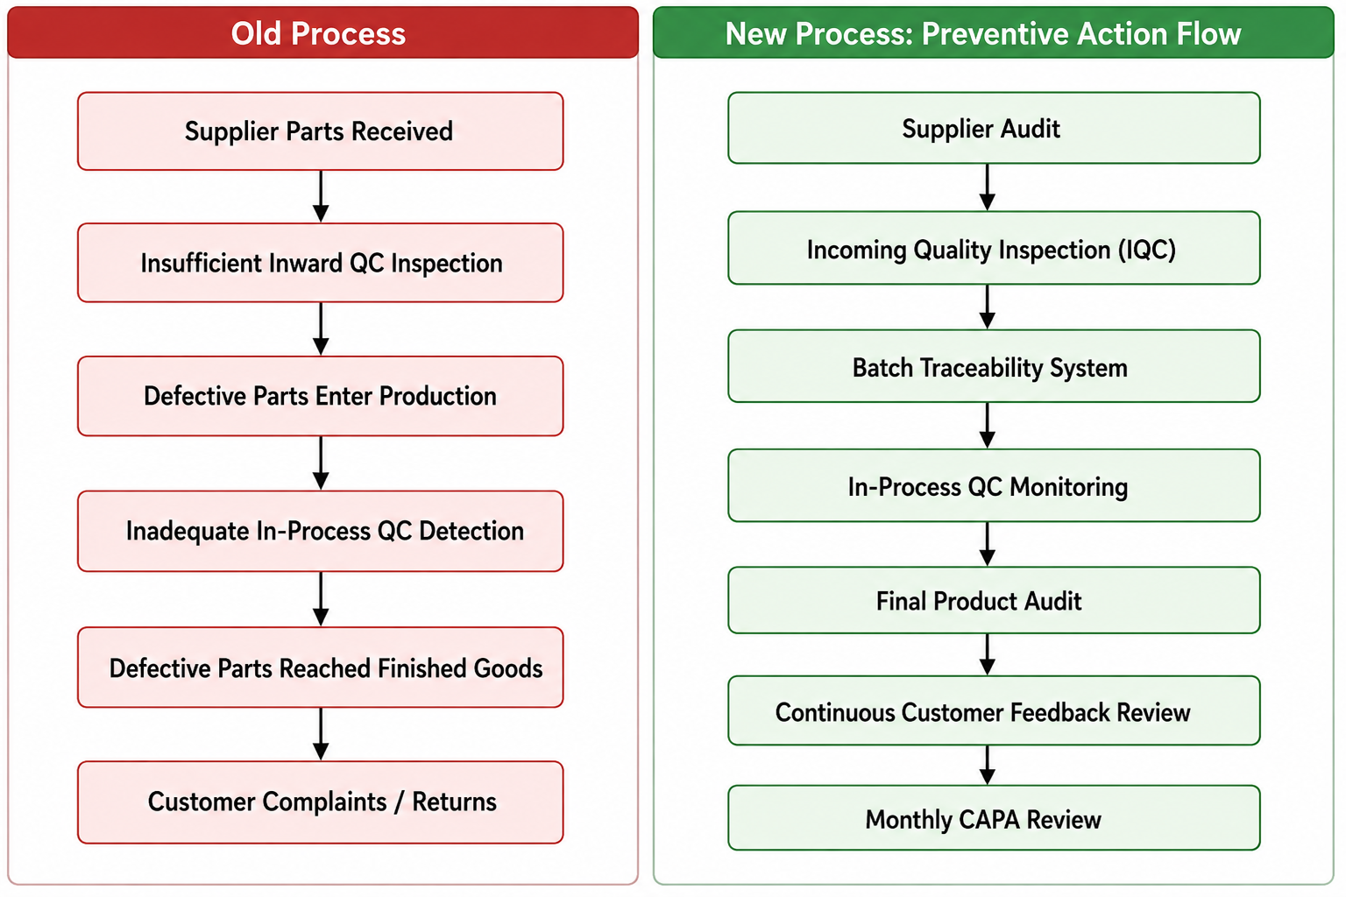
- Established a continuous improvement process.

B) The multilocked doesn’t work as expected / Issue with the locking system
1. Defect Identified (Root Cause) :
- Lack of sufficient end-line functional testing for lock and recline positions.
- Improper handling during transit leads to occasional alignment issues.
- Inadequate inspection checkpoints for mechanism movement and locking functionality.

2. Corrective Actions Implemented
- Stopped dispatch of all affected inventory batches.
- Conducted 100% inspection of available stock for lock/recline functionality.
- Replaced defective mechanisms in identified inventory.
- Introduced torque-controlled assembly process for mechanism fitting.
- Added functional testing for all lock positions before packaging.
- Coordinated with supplier for strengthened quality validation and batch certification.
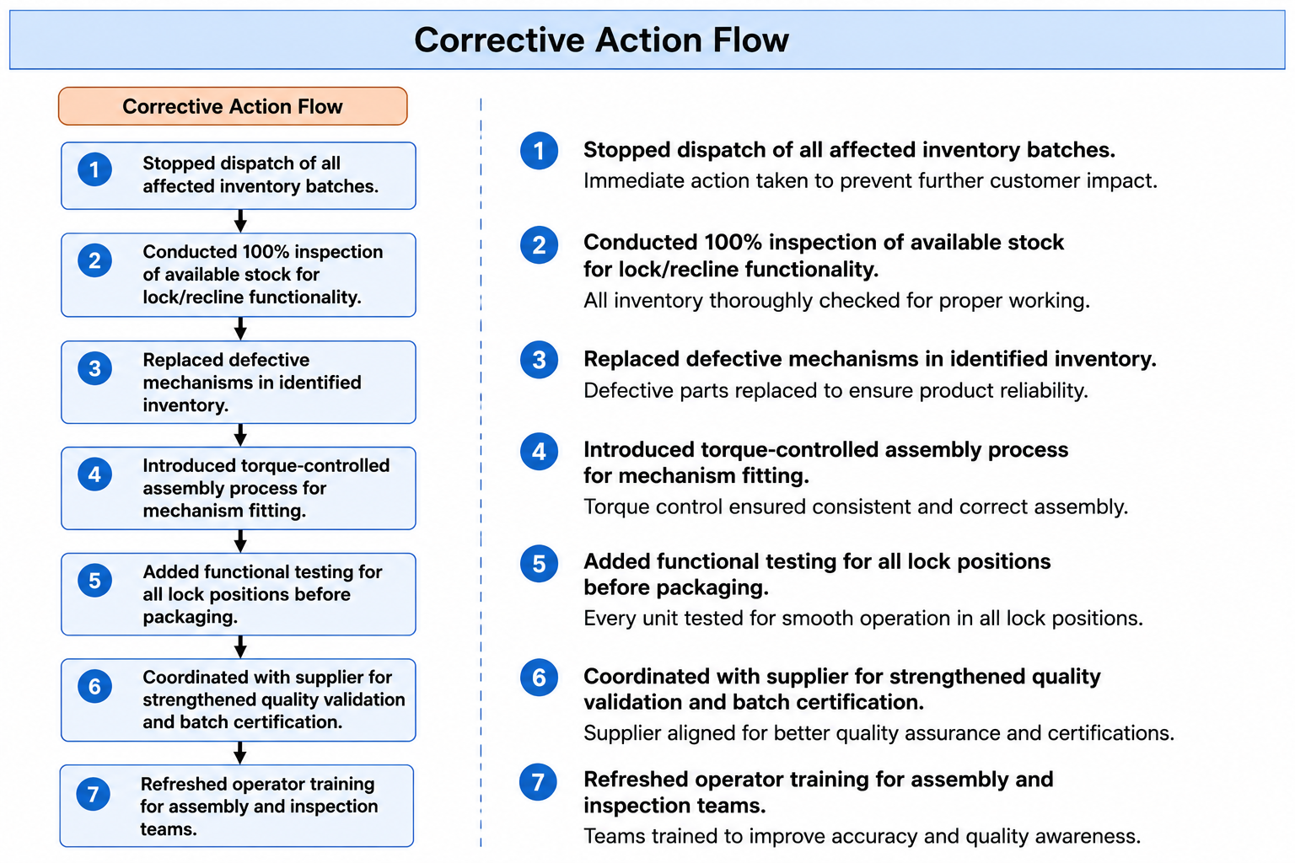
- Refreshed operator training for assembly and inspection teams.

3. Preventive / Proactive Measures
- Incoming Quality Check (IQC) strengthened for every mechanism batch.
- Defined standard torque specifications and audit frequency.
- Added pre-dispatch quality checklist including recline and multi-lock testing.
- Increased supplier quality monitoring and periodic audits.
- Implemented random drop-test validation for packed chairs.
- Established traceability for mechanism batches to identify future concerns quickly.
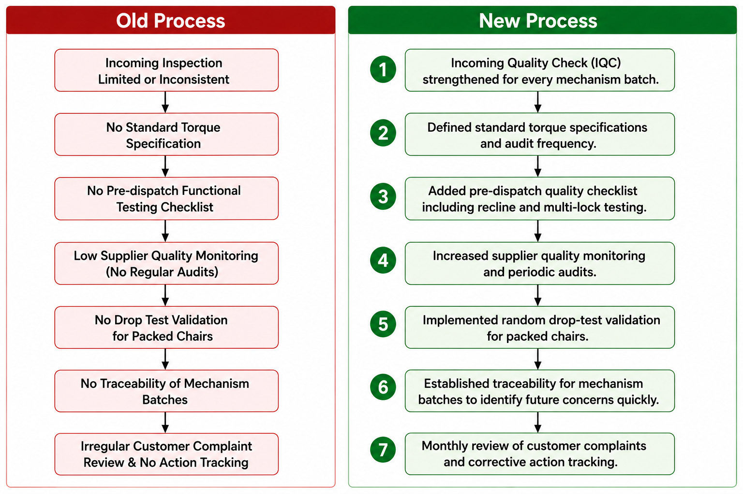
- Monthly review of customer complaints and corrective action tracking.

Please find the answered questionnaire :
1) Is the functional test/QC done for the product? (For Brand Owners only)

- Yes

2) Does the product package contain user manual, installation guidelines & other product related information? (only if applicable to the product)

- Yes, 'user manual, installation guidelines & product related information are available in the product package'.

3) Does the physical product match with the detail page on labeling, barcode and color?

- Yes, physical product matches with the detail page for all attributes.

4) Are the a. Unit_count and b. included_component correctly described on the Detail Page?

- Yes, Unit_count and b. included_component on the package matches with that on the DP'.

5) Does the product have a manufacturing website or a brand website?

- Yes, website links. www.wakefit.co

6) If the product has a manufacturing/brand website, does the information on Amazon's Detail Page match the details on the manufacturer website?

- Yes, 'Information on Amazon DP matches with that on the manufacturer website'.

7) Does the detail page have the service center list or toll-free number?

- Yes, 'service center details available on the DP'.

8) Is the product dimension correctly mentioned on the detail page?

- Yes, 'product dimensions on the detail page are correct'.

9) Does the product image on the detail page looks different due to photographic effect?

- No, 'Product looks the same as per the DP'.

10) Does the MRP on the product match with the MRP listed on detail page?
- Yes 'MRP on the product matches with that on the detail page'.

11) Does the item require any additional packaging [based on the damages issue faced by the customer in the last 90 days]?

- No, 'no additional packaging required'.

We are committed to ensuring a defect-free customer experience and preventing recurrence of this issue.

