Hi Team,
This is with respect to ASIN B0DP9Z528W which has been warned for suppression for multiple return reasons etc. We have understood this is due to customer complaints.
ASIN: B0DP9Z528W
Title: Wakefit ShapeSense Orthopedic Classic Memory Foam Mattress | 10 Years Warranty | Mattress Single Bed, 6-Inch Bed Mattress, Single Size (70x30x6 Inches, Medium Firm)
Root Cause Analysis: After reviewing all the return orders as mentioned in the “Voice of the Customer” we have identified product issues highlighted by customers, review feedback and take action to fix them.
Customer Reviews:
- Wrong Item / Size Received
- Defective Product
- Damaged Product
- Product Not as Advertised

1.Wrong Item / Size Received
1.1. Defect Identified (Root Cause)
- Product identification during packing relied on manual verification.
- Absence of a cross-verification system between size labels and MRP labels during packing.
- Barcode-based cross-verification was not established in the packing process.
- Size/model verification before packing was not system controlled.
- Final packing verification relied on manual checks.
This increased the risk of incorrect product, model, or size dispatch, resulting in customer complaints related to wrong item and wrong size receipt.
1.2. Corrective Actions Implemented (Fix)
- Implemented One-Piece Flow in roll packing to ensure controlled product handling.
- Introduced barcode scanning verification of size labels and MRP labels before packing.
- Packing is allowed only when the system displays a "MATCH" status.
- Implemented size and model verification before dispatch.
- Added QC cross-verification between barcode labels and MRP labels during packing operations.

Barcode scanning and MATCH validation implemented during roll packing to prevent wrong item and wrong size dispatch.

1.3. Preventive / Proactive Measures
- Barcode verification has been made mandatory for all mattress packing operations
- Updated SOPs and work instructions for packing and dispatch processes.
- Training provided to packing operators and QC personnel on revised verification procedures.
- Periodic audits introduced to monitor compliance with packing and dispatch controls.
- Continuous monitoring implemented to ensure adherence to SKU verification protocols.
2. Defective Product
2.1. Defect Identified (Root Cause)
- Visual defects were not consistently identified during the inspection process.
- Inspection coverage was limited, increasing the possibility of defects escaping detection.
- Stitching, quilting, and appearance-related defects could pass through production without being identified.
- Defect detection controls were not sufficiently robust across all inspection stages.
This increased the likelihood of defective products reaching customers, resulting in product quality complaints.
2.2. Corrective Actions Implemented (Fix)
- Introduced dual-side inspection to ensure both sides of the mattress are thoroughly checked before packing.
- Strengthened inspection checkpoints for stitching quality, quilting quality, and outer cover appearance.
- Implemented enhanced visual defect detection controls during inspection.
- Improved inspection processes to identify defects at an earlier stage of manufacturing.
- Strengthened quality checks prior to packing and dispatch.
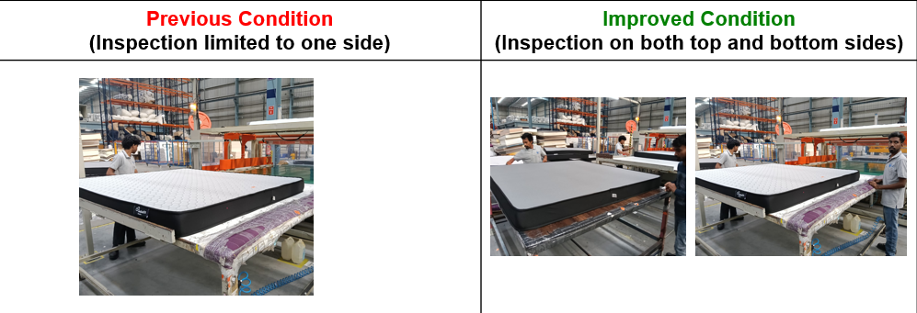Visual defect detection process enhanced from one-side inspection to dual-side inspection to improve defect identification and product quality.
2.3. Preventive / Proactive Measures
- Dedicated QC personnel deployed at critical manufacturing and inspection stages.
- Standardized inspection criteria implemented across production lines.
- Periodic quality audits introduced to monitor inspection effectiveness.
- Refresher training conducted for operators and inspectors on defect identification standards.
- Continuous monitoring established to ensure compliance with inspection protocols.
3. Damaged Product
3.1. Defect Identified (Root Cause)
- Product damages and manufacturing defects were not consistently identified before packing and dispatch.
- Inspection checkpoints were limited across certain manufacturing stages.
- Defects could pass through production without being detected at the source.
- Quality verification controls required strengthening to improve defect containment.
This increased the risk of damaged products reaching customers and resulted in customer complaints related to product condition.
3.2. Corrective Actions Implemented (Fix)
- Introduced additional Quality Gates (Q-Gates) across critical manufacturing stages.
- Strengthened in-process quality inspections to identify defects at an earlier stage.
- Implemented defect containment and segregation controls for non-conforming products.
- Enhanced inspection checkpoints across production and packing operations.
- Strengthened quality verification before products proceed to the next manufacturing stage.
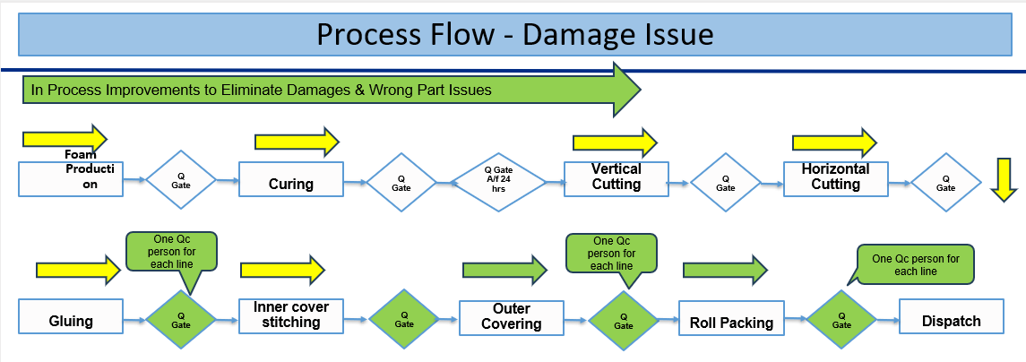
Additional Quality Gates (Q-Gates) and dedicated QC checkpoints implemented across manufacturing stages to identify and eliminate damage-related defects before dispatch.

3.3. Preventive / Proactive Measures
- Dedicated QC personnel deployed across manufacturing lines.
- Daily monitoring introduced for damage-related defects and quality observations.
- Periodic process audits implemented to ensure adherence to quality standards.
- Quality checkpoints standardized across manufacturing operations.
- Continuous review of customer complaints and defect trends implemented to prevent recurrence.

4. Product Not as Advertised
4.1. Defect Identified (Root Cause)
- Product images and PDP content did not sufficiently communicate certain product specifications and construction details.
- Key product attributes were not prominently highlighted, leading to differences in customer expectations.
- Product content required additional clarity to improve customer understanding of the product.
This resulted in customer concerns regarding the product received versus the product expected.
4.2. Corrective Actions Implemented (Fix)
- Conducted a detailed review of product images, PDP content, and product specifications.
- Updated the PDP with detailed layering images that clearly explain the mattress construction.
- Enhanced product content to clearly communicate the foam composition, layer configuration, cover construction, and materials used in the mattress.
- Reviewed customer feedback and updated product communication to ensure customer expectations align with the actual product.
4.3.Preventive / Proactive Measures
- Introduced periodic audits of PDP content, product images, and specifications.
- Regularly monitor customer feedback and VOC trends to identify and address product communication gaps.
- Established a cross-functional review process between Product, Category, and Quality teams before any content updates.

Process Improvements Implement
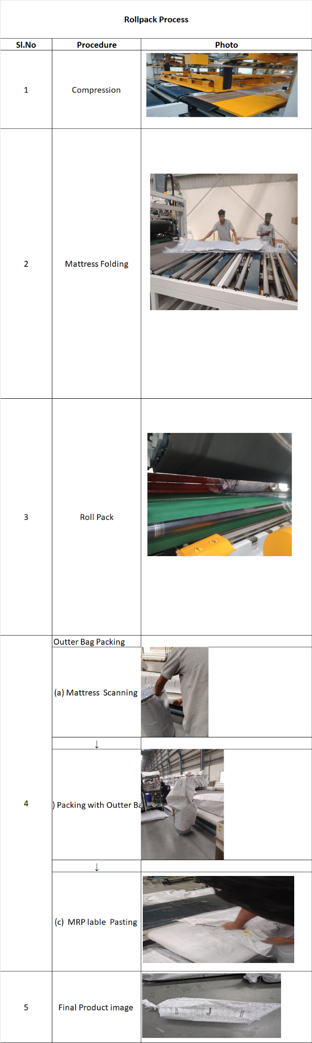

Process Summary
- Mattress is compressed then folded
- Mattress is roll packed directly (PVC)
- After roll packing, outer bag packing is done:
  - Mattress scanning
  - Outer bag packing
  - MRP label pasting
- Final product is prepared and dispatched
👉 Key Point:
All identification (scanning, labeling) and protection (outer bag) happen after roll packing, which can lead to:
- Label mismatch risk

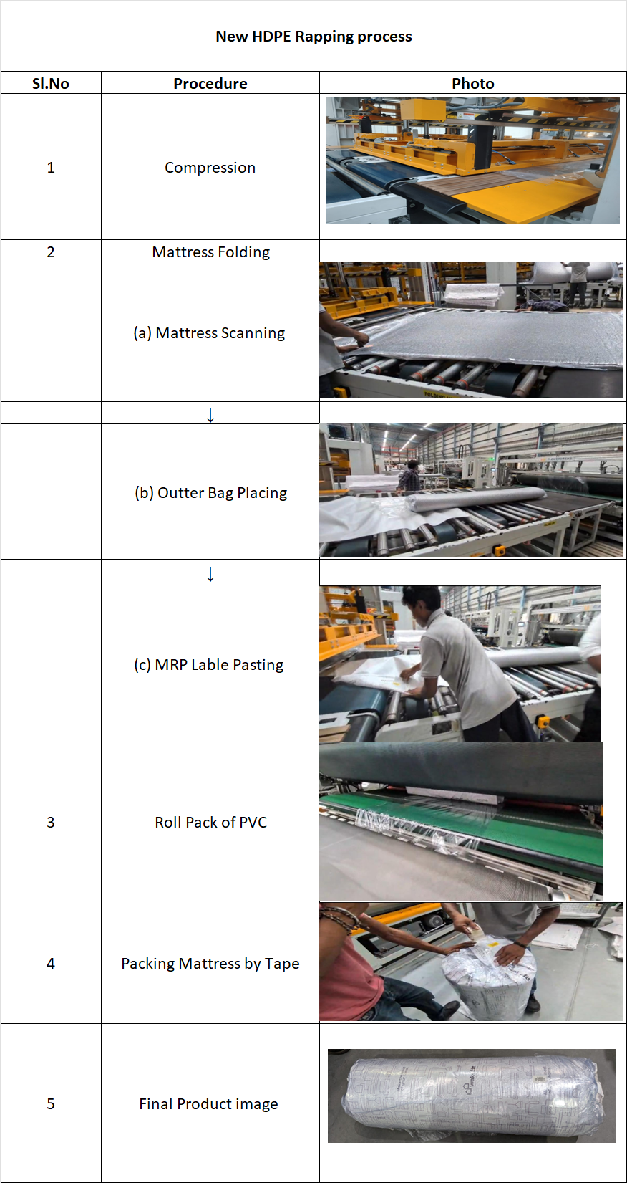

Process Summary
- Mattress is compressed then folded
- Before roll packing, HDPE outer bag process is done:
  - Mattress scanning
  - Outer bag (HDPE) placement
  - MRP label pasting
- Mattress is then roll packed with PVC
- Additional tape packing is applied for better sealing
- Final product is prepared and dispatched
👉 Key Point:
All identification and primary protection are completed before roll packing, ensuring:
- Correct labeling before sealing
- Reduced mismatch errors
- Better product protection (HDPE + PVC + tape)
- Improved process control and traceability

Please find the answered questionnaire :
1) Is the functional test/QC done for the product? (For Brand Owners only)

- Yes

2) Does the product package contain user manual, installation guidelines & other product related information? (only if applicable to the product)

- Yes, 'user manual, installation guidelines & product related information are available in the product package'.

3) Does the physical product match with the detail page on labeling, barcode and color?

- Yes, physical product matches with the detail page for all attributes.

4) Are the a. Unit_count and b. included_component correctly described on the Detail Page?

- Yes, Unit_count and b. included_component on the package matches with that on the DP'.

5) Does the product have a manufacturing website or a brand website?

- Yes, website links. www.wakefit.co

6) If the product has a manufacturing/brand website, does the information on Amazon's Detail Page match the details on the manufacturer website?

- Yes, 'Information on Amazon DP matches with that on the manufacturer website'.

7) Does the detail page have the service center list or toll-free number?

- Yes, 'service center details available on the DP'.

8) Is the product dimension correctly mentioned on the detail page?

- Yes, 'product dimensions on the detail page are correct'.

9) Does the product image on the detail page looks different due to photographic effect?

- No, 'Product looks the same as per the DP'.

10) Does the MRP on the product match with the MRP listed on detail page?
- Yes 'MRP on the product matches with that on the detail page'.

11) Does the item require any additional packaging [based on the damages issue faced by the customer in the last 90 days]?

- No, 'no additional packaging required'.

Additional Actions taken for future:
Sourcing:
- We always source the best quality raw material. Best quality raw material leads to the best quality manufactured product.
- We ensure that quality check is present at each step, so that product manufactured doesn’t have any defects
Listing:
- Yes, we have checked from our end and as now the whole staff is trained there would not be any ambiguity and also we are taking services from Amazon SPN would be informing, managing all customer concerns.
- We have 2 checkpoints before making listing live. Each listing would be made by SPN Person and checked by another person (who would be from Team B of the quality department). Thus, there would be a maker-checker process that would lead to the minimization of errors in listings.
- We have also provided complete training on following points to all our employees

Packing Process:
- The packing process started 100% scanning for SAP labels to detect the different quantity reach to the customer.
- We ensure that quality checks are present at each step, so that the product manufactured doesn’t have any defects.
Delivery Process:
- Warehouses will be audited frequently to check the right packaging quantity and quality both.
- We have also provided complete training on the following points to all our employees.

Kindly help reinstating this ASIN which was suppressed. Our factory has started adapting to the above actions already.

Thanks
Wakefit

