Hi Team,
This is with respect to ASIN B0HCW9117N which has been warned for suppression for negative feedback received from customers. We have understood this is due to customer complaints who have felt .
ASIN: B0HCW9117N
Title: Wakefit Maven Ergonomic Office Chair for Work | 1 Year Warranty | Single Lock and Recline | Soft Foldable Armrest | Strong Nylon Base | 8+ Hours of Comfort | Black & Grey
Root Cause Analysis: After reviewing all the reviews as mentioned in the “Voice of the Customer” we have identified product issues highlighted by customers, review feedback and take action to fix them.
Customer Review:
A) Product is defective/ Defective item/ doesn't work
1. Defect Identified (Root Cause):
• Inadequate incoming inspection of supplier parts.
• Variation in component quality across supplier batches.
• Lack of defined sampling standards during inward quality checks.
• Missed detection of cosmetic and functional defects during assembly.
• Insufficient in-process inspection checkpoints during production.
• Inconsistent documentation and traceability of inspected parts.
2. Corrective Actions Implemented
- Segregated suspect inventory and stopped dispatch of affected batches.
- Implemented 100% inspection for critical supplier components.
- Introduced supplier-wise quality and rejection tracking.
- Standardized inspection criteria and approved reference samples.
- Increased inspection frequency for high-risk suppliers.
- Added QC checkpoints at critical assembly stages.
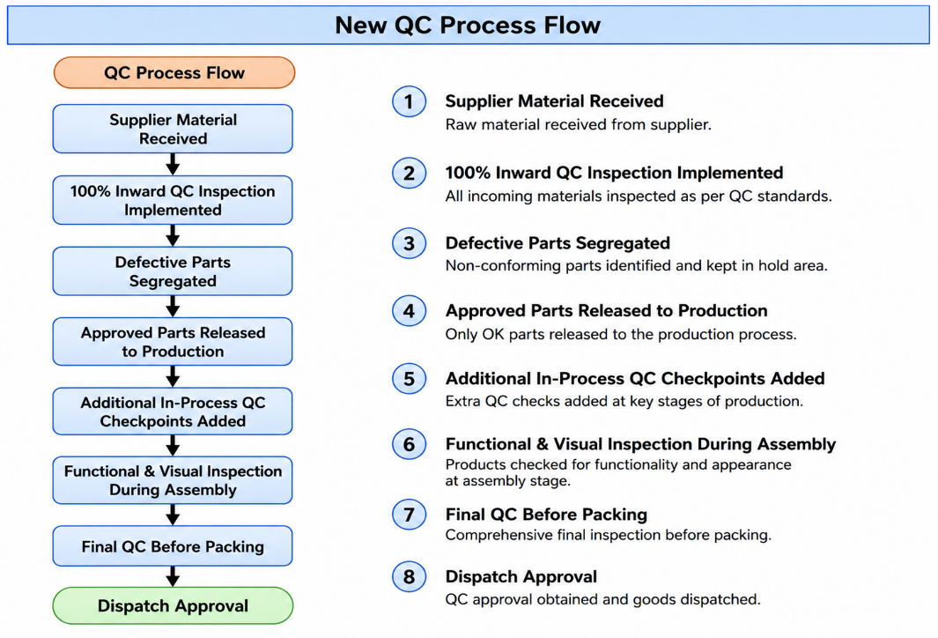
- Implemented operator self-inspection and random functional checks.
- Increased supervisor audits during production shifts.
- Trained operators and QC inspectors on defect identification.
- Reworked or rejected defective parts identified during production.
3. Preventive / Proactive Measures
- Standardized IQC checklists for all suppliers.
- Scheduled periodic supplier quality audits.
- Implemented batch traceability for incoming parts.
- Defined AQL standards for inspections.
- Conducted monthly supplier performance reviews based on rejection trends.
- Displayed SOPs at all production stations.
- Introduced layered process audits for critical operations.
- Initiated daily QC reporting and defect trend analysis.
- Implemented poka-yoke methods to reduce assembly errors.
- Strengthened final product inspection before packaging and dispatch.
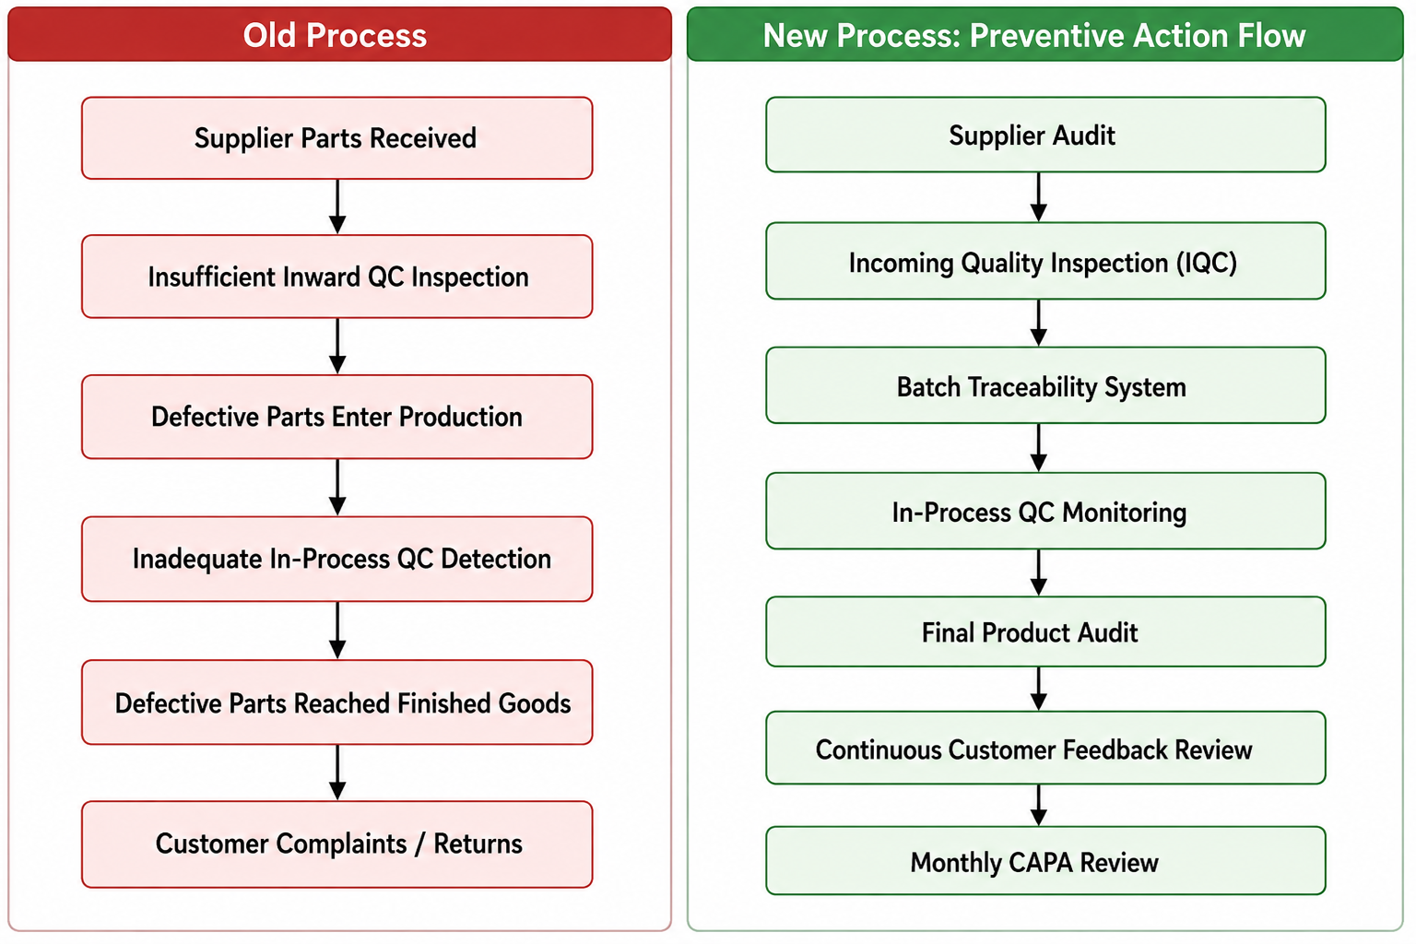
- Established a continuous improvement process.

B) The multilocked doesn’t work as expected / Issue with the locking system
1. Defect Identified (Root Cause) :
- Lack of sufficient end-line functional testing for lock and recline positions.
- Improper handling during transit leads to occasional alignment issues.
- Inadequate inspection checkpoints for mechanism movement and locking functionality.

2. Corrective Actions Implemented
- Stopped dispatch of all affected inventory batches.
- Conducted 100% inspection of available stock for lock/recline functionality.
- Replaced defective mechanisms in identified inventory.
- Introduced torque-controlled assembly process for mechanism fitting.
- Added functional testing for all lock positions before packaging.
- Coordinated with supplier for strengthened quality validation and batch certification.
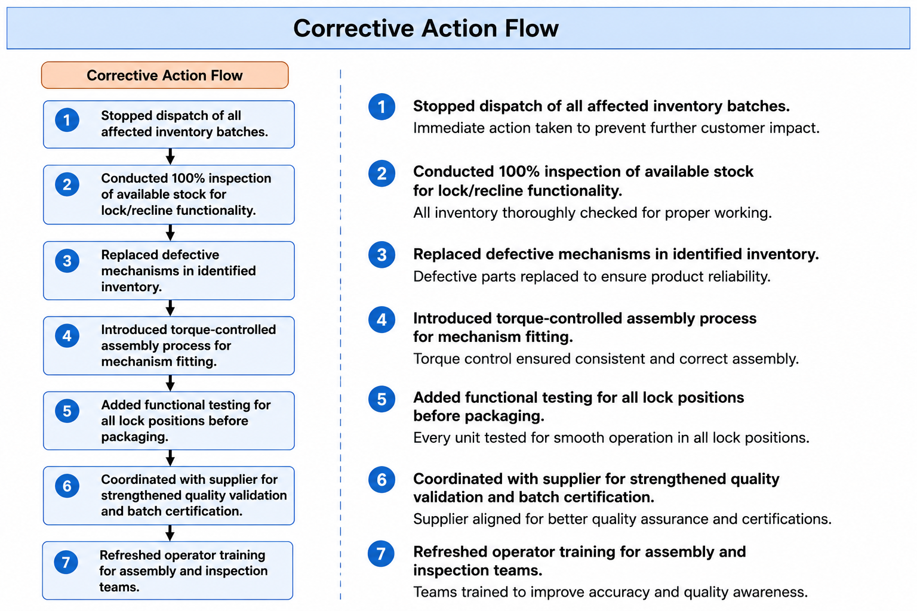
- Refreshed operator training for assembly and inspection teams.

3. Preventive / Proactive Measures
- Incoming Quality Check (IQC) strengthened for every mechanism batch.
- Defined standard torque specifications and audit frequency.
- Added pre-dispatch quality checklist including recline and multi-lock testing.
- Increased supplier quality monitoring and periodic audits.
- Implemented random drop-test validation for packed chairs.
- Established traceability for mechanism batches to identify future concerns quickly.
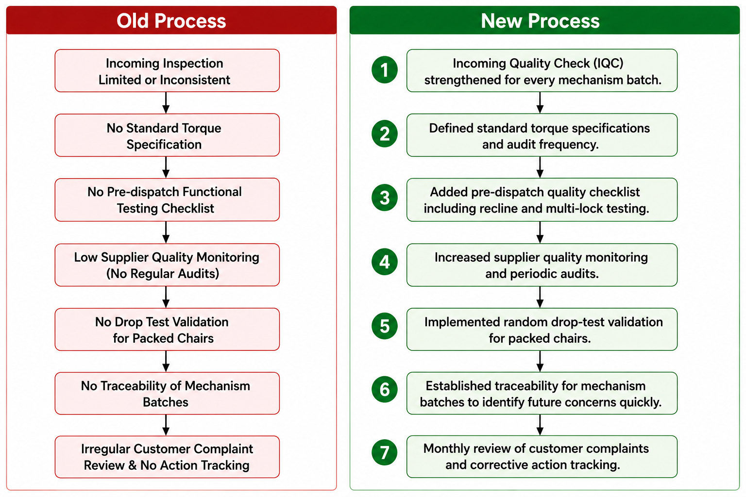
- Monthly review of customer complaints and corrective action tracking.

We are committed to ensuring a defect-free customer experience and preventing recurrence of this issue.

