Required tools and Softwares :
1. Install Python and Required Libraries
Install Python 3.10 (or Latest Version)
- Go to the official Python website: https://www.python.org/downloads/.
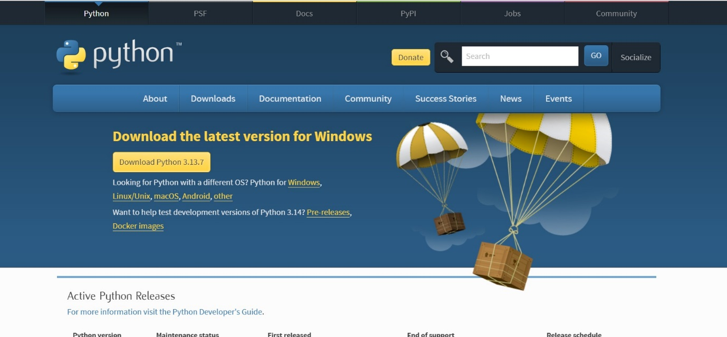
- Download the latest version (Python 3.10 or higher) for Windows.

- During installation, make sure to check the option "Add Python to PATH".
- After installation, open Command Prompt and verify Python installation:
- python --version
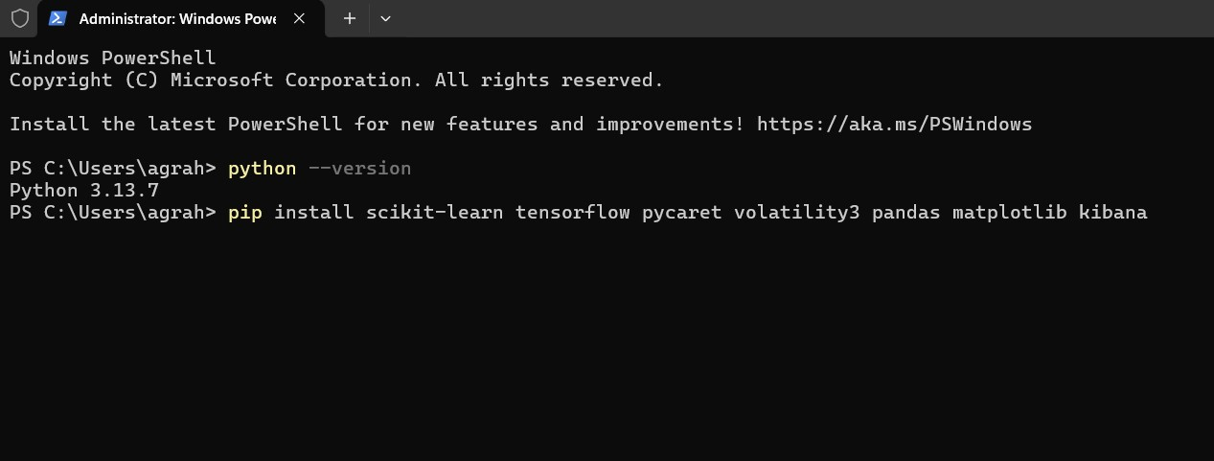

This should display the Python version you've installed.
Install Required Libraries:
- Open Command Prompt as Administrator.
- Install the following Python libraries (machine learning, forensic tools, and visualization libraries).
- “pip install scikit-learn tensorflow pycaret volatility3 pandas matplotlib kibana”

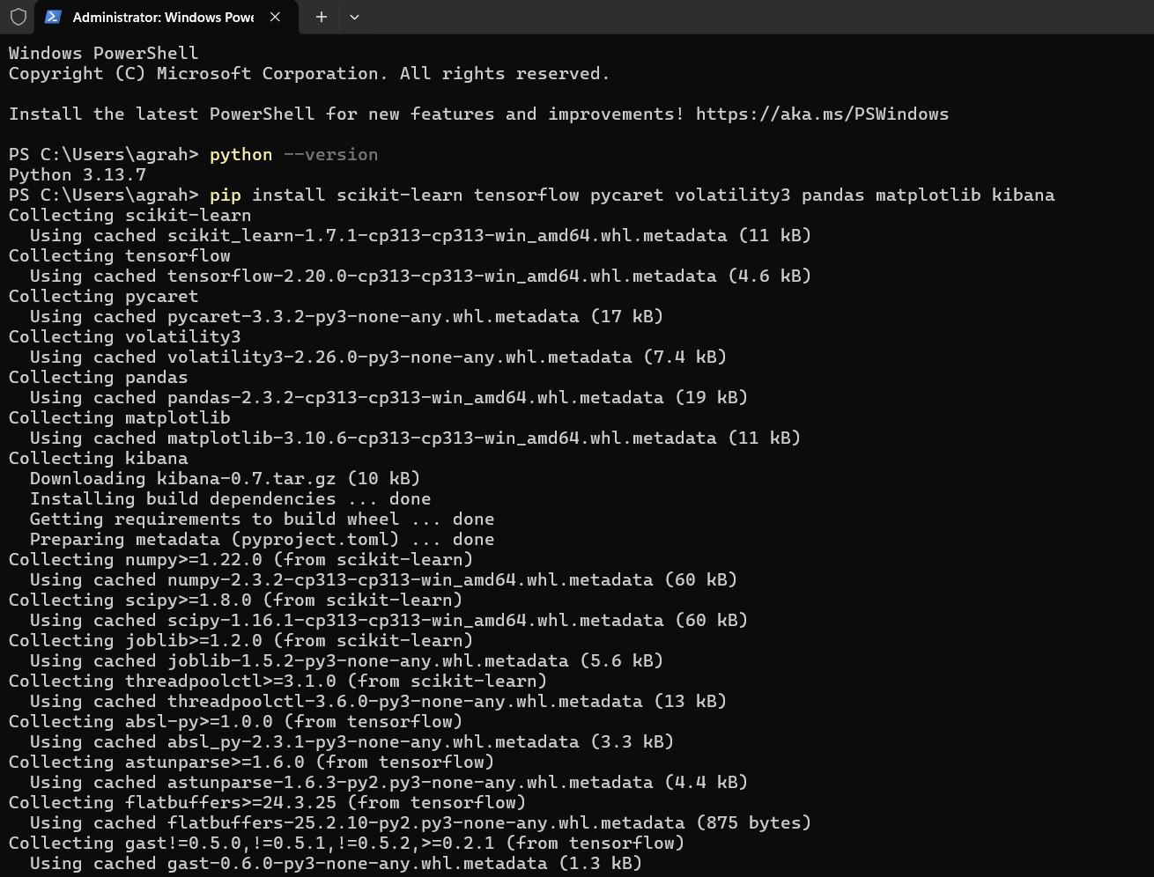

2. Install Forensic Tools
Install Autopsy (Digital Forensics Platform)
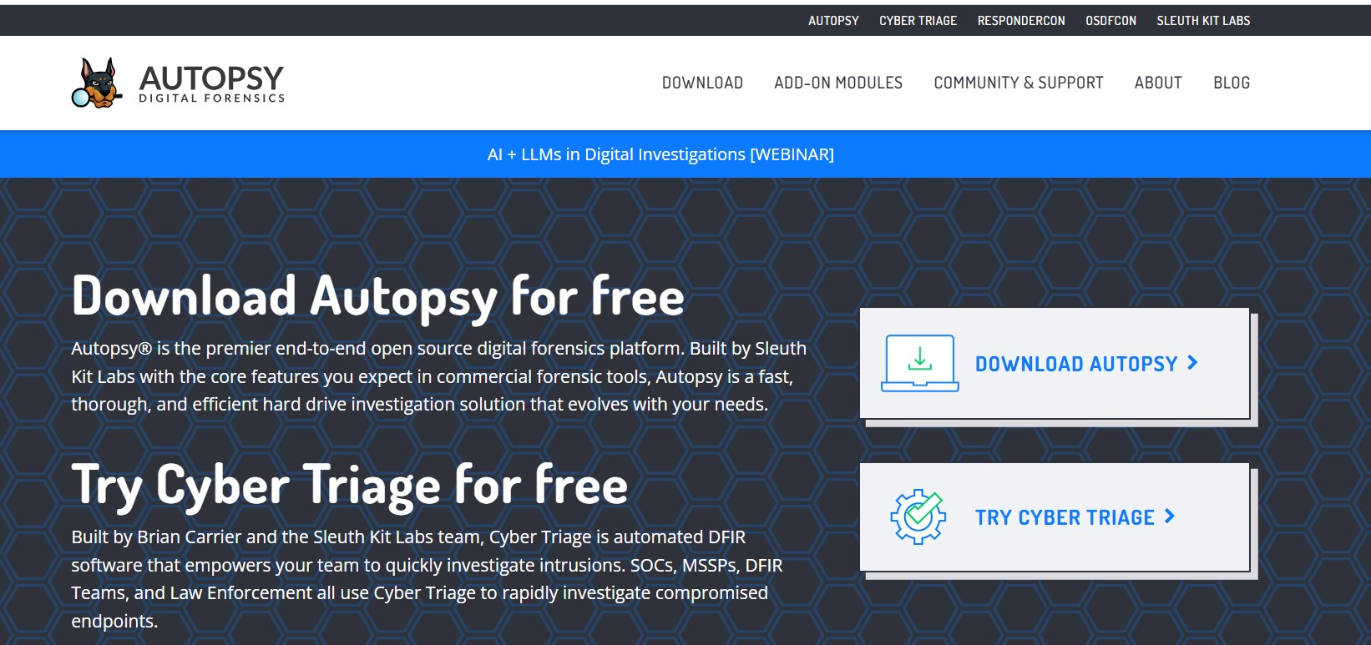
- Go to Autopsy Download Page.

- Download the Windows version of Autopsy and run the installer.
- After installation, launch Autopsy and follow the setup wizard to configure it.

Install Volatility 3 (Memory Forensics Framework)
- Open Command Prompt as Administrator.
- First, make sure Git is installed on your Windows machine. If not, install it using winget:
- winget install --id Git.Git -e --source winget
- Clone Volatility 3 using Git:
- git clone https://github.com/volatilityfoundation/volatility3.git
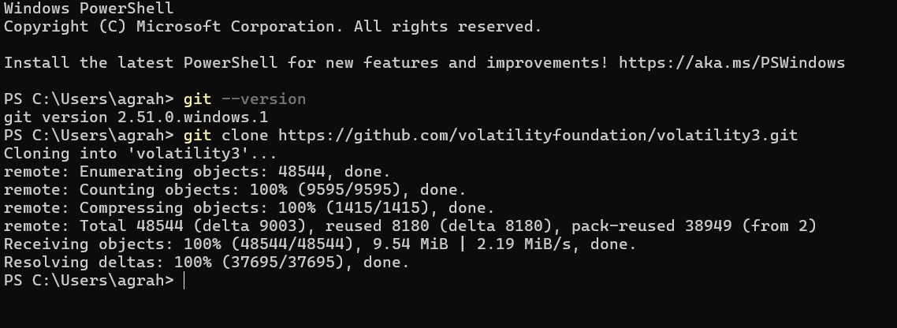

- cd volatility3
- Install dependencies:
- pip install -r requirements.txt
- You can now run Volatility 3 from the Command Prompt in the volatility3 directory.
3. Install Machine Learning Libraries
Install TensorFlow, scikit-learn, PyCaret
- Open Command Prompt and install the necessary machine learning libraries:
- pip install tensorflow scikit-learn pycaret
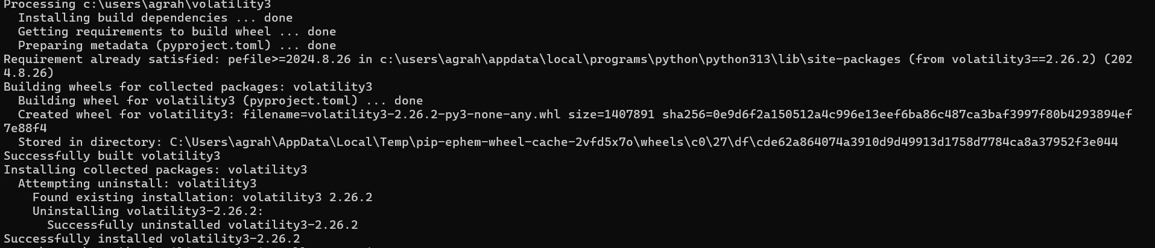
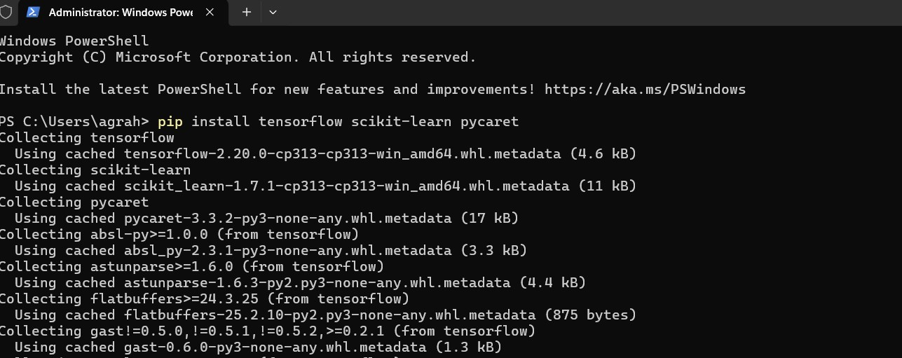

4. Install Data Visualization Tools
Install Grafana
- Download the Grafana Windows Installer from the official Grafana website: https://grafana.com/grafana/download.
- Run the installer and follow the instructions.
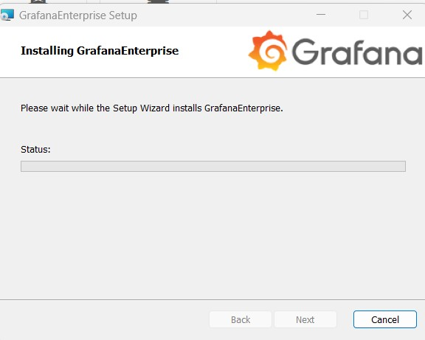
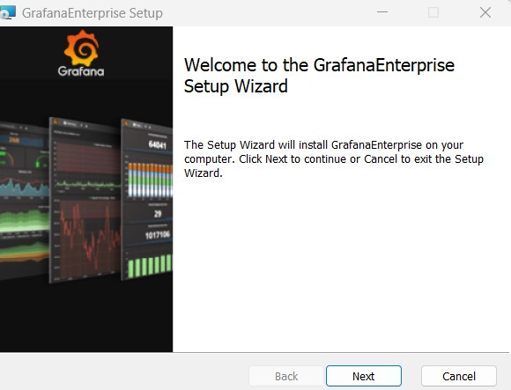
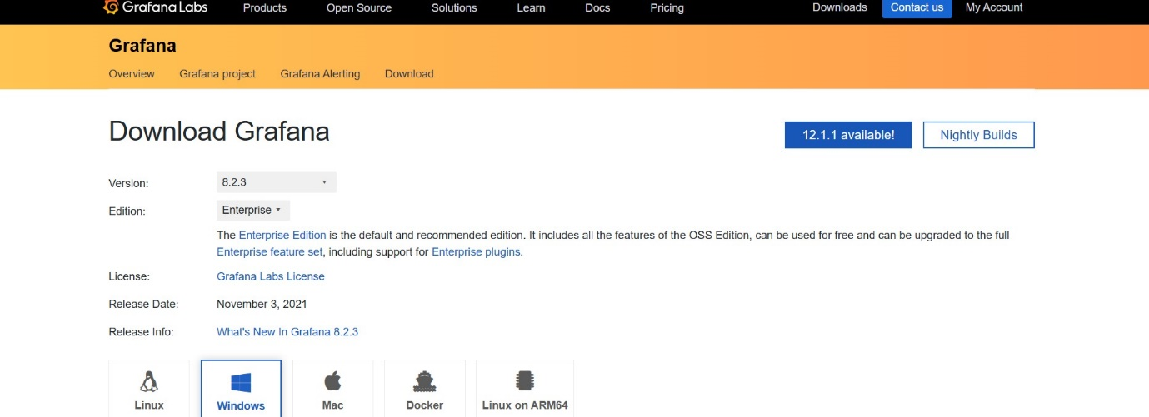
- After installation, start Grafana:
- grafana-server.exe
- Open your browser and go to http://localhost:3000 to access Grafana.

Install Kibana
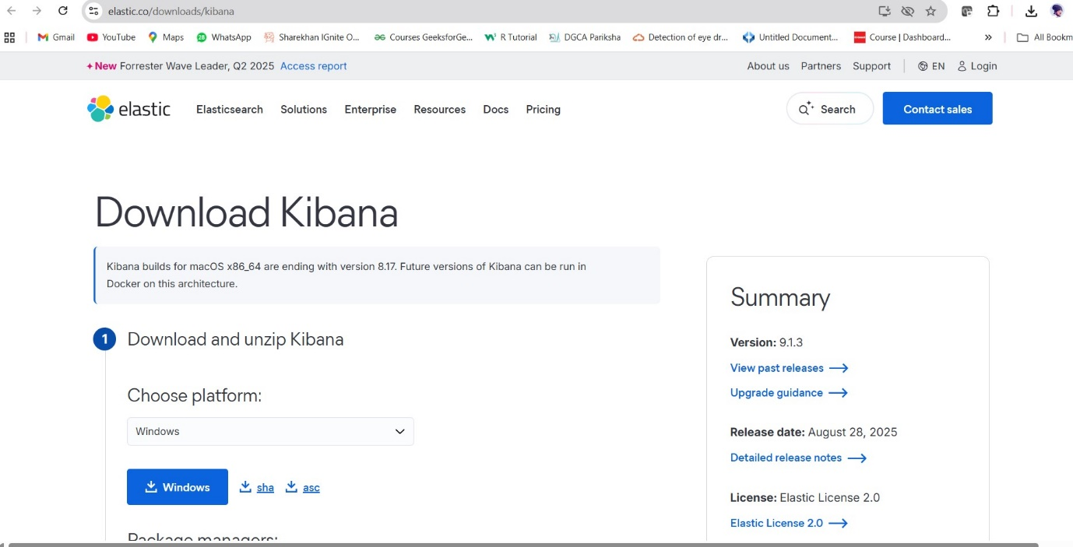
- Download Kibana from the Elastic website.

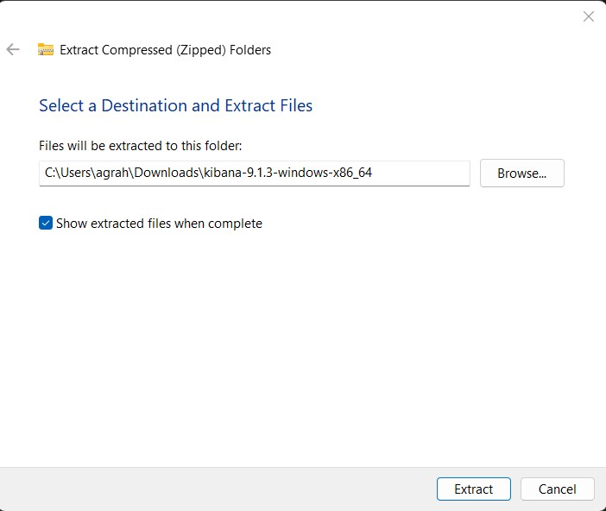
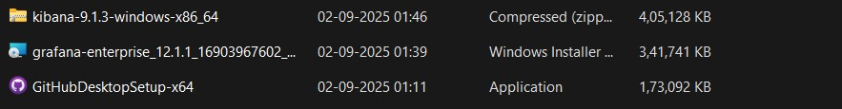
- Extract the downloaded ZIP file to a folder.
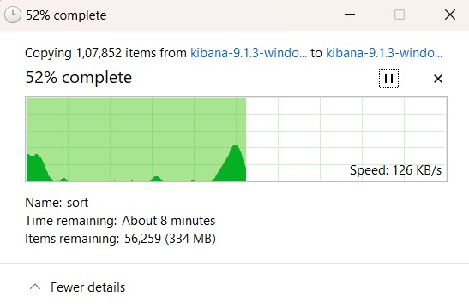
- To start Kibana, run the following in Command Prompt:
- cd <path-to-kibana-directory>\bin
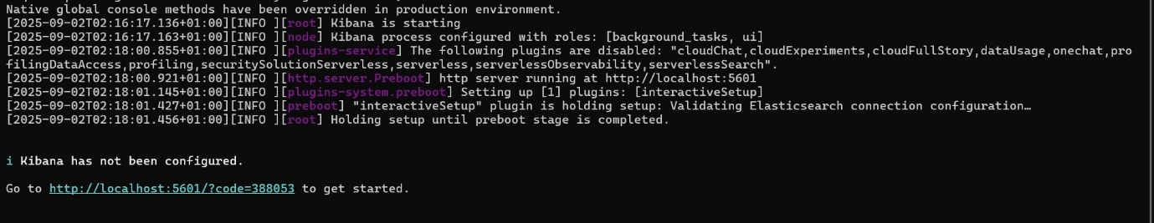
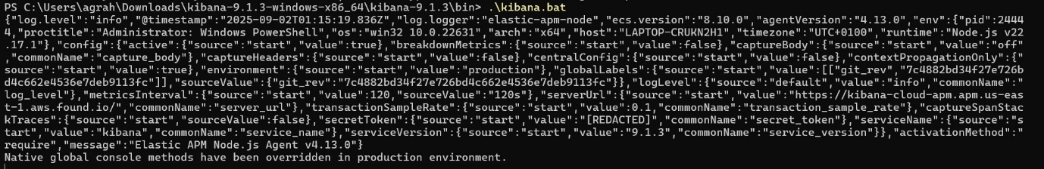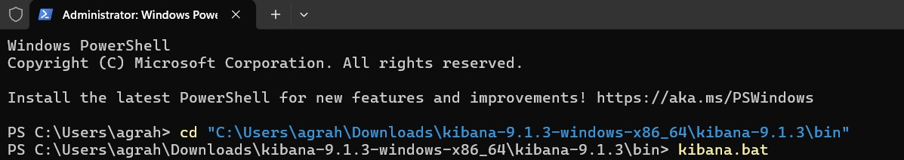
- kibana.bat
- Open your browser and go to http://localhost:5601 to access Kibana.
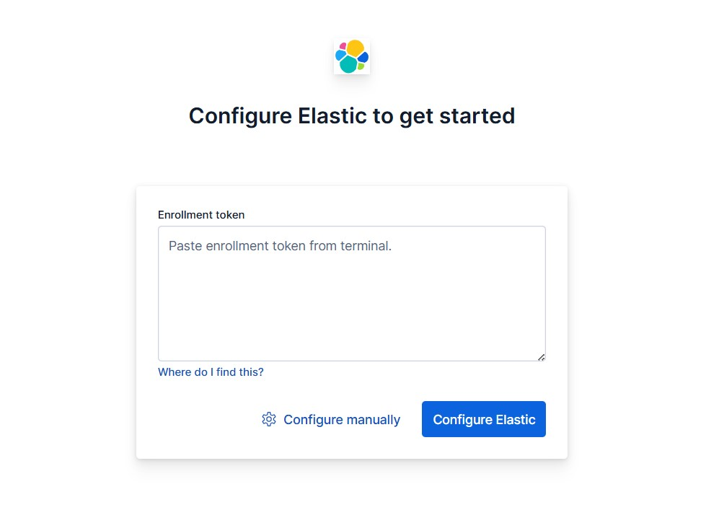

5. Download and Set Up DikeDataset
Download DikeDataset
- Go to the DikeDataset GitHub Repository.
- Download the dataset, or if you have Git installed, clone the repository:
- git clone https://github.com/iosifache/DikeDataset.git
- Preprocess the dataset as necessary (e.g., handle obfuscation, clean metadata).
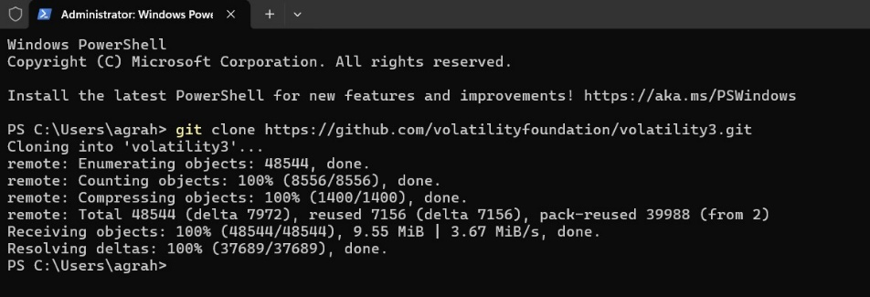
6. Install Jupyter Notebook for Code Execution and Reporting
- Open Command Prompt.
- Install Jupyter Notebook:
- pip install notebook
- To start Jupyter Notebook, run:
- jupyter notebook
- This will open a browser window where you can create and manage your notebooks for data analysis and reporting.
7. Set Up the Forensic Analysis Workflow
- Autopsy: You will use Autopsy for file and disk-based artifact analysis.
  - Use Autopsy to load forensic images (e.g., disk images) and extract file artifacts, metadata, and other relevant information.
- Volatility 3: Use Volatility 3 to perform memory forensics, focusing on volatile memory and processes.
  - For memory analysis, run Volatility 3 from the Command Prompt:
  - python vol.py -f <memory-image> --profile=<profile> pslist
  - Replace <memory-image> with the path to your memory dump and <profile> with the appropriate profile for your image.

