Artifact Documentation: Hybrid Forensic Framework for Data Breach Analysis

1. Introduction
This artifact documentation provides supporting evidence for the thesis titled 'Hybrid Forensic Framework for Data Breach Analysis.' It presents the key artifacts, including forensic screenshots, figures, and outputs from the analysis, which collectively demonstrate the research methodology and findings. Each artifact is contextualized to highlight its relevance to the investigation of data breaches using disk forensics, memory forensics, and machine learning approaches.

2. Artifact Documentation

Figure 1 – Taxonomy of Digital Forensic Research (Source: Raghavan, 2013)
This figure provides the foundational taxonomy of digital forensic research, illustrating where this thesis contributes in the broader landscape.
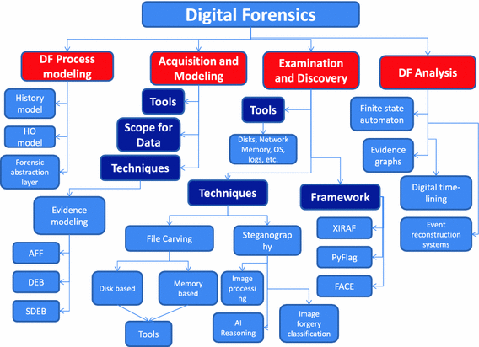
Fig 1:Taxonomy of Digital Forensic Research (Source: Raghavan, 2013)

Figure 2 – Autopsy Tool interface used for disk forensic analysis (Source: Self)
Screenshot of the Autopsy forensic tool, showing the disk analysis environment used to investigate logical files from the DikeDataset.


Figure 2 Autopsy Tool (Source: Self)

Figure 3 – Proposed research methodology pipeline for hybrid forensic analysis (Source: Self)
The research methodology pipeline demonstrating the integrated approach of disk forensics, memory forensics, and machine learning for anomaly detection.
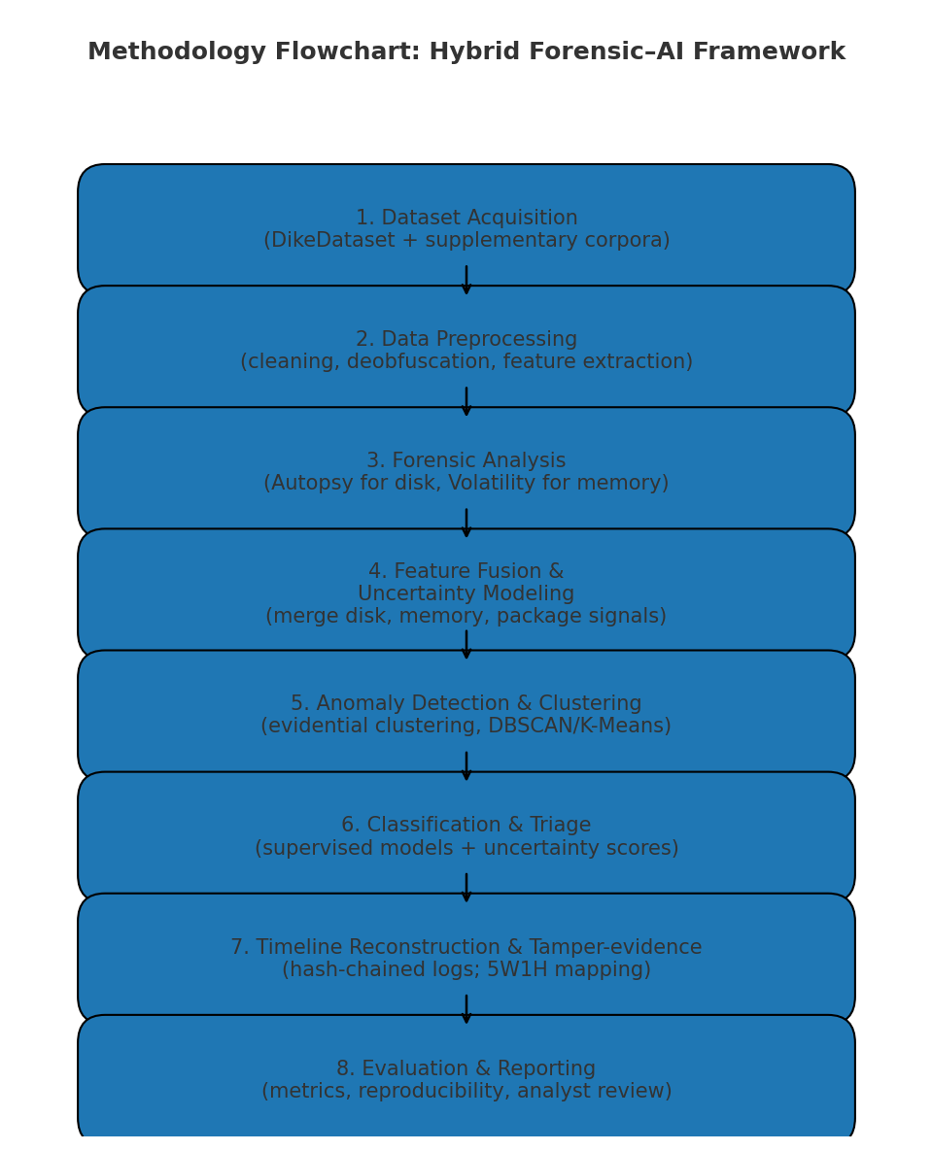

Figure 3 Proposed Methodology
(Source: Self)

Figure 4 – Logical files imported into Autopsy from the DikeDataset (Source: Self)
Illustrates the process of importing logical files from the DikeDataset into Autopsy to begin forensic artifact examination.
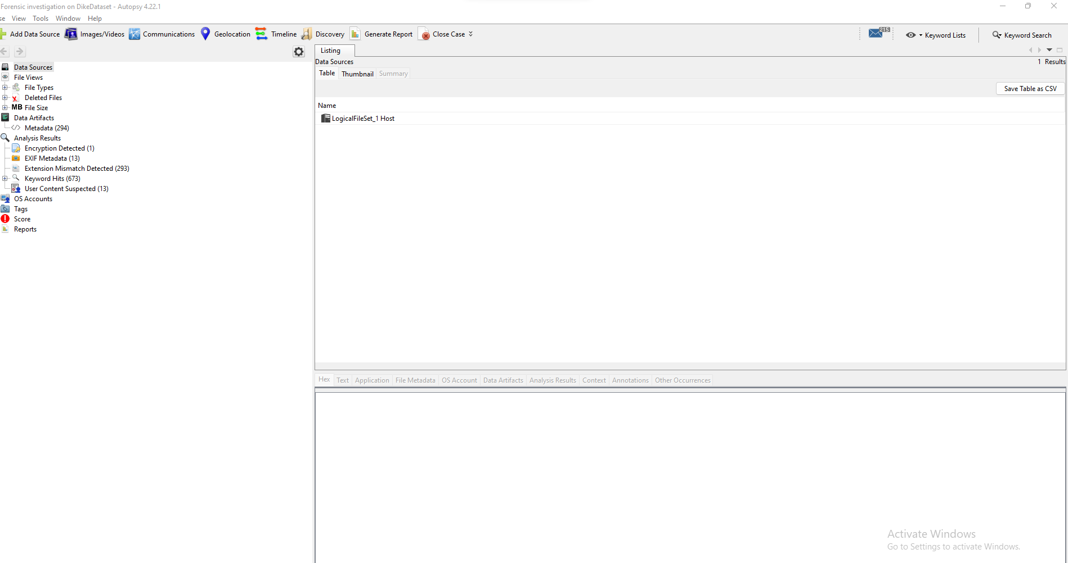
Fig 4: logical files added to the autospy

Figure 5 – Malicious files detected and analyzed using Autopsy (Source: Self)
Shows malicious files identified within the dataset using Autopsy forensic features.
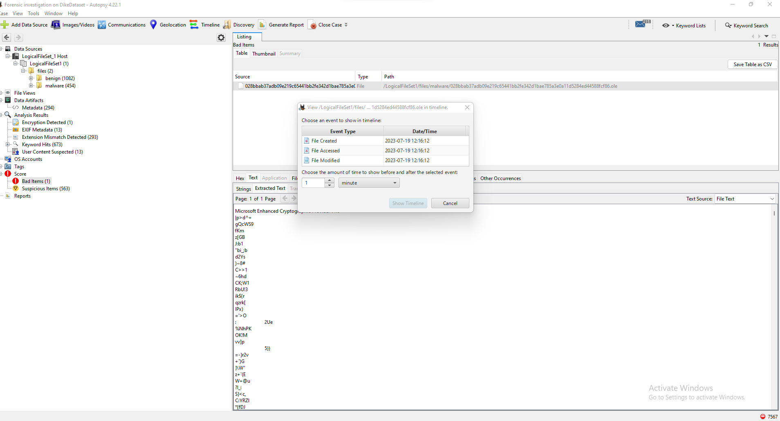
Fig 5: Bad files detected and analysed using autopsy

Figure 6 – Suspicious Microsoft document flagged in Autopsy analysis (Source: Self)
Highlights an anomalous Microsoft Office document flagged as suspicious during the disk forensic analysis.
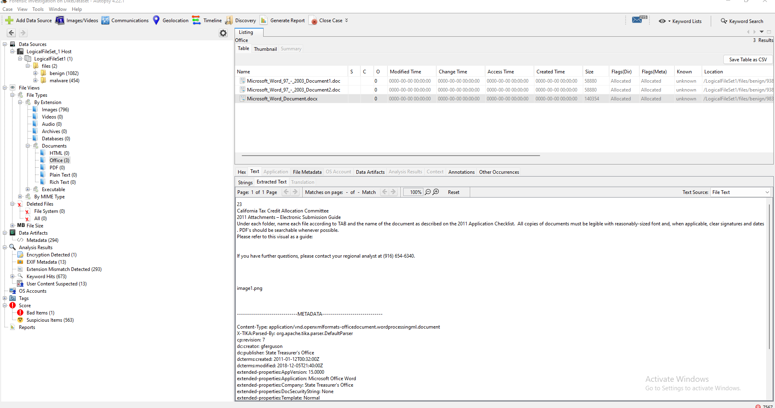
Fig 6: Suspicious Microsoft document

Figure 7 – Malware files identified and analyzed with Autopsy forensic tools (Source: Self)
Demonstrates the detection and classification of malware samples using Autopsy capabilities.

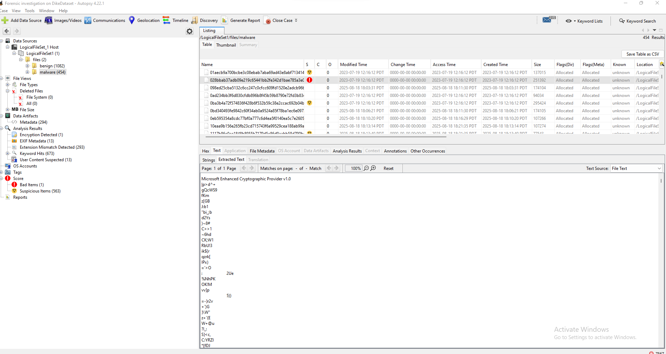
Fig 7: Malware files detected and analysed using autospy

Figure 8 – Benign files containing anomalous or malicious features (Source: Self)
Illustrates benign files that exhibited suspicious or anomalous features, indicating the subtlety of data breach evidence.
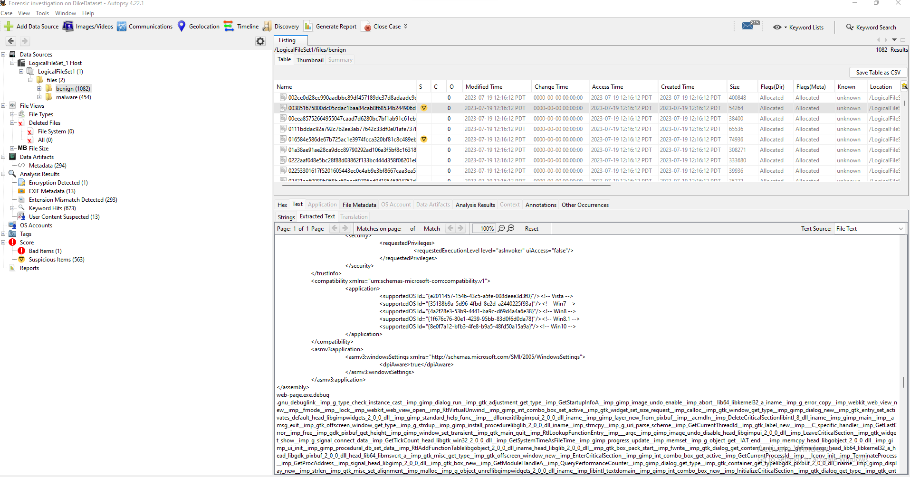
Fig 8: Suspicious benign files detected from dike dataset

Figure 9 – Metadata of suspicious files retrieved using Autopsy (Source: Self)
Metadata details of flagged suspicious files, supporting forensic timeline reconstruction.

Fig 9: Metadata of the bad file retrieved using autospy

Figure 10 – Reconstructed event log generated in Python environment (Source: Self)
Depicts an event log reconstructed programmatically using Python, providing insights into file activities and anomaly correlations.
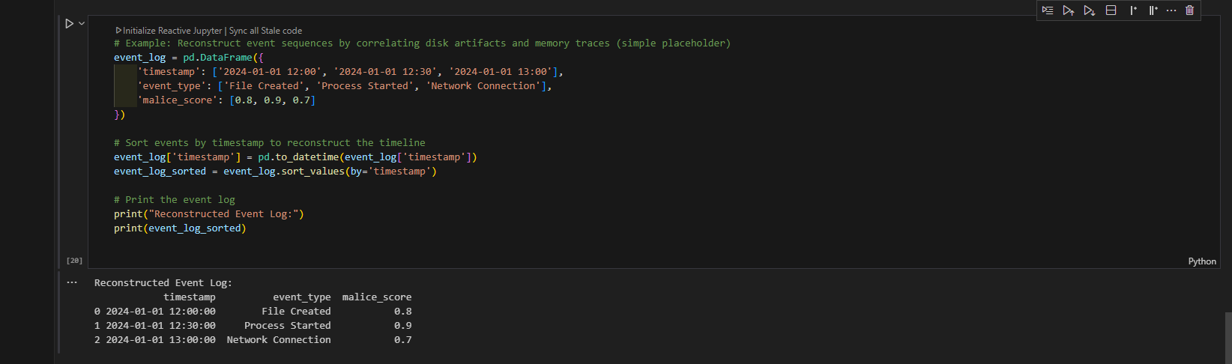
Fig 10: Reconstructed event log on python

Figure 11 – Machine learning model results with precision, recall, and F1-score (Source: Self)
Performance metrics of the applied machine learning models, validating accuracy in forensic anomaly detection.
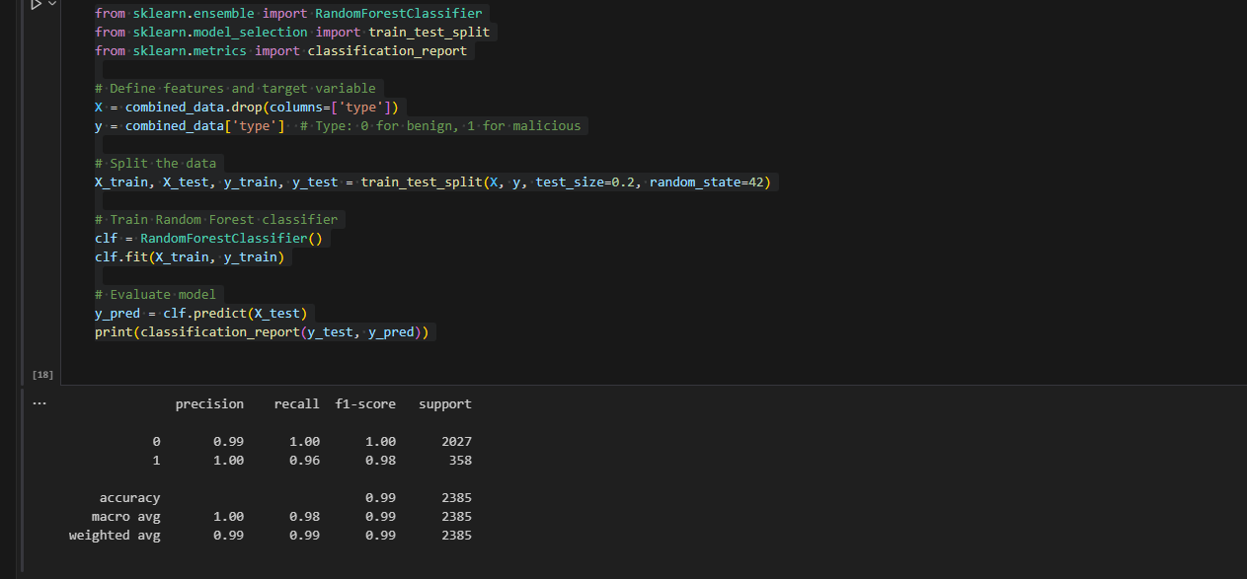
Fig 11: Model results

Figure 12 – DBSCAN clustering output of malware data samples (Source: Self)
Unsupervised clustering of malware data samples using DBSCAN, revealing hidden structure in malicious activity patterns.
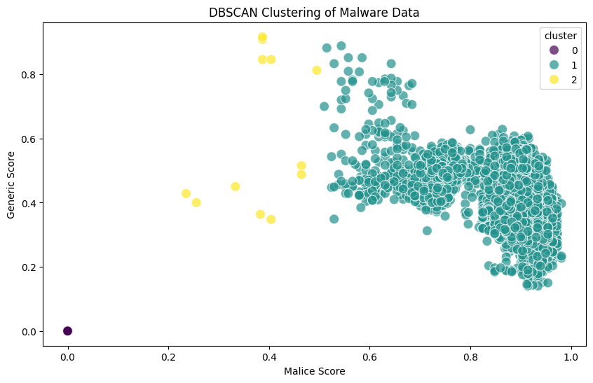
Fig 12:DBSCAN clustering of malware data

Figure 13 – Malice score distribution graph for forensic anomaly detection (Source: Self)
Graphical representation of malice scores assigned to files, supporting detection and classification of anomalous files in the dataset.
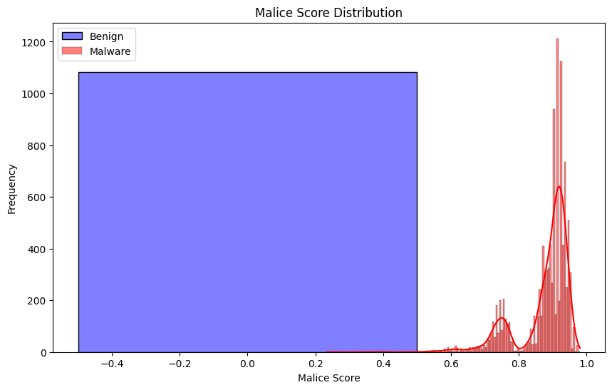
Fig 13: Malice score distribution

3. Conclusion
The artifacts presented provide a comprehensive view of the forensic investigation process conducted in this thesis. From disk analysis using Autopsy to machine learning-based anomaly detection, these artifacts validate the hybrid forensic framework proposed for effective data breach analysis. They serve as evidence of methodological rigor and support the reproducibility of the research outcomes.

