**Fall 2020 Project**

**Project #1**: The purpose of this project is to assure that you know what your project implementation will be about. See all the views for the project and write a two-page paper about your understanding of the project. You will have to implement the database to support this project. This is a dynamic project and it needs a database to show it.

**Project #2**: This assignment introduces each website scenario, presents the site map. You have two tasks for this assignment.

Task 1: Create a folder for the catalogue management system called “yourlastname_cms”.

Task 2: Create all static pages except Blog.html (Project 3).

* Create an external style sheet named cataloguesystem.css that configures the color and text for the CMS(Catalogue Management System) website.
* Configure all the content to be centered 80% width (use a style rule with id named wrapper.

The main goal of this project is to learn server-side web programming using PHP and a relational database system (MySQL). More specifically, every university has a unique set of classes made with special editions by professors. These courses could sometime become difficult to manage by the organizing department. And, this can lead to further mess when students register for their classes. In order to overcome this problem, we can design a catalogue management system where an advisor/staff can add/update/delete courses after deciding what’s good for students, and then after taking approval from professors they can list down the available courses for upcoming semesters. This will make each and every student updated about their upcoming semesters, and they can decide what is best for them after consulting with the advisors.

The system will have three different kind of users:

**Student / Staff / Admin.**

**And a Universal Guest Feature.**

**ROLES:**

Visitor/Guest:

1. Default view of the sitemap
2. They can only view the pages not under GUI Login

Students:

1. They need to register/login.
2. They can decide courses by seeing the list decided by Staff/ Admin.
3. They can give a feedback about a course which can be added or removed.
4. They can request a course by sending a contact form.

Staff:

1. They need to register/ login
2. They can add/ update/ delete courses for upcoming semester.
3. They can see the list of courses planned.
4. They can see feedbacks from students.

Admin:

1. Can add/delete/edit users.

**Project #3:** This project is about doing the Blog.html.

**Project #4:** This project is to validate fields and connect to the database.

For this assignment, you have the following task

1. Validate all the fields using JavaScript and HTML, PHP

2. Do the corresponding Database connection, show your Database.

3. Provide screenshots of testing.

4. Place all your pages in your folder. Compress it and Submit.

All fields in the form should be validated on the client side and server side.

**Platform**

* As in the previous projects, you will develop this project on your PC/laptop using XAMPP. To create the database, start the Apache Web Server and the MySQL Database on your PC using the XAMPP manager console.
* Run phpMyAdmin on your browser, create a new database with “CatalogueSystem” and click on New. Select this database, go to the SQL tab and write the appropriate CREATE table queries and push Go. You can run queries from CreateDB.sql for testing.
* Requirements (I am not helping with the DB, check it out).
* Project Requirements. Data will be coming from the DB.
* Make sure that you have populated enough data to answer all queries in the project.

**Project #5:** It is the same as Project 4 but using Laravel.

Each phase, when posted on canvas, will have a detailed description what exactly is expected.

**Following screenshots are attached just for your reference. You are free to use your creativity and implement the project. You may also implement constructive & creative additions to your website using any techniques explained in class. The most creative/polished project is on track for a good grade in the course (provided you do your exam well).**

**Note: These pictures are designed to only give you a rough idea and you are not required to use the same content given here.**

* **Login/Register Pages:**

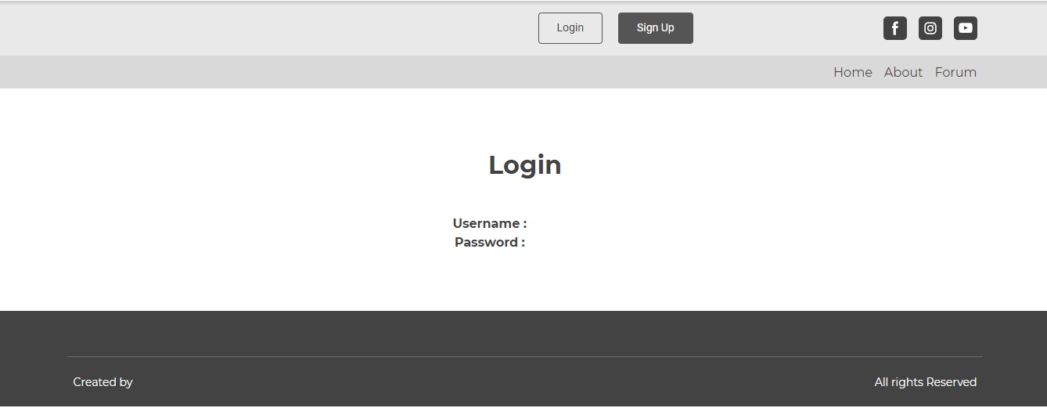

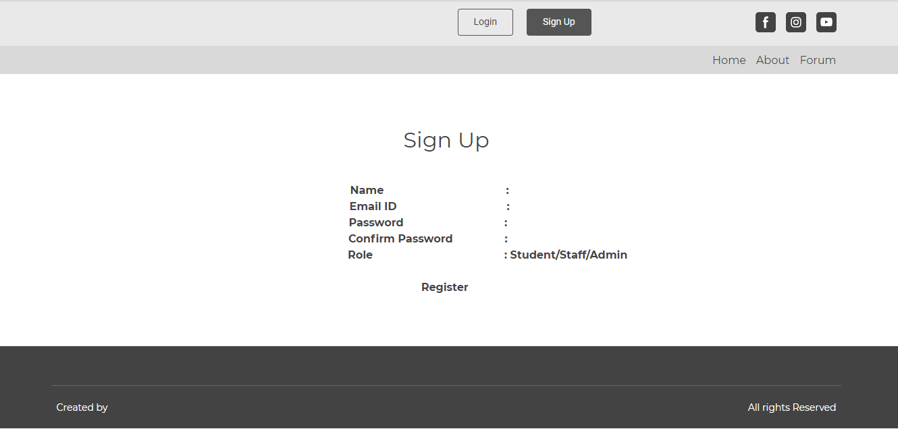

* **Guest/Visitor Pages:**
* **Home page**

* **About Page**

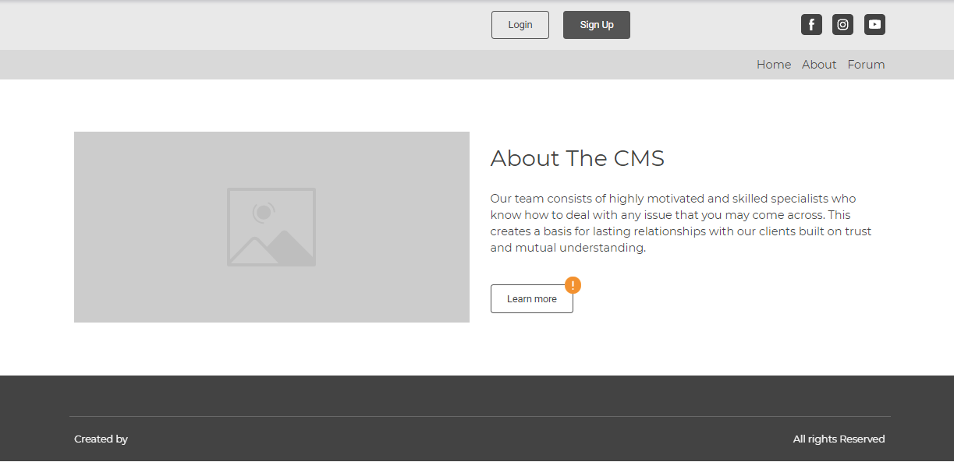

* **Forum Page**

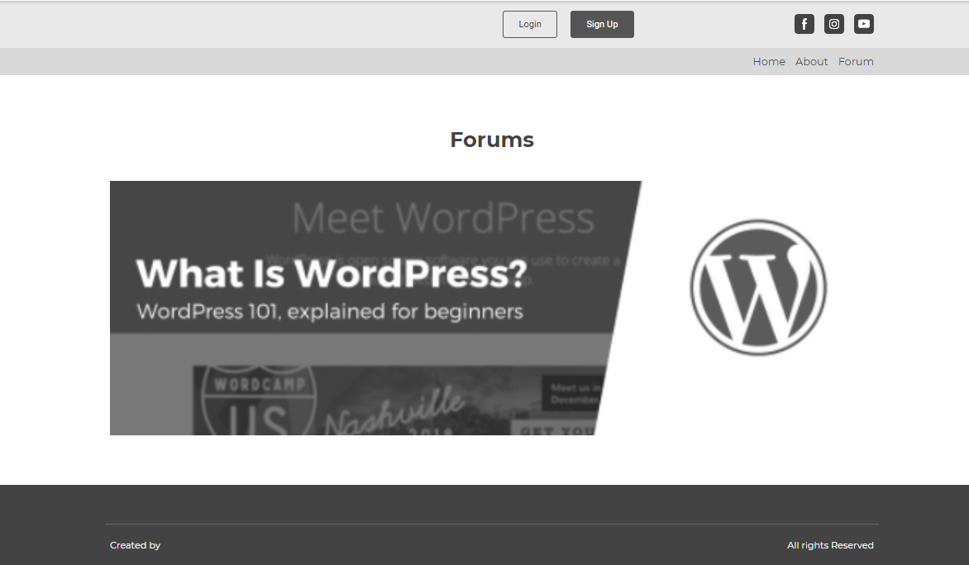

* **Student pages after login**
* **Home page**

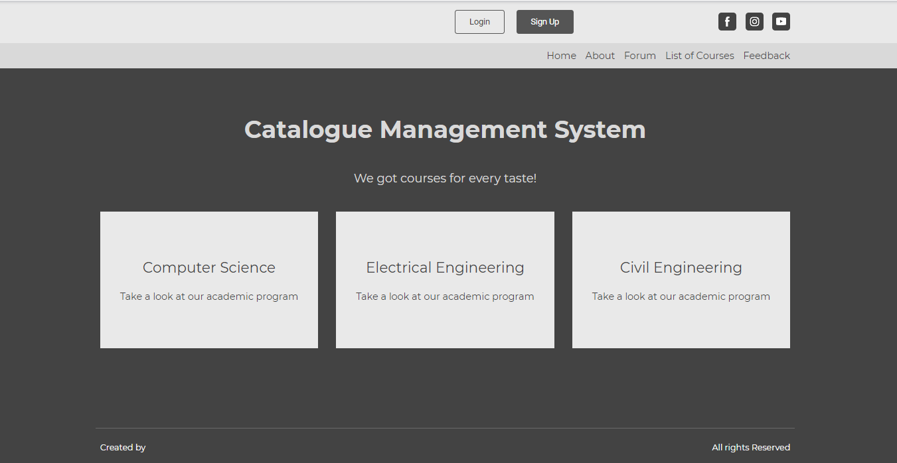

* **About Page**

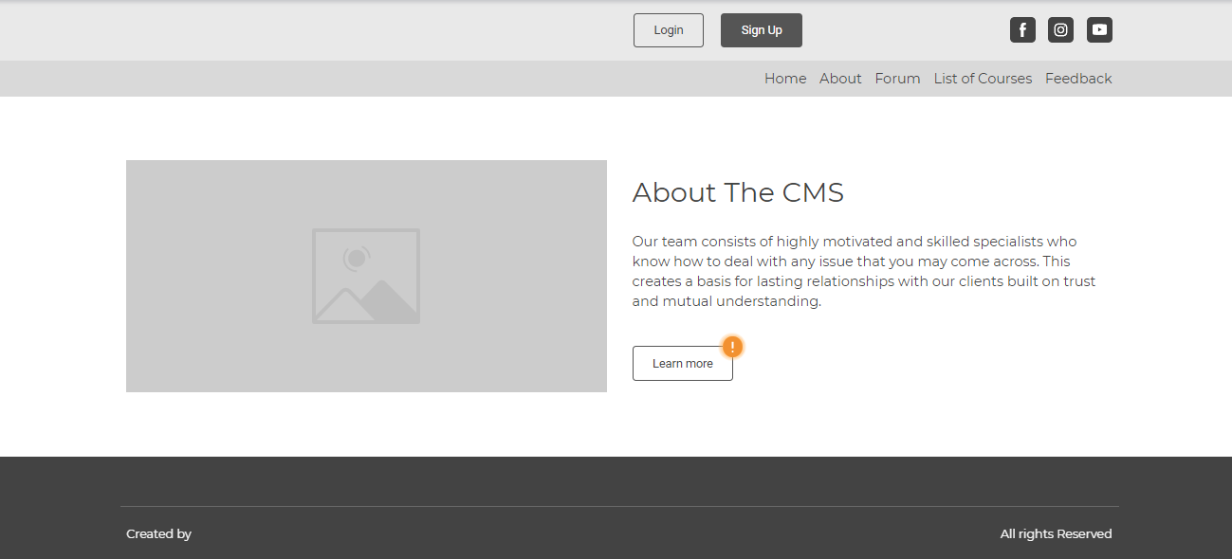

* **Contact Forum Page**

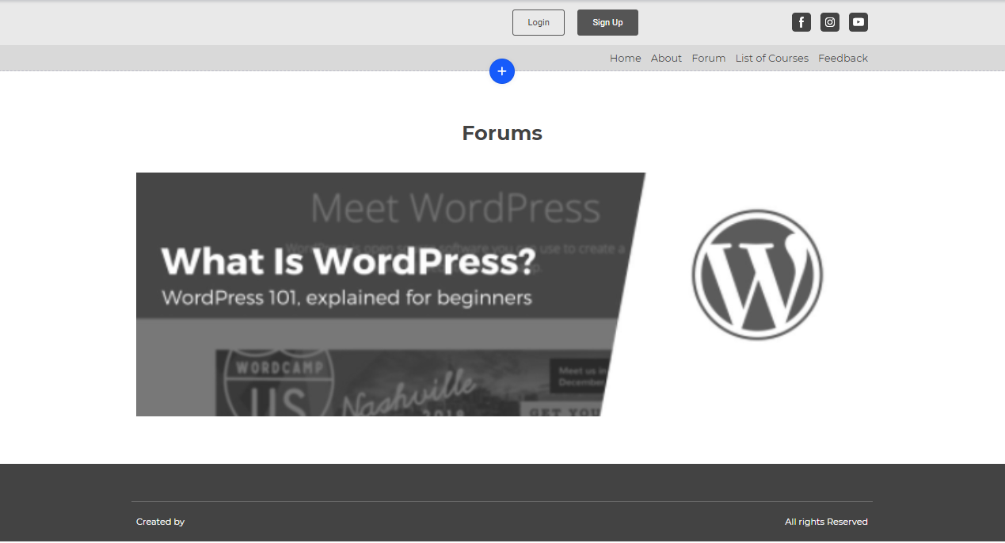

* **List of courses**

* **Feedback**

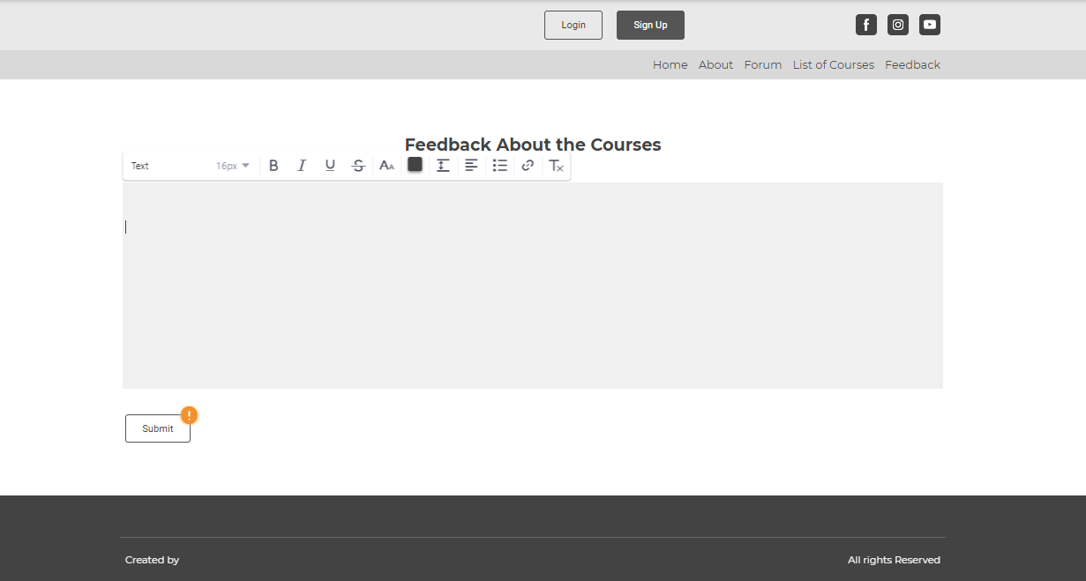

* **Staff pages after login**
* **Home page**

* **About page**

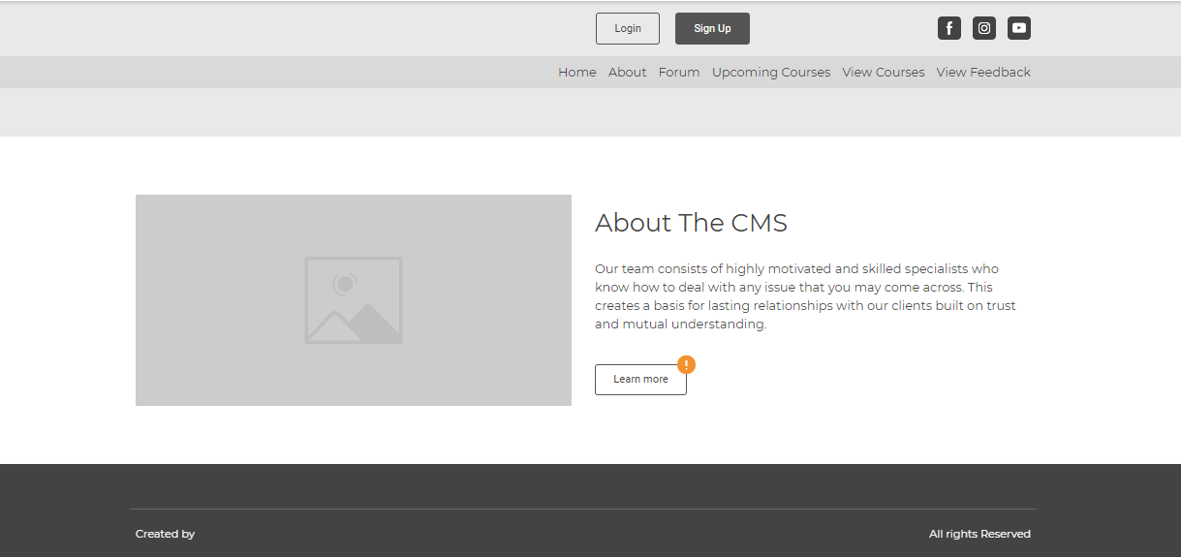

* **Forums page**

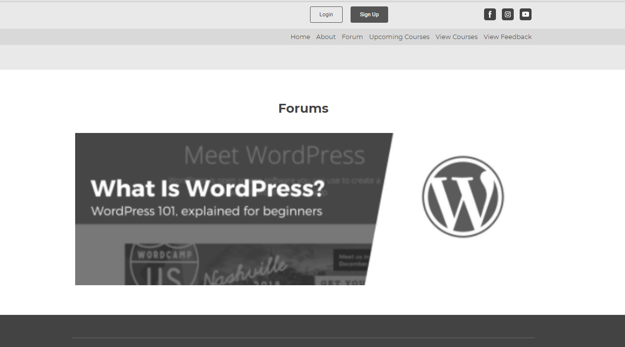

* **Upcoming courses**

* **Planned courses**

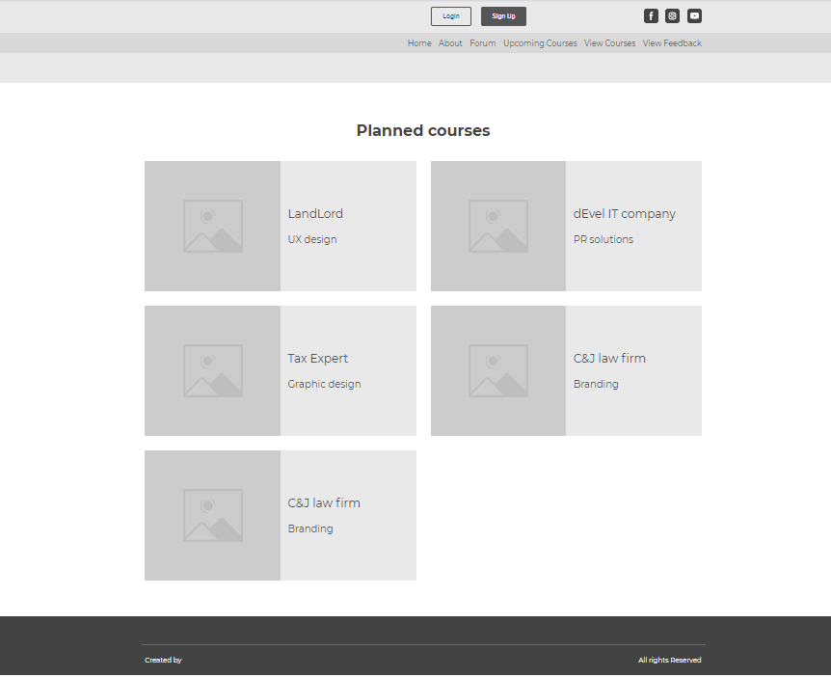

* **View feedback**

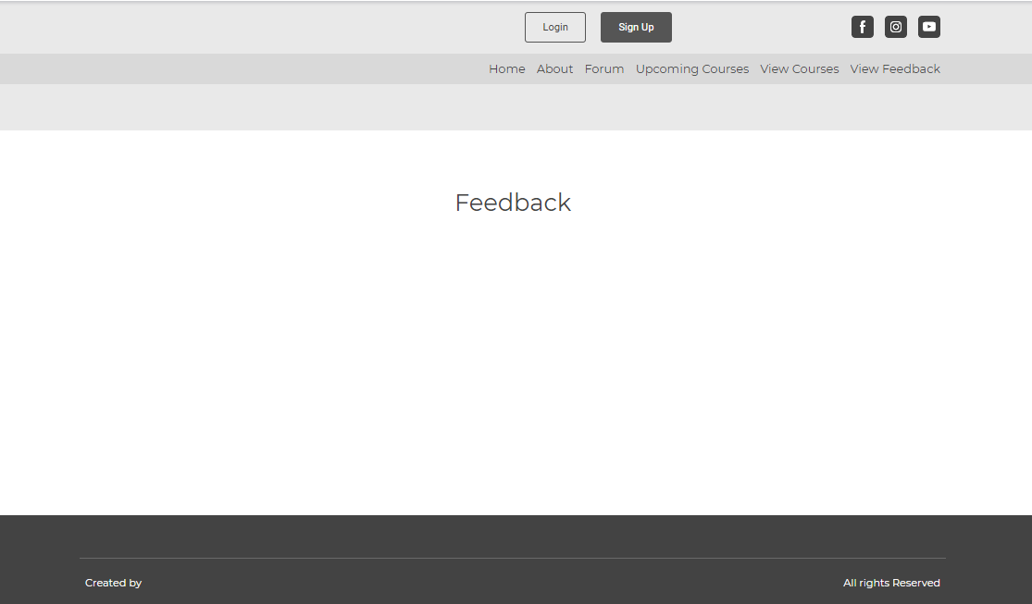

* **Admin Page after login**

