Mage AI Data Pipeline:

Compute Instance:

Cloud Storage:

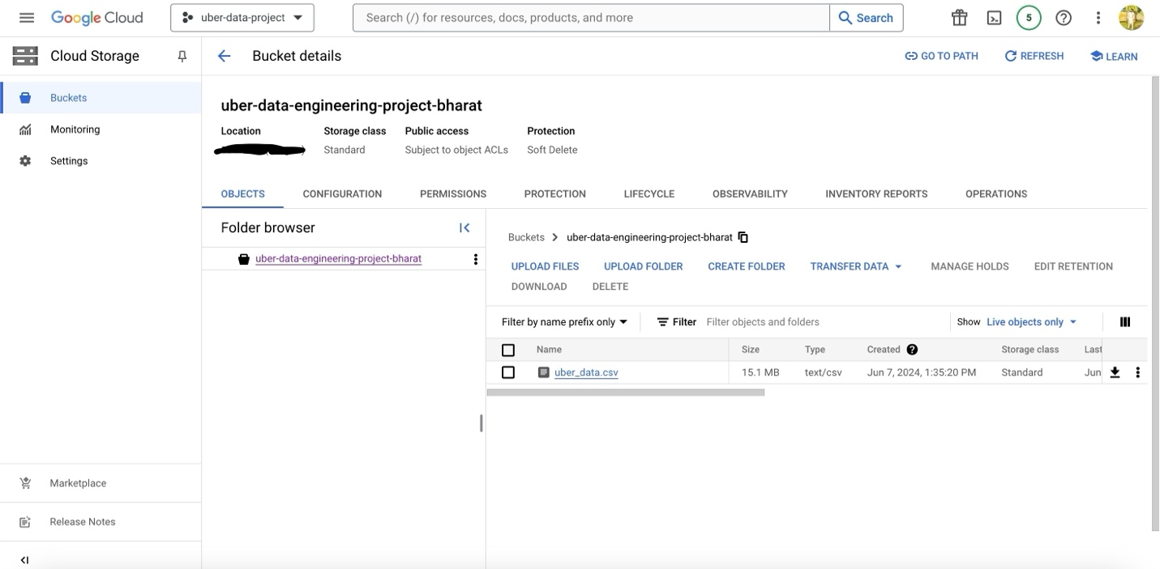

Big Query:

