Table of Contents
1. Introduction 3
2. Scope 3
3. Glossary 3
4. PACS - Spine Interface Architecture Specifications 4
5. MHS Specification 5
5.1. Introduction 5
5.2. Interaction Map 6
5.3. MHS modes: 7
6. Technologies involved 9
6.1. MIM 9
6.2. JAXB 9
6.3. HL7 version 3 9
6.4. JAXM 9
6.5. ebXML 9
6.6. Web services: 10
7. Class Overview 11
7.1. MessageHandler 11
7.2. HL7 Message Manager 11
7.3. Spine Communication Service 12
8. Component Interactions 13
List of Figures
• Figure 1 Architecture diagram for Spine Messaging framework 4
• Figure 2 A sample Spine query – PDS consent request 5
• Figure 3 An example of ebXML reliable interaction diagram 8
• Figure 4 Synchronous service Interaction diagram 8
• Figure 6 Web Service Mode (HL7) SOAP Envelope 10
• Figure 7 Class Diagram for Message Handler 11
• Figure 8 Class diagram for HL7 Message Manager 12
• Figure 9 Class diagram for Spine Communication Service 13
• Figure 10 Sequence Diagram for PDS consent query 14
• Figure 11 Sequence Diagram for LR Confirmation 15
• Figure 13 Sequence Diagram for Legitimate relationship (LR) create query 16
Related Documents
Document Title | Number/ Revision
EIS6[1].3--Part 1--Intro.doc | 6[1].3
EIS6[1].3--Part 2--MHS.doc | 6[1].3
EIS6[1].3--Part 3--MessageInteractionMap.doc | 6[1].3
EIS6[1].3--Part A--Appendix.doc | 6[1].3
MHSInteractionBehaviour 4[1].2.doc | 4[1].2
NPfIT Message Implementation Manual (MIM) | 3.1.10
Table 1 Related Documents

Introduction
Messaging framework acts as a messaging solution for the Spine subsystem in conjunction with the NPfIT message specifications. The framework is designed to run on the MT and to be implemented along side MT webservices. The PACS clients will use the webservices to access any Spine services. Message framework involves two main functional components: HL7 message manager, Spine communication service.
HL7 message manager generates HL7 v3 message, which carry the Spine Query and heathcare information. The messages supported include PDS Consent check, LR confirmation LR creation (Self claimed). The framework can be extended to support to other messages.
Spine communication manager behaves as a MHS node, carries SOAP message and binds to HTTP transport. Spine supports two different modes of messaging, ebXML mode and Web services mode. Each mode has its own messaging behaviour and message pattern. A feature common to the modes is that the messages are SOAP messages and carry HL7 message. The communication manager also processes the responses from Spine.
In future, more messages can be added to the framework facilitating the support for more healthcare domains from spine services. The framework provides needed scalability and flexibility required for the change. The framework incorporates the object-oriented concepts and patterns to achieve modularity, information hiding and polymorphism to mention a few.
The framework design is the one among the first few to be implemented with HL7 version 3 support.

Scope
This document outlines the messaging architectural specifications for PACS to Spine. It serves as a first draft of the framework. Listed below are the important topics covered in this document.
- Architecture and Technology choice
- Messaging modes and behaviour supported
- Interaction Map
- Message Handler
- HL7 Message Manager
- Spine Communication Service
- Component Interaction

Glossary
Electronic Business XML (ebXML): A joint initiative of OASIS and UN/CEFACT began in November 1999, seeking to develop specifications for exchanging business messages worldwide using XML
Simple Object Access Protocol (SOAP): SOAP is a lightweight XML based protocol for exchange of information in a decentralized, distributed environment.
Java Architecture for XML Binding (JAXB): provides an API and tools that automate the mapping between XML documents and Java objects.
JAXM: (Java API for XML Messaging): An API that provides a standard way to send XML documents over the Internet from the Java platform.
Java API for XML Processing (JAXP): An API for processing XML documents. It supports both SAX and DOM parsers.
Java Web Services Developer Pack (Java WSDP): An environment containing key technologies to simplify building of Web services using the Java 2 Platform.
Message Handling Service (MHS): A MHS is a software component that is responsible for handling all XML-type messages sent between applications. All senders/receivers of NPfIT XML document MUST implement an MHS.
Patient Demographic Services (PDS): The Patient Demographic Services enables to retrieve/ update/ trace and confirm patient – related information of Spine.
Legitimate Relationship Services (LRs): The Legitimate Relationship (LR) Messaging Service enables an electronic relationship to exist between a patient and either a Health Care Professional, NHS Organisation workgroup or another person.

PACS - Spine Interface Architecture Specifications
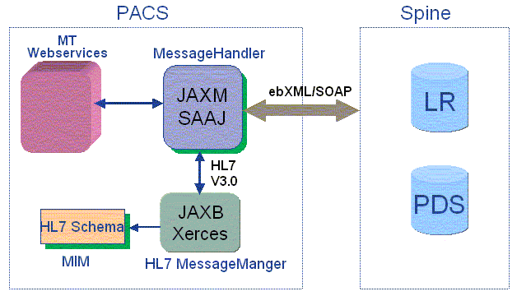
- Figure 1 Architecture diagram for Spine Messaging framework
The architecture and technologies used are depicted in the diagram. It provides an outline of the relationship between the components of the messaging framework and Spine services.
Messaging framework bird’s eye view – The MT webservice is provided by the PACS MT, which can be accessed by the PACS clients who wish to use spine services like LR and PDS.
- The MT webservice delegates the calls to MessageHandler.
- On receiving the request, Message Handler, processes the input arguments.
- Calls for HL7 Message manager to generate the HL7 message.
- The HL7 Message Manager generates HL7 message using the HL7 Schema (XSD) or rules provided by MIM and sends it to the Message Handler.
- The message handler generates a SOAP message using SOAP specifications and SAAJ API. Then, the SOAP message is sent to LR or PD Services of spine in either ebXML/ webservices mode.
- The HL7 response from the Spine services is sent to the HL7 Message Manager to be processed for the necessary response.
- The processed result is sent back to the client through the webservices

The diagram below shows the sample PDS query from Client application perspective.
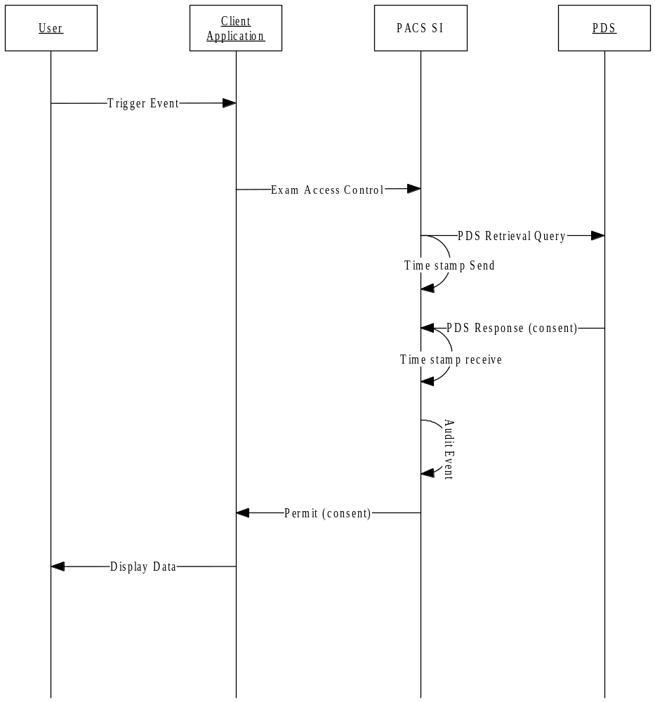
- Figure 2 A sample Spine query – PDS consent request

MHS Specification

Introduction
The framework supports the modes and behaviour supported by a MHS node. An MHS node operates in two modes; ebXML Mode, and Web Service Mode. As their names imply, they represent two different structural and behavioural specifications within the general SOAP structures and behaviours.
Message framework also complies with MHS behaviour,
- Header processing. The creation and processing of (ebXML or web service) header elements. This also includes the parsing of header elements, the interaction with contract properties, and the passing of elements to and from the message service interface.
- Message packaging. The building of the ebXML and web service envelopes, including the ebXML SOAP attachment structure.
- Security. No message level security behaviour is required.
- Reliable message processing. Responsible for the delivery and acknowledgement of MHS messages. This component deals with persistence, retries, error notification, and acknowledgement of messages requiring reliable delivery.
- Error handler. Response for the reporting of errors encountered during MHS processing, including errors across the service interface.
- MHS Service Interface. The abstract interface between the MHS and a system that is sending or receiving messages.

Interaction Map
Message Interaction map aligns MIM domains and interactions with MHS and HL7 message behaviour patterns. Following table here depicts the Interaction map for the messages exchanged between PACS and spine.

Interaction (Business Action) | MHS Message Behaviour | HL7 Forms of Operation
PDS Retrieve Query | Web Service | RIF Form
Request: | Web Service | RIF Form
· PDS Retrieval Query (QUPA_IN040000UK14) | Web Service | RIF Form
Response: | Web Service | RIF Form
· Query Act Failed (QUQI_IN010000UK14) | Web Service | RIF Form
· Retrieval Query Successful (QUPA_IN050000UK16) | Web Service | RIF Form
Create LR | ebXML Reliable Asynchronous | State Exchange Form
Request: | ebXML Reliable Asynchronous | State Exchange Form
· Request Create LR (REPC_IN010000UK15) | ebXML Reliable Asynchronous | State Exchange Form
Response: | ebXML Reliable Asynchronous | State Exchange Form
· Create LR Confirm (REPC_IN020000UK13) | ebXML Reliable Asynchronous | State Exchange Form
· Application Acknowledgement (MCCI_IN010000UK13) | ebXML Reliable Asynchronous | State Exchange Form
Query LR Confirmation | Web Service | RIF Form
Request: | Web Service | RIF Form
· Query LR Confirmation (QUPC_IN010000UK15) | Web Service | RIF Form
Response: | Web Service | RIF Form
· LR Result with short response (QUPC_IN030000UK14) | Web Service | RIF Form
· LR Result with history response (QUPC_IN040000UK14) | Web Service | RIF Form
· Query Request Failed (QUQI_IN010000UK14) | Web Service | RIF Form
Table 2. Interaction Map for PACS Spine messages
Schemas (XSD) are defined for each message format defined above. The schemas provide the basic consistent format of the PACS Spine message.

MHS modes:
So, the message behaviour of messages is either ebXML or web service mode. The PDS consent query retrieve message and LR confirmation messages are ‘Web service’ message pattern. The self-claimed LR Create message is of ‘ebXML reliable Asynchronous’ message pattern.
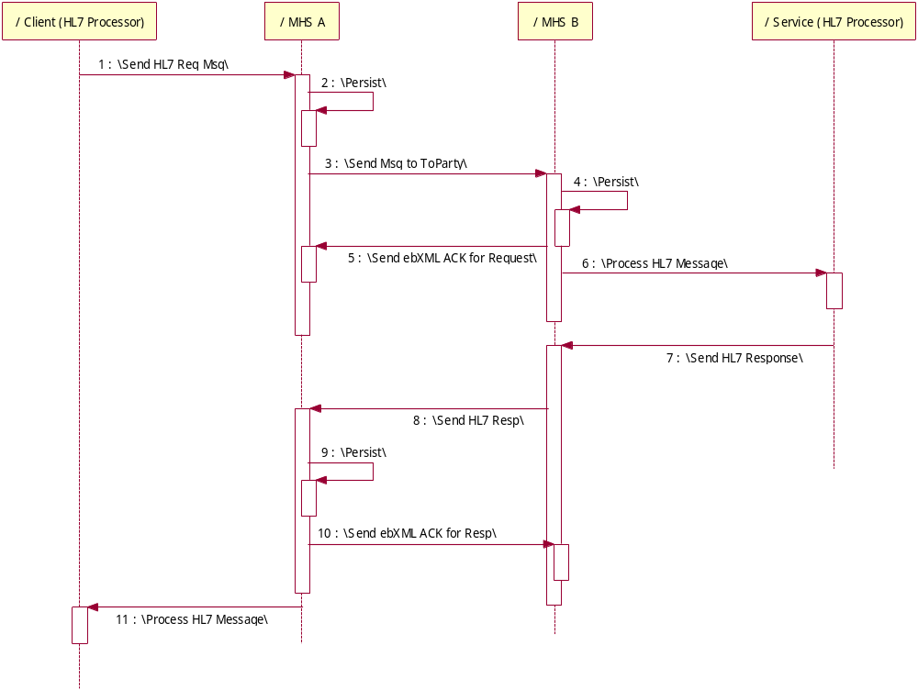
- Figure 3 An example of ebXML reliable interaction diagram
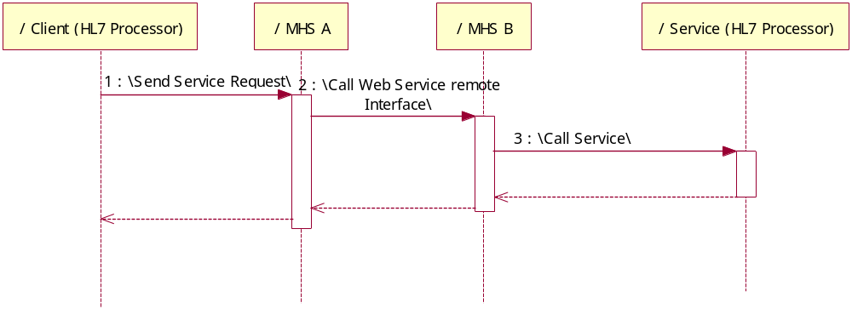
- Figure 4 Synchronous service Interaction diagram
Refer to MHSInteractionBehaviour 4[1].2.doc for more information about the message behaviour in these modes of messaging. The message for each message pattern is different.

Technologies involved

MIM
The NpfIT Message Implementation Manual provides information to implementers regarding the use of HL7 v3 messages within the National Programme for Information Technology (NPfIT). Messages and Data Types are based on the HL7 v3 RIM.

JAXB
Java Architecture for XML Binding (JAXB) provides an API and tool that allow automatic two-way mapping between XML documents and Java objects.
Java classes are generated from the Schemas given by the NpfIT MIM specification. This will allow the developers to build applications that read, manipulate and create HL7 messages (XML documents). The generated codes provide an abstraction layer by exposing a public interface that allows access to the XML data without any specific knowledge about the underlying data structure. The java classes forms the object model to develop the HL7 message based on them. The HL7 message can also be validated depending on the object model.

HL7 version 3
HL7 version 3 is the specification to carry the Spine query and also the healthcare related data necessary to carry out the Spine query in the spine side.

JAXM
The Java API for XML Messaging (JAXM) enables PACS to send and receive SOAP messages, which is nothing but document-oriented XML messages. JAXM implements Simple Object Access Protocol (SOAP) 1.1 with Attachments. JAXM is extended to work with ebXML (electronic business XML) Message Service Specification, by adding the protocol’s functionality on top of SOAP.

ebXML
ebXML is a specification that takes care of business interactions. The PACS and Spine are the parties acting as partners communicating with each other. The partners communicate with each other depending on the contract properties established between them. The contract properties establish the end-points definition, the type of messages exchanged, transport protocol and other properties like number of retries in case of exception.
An ebXML message format:

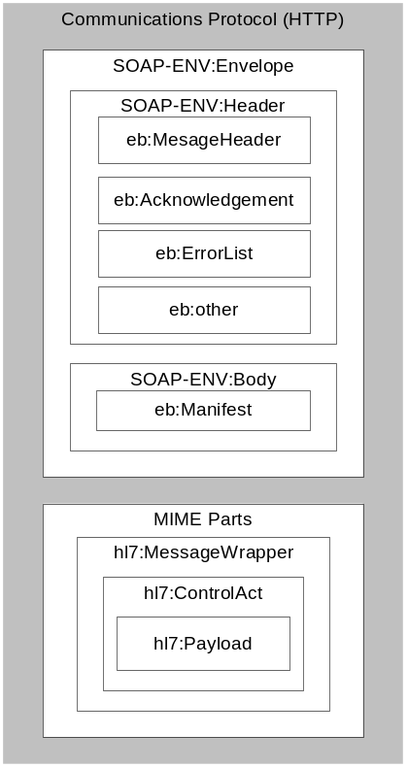
Figure 5 ebXML mode SOAP envelope structure

Web services:
SOAP Message can also be transferred using Web services mode of message transfer. WS Addressing is used to specify the SOAP headers and HL7 message is included in the SOAP body.
A webservice message format:
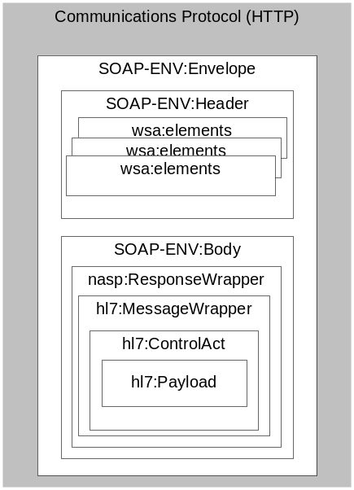
- Figure 6 Web Service Mode (HL7) SOAP Envelope

Class Overview

MessageHandler
The message handler component is designed to handle the messages for the MT webservices. The call consists of the input arguments necessary to issue the call to spine. A ‘MessageHandlermpl’ class handles the three calls for PDS and LRs, services from Spine. The message calls enters the message framework through this class.
The class diagram looks like this,
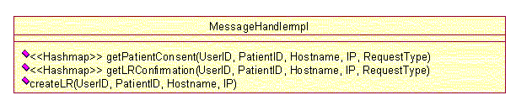
- Figure 7 Class Diagram for Message Handler

HL7 Message Manager
HL7 message manager consists of the 3 implementations.
- A java object model
- The HL7 v3 message generator and
- The Spine HL7 message response parser.
The static object model, generated by the JAXB API, imposes rules defined by the MIM XSD files provided by the NpfIT.
To generate a HL7 message, client needs to instantiate a class of HL7Message type (done through HL7MessageFactory) and then generate HL7 message using the methods provided by the classes.
The ‘HL7MessageFactory’ singleton class generates the HL7 message on ‘newInstance’ call to the method, either a PDSQueryRetrieveMessage, LRConfirmationMessage or LRCreateMessage. The HL7MessageFactory takes SpineMessageVO as the input and returns HL7Message. Any additional information necessary to generate the message is picked from the MessageConfiguration.properties file or from the database. The type of the message returned will depend on the query issued by the client.
Each type of the message class has few private methods to help generate the HL7 messages. (say, getREPC_MT070101UK13MessageType() to generate REPC_MT070101UK13 MessageType element in the message). The HL7Message interface has three interface methods ‘getDocument’, ‘getFile’ and ‘processHL7Response’. ‘getDocument’ and ‘getFile’ methods are related to generating HL7messages in Document / File Object and ‘processHL7Request’ is related to parsing the HL7response received from spine.
‘processHL7Response’ helps to parse the HL7MessageResponses received and filter out the information.
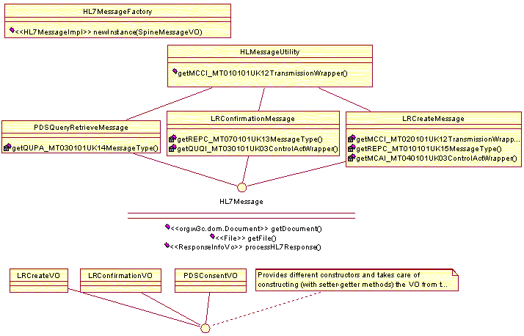
- Figure 8 Class diagram for HL7 Message Manager

Spine Communication Service
Spine communication Service is a service that sends SOAP message to the Spine with message. The SOAP message is bound to the HTTP protocol and the messaging medium is JAXM. The service generates the necessary header definitions, attaches the HL7 message as an attachment or to the SOAP body depending on the Message mode.
The SpineCommunicationHandler has public sendMessage() method, which receives an ActionID and the HL7Message as its inputs. The initialize () method resolves to either sendebXMLMsg() or sendWebServiceMsg() depending on the mapping between the ActionID and the messagetype (either ebXML or Webservice), provided in the MessageConfiguration.properties file. A call to getSOAPMessage() gets either a ebXML or web service message. Based on the message type, sendebXMLMsg() or sendWebServiceMsg() is called which in turn sends a message to spine services.
Receiving servlet is extended from the JAXMServlet. It receives the asynchronous responses from spine.
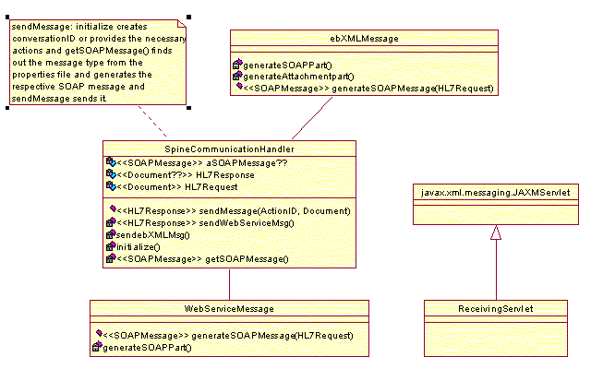
- Figure 9 Class diagram for Spine Communication Service

Component Interactions
Three main interactions encompass the messaging framework. Interactions following calls, getPatientConsent(…), getLRConfirmation(…), createLR(…).
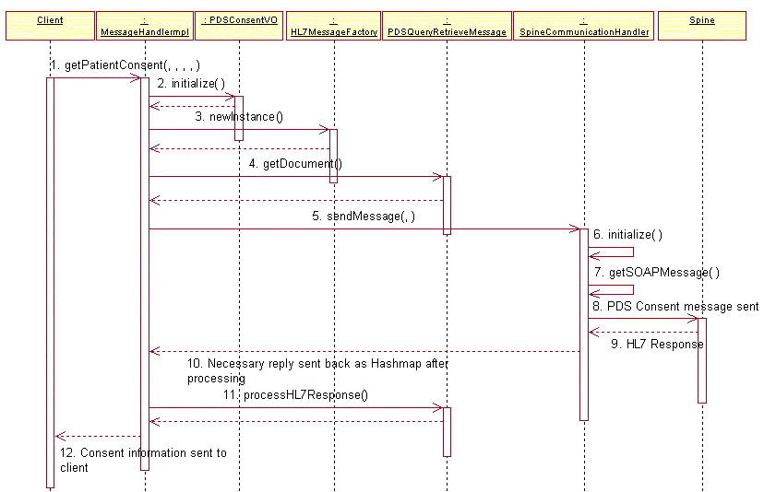
- Figure 10 Sequence Diagram for PDS consent query
The above interaction represents the necessary actors/actions for the Patient consent query.
- The PACs client requests for the patient consent by issuing the call ‘getPatientConsent(..)’ which is issued to the MessageHandler
- PDSConsentVO.initialize() will generate the necessary VO object for the PDS Consent Query. The necessary values for the VO object are picked from the input arguments of the MT services call, database and properties file.
- The VO object is sent to HL7MessageFactory.newInstance() method, which in turn sends back the PDSQueryRetrieveMessage Instance.
- PDSQueryRetrieveMesssage.getDocument() method is called to obtain the HL7 message.
- When the HL7Message is received from the getDocument method, it is passed to the SpineCommunicationHandler.sendMessage() along with an action ID related to the query. This method will take care of initializing, getting the SOAP message, sending the PDS Consent query to spine.
- initialize() call will resolve to either a ebXML / web service messaging mode depending on the Action ID. This method will resolve to web service mode, as this is LR Confirmation call.
- getSOAPMessage() will returns the SOAP message by adding the web service addressing headers and envelope the HL7Message inside the SOAP body
- send() call sends the PDS Consent query message to spine.
- PACS SI receives the HL7 response which has consent information
- This response is sent back to the MessageHandlerIMpl
- MessageHandler will call processHL7Response on PDSQueryRetrieveMessage.
- PDSQueryRetrievMessage parses and filters out the Patient Consent detail in a hashmap
- This hashmap is returned back to the client.

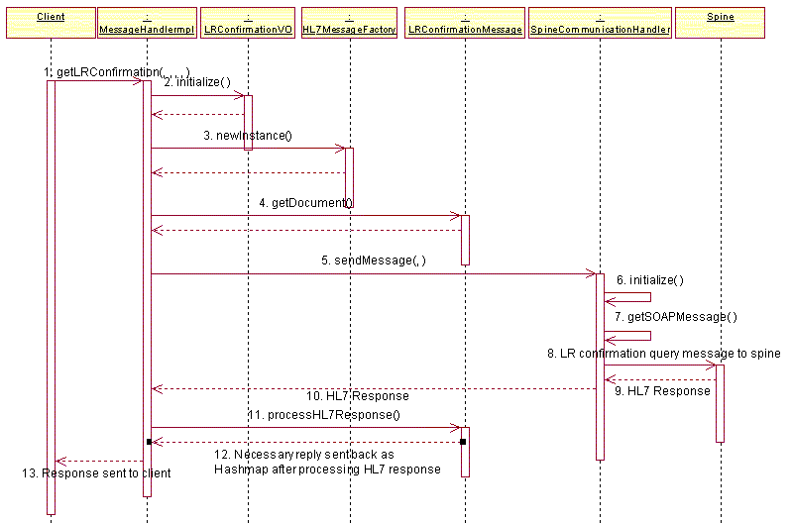
- Figure 11 Sequence Diagram for LR Confirmation
The LR confirmation query interaction is very similar to PDS Consent interaction as it is also a webservice mode of message transfer.
- Here, the ‘getLRConfirmation(..)’ message is issued to the MessageHandler
- LRConfirmationVO.initialize() will generate the necessary VO object for the LR Confirmation Query. The necessary values for the VO object are picked from the input arguments of the MT services call, database and properties file.
- The VO object is sent to HL7MessageFactory.newInstance() method, which in turn sends back the LRconfirmationMessage Instance.
- LRConfirmationMessage.getDocument() method is called to obtain the HL7 message for the LR confirmation query.
- When the HL7Message is received from the getDocument method, it is passed to the SpineCommunicationHandler.sendMessage() along with an action ID related to the query. This method will take care of initializing, getting the SOAP message, sending the LR confirmation query to spine.
- initialize() call will resolve to either a ebXML / web service messaging mode depending on the Action ID. This method will resolve to web service mode as this is LR Confirmation call.
- getSOAPMessage() will returns the SOAP message by adding the web service addressing headers and envelope the HL7Message inside the SOAP body
- send() call sends the LR Confirmation message to spine.
- PACS SI receives the HL7 response which has confirmation information
- This response is sent back to the MessageHandler
- MessageHandler will call processHL7Response on LRConfirmationMessage
- LRConfirmationMessage parses and filters out the Confirmation detail in a hashmap.
- This hashmap is returned back to the client.

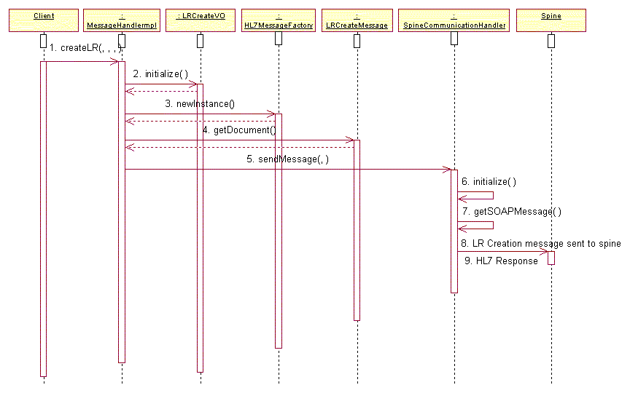
- Figure 13 Sequence Diagram for Legitimate relationship (LR) create query
The LR creation query interaction is different from PDS Consent or LR confirmation query as it is also an ebXML mode of message transfer. Also the message behaviour is asynchronous. So, the client will not expect a reply from the Spine service.
- ‘getLRCreate(..)’ message is issued to the MessageHandler
- LRCreateVO.initialize() will generate the necessary VO The necessary values for the VO object are picked from the input arguments of the MT services call, database and properties file.
- The VO object is sent to HL7MessageFactory.newInstance() method, which in turn sends back the LRcreateMessage Instance.
- LRCreateMessage.getDocument() method is called to obtain the HL7 message for the LR confirmation query.
- When the HL7Message is received from the getDocument() method, it is passed to the SpineCommunicationHandler.sendMessage() along with an action ID related to the query. This method will take care of initializing, getting the related SOAP message, sending the LR create query to spine.
- initialize() call will resolve to either a ebXML / web service messaging mode depending on the Action ID. This method will resolve to ebXML mode as this is self-claimed LR Creation call.
- getSOAPMessage() will returns the SOAP message by adding ebXML headers and attach the HL7Message as a MIME attachment.
- send() call sends the LR Create SOAP message to spine.

