

**DEPARTMENT OF MECHATRONICS**

**SQL**

**ASSIGNMENT -1**

|  |  |
| --- | --- |
| **NAME OF THE STUDENT** | **BHARANEEDHARAN K** |
| **REGISTER NUMBER** | **22MTL003** |
| **YEAR/SEMESTER** | **IV/VII** |
| **ASSIGNMENT NUMBER** | **1** |

SQL ASSIGNMENT-1

Q1. Increase salary by 10% for all employees in the 'IT' department.

**Query:**

create table student(id int,name varchar(100),dept varchar(100),salary float);

insert into student values(1,"Riy","IT",40000),(2,"Faz","IT",89000)

,(3,"kailash","Finance",78000);

select * from student

update student set salary=salary*1.10 where dept="IT";

**Output:**

Q2. Delete all employees whose department is 'HR'.

**Query:**

create table studenrt(id int,name varchar(100),dept varchar(100),salary float);

insert into studenrt values(1,"Riy","IT",40000),(2,"Faz","IT",89000)

,(3,"kailash","Finance",78000),(4,"Abilash","HR",98000);

select * from student

DELETE FROM student

WHERE dept = 'HR';

SELECT * FROM student;

**Output:**

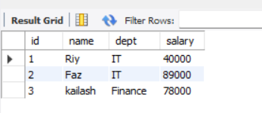

Q3.Write a query to delete a record from the Employees table where ID = 5.

**Query:**

create table studentr1(id int,name varchar(100),dept varchar(100),salary float);

insert into studentr1 values(1,"Riy","IT",40000),(2,"Faz","IT",89000)

,(3,"kailash","Finance",78000),(4,"Abilash","HR",98000),(5,"deepak","HR",40000);

delete from studentr1 where id=5;

select * from studentr1

**Output:**

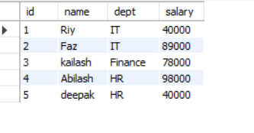

Q4.Write a query to update multiple columns in a table using a single statement.

**Query:**

create table studentr1(id int,name varchar(100),dept varchar(100),salary float);

insert into studentr1 values(1,"Riy","IT",40000),(2,"Faz","IT",89000)

,(3,"kailash","Finance",78000),(4,"Abilash","HR",98000),(5,"deepak","HR",40000);

UPDATE studentr1

SET name = 'Riy', salary = 55000

WHERE id = 1;

select * from studentr1

**Output:**

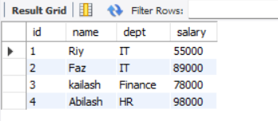

Q5.Delete all records from a table but keep the structure.

**Query:**

create table studentr1(id int,name varchar(100),dept varchar(100),salary float);

insert into studentr1 values(1,"Riy","IT",40000),(2,"Faz","IT",89000)

,(3,"kailash","Finance",78000),(4,"Abilash","HR",98000),(5,"deepak","HR",40000);

UPDATE studentr1

SET name = 'Riy', salary = 55000

WHERE id = 1;

delete from studentr1;

select * from studentr1

**Output:**

Q6. Write a query to create a table called Students with columns: ID, Name, Age, and Email

**Query:**

create table Students(id int,Nam varchar(100),age int,email varchar(100));

insert into Students values(1,"ganesh",20,"ganesh@gmail"),(2,"kalimuthu",19,"kali@gmail");

select * from Students

**Output:**

Q7. Create a table and set the default value of the status column to 'Active'.

**Query:**

CREATE TABLE Users (

ID INT PRIMARY KEY,

Name VARCHAR(100),

Email VARCHAR(100),

Status VARCHAR(20) DEFAULT 'Active'

);

INSERT INTO Users (ID, Name, Email)

VALUES (1, 'Riyas', 'riyas@email.com');

SELECT * FROM Users;

**Output:**

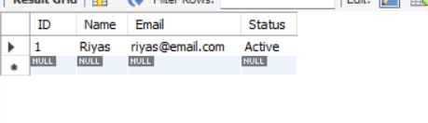

Q8.Write a query to drop a table named TempData.

**Query:**

create database fan;

create table tempdata(id int,namess varchar(100),age varchar(100));

insert into tempdata values(11,"tahir","12");

drop table tempdata;

drop data

create database fan;

create table tempdat1a(id int,namess varchar(100),age varchar(100));

insert into tempdat1a values(11,"tahir","12"),(12,"bala","90"),(13,"joe","78");

alter table tempdat1a drop column age;

select * from tempdat1a;

**Output:**

Q9. Drop all indexes on a given table.

**Query:**

CREATE TABLE Employee4s (

ID INT PRIMARY KEY,

Name VARCHAR(100),

Department VARCHAR(100),

Salary FLOAT

);

CREATE INDEX idx_name ON Employee4s(Name);

CREATE INDEX idx_dept ON Employee4s(Department);

DROP INDEX idx_name ON Employee4s;

DROP INDEX idx_dept ON Employee4s;

Q10.Write a query to add a new column DOB of type DATE to the Employees table.

**Query:**

Create the Employees table

CREATE TABLE Employ2ees (

ID INT PRIMARY KEY,

Name VARCHAR(100),

Department VARCHAR(100),

Salary FLOAT

);

INSERT INTO Employ2ees (ID, Name, Department, Salary) VALUES

(1, 'Riyas', 'IT', 50000),

(2, 'Fazil', 'HR', 60000),

(3, 'Kailash', 'Finance', 70000);

ALTER TABLE Employ2ees

ADD DOB DATE;

UPDATE Employ2ees

SET DOB = '1995-06-15'

WHERE ID = 1;

UPDATE Employ2ees

SET DOB = '1993-09-20'

WHERE ID = 2;

UPDATE Employ2ees

SET DOB = '1990-01-10'

WHERE ID = 3;

select * from Employ2ees

**Output:**

Q11.Modify the data type of the column Salary from INT to FLOAT.

**Query:**

CREATE TABLE Empl (

ID INT PRIMARY KEY,

Name VARCHAR(100),

Department VARCHAR(100),

Salary INT

);

INSERT INTO Empl (ID, Name, Department, Salary) VALUES

(1, 'Riyas', 'IT', 50000),

(2, 'Fazil', 'HR', 60000),

(3, 'Kailash', 'Finance', 70000);

ALTER TABLE Empl

modify Salary FLOAT;

UPDATE Empl

SET Salary = Salary * 1.5;

SELECT * FROM Empl;

**Output:**

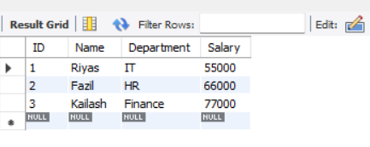

Q12.Rename a column in a table from fullname to name.

**Query:**

CREATE TABLE Empl1 (

ID INT PRIMARY KEY,

realname VARCHAR(100),

fullname VARCHAR(100),

Salary INT

);

INSERT INTO Empl1 (ID, realname, fullname, Salary) VALUES

(1, 'Riyas', 'IT', 50000),

(2, 'Fazil', 'HR', 60000),

(3, 'Kailash', 'Finance', 70000);

select * from Empl1;

**Output:**

Q13. Rename the table Customers to Clients.

**Query:**

create database yesterday;

CREATE TABLE Customers (

ID INT PRIMARY KEY,

Name VARCHAR(100),

Email VARCHAR(100)

);

INSERT INTO Customers (ID, Name, Email) VALUES

(1, 'Riyas', 'riyas@example.com'),

(2, 'Fazil', 'fazil@example.com');

RENAME TABLE Customers TO Clients;

SELECT * FROM Clients;

**Output:**

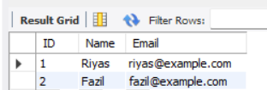

Q14. Truncate a table and insert one row back using INSERT.

**Query:**

CREATE TABLE Employees (

ID INT PRIMARY KEY,

Name VARCHAR(100),

Department VARCHAR(50),

Salary FLOAT

);

INSERT INTO Employees (ID, Name, Department, Salary) VALUES

(1, 'Riyas', 'IT', 50000),

(2, 'Fazil', 'HR', 55000),

(3, 'Kailash', 'Finance', 60000);

SELECT * FROM Employees;

TRUNCATE TABLE Employees;

INSERT INTO Employees (ID, Name, Department, Salary)

VALUES (1, 'Riyas', 'IT', 50000);

SELECT * FROM Employees;

**Output:**

After inserting row:

Q15. Update the department of all employees from 'Sales' to 'Marketing'.

**Query:**

CREATE TABLE Employeees (

ID INT,

Name VARCHAR(100),

Department VARCHAR(100),

Salary FLOAT

);

INSERT INTO Employeees (ID, Name, Department, Salary) VALUES

(1, 'Riyas', 'Sales', 45000),

(2, 'Fazil', 'Sales', 50000),

(3, 'Kailash', 'IT', 60000),

(4, 'Dilip', 'HR', 55000),

(5, 'Bharanee', 'Sales', 47000);

UPDATE Employeees

SET Department = 'Marketing'

WHERE Department = 'Sales';

SELECT * FROM Employeees;

**Output:**

