Data Flow Diagram

Date | 30 September 2026
Team ID | SWTID-2026-3990
Project Name | LegalEase AI
Maximum Marks | 2 Marks

Data Flow Diagram
Create a Data Flow Diagram (DFD) to show how data moves through your system - between external entities, processes, and data stores. Use the symbol legend below as a guide.

DFD Symbol Legend

Symbol | Name | Description
Oval / Rounded shape | External Entity | A person, organization, or system outside the project that sends or receives data (e.g., Customer, Payment Gateway).
Rectangle with  numbered header | Process | An activity that transforms incoming data into outgoing data (e.g., Validate Request, Process Order).
Rectangle (solid fill, no number) | Data Store | A place where data is held for later use (e.g., Customer Database, Inventory).
Labeled arrow | Data Flow | The movement of data between entities, processes, and data stores, labeled with what data is being passed.

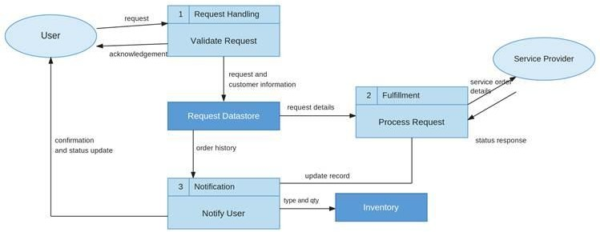
LegalEase AI – Level 1 Data Flow Diagram
Data flow based on the architecture and workflow documented in the supplied LegalEase PDF.
USER | → | 1. Streamlit  User Input | → | 2. FastAPI  /generate
Document type,  parties, terms,  dates |  | Input data |  | Validated request
 |  | 3. GeminiDocumentGenerator | → | 4. Gemini 1.5 Pro  AI Generation
 |  | Structured prompt |  | Generated legal text
 | ← | 5. FastAPI  Response | ← | AI output
 |  | 6. Editable Preview  & Formatting | → | 7. Export  TXT / DOCX / PDF
USER | ← | Edited / formatted  document | ← | Downloaded file
DFD Notes
• External Entity: User — provides document type, parties, terms, and effective date.
• Processes: Streamlit input/preview, FastAPI /generate, GeminiDocumentGenerator, Gemini 1.5 Pro generation, and document formatting/export.
• Data Flows: User inputs → API request → structured AI prompt → generated legal text → preview/edit → downloadable document.
• Data Store: No persistent database/data store is specified in the supplied LegalEase PDF. The diagram therefore does not claim a database that the project documentation does not support.
Team Members: Bharaneeshwar.V; Pragadheeswaran.S; Santhosh kumar.G; Karthikeyan.P; Kesavan.N

