Project Executable Files

Date | 30 September 2026
Team ID | SWTID-2026-3990
Project Name | LegalEase AI
Maximum Marks | 3 Marks
Team Members | 1. Bharaneeshwar.V  2. Pragadheeswaran.S  3. Santhosh kumar.G  4. Karthikeyan.P  5. Kesavan.N

Project Executable Files
This section requires submission of all executable and deployable files for your project. Ensure all files are properly organized, named, and uploaded to the specified submission platform. The evaluator must be able to run or deploy your solution using the provided files and instructions.

Step 1: Submission Checklist

S.No | Item to Submit | Submitted (Yes / No / NA)
1 | Complete source code (all files and folders) | Yes – source code is documented
2 | README / Setup Guide (instructions to run the project) | Not provided
3 | requirements.txt / package.json / dependency file | Yes – dependency list is documented
4 | Database schema / seed files (if applicable) | NA – no database/storage is documented
5 | Environment configuration file (.env.example or similar) | Yes – .env API-key configuration is documented
6 | Deployed application URL (if hosted) | Not provided
7 | APK / Executable binary (if applicable for mobile/desktop apps) | NA – web application (FastAPI + Streamlit)
8 | Dockerfile / Containerization config (if applicable) | Not provided
9 | Test files and test results | Yes – local/end-to-end testing is documented
10 | Demo video or walkthrough (if required) | Not provided

Step 2: File / Folder Structure
Provide an overview of the project's file and folder structure below:
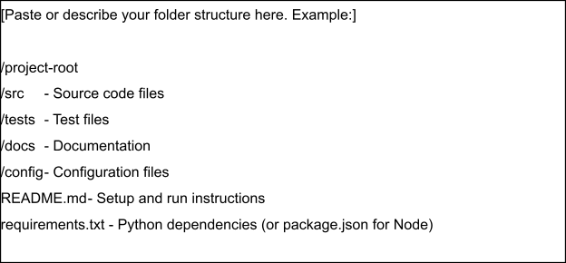

Step 3: Deployment / Access Details

Field | Details
Hosted / Deployed URL | Not provided in the LegalEase documentation
Login Credentials (Demo) | Local deployment: FastAPI backend + Streamlit frontend
Platform / Hosting Provider | Not provided; user authentication is not documented
Repository Link | Not provided
Demo Video Link | Not provided

Step 4: Run Instructions
Provide clear, step-by-step instructions for the evaluator to run your project locally:
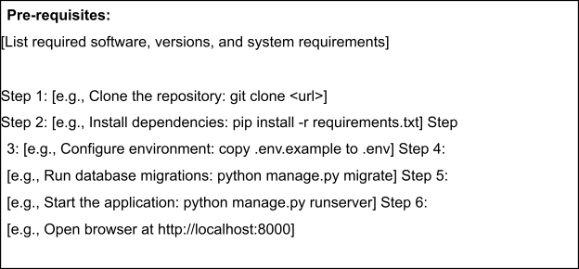

Step 5: Known Issues / Limitations

S.No | Known Issue / Limitation | Workaround / Status
1 | No hosted/deployed URL is provided. | Use the documented local deployment; add the URL if a hosted deployment exists.
2 | No repository link or demo credentials are provided. | Provide them if evaluator access requires a remote repository/demo.
3 | Formal performance benchmarks and production/cloud deployment are not documented. | Add measured performance and cloud deployment details when available.
Documented LegalEase project structure:
• main.py – FastAPI backend application entry point.
• routes.py – FastAPI route handling, including POST /generate.
• ai_core/gemini_generator.py – Gemini 1.5 Pro integration and legal document generation.
• Formatting modules/utilities – DOCX, PDF, TXT and HTML preview/export.
• Streamlit frontend – input collection, editable preview and download controls.
• .env – Gemini API key configuration for local execution.
1. Install Python 3.10 or a compatible Python version.
2. Create and activate a Python virtual environment for LegalEase.
3. Install the documented dependencies: FastAPI, Uvicorn, Streamlit, google-generativeai, python-docx, FPDF, Pillow, requests and python-dotenv.
4. Create the required .env configuration and provide the Gemini API key.
5. Start the FastAPI backend with Uvicorn using the project's configured application entry point.
6. Start the Streamlit frontend using the project's configured Streamlit application entry point.
7. Open the Streamlit interface and enter document type, parties, terms and dates.
8. Generate the legal document, review/edit the preview, and export it as TXT, DOCX or PDF.
9. The supplied LegalEase documentation does not state the exact shell commands for starting the two applications; use the actual commands/entry points in the executable project files.

