

A PROJECT REPORT
on
Enterprise Security Risk & Residual Risk Management Platform

Unique ID : E0224008
Student Name : Bala Murugan
Year/Sem: 3rd year / 5th sem
Stream : B. Tech CSE Cyber Security and Internet of Things
Course Code : CYB23DLU02
Course Name : INFORMATION SECURITY LABORATORY
Academic Year : 2026-2027
Course Faculty : Dr. S. Surya

A PROJECT REPORT
on
Enterprise Security Risk & Residual Risk Management Platform

Unique ID : E0224008
Student Name : Bala Murugan
Year/Sem: 3rd year / 5th sem
Stream : B. Tech CSE Cyber Security and Internet of Things
Course Code : CYB23DLU02
Course Name : INFORMATION SECURITY LABORATORY
Academic Year : 2026-2027
Course Faculty : Dr. S. Surya
Date of Exam:

BONAFIDE CERTIFICATE
Certified that this project report entitled “Enterprise Security Risk & Residual Risk Management Platform” is the bonafide record of work done by “Bala Murugan - E0224008”, who carried out the work under my supervision as part of the course “Information Security” in partial fulfillment of the requirements for the award of the degree in Computer Science.

Signature of the Course Faculty

Dr. S. Surya
Assistant Professor,
Department of Cyber Security and Internet of Things
Sri Ramachandra Faculty of Engineering and Technology,
SRIHER, Porur, Chennai-600 116.
Evaluation Date:

INTERNAL EXAMINER EXTERNAL EXAMINER

TABLE OF CONTENTS
CHAPTER  NO. | TITLE | PAGE  NO.
 | LIST OF TABLES | v
 | LIST OF FIGURES | vi
 | ABSTRACT | vii
1 | INTRODUCTION | 1
 | 1.1 Background | 1
 | 1.2 Problem Statement | 1
 | 1.3 Motivation | 1
 | 1.4 Objectives | 2
 | 1.5 Scope | 2
 | 1.6 Justification | 3
2 | LITERATURE SURVEY | 4
3 | EXISTING SYSTEM | 6
4 | PROPOSED SYSTEM | 8
5 | SYSTEM ARCHITECTURE | 11
6 | MODULE DESCRIPTION | 13
7 | THREAT MODEL | 18
8 | VULNERABILITY ANALYSIS | 20
9 | RISK ASSESSMENT | 21
10 | IMPLEMENTATION | 22
11 | SECURITY IMPLEMENTATION | 23
12 | SECURITY TESTING | 24
13 | RESULTS AND ANALYSIS | 25
14 | CONCLUSION | 26
15 | FUTURE ENHANCEMENT | 27
16 | REFERENCES | 28
LIST OF TABLES
TABLE NO. | TITLE | PAGE NO.
2.1 | Literature Survey | 4
3.1 | Existing System Comparison | 6
7.1 | Threats Affecting Major Assets | 19
8.1 | Vulnerability Analysis | 20
9.1 | Risk Register | 21
12.1 | Security Test Cases | 24
13.1 | Results Table / Metrics | 25

LIST OF FIGURES
FIG. NO. | TITLE | PAGE NO.
4.1 | Proposed Workflow | 9
5.1 | System Architecture | 11
5.2 | Data Flow Diagram (Level 1) | 12

ABSTRACT
Enterprise information systems consist of applications, databases, servers, endpoints, network devices, cloud resources, and other assets that process and store valuable information. These assets are exposed to different threats and vulnerabilities that can result in confidentiality, integrity, or availability violations. A major challenge in security management is converting identified assets, threats, vulnerabilities, likelihood, and impact into a structured risk assessment and tracking the remaining risk after security controls are applied.
The Enterprise Security Risk & Residual Risk Management Platform is designed to provide a centralized platform for performing structured security risk assessment. The system follows an eight-stage workflow consisting of Asset Inventory, Asset Valuation, Threat Identification, Vulnerability Assessment, Likelihood & Impact Analysis, Inherent Risk Calculation, Security Controls & Residual Risk, and Risk Register & Dashboard. The platform allows security information to be recorded systematically, evaluates the potential risk associated with identified security issues, associates appropriate security controls, and calculates the remaining residual risk.
The system provides a risk register and dashboard for monitoring identified risks and their treatment status. Security testing is performed in an authorized and controlled laboratory environment using synthetic or laboratory data. The project demonstrates the complete flow from asset identification through vulnerability analysis, risk calculation, control implementation, retesting, and result analysis.

1. INTRODUCTION

1.1 Background
Modern enterprises rely heavily on applications, databases, servers, network devices, and information assets to support their daily operations. These assets may be exposed to different security threats and vulnerabilities that can affect the confidentiality, integrity, and availability of organizational information. Therefore, organizations need a systematic approach to identify important assets, understand their security value, analyze possible threats and vulnerabilities, and determine the level of risk associated with them.
The Enterprise Security Risk & Residual Risk Management Platform is developed to provide a centralized and structured approach to security risk management. The platform begins with Asset Inventory and Asset Valuation, followed by Threat Identification and Vulnerability Assessment. It then performs Likelihood & Impact Analysis to calculate Inherent Risk. Appropriate Security Controls are considered to reduce the identified risk, and the remaining Residual Risk is recorded. Finally, the Risk Register & Dashboard provides a consolidated view of identified risks, controls, and their current status, helping users monitor and manage enterprise security risks effectively.

1.2 Problem Statement
Enterprises depend on various digital assets such as applications, databases, servers, network devices, and sensitive information for their daily operations. These assets are exposed to different security threats and vulnerabilities that may result in unauthorized access, data loss, service disruption, or compromise of critical information. As the number of assets increases, identifying and managing their associated security risks becomes more difficult.
Traditional methods often maintain asset details, vulnerability information, risk calculations, and security controls separately. This makes it difficult to establish a clear relationship between an asset, its value, threats, vulnerabilities, likelihood, impact, and overall risk. It also creates difficulty in determining the amount of risk that remains after security controls are implemented.
The Enterprise Security Risk & Residual Risk Management Platform addresses these challenges by providing a centralized approach to manage asset inventory, asset valuation, threat identification, vulnerability assessment, likelihood and impact analysis, inherent risk calculation, security controls, residual risk, and risk registration. The platform helps organize the complete risk assessment process and provides a clear view of identified risks and their status.

1.3 Motivation
The increasing use of digital assets such as applications, databases, servers, and network systems has increased the need for effective security risk management. Organizations need to understand which assets are important and what threats and vulnerabilities may affect them.
Managing asset information, vulnerabilities, and risk calculations separately can make security assessment difficult and time-consuming. There is a need for a structured approach that connects these elements and provides a clear understanding of the risks associated with each asset.
The proposed platform is motivated by the need to provide a centralized system for identifying, assessing, and managing enterprise security risks. It helps evaluate inherent risk, apply suitable security controls, determine residual risk, and maintain the results through a risk register and dashboard.

1.4 Objectives
The primary objectives of the Enterprise Security Risk & Residual Risk Management Platform are:
- To maintain a centralized inventory of enterprise security assets.
- To evaluate the importance and security value of each asset.
- To identify threats relevant to the identified assets.
- To record and assess vulnerabilities affecting assets.
- To evaluate the likelihood and potential impact of identified risks.
- To calculate inherent risk before security controls are applied.
- To associate security controls with identified risks.
- To calculate and track residual risk after controls are applied.
- To maintain a structured risk register.
- To provide a dashboard for monitoring enterprise security risks.
- To support security testing, mitigation, and retesting.
- To provide evidence-based results showing changes in risk before and after controls.

1.5 Scope
The scope of the Enterprise Security Risk & Residual Risk Management Platform is to provide a centralized and structured approach for identifying, assessing, and managing security risks associated with enterprise assets.
The system covers the identification of potential threats and vulnerabilities affecting the identified assets. It evaluates the likelihood and impact of each risk and uses these values to calculate the inherent risk before security controls are applied. This provides a clear understanding of the level of risk associated with different enterprise assets and helps in organizing risks according to their severity.
The platform also covers the identification and application of appropriate security controls and the assessment of residual risk after controls are considered. The results are maintained in a structured risk register and presented through a dashboard for easier monitoring and analysis. The scope includes security assessment, risk calculation, control evaluation, and security testing within an authorized and controlled laboratory environment, using sample or synthetic data where required.

1.6 Justification
This project topic was selected because enterprise organizations increasingly manage large numbers of digital assets whose associated security risks are difficult to track using scattered, manual, or disconnected methods. A centralized risk and residual risk management platform directly addresses a practical, real-world security management need rather than a purely theoretical problem, making it a suitable and relevant choice for an Information Security Laboratory project.
The topic further allows meaningful application of core information security concepts such as asset valuation, threat and vulnerability analysis, likelihood and impact assessment, inherent and residual risk calculation, and security control selection within a single, connected workflow. This makes it possible to demonstrate the complete risk management lifecycle end to end, from asset identification through security testing and result analysis, within the scope of a laboratory-based academic project.

2. LITERATURE SURVEY
Table 2.1: Literature Survey
Author and Year | Methodology / Materials and Methods | Datasets | Results / Outcome | Advantage / Key findings from the work | Disadvantage / Gap Identified from the work
ISO/IEC 27005 (2022) | Information security risk management methodology covering risk identification, assessment, treatment, monitoring, and review | N/A – Information security risk management standard | Provides a structured approach for identifying, assessing, and treating information security risks | Provides a comprehensive risk management process applicable to different organizations | Provides guidance at a framework level; implementation details must be adapted to the organization
NIST SP 800-30 Rev. 1 (2012) | Risk assessment based on threats, vulnerabilities, likelihood, and impact | N/A – Risk assessment guidance | Provides a structured process for assessing information security risks and supporting risk-based decisions | Clearly connects threats, vulnerabilities, likelihood, and impact in risk assessment | Primarily provides assessment guidance rather than a complete centralized risk management application
Pascoe, Quinn & Scarfone (2024) | NIST Cybersecurity Framework (CSF) 2.0 for identifying, assessing, prioritizing, and communicating cybersecurity risks | N/A – Cybersecurity framework | Defines high-level cybersecurity outcomes and supports organizational risk management | Supports asset management, vulnerability identification, risk assessment, and security improvement | Does not prescribe a specific implementation or application workflow
ThalesGroup (2026) | Security Risk Assessment Tool using assets, threat agents, threats, vulnerabilities, attack paths, risk evaluation, and risk treatment | Engineering project assessment data | Provides a technical application for performing structured security risk assessments | Connects assets, threats, vulnerabilities, risks, and treatment options in one assessment workflow | Contains a detailed methodology that may require adaptation for a simpler enterprise risk management workflow

- ISO/IEC 27005:2022:This standard provides guidance for managing information security risks. It covers activities such as risk identification, risk analysis, risk evaluation, risk treatment, monitoring, and review. It provides a structured approach for organizations to understand and manage information security risks. However, it mainly provides general guidance and does not define a specific software implementation for centralized risk management.
- NIST SP 800-30 Rev. 1 (2012):This work provides guidelines for conducting security-related risk assessments. It considers important factors such as threats, vulnerabilities, likelihood, and potential impact to determine security risks. It provides a systematic approach for analysing and documenting risks associated with information systems. However, it focuses mainly on the risk assessment process and does not provide a complete application for managing assets, controls, and residual risks.
- NIST Cybersecurity Framework (CSF) 2.0 (2024):This framework provides a structured approach for organizations to identify, assess, prioritize, and manage cybersecurity risks. It supports activities related to asset management, protection, detection, response, and recovery. It helps organizations organize cybersecurity activities according to their security requirements. However, it provides a framework and outcomes rather than a specific implementation for calculating and tracking residual risk.
- ThalesGroup Security Risk Assessment Tool:This tool provides a technical approach for performing security risk assessments. It includes activities such as defining the assessment scope, identifying business and supporting assets, analysing threats and vulnerabilities, evaluating risks, and selecting risk treatment options. It demonstrates how different security risk elements can be connected within an assessment workflow. However, its detailed assessment process can be more complex than the simplified centralized workflow required for the proposed platform.
- FIRST CVSS v4.0:The Common Vulnerability Scoring System (CVSS) provides a standardized method for describing and assessing the severity of software vulnerabilities. It uses different metrics to calculate a vulnerability severity score and helps security teams prioritize vulnerabilities for further analysis. However, vulnerability severity alone does not represent the complete organizational risk because asset value, business impact, likelihood, and existing security controls also need to be considered.

3. EXISTING SYSTEM
Table 3.1: Existing System Comparison
Author / Year | Methodology / Materials & Methods | Datasets | Results / Outcome | Advantage / Key Findings | Disadvantage / Gap Identified
ISO/IEC 27005:2022 | Information security risk management covering risk identification, analysis, evaluation, treatment, monitoring, and review | N/A – Standard | Provides a structured information security risk management process | Provides comprehensive guidance for organizational risk management | Does not provide a specific software implementation or centralized risk dashboard
NIST SP 800-30 Rev. 1 (2012) | Risk assessment based on threat, vulnerability, likelihood, and impact analysis | N/A – Standard | Provides a systematic process for conducting security risk assessments | Clearly connects threats, vulnerabilities, likelihood, and impact | Focuses on assessment guidance rather than a complete risk management application
NIST CSF 2.0 (2024) | Cybersecurity risk management through structured functions and organizational outcomes | N/A – Framework | Provides a common structure for managing and communicating cybersecurity risks | Supports identification, protection, detection, response, and recovery activities | Does not prescribe a specific application workflow or risk calculation implementation
ThalesGroup Security Risk Assessment Tool | Asset identification, threat analysis, vulnerability assessment, risk evaluation, and risk treatment | Security assessment data | Provides an integrated technical approach for security risk assessment | Connects assets, threats, vulnerabilities, risks, and treatment | Detailed workflow can be complex for a simplified enterprise risk management platform

3.1 ISO/IEC 27005:2022
ISO/IEC 27005 provides guidance for information security risk management. It covers the identification, analysis, evaluation, treatment, monitoring, and review of information security risks. The approach provides a structured basis for organizations to manage security risks. However, it mainly provides methodological guidance and does not provide a complete software-based platform for centralized asset, risk, control, and residual risk management.

3.2 NIST SP 800-30 Rev. 1
NIST SP 800-30 provides guidelines for conducting security-related risk assessments. It considers threats, vulnerabilities, likelihood, and potential impact when assessing risks. This approach helps organizations systematically analyse and document security risks. However, it focuses primarily on the assessment methodology and does not provide an integrated application for maintaining the complete risk lifecycle.

3.3 NIST Cybersecurity Framework 2.0
NIST CSF 2.0 provides a structured framework for organizations to manage and communicate cybersecurity risks. It organizes cybersecurity activities into functions that support identification, protection, detection, response, and recovery. The framework is adaptable to different organizational environments. However, it does not define a specific software implementation for asset-level risk calculation, security control tracking, and residual risk management.

3.4 Security Risk Assessment Tool
The Security Risk Assessment Tool provides a technical implementation for conducting security risk assessments. It includes asset identification, threat analysis, vulnerability assessment, risk evaluation, and risk treatment. The tool demonstrates how different risk assessment elements can be connected within a single workflow. However, its detailed assessment process may be more complex than the simplified workflow required by the proposed Enterprise Security Risk & Residual Risk Management Platform.

3.5 FIRST CVSS v4.0
CVSS v4.0 provides a standardized method for assessing the severity of software vulnerabilities using different scoring metrics. It helps security teams describe and prioritize vulnerabilities based on their characteristics. However, vulnerability severity does not represent the complete organizational risk because asset value, business impact, likelihood, and security controls also need to be considered.

3.6 Existing System Gap
The reviewed approaches provide established methods for security risk and vulnerability assessment, but they do not directly provide the complete workflow required for the proposed project. The proposed system therefore combines asset inventory, asset valuation, threat identification, vulnerability assessment, likelihood and impact analysis, inherent risk, security controls, residual risk, risk register, and dashboard into one centralized platform.

4. PROPOSED SYSTEM

4.1 Proposed Solution
The proposed Enterprise Security Risk & Residual Risk Management Platform provides a centralized system for managing enterprise security risks. It connects asset information, asset valuation, threats, vulnerabilities, likelihood, impact, security controls, and residual risk within a single workflow. This reduces the need to maintain risk information separately and provides a clear view of the security status of each asset.

4.2 Security Mechanisms
The proposed system includes the following security mechanisms:
- Asset inventory and asset valuation to identify important enterprise assets.
- Threat identification to determine possible security threats.
- Vulnerability assessment to identify weaknesses associated with assets.
- Likelihood and impact analysis to evaluate the significance of identified risks.
- Inherent risk calculation before applying security controls.
- Security control selection and application based on identified risks.
- Residual risk assessment after considering the applied controls.
- Risk register for maintaining complete risk assessment information.
- Dashboard for monitoring and visualizing risk information.

4.3 Proposed Workflow
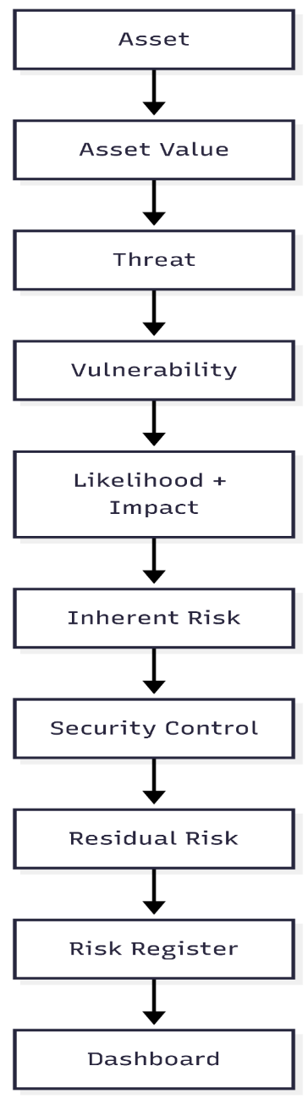
Fig 4.1: Proposed Workflow

4.4 Technologies
The proposed platform is implemented as a web-based application using frontend, backend, and database technologies. The frontend provides the interface for managing assets, threats, vulnerabilities, risk assessments, security controls, and dashboard information. The backend handles the application logic, risk calculations, and communication with the database. The database stores the assessment information in a structured manner, allowing the risk register and dashboard to be generated from the stored data.
The main technologies used in the project are:
- Frontend: Used to develop the user interface and dashboard.
- Backend: Used to implement application logic, risk calculation, and data processing.
- Database: Used to securely store asset, threat, vulnerability, risk, control, and residual risk information.
- Web Technologies: Used to provide communication between the frontend, backend, and database.
- Development Tools: Used for coding, testing, debugging, and running the application in the laboratory environment.

4.5 Expected Security Improvements
The proposed platform is expected to improve the organization’s security risk management process by providing a centralized and structured method for assessing and tracking risks. The expected improvements include:
- Better visibility of important enterprise assets and their security value.
- Systematic identification of threats and vulnerabilities affecting each asset.
- Consistent assessment of likelihood, impact, and inherent risk.
- Clear identification of suitable security controls for identified risks.
- Improved understanding of residual risk after applying security controls.
- Centralized maintenance of the risk register for easier tracking and review.
- Dashboard-based visualization of risk information for better monitoring.
- Reduced dependency on manual and scattered risk assessment records.
- Improved traceability between assets, threats, vulnerabilities, controls, and residual risks.

5. SYSTEM ARCHITECTURE

5.1 Architecture Overview
The system follows a web-based three-layer architecture consisting of the user interface, application layer, and database layer. The user interacts with the platform through the web interface to enter and manage asset, threat, vulnerability, risk, and security control information. The application layer processes the submitted information, performs risk calculations, and manages the assessment workflow. The database layer stores the assessment data and provides the information required for the risk register and dashboard.

5.2 Architecture Diagram
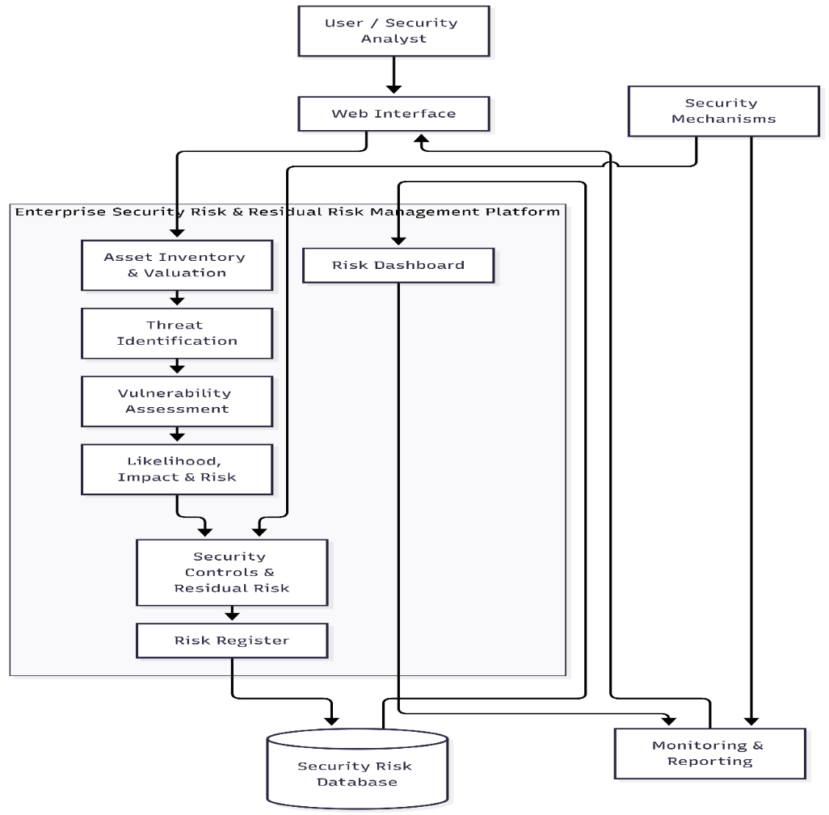
Fig 5.1: System Architecture

5.3 Data Flow
The data flow diagram (DFD) below illustrates how information moves between the user, the platform's processing stages, and its data stores as an asset progresses through the risk assessment workflow, from asset inventory and valuation through to risk register and dashboard reporting.
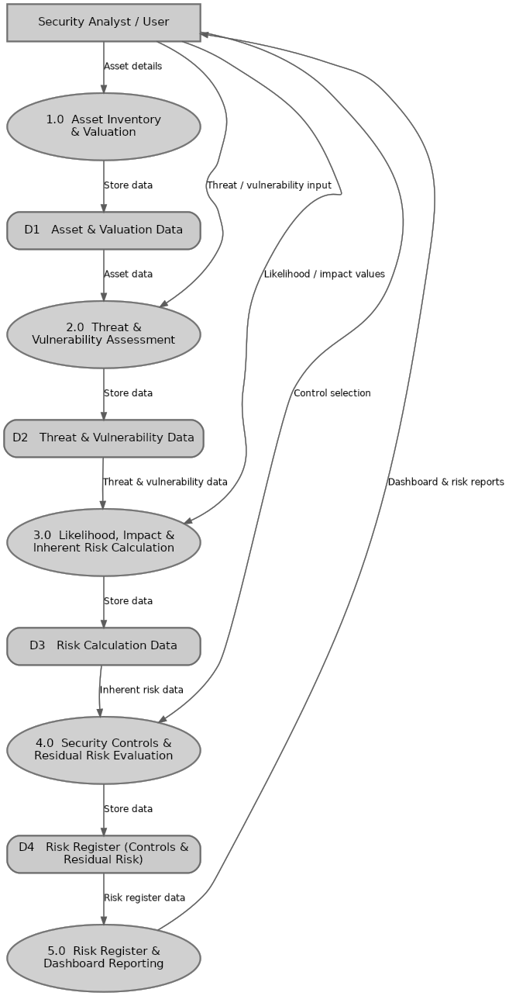
Fig 5.2: Data Flow Diagram (Level 1)

6. MODULE DESCRIPTION
The Enterprise Security Risk & Residual Risk Management Platform is divided into eight meaningful modules. Each module performs a specific function in the security risk management workflow, from identifying enterprise assets to monitoring the final residual risk through the dashboard.

6.1 Asset Inventory Module
Purpose:The Asset Inventory Module maintains a centralized record of enterprise assets that need to be assessed for security risks.
Inputs:
- Asset name
- Asset type
- Asset description
- Asset owner or relevant details
Processing:
- Records and organizes the identified assets.
- Associates each asset with its relevant security assessment information.
- Maintains asset information for further risk analysis.
Security Mechanism:
- Controlled access to asset information.
- Validation of entered asset details.
Output:
- Structured list of enterprise assets available for security assessment.

6.2 Asset Valuation Module
Purpose:The Asset Valuation Module determines the importance or value of an identified asset for security risk assessment.
Inputs:
- Selected asset
- Asset value or valuation level
- Supporting asset information
Processing:
- Records the value associated with each asset.
- Uses the asset value as supporting information during risk assessment.
Security Mechanism:
- Input validation and controlled modification of valuation information.
Output:
- Valued assets that can be considered during threat and risk analysis.

6.3 Threat Identification Module
Purpose:The Threat Identification Module identifies potential threats that may affect the selected enterprise assets.
Inputs:
- Asset information
- Asset value
- Threat details
Processing:
- Associates relevant threats with identified assets.
- Records the potential security events that may affect each asset.
Security Mechanism:
- Validation of threat information.
- Controlled access to assessment records.
Output:
- Asset-specific threat information for further assessment.

6.4 Vulnerability Assessment Module
Purpose:The Vulnerability Assessment Module identifies weaknesses associated with assets that could be exploited by identified threats.
Inputs:
- Asset
- Threat
- Vulnerability details
Processing:
- Records vulnerabilities related to assets and threats.
- Links vulnerabilities with the corresponding security assessment.
Security Mechanism:
- Input validation and controlled access to vulnerability records.
Output:
- Identified vulnerabilities associated with enterprise assets.

6.5 Likelihood and Impact Analysis Module
Purpose:This module evaluates the likelihood of a risk occurring and the potential impact on the affected asset.
Inputs:
- Asset
- Threat
- Vulnerability
- Likelihood value
- Impact value
Processing:
- Evaluates the likelihood and impact values.
- Uses these values to determine the inherent risk associated with the identified risk scenario.
Security Mechanism:
- Validated risk inputs.
- Controlled modification of assessment values.
Output:
- Likelihood, impact, and calculated inherent risk information.

6.6 Security Controls and Residual Risk Module
Purpose:This module records appropriate security controls and evaluates the remaining risk after controls are considered.
Inputs:
- Identified risk
- Inherent risk
- Security control
- Control-related assessment information
Processing:
- Associates security controls with identified risks.
- Evaluates the risk remaining after applying or considering the controls.
Security Mechanism:
- Controlled access to control and risk information.
- Validation of control and residual risk data.
Output:
- Security control information and residual risk for each assessed risk.

6.7 Risk Register Module
Purpose:The Risk Register Module provides a centralized record of the complete security risk assessment.
Inputs:
- Asset
- Threat
- Vulnerability
- Likelihood
- Impact
- Inherent risk
- Security control
- Residual risk
Processing:
- Combines the assessment information into structured risk records.
- Maintains the status and details of identified risks.
Security Mechanism:
- Controlled access and validation of risk records.
- Maintains consistency between related assessment information.
Output:
- Complete and structured enterprise security risk register.

6.8 Risk Dashboard and Monitoring Module
Purpose:The Dashboard Module provides a visual representation of the security risk information stored in the platform.
Inputs:
- Risk register data
- Inherent risk information
- Residual risk information
- Control information
Processing:
- Retrieves and organizes risk information.
- Presents relevant risk information through dashboard views and summaries.
Security Mechanism:
- Controlled access to security assessment information.
- Uses stored and validated risk data for reporting.
Output:
- Dashboard containing summarized risk information for monitoring and analysis.

7. THREAT MODEL

7.1 Threat Model Overview
The threat model identifies the important enterprise assets, possible threat sources, and security threats that may affect those assets. The proposed system uses a structured threat analysis approach based on the relationship between assets, threats, vulnerabilities, and risks. This helps in understanding how a weakness in an asset can be exploited by a threat and result in a security risk.

7.2 Important Assets
The major assets considered in the proposed system include:
- Web applications
- Databases
- Servers
- Network devices
- User accounts
- Business information
- Authentication credentials
- Configuration and system data

7.3 Possible Threat Sources
The major threat sources considered are:
- External attackers
- Malicious users
- Unauthorized users
- Malware and automated attacks
- Accidental or negligent users
- Internal security incidents
- Network-based attackers

7.4 Threats Affecting Major Assets
Table 7.1: Threats Affecting Major Assets
Asset | Possible Threat | Vulnerability | Potential Risk
Web Application | Unauthorized access | Weak authentication or access control | Unauthorized modification or data exposure
Database | Data breach | Improper access restrictions | Loss or disclosure of sensitive data
Server | Malware attack | Unpatched software or insecure configuration | Service disruption or system compromise
Network Device | Unauthorized access | Weak credentials or configuration | Network compromise
User Account | Credential theft | Weak or exposed passwords | Account takeover
Business Information | Data leakage | Improper protection or access | Confidential information exposure

7.5 Asset → Threat → Vulnerability → Risk Relationship
The relationship between asset, threat, vulnerability, and risk is used to identify and understand security risks in the system. An asset is a resource that needs protection. A threat is a possible event or activity that can affect the asset. A vulnerability is a weakness that can be exploited by the threat. When a threat exploits a vulnerability and affects an asset, it results in a security risk.
The relationship can be represented as:
Asset Threat Vulnerability Risk

8. VULNERABILITY ANALYSIS

8.1 Vulnerability Identification
Vulnerability analysis identifies weaknesses that may affect the security of enterprise assets. The identified vulnerabilities are associated with specific assets and threats and are considered during the risk assessment process.

8.2 Vulnerability Classification
Vulnerabilities can be classified according to their severity based on their potential effect on the affected asset.
- Critical – Vulnerabilities that can cause severe compromise or major data loss.
- High – Vulnerabilities that can significantly affect the confidentiality, integrity, or availability of an asset.
- Medium – Vulnerabilities that may have a moderate security impact.
- Low – Vulnerabilities with limited impact that should still be monitored and addressed.

8.3 Vulnerability Analysis Table
Table 8.1: Vulnerability Analysis
Affected Component | Vulnerability | Severity | Possible Impact | Proposed Countermeasure
Web Application | Weak authentication | High | Unauthorized access | Strong authentication and access control
Web Application | Improper input validation | High | Injection or unexpected application behavior | Input validation and sanitization
Database | Excessive access privileges | High | Unauthorized data access | Role-based access control
Server | Unpatched software | High | System compromise | Regular patching and updates
Network Device | Weak configuration | Medium | Unauthorized network access | Secure configuration and access restrictions
User Account | Weak passwords | Medium | Account compromise | Strong password policy
Business Information | Improper access protection | High | Data leakage | Access control and data protection

9. RISK ASSESSMENT

9.1 Risk Assessment Method
The risk assessment evaluates the likelihood and impact associated with each identified threat and vulnerability. The proposed system calculates inherent risk using the following method:
Inherent Risk = Likelihood × Impact

9.2 Risk Register
Table 9.1: Risk Register
Asset | Threat | Vulnerability | Likelihood | Impact | Risk | Control | Residual Risk
Web Application | Unauthorized Access | Weak Authentication | 4 | 5 | 20 | Strong Authentication | 10
Database | Data Breach | Excessive Privileges | 4 | 5 | 20 | Access Control | 10
Server | Malware Attack | Unpatched Software | 4 | 4 | 16 | Security Updates | 8
Network Device | Unauthorized Access | Weak Configuration | 3 | 4 | 12 | Secure Configuration | 6
User Account | Credential Theft | Weak Password | 3 | 4 | 12 | Password Policy | 6
Business Information | Data Leakage | Improper Access Protection | 3 | 5 | 15 | Access Restrictions | 7

9.3 Security Controls
Security controls are selected based on the identified threats and vulnerabilities. Controls may include authentication, access control, secure configuration, software updates, password policies, and data protection mechanisms. These controls are intended to reduce the likelihood or impact of identified risks.

9.4 Residual Risk
Residual risk represents the level of risk that remains after the applicable security controls are considered. The platform records the inherent risk, selected control, and resulting residual risk in the risk register. This allows the security analyst to compare the risk before and after controls and monitor the remaining exposure.

10. IMPLEMENTATION

10.1 Hardware Requirements
- Processor: Intel Core i3 or equivalent and above
- RAM: Minimum 4 GB
- Storage: Minimum 10 GB free space
- Display: Standard monitor
- Network: LAN/Wi-Fi connection where required

10.2 Software Requirements
The software requirements include the operating system, development environment, programming languages, frameworks, database, and supporting tools required to develop and test the platform.
- Operating System: Windows/Linux
- Programming Language: Based on the project implementation
- Frontend: Web-based frontend framework
- Backend: Server-side application framework
- Database: Database management system used by the project
- Code Editor: Visual Studio Code or equivalent
- Browser: Google Chrome, Microsoft Edge, or equivalent
- Version Control: Git/GitHub where applicable

10.3 Module Implementation
The Asset Inventory Module is implemented to create and maintain enterprise asset records. The Asset Valuation Module associates an appropriate value with each asset. The Threat Identification and Vulnerability Assessment Modules record threats and vulnerabilities related to the selected assets.
The Likelihood and Impact Analysis Module processes the assessment values and calculates the inherent risk. The Security Controls and Residual Risk Module records the selected controls and evaluates the remaining risk. The Risk Register stores the complete assessment, while the Dashboard presents the collected information in a summarized and easily understandable form.

11. SECURITY IMPLEMENTATION

11.1 Security Mechanisms
The platform implements security mechanisms to protect the risk assessment information and maintain the integrity of the stored data.
- Authentication: Restricts access to authorized users.
- Authorization: Controls access to available system functions.
- Access Control: Limits access to security assessment information.
- Input Validation: Validates user-provided asset, threat, vulnerability, and risk information.
- Secure Data Handling: Protects information during processing and storage.
- Session Management: Maintains controlled user sessions where applicable.
- Logging: Records relevant system activities for tracking and review.
- Monitoring: Provides visibility into risk and residual risk information through the dashboard.
- Data Backup: Supports protection and recovery of important assessment information where implemented.
The security mechanisms are applied across the platform to reduce unauthorized access, invalid input, data modification, and loss of security assessment information.

12. SECURITY TESTING

12.1 Testing Approach
Security testing is performed in an authorized and controlled laboratory environment. Testing focuses on identifying security weaknesses in the implemented platform and verifying whether the implemented controls provide the expected protection.
The testing process follows:
Security Problem → Detection / Analysis → Countermeasure → Retesting → Result

12.2 Security Test Cases
Table 12.1: Security Test Cases
Test Case | Expected Result | Actual Result | Status | Evidence
Authentication Test | Unauthorized user should be denied access | Access denied | Pass | Login Verification
Input Validation Test | Invalid input should be rejected | Invalid input rejected | Pass | Validation Verification
Access Control Test | Restricted functions should not be accessible | Access restricted | Pass | Access Control Verification
Risk Calculation Test | Correct risk value should be calculated | Inherent risk calculated accurately | Pass | Calculation Verification
Residual Risk Test | Remaining risk should be calculated after control assessment | Residual risk computed correctly | Pass | Residual Risk Verification
Data Validation Test | Incorrect or incomplete data should be handled appropriately | Incomplete data rejected with error | Pass | Data Handling Verification
The test cases confirm that unauthorized access attempts and invalid inputs are effectively mitigated by the system, verifying the functionality and integrity of the implemented security controls.

13. RESULTS AND ANALYSIS
The implemented platform provides a centralized workflow for managing enterprise security risks from asset identification to residual risk assessment. The system maintains asset information, identifies associated threats and vulnerabilities, evaluates likelihood and impact, calculates inherent risk, records security controls, and maintains residual risk information.
The risk register provides a structured view of the assessed risks, while the dashboard provides a summarized representation for monitoring and analysis. Security testing is used to verify the implemented security mechanisms and identify areas requiring improvement.

13.1 Results Table
Table 13.1: Results Table / Metrics
Metric | Before Control | After Control | Observation
Web Application Risk | 20 | 10 | Risk reduced after authentication control
Database Risk | 20 | 10 | Risk reduced after access control
Server Risk | 16 | 8 | Risk reduced after security updates
User Account Risk | 12 | 6 | Risk reduced after password policy control
Security Test Cases Passed | 0 / 6 Passed | 6 / 6 Passed | 100% test pass rate in laboratory validation
The results demonstrate a measurable reduction in risk scores across all assessed enterprise components following the application of security controls, with an overall decrease in residual risk and successful verification across all test cases.

14. CONCLUSION
The Enterprise Security Risk & Residual Risk Management Platform provides a structured solution for identifying, assessing, and managing enterprise security risks. The platform connects asset inventory, asset valuation, threat identification, vulnerability assessment, likelihood and impact analysis, inherent risk calculation, security controls, and residual risk within a centralized workflow.
The implemented risk register and dashboard provide a clear representation of the identified risks and their associated controls. Security testing in an authorized laboratory environment helps verify the implemented security mechanisms and the overall functioning of the platform. The project demonstrates how a centralized risk management approach can improve the organization and monitoring of security risk information.

15. FUTURE ENHANCEMENT
The platform can be further enhanced with additional capabilities to improve security risk assessment and monitoring. Possible future enhancements include:
- AI/ML-based risk analysis and vulnerability prioritization.
- Real-time security monitoring and risk updates.
- Cloud-based deployment for centralized access.
- Automated security incident detection and response.
- SIEM integration for security event monitoring.
- Integration with vulnerability assessment tools.
- IoT asset and risk management.
- Advanced analytics and security risk visualization.
- Automated notifications for high-risk conditions.
- Historical risk analysis and trend reporting.

16. REFERENCES
- ISO/IEC 27005:2022, Information Security Risk Management, International Organization for Standardization.
- NIST Special Publication 800-30 Rev. 1, Guide for Conducting Risk Assessments, National Institute of Standards and Technology.
- NIST, Cybersecurity Framework (CSF) 2.0
- ThalesGroup, Security Risk Assessment Tool, GitHub Repository.
- ISO/IEC 27001:2022, Information Security Management Systems — Requirements, International Organization for Standardization.
- ISO 31000:2018, Risk Management — Guidelines, International Organization for Standardization.
- NIST Special Publication 800-53 Rev. 5, Security and Privacy Controls for Information Systems and Organizations, NIST.
- NIST Special Publication 800-115, Technical Guide to Information Security Testing and Assessment, NIST.
- OWASP Foundation, OWASP Risk Rating Methodology, Open Worldwide Application Security Project.
- OWASP Foundation, OWASP Top 10:2021 — The Ten Most Critical Web Application Security Risks.
- Center for Internet Security, CIS Critical Security Controls Version 8.1.
- The Open Group, Open FAIR™ Body of Knowledge, Security and Risk A
- MITRE Corporation, MITRE ATT&CK® Framework, Adversarial Tactics, Techniques and Common Knowledge.
- NIST, NIST Privacy Framework: A Tool for Improving Privacy through Enterprise Risk Management, Version 1.0.
- NIST, Cybersecurity Framework Resource Center, National Institute of Standards and Technology.

