VOLUNTEERHUB
Volunteer & Social Service Activity Management Portal
PROJECT DOCUMENTATION
CodeFusion 2026

Project Information | Details
Project Name | VolunteerHub
Project Type | Web-based Volunteer & Social Service Activity Management Portal
Primary Roles | Admin, Organizer / Staff, Volunteer / User
Frontend | React (Next.js App Router), Tailwind CSS, shadcn/ui
Backend | Next.js API Routes / Node.js
Database & Authentication | Supabase (PostgreSQL, Row-Level Security, Realtime, Storage)
Deployment | Vercel
Version | 1.0
Prepared By | Team - FusiO(n) Squad
Institution | Bannari Amman Institute of Technology

Document Control
Field | Entry
Document Title | VolunteerHub Project Documentation
Project | Volunteer & Social Service Activity Management Portal
Date | 1 August 2026

Repository & Project Links:
Vercel Link: https://impact-pulse-final.vercel.app/
GitHub Link: https://github.com/bharani-thangavel/ImpactPulse

Project UI – Front Page :

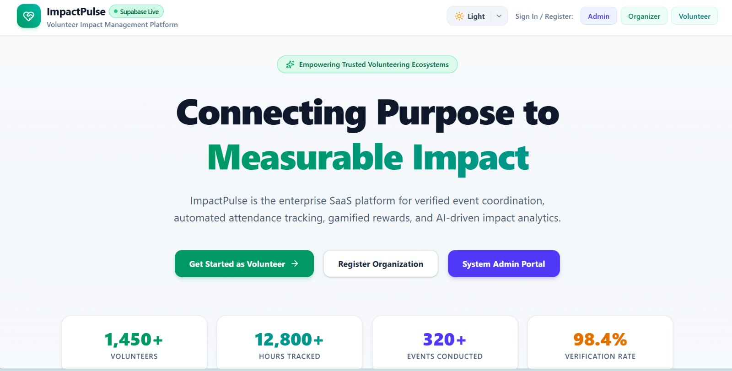

1. Project Overview
VolunteerHub is a web-based Volunteer and Social Service Activity Management Portal designed to centralize and digitize the lifecycle of volunteering activities. The system supports administrators, organizers/staff, and volunteers/users through role-specific workflows for event creation, approval, registration, attendance, leadership selection, notifications, feedback, points, badges, and reporting.
The platform is intended to reduce manual paperwork and communication delays while improving transparency, accountability, collaboration, and the overall volunteering experience.

1.1 Project Summary
Aspect | Description
Problem Domain | Volunteer and social service activity management
Core Approach | Centralized role-based web portal
Main Workflow | Create → Approve → Publish → Register → Participate → Track → Recognize
Primary Roles | Admin, Organizer / Staff, Volunteer / User
Key Differentiators | Leadership workflow, skill tagging, slot-based signups, waitlists, recurring activities, digital consent, points and badges

1.2 Project Abstract
VolunteerHub provides a centralized platform for managing social service and volunteering activities. It replaces fragmented manual processes with role-based digital workflows. Administrators can oversee organizers and events, organizers can create and manage activities and select leaders, and volunteers can discover activities, register, monitor participation, and receive recognition through points and badges. The system also provides notification, feedback, and reporting capabilities to improve institutional visibility.

2. Problem Statement
The existing volunteering process can involve manual records, fragmented communication, and limited visibility into event availability and participation. VolunteerHub addresses these limitations by digitizing the complete activity-management lifecycle.

2.1 Major Problems Identified
- Manual, paper-based tracking of volunteer activities and attendance.
- No centralized system for approving events or organizers.
- Lack of real-time visibility into available activities and seat capacity.
- No structured way to recognize or reward volunteer contribution.
- Absence of analytics/reporting for institutional accountability.

2.2 Proposed Solution
VolunteerHub introduces a centralized portal that connects administrators, organizers, and volunteers. It streamlines event creation and approval, registration, attendance tracking, leadership selection, notifications, feedback, recognition, and reporting.

3. Objectives
- Simplify volunteer registration and participation.
- Enable organizers to efficiently create and manage events.
- Provide administrators with centralized approval and monitoring capabilities.
- Maintain accurate attendance and participation records.
- Recognize volunteers through points, badges, and certificates.
- Improve communication through real-time notifications.
- Generate reports and analytics for better decision-making.

4. Target Users & Roles
Role | Access Level | Primary Capabilities
Admin | System-wide | Approve/decline events and organizers; search organizer and volunteer lists; audit and oversee platform activity.
Organizer / Staff | Event-scoped | Create events; manage ongoing events and history; select team leaders; view member and leader details.
Volunteer / User | Self-scoped | Browse and register for activities; track attendance and history; view profile, badges, points; receive notifications.

5. Scope of the System
The documented scope includes the following major areas:
- Role-based registration, authentication, and access control.
- Organizer and event approval workflows.
- Event creation, publishing, ongoing-event management, completion, cancellation, and archival lifecycle.
- Slot/shift-based volunteer signups and seat-capacity tracking.
- Volunteer registration and attendance tracking.
- Leadership application and selection.
- Skill tagging for volunteers and activity requirements.
- Waitlists and auto-promotion when capacity becomes available.
- Recurring activities.
- Digital consent/waiver forms.
- Notifications, feedback, points, badges, certificates, and participation history.
- Administrative search, monitoring, reports, and analytics.

6. Functional Requirements
ID | Requirement | Description
FR-01 | User registration and role-based authentication | Users can register and access role-specific functionality.
FR-02 | Event creation and management | Organizers can create and manage volunteering events.
FR-03 | Event approval | Administrators can approve or decline events.
FR-04 | Event registration | Volunteers can browse and register for available events.
FR-05 | Attendance tracking | Organizers/assigned leaders can mark attendance.
FR-06 | Leadership application and approval | Volunteers can apply for leadership and selected leaders can be assigned.
FR-07 | Notifications | Users can receive activity-related notifications.
FR-08 | Feedback | Participants can submit comments and ratings.
FR-09 | Rewards | Volunteer points and badges can be maintained.
FR-10 | Administration | Admins can manage users, events, and reports.

7. Non-Functional Requirements
ID | Category | Requirement
NFR-01 | Performance | Fast response and support for concurrent users.
NFR-02 | Security | Secure authentication and role-based access.
NFR-03 | Reliability | Accurate and consistent data handling.
NFR-04 | Usability | Responsive and user-friendly interface.
NFR-05 | Scalability | Support future growth in users and events.
NFR-06 | Maintainability | Modular and well-structured architecture.

8. Technology Stack
Layer | Technology | Purpose
Frontend | React + Next.js App Router | Build responsive role-specific interfaces.
UI | Tailwind CSS + shadcn/ui | Styling and reusable UI components.
Backend | Next.js API Routes / Node.js | Business logic and API endpoints.
Database | Supabase PostgreSQL | Store users, events, registrations, notifications, feedback, and rewards.
Authentication | Supabase Auth / role-based access | Secure sign-in and authorization.
Security | Row-Level Security | Restrict data access according to roles and ownership.
Realtime | Supabase Realtime | Real-time updates/notifications.
Storage | Supabase Storage | File/storage support where required.
Email | Resend / Nodemailer | Email notifications.
Deployment | Vercel | Deploy the web application.

9. System Architecture & Design
The system follows a web application architecture in which the Next.js frontend communicates with backend API routes/Node.js services and Supabase provides PostgreSQL database, authentication, Row-Level Security, Realtime, and Storage capabilities.

9.1 Role-Based Architecture
Role | Main Flow
Admin | Login → Admin Dashboard → Approve organizers/events → Search users → Monitor activities → Reports/Oversight
Organizer | Signup → Admin Approval → Organizer Dashboard → Create Event → Manage Event → Select Leader → Track Attendance
Volunteer | Signup → Volunteer Dashboard → Browse Activities → Register/Waitlist → Attend → Feedback → Points/Badges/History

10. User Workflows

10.1 Volunteer / User Signup Flow
- User provides credentials such as email and password.
- User enters interest/profile information such as name, age, and other requirements.
- User indicates interest in leadership or direct volunteering.
- Leadership interest is routed through an approval workflow.
- Direct volunteering routes the user into the Volunteer role.
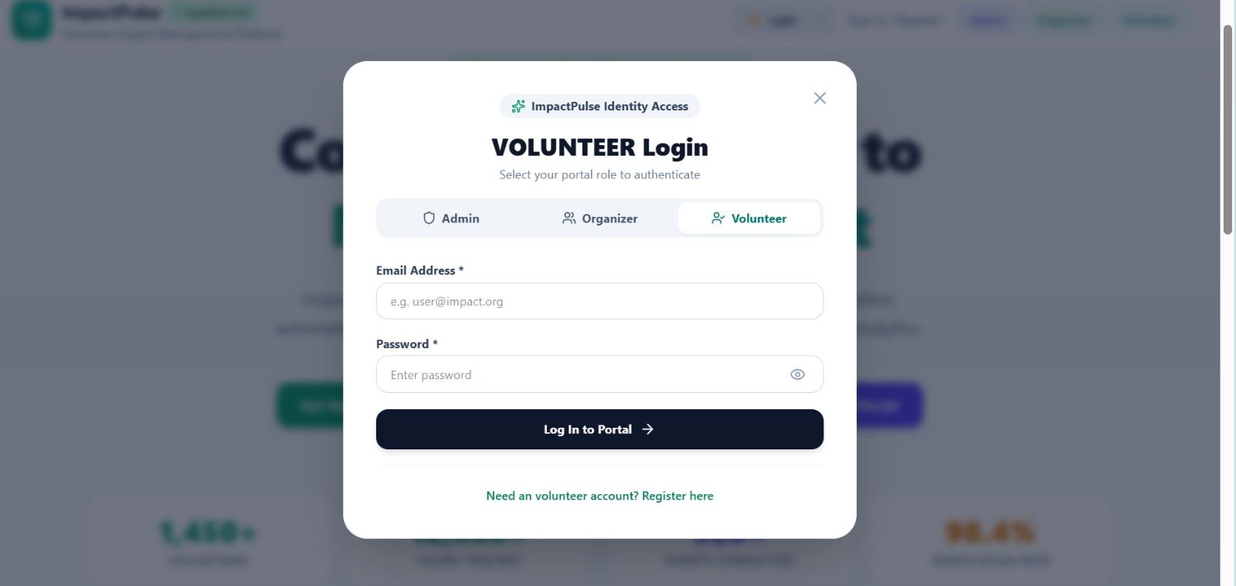

10.2 Organizer Signup Flow
- Organizer provides credentials.
- Organizer submits organizational information such as registration number, department, and year.
- Application is routed to Admin for approval.
- After approval, the organizer receives access to the Organizer Dashboard.
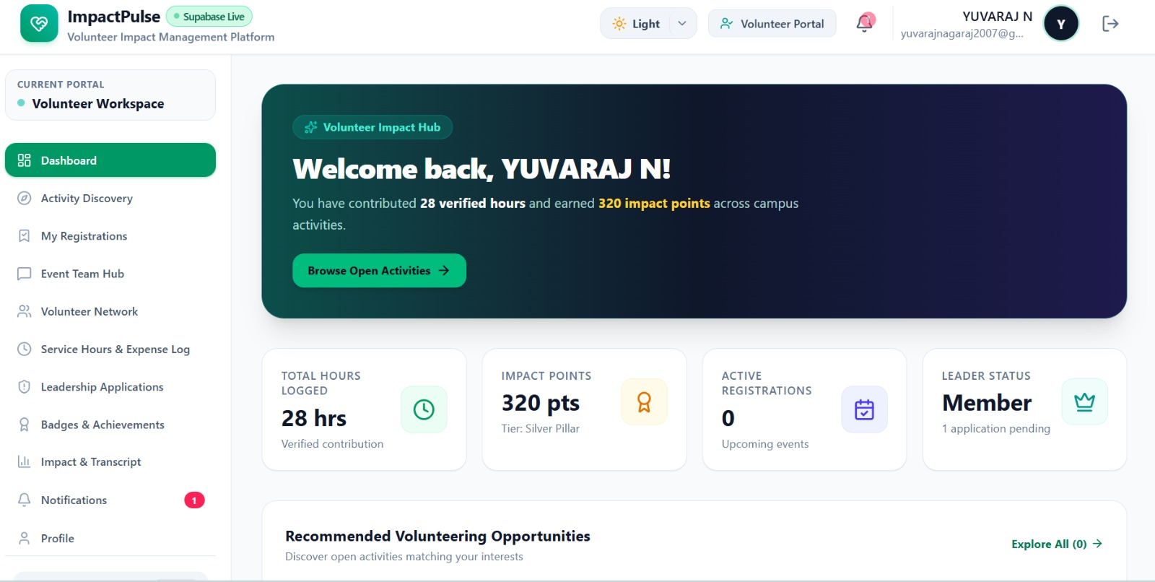

10.3 Event Participation Flow
- Organizer creates an event.
- Admin approves the event where required.
- Event becomes available to volunteers.
- Volunteer selects an available activity/slot and registers.
- If capacity is reached, the volunteer may be placed on a waitlist.
- Attendance is recorded during the event.
- Participation can result in feedback, points, badges, and certificates.

11. Module & Feature Documentation

11.1 Authentication & Role Management
- Registration and login.
- Role-based access for Admin, Organizer/Staff, and Volunteer/User.
- Approval status for organizer and applicable user workflows.
- Secure authentication and authorization.

11.2 Organizer Dashboard
Tab | Features
Create Event | Title, description, members required, timing/date, duration, venue, contact details, points rewarded, available seats.
My Events | Ongoing events with member/leader details; history of past events and event status.
Leader Selection | View leadership applicants for organizer events and assign selected volunteers as leaders.

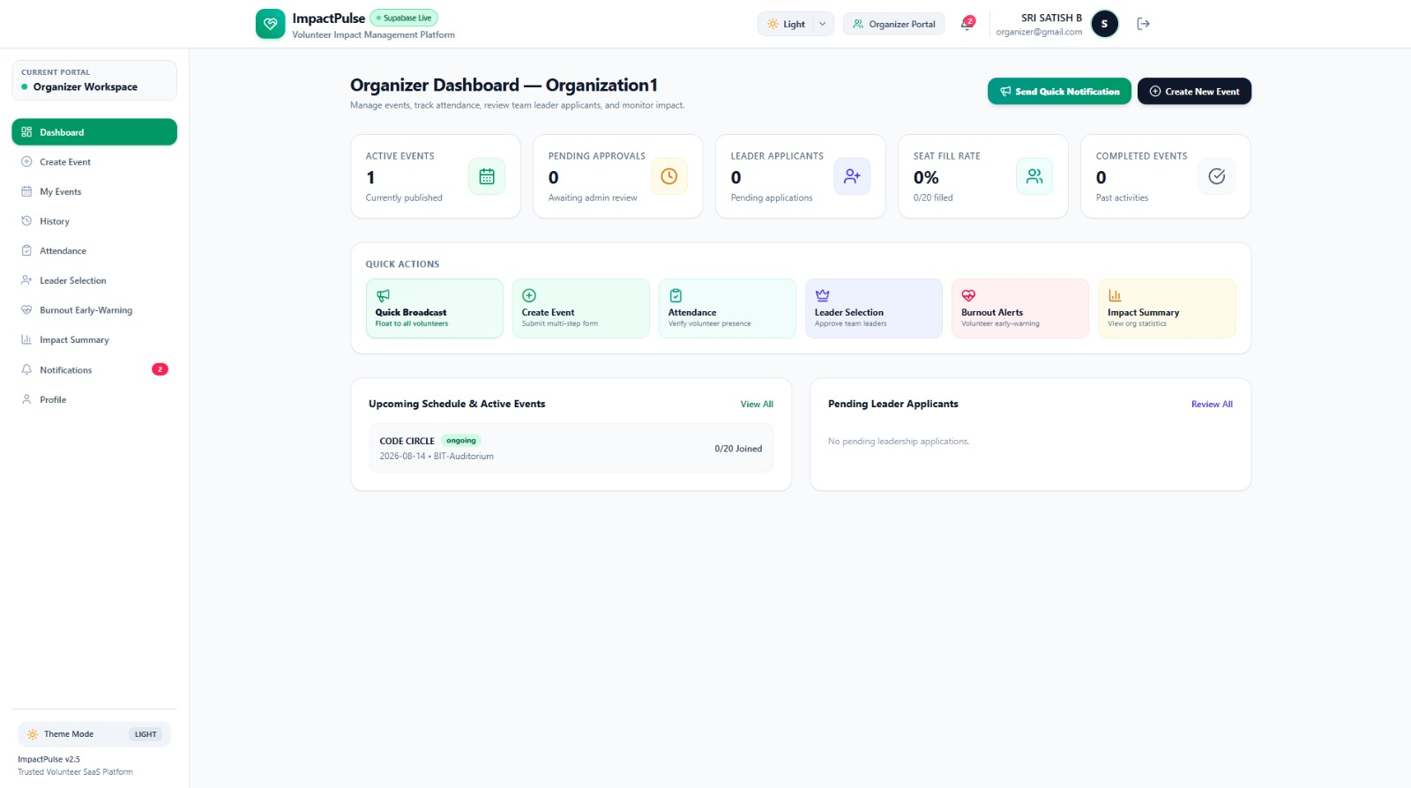

11.3 Admin Dashboard
Tab | Features
Event List | View current events, approve/decline pending events, and track event status.
Organizer's Tab | Searchable list of organizers and their credentials.
Volunteer's Tab | Searchable list of volunteers and their credentials.

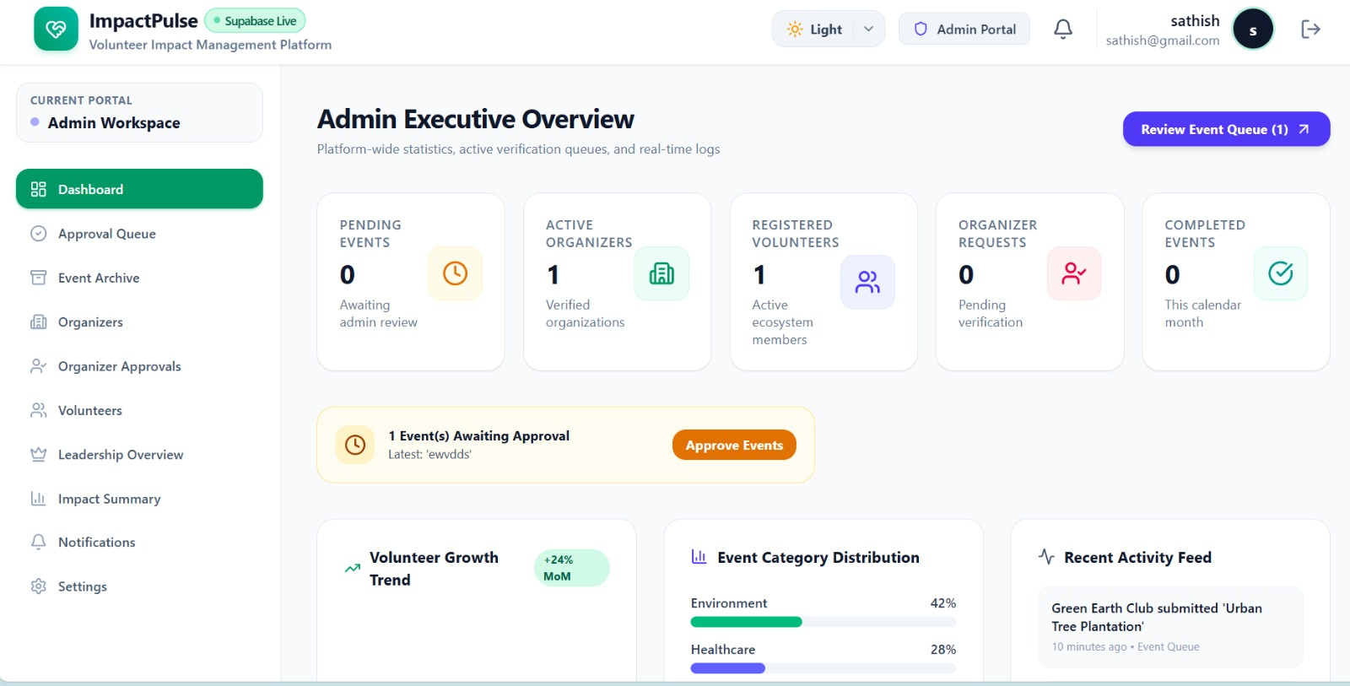

11.4 Volunteer / User Dashboard
Tab | Features
Homepage | Floating task shortcuts, notification feed, points summary widget.
Booking | Available activities, registration, history, and attendance records.
Profile | Personal details, badges, total points, member-since date, and total volunteering hours.



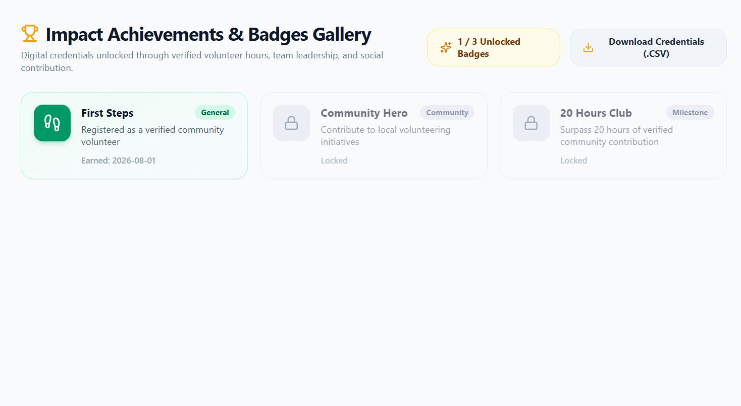

12. Database Design
The core entities specified for the platform are:
Entity | Key Fields / Purpose
Users | id, name, email, password_hash, role, age, reg_no, department, year, status
Events | id, organizer_id, title, description, members_required, timing, date, duration, venue, contact_details, points_rewarded, status, available_seats
Registrations | id, event_id, user_id, registration_date, attendance_status, role_in_event
LeadershipApplications | id, user_id, event_id, status, badge_awarded
Notifications | id, user_id, message, type, is_read, created_at
Feedback | id, event_id, user_id, comments, rating
Badges/Points | id, user_id, total_points, member_since, badges_earned

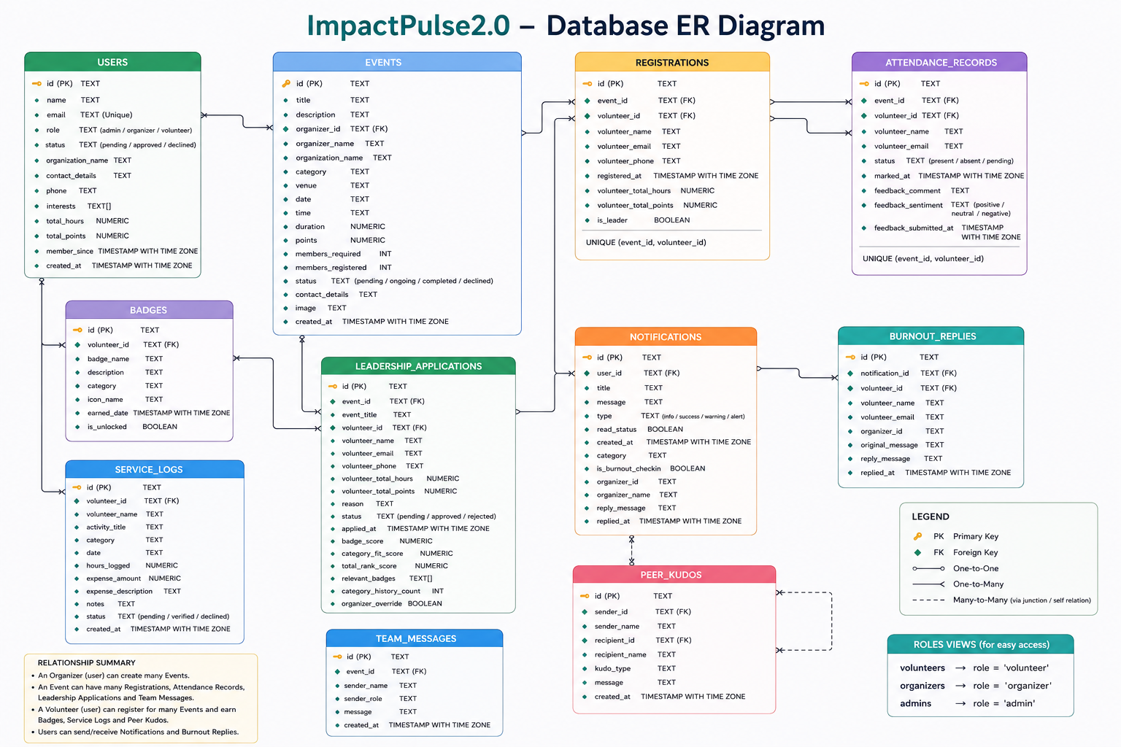

12.1 Database Screenshot / Supabase Evidence
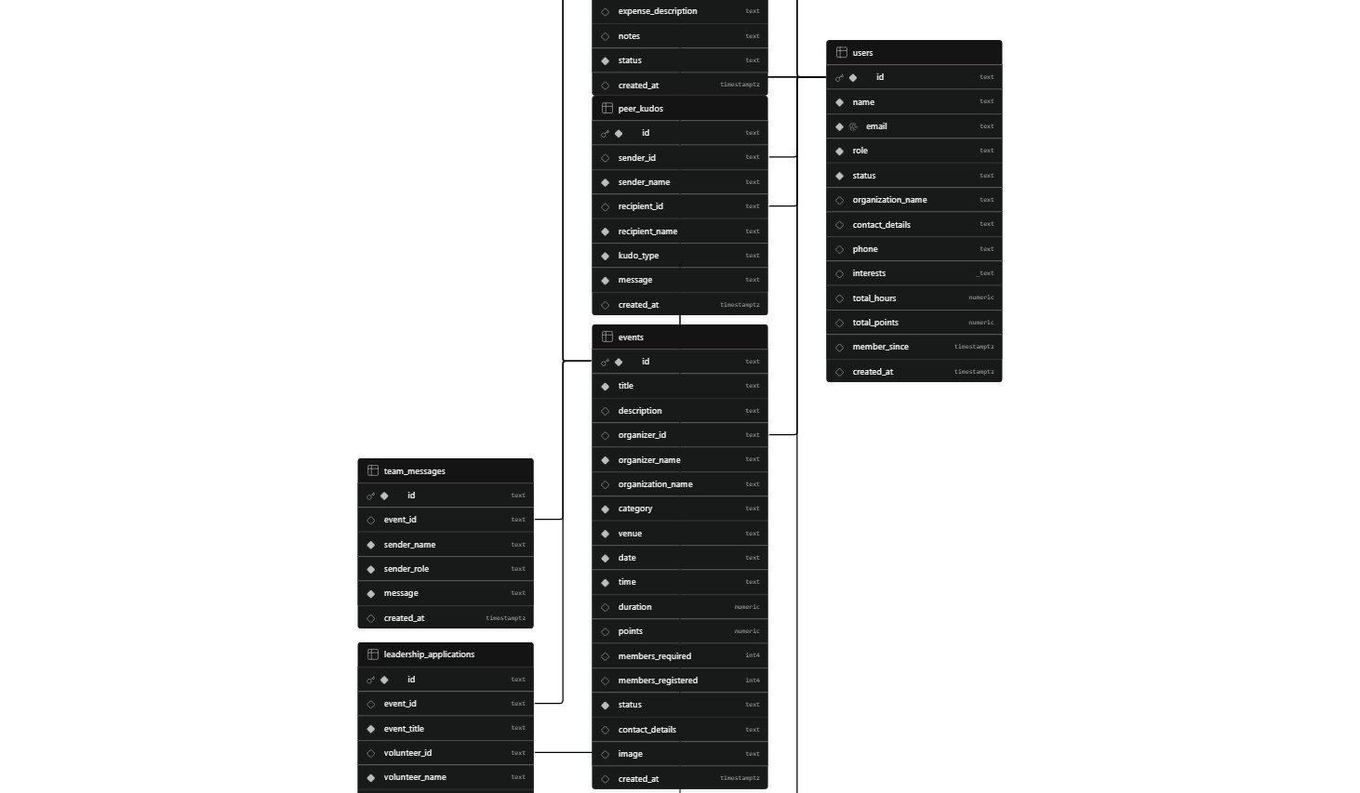

13. API Documentation
Module | Method | Endpoint | Purpose
Authentication | POST | /api/auth/signup | Register a new user with role-based access.
Authentication | POST | /api/auth/login | Authenticate user and generate access token.
Events | GET | /api/events | Retrieve events with optional filters.
Events | POST | /api/events | Create a new event (Organizer).
Events | PATCH | /api/events/:id/status | Approve, decline, or cancel an event (Admin).
Registration | POST | /api/events/:id/register | Register a volunteer for an event.
Attendance | PATCH | /api/events/:id/attendance | Mark volunteer attendance.
Leadership | POST | /api/leadership/apply | Submit a leadership application.
Leadership | PATCH | /api/leadership/:id/approve | Approve/reject leadership application.
Notifications | GET | /api/notifications | Retrieve notifications for authenticated user.
Admin | GET | /api/admin/organizers | Retrieve/search organizer records.
Admin | GET | /api/admin/volunteers | Retrieve/search volunteer records.

13.1 API Testing Evidence
[ API TESTING SCREENSHOT ]
Insert Postman/Thunder Client/API client screenshots showing successful requests and responses.
Replace this placeholder with the actual project image/screenshot before final submission.
API Collection / Documentation Link: [Paste link here]

14. UI / UX Documentation
This section is reserved for documenting the final user interface. Add screenshots of each completed screen and briefly describe what the user can do on that screen.
Screen | Screenshot | UI Description
Login Page | [Insert screenshot] | [Describe login/authentication behavior]
Volunteer Signup | [Insert screenshot] | [Describe onboarding fields and choices]
Organizer Signup | [Insert screenshot] | [Describe organization details and approval flow]
Admin Dashboard | [Insert screenshot] | [Describe event/user oversight]
Organizer Dashboard | [Insert screenshot] | [Describe event management and leader selection]
Volunteer Homepage | [Insert screenshot] | [Describe notifications, shortcuts, points]
Booking Page | [Insert screenshot] | [Describe event discovery and registration]
Profile Page | [Insert screenshot] | [Describe profile, badges, points, hours]

15. Testing & Validation
Record the major test cases used to verify the implemented system.
ID | Test | Input / Condition | Expected Result | Status
TC-01 | Valid login | Correct credentials | User reaches correct role dashboard | Pass / Fail
TC-02 | Invalid login | Incorrect credentials | Error message shown; access denied | Pass / Fail
TC-03 | Organizer event creation | Valid event details | Event is created and enters expected workflow | Pass / Fail
TC-04 | Admin event approval | Pending event | Admin can approve/decline event | Pass / Fail
TC-05 | Volunteer registration | Open event with seats | Registration succeeds and seat count updates | Pass / Fail
TC-06 | Attendance tracking | Registered volunteer | Attendance status is recorded | Pass / Fail
TC-07 | Leadership workflow | Leadership application | Application can be reviewed/approved | Pass / Fail
TC-08 | Notifications | User activity | Relevant notification is delivered/displayed | Pass / Fail
TC-09 | Profile rewards | Completed participation | Points/badges/history reflect expected result | Pass / Fail
TC-10 | Role access | Different user roles | Unauthorized role cannot access restricted features | Pass / Fail

16. Innovation / Novelty
- Role-based workflow mirrors institutional processes and supports transparency and accountability.
- Leadership application and approval creates a growth path for volunteers beyond simple event registration.
- Points, badges, and volunteering-hour tracking provide a gamified recognition layer.
- Shift/slot-based signups allow volunteers to select specific time slots.
- Skill tagging can connect volunteer capabilities with activity requirements.
- Waitlists can automatically promote volunteers when capacity becomes available.
- Recurring activities can be managed without recreating the same event each time.
- Digital consent/waiver forms support institutional and compliance-oriented workflows.
- The planned AI/analytics layer can support intelligent matching and reporting as the project evolves.

17.1 Innovation Evidence
[ INNOVATION / ANALYTICS SCREENSHOT ]
Insert the implemented innovative feature, analytics view, or AI-assisted feature here.
Replace this placeholder with the actual project image/screenshot before final submission.

18. Future Enhancements
- Expand intelligent volunteer-to-activity matching based on skills and interests.
- Enhance analytics dashboards for institutional reporting.
- Add richer certificate generation and verification.
- Expand recurring event automation and scheduling.
- Integrate additional institutional systems where appropriate.
- Improve notification channels and configurable reminders.

19. Team Details
Member | Reg. No.
Bharani T | 7376252AD131
Yaswanth Kalis P | 7376252AD377
Sri Satish B | 7376252AD342
Yuvaraj N | 7376252AD380

20. Conclusion
VolunteerHub digitizes the volunteer management lifecycle from event creation and approval through discovery, registration, attendance, leadership selection, feedback, and recognition. The role-based architecture provides a clear separation of responsibilities between administrators, organizers, and volunteers while supporting transparency and efficient collaboration. The project documentation can be updated with the final implementation screenshots, GitHub links, API evidence, database evidence, and deployment details before submission.
Final GitHub Link: https://github.com/bharani-thangavel/ImpactPulse

