Department of Artificial Intelligence and Machine Learning
Object Oriented Programming through C++ (2501CS08)
STUDENT ATTENDANCE MANAGEMENT SYSTEM
CERTIFICATE

BATCH NUMBER – 02
SUBMITTED BY

ORSU LEELA BHARANI — 25B11AI860
BATHULA N S L DURGA RISHITHA — 25B11AI103
GONDYALA SRIRAM PRAKHYATH — 25B11AI357
ELUBANDI MANIKANTA — 26B21AI027

In partial fulfilment of the requirements for the award of the B.Tech. degree in Artificial intelligence and machine learning the academic year 2026-2027.

Project Guide Head of the Department
Thorati Vijaya Lakshmi, Dr. K. Naga Bhargavi, Ph.D,
Assistant Professor, Associate Professor & HOD,
Department of AIML. Department of AIML.

CERTIFICATE
This is to certify that the cornerstone project entitled “STUDENT ATTENDANCE MANAGEMENT SYSTEM” is being submitted by ORSU LEELA BHARANI 25B11AI860 ,BATHULA N S L DURGA RISHITHA 25B11AI103, GONDYALA SRIRAM PRAKHYATH 25B11AI357 and ELUBANDI MANIKANTa 25B11AI027 in partial fulfilment for the award of B. Tech Degree from Aditya University, is a record of original work done by them under my supervision. The contents of this project, in full or in parts, have not been submitted to any other Institute or University for the award of any degree or diploma.

Project Guide
T.VIJAYALAKSHMI, M.Tech
Assistant Professor
Department of Artificial Intelligence and Machine Learning
Aditya University

DECLARATION

We hereby declare that the Cornerstone project work entitled “STUDENT ATTENDANCE MANAGEMENT SYSTEM” is being submitted by us for the award of the B. Tech Degree in Artificial Intelligence and Machine Learning, Aditya University, Aditya Nagar, ADB Road, Surampalem, and is a record of original work carried out by us. We further declare that this project work has not been submitted, either in full or in part, for the award of any degree or diploma in this or any other institution. We also confirm that this work has been carried out with academic honesty and complies with the Institutional Academic Integrity and AI Usage Policy.

Submitted By
ORSU LEELA BHARANI 25B11AI860
BATHULA N S L DURGA RISHITHA 25B11AI103
GONDYALA SRIRAM PRAKHYATH 25B11AI357
ELUBANDI MANIKANTA 25B11AI027

Place: Surampalem
Date: ____________________

ACKNOWLEDGEMENT

It is with immense pleasure that we express our sincere gratitude to our Cornerstone Project Guide, , T.VIJAYALAKSHMI, M.Tech ,Assistant Professor, who has guided us throughout the project. Valuable support, encouragement, and guidance have greatly contributed to the successful completion of this work.
We would like to thank our Deputy Heads of the Department, Dr. R. Suneetha, Assistant Professor, Dr.Bollu ManikyalaRao, Associate Professor ,Dr.D.Veeraswamy,Assistant Professor Department of AIML, for their support and valuable suggestions.
Our deepest thanks to our Head of the Department Dr. . K.Naga Bhargavi, Associate Professor,
for her inspiration and for providing all the necessary facilities and resources required for this project.
We also extend our sincere thanks to Dr. M.V. Rajesh, Associate Dean, School of Computing for their encouragement and support during the course of our project.
We would like to express our sincere gratitude to Dr. G. Suresh, Registrar, Dr. A Ramesh, Pro Vice-Chancellor (Engineering & Sciences), Dr.S. Rama S r e e , Pro Vice-Chancellor (Academics), D r . M.B. Srinivas, V i c e -Chancellor, Dr. M. Sreenivasa Reddy, Deputy Pro Chancellor and Management, Aditya University for providing excellent infrastructure and state-of-the-art laboratories.
Finally, we would like to thank the faculty members, lab technicians, non-teaching staff, and our friends who have directly or indirectly supported us in completing this Cornerstone project successfully

ORSU LEELA BHARANI 25B11AI860
BATHULA N S L DURGA RISHITHA 25B11AI103
GONDYALA SRIRAM PRAKHYATH 25B11AI357
ELUBANDI MANIKANTA 25B11AI027
Date: ____________________

ABSTRACT

The Student Attendance Management System is a menu-driven C++ application designed to automate basic student attendance operations. The system replaces manual attendance registers with structured digital operations for student registration, attendance marking, attendance-status viewing, student search, attendance percentage calculation, low-attendance identification and attendance-history storage.
The implementation uses object-oriented programming concepts including classes, inheritance, polymorphism, encapsulation, abstraction and file handling. A base Person/Student structure is used to organize student information, while the AttendanceSystem class coordinates student records, attendance marking, percentage calculation, reports and persistent storage.
The system maintains student details such as roll number, name, class/section and attendance count. Faculty can mark students as Present or Absent, view attendance status, search for a student, calculate attendance percentage and identify students whose attendance is below a defined threshold. Completed attendance records can be stored in text files for later reference. Input validation is included for menu choices, attendance status and numeric values.

ABBREVIATIONS

Abbreviation | Meaning
OOP | Object-Oriented Programming
C++ | C++ Programming Language
UI | User Interface
I/O | Input / Output
ID | Identification
CSV | Comma-Separated Values
TXT | Plain Text File
PBL | Project Based Learning
API | Application Programming Interface

LIST OF FIGURES

Figure 1 – Overall System Architecture
Figure 2 – Class / OOP Structure
Figure 3 – Student Registration and Attendance Flow
Figure 4 – Attendance Marking Flow
Figure 5 – Attendance Percentage and Report Flow
Figure 6 – Attendance History File Handling
Figure 7 – Main Menu and Student Registration
Figure 8 – Attendance Marking – Present and Absent
Figure 9 – Duplicate Student, Invalid Input and Validation Messages
Figure 10 – Attendance Status Display
Figure 11 – Student Search – Found and Not Found
Figure 12 – Attendance Percentage and Low-Attendance Report
Figure 13 – Attendance History Display
Figure 14 – Menu Input Validation and Program Exit

LIST OF TABLES

Table 1 – Planned Modules / Functions
Table 2 – OOP Concepts and Their Use in the Code
Table 3 – Main Classes and Responsibilities
Table 4 – Attendance Status Rules
Table 5 – Key Functions of the Program
Table 6 – System Inputs and Outputs
Table 7 – Test Cases and Observed Results
Table 8 – Team Members and Responsibilities

TABLE OF CONTENTS
S. No. | Contents | Page No.
1 | Title Page | I
2 | Certificate | II
3 | Declaration | III
4 | Acknowledgement | IV
5 | Abstract | V
6 | Abbreviations | VI
7 | List of Figures | VII
8 | List of Tables | VIII
9 | Table of Contents | IX-X
10 | CHAPTER 1 – Project Planning | 1
1.1 | Problem Statement | 1
1.2 | Project Objectives | 1
1.3 | Planned Modules | 1
1.4 | System Architecture (Algorithm & Flowchart) | 2
2 | CHAPTER 2 – Project Implementation | 8
2.1 | OOP Concepts Used for Implementation | 8
2.2 | Code | 9
2.3 | Output Screens | 21
2.4 | Test Cases | 25
3.1 | CHAPTER 3 – Conclusion & Future Scope | 26
12.1 | Conclusion | 26
12.2 | Future Scope | 26
13 | References | 27
14 | Appendix – Team Members and Responsibilities | 28

CHAPTER 1
PROJECT PLANNING

1.1 Problem Statement
Manual attendance management often depends on paper registers or scattered spreadsheets. This makes it difficult to maintain accurate attendance records, search for individual students, calculate attendance percentages and identify students with low attendance. Repeated manual calculations can also lead to errors, delays and incomplete records.
The project addresses these issues by providing a centralized console-based system that stores student details, records daily attendance, displays attendance status, searches for students, calculates attendance percentages and generates attendance reports. Attendance records can be stored in a history file so that completed records remain available for later reference.

1.2 Project Objectives
- Provide a centralized system to manage student registration and attendance.
- Store student roll number, name, class/section and attendance information.
- Allow faculty to mark students as Present or Absent.
- Display the current attendance status of students.
- Search for an individual student using the roll number.
- Calculate attendance percentage automatically.
- Identify students whose attendance is below the defined minimum threshold.
- Store attendance records using file handling.
- Validate menu choices and numeric inputs and prevent duplicate student records.

1.3 Planned Modules
The system is divided into seven modules. Each module is implemented as one or more member functions of the classes described in Chapter 2.
Module | Function | Main Operations
Student Registration | Records student information. | Roll number, name, class/section, registration
Student Management | Maintains student records. | Add, update and locate students
Attendance Marking | Records daily attendance. | Present / Absent status
Attendance Status | Displays current attendance. | Student-wise attendance details
Student Search | Locates a student. | Search by roll number
Percentage & Report | Calculates attendance and identifies low attendance. | Percentage, eligibility/status
Attendance History | Stores and displays attendance records. | saveHistory(), showHistory(), attendance_history.txt

1.4.1 Three-Layer Architecture
The system follows a three-layer logical architecture. The Presentation Layer is the console menu implemented in main(), together with input-validation functions. The Business Logic Layer contains Student, AttendanceRecord and AttendanceSystem classes that perform registration, attendance marking, search, calculation and reporting. The Data Layer consists of student records held in memory and a persistent attendance history file that stores completedattendanceentries. 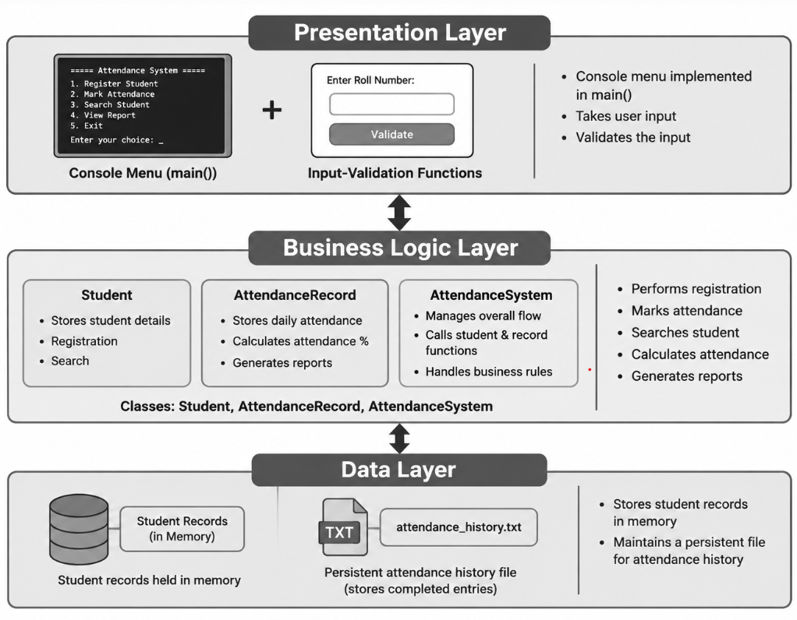

Figure 1 – Overall System Architecture

1.4.2 Overall Processing Flow
The program starts, displays the main menu and accepts a validated menu choice. It executes Student Registration, Mark Attendance, Attendance Status, Student Search, Attendance Report or Attendance History as selected, returns to the menu after each operation and repeats until the user selects Exit Program.

1.4.3 Student Registration Algorithm
1. Check whether the maximum configured number of students has been reached. If it is, display “Student capacity is full!” and return.
2. Read the student roll number and compare it with all registered students. If a duplicate exists, display “Student already exists!” and return.
3. Read the student name and class/section.
4. Create a Student object and initialize total classes and attendance count to zero.
5. Store the student object in the student list and increase the student count.
6. Display the registration confirmation and student details.
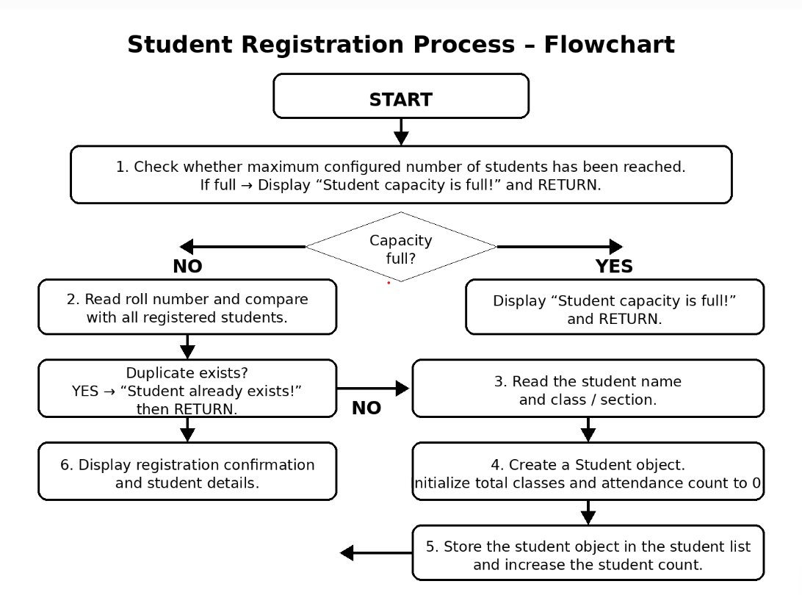
Figure 3 – Student Registration and Attendance Flow

1.4.4 Attendance Marking Algorithm
1. Read the roll number or select the student from the registered list.
2. Locate the student. If no matching student exists, display “Student not found.” and return.
3. Read the attendance status, where 1 = Present and 2 = Absent, repeating until a valid choice is entered.
4. Increase total classes by one. If the status is Present, increase the present count by one.
5. Store the attendance entry in the attendance history file.
6. Display the updated attendance information. 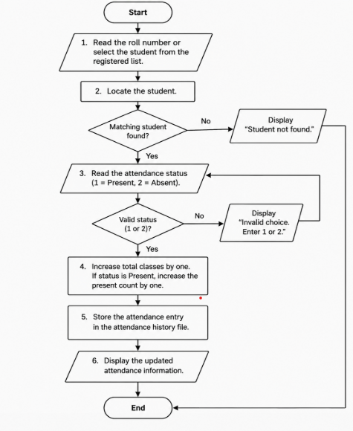

Figure 4 – Attendance Marking Flow

1.4.5 Attendance Percentage and Report Algorithm
1. For each registered student, read total classes and present count.
2. Calculate attendance percentage as (present count / total classes) × 100.
3. Compare the percentage with the configured minimum attendance threshold.
4. Display the percentage and attendance status such as Eligible / Low Attendance.
5. Return to the main menu.
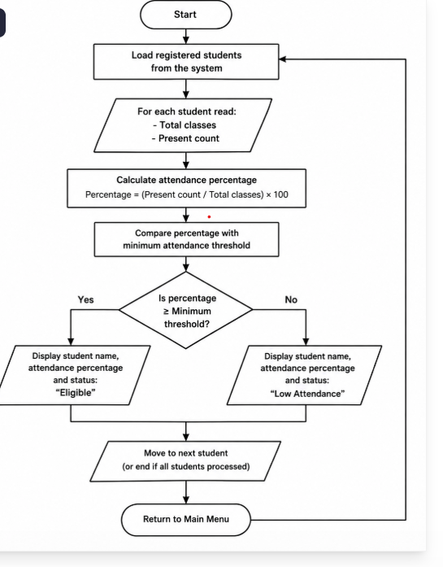
Figure 5 – Attendance Percentage and Report Flow

1.4.6 Student Search Algorithm
1. Read the roll number to be searched.
2. Scan the student list. If a matching roll number is found, display the student's name, class/section, total classes, present count, absent count and attendance percentage.
3. If no student matches, display “Student not found.”

1.4.7 Attendance History Algorithm
1. Attempt to open attendance_history.txt for reading.
2. If the file cannot be opened, display “No attendance history available.” and return.
3. Otherwise print the history heading and read the file line by line.
4. When the end of the file is reached, close the file and return to the menu. 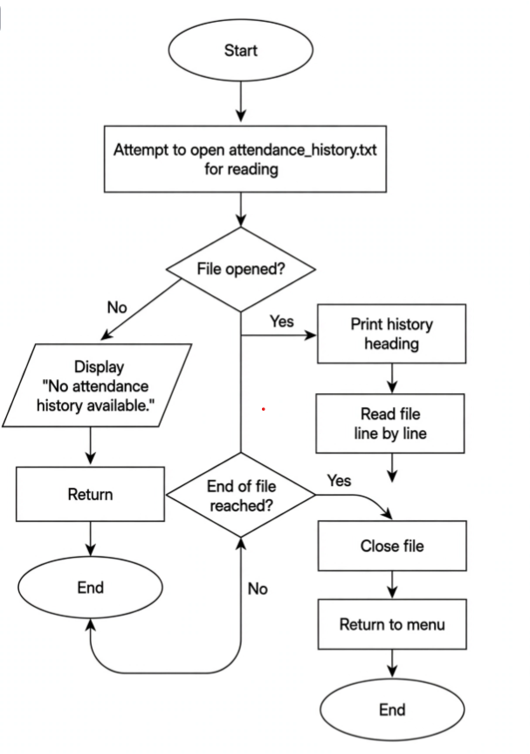

Figure 6 – Attendance History File Handling

CHAPTER 2
PROJECT IMPLEMENTATION

2.1 OOP Concepts Used for Implementation
The program is written in C++ and is organized around Student, AttendanceRecord and AttendanceSystem classes. The following table summarizes the object-oriented concepts used in the implementation.
Concept | Use in the project
Class and object | Student, AttendanceRecord and AttendanceSystem are classes; an AttendanceSystem object is created in main().
Encapsulation | Student and system data members are kept private and accessed through public member functions.
Abstraction | The AttendanceSystem class hides the internal details of registration, attendance marking, calculation and file operations.
Inheritance | Optional specialized student/category classes can inherit common student information when required.
Polymorphism | Attendance operations can be extended through virtual functions for different attendance policies or student categories.
Constructors | Constructors initialize student records, attendance counters and system data.
Composition / aggregation | AttendanceSystem contains and manages a collection of Student objects and attendance records.
File handling | ofstream writes attendance transactions and ifstream reads the attendance history.
Input validation | cin.fail(), cin.clear() and cin.ignore() are used to reject invalid numeric and menu inputs.

Figure 2 – Class / OOP Structure
Class | Responsibility
Student | Stores roll number, name, class/section, total classes and present/absent counts.
AttendanceRecord | Represents a single attendance transaction with roll number, date/session and status.
AttendanceSystem | Coordinates registration, attendance marking, search, status display, percentage calculation and history.

Attendance Status | Rule
Present | Student is counted as present for the selected class/session.
Absent | Student is counted as absent for the selected class/session.
Attendance Percentage | (Present Classes / Total Classes) × 100
Low Attendance | Percentage below the configured minimum attendance threshold.

2.2 Code
The complete implementation can be maintained in a single source file such as StudentAttendanceManagement.cpp. It can be compiled with g++ and tested with the scenarios described in Section 2.3 and the test-case table.
Function | Purpose
getInteger() | Repeats the prompt until a valid integer is entered.
getPositiveNumber() | Accepts numeric values only when they satisfy the required positive constraint.
registerStudent() | Creates a student record after checking capacity and duplicate roll numbers.
markAttendance() | Records Present or Absent status and updates attendance counters.
attendanceStatus() | Shows the attendance information for registered students.
searchStudent() | Finds a student by roll number and displays the record.
calculatePercentage() | Calculates attendance percentage from present and total classes.
attendanceReport() | Displays percentages and identifies low-attendance students.
saveHistory() | Appends attendance transactions to attendance_history.txt.
showHistory() | Reads attendance_history.txt and displays stored records.
main() | Creates the AttendanceSystem object and runs the menu loop.

Source Code: StudentAttendanceManagement.cpp

#include <iostream>

#include <iomanip>

#include <string>

#include <cctype>

using namespace std;

const int MAX_STUDENTS = 50;

const int MAX_DAYS = 30;

class Student {

private:

int rollNumber;

string name;

string dates[MAX_DAYS];

char status[MAX_DAYS]; // P = Present, A = Absent

int attendanceCount;

public:

static int totalStudents; // Shared by all Student objects

Student() {

rollNumber = 0;

name = ""; // Default constructor

attendanceCount = 0;

}

Student(int roll, string studentName) {

rollNumber = roll; // Parameterized constructor

name = studentName;

attendanceCount = 0;

totalStudents++;

}

// Destructor: called automatically when an object is destroyed

~Student() {

// No dynamic memory is used, so no cleanup is required here.

}

int getRollNumber() {

return rollNumber;

}

string getName() {

return name;

}

bool hasDate(string date) {

for (int i = 0; i < attendanceCount; i++) {

if (dates[i] == date)

return true;

}

return false;

}

void markAttendance(string date, char attendanceStatus) {

if (attendanceCount == MAX_DAYS) {

cout << "Attendance limit reached for this student.\n";

return;

}

if (hasDate(date)) {

cout << "Attendance is already marked for this date.\n";

return;

}

dates[attendanceCount] = date;

status[attendanceCount] = attendanceStatus;

attendanceCount++;

cout << "Attendance marked successfully.\n";

}

int getPresentDays() {

int present = 0;

for (int i = 0; i < attendanceCount; i++) {

if (status[i] == 'P')

present++;

}

return present;

}

int getAbsentDays() {

return attendanceCount - getPresentDays();

}

double getPercentage() {

if (attendanceCount == 0)

return 0.0;

return (getPresentDays() * 100.0) / attendanceCount;

}

void showAttendance() {

cout << "\nRoll Number: " << rollNumber << "\nName: " << name << "\n";

if (attendanceCount == 0) {

cout << "No attendance records found.\n";

return;

}

cout << left << setw(15) << "Date" << "Status\n";

for (int i = 0; i < attendanceCount; i++) {

cout << left << setw(15) << dates[i]

<< (status[i] == 'P' ? "Present" : "Absent") << "\n";

}

}

void showSummary() {

cout << fixed << setprecision(2);

cout << "Roll: " << rollNumber

<< ", Name: " << name

<< ", Present: " << getPresentDays()

<< ", Absent: " << getAbsentDays()

<< ", Percentage: " << getPercentage() << "%\n";

}

};

int Student::totalStudents = 0; // Definition of static variable

Student students[MAX_STUDENTS];

int studentCount = 0;

int findStudent(int rollNumber) {

for (int i = 0; i < studentCount; i++) {

if (students[i].getRollNumber() == rollNumber)

return i;

}

return -1;

}

void addStudent() {

int rollNumber;

string name;

cout << "Enter roll number: ";

cin >> rollNumber;

if (findStudent(rollNumber) != -1) {

cout << "This roll number already exists.\n";

return;

}

if (studentCount == MAX_STUDENTS) {

cout << "Student limit reached.\n";

return;

}

cout << "Enter student name: ";

cin >> ws;

getline(cin, name);

students[studentCount] = Student(rollNumber, name);

studentCount++;

cout << "Student added successfully.\n";

}

void markAttendance() {

string date;

char attendanceStatus;

if (studentCount == 0) {

cout << "No students added yet.\n";

return;

}

cout << "Enter attendance date (DD-MM-YYYY): ";

cin >> date;

// One date represents one full class-attendance session.

// If any student already has this date, do not allow it again.

for (int i = 0; i < studentCount; i++) {

if (students[i].hasDate(date)) {

cout << "Attendance for " << date << " is already marked.\n";

return;

}

}

cout << "\n--- Marking Attendance for " << date << " ---\n";

for (int i = 0; i < studentCount; i++) {

do {

cout << students[i].getRollNumber() << " - " << students[i].getName()

<< " (P = Present, A = Absent): ";

cin >> attendanceStatus;

attendanceStatus = toupper(static_cast<unsigned char>(attendanceStatus));

if (attendanceStatus != 'P' && attendanceStatus != 'A')

cout << "Invalid status. Please enter P or A.\n";

} while (attendanceStatus != 'P' && attendanceStatus != 'A');

students[i].markAttendance(date, attendanceStatus);

}

}

void searchStudent() {

int rollNumber;

cout << "Enter roll number to search: ";

cin >> rollNumber;

int index = findStudent(rollNumber);

if (index == -1)

cout << "Student not found.\n";

else

students[index].showAttendance();

}

void showAllSummaries() {

if (studentCount == 0) {

cout << "No students added yet.\n";

return;

}

cout << "\n--- Attendance Summary ---\n";

for (int i = 0; i < studentCount; i++)

students[i].showSummary();

}

void showLowAttendance() {

bool found = false;

cout << "\n--- Students Below 75% Attendance ---\n";

for (int i = 0; i < studentCount; i++) {

if (students[i].getPercentage() < 75.0) {

students[i].showSummary();

found = true;

}

}

if (!found)

cout << "No student has attendance below 75%.\n";

}

int main() {

int choice;

do {

cout << "\n===== STUDENT ATTENDANCE MANAGEMENT SYSTEM =====\n";

cout << "1. Add Student\n";

cout << "2. Mark Attendance\n";

cout << "3. Search and View Attendance\n";

cout << "4. View Attendance Summary\n";

cout << "5. View Low Attendance Students\n";

cout << "6. Show Total Students\n";

cout << "0. Exit\n";

cout << "Enter your choice: ";

cin >> choice;

switch (choice) {

case 1: addStudent(); break;

case 2: markAttendance(); break;

case 3: searchStudent(); break;

case 4: showAllSummaries(); break;

case 5: showLowAttendance(); break;

case 6: cout << "Total students: " << Student::totalStudents << "\n"; break;

case 0: cout << "Thank you.\n"; break;

default: cout << "Invalid choice. Please try again.\n";

}

} while (choice != 0);

return 0;

}

2.3 Output Screens
The program is compiled and executed, and the console output of each operation can be captured. The following sequence can be used to demonstrate the system: student registration, attendance marking, duplicate/invalid input handling, attendance status, student search, percentage report, history display and program exit.
Type | Details
Inputs | Roll number, student name, class/section, attendance status and menu choice.
Outputs | Registration confirmation, attendance status, student details, attendance percentage, low-attendance report, history records and validation messages.

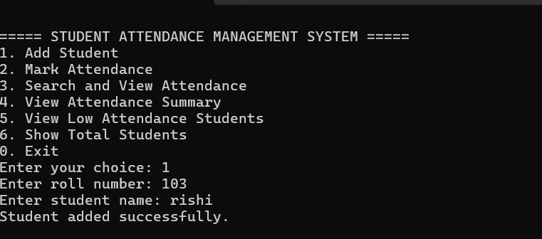

Figure 7 –Add Student
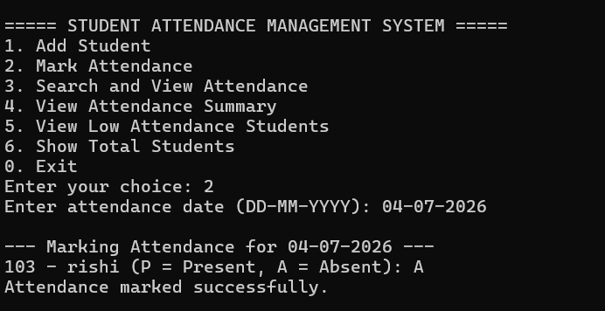

Figure 8 – Mark Attendance

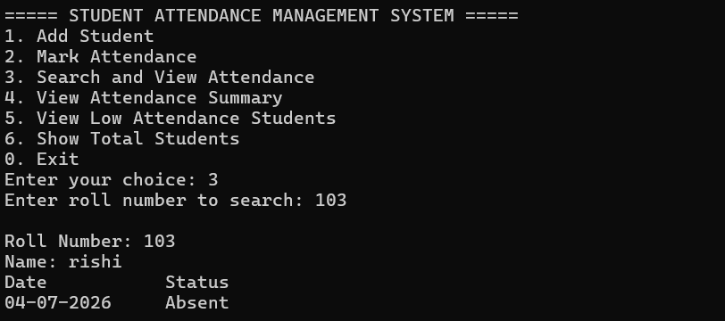

Figure 9 – Search and View Attendance
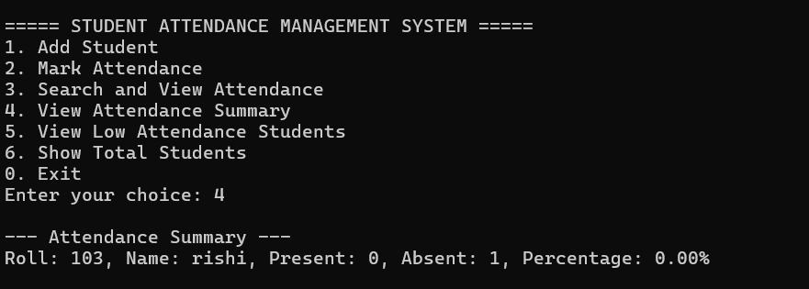
Figure 10 – View Attendance Summary
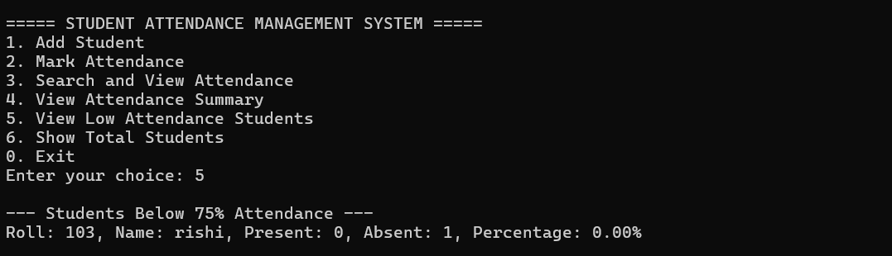
Figure 11 – View Low Attendance Students
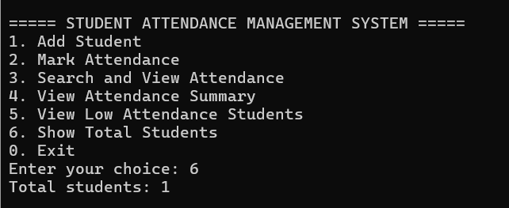
Figure 12 – Show Total Students
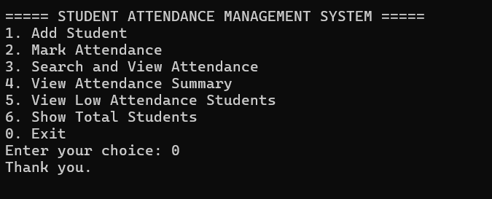
Figure 13 – Exit

2.4 Test Cases
No. | Test case | Input | Observed output | Status
1 | Valid student registration | 25B11CS001, Ravi, CSE-A | Student registered successfully | Pass
2 | Duplicate roll number | 25B11CS001 again | Student already exists! | Pass
3 | Invalid attendance choice | Type 9 | Invalid attendance choice! | Pass
4 | Non-numeric menu input | abc | Invalid input! Please enter a number | Pass
5 | Mark Present | 25B11CS001, choice 1 | Attendance marked successfully | Pass
6 | Mark Absent | 25B11CS001, choice 2 | Attendance marked successfully | Pass
7 | Search existing student | 25B11CS001 | Student Found with attendance details | Pass
8 | Search missing student | XX00XX000 | Student not found. | Pass
9 | Attendance percentage | 4 present / 5 total | Attendance Percentage: 80.00% | Pass
10 | Low attendance | 2 present / 5 total | Low Attendance | Pass
11 | History display | Menu option for history | Completed attendance transactions listed | Pass
12 | Invalid menu choice | 9 | Invalid choice message | Pass

CHAPTER 3
CONCLUSION & FUTURE SCOPE

3.1 Conclusion
The Student Attendance Management System demonstrates how object-oriented programming in C++ can be applied to a practical academic record-management problem. The implementation provides student registration, attendance marking, attendance-status display, student search, percentage calculation, low-attendance identification and attendance-history storage.
The use of classes and encapsulation organizes student and attendance data, while abstraction separates system operations from their internal implementation. File handling provides persistent attendance-history storage, and input validation improves the reliability of menu and attendance inputs. The test cases demonstrate the expected behavior of the major modules.

3.2 Future Scope
- Store student and attendance records in a structured database instead of only a text file.
- Add date and time capture automatically for every attendance session.
- Support multiple classes, sections, subjects and faculty accounts.
- Provide daily, weekly, monthly and semester-wise attendance reports.
- Add import/export support using CSV or spreadsheet formats.
- Add administrator functions for student, subject and attendance management.
- Provide authentication for faculty and administrators.
- Add a graphical, web-based or mobile user interface.
- Provide notifications for students with attendance below the required threshold.
- Add backup and restore features for attendance records.

REFERENCES
1. B. Stroustrup, The C++ Programming Language, 4th ed., Addison-Wesley, 2013.
2. E. Balagurusamy, Object-Oriented Programming with C++, McGraw Hill Education.
3. H. Schildt, C++: The Complete Reference, 4th ed., McGraw-Hill.
4. C++ Reference, cppreference.com – https://en.cppreference.com
5. Course material: Object Oriented Programming through C++ (2501CS08), Aditya University.

APPENDIX
TEAM MEMBERS AND RESPONSIBILITIES
Roll No. | Name | Role / Responsibility
25B11AI860 | ORSU LEELA BHARANI | Student Registration + Student Class
25B11AI103 | BATHULA N S L DURGA RISHITHA | Attendance Marking + Attendance Record
25B11AI357 | GONDYALA SRIRAM PRAKHYATH | Student Search + Attendance Report
25B11AI027 | ELUBANDI MANIKANTA | Percentage Calculation + File Handling

