Automating Document Data Entry with Salesforce Document AI
Extract data from files uploaded on an Experience Cloud portal and populate Salesforce records, with confidence-based human review
Author: [Your Name] · Salesforce Architect · LinkedIn
Stack: Data 360 (Data Cloud) Document AI · Agentforce · Experience Cloud · Apex · Platform Events · Flow

At a Glance
Problem | Portal users upload application forms, certificates and invoices. Staff re-key the data into Salesforce by hand.
Solution | Document AI extracts the values with an LLM, using a schema you define. Automation maps them onto the record, and anything below a confidence threshold goes to a reviewer.
Key patterns | Platform Event handoff to an integration user · staging and audit object · metadata-driven field mapping · pluggable extraction client (Flow action or REST) · idempotent processing
Source code | 7 Apex files (triggers, classes, test) and 1 metadata file. See section 14.

Contents
- The Problem
- Choosing the Right Salesforce Capability
- Prerequisites
- Supported File Types
- Architecture
- Key Design Decisions
- Implementation, Step by Step
- Reading the Extraction Output
- Human-in-the-Loop Review
- Security
- Gotchas and Lessons Learned
- Testing and Rollout
- Extending with Agentforce
- Source Files
- References

1. The Problem
External users (applicants, customers, partners) upload supporting documents on an Experience Cloud site against a record, for example an Application__c. An internal team then opens every file and types the values into fields.
Requirements
- Extract defined values from PDF, Word and image files automatically.
- Populate the fields on the related record.
- Never write low-confidence data silently. Route it to a human.
- Keep an audit trail of the file, the configuration used, the raw output and the confidence.
- Make field mappings maintainable by admins, without code changes.
Document field | Target field (example)
Applicant Name | Application__c.Applicant_Name__c
Date of Birth | Application__c.Date_of_Birth__c
Registration Number | Application__c.Registration_Number__c
Issue Date | Application__c.Certificate_Issue_Date__c
Application__c is a placeholder. Swap in your own object.

2. Choosing the Right Salesforce Capability
Three Salesforce options come up for this requirement. Only one of them is built for it.
Capability | Built for | Verdict
Agentforce Data Library | Retrieval (RAG). It chunks and vector-indexes content so agents can answer questions about documents. | ❌ It doesn't put values into fields. Files must be explicitly added to the library, and uploads are limited to text, HTML and PDF.
Intelligent Document Automation / Intelligent Form Reader | Document intake workspaces in industry clouds (Health Cloud, Public Sector), powered by Amazon Textract. | ⚠️ Only available in those clouds, and it needs a separate Textract licence.
Data 360 Document AI | Extraction. You define a schema, an LLM extracts the values, and you get a confidence score per field. It can read files already in Salesforce Files. | ✅ Chosen.
A common first instinct is: "we're getting Agentforce, so let's use the Data Library". The distinction to remember is retrieval versus extraction. The Data Library helps an agent talk about a document. Document AI turns the document into data.

3. Prerequisites

3.1 Licences and Features
Requirement | Why
Data 360 licence | Document AI runs on Data 360. It is not available with Customer Data Platform (CDP) licences.
Einstein Generative AI turned on | Document AI uses LLMs.
Agentforce enabled | Required to use Document AI.
Flex Credits / Data 360 credits | Each extraction consumes credits. Forecast documents × pages.
Document Processing org permission | Enables the extraction capability.
MuleSoft for Flow: IDP add-on, or Agentforce 1 Editions | Needed only if you use the standard Extract Data from Document action. It is licensed per user.
Experience Cloud | Authenticated portal users who can access the target record.
Licensing decides the invocation path. There are two ways to call Document AI (section 6, decision 5). Confirm with your Salesforce account team which one your contract covers before you build.

3.2 Permissions
Persona | Access
Integration user (runs all extractions) | Document Processing permission, Data 360 access, Read on ContentVersion, and Edit on the target object and staging object. Holds the IDP add-on if you use the standard action.
Admin | Data 360 permissions to build Document AI configurations.
Reviewers | Staging object, review queue, target record and source file.
Portal users | Upload files on their own records only. No Document AI access.

3.3 REST Path Only
- An External Client App (the replacement for Connected Apps) for OAuth.
- A Named Credential backed by an External Credential using OAuth 2.0 Client Credentials, pointing at your own org's My Domain.

4. Supported File Types
Format | Extension | MIME type
PDF | .pdf | application/pdf
Images | .png, .jpeg/.jpg | image/png, image/jpeg
Word | .docx | application/vnd.openxmlformats-officedocument.wordprocessingml.document
PowerPoint | .pptx | application/vnd.openxmlformats-officedocument.presentationml.presentation
Excel (single sheet) | .xlsx | application/vnd.openxmlformats-officedocument.spreadsheetml.sheet
Legacy .doc files, multi-sheet workbooks and password-protected files aren't supported. Block them at upload.
Word through the standard action: Document AI supports .docx. However, the action's Base64 mimeType input documents only PDF and image types. When you use the standard action, pass the contentDocumentId and include .docx samples in your acceptance tests. Otherwise, use the REST path.

5. Architecture

5.1 Components
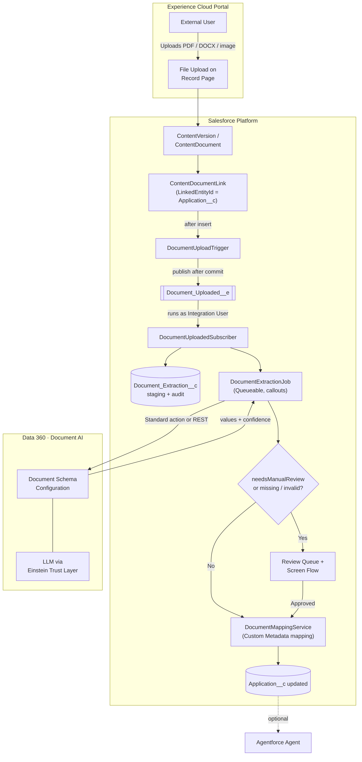

5.2 Runtime Sequence
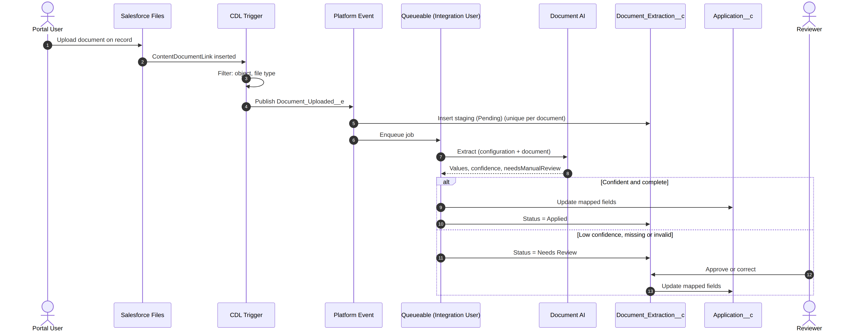

6. Key Design Decisions
1. Hand off to an integration user through a Platform Event. The upload runs in the portal user's context, and asynchronous Apex runs as the user who enqueued it. Enqueuing extraction straight from the trigger would therefore require every external user to hold Document AI permissions and add-on licences. Instead, the trigger publishes Document_Uploaded__e, and a PlatformEventSubscriberConfig runs the subscriber as a single integration user. Permissions stay least-privilege, and licensing is limited to one user.
2. Use a staging object instead of writing straight to the record. Document_Extraction__c stores the raw JSON, flags, status and errors. It gives you an audit trail, a review surface, a retry mechanism and an operations dashboard, and it separates "what the AI said" from "what we committed".
3. Enforce idempotency with a unique External ID. Content_Document_Id__c is unique. When the same file is shared to another record, or an event is redelivered, the second insert fails quietly and no credits are spent twice.
4. Process one document per Queueable. File size, heap and callout limits vary per document. Isolating each document keeps failures contained and resource use predictable.
5. Make the extraction client pluggable. DocumentAIClients.Client has two implementations:
- StandardActionClient: the extractDataFromDocument standard action, which needs the IDP add-on or Agentforce 1.
- RestApiClient: the Data 360 endpoint /ssot/document-processing/actions/extract-data through a Named Credential.
A Custom Metadata switch selects the client, so licensing changes don't require code changes, and tests can inject a stub.
6. Drive field mapping with metadata. Document_Field_Mapping__mdt maps each extracted field to an object field, with a type and a required flag. Admins add fields without a deployment of code.
7. Review only on confidence, completeness and type safety. A record is auto-applied only when Document AI reports no low-confidence fields, every required field is present, and every value converts cleanly to its target type. Anything else goes to a human.

7. Implementation, Step by Step

Step 1: Enable the Platform
- Confirm the Data 360 licence and complete Data 360 setup.
- Turn on Einstein Generative AI and enable Agentforce.
- Have Salesforce enable the Document Processing org permission.
- For the standard-action path, confirm that the MuleSoft for Flow: IDP add-on or Agentforce 1 is provisioned.

Step 2: Create the Integration User
- Create the user document.ai@yourco.com.
- Create a permission set Document_AI_Processing containing Document Processing, Data 360 access, Read on Files, Edit on Application__c, and full access to Document_Extraction__c.
- Assign the IDP add-on licence to this user if you use the standard action.

Step 3: Build the Document AI Configuration
In Data 360 → Document AI, create one configuration per document type. Build it without a source object, because real-time (transactional) mode doesn't need Unstructured Data Model Objects.
- Choose the document type and the LLM.
- Upload 3–5 representative samples, including a poor scan and a layout variant.
- Define the fields with auto-extraction (then prune) or manually. Write a short description for each field. Descriptions are the main lever for improving accuracy.
- Set a confidence threshold on each field. Start around 80 for critical fields.
- Test, refine, then publish with a stable API name, for example Application_Form_Extraction.

Step 4: Create the Data Model
Document_Extraction__c (Private OWD, no portal access)
Field | Type | Notes
Target_Record_Id__c | Text(18) | Record the file is attached to
Content_Document_Id__c | Text(18) · Unique · External ID | Idempotency key
Content_Version_Id__c | Text(18) | Exact version processed
Configuration_Name__c | Text(255) | Document AI configuration API name
Status__c | Picklist | Pending, Extracted, Needs Review, Applied, Failed
Needs_Manual_Review__c | Checkbox
Extracted_Data_JSON__c | Long Text (131,072) | Raw output, for audit
Error_Message__c | Long Text
Attempts__c | Number | Retry counter
Document_Field_Mapping__mdt: Configuration_Name__c, Extracted_Field_Name__c, Target_Field__c, Data_Type__c (Text / Date / Number / Currency / Checkbox), Required__c.
Document_AI_Setting__mdt (one record, Default): Use_REST_API__c (Checkbox), Named_Credential__c, API_Version__c, Default_Configuration__c.
Document_Uploaded__e: Target_Record_Id__c, Content_Document_Id__c, Content_Version_Id__c, Configuration_Name__c. Set Publish Behavior to Publish After Commit.

Step 5: Configure the Portal Upload
Add Related Files, or a custom LWC that uses lightning-file-upload with record-id, to the record page in Experience Builder. Restrict formats to .pdf, .docx, .png, .jpg, .jpeg and set a file size limit. Uploading on the record creates a ContentDocumentLink to that record, and that link is the trigger point.

Step 6: Deploy the Automation
Order | File | Role
1 | DocumentUploadTrigger.trigger + DocumentUploadHandler.cls | Detect relevant uploads and publish the event
2 | DocumentUploadedSubscriber.trigger | Create the staging record and enqueue the job, as the integration user
3 | DocumentUploadedSubscriberConfig.platformEventSubscriberConfig-meta.xml | Sets the subscriber's running user
4 | DocumentAIClients.cls | Pluggable extraction client (standard action or REST)
5 | DocumentExtractionJob.cls | Callout first, then DML; handles errors and retries
6 | DocumentMappingService.cls | Maps, type-converts, and decides whether to apply or review
7 | DocumentExtractionTest.cls | End-to-end test with a stubbed client

Step 7: Low-Code Alternative (Flow)
Teams that prefer Flow can keep the trigger and subscriber in Apex, and have the job start an autolaunched Flow:
Get Records (staging) → Action: Extract Data from Document (Content Document ID, Document Processing Configuration) → Decision on needsManualReview → Update Records (target) → Update Records (staging status) → Fault path (status Failed).
The action's Extracted Data output is an Apex-defined type generated from your configuration, so its fields are directly usable in Flow.

8. Reading the Extraction Output
The standard action returns these outputs:
Output | Meaning
extractedData | Object with one entry per configured field: value plus confidence metadata
extractedDataJson | The same data as a JSON string. This is what we store and parse.
needsManualReview | true if any field scored below its threshold
contentDocumentId, documentProcessingConfigurationId | Traceability
Example extractedDataJson:
{
"applicant name": { "type": "string", "value": "Jane Doe", "confidence_score": 0.98, "confidence_threshold": 80.0 },
"registration number": { "type": "string", "value": "RX-20931", "confidence_score": 0.71, "confidence_threshold": 80.0 },
"needsManualReview": { "type": "boolean", "value": true }
}
Three details trip people up:
- Mixed scales. In the JSON string, confidence_score runs from 0 to 1 while confidence_threshold runs from 0 to 100. In the extractedData object, scores are integers from 0 to 100.
- Hex-encoded keys. In the extractedData object, a space becomes x20 and an underscore becomes x5f (for example, registrationx20number). The JSON string keeps the plain names, which is another reason to parse the JSON.
- needsManualReview is injected as a pseudo-field alongside your real fields. Skip it when mapping.

9. Human-in-the-Loop Review
A staging record moves to Needs Review when Document AI flags low confidence, a required value is missing, or a value can't be converted to the target type. Reviewers work from a queue list view and a Screen Flow that shows:
- a File Preview of the source document;
- each extracted value with its confidence score, next to the current record value;
- editable inputs for each correction, then Approve → apply to the record → Applied.
Keep the corrections. Recurring corrections on the same field are the signal to improve that field's description or threshold in the configuration.

10. Security
- Least privilege: portal users only upload. Every Document AI call runs as the integration user.
- Staging data is private: Document_Extraction__c uses a Private OWD and is not exposed to the portal. Consider Shield Platform Encryption for Extracted_Data_JSON__c when documents contain PII.
- Trust Layer: extraction runs through Salesforce's LLM stack. Get the chosen model approved against your data-residency and retention requirements.
- Credentials: the REST path uses an External Credential with Client Credentials. There are no tokens in code.
- Scope: this design assumes authenticated portal users. Unauthenticated guest uploads need a separate threat review.

11. Gotchas and Lessons Learned
# | Gotcha | How it's handled
1 | Picking the Data Library because "we have Agentforce" | It's retrieval, not extraction. Use Document AI.
2 | The standard action needs the MuleSoft for Flow: IDP add-on, per user | Licence one integration user, or use the REST client.
3 | Async jobs run as the portal user | Platform Event plus PlatformEventSubscriberConfig running user
4 | "You have uncommitted work pending" | The job performs the callout before any DML. The staging record is created earlier, in the subscriber transaction.
5 | Base64 adds ~33% to the payload (REST path) | One document per job (async heap is 12 MB), plus a portal upload size limit
6 | The same file linked to several records fires the trigger again | Unique Content_Document_Id__c, inserted with allOrNone = false
7 | Portal users can't query the staging object | The duplicate check happens in the subscriber, which runs as the integration user
8 | Confidence scales differ (0–1 versus 0–100) | Rely on needsManualReview and don't recompute thresholds
9 | Hex-encoded keys in extractedData | Parse extractedDataJson instead
10 | Date formats vary between documents | Try ISO first, then locale parsing, else send to review
11 | Credits are spent on every call | Idempotency, file-type filtering and a retry cap (3)
12 | A new version of a file isn't re-extracted | By design. To re-extract, key the staging record on Content_Version_Id__c and trigger on ContentVersion.

12. Testing and Rollout
Accuracy pilot
- Collect 20–50 real, anonymised documents per type, including poor scans and layout variants.
- Score each field as correct / wrong / missing, and record the review rate at each threshold.
- Tune field descriptions first and thresholds second. Re-run the pilot.
- Measure credits per document to forecast cost.
Apex tests (DocumentExtractionTest.cls)
- Inject a stub DocumentAIClients.Client. No real callouts run in tests.
- Cover: the end-to-end upload → event → job → applied path; low confidence → review; a missing required field; a failed type conversion; a duplicate upload; and an extraction error → Failed.
Deployment
- Move Document AI configurations between orgs with Data Kits.
- Deploy the Apex, objects, Custom Metadata, Platform Event and PlatformEventSubscriberConfig through your CI/CD (SFDX or DevOps Center).
- Complete Data 360 setup separately in each sandbox.

13. Extending with Agentforce
Once the data is structured, agents can act on it:
- Validate: check the extracted values against business rules or existing records, then explain any mismatch to the case owner.
- Summarise: give reviewers a short summary of long documents.
- Re-run: expose DocumentExtractionJob as an agent action, so an agent can reprocess a failed extraction on request.
- Salesforce also documents adding a Document AI configuration to an agent topic for conversational extraction.

14. Source Files
File | Purpose
DocumentUploadTrigger.trigger | ContentDocumentLink after-insert trigger
DocumentUploadHandler.cls | Filters uploads and publishes Document_Uploaded__e
DocumentUploadedSubscriber.trigger | Creates staging records and enqueues jobs
DocumentUploadedSubscriberConfig.platformEventSubscriberConfig-meta.xml | Runs the subscriber as the integration user
DocumentAIClients.cls | Client interface, standard-action client and REST client
DocumentExtractionJob.cls | Queueable orchestration: extract, stage, apply or route
DocumentMappingService.cls | Metadata-driven mapping and type conversion
DocumentExtractionTest.cls | Unit and end-to-end tests with a stub client

15. References
- Document AI – Salesforce Help (Data 360)
- Extract Data from Document Action – Actions Developer Guide
- Extract Data from Document – Flow Action (Salesforce Help)
- MuleSoft for Flow: IDP – Extract Data from Document
- Integrate Data Cloud's Document AI with Agentforce – Salesforce Developers Blog
- Process Unstructured Data with Document AI – Salesforce Developers Blog
- External Client Apps – Salesforce Help

