The code developed can be found in github under

<https://github.com/bharanivadlamani/EmployeeStateMgmt>

After running the code (run EmployeeStateMgmtApplication.java class as java application) the application will be up and running and following endpoints will be available.

1. Endpoint to add an employee

For adding an Employee, from postman send the request as below

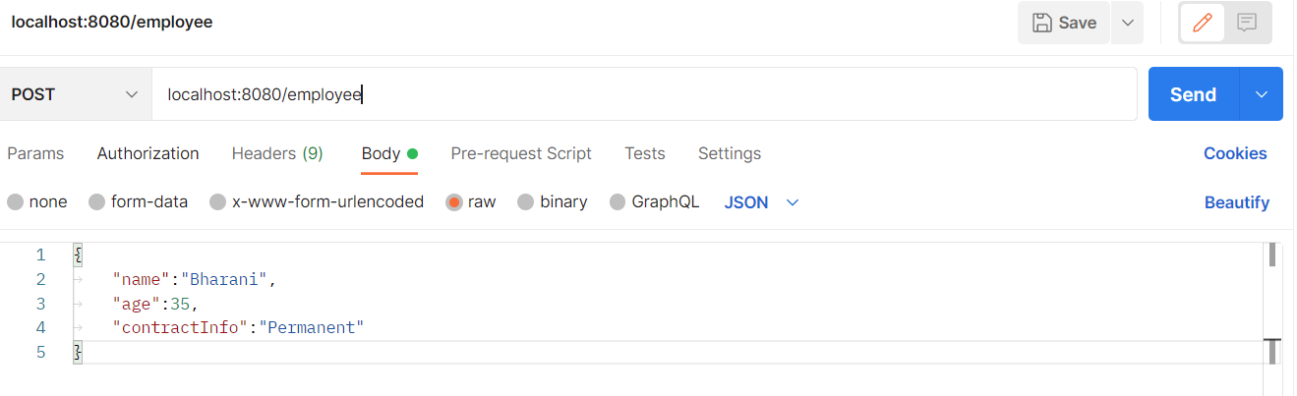

Response is

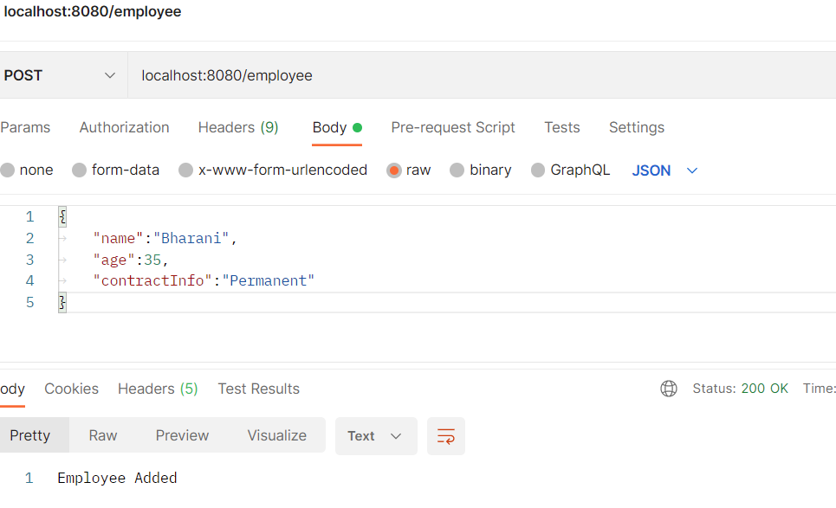

2. An Endpoint to fetch employee details

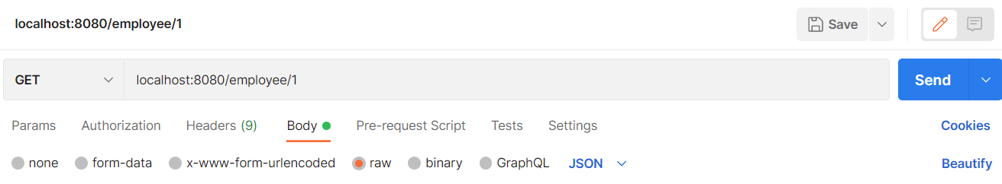

Response is

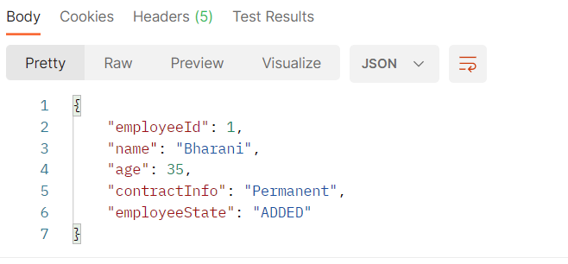

3. Endpoint to change the state of an employee

Have to send patch request with url with parameters empId and event name for eg. As below

localhost:8080/employee?empId=1&event=BEGIN_CHECK

the response is

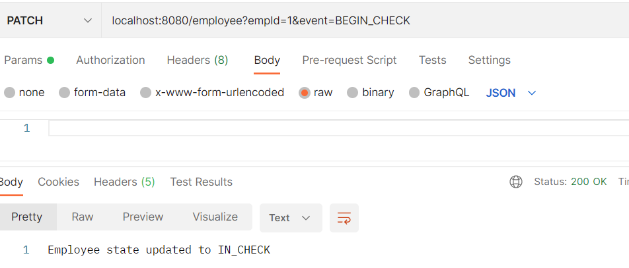

To change the employee state to approved, send event APPROVE as below

localhost:8080/employee?empId=1&event=APPROVE

response is

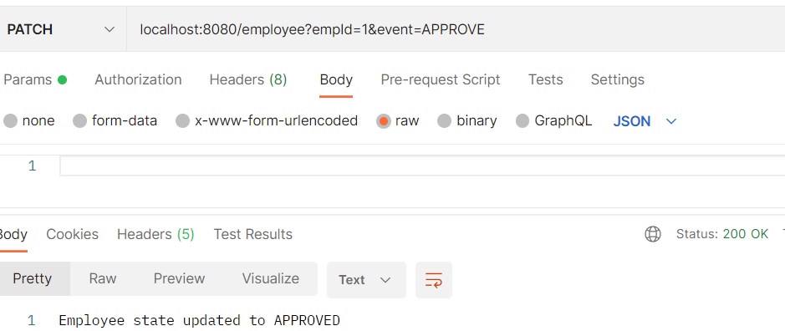

Employee status can be changed back to in check, by sending event UNAPPROVE

localhost:8080/employee?empId=1&event=UNAPPROVE

response is

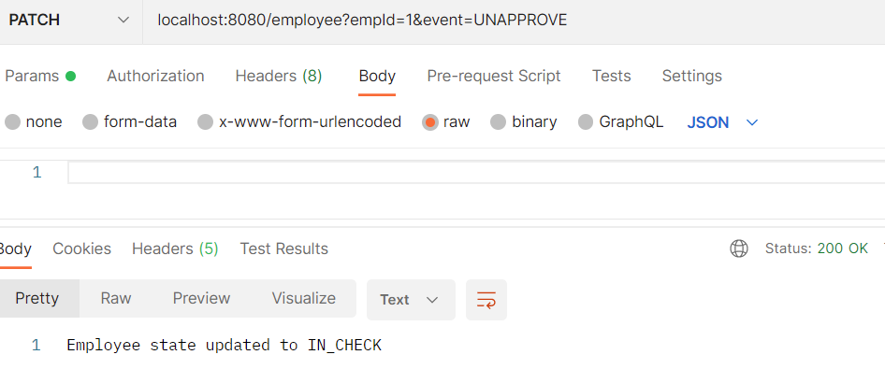

Now the employee state is updated back to Approved by sending APPROVE event.

Now changing the status to activate as below

localhost:8080/employee?empId=1&event=ACTIVATE

The response is

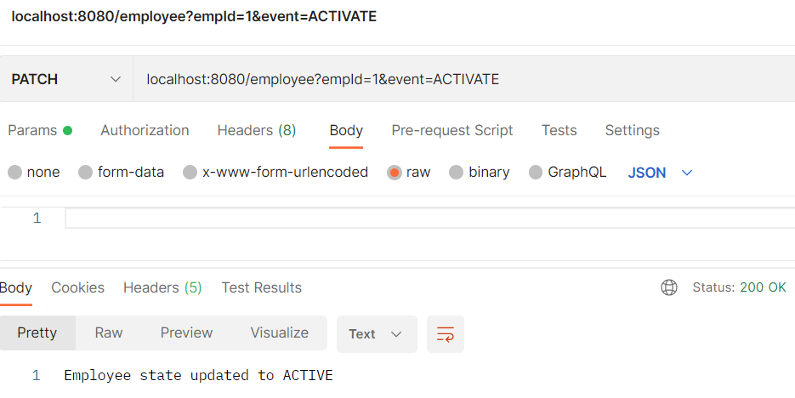

For OpenAPI spec, hit following URLs in the browser

http://localhost:8080/v3/api-docs/

http://localhost:8080/swagger-ui/index.html