**ByteBridge – Blood Bank Management System**

**AN INTERNSHIP REPORT**

***Submitted by***

**Patel Uma Jigneshbhai**

**2001701070**

***In partial fulfillment for the award of the degree of***

**BACHELOR OF ENGINEERING**

***In***

**Computer Engineering**

**VISHWAKARMA GOVERNMENT ENGINEERING COLLEGE**

**CHANDKHEDA, AHMEDABAD**

 

**Gujarat Technological University, Ahmedabad**

**[April, 2024]**

 

**VISHWAKARMA GOVERNMENT ENGINEERING COLLEGE**

**CHANDKHEDA, AHMEDABAD**

**CERTIFICATE**

This is to certify that the Internship report along with the project entitled **ByteBridge – Blood Bank Management System** has been carried out by **Patel Uma Jigneshbhai(Enrollment No: 200170107059)** under my guidance in partial fulfilment for the degree of Bachelor of Engineering in Computer Engineering, 8th Semester of Gujarat Technological University, Ahmedabad during the academic year 2023-24.

Prof. Rahul K. Shah Prof. Kajal Patel

Internal Guide Head of the Department

**INTERNSHIP CERTIFICATE**

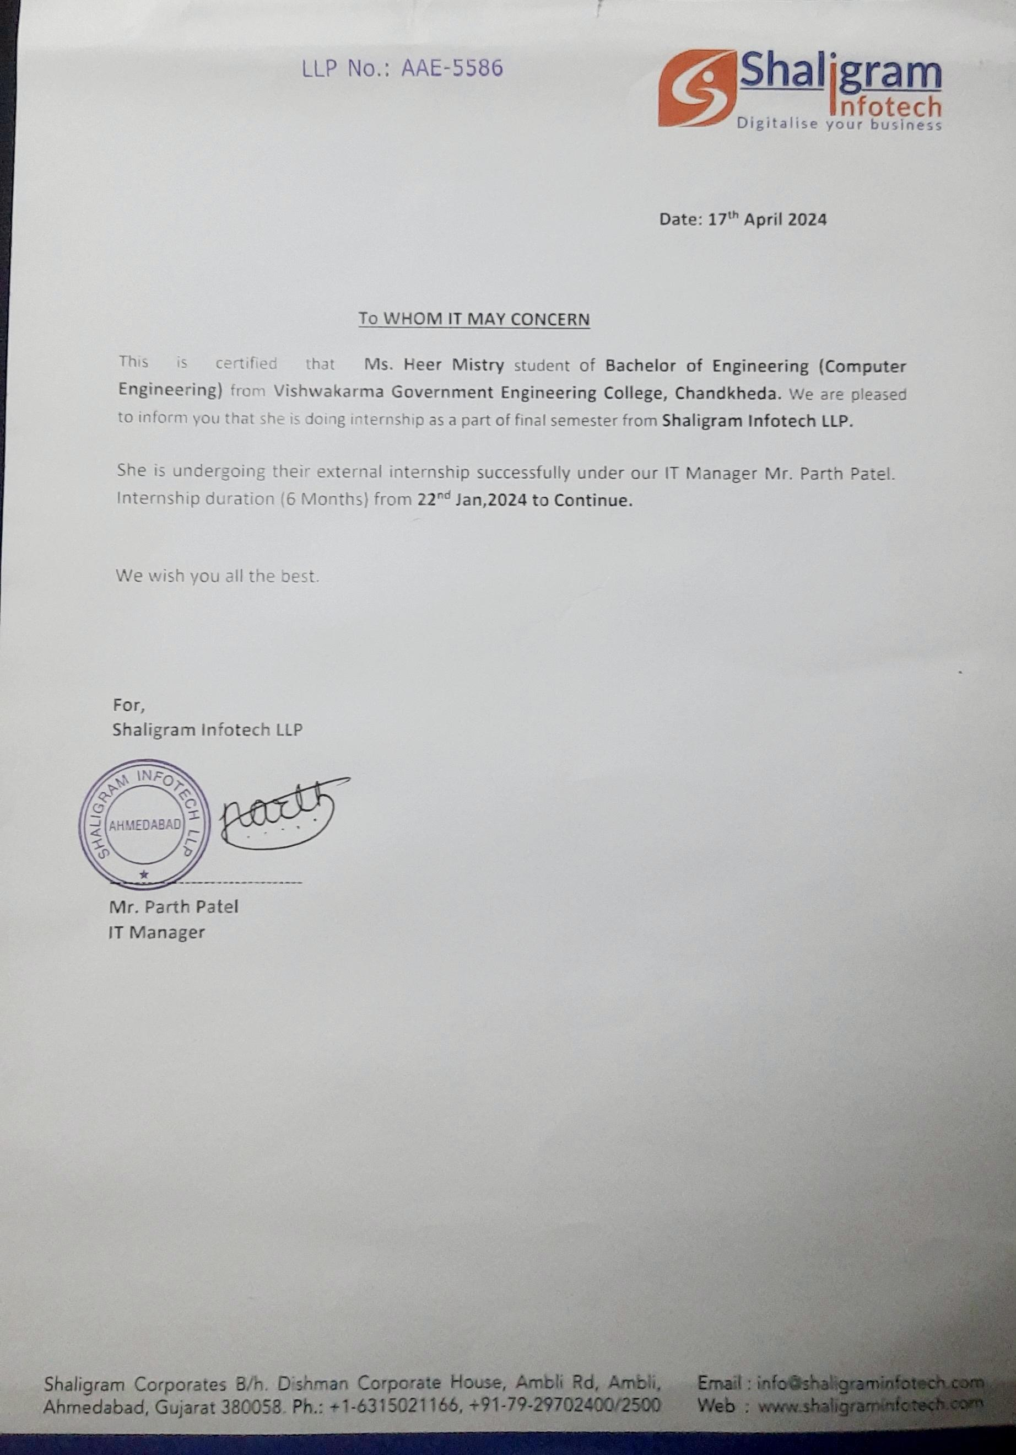

 

**VISHWAKARMA GOVERNMENT ENGINEERING COLLEGE**

**CHANDKHEDA, AHMEDABAD**

**DECLARATION**

We hereby declare the Internship report submitted along with the Project entitled **ByteBridge – Blood Bank Management System** submitted in partial fulfilment for the degree of Bachelor of Engineering in Computer Engineering, 8th Semester of Gujarat Technological University, Ahmedabad, is a bonafide record of original project work carried out by me at SHALIGRAM INFOTECH LLP. Under the supervision of Internal Guide Prof. Rahul K. Shah and External Guide Mr. Bhavik Vaghasiya and that no part has been directly copied from any students’ reports or taken from any other source, without providing due reference.

**Name of the Student Sign of the Student**

Patel Uma Jigneshbhai

(200170107059)

**ACKNOWLEDGEMENT**

I would like to express my sincere gratitude to all those who have contributed to the successful completion of my internship report on full stack web development.

First and foremost, I am immensely thankful to **Mr. Bhavik Vaghasiya**, my external guide for their invaluable guidance, support, and mentorship throughout this internship journey. Their expertise, constructive feedback, and encouragement were instrumental in shaping this report. I would also like to thank my Internal Guide **Prof. Rahul K. Shah** and my H.O.D **Prof. Kajal Patel** for helping me throughout my internship by giving me the necessary suggestions and advices along with her valuable co-ordination in completing this internship.

I would also like to extend my appreciation to the entire team at **Shaligram Infotech LLP** for providing me with the opportunity to gain hands-on experience in full stack web development. Their collaborative environment and willingness to share knowledge have enriched my learning experience immensely.

Furthermore, I am grateful to my colleagues for their assistance and camaraderie during this internship period. Their insights and contributions have added depth to my understanding of web development technologies.

Last but not least, I would like to thank my family and friends for their unwavering support and encouragement throughout this endeavor.

Thank you all for being part of this enriching experience.

**With Sincere Regards**

Uma Jigneshbhai Patel

**ABSTRACT**

This report encapsulates the immersive 12-week internship journey at Shaligram Infotech LLP, where I served as a Full Stack Web Developer intern. Throughout this period, I gained invaluable insights and practical experience in both front-end and back-end technologies, shaping my understanding of modern web development practices.

The internship commenced with an orientation to Shaligram Infotech's workflow, followed by a deep dive into the essential front-end technologies of HTML, CSS, JavaScript, jQuery, and Angular. These technologies formed the cornerstone for crafting dynamic and engaging user interfaces, ensuring seamless user experiences across various devices and platforms.

Subsequently, attention turned to the back-end technologies, including SQL, .NET MVC, and C#. Leveraging these robust technologies, I gained proficiency in database management, server-side development, and application logic implementation, thereby completing the full stack development cycle.

Hands-on project served as the backbone of this internship, allowing for the practical application of theoretical knowledge to real-world scenarios. This project ranged from creating static web pages with intricate designs to developing dynamic web applications with interactive features and database integration.

Collaboration within the development team fostered an environment conducive to learning and growth, enabling the exchange of ideas, troubleshooting, and peer review. Additionally, regular mentorship sessions provided invaluable guidance and direction, ensuring continual progress and skill refinement.

The internship at Shaligram Infotech LLP was a transformative experience, equipping me with the requisite skills and knowledge to thrive in the dynamic field of full stack web development. I am grateful for the opportunity to learn from industry professionals and contribute to meaningful projects, laying a solid foundation for my future endeavors.

**Keywords**: Full Stack Web Development, Internship, HTML, CSS, JavaScript, jQuery, Angular, SQL, .NET MVC, C#, Hands-on Project, Collaboration, Mentorship.

**List of Figures**

Figure 1.1 Company Logo 1

Figure 1.3 Organization Chart 3

Figure 3.7 Project Scheduling (Gantt Chart)  14

Figure 8.6.1 Use Case Diagram 35

Figure 8.6.2 Sequence Diagram 36

Figure 8.6.3 Activity Diagram 36

Figure 8.6.4 First Lavel Data Flow Diagram 37

Figure 8.6.5 Second Level Data Flow Diagram 37

Figure 8.6.6 ER Diagram 38

Figure: plagiarism Report 59

**List of Tables**

Table 3.6 Internship Planning 12

Table 11.2 Test Results 52 - 55

Table 12.2 Dates of Continuous Evaluation 56

**Table of Contents**

**CHAPTER-1 OVERVIEW OF THE COMPANY** **1**

1.1 History 1

1.2 Scope of work 2

1.3 Organization Chart  3

**CHAPTER-2 OVERVIEW OF DIFFERENT DEPARTMENTS**  **4**

2.1 Different Departments 4

2.2 Technical Specification 5

**CHAPTER-3 INTRODUCTION TO INTERNSHIP AND PROJECT** **7**

3.1 Internship Summary 7

3.2 Purpose 7

3.3 Objective 8

3.4 Scope 8

3.5 Technology and Literature Review 9

3.6 Internship Planning 11

* Internship and project development Approach and justification 11
* Internship and project Efforts and time 12

3.7 Project Scheduling (Gantt Chart) 14

**CHAPTER-4 SYSTEM REQUIREMENTS AND ANALYSIS** **29**

4.1 System Requirements 29

* User Characteristics 29
* Hardware and Software Requirements 29
* Execution Environment 30
* Assumptions 30
* Dependencies 30

4.2 System Analysis 31

* Methodology 31
* Problems of Current System 31

4.3 Functional and Non-Functional Requirements 32

* Functional Requirements 32
* Non-Functional Requirements 33

4.4 Feasibility Study 33

* Does the System Contribute to The Overall Objectives of The Organization?33
* Can the System Be Implemented Using the Current Technology and Within the Given Cost and Schedule Constraints? 34
* Can the System Be Integrated with Other Systems Which Are Already in Place?34

4.5 Features of New System 34

4.6 Diagrams 35

* Use Case Diagram 35
* Sequence Diagram 35
* Activity Diagram 36
* First Lavel Data Flow Diagram 36
* Second Level Data Flow Diagram 37
* ER Diagram 37

4.7 List of Main Modules of New System  38

**CHAPTER-5 SYSTEM DESIGN**  **39**

5.1 System Design & Methodology 39

* BMS System Design 39
* Methodology 39

5.2 Database Design 40

5.3 Input/Output and System Design 41

* Home Page 41
* Registration Page  43
* Login Page 43
* Registration Pages for Donor/Hospital/Seeker/Blood Bank 44
* Request Types 44
* Cities  45
* Blood Groups 45
* All New Requests  46
* Profile Report 46
* Edit Profile 47
* Campaigns 47

**CHAPTER-6 IMPLEMENTATION PLANNING** **50**

6.1 Implementation Platform 50

6.2 Modules Specifications 50

6.3 Outcomes 51

6.4 Result Analysis 51

**CHAPTER-7 TESTING** **52**

7.1 Testing Strategy 52

7.2 Test Results & Analysis 52

**CHAPTER-12 CONCLUSION AND DISCUSSION** **56**

8.1 Overall Analysis of Internship 56

8.2 Dates of Continuous Evaluation 56

8.3 Problem Encountered and possible Solutions 56

8.4 Summary of Project Work 57

8.5 Limitation and Future Enhancement  57

**PLAGIARISM REPORT** **59**

**REFERENCES** **6**

**Abbreviations**

**HTML:** Hyper Text Markup Language

**CSS**: Cascading Style Sheets

**JS:** JavaScript

**.NET:** .NET Framework

**MVC:** Model-View-Controller

**BMS:** Building Management System

**EHR:** Electronic Health Record

**CRM:** Customer Relationship Management

**SQL:** Structured Query Language

**NoSQL:** Not Only SQL

**C#:** C Sharp

**SSMS:** SQL Server Management Studio

**MSSQL:** Microsoft SQL Server

**RAM:** Random Access Memory

**OS:** Operating System

**DBMS:** Database Management System

**CHAPTER-1 OVERVIEW OF THE COMPANY**

* 1. **History**

Shaligram Infotech is a renowned award-winning software development company that has established itself as a leader in providing top-notch web and mobile solutions to a diverse clientele, holds the prestigious status of being a Microsoft Dynamics 365 Gold Partner. Since its inception over eight years ago, the company has been dedicated to combining knowledge, experience, and innovation to transform businesses across various industries.

The journey of Shaligram Infotech began with a vision to offer end-to-end development services tailored to the precise needs of clients, ranging from startups to large enterprises. From the outset, the company has focused on ensuring business efficiency by leveraging the best of technology and fostering innovation in every project undertaken.

Throughout its history, Shaligram Infotech has demonstrated its commitment to excellence by consistently delivering flexible, scalable, and highly competitive solutions that empower its clients to thrive in the marketplace. With a team of over 100 developers, the company has the expertise and resources to tackle diverse challenges and deliver impactful digital solutions.

Over the years, Shaligram Infotech has built a strong reputation for its ability to understand and address the unique requirements of different industry domains. The company has successfully partnered with businesses worldwide, providing them with cutting-edge digital solutions that drive growth and success.

As Shaligram Infotech continues to evolve, it remains dedicated to its core values of innovation, quality, and customer satisfaction. Whether clients have a project idea in mind or are seeking to overcome specific business challenges, the company's team stands ready to provide expert guidance and support. With a focus on delivering business success through powerful digital solutions, Shaligram Infotech remains a trusted partner for organizations seeking to harness the power of technology to achieve their goals.



Figure 1.1 Company Logo

* 1. **Scope of work**

**Custom Software Development:** We specialize in developing bespoke software solutions tailored to the unique needs of our clients. From web and mobile applications to enterprise software, we leverage the latest technologies to deliver innovative and scalable solutions.

**Microsoft Dynamics 365 Implementation:** As a Microsoft Dynamics 365 Gold Partner, we provide end-to-end implementation services for Dynamics 365 applications. Our expertise covers CRM, ERP, and other modules, helping businesses streamline operations and improve productivity.

**Web Development:** We design and develop cutting-edge websites that are visually stunning, user-friendly, and optimized for performance. Our team utilizes modern web technologies to create responsive and feature-rich web experiences.

**Mobile App Development:** We build custom mobile applications for iOS and Android platforms, catering to various business needs. Whether it's a consumer-facing app or an enterprise mobility solution, we deliver high-quality mobile experiences that engage users and drive results.

**Customer Relationship Management (CRM):** Our CRM solutions empower businesses to manage customer interactions, streamline sales processes, and improve customer satisfaction. We offer custom CRM development, CRM integration, and CRM consulting services to help organizations enhance their customer relationships and drive revenue growth.

**Enterprise Solutions:** We offer comprehensive enterprise solutions, including ERP, CRM, BI, and ECM systems, to help organizations optimize their processes, enhance decision-making, and achieve operational excellence

**Quality Assurance and Testing:** We ensure the reliability and performance of our solutions through rigorous quality assurance and testing processes. Our QA experts employ industry-leading tools and methodologies to deliver bug-free and high-quality software products.

**Digital Transformation Services:** We assist businesses in embracing digital transformation by leveraging emerging technologies such as AI, IoT, blockchain, and machine learning. Our solutions empower organizations to innovate, adapt to changing market dynamics, and stay ahead of the competition.

**IT Consulting:** We provide strategic IT consulting services to help businesses align technology initiatives with their overall business objectives. Our consultants offer expert guidance on technology adoption, digital strategy, and IT infrastructure optimization.

**Support and Maintenance:** We offer ongoing support and maintenance services to ensure the smooth operation and continuous improvement of our clients' software solutions. Our dedicated support team provides timely assistance and proactive monitoring to address any issues and minimize downtime.

* 1. **Organization Chart**

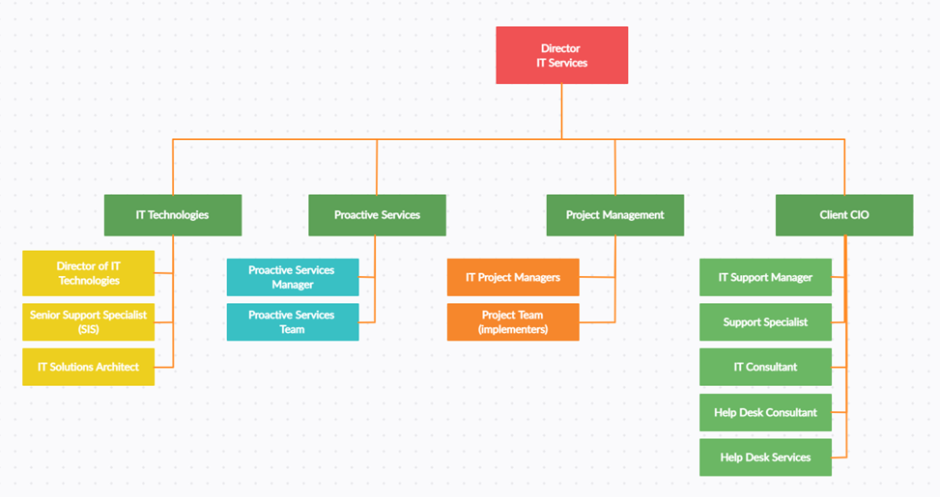

Figure 1.3 Organization Chart

**CHAPTER-2 OVERVIEW OF DIFFERENT DEPARTMENTS**

At Shaligram Infotech, the company is typically organized into different departments, each responsible for specific functions within the organization. Here's a typical layout of the company's departments:

**2.1 Different Departments**

**Executive Management:**

* Responsible for setting the company's vision, goals, and strategic direction.
* Oversees the overall operations of the company and ensures alignment with business objectives.

**Business Development:**

* Engages with potential clients, identifies new business opportunities, and builds strategic partnerships.
* Develops tailored solutions and proposals to meet client needs and drive revenue growth.

**Project Management:**

* Manages project lifecycles, resources, timelines, and budgets to ensure successful project delivery.
* Coordinates communication between clients and internal teams to ensure project requirements are met.

**Software Development:**

* Comprised of multiple teams specializing in various technologies and platforms.
* Responsible for designing, developing, and testing custom software solutions, including web and mobile applications, enterprise software, and CRM systems.

**Microsoft Dynamics 365 Department:**

* Specialized team dedicated to Microsoft Dynamics 365 solutions.
* Offers expertise in Dynamics 365 CRM and ERP implementations, customizations, integrations, and support services.
* Collaborates closely with clients to understand their business processes and requirements, delivering tailored Dynamics 365 solutions that drive efficiency and productivity.

**Web Development:**

* Designs and develops websites, web applications, and e-commerce platforms.
* Utilizes modern web technologies and frameworks to create visually appealing, responsive, and user-friendly web experiences.

**Mobile App Development:**

* Focuses on building native and cross-platform mobile applications for iOS and Android devices.
* Develops custom mobile solutions tailored to client specifications, ranging from consumer-facing apps to enterprise mobility solutions.

**Quality Assurance and Testing:**

* Ensures the quality, reliability, and performance of software solutions through comprehensive testing.
* Conducts manual and automated testing to identify and resolve issues, ensuring a seamless user experience.

**IT Support and Maintenance:**

* Offers ongoing support, maintenance, and troubleshooting services for software solutions post-deployment.
* Provides technical assistance, software updates, and performance monitoring to ensure the smooth operation of client systems.

**2.2 Technical Specification**

* 100 MBPS internet line
* 100/1000 MBPS Layer 2-switched intranet
* High grade machines for the engineers - Quad-Core Intel® i5® processor 3.16 GHz, 12 GB RAM
* High grade server with – four Quad-Core Intel® Xeon® processor3.16 GHz, and 64 GB RAM
* Shared UPS for all team and centralized UPS for servers.
* Backup for the whole facility with automatic line interactive switchover
* Up to 5 test machines and approximately 110 user machines, all equipped with OS combinations needed for testing apart from individual testing machines.
* Several UNIX/Linux boxes, Windows operating systems and a few Macintoshes machines form part of our test lab.
* Video Conferencing facilities.

**CHAPTER-3 INTRODUCTION TO INTERNSHIP AND PROJECT**

**3.1 Internship Summary**

During my Full Stack Web Development internship, I delved into a plethora of cutting-edge technologies, harnessing their power to craft dynamic and robust web applications. At the frontend, I honed my skills in HTML, CSS, and JavaScript, mastering the art of creating visually stunning and responsive user interfaces. Leveraging frameworks like jQuery, I enhanced interactivity and user experience, adding seamless animations and dynamic content to web pages. On the backend, I immersed myself in the .NET framework, utilizing C# to build powerful server-side components that seamlessly integrated with frontend interfaces.

In tandem with backend development, I delved into SQL for database management, learning to design and query relational databases to efficiently store and retrieve data. This proficiency in SQL enabled me to architect scalable and efficient database schemas, ensuring optimal performance for web applications. Additionally, my internship provided practical experience in deploying web applications using .NET technologies, familiarizing myself with deployment strategies and best practices essential for real-world application development.

Applying the knowledge gained from these experiences, I actively participated in the development of a project called Byte Bridge, a Blood Bank Management System. Leveraging my newfound expertise in full stack web development, I contributed to designing and implementing various features of the system, ensuring its functionality, reliability, and security. This hands-on project allowed me to apply theoretical concepts to real-world scenarios, further solidifying my understanding of web development principles. Overall, the internship provided me with a comprehensive understanding of full stack web development, equipping me with the skills and expertise necessary to thrive in the ever-evolving landscape of web technologies.

**3.2 Purpose**

The purpose of the Full Stack Web Development internship was to provide me with hands-on experience and practical exposure to modern web technologies, including frontend and backend frameworks such as HTML, CSS, JavaScript, jQuery, SQL, and .NET. Through guided learning and real-world projects, the internship aimed to deepen my understanding of web development concepts and prepare me for a career in the field. Additionally, the internship provided an opportunity to bridge the gap between theoretical knowledge and practical application, honing my problem-solving skills and critical thinking abilities in a professional work environment. Overall, the internship aimed to equip me with the skills, knowledge, and experience necessary to succeed in the dynamic and fast-paced world of web development.

**3.3 Objective**

The primary goal of the internship centered on furnishing me with an extensive comprehension and hands-on experience in full stack web development. Specifically, it sought to:

* Enhance my grasp of contemporary web technologies, encompassing both frontend and backend frameworks like HTML, CSS, JavaScript, jQuery, SQL, and .NET.
* Act as a conduit for integrating theoretical concepts amassed through academic studies into practical scenarios encountered in real-world web development endeavors.
* Empower me with the requisite skills, expertise, and self-assurance essential for navigating a prosperous career trajectory within the realm of full stack web development.

**3.4 Scope**

**1. Frontend Development**

* Mastery of HTML, CSS, JavaScript, and jQuery for creating visually appealing and interactive user interfaces.
* Understanding of frontend frameworks like Angular for building dynamic single-page applications (SPAs) with advanced features and components.

**2. Backend Development**

* Proficiency in backend technologies such as .NET, C#, and SQL for developing robust server-side components and managing databases.
* Familiarity with MVC architecture for organizing code and separating concerns in web applications.

**3. Full Stack Development**

* Integration of frontend and backend technologies to build end-to-end web applications with seamless communication between client and server.
* Implementation of RESTful APIs for data exchange between frontend and backend components.

**4. Database Management**

* Knowledge of SQL for database design, querying, indexing, and optimization to ensure efficient data storage and retrieval.
* Understanding of ORM (Object-Relational Mapping) frameworks for simplifying database interactions in .NET applications.

**5. Application Deployment**

* Experience in deploying web applications using .NET technologies to web servers or cloud platforms.
* Familiarity with deployment strategies and best practices for ensuring application reliability, scalability, and security.

**6. Project Work**

* Hands-on experience in working on real-world projects or building prototypes under the guidance of experienced mentors.
* Opportunities to contribute to the development of web applications, from design and implementation to testing and deployment.

**7. Learning and Skill Development**

* Continuous learning and skill development through practical experience, guided learning materials, and mentorship.
* Exposure to industry best practices, coding standards, and emerging trends in web development.

**3.5 Technology and Literature Review**

**1. HTML (Hypertext Markup Language)**

* Literature on HTML often covers its foundational role in web development, outlining its syntax, structure, and semantic elements.
* Topics may include HTML5 advancements, such as new semantic tags, multimedia support, and APIs, along with best practices for creating accessible and SEO-friendly web pages.

**2. CSS (Cascading Style Sheets)**

* Literature on CSS explores styling techniques, layout design, responsiveness, and CSS frameworks like Bootstrap or Foundation.

**3. JavaScript**

* Literature on JavaScript covers its role in frontend development, including DOM manipulation, event handling, asynchronous programming, and ES6+ features.
* Topics may include JavaScript frameworks/libraries like React, Vue.js, or Angular, as well as tools for code organization, testing, and performance optimization.

**4. jQuery**

* Literature on jQuery discusses its utility functions, event handling, AJAX requests, and plugin development.
* While jQuery's usage has declined with the rise of modern JavaScript frameworks, literature may still highlight its legacy in web development and migration strategies to newer technologies.

**5. SQL (Structured Query Language)**

* Literature on SQL covers database fundamentals, querying techniques, normalization, indexing, and transaction management.
* Advanced topics may include database administration, optimization strategies, security measures, and NoSQL databases like MongoDB or PostgreSQL.

**6. .NET (Microsoft's .NET Framework)**

* Literature on .NET explores its ecosystem, including the C# programming language, ASP.NET for web development, and WinForms/WPF for desktop applications.
* Discussions may include .NET Core, cross-platform development, microservices architecture, cloud integration with Azure, and best practices for performance and security.

**7. MVC (Model-View-Controller)**

* Literature on MVC architecture discusses its principles, separation of concerns, and advantages for building scalable and maintainable web applications.
* Topics may include implementation patterns, frameworks like ASP.NET MVC or Express.js, and comparisons with other architectural patterns like MVVM or Flux.

**8. C# (C-Sharp Programming Language)**

* Literature on C# covers language features, syntax, object-oriented programming concepts, and best practices for writing clean and efficient code.
* Advanced topics may include LINQ (Language Integrated Query), asynchronous programming with async/await, and design patterns like SOLID principles.

**9. Angular**

* Literature on Angular explores its architecture, components, modules, data binding, routing, and dependency injection.
* Discussions may include Angular CLI for project scaffolding, RxJS for reactive programming, state management with NgRx, and server-side rendering with Angular Universal.

**3.6 Internship Planning**

* **Internship and project development Approach and justification**

This Internship divided into 3 different phases

Phase 1: Basic Frontend Technologies

Phase 2: SQL Fundamentals

Phase 3: Advanced Web Development with .NET MVC and Angular

& Project Implementation

* **Internship and project Efforts and time**

|  |  |  |  |
| --- | --- | --- | --- |
| Week1 | Week2 | Week3 | Week4 |
| Intro + HTML | CSS + Bootstrap | JS + jQuery | Introduction to Databases |
| Week5 | **Week6** | **Week7** | **Week8** |
| MS SQL SERVER | SQL Querying | Introduction to .NET MVC | Model-View-Controller (MVC) architectural pattern |
| Week9 | **Week10** | **Week11** | **Week12** |
| set up and configure a .NET MVC project  &  Project Planning | Project Design  (ByteBridge) | Project Development  (ByteBridge) | Project Development  (ByteBridge) |

Table 3.6 Internship Planning

**Phase 1: Basic Frontend Technologies (3 Weeks)**

**1. HTML and CSS Fundamentals**

* + Learn the basics of HTML markup for structuring web pages.
  + Understand CSS syntax, selectors, and properties for styling.
  + Complete exercises to create simple web pages with HTML and CSS.

**2. JavaScript and jQuery Basics**

* + Introduction to JavaScript programming fundamentals.
  + Explore DOM manipulation, event handling, and basic jQuery usage.
  + Practice building interactive elements and simple animations.

**Phase 2: SQL Fundamentals (3 Weeks)**

**1. Introduction to Databases**

* + Understand the importance of databases in web development.
  + Learn basic database concepts such as tables, rows, columns, and relationships.
  + Explore different types of databases (relational, NoSQL) and their use cases.

**2. SQL Querying**

* + Dive into SQL language fundamentals for data manipulation and retrieval.
  + Learn to write basic to intermediate SQL queries for creating, updating, deleting, and querying data.
  + Practice SQL querying using a relational database management system like MySQL.

**Phase 3: Advanced Web Development with .NET MVC and Angular (6 Weeks)**

1. **.NET MVC**
   * Understand the Model-View-Controller (MVC) architectural pattern.
   * Learn to set up and configure a .NET MVC project.
   * Explore controllers, views, models, routing, and data access using Entity Framework.

**Project Implementation**

**1. Project Planning and Design**

* + Define project requirements, goals, and scope.
  + Create wireframes, mockups, and user stories.
  + Develop a project plan with milestones and deliverables.

**2. Project Development**

* + Implement frontend and backend functionalities according to the project plan.
  + Conduct regular code reviews and testing to ensure quality and functionality.
  + Iteratively refine and improve the project based on feedback.
* **Roles and Responsibilities**
* Frontend (HTML, CSS, JS, jQuery, AngularJS)
* Backend (ASP .Net MVC, C#)
* Database (SQL)
* Full-Stack Developer

**3.7 Project Scheduling (Gantt Chart)**

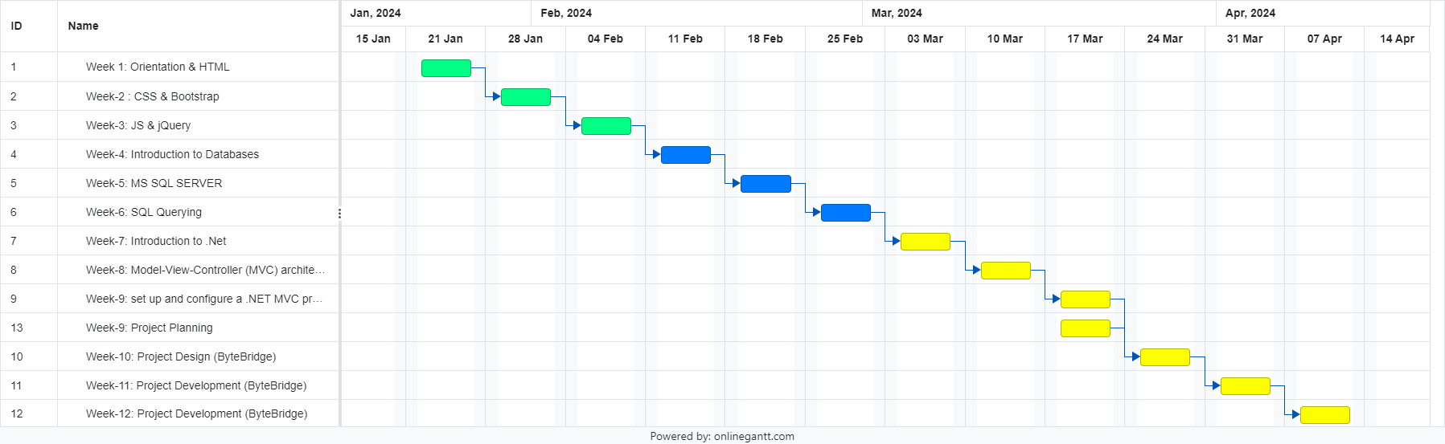

Figure 3.7 Project Scheduling (Gantt Chart)

**CHAPTER-4 SYSTEM REQUIREMENTS AND ANALYSIS**

**4.1 System Requirements**

**4.1.1 User Characteristics:**

* Blood Bank Administrators: Responsible for managing the overall operation of the blood bank, including donor management, inventory tracking, and blood request processing.
* Medical Staff: Utilize the system to access donor information, request blood products for patients, and record transfusion details.
* Donors: Register, schedule appointments, and donate blood through the system. Access their donation history and eligibility status.
* Patients: Hospitals and healthcare facilities submit blood requests and track the status of their requests through the system.

**4.1.2 Hardware and Software Requirements:**

**Server Requirements:**

* Operating System: Windows Server or Linux-based OS
* Processor: Intel Core i5 or equivalent
* RAM: Minimum 8GB
* Storage: Sufficient storage capacity for database and application files
* Internet Connectivity: Stable internet connection for remote access and data synchronization

**Client Requirements:**

* Operating System: Windows, macOS, or Linux
* Web Browser: Latest versions of Google Chrome, Mozilla Firefox, Safari, or Microsoft Edge
* Processor: Intel Core i3 or equivalent
* RAM: Minimum 4GB
* Screen Resolution: 1280x800 pixels or higher

**Software Requirements:**

* Database Management System (DBMS): Microsoft SQL Server or MySQL
* Web Server: Internet Information Services (IIS) or Apache
* Development Tools: Visual Studio or Visual Studio Code for development
* ASP.NET MVC Framework
* C# Programming Language
* JavaScript/jQuery for client-side scripting
* Entity Framework for data access

**4.1.3 Execution Environment:**

* The Blood Bank Management System is executed within a networked environment, accessible to authorized users through web browsers.
* The system is hosted on a server with appropriate hardware and software configurations, providing centralized access to data and functionalities.
* Client devices, including desktops, laptops, tablets, or smartphones, connect to the system via the internet or local network.

**4.1.4 Assumptions:**

* Users have basic computer literacy and familiarity with web-based applications.
* Access to the system is restricted to authorized personnel through secure authentication mechanisms.
* The system complies with relevant regulatory requirements for blood banking, including FDA regulations and AABB accreditation.
* Adequate training and support are provided to users for efficient utilization of the system.
* Regular backups and security measures are implemented to safeguard sensitive data.

**4.1.5 Dependencies:**

* Availability of reliable internet connectivity for remote access and data synchronization.
* Integration with external systems or databases for data exchange, such as electronic health record (EHR) systems or laboratory information management systems (LIMS).
* Compliance with regulatory standards and guidelines governing blood banking practices.
* Collaboration with blood donation centers and healthcare facilities for donor recruitment, blood collection, and distribution processes.

**4.2 System Analysis**

Study of the current Blood Bank Management System (BMS), aiming to analyze its functionalities, strengths, and shortcomings. The study intends to identify existing problems within the system to inform the development of an improved BMS.

**4.2.1 Methodology:**

* The study employed a multifaceted approach, including user interviews, observational studies, and data analysis.

**User Interviews:**

* In-depth interviews were conducted with blood bank administrators, medical staff, donors, and patients.
* Participants were asked about their experiences, challenges, and suggestions regarding the current BMS.

**Observational Studies:**

* Researchers observed the daily operations of blood bank staff using the current system.
* Instances of manual processes, inefficiencies, and bottlenecks were noted.

**Data Analysis:**

* Data from the current BMS, including blood inventory records, donor information, and transaction history, were analyzed.
* Trends, patterns, and discrepancies in the data were identified to uncover underlying issues.

**4.2.2 Problems of Current System:**

**Manual Processes and Time-Consuming Tasks:**

* Users reported significant manual effort and time consumption in tasks such as data entry, inventory management, and blood request processing.
* Lack of automation led to inefficiencies and delays in operations.

**Limited Visibility into Blood Inventory:**

* The current system lacked real-time visibility into blood inventory levels.
* Instances of stockouts and overstocking occurred due to inaccurate inventory tracking.

**Challenges in Donor Management:**

* Difficulties were encountered in managing donor records, scheduling appointments, and tracking donation history efficiently.
* Manual processes for donor registration and eligibility screening were cumbersome and error-prone.

**Communication and Coordination Issues:**

* Inefficient communication and coordination between blood banks, hospitals, and donors were identified.
* Lack of streamlined communication channels led to delays and miscommunications in blood request processing.

**Reporting and Analytics Limitations:**

* The current system offered limited reporting and analytics capabilities.
* Users faced challenges in generating comprehensive reports and extracting meaningful insights from the data.

**Security and Compliance Concerns:**

* Users expressed concerns regarding data security and compliance with regulatory requirements.
* The current system lacked robust security measures to protect sensitive donor information and transaction records.

**4.3 Functional and Non-Functional Requirements**

**4.3.1 Functional Requirements**

* **User Management:** Ability to manage user roles and permissions for administrators, medical staff, donors, and patients.
* **Donor Management:** Features for donor registration, donor eligibility screening, appointment scheduling, and donor profile management.
* **Inventory Management:** Functionality for blood inventory tracking, including blood type, quantity, expiration dates, and storage locations.
* **Blood Request Processing:** Capability to submit, process, and fulfill blood requests from hospitals and healthcare facilities.
* **Reporting and Analytics:** Tools for generating reports on blood inventory levels, donor demographics, donation trends, and transfusion history.

**4.3.2 Non-Functional Requirements**

* **Security:** Implementation of robust security measures to protect sensitive data, including encryption, access controls, and audit trails.
* **Scalability:** Designing the system to accommodate future growth in data volume and user base.
* **Usability:** Creating intuitive user interfaces with clear navigation and minimal learning curve for users.
* **Performance:** Ensuring optimal system performance, responsiveness, and reliability under varying load conditions.
* **Compliance:** Adherence to regulatory standards and guidelines governing blood banking practices, including FDA regulations and AABB accreditation.

**4.4 Feasibility Study**

**4.4.1 Does the System Contribute to The Overall Objectives of The Organization?**

The proposed Blood Bank Management System (BMS) aligns with the overall objectives of the organization by enhancing operational efficiency, improving service delivery, facilitating data-driven decision-making, ensuring compliance, and supporting strategic alignment. By streamlining blood bank operations, automating manual processes, and providing real-time visibility into inventory levels, the BMS contributes to organizational success and mission fulfillment.

**4.4.2 Can the System Be Implemented Using the Current Technology and Within the Given Cost and Schedule Constraints?**

The feasibility study indicates that the system can be implemented using existing technologies such as ASP.NET MVC for web development, Microsoft SQL Server for database management, and C# programming language for backend logic. Additionally, the development can be carried out within the given cost and schedule constraints by employing an iterative and incremental approach, prioritizing essential features, and adhering to project management best practices.

**4.4.3 Can the System Be Integrated with Other Systems Which Are Already in Place?**

The system can be integrated with other systems already in place, such as electronic health record (EHR) systems, laboratory information management systems (LIMS), and hospital information systems (HIS). Integration can be achieved through APIs, data exchange formats such as HL7, and middleware solutions to ensure seamless communication and data interoperability between the BMS and existing systems. Compatibility and interoperability testing will be conducted to ensure successful integration without disrupting existing workflows.

**4.5 Features of New System**

* User Authentication and Authorization
* Intuitive User Interface
* Real-Time Inventory Tracking
* Automated Alerts and Notifications
* Appointment Scheduling
* Integration with External Systems
* Comprehensive Reporting and Analytics
* Security and Compliance

**4.6 Diagrams**

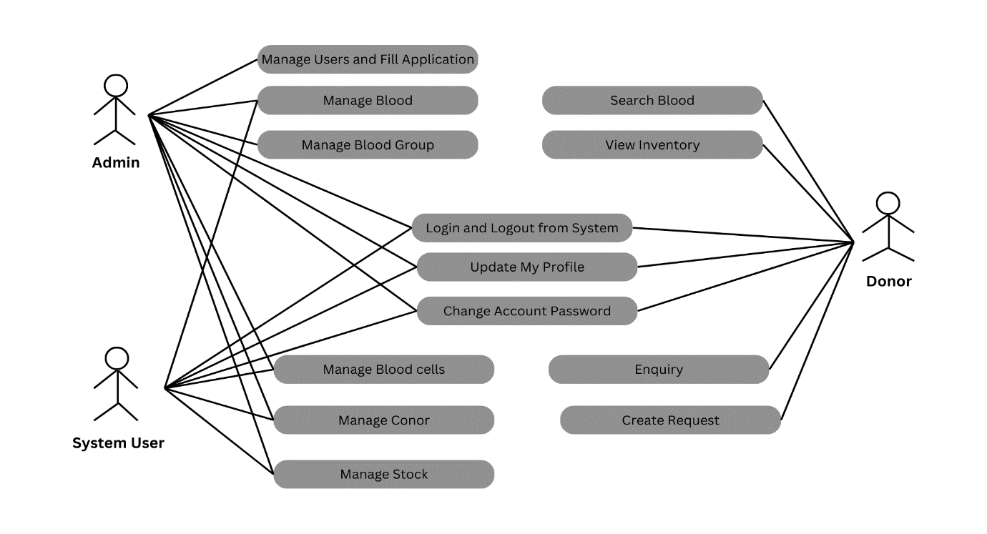

Figure 4.6.1 Use Case Diagram

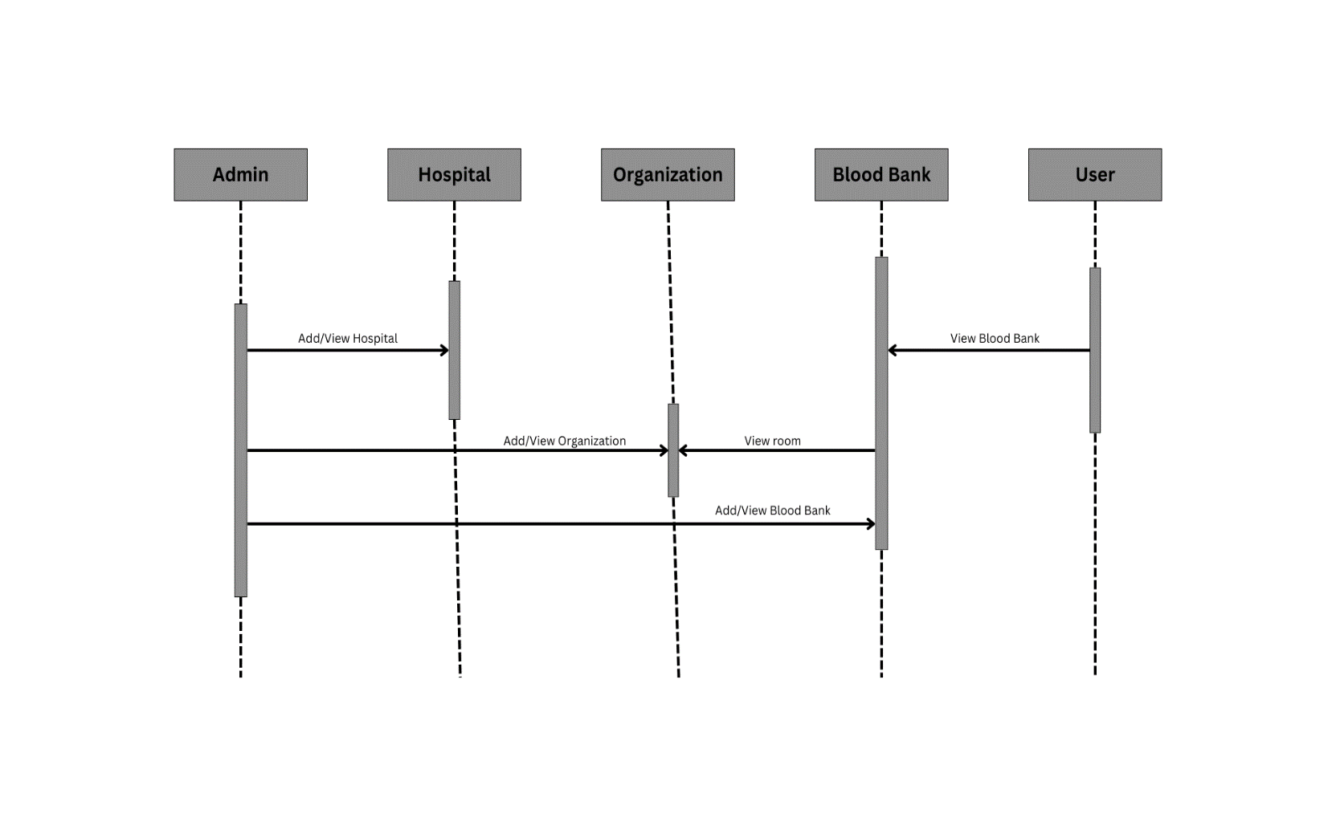

Figure 4.6.2 Sequence Diagram

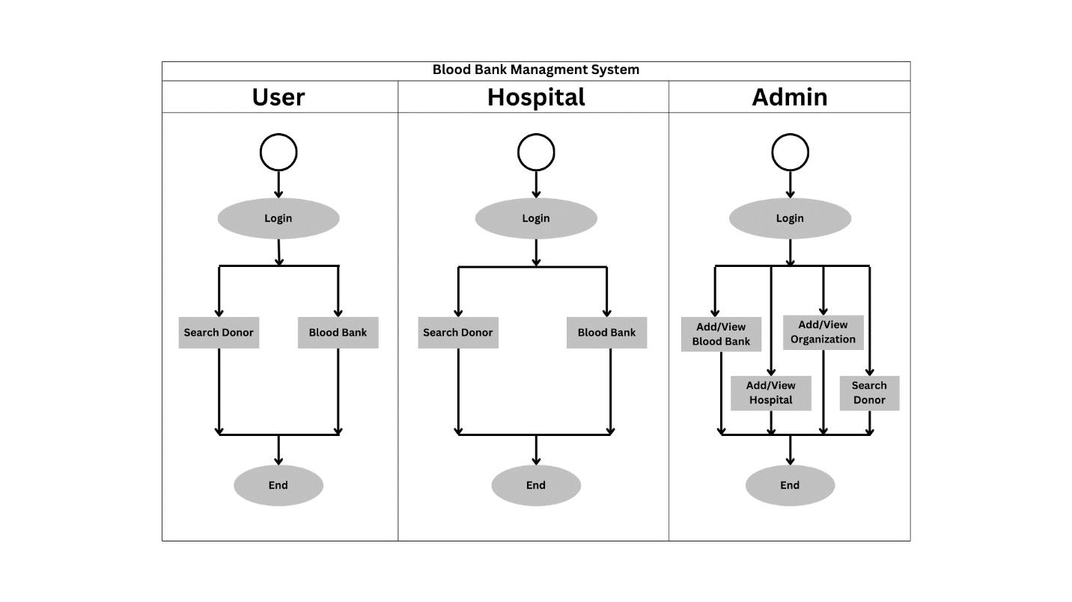

Figure 4.6.3 Activity Diagram

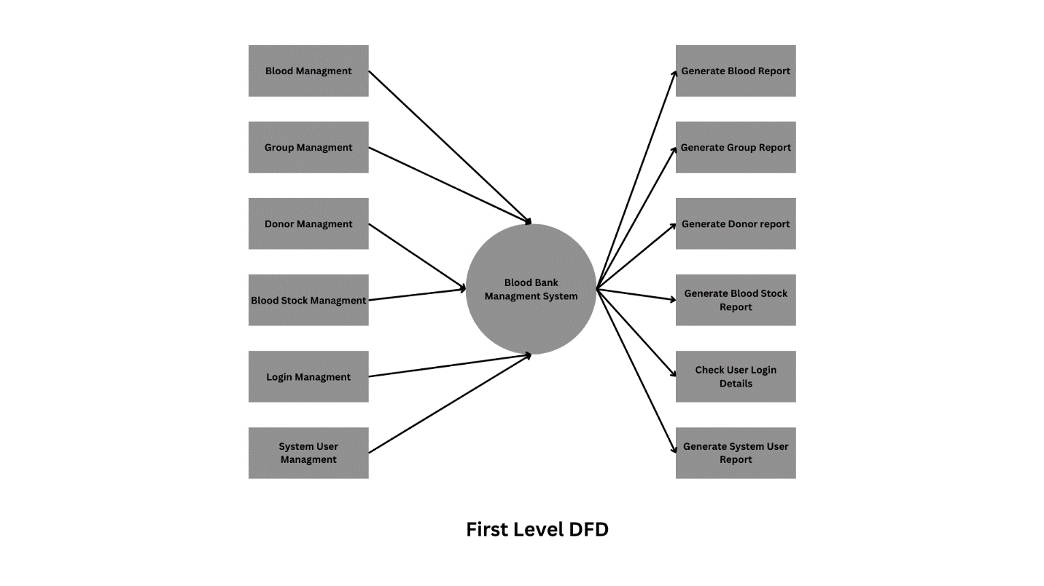

Figure 4.6.4 First Lavel Data Flow Diagram

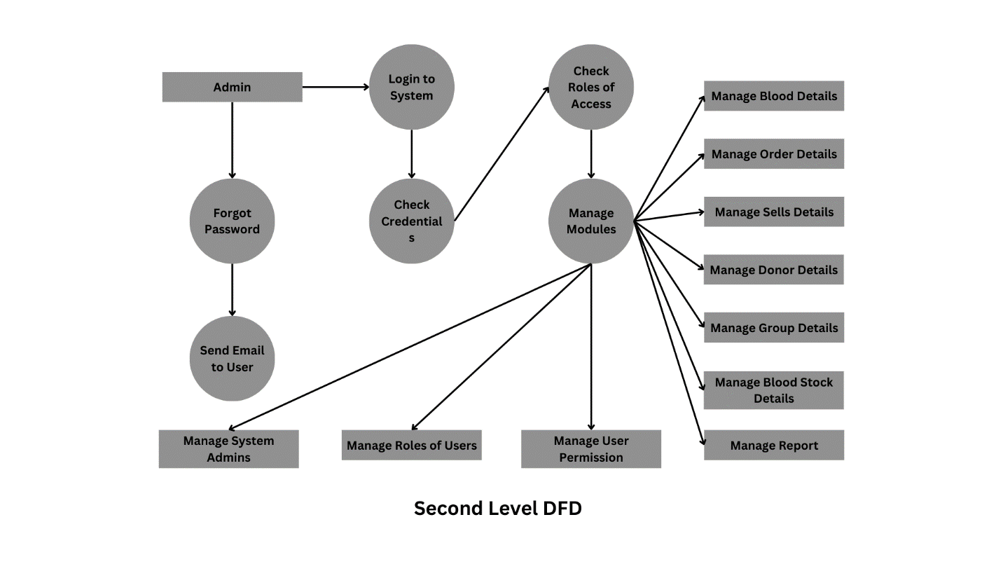

Figure 4.6.5 Second Level Data Flow Diagram

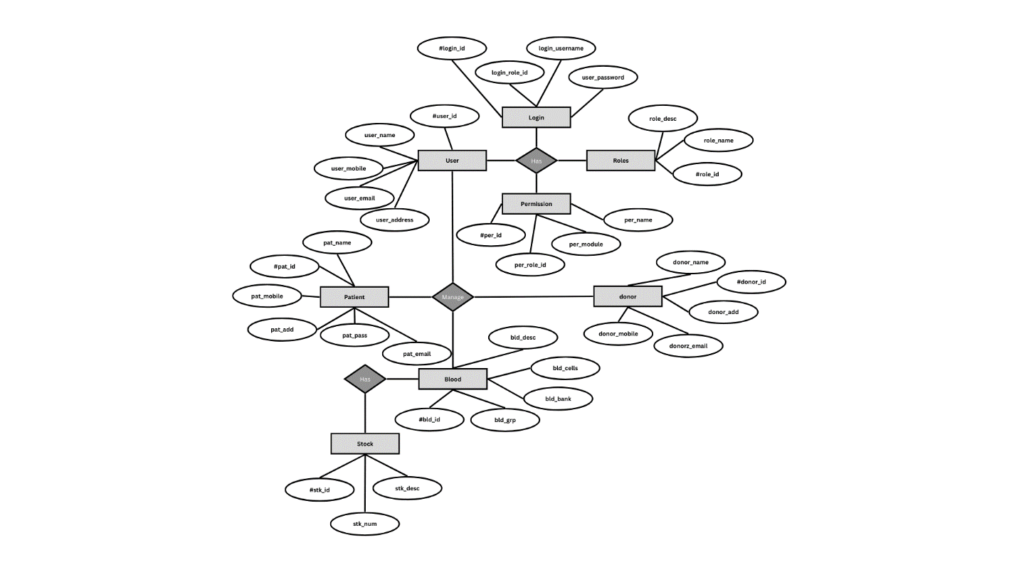

Figure 4.6.6 ER Diagram

**4.7 List of Main Modules of New System**

Main Modules of the ByteBridge (BMS):

* User Management Module
* Donor Management Module
* Inventory Management Module
* Blood Request Processing Module
* Reporting and Analytics Module
* Security and Compliance Module
* Communication Module
* Integration Module

**CHAPTER-5 SYSTEM DESIGN**

**5.1 System Design & Methodology**

**5.1.1 BMS System Design:**

**1. System Modules:**

* **Donor Management:** Donor registration and eligibility screening.
* **Inventory Management:** Blood inventory tracking and storage monitoring.
* **Testing and Quality Control:** Blood testing and quality assurance.
* **Distribution and Transfusion:** Blood request management and patient matching.
* **Reporting and Analytics:** Generate reports and analytics on donor statistics, inventory, and usage.

**2. User Interface:**

* **Dashboard:** User-friendly dashboard for quick access to key functionalities.
* **Role-Based Access Control**: Different access levels for administrators, technicians, and staff.

**3. Integration:**

* **Interoperability:** Compatibility with other healthcare systems.
* **Data Import/Export:** Import/export data in various formats.

**4. Security:**

* **Data Encryption:** Secure sensitive data using encryption.
* **Access Control**: Prevent unauthorized access with access control measures.

**5.1.2 Methodology:**

The implementation of a Blood Bank Management System (BMS) typically follows a structured methodology starting with **Requirement Analysis**. This involves engaging with stakeholders to gather specific requirements and define functionalities needed for the system.

Next is the System **Design phase**, where a high-level design is developed outlining system modules, user interface, and integration points. This is followed by the **Development and Customization stage**, where the software is developed or customized to meet the specific needs of the blood bank.

Once the development is completed, the system undergoes **Testing,** which includes unit testing, integration testing, and user acceptance testing (UAT) to ensure functionality, integration, and user satisfaction.

After successful testing, the system is ready for **Training and Deployment.** Staff members are trained on how to use the BMS effectively, and the system is deployed in a production environment.

Ongoing **Maintenance and Support** are provided to address any issues and ensure the system remains secure and up-to-date. Additionally, comprehensive **Documentation** is provided to assist users and IT teams in understanding and maintaining the system.

Throughout the implementation process, **Continuous Improvement** is emphasized, with feedback collection, updates, and upgrades planned to enhance functionality and address new requirements as needed.

**5.2 Database Design**

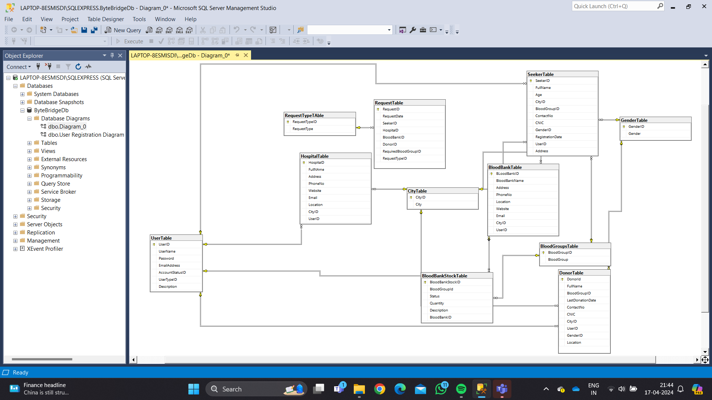

Figure 5.2 Database Diagram

**5.3 Input/Output and System Design**

**5.3.1 Home Page**

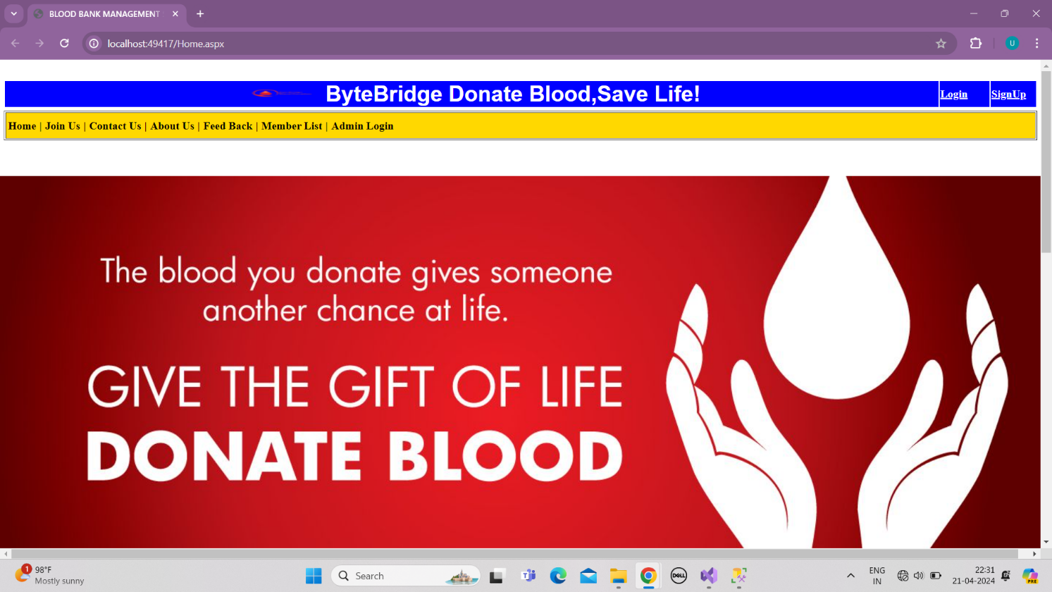

Figure 5.3.1.1 Home page

**5.3.2 Registration Page**

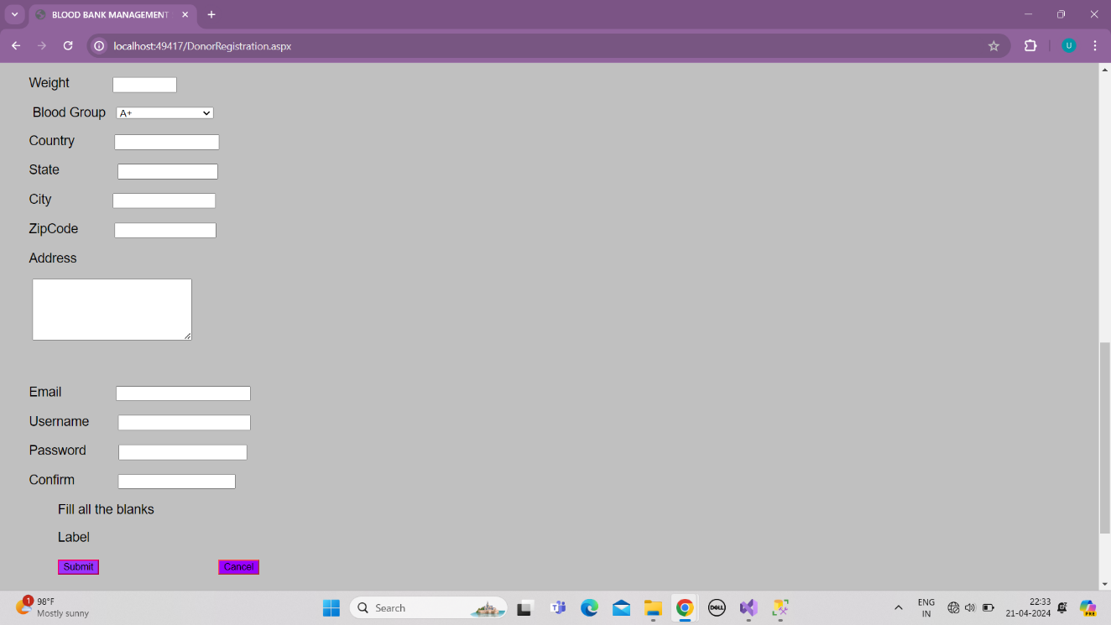

Figure 5.3.2 Registration Page

**5.3.3 Login Page**

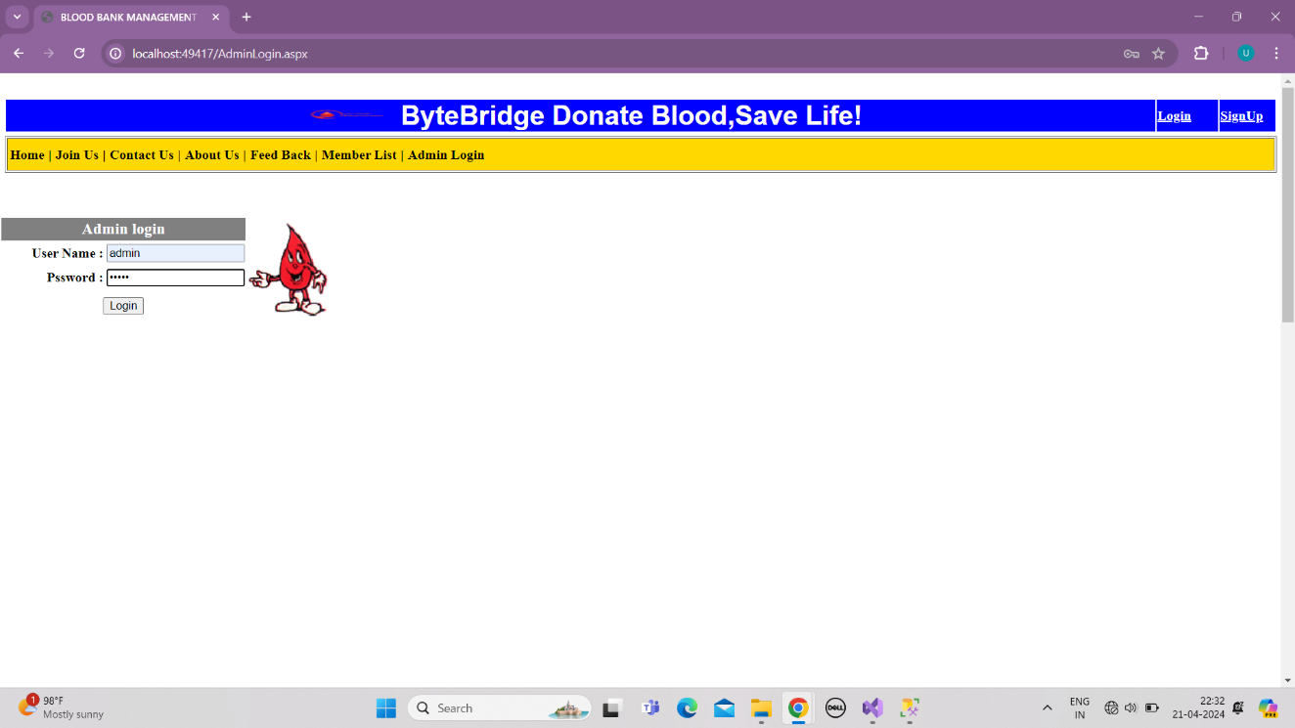

Figure 5.3.3 Login Page

**5.3.4 Admin side**

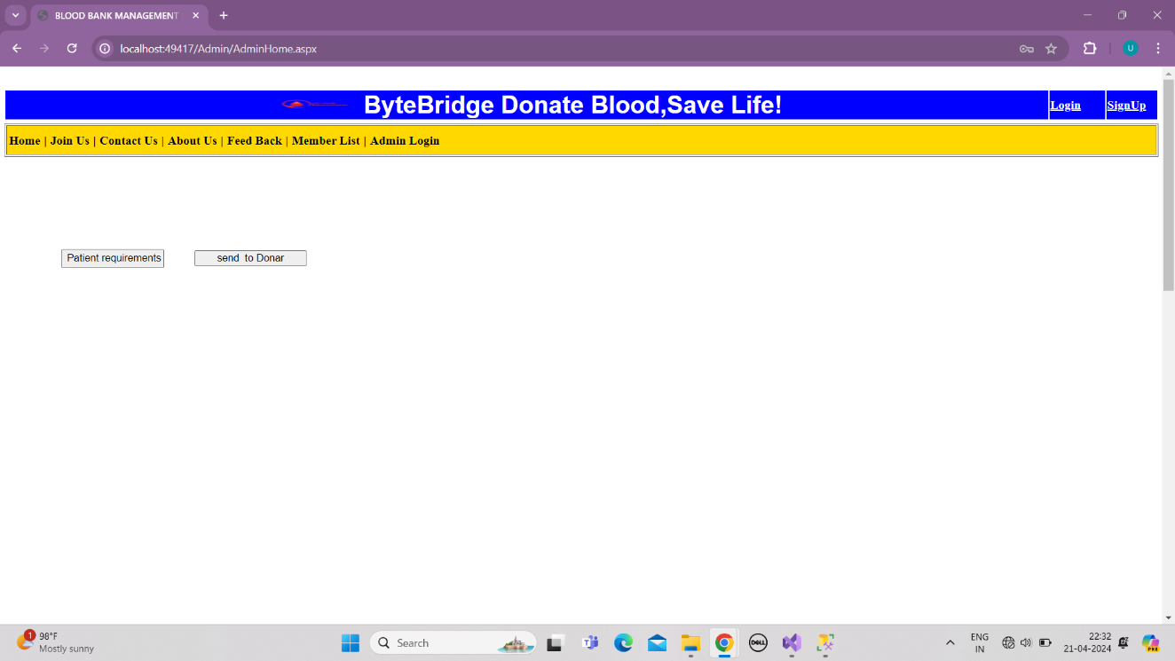

Figure 5.3.4 Admin side

**5.3.5 Contact us**

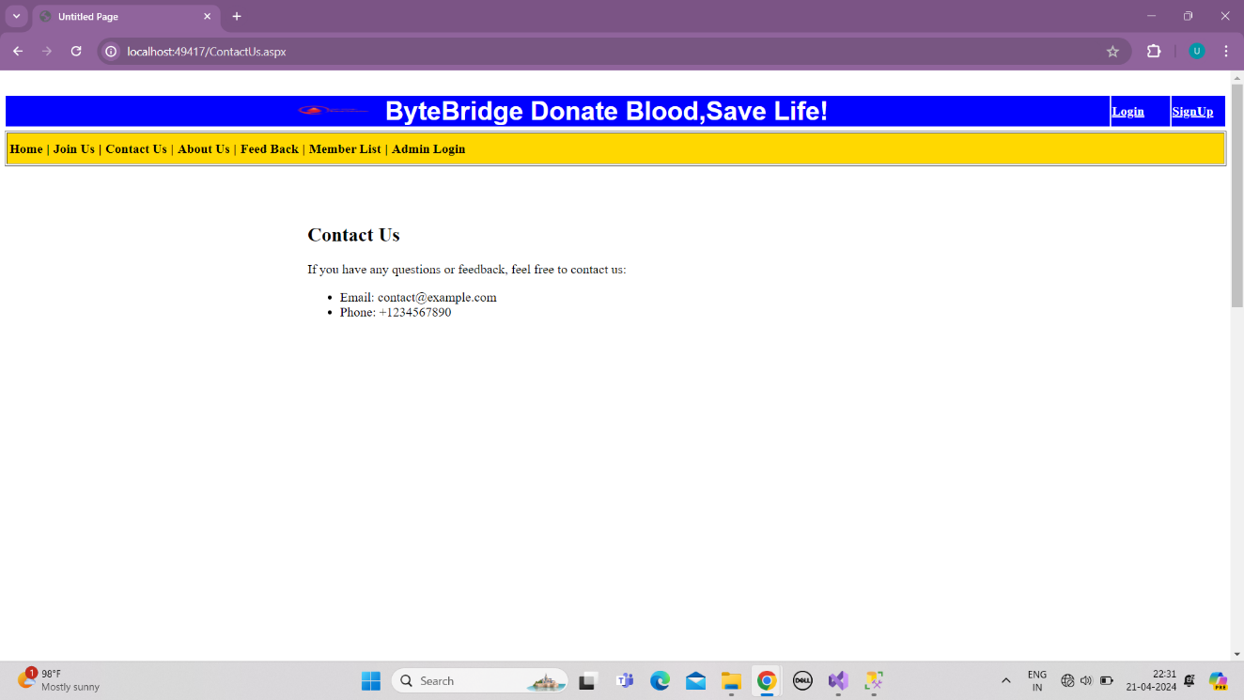

Figure 5.3.5 Contact us

**5.3.6 About us**

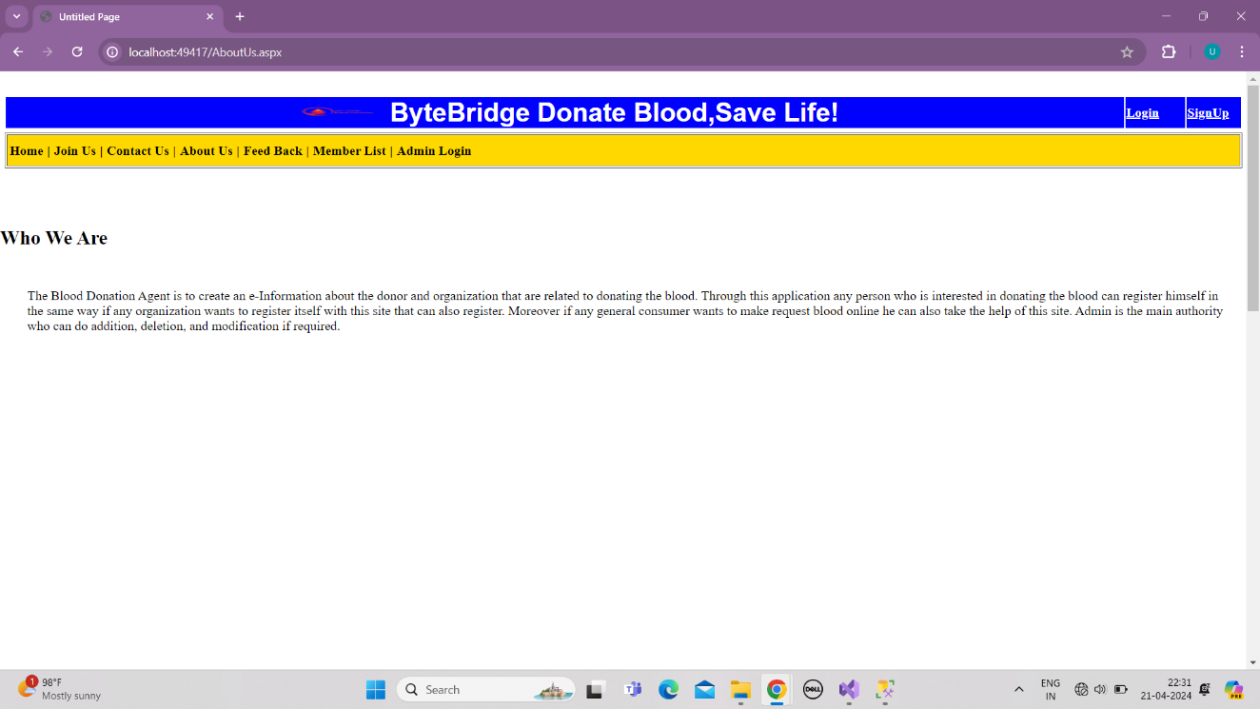

Figure 5.3.6 about us

**5.3.7 feedback**

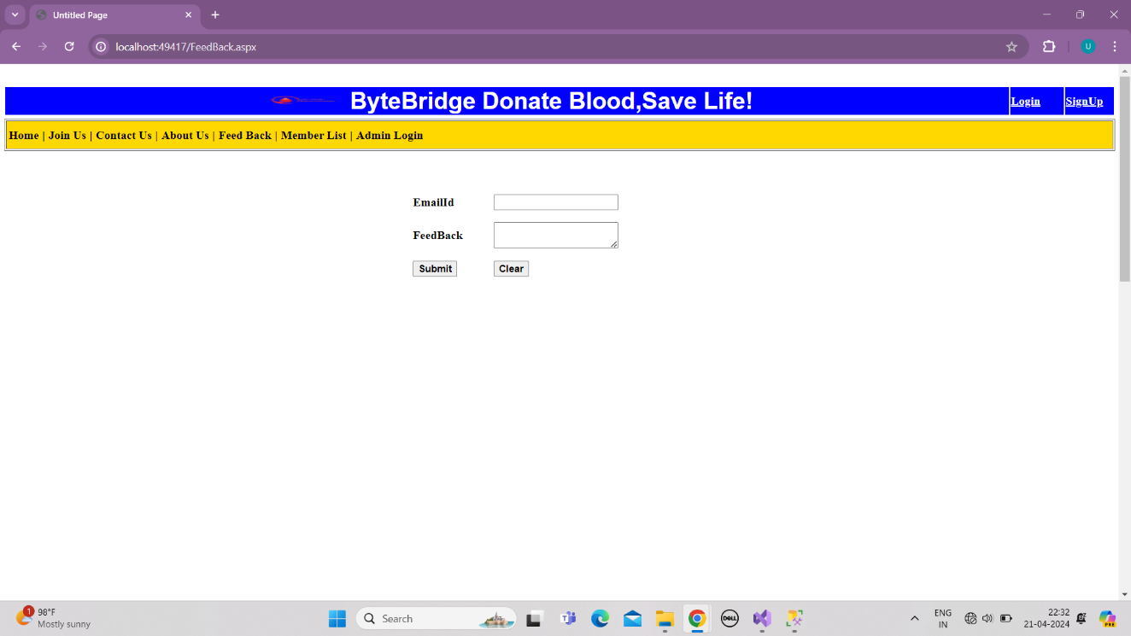

Figure 5.3.7 feedback

**5.3.8 Patient side**

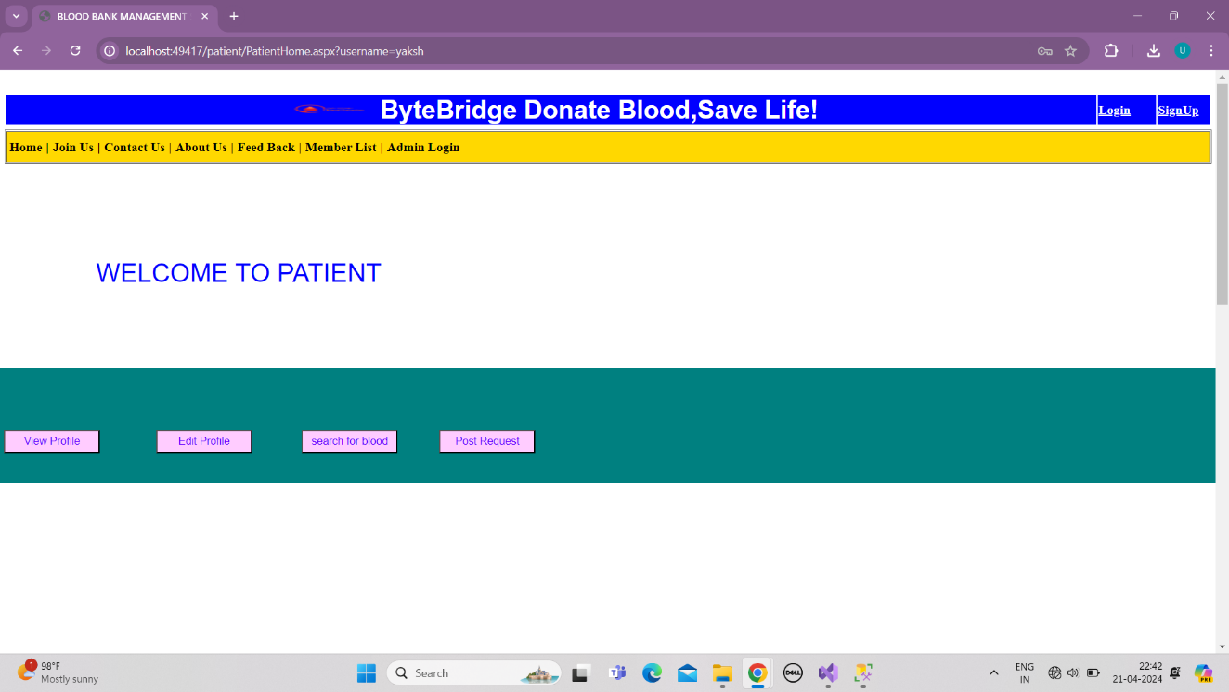

Figure 5.3.8 Patient side

**5.3.9 Edit Profile**

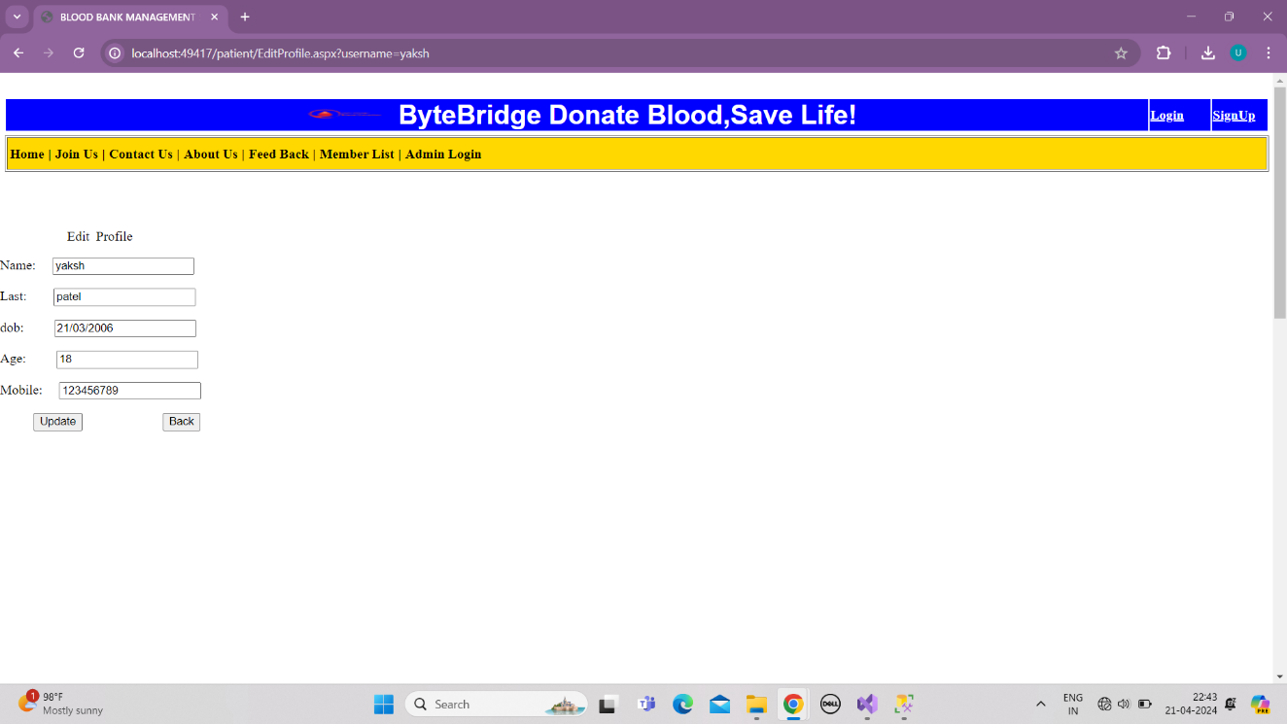

Figure 5.3.9.1 Edit Profile

**5.3.10 Donor Finder**

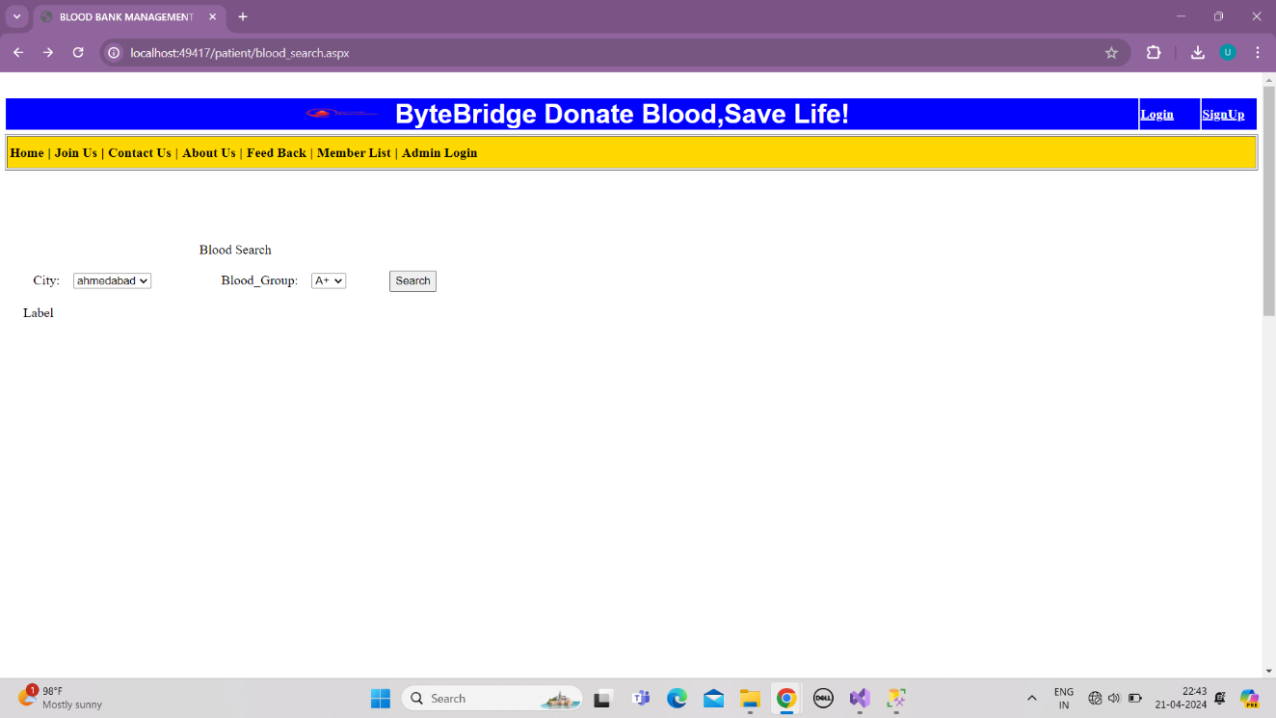

Figure 5.3.10 Donor Finder

**5.3.11 Request for Blood**

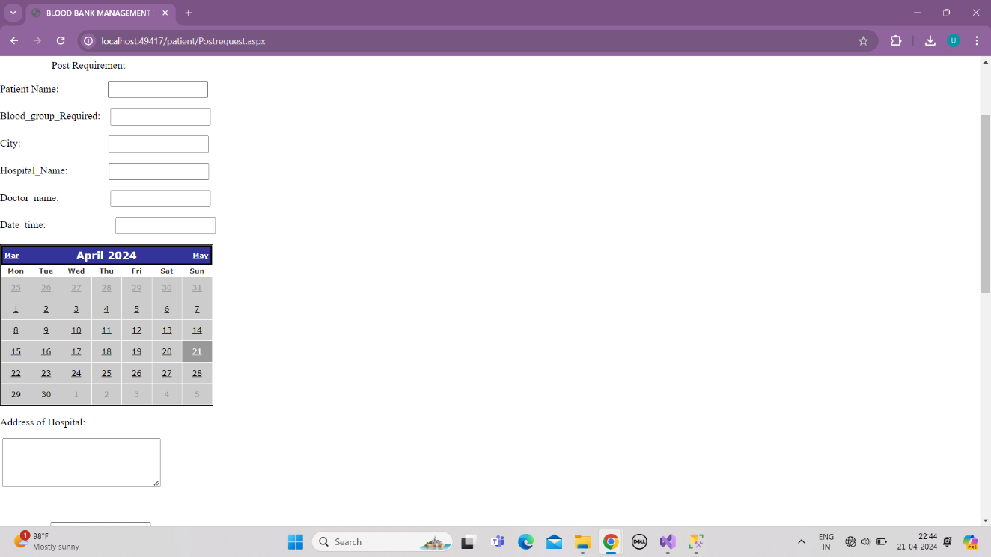

Figure 5.3.11 Request for Blood

**CHAPTER-6 IMPLEMENTATION PLANNING**

Implementation planning provides a roadmap for successful execution, ensuring that the BMS implementation is well-managed, efficient, and meets the blood bank's operational needs while delivering value to stakeholders.

**6.1 Implementation Platform**

**Web-Based Platform:**

Description: A web-based platform allows access to the BMS through a web browser, making it accessible from any device with an internet connection.

**Advantages:**

* Cross-platform compatibility
* Centralized management and updates
* Accessibility from anywhere

**Technologies:**

* Frontend: HTML, CSS, JavaScript
* Backend: .NET
* Database: MySQL

**6.2 Modules Specifications**

**1. Donor Management:**

* Features: Registration, Eligibility Screening, Scheduling
* Data Fields: Name, Contact, Medical History, Blood Type

**2. Inventory Management:**

* Features: Tracking, Storage Management, Stock Alerts
* Data Fields: Blood Type, Quantity, Expiration Date, Storage Location

**3. Testing and Quality Control:**

* Features: Quality Assurance, Test Results Management
* Data Fields: Test Type, Results, Date and Time

**4. Distribution and Transfusion:**

* Features: Request Management, Allocation, Transfusion Records
* Data Fields: Patient Details, Blood Type, Transfusion Date

**5. Reporting and Analytics:**

* Features: Donor Statistics, Inventory Reports, Operational Analytics
* Data Fields: Donor Demographics, Inventory Levels, Operational Metrics

**6. User Management and Security:**

* Features: User Profiles, Access Control, Audit Trails
* Data Fields: User Details, Access Permissions, Audit Logs

**7. Communication and Notification:**

* Features: Donor Communication, Stock Alerts, Emergency Alerts
* Data Fields: Recipient Details, Notification Type, Date and Time

**6.3 Outcomes**

* **Speeds Things Up:** Tasks like checking blood supplies or adding a new donor are done faster.
* **Fewer Mistakes:** Automated systems mean less chance of getting things wrong.
* **Know What's in Stock:** Easily see how much of each blood type is available.
* **Safe Blood:** The system checks to make sure donated blood is safe for patients.

**6.4 Result Analysis**

* **Check the Numbers:** Look at how many donors visited, how much blood was used, and other important numbers.
* **Ask Users:** Get feedback from people who use the system to see if they like it.
* **Meet the Rules:** Make sure the system meets all safety and reporting rules.
* **See Trends:** Use simple charts to spot trends, like when donations are high or low.

**CHAPTER-7 TESTING**

Testing is crucial for ensuring the reliability, functionality, and security of a Blood Bank Management System.

**7.1 Testing Strategy**

* **Test Planning:** Define objectives, scope, and resources for testing.
* **Test Design:** Create test cases, scripts, and data.
* **Test Execution:** Run tests and record results.
* **Defect Tracking:** Log and prioritize any issues found.
* **Test Reporting:** Document test results and provide feedback.
* **Retesting:** Confirm issues are resolved in subsequent versions or patches.

**7.2 Test Results & Analysis**

|  |  |  |  |  |
| --- | --- | --- | --- | --- |
| Testcase ID | Testcase Description | Expected Result | Actual Result | Status (Pass/Fail) |
| TC001 | User Registration | User should be registered | User registered | Pass |
| TC002 | User Login | User should be able to login | User logged in | Pass |
| TC003 | Add Blood Donor | Donor details should be added | Donor added | Pass |
| TC004 | Search Blood Donor | Donor details should be found | Donor found | Pass |
| TC005 | Edit Blood Donor Information | Donor details should be updated | Donor updated | Pass |
| TC006 | Delete Blood Donor | Donor should be deleted | Donor deleted | Pass |
| TC007 | Add Blood Request | Request should be added | Request added | Pass |
| TC008 | Search Blood Request | Request should be found | Request found | Pass |
| TC009 | Edit Blood Request Information | Request details should be updated | Request updated | Pass |
| TC010 | Delete Blood Request | Request should be deleted | Request deleted | Pass |
| TC011 | Add Blood Stock | Blood stock should be added | Stock added | Pass |
| TC012 | Search Blood Stock | Blood stock should be found | Stock found | Pass |
| TC013 | Edit Blood Stock Information | Blood stock details should be updated | Stock updated | Pass |
| TC014 | Delete Blood Stock | Blood stock should be deleted | Stock deleted | Pass |
| TC015 | Generate Blood Stock Report | Report should be generated | Report generated | Pass |
| TC016 | Generate Blood Donation Report | Report should be generated | Report generated | Pass |
| TC017 | Generate Blood Request Report | Report should be generated | Report generated | Pass |
| TC018 | User Profile Update | Profile should be updated | Profile updated | Pass |
| TC019 | Password Reset | Password should be reset | Password reset | Pass |
| TC020 | Logout | User should be logged out | User logged out | Pass |
| TC021 | Blood Type Validation | Valid blood type should be accepted | Blood type accepted | Pass |
| TC022 | Invalid Blood Type Validation | Invalid blood type should be rejected | Blood type rejected | Pass |
| TC023 | Search Donor by Blood Type | Donors with specific blood type should be found | Donors found | Pass |
| TC024 | Add Blood Donation Event | Donation event should be added | Event added | Pass |
| TC025 | Edit Blood Donation Event Information | Donation event details should be updated | Event updated | Pass |
| TC026 | Delete Blood Donation Event | Donation event should be deleted | Event deleted | Pass |
| TC027 | Search Blood Donation Event | Donation event should be found | Event found | Pass |
| TC028 | Add Blood Group | Blood group should be added | Blood group added | Pass |
| TC029 | Edit Blood Group Information | Blood group details should be updated | Blood group updated | Pass |
| TC030 | Delete Blood Group | Blood group should be deleted | Blood group deleted | Pass |
| TC031 | Search Blood Group | Blood group should be found | Blood group found | Pass |
| TC032 | Add Blood Donation Campaign | Campaign should be added | Campaign added | Pass |
| TC033 | Edit Blood Donation Campaign | Campaign details should be updated | Campaign updated | Pass |
| TC034 | Delete Blood Donation Campaign | Campaign should be deleted | Campaign deleted | Pass |
| TC035 | Search Blood Donation Campaign | Campaign should be found | Campaign found | Pass |
| TC036 | Notification for Low Blood Stock | Notification should be sent for low blood stock | Notification sent | Pass |
| TC037 | User Role-Based Access Control | Users should have appropriate access based on their roles | Access granted | Pass |
| TC038 | Secure Data Encryption | Data should be encrypted | Data encrypted | Pass |
| TC039 | Backup and Restore Data | Data should be backed up and restored without loss | Data backed up & restored | Pass |
| TC040 | User Interface Responsiveness | UI should be responsive on different devices | UI responsive | Pass |

Table 11.2 Test Results

**CHAPTER-8 CONCLUSION AND DISCUSSION**

**8.1 Overall Analysis of Internship**

The internship in Blood Bank Management System (BMS) provided practical experience in healthcare technology and system implementation. Through this internship, I gained hands-on experience in BMS functionalities such as donor management, inventory tracking, and quality control. Working on real-world projects enhanced my understanding of healthcare operations and software development in this specialized field. Collaborating with the team and adapting to challenges strengthened my problem-solving and teamwork skills. Overall, the internship was a valuable opportunity that enriched my knowledge and skills in BMS and healthcare management.

**8.2 Dates of Continuous Evaluation**

|  |  |
| --- | --- |
| Dates of Continuous Evaluation - I | 16th March, 2024 |
| Dates of Continuous Evaluation - II | 6th April, 2024 |

Table 12.2 Dates of Continuous Evaluation

**8.3 Problem Encountered and possible Solutions**

**Problem Encountered:**

* **Data Accuracy Issues:** Incorrect or outdated information in donor records and inventory.
* **System Downtime:** Unplanned system outages affecting daily operations.
* **User Training Challenges**: Difficulty in training staff to use the new BMS effectively.

**Possible Solutions:**

**1. Data Accuracy Issues:**

Solution: Implement regular data validation checks and encourage staff to update records promptly. Introduce automated data verification tools to ensure accuracy.

**2. System Downtime**:

Solution: Implement a robust backup and recovery system. Schedule regular maintenance during off-peak hours and notify users in advance.

**3. User Training Challenges:**

Solution: Provide comprehensive training sessions with hands-on exercises. Create user-friendly manuals and tutorials. Consider on-going refresher training sessions.

By addressing these problems with the suggested solutions, the BMS can become more reliable, user-friendly, and secure, ensuring smooth operations and better patient care in the blood bank.

**8.4 Summary of Project Work**

The project involved developing and implementing a Blood Bank Management System (BMS) to streamline donor management, inventory tracking, and blood distribution. Challenges encountered included data accuracy issues and system downtime. Solutions such as implementing data validation checks, enhancing security measures, and scheduling regular maintenance were implemented to address these challenges. Through collaboration with the team and hands-on problem-solving, improving efficiency and ensuring better patient care in the blood bank.

**8.5 Limitation and Future Enhancement**

**Limitations:**

**1. Scalability:** The current system may face challenges in handling a significant increase in data or user load.

**2. Integration:** Some existing systems or equipment may not fully integrate with the BMS.

**3. User Experience:** Initial feedback from users may reveal areas where the system's usability can be improved.

**4. Security:** While measures are in place, continuous monitoring and updates are required to stay ahead of emerging threats.

**5. Reporting Flexibility:** The current reporting module may lack customization options for generating specific or complex reports.

**Future Enhancements:**

**1. Scalability Improvement:**

* Enhance system architecture to support increased data storage and user capacity.
* Implement cloud-based solutions for better scalability and flexibility.

**2. Enhanced Integration:**

* Develop APIs or middleware for seamless integration with other healthcare systems.
* Explore IoT integration for real-time monitoring of storage conditions and equipment.

**3. User Experience Enhancement:**

* Conduct user feedback sessions to identify areas for improvement in system usability.
* Implement a user-friendly interface with customizable dashboards and shortcuts.

**4. Advanced Security Features:**

* Introduce advanced encryption techniques and biometric authentication.
* Regularly update security protocols and conduct vulnerability assessments.

**5. Customizable Reporting:**

* Develop a more flexible reporting module with customizable templates and filters.
* Implement data visualization tools for easier interpretation and analysis of reports.

By addressing these limitations and implementing future enhancements, the Blood Bank Management System (BMS) can evolve into a more robust, scalable, and user-friendly solution that continues to meet the evolving needs of the blood bank and its stakeholders.

**PLAGIARISM REPORT**

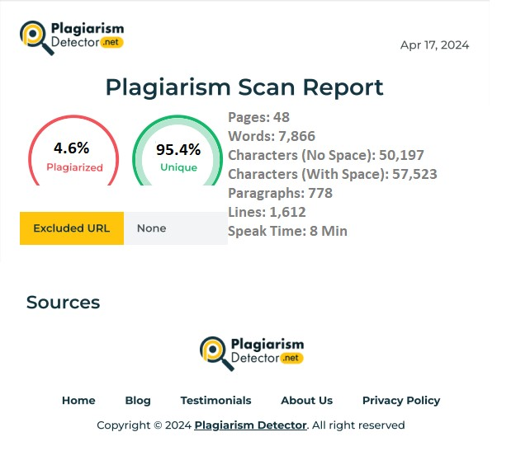

Figure: plagiarism Report

**REFERENCES**

* [JavaScript | MDN (mozilla.org)](https://developer.mozilla.org/en-US/docs/Web/javascript)
* [JavaScript Tutorial (w3schools.com)](https://www.w3schools.com/Js/)
* [e-RaktKosh:Centralized Blood Bank Management System (eraktkosh.in)](https://www.eraktkosh.in/BLDAHIMS/bloodbank/transactions/bbpublicindex.html)
* [ASP Tutorial (w3schools.com)](https://www.w3schools.com/asp/)
* [C Sharp (programming language) - Wikipedia](https://en.wikipedia.org/wiki/C_Sharp_%28programming_language%29)
* [Get started with ASP.NET Core MVC | Microsoft Learn](https://learn.microsoft.com/en-us/aspnet/core/tutorials/first-mvc-app/start-mvc?view=aspnetcore-8.0&tabs=visual-studio)
* [Online Blood Bank System Project - ProjectsGeek](https://projectsgeek.com/2018/12/online-blood-bank-system-project.html)
* [Blood Bank Management System | Devpost](https://devpost.com/software/blood-bank-management-system-5e1toh)
* [Assessment of Performance of Blood Banks in India: A National Level Cross Sectional Study | Indian Journal of Hematology and Blood Transfusion (springer.com)](https://link.springer.com/article/10.1007/s12288-021-01399-9)