

Inst tute of Informat on and Commun cat on

R shabh Chauhan

22285756009

CLOUD COMPUTING(ITEC304)

SEMESTER-3rd BATCH 2022-2024 COURSE-M.Sc. INFORMATICS

SUBMITTED TO:

Dr.Unmesh Shukla

ASSIGNMENT (MySQL)

**Question 1:**Can you store these data objects in a **MySQL table** along with a **primary key** (**INT** type) **ID column** and a **DESCRIPTION** column

(**TEXT** type)?

**Answer:**

Storing large data objects (e.g., files of 10 MB or more) directly in a MySQL table, especially within a TEXT column, is not typically recommended. While it is technically possible to store such data in a database, doing so can have several drawbacks and is not considered a best practice for large files or multimedia content. Here are some issues you might encounter:

**Performance:** Storing large data objects in a MySQL table can negatively impact database performance. Retrieving or updating these objects can be slow and resource-intensive, especially if many users are accessing the database concurrently.

**Database Bloat:** Large data objects can quickly lead to database bloat, which can result in slower backups, longer query times, and increased storage costs.

**Lack of Indexing:** TEXT columns are typically not indexed for searching or sorting, making it inefficient to search for specific content within these large objects.

**Limited Scalability**: As your dataset grows, it becomes increasingly challenging to scale your database, and it may require more resources to handle the large data objects effectively.

**Complexity:** Managing large data objects in a database introduces complexity in your application code and database maintenance.

**Question 2:**According to you, what can be an ideal solution for storing the information of such objects in a table?

**Answer:** Instead of storing large data objects directly in the database, here's a more common and recommended approach:

**File System Storage**: Store the large data objects (multimedia files, large text documents, etc.) in the file system of your server or a dedicated file storage service like Amazon S3, Google Cloud Storage, or a content delivery network (CDN). Each object should be saved as a file, and you can store the file paths or references in the database.

**Database Metadata:** In your database, store metadata about these objects in a structured manner. This metadata might include information like the file name, description, file path or URL, file size, date uploaded, and any other relevant attributes. You can use a table structure similar to what you suggested, with an ID column and a DESCRIPTION column, to manage this metadata.

Deliverable:

1. Screenshot of **timestamp** and **system user name** with **MySQL workbench** open.
2. Screenshot of **MySQL running** on **terminal** or **command prompt**.
3. Screenshot of the **top 10** objects **retrieved** from the **table** using **SELECT** query.

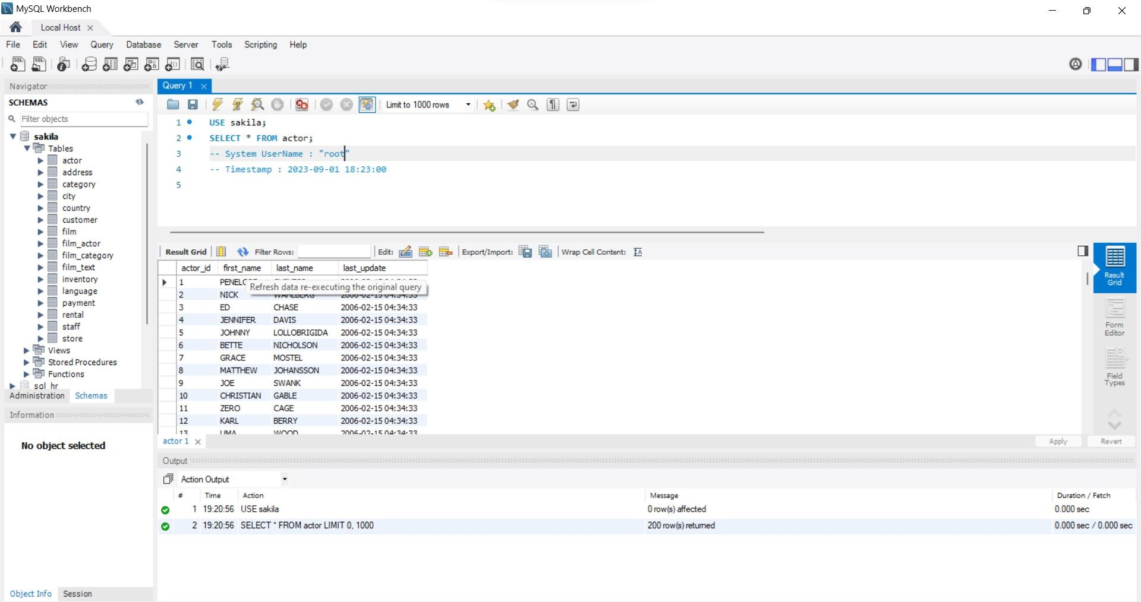1.

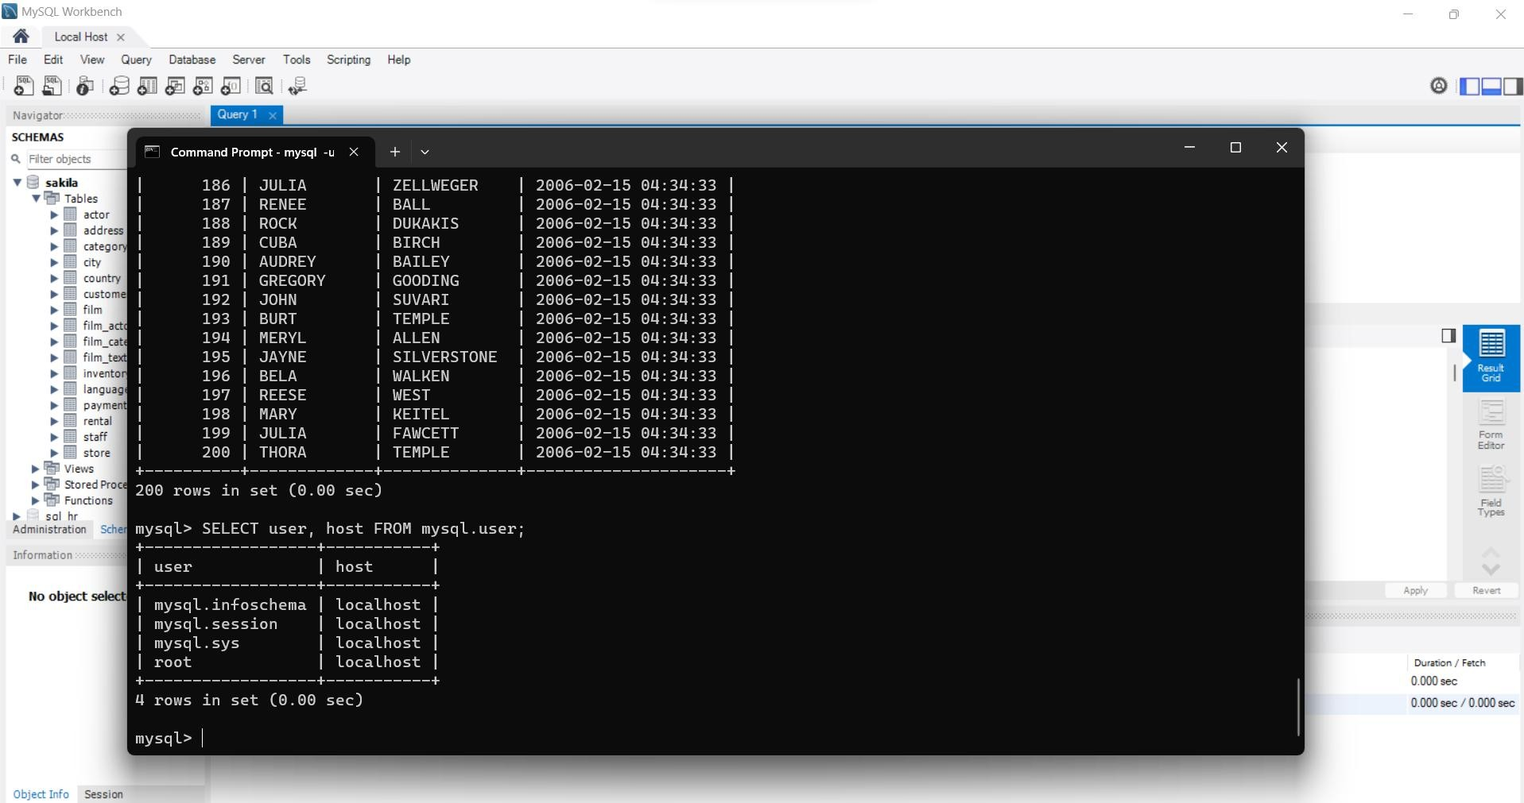2.

3.

