# Introduction

The goal of a communication system is to transfer information from one location to another. The source's original information might be in analogue form, such as human speech or music, or digital form, such as binary data or alphanumeric codes. All kinds of communication, however, must be transformed to electromagnetic energy before they can be sent over a communication system. Analogue signals can be delivered directly across the communication channel using carrier modulation and demodulated appropriately at the receiver. Such a communication system is known as an analogue communication system. Alternatively, an analogue source output can be transformed to digital form, and the message can be delivered digitally and demodulated as a digital signal at the receiver. The signal flow via a typical digital communication system is depicted in the functional block diagram illustrated in Fig 1.

Fig 1: A typical block diagram of a digital communication system

# Binary Frequency Shift Keying (BFSK)

The team used Binary FSK as the type of modulation for modulating. Binary FSK is a constant-envelope type of angle modulation identical to conventional frequency modulation, except that the modulating signal alternates between two discrete voltage levels (i.e., 1's and 0's) rather than a continually changing value, such as a sine wave. The most frequent type of FSK is binary FSK. A scheme for generating a binary FSK signal is depicted in Fig 2(a). Coherent binary FSK receiver is shown in Fig 2(b).

## Probability of error:

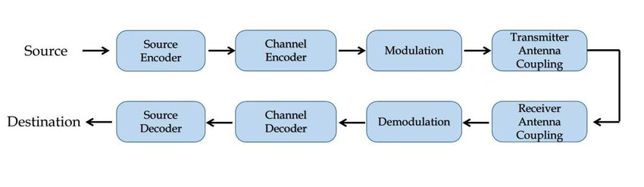 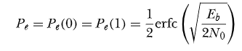

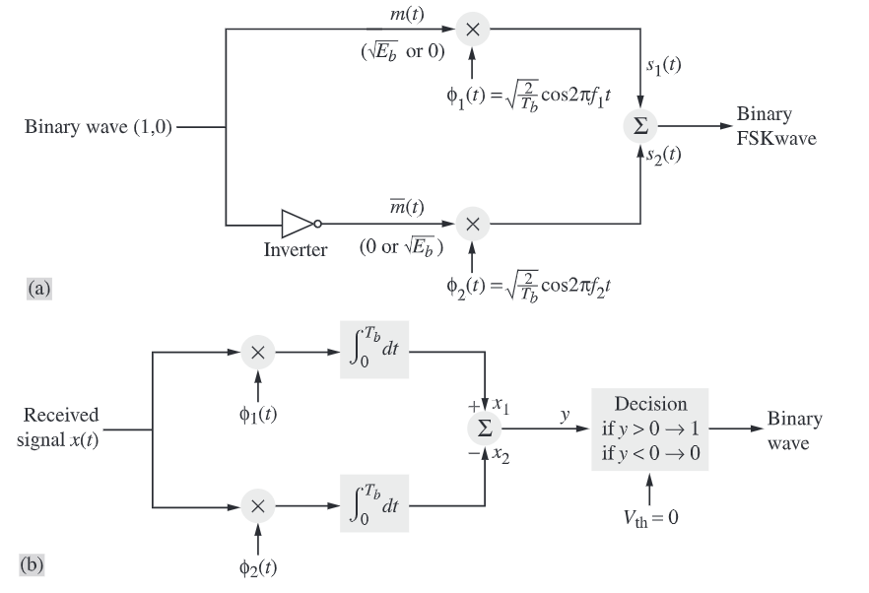

Fig 2: (a) Generation of FSK signal (b) Coherent binary FSK receiver

# Comparative Study

A comparative study of various digital modulation techniques of BFSK, BPSK, QPSK and QAM, is presented here.

|  |  |  |
| --- | --- | --- |
|  | PARAMETERS | |
| Modulation Technique | Bit Error Rate (BER) | Spectral Efficiency |
| BFSK | 54% | <1 |
| BPSK | 29.7% | 1 |
| QPSK | 9.09% | 2 |
| QAM | 60.4% | 4 |

The Bit Error Rate results were observed from the Matlab & Simulink simulations. The AWGN channel has the Eb/No = 1.

# Simulation Conditions

The simulation of BFSK was carried out in Matlab & Simulink. The block diagram in Fig 2, is used as a reference and the Simulink model is created.

The input signal is taken to be a random wave.

The model is represented in the Fig 3.

Fig 3: Simulink model of BFSK

# Model Explanation

A sampled sine signal form the “Sine wave” block is quantized and then encoded. This encoded signal is sent to the FSK modulator. Then the signal is passed through a Gaussian Noise channel.

The received signal is then passed through a FSK demodulator to get back the signal. The signal is then sent to the quantizer-decoder to get the signal.

The “Error Rate Calculation” block is employed to get the BER.

# Results

The graphs for various stages of the FSK modulator and demodulator are presented below.

## Input signal

## Diagram Description automatically generated with medium confidenceEncoded signal

## A picture containing text Description automatically generatedModulated signal

## Demodulated signal

## Chart, histogram Description automatically generatedDecoder signal

## Chart Description automatically generatedConstellation diagram

# Applications

FSK is employed in various domains and technologies such as telemetry, caller IDs, garage door openers and low frequency radio transmission.