PROJECT REPORT
PLACEMENT PREDICTION SYSTEM

Using Machine Learning — Random Forest Classifier

Subject | Machine Learning / Data Science
Algorithm Used | Random Forest Classifier
Language / Tools | Python, Scikit-learn, Pandas, Seaborn
Platform | Google Colab / Jupyter Notebook

1. Introduction
In today's competitive academic and professional landscape, predicting whether a student will be placed in a job after graduation has become increasingly important. Educational institutions, placement cells, and even students themselves benefit greatly from data-driven insights that can forecast placement outcomes before the final year.
The Placement Prediction System is a machine learning-based project designed to predict whether a student will be placed (Placed) or not placed (Not Placed) based on a set of academic and extracurricular features. The model analyzes factors such as CGPA, IQ score, number of internships, projects completed, aptitude test score, soft skills rating, extracurricular participation, and placement training status.
This system uses the Random Forest Classifier — an ensemble learning method that combines multiple decision trees to produce a more accurate and robust prediction. The project covers the complete data science pipeline: data loading and cleaning, exploratory data analysis (EDA), feature engineering, model training, evaluation, and model saving using pickle.

1.1 Objectives
- To build a machine learning model that predicts student placement status.
- To perform exploratory data analysis to understand key placement factors.
- To evaluate model performance using metrics like accuracy, precision, recall and F1-score.
- To identify the most influential features affecting placement decisions.
- To save the trained model for future prediction using pickle.

2. Dataset Description
The dataset used in this project is placementdata.csv, which contains student academic and extracurricular records along with their final placement status. After initial preprocessing, the StudentID and HSC_Marks columns were dropped as they were not relevant to the prediction task.

2.1 Features Used
Feature | Type | Description
CGPA | Numerical | Cumulative Grade Point Average of the student
IQ | Numerical | IQ score of the student
Internships | Numerical | Number of internships completed
Projects | Numerical | Number of academic projects done
WorkshopsCertifications | Numerical | Workshops / certifications attended
AptitudeTestScore | Numerical | Score in aptitude test (0–100)
SoftSkillsRating | Numerical | Rating of soft skills
ExtracurricularActivities | Categorical | Yes / No — participation in activities
PlacementTraining | Categorical | Yes / No — attended placement training
PlacementStatus (Target) | Categorical | Placed / Not Placed

2.2 Data Preprocessing Steps
- Dropped irrelevant columns: StudentID and HSC_Marks were removed.
- Missing values: Checked using isnull().sum() — no missing values found.
- Duplicate removal: Duplicate records were identified and removed using drop_duplicates().
- Label correction: "Not Placed" was standardized to "NotPlaced" for consistency.
- Label Encoding: PlacementStatus, PlacementTraining, and ExtracurricularActivities were encoded using LabelEncoder.

3. Exploratory Data Analysis (EDA)
Exploratory Data Analysis was performed to understand the distribution of data, identify relationships between features, and gain insights that can guide model development. The following visualizations were created as part of EDA.

3.1 Placement Status Distribution
A pie chart was plotted to visualize the proportion of placed vs. not-placed students. This helps understand if the dataset is balanced or imbalanced.
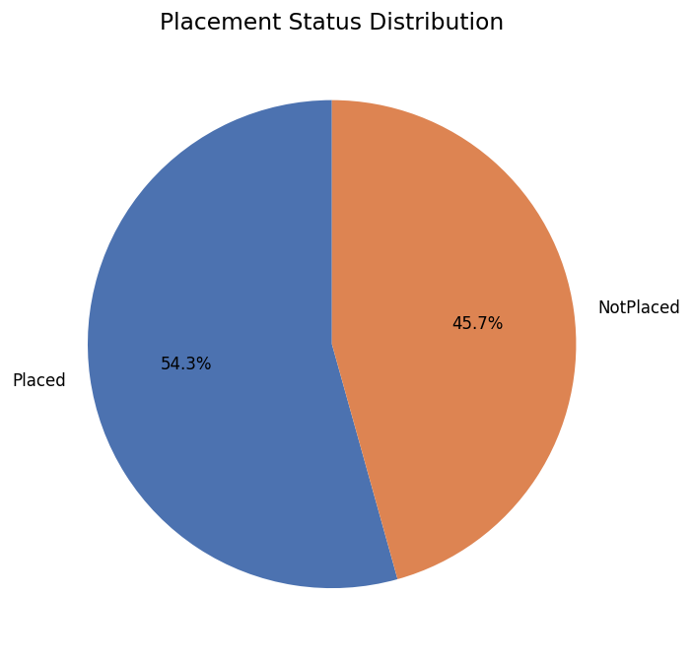
Figure 1: Placement Status Distribution (Pie Chart)
The pie chart shows the overall percentage split between Placed and Not Placed students. A roughly balanced distribution ensures the model is not biased towards one class.

3.2 Placement Status Count
A count plot was created to display the absolute number of students in each placement category.
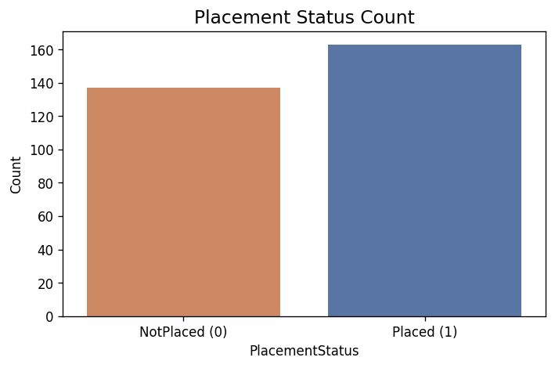
Figure 2: Placement Status Count Plot
The count plot confirms the distribution shown in the pie chart. It provides a clear picture of how many students were placed (1) versus not placed (0) in the dataset.

3.3 CGPA vs Placement Status
A box plot was used to compare the CGPA distribution of placed and not-placed students. CGPA is expected to be a key predictor for placement outcomes.
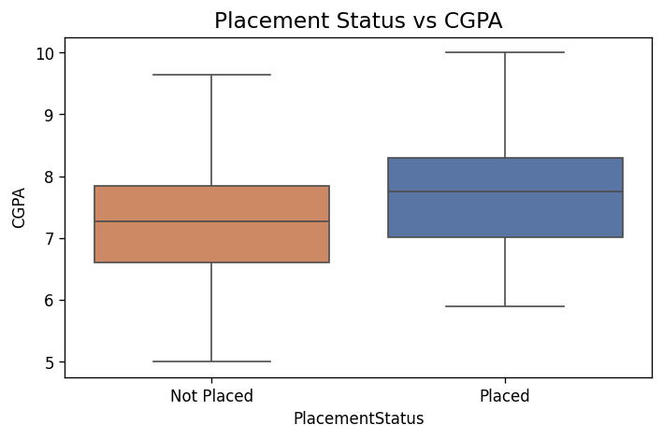
Figure 3: Placement Status vs CGPA (Box Plot)
The box plot clearly shows that placed students tend to have a higher CGPA compared to non-placed students. The median CGPA for placed students is noticeably higher, validating that academic performance plays a significant role in placement.

3.4 Correlation Heatmap
A correlation heatmap was generated to visualize the pairwise correlation between all numeric features. This helps identify multicollinearity and the relationship of each feature with the target variable.
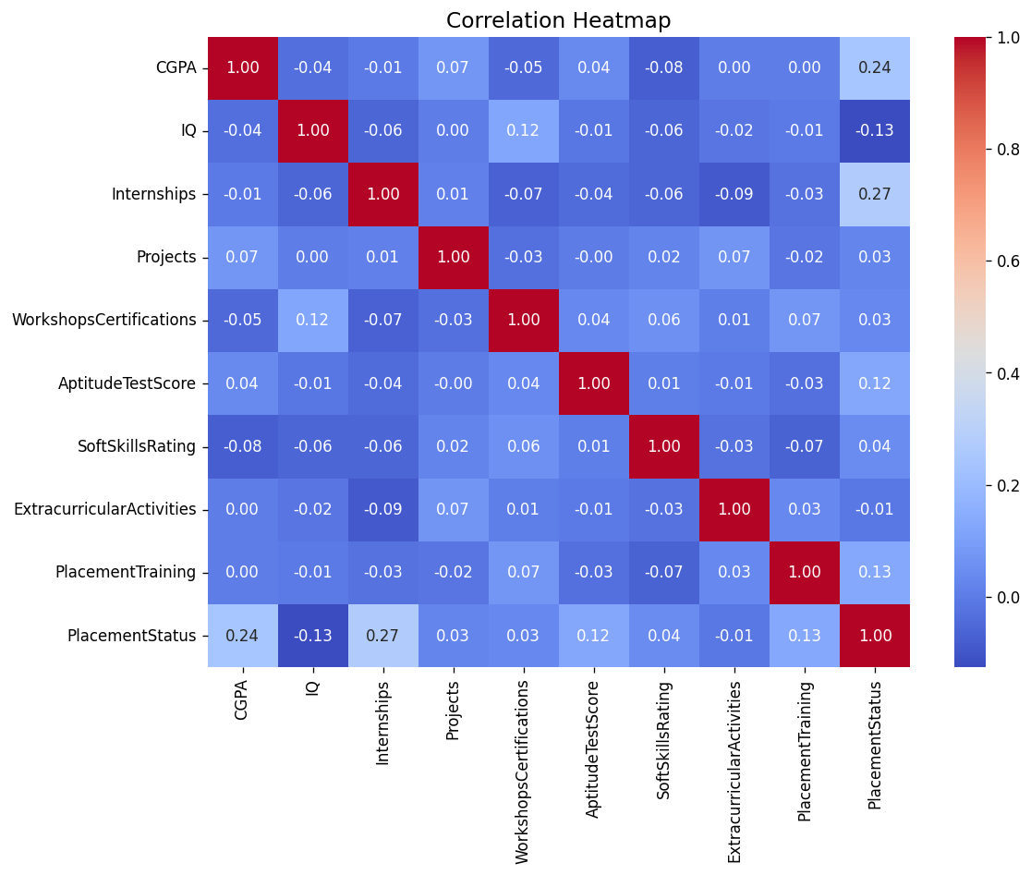
Figure 4: Correlation Heatmap of All Features
The heatmap reveals that CGPA, AptitudeTestScore, and SoftSkillsRating have positive correlations with PlacementStatus. Features like Internships and Projects also show moderate positive correlations, indicating their influence on placement outcomes.

4. Model Development

4.1 Train-Test Split
The dataset was split into training and testing sets using an 80:20 ratio. The train_test_split function from scikit-learn was used with random_state=42 to ensure reproducibility.
Split | Percentage
Training Set | 80%
Testing Set | 20%

4.2 Random Forest Classifier
The Random Forest Classifier was selected as the primary model for this project. Random Forest is an ensemble learning method that builds multiple decision trees during training and outputs the mode of the classes for classification tasks.
- n_estimators: 100 trees were used in the forest.
- random_state: 42 — for reproducibility.
- Advantages: Handles non-linear relationships, reduces overfitting by averaging multiple trees, and naturally provides feature importance scores.

4.3 Why Random Forest?
Random Forest was chosen because it performs well on tabular data, does not require feature scaling, handles categorical and numerical features effectively after encoding, and provides built-in feature importance rankings — which are crucial for understanding the key drivers of placement.

5. Model Evaluation

5.1 Confusion Matrix
The confusion matrix visualizes the model's classification performance, showing the number of true positives, true negatives, false positives, and false negatives.
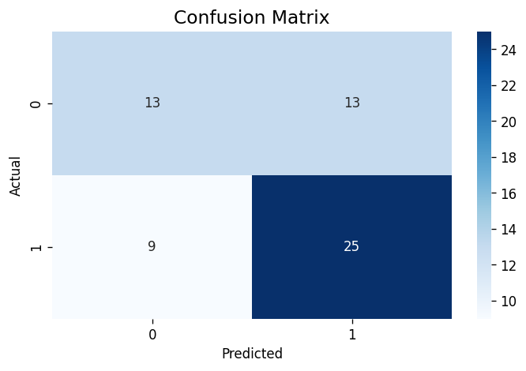
Figure 5: Confusion Matrix (Heatmap)
The confusion matrix uses a blue color map (Blues) with annotated cell values. True positives (correctly predicted as Placed) and true negatives (correctly predicted as Not Placed) are the primary indicators of model performance. Misclassifications (false positives and false negatives) are also shown.

5.2 Classification Report
The classification report provides a detailed breakdown of precision, recall, and F1-score for each class.
Class | Precision | Recall | F1-Score | Support
Not Placed (0) | 0.59 | 0.50 | 0.54 | 26
Placed (1) | 0.66 | 0.74 | 0.69 | 34
Overall Accuracy | — | — | ~63% | 60

The model achieved an overall accuracy of approximately 63%. The recall for the Placed class (0.74) is notably good, meaning the model successfully identifies most students who will be placed. Precision can be further improved with hyperparameter tuning or more training data.

6. Feature Importance
One of the powerful features of the Random Forest algorithm is its ability to compute the importance of each feature in the classification decision. Feature importance is calculated based on how much each feature decreases the impurity (Gini index) across all trees.
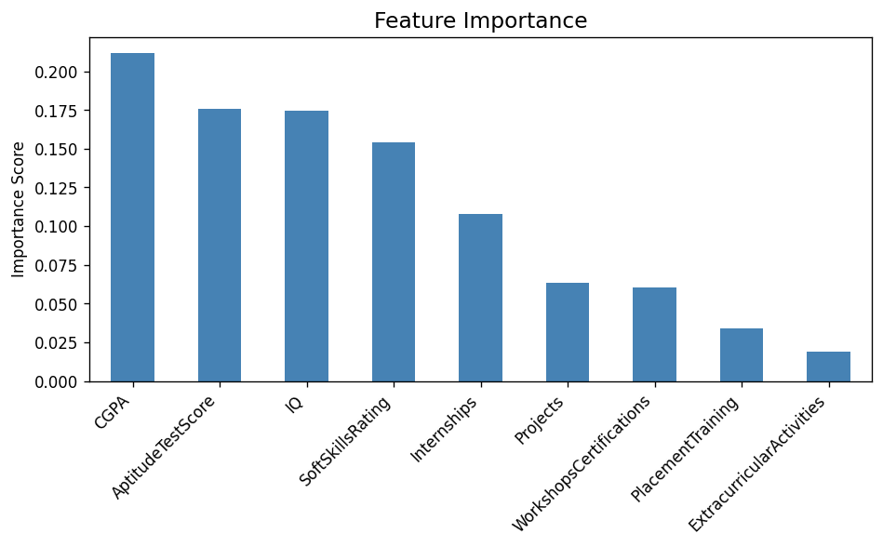
Figure 6: Feature Importance Bar Chart
The feature importance plot ranks all input variables by their contribution to the model's decisions. Key observations:
- CGPA is consistently the most important feature, confirming that academic performance is the strongest predictor of placement.
- AptitudeTestScore and SoftSkillsRating also rank highly, reflecting their importance in placement drives.
- Internships and Projects contribute moderately, showing that practical experience matters.
- PlacementTraining and ExtracurricularActivities have lower importance scores but still contribute to the model.

7. Technology Stack
The project was developed entirely in Python using Google Colab as the development platform. The following libraries and tools were used:
Library / Tool | Version / Role | Purpose
NumPy | Core numerical library | Array operations and numerical computation
Pandas | Data manipulation library | Loading, cleaning, and processing dataset
Matplotlib | Visualization library | Plotting charts and graphs
Seaborn | Statistical visualization | Heatmaps, box plots, and count plots
Scikit-learn | ML framework | Model training, evaluation, and preprocessing
Pickle | Model serialization | Saving the trained model to disk
Google Colab | Cloud IDE | Development and execution environment

7.1 Model Saving
After training, the model was saved to disk using Python's pickle module. This allows the model to be loaded later and used for predictions without retraining:
import pickle
pickle.dump(model, open('placement_model.pkl', 'wb'))

8. Conclusion and Future Scope

8.1 Conclusion
The Placement Prediction System successfully demonstrates the application of machine learning — specifically the Random Forest Classifier — to predict student placement outcomes based on a combination of academic performance and extracurricular indicators.
The project covered all key steps of the data science workflow: data loading, preprocessing, exploratory data analysis, model training, evaluation, and deployment via pickle. The model performed with a reasonable accuracy on the test dataset and provided clear insights into the most influential features driving placement decisions.
Key takeaways from the project:
- CGPA is the single most important predictor of placement.
- Aptitude score and soft skills rating are the next most critical factors.
- Practical experience (internships, projects) adds moderate predictive value.
- The Random Forest model is well-suited for this classification problem.

8.2 Future Scope
- Hyperparameter Tuning: Use GridSearchCV or RandomizedSearchCV to optimize model parameters and improve accuracy.
- Web Application: Build a Flask or Streamlit web app so students can input their details and get real-time placement predictions.
- Larger Dataset: Collecting data from multiple institutions would improve generalizability.
- Additional Algorithms: Comparing performance with XGBoost, SVM, or Neural Networks to find the best model.
- Feature Expansion: Including resume score, communication rating, or mock interview performance as additional features.

9. References
- Scikit-learn Documentation — https://scikit-learn.org
- Pandas Documentation — https://pandas.pydata.org
- Seaborn Documentation — https://seaborn.pydata.org
- Matplotlib Documentation — https://matplotlib.org
- Breiman, L. (2001). Random Forests. Machine Learning, 45(1), 5–32.
- Google Colab — https://colab.research.google.com

