**STD4: Ch1.**

**A. Fill in the blanks with the help of the given words.**

1. Binary, 2. Bit, 3. Primary, 4. RAM, 5. optical

**B. Tick (**✓**) the correct option.**

1. d, 2. b, 3. c, 4. a, 5. b

**C. State True or False.**

1. T, 2. F, 3. T, 4. F, 5. T

**D. Match the following.**

1. d, 2. c, 3. e, 4. b, 5. a

**E. Find the odd one out.**

1. Volatile, 2. RAM, 3. RAM, 4. ROM, 5. Internal Memory

**F. Answer the following questions.**

1. List five units of measurement.

Ans: Five units of measurement are: Bit, Byte, Kilobyte, Megabyte, Gigabyte, Terabyte

2.Differentiate between:

a.RAM and ROM b. Internal memory and External memory

Ans: Difference between the two are following:

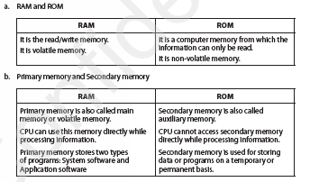

3. Why do you think secondary storage device are essential?

Ans:the computer memory is limited and temporary. Therefore, there is need to use secondary storage devices. They help to store large amount of data permanently.

5. Differentiate between CD,DVD and Blue-ray with respect storage capacity.

Ans:Compact Disc: 650–700 MB

DVD: 4.7–8.7 GB

Blu-ray Disc: 25–50 GB