# Table of Contents

# 

**Acknowledgement**i

**Abstract**ii

**List of figures** iii

**Abbreviation** iv

1. **Introduction** 1-3

1.1. **Purpose** **of Project**1

1.2. **Scope of Project**2

1.3.**Theory of C++** 2-3

1. **System Requirement** 3

2.1.**Hardware Requirement** 3

2.2.**Software Requirement**3

**3.** **Design** 4

1. **Implementation** 4-5

4.1 **Home page**4

4.2 **Login page**4

4.3 **Admin Login page**4

4.4 **User Login page**5

4.4 **Admin Dashboard page**5

4.5 **User Dashboard page**5

4.6 **Signup page**5

4.7 **Exit page**5

**Project Scheduling**6

**Source Code**7-10

**Conclusion**11

**Reference**11

**Acknowledgement**

According to the course of study of BCA II semester determined by P.U, a computer project is to be carried out for the partial fulfillment of the requirement for the bachelor in Computer Application. Therefore, as students of the course we will developed a small **CUI** application " MOVIE TICKETING MANAGEMENT SYSTEM".

We feel glad for getting such an opportunity to accomplish the BCA. This second semester project and feeling the experience of the team environment and team spirit. This gave us insight knowledge about the practical aspect of the various stages and procedures of software development projects. We are very thankful towards **Gomendra Multiple College** for the facilitating the completion of entire project work.

We are really greatful because we managed to complete our project within the given time by our principal Mr. RupakKhanal. We also thank our mentor/teacher **Mr.Kushal Niroula** for the guidance and encouragement in finishing this project and also teaching us this course. And also special thanks to our group member for cooperation and effort for the project

**Abstract**

The Main objective of the project on movie ticketing system is to automate the existing manual system by the help computerized equipments and full-fledged computer software, fulfilling their requirements, so that their valuable data/information can be stored for a longer period with easy accessing and manipulation of the same. The required software and hardware are easily available and easy to work with. Basically the project describes how to manage for good performance and better services for the clients.

**LIST OF FIGURES**

**Page**

1. **Flowchart** ………………………………….….4.

**Abbreviation:**

Movie Ticketing System can be abbreviated as OMTS. It refers to a digital platform or application that allows users to purchase movie tickets through the internet.The system typically includes functionalities such as movie listing, showtime selection,seat reservation. By implementing the project in C++, developers can leverage the language’s features to create a robust and efficient system.C++ allows for object-oriented programming, which helps in organizing the codebase and modularizing different components of the OMTS.

Overall, the OMTS( Movie Ticketing System) in C++ aims to provide users with a seamless and convenient experience for booking movie tickets.

**Introduction**

MOVIE TICKETING MANGAEMENT SYSTEM is the process whereby consumers directly buy movie tickets from a multiple application interactively in realtime .It is an ticket booking project &customers can book tickets 24 hours a day from anywhere in the world.It is a CUI application written for 64-bit windows operating system which focused in the area of adding, editing and deleting the details of Client and Movie. The system software installed on the system includes single user s/he can manage information of the Customer detail, Movie detail and User login.Here we would use C++ Program to develop one real life project with a simple project life cycle using Turbo C.

The project provides a very user friendly interface through which anybody with the basic knowledge of computer and English language can access the system .Though it is very user friendly it doesnot lack proper security

**Purpose of project:**

The main objective of this document is to illustrate the requirement of the project Ticketing Management System. The documents give the detail information of both functional and non-functional requirements of Movie . It store the information of Customer Name , DOB , Address , Movie Name, Movie price.

**Scope of Project:**

* To make the Ticketing system more efficient and effective.
* To provide a user friendly environment where user can be serviced better.
* Facility to store the information of new customer& different types of movieshow timing& ticket rates of different types on show class etc
* Facility to generate different reports& which are helpful for the management in decision making
* Facility to change users password account.
* Customers can view all currently running movies and book their tickets for any specific date .

**Theory C++ program**

C++ is a general-purpose, object-oriented programming language that was developed in the early 1980s by Bjarne Stroustrup at Bell Labs. C++ was initially designed as an extension to the popular C language, adding features such as classes, inheritance, polymorphism, and templates. C++ is a compiled language, which means that code written in C++ must first be compiled into machine code before it can be run on a computer. The language is highly efficient and offers a great deal of control over memory management, making it a popular choice for systems programming, such as operating systems, device drivers, and other low-level software. One of the main features of C++ is its support for object-oriented programming (OOP). This allows programmers to organize their code into classes, which can encapsulate data and behavior. C++ also supports inheritance, which allows classes to inherit properties and methods from other classes, and polymorphism, which allows different objects to be treated as if they are of the same type.

Overall, C++ is a powerful and versatile programming language that is widely used in a variety of industries, including gaming, finance, and scientific computing. Its popularity stems from its efficiency, flexibility, and support for low-level programming, making it a popular choice for developing high-performance applications.

C++ also includes support for generic programming through the use of templates. Templates allow programmers to write code that can work with different types of data, making it possible to write highly reusable and generic algorithms.

Another important feature of C++ is its support for low-level programming. C++ provides direct access to hardware resources and allows programmers to manipulate memory at a very low level, making it a popular choice for developing systems-level software.

1. **System Requirement**
   1. **Hardware Requirement**

This program is created thinking that it will make the working environment easier and make the user fell less tired of working in computer instead of register. The hardware requirement can be listed below:

* Pc with AMD or intel 2.1 GHz or above processor.
* Pc with minimum 4 GB RAM or above
* Pc with any type of monitor and standard keyboard for input data

**2.2 Software Requirement**

For software requirement there must be compatible software installed in the PC to conduct the program successfully. Different program requires different software installed to run according to the platform in which the developers have develop it.

* Any operating System supports the application
* Compiler:Code blocks , Turbo C++

1. **Design**

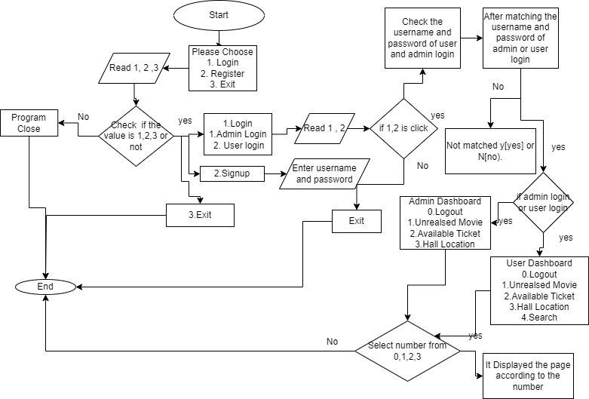

1. **Implementation** 
   1. **Home page**

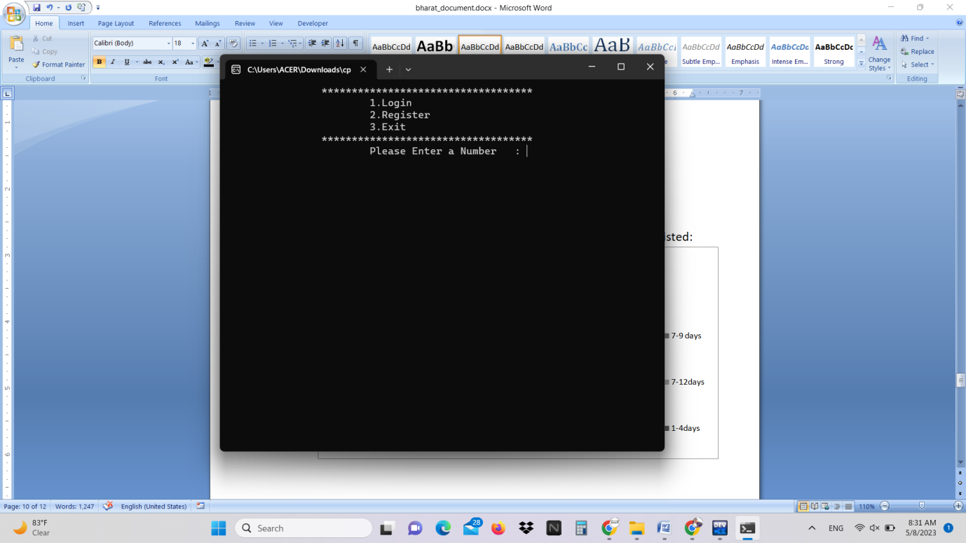

* 1. **Login page**

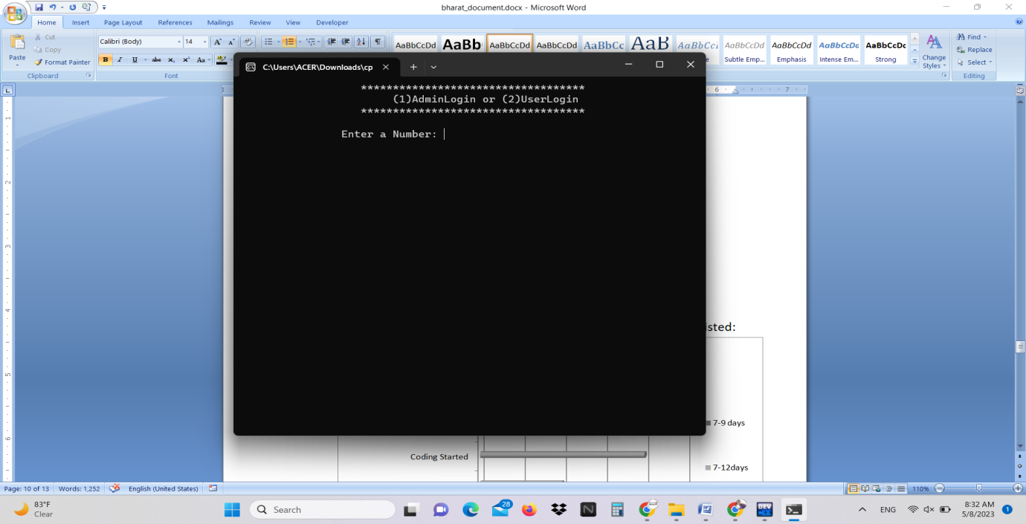

* 1. **Admin Login page**

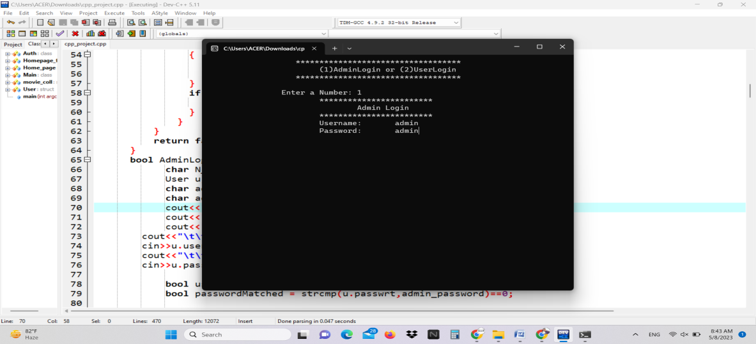

* 1. **User Login page**

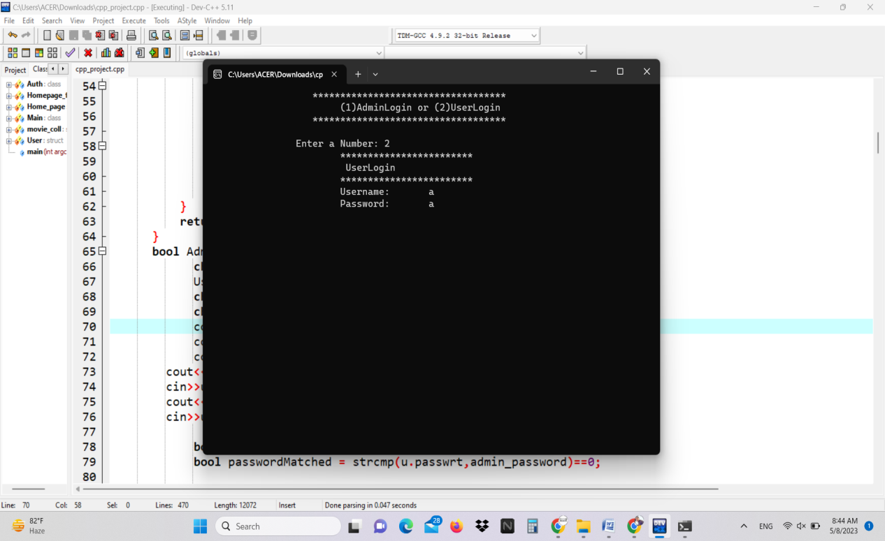

* 1. **Admin Dashboard page**

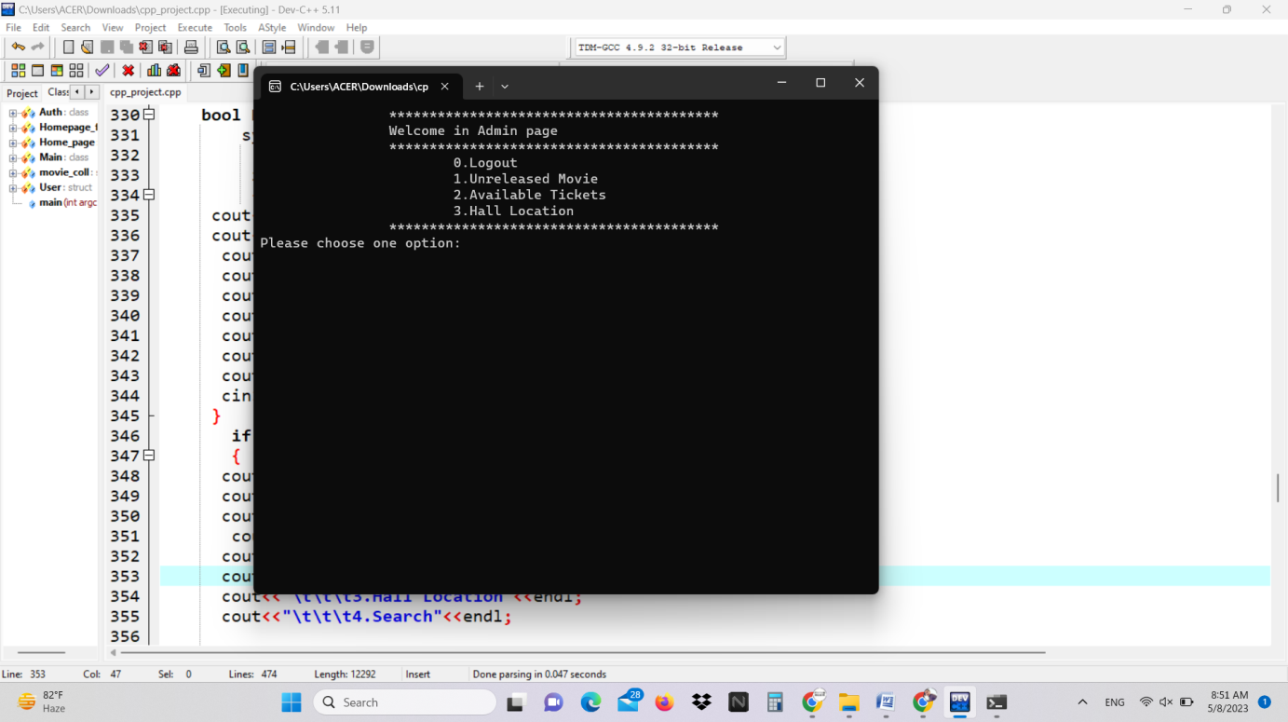

* 1. **User Dashboard page**

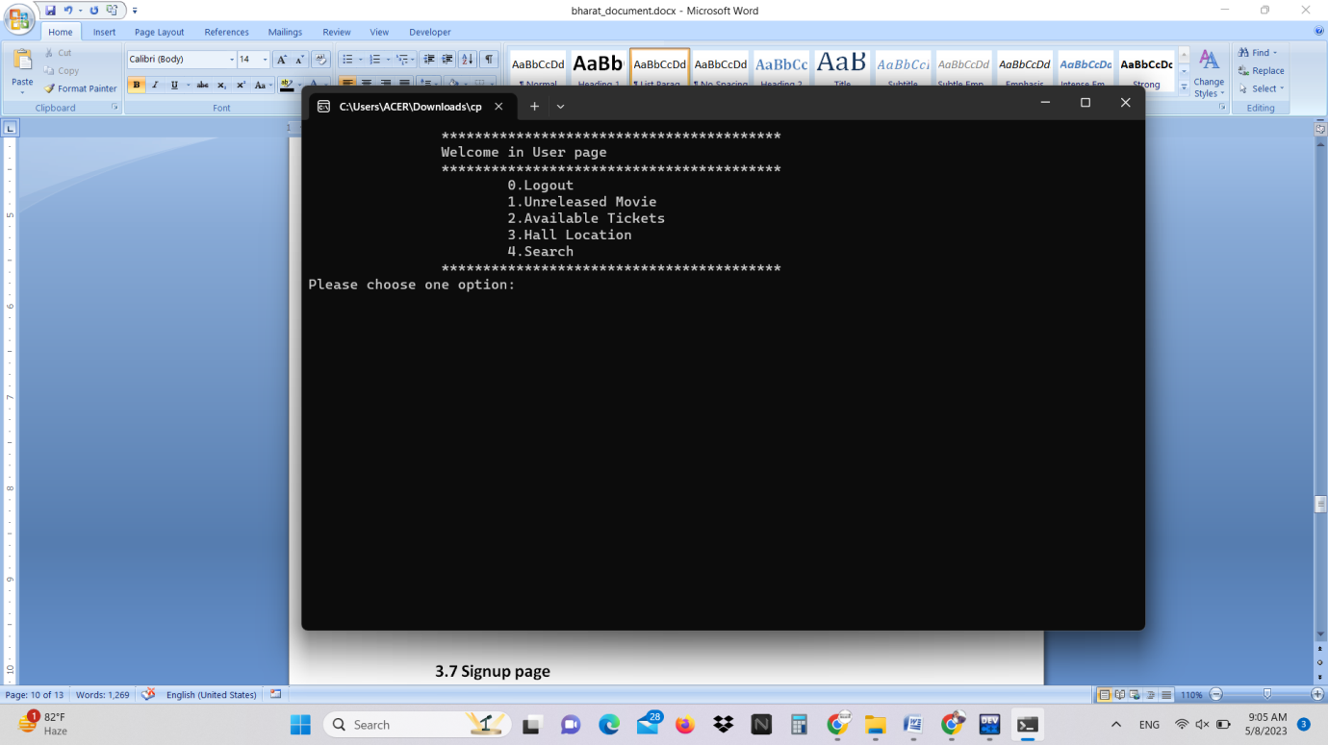

* 1. **Signup page**

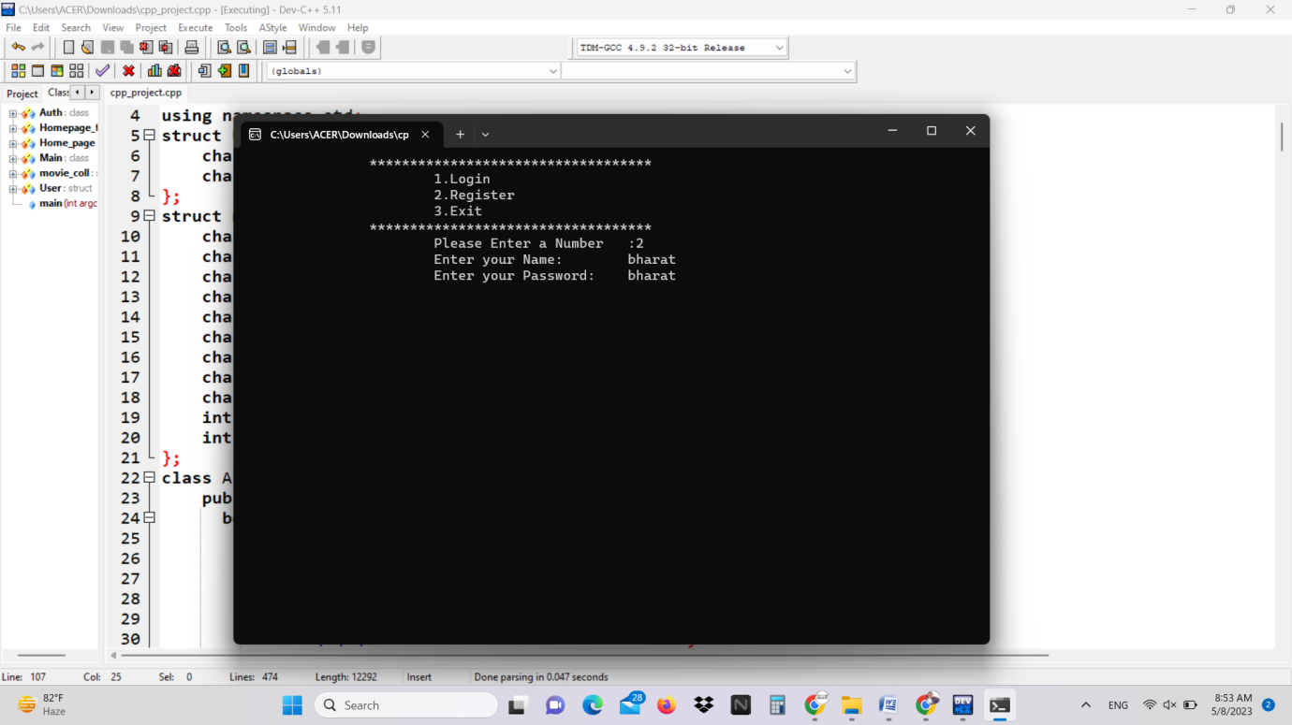

**4.8 Exit**

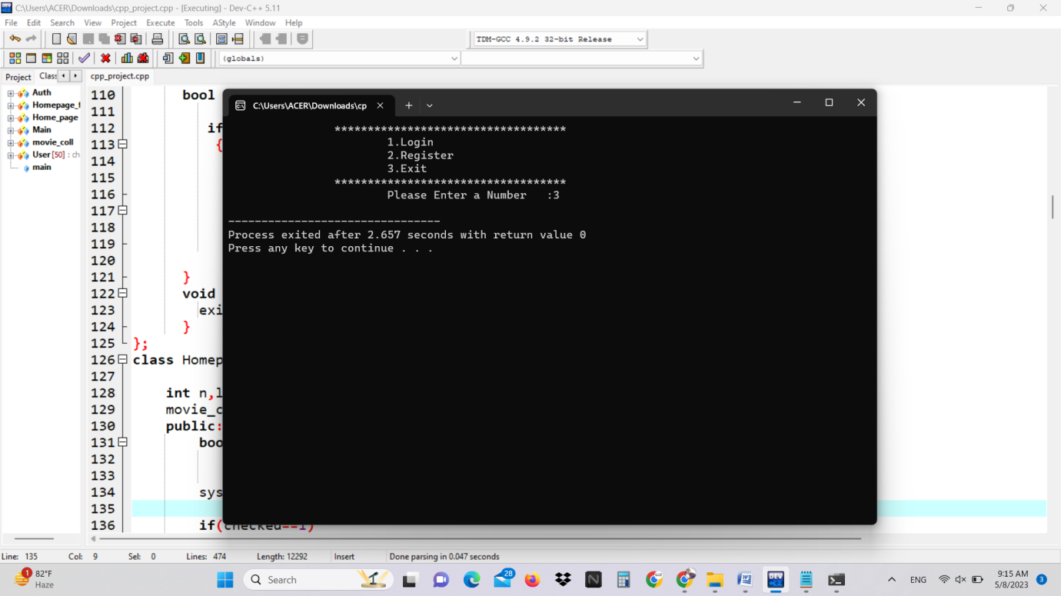

**Project Scheduling:**

* Our Project life-cycle took over weeks of scheduling which are as listed:

**Source Code**

**#include <iostream>**

**#include<fstream>**

**#include<string.h>**

**using namespace std;**

**struct User {**

**char username[50];**

**char passwrt[50];**

**};**

**struct movie_coll{**

**char movie_name[50];**

**char release_date[50];**

**char sold_out[50];**

**char movie_shedule[50];**

**char location[50];**

**char seats[50];**

**char hall_name[50];**

**char available[50];**

**char reserved[50];**

**int price;**

**int phone_number;**

**};**

**class Auth{**

**public:**

**bool UserLogin(){**

**char N_M='y';**

**fstream authfile;**

**User u,temp;**

**authfile.open("auth.txt",ios::in|ios::binary);**

**cout<<"\t\t\t************************"<<endl;**

**cout<<"\t\t\t UserLogin"<<endl;**

**cout<<"\t\t\t************************"<<endl;**

**cout<<"\t\t\tUsername:\t";**

**cin>>u.username;**

**cout<<"\t\t\tPassword:\t";**

**cin>>u.passwrt;**

**if(!authfile)**

**{**

**cout<<"File Does not Exit";**

**}**

**while(authfile.read((char *) &temp , sizeof(User))){**

**bool usernameMatched = strcmp(u.username,temp.username)==0;**

**bool passwordMatched = strcmp(u.passwrt,temp.passwrt)==0;**

**if(usernameMatched && passwordMatched){**

**return 2;**

**}**

**else{**

**cout<<"\t\t\tNot Matched,Try again[y/n]\t:";**

**cin>>N_M;**

**if(N_M == 'y')**

**{**

**system("cls");**

**return UserLogin();**

**}**

**if(N_M == 'n'){**

**exit(0);**

**}**

**}**

**}**

**return false;**

**}**

**bool AdminLogin(){**

**char N_M='y';**

**User u,temp;**

**char admin_name[50] = "admin";**

**char admin_password[50] = "admin";**

**cout<<"\t\t\t************************"<<endl;**

**cout<<"\t\t\t\tAdmin Login"<<endl;**

**cout<<"\t\t\t************************"<<endl;**

**cout<<"\t\t\tUsername:\t";**

**cin>>u.username;**

**cout<<"\t\t\tPassword:\t";**

**cin>>u.passwrt;**

**bool usernameMatched = strcmp(u.username,admin_name)==0;**

**bool passwordMatched = strcmp(u.passwrt,admin_password)==0;**

**if(usernameMatched && passwordMatched){**

**return true;**

**}**

**else{**

**cout<<"\t\t\tNot Matched,Try again[y/n]\t:";**

**cin>>N_M;**

**if(N_M == 'y')**

**{**

**return AdminLogin();**

**}**

**if(N_M == 'n'){**

**exit(0);**

**}**

**return false;**

**}**

**}**

**bool Register(){**

**fstream authfile;**

**User u;**

**authfile.open("auth.txt",ios::app|ios::binary);**

**cout<<"\t\t\tEnter your Name:\t";**

**cin>>u.username;**

**cout<<"\t\t\tEnter your Password:\t";**

**cin>>u.passwrt;**

**bool fwrite=authfile.write((char *)&u, sizeof(User));**

**if(fwrite==1)**

**{**

**return true;**

**}**

**else{**

**cout<<"\t\tUnsuccessfully"<<endl;**

**} void Exit(){**

**exit(0);**

**}**

**};**

**class Homepage_feature{**

**int n,logout;**

**movie_coll un_m, temp_movie;**

**public:**

**bool Unreleased(int checked){**

**fstream unrelesed;**

**char homepg='y';**

**system("cls");**

**if(checked==1)**

**{**

**cout<<"*************************UnReleased Movie**************************"<<endl;**

**unrelesed.open("unreleased_movie.txt",ios::app|ios::binary);**

**cout<<"*******************************************************************************"<<endl;**

**cout<<"\t\t\tEnter Movie Name:\t";**

**cin>>un_m.movie_name;**

**cout<<"\t\t\tRelease Date:\t";**

**cin>>un_m.release_date;**

**bool fwrite = unrelesed.write((char *)&un_m,sizeof(movie_coll));**

**if(fwrite==1)**

**{**

**return checked;**

**}**

**else{**

**cout<<"Invalid";**

**}}**

**if(checked==2)**

**{**

**cout<<"*************************UnReleased Movie**************************"<<endl;**

**unrelesed.open("unreleased_movie.txt",ios::in|ios::binary);**

**cout<<"\t\tMovie Name\t\t\t\t\t Release Date"<<endl;**

**cout<<"*******************************************************************************"<<endl;**

**while(unrelesed.read((char *) &un_m,sizeof(movie_coll))){**

**// cout<<"*******************************************************************************"<<endl;**

**cout<<"\t\t"<<un_m.movie_name<<"\t\t\t\t\t\t"<<un_m.release_date<<endl;**

**cout<<"*******************************************************************************"<<endl;**

**}**

**cout<<"\t\t You want to go back[y/n]:\t";**

**cin>>homepg;**

**if(homepg == 'y')**

**{**

**return checked;**

**}}}**

**bool AvailableTicket(int checked){**

**fstream available_ticket;**

**system("cls");**

**char homepg='y';**

**if(checked==1)**

**{**

**cout<<"*************************Available Movie Ticket**************************"<<endl;**

**available_ticket.open("available_ticket.txt",ios::app|ios::binary);**

**cout<<"*******************************************************************************"<<endl;**

**cout<<"\t\t\tEnter Movie Name:\t";**

**cin>>un_m.movie_name;**

**cout<<"\t\t\tRelease Date:\t";**

**cin>>un_m.release_date;**

**cout<<"\t\t\t Ticket Pice:\t";**

**cin>>un_m.price;**

**cout<<"\t\t\tAvailable[Y/N]:\t";**

**cin>>un_m.available;**

**cout<<"\t\t\tMovie Schedule:\t";**

**cin>>un_m.sold_out;**

**bool fwrite = available_ticket.write((char *)&un_m,sizeof(movie_coll));**

**if(fwrite==1)**

**{**

**return checked;**

**}**

**else{**

**cout<<"Invalid";**

**}}**

**if(checked==2)**

**{**

**cout<<"*************************Available Movie Ticket**************************"<<endl;**

**available_ticket.open("available_ticket.txt",ios::in|ios::binary);**

**cout<<"Movie Name\tReleased date\tPrice\tAvailable\tMovie Schedule"<<endl;**

**cout<<"***********************************************************************************"<<endl;**

**while(available_ticket.read((char *) &un_m,sizeof(movie_coll))){**

**cout<<un_m.movie_name<<"\t\t"<<un_m.release_date<<"\t\t"<<un_m.price<<"\t\t"<<un_m.available<<"\t\t"<<un_m.movie_shedule<<endl;**

**cout<<"*******************************************************************************"<<endl;**

**}**

**cout<<"\t\t You want to go back[y/n]:\t";**

**cin>>homepg;**

**if(homepg == 'y')**

**{**

**return checked;**

**}**

**}**

**}**

**bool Hall_location(int checked){**

**fstream hall_location;**

**char homepg='y';**

**if(checked==1)**

**{**

**cout<<"*************************Hall Location**************************"<<endl;**

**hall_location.open("hall_location.txt",ios::app|ios::binary);**

**cout<<"*******************************************************************************"<<endl;**

**cout<<"\t\t\tEnter Hall Name:\t";**

**cin>>un_m.hall_name;**

**cout<<"\t\t\tHall Location:\t";**

**cin>>un_m.location;**

**cout<<"\t\t\t Seats:\t";**

**cin>>un_m.seats;**

**cout<<"\t\t\tPhone Number:\t";**

**cin>>un_m.phone_number;**

**bool fwrite = hall_location.write((char *)&un_m,sizeof(movie_coll));**

**if(fwrite==1)**

**{**

**return checked;**

**}**

**else{**

**cout<<"Invalid";**

**}**

**}**

**if(checked==2)**

**{**

**hall_location.open("hall_location.txt",ios::in|ios::binary);**

**cout<<"*************************Hall Location**************************"<<endl;**

**cout<<"**************************************************************"<<endl;**

**cout<<"Hall Name\tHall Location\t Seats\tContact Number"<<endl;**

**cout<<"***************************************************************"<<endl;**

**while(hall_location.read((char *) &un_m,sizeof(movie_coll))){**

**cout<<un_m.hall_name<<"\t\t"<<un_m.location<<"\t\t"<<un_m.seats<<"\t\t"<<un_m.phone_number<<endl;**

**cout<<"*******************************************************************************"<<endl;**

**}**

**cout<<"\t\t You want to go back[y/n]:\t";**

**cin>>homepg;**

**if(homepg == 'y')**

**{**

**return checked;**

**}**

**}**

**}**

**bool Search(int checked){**

**fstream search;**

**char homepg='y';**

**char movie_name[50];**

**cout<<"*************************Search**************************"<<endl;**

**cout<<checked;**

**cout<<"Enter Movie Name:\t";**

**cin>>movie_name;**

**if(checked==2){**

**search.open("available_ticket.txt",ios::in|ios::binary);**

**if(!search)**

**{**

**cout<<"File DoesNot Exit";**

**}**

**while(search.read((char *) &un_m,sizeof(movie_coll))){**

**bool Movie_Name_Matched = strcmp(un_m.movie_name,movie_name)==0;**

**if(Movie_Name_Matched==true)**

**{**

**cout<<"Movie Name:\t"<<un_m.movie_name<<endl;**

**cout<<"Released Date:\t"<<un_m.release_date<<endl;**

**cout<<"Price:\t"<<un_m.price<<endl;**

**break;**

**}**

**else{**

**cout<<"OOPS!Not Found"<<endl;**

**break;**

**}**

**}**

**cout<<"\t\t You want to go back[y/n]:\t";**

**cin>>homepg;**

**if(homepg == 'y')**

**{**

**return checked;**

**}**

**}**

**}**

**bool Logout(){**

**cout<<"Press 1 for Logout:\t";**

**cin>>logout;**

**if(logout==1)**

**{**

**}**

**}**

**};**

**class Home_page : public Homepage_feature {**

**int n,checked;**

**bool check;**

**public:**

**bool Home_init(int checked){**

**system("cls");**

**if(checked==1)**

**{**

**cout<<"\t\t*****************************************"<<endl;**

**cout<<"\t\tWelcome in Admin page"<<endl;**

**cout<<"\t\t*****************************************"<<endl;**

**cout<<"\t\t\t0.Logout"<<endl;**

**cout<<"\t\t\t1.Unreleased Movie"<<endl;**

**cout<<"\t\t\t2.Available Tickets"<<endl;**

**cout<<"\t\t\t3.Hall Location"<<endl;**

**cout<<"\t\t*****************************************"<<endl;**

**cout<<"Please choose one option:\t";**

**cin>>n;**

**}**

**if(checked==2)**

**{**

**cout<<"\t\t*****************************************"<<endl;**

**cout<<"\t\tWelcome in User page"<<endl;**

**cout<<"\t\t*****************************************"<<endl;**

**cout<<"\t\t\t0.Logout"<<endl;**

**cout<<"\t\t\t1.Unreleased Movie"<<endl;**

**cout<<"\t\t\t2.Available Tickets"<<endl;**

**cout<<"\t\t\t3.Hall Location"<<endl;**

**cout<<"\t\t\t4.Search"<<endl;**

**cout<<"\t\t*****************************************"<<endl;**

**cout<<"Please choose one option:\t";**

**cin>>n;**

**}**

**// cout<<"Please choose one option:\t";**

**// cin>>n;**

**switch(n){**

**case 0:**

**check =Logout();**

**if(check)**

**{**

**Home_page Hp;**

**Hp.Home_init(check);**

**}**

**break;**

**case 1:**

**Homepage_feature::Unreleased(checked);**

**checked=checked;**

**if(checked)**

**{**

**Home_page Hp;**

**Hp.Home_init(checked);**

**}**

**break;**

**case 2:**

**Homepage_feature::AvailableTicket(checked);**

**checked=checked;**

**if(checked)**

**{**

**Home_page Hp;**

**Hp.Home_init(checked);**

**}**

**break;**

**case 3:**

**Homepage_feature::Hall_location(checked);**

**if(checked)**

**{**

**Home_page Hp;**

**Hp.Home_init(checked);**

**}**

**break;**

**case 4:**

**Homepage_feature::Search(checked);**

**if(checked)**

**{**

**Home_page Hp;**

**Hp.Home_init(checked);**

**}**

**break;**

**default:**

**break;**

**}}};**

**class Main : public Auth,public Home_page{**

**int n,check_login,checked;**

**bool check;**

**public:**

**void init(){**

**cout<<"\t\t***********************************"<<endl;**

**cout<<"\t\t\t1.Login"<<endl;**

**cout<<"\t\t\t2.Register"<<endl;**

**cout<<"\t\t\t3.Exit"<<endl;**

**cout<<"\t\t***********************************"<<endl;**

**cout<<"\t\t\tPlease Enter a Number\t:";**

**cin>>n;**

**switch(n){**

**case 1:**

**system("CLS");**

**cout<<"\t\t ***********************************"<<endl;**

**cout<<"\t\t\t(1)AdminLogin or (2)UserLogin"<<endl;**

**cout<<"\t\t ***********************************"<<endl<<endl;**

**cout<<"\t\tEnter a Number:\t";**

**cin>>check_login;**

**if(check_login == 1)**

**{**

**check=Auth::AdminLogin();**

**if(check){**

**checked=1;**

**Home_page::Home_init(checked);**

**}**

**}**

**if(check_login == 2)**

**{**

**check = Auth::UserLogin();**

**if(check){**

**checked=2;**

**Home_page::Home_init(checked);**

**}**

**}**

**break;**

**case 2:**

**check=Auth::Register();**

**if(check)**

**{**

**checked = 2;**

**Home_page::Home_init(checked);**

**}**

**break;**

**case 3:**

**Auth::Exit();**

**break;**

**default:**

**break;**

**}}};**

**int main(int argc, char** argv) {**

**Main m;**

**m.init();**

**return 0; }**

**Conclusion**

After we have completed the project we are sure the problems in the existing system would overcome the “ MOVIE MANAGEMENT SYSTEM” process made computerized to reduce human errors and to increase the efficiency. The main focus of this project is to lessen human efforts. Our main aim of the project is to get the correct information about a customer. The computerization of the Ticketing Management will not only improves the efficiency but will also reduce human stress thereby indirectly improving human recourses.

**Reference**

* <https://cppsecrets.com/users/22319897989712197103975756505164103109971051084699111109/C00-MOVIE-TICKET-BOOKING-SYSTEM.php>
* <https://www.youtube.com/watch?v=yvBzlCyFaRo>
* <https://www.freeprojectz.com/project-report/3053>
* <https://chat.openai.com/c/7dff6f9a-06db-4355-81dc-247bee05ad8f>