

**PURBANCHAL UNIVERSITY**

**Gomendra Multiple Campus**

**ONLINE MOVIE TICKETING MANGAEMENT SYSTEM**

**IN PARTIAL FULFILLMENT OF THE REQUIREMENT FOR THE DEGREE OF**

**[BCA-2]**

**Submitted by Name of Student : BHARAT OLI**

**(Exam Roll No):322282**

**Under the supervision of**

**KUSHAL NIROULA**

**2079**

**Certificate**

I hereby declare that the Project entitled **ONLINE MOVIE TICKETING** submitted to the Department of **Science and Technology, Gomendra Multiple Campus Birtamod-7, Jhapa** in partial fulfillment for the award of the Degree of **BACHELOR IN COMPUTER APPLICATION** is an authentic record of my own work carried out under the guidance of Mr **Bharat oli** and that the Project has not previously formed the basis for the award of any other degree.

Name:Kushal Niroula Name:

Designation:Lecturer Designation:Lecturer

Signature: Signature:

(Project Supervisor) (External Examiner)

Name:Rupak Khanal

Designation:CAMPUS CHIEF

Address:GM College,Birtamod-Jhapa

Date:

Signature:

# Table of Contents

# 

**Acknowledgement**i

**Abstract**ii

**List of figures** iii

1. **Introduction** 1-3

1.1. **Purpose** **of Project**1

1.2. **Scope of Project**2

1.3.**About C++** 2-3

1. **System Requirement** 3

2.1.**Hardware Requirement** 3

2.2.**Software Requirement**3

**Project Scheduling**4

**Conclusion**5

**Reference**5

**Acknowledgement**

According to the course of study of BCA II semester determined by P.U, a computer project is to be carried out for the partial fulfillment of the requirement for the bachelor in Computer Application. Therefore, as students of the course we will developed a small **CUI** application "ONLINE MOVIE TICKETING MANAGEMENT SYSTEM".

We feel glad for getting such an opportunity to accomplish the BCA. This second semester project and feeling the experience of the team environment and team spirit. This gave us insight knowledge about the practical aspect of the various stages and procedures of software development projects. We are very thankful towards **Gomendra Multiple College** for the facilitating the completion of entire project work.

We are really greatful because we managed to complete our project within the given time by our principal Mr. RupakKhanal. We also thank our mantor/teacher **Mr.Kushal Niroula** for the guidance and encouragement in finishing this project and also teaching us this course. And also special thanks to our group member for cooperation and effort for the project

**Abstract**

The Main objective of the project on Online movie ticketing system is to automate the existing manual system by the help computerized equipments and full-fledged computer software, fulfilling their requirements, so that their valuable data/information can be stored for a longer period with easy accessing and manipulation of the same. The required software and hardware are easily available and easy to work with. Basically the project describes how to manage for good performance and better services for the clients.

**LIST OF FIGURES**

**Page**

1. **Flowchart** ……………………………………………………………………………4.

**Introduction**

ONLINE MOVIE TICKETING MANGAEMENT SYSTEM is the process whereby consumers directly buy movie tickets from a multiple application interactively in realtime .It is an online ticket booking project &customers can book tickets 24 hours a day from anywhere in the world.It is a CUI application written for 64-bit windows operating system which focused in the area of adding, editing and deleting the details of Client and Movie. The system software installed on the system includes single user s/he can manage information of the Customer detail, Movie detail and User login.Here we would use C++ Program to develop one real life project with a simple project life cycle using Turbo C.

The project provides a very user friendly interface through which anybody with the basic knowledge of computer and English language can access the system .Though it is very user friendly it doesnot lack proper security

**Purpose of project:**

The main objective of this document is to illustrate the requirement of the project Online Movie Ticketing Management System. The documents give the detail information of both functional and non-functional requirements of Movie . It store the information of Customer Name , DOB , Address , Movie Name, Movie price.

**Scope of Project:**

* To make the Online Movie Ticketing system more efficient and effective.
* To provide a user friendly environment where user can be serviced better.
* Facility to store the information of new customer& different types of movieshow timing& ticket rates of different types on show class etc
* Facility to generate different reports& which are helpful for the management in decision making
* Facility to change users password account.
* Customers can view all currently running movies and book their tickets for any specific date .

**Theory C++ program**

C++ is a general-purpose, object-oriented programming language that was developed in the early 1980s by Bjarne Stroustrup at Bell Labs. C++ was initially designed as an extension to the popular C language, adding features such as classes, inheritance, polymorphism, and templates. C++ is a compiled language, which means that code written in C++ must first be compiled into machine code before it can be run on a computer. The language is highly efficient and offers a great deal of control over memory management, making it a popular choice for systems programming, such as operating systems, device drivers, and other low-level software. One of the main features of C++ is its support for object-oriented programming (OOP). This allows programmers to organize their code into classes, which can encapsulate data and behavior. C++ also supports inheritance, which allows classes to inherit properties and methods from other classes, and polymorphism, which allows different objects to be treated as if they are of the same type.

Overall, C++ is a powerful and versatile programming language that is widely used in a variety of industries, including gaming, finance, and scientific computing. Its popularity stems from its efficiency, flexibility, and support for low-level programming, making it a popular choice for developing high-performance applications.

C++ also includes support for generic programming through the use of templates. Templates allow programmers to write code that can work with different types of data, making it possible to write highly reusable and generic algorithms.

Another important feature of C++ is its support for low-level programming. C++ provides direct access to hardware resources and allows programmers to manipulate memory at a very low level, making it a popular choice for developing systems-level software.

1. **System Requirment**
   1. **Hardware Requirement**

This program is created thinking that it will make the working environment easier and make the user fell less tired of working in computer instead of register. The hardware requirement can be listed below:

* PC with AMD or intel 2.1 GHz or above processor.
* Pc with minimum 4 GB RAM or above
* Pc with any type of monitor and standard keyboard for input data

**2.2 Software Requirement**

For software requirement there must be compatible software installed in the PC to conduct the program successfully. Different program requires different software installed to run according to the platform in which the developers have develop it.

* Any operating System supports the application
* Compiler:Code blocks , Turbo C++

1. **Project Scheduling**
2. **Design**

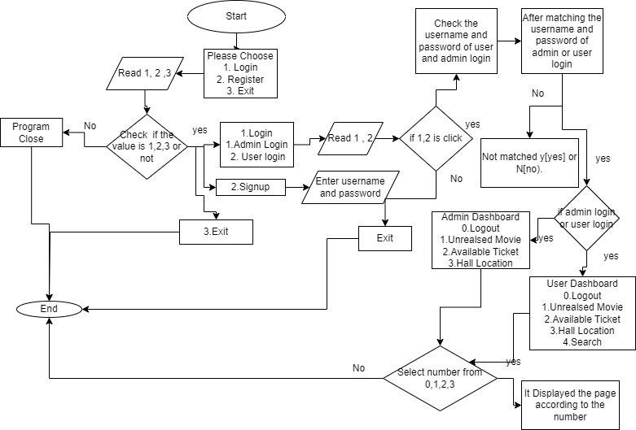

**Conclusion**

After we have completed the project we are sure the problems in the existing system would overcome the “ONLINE MOVIE TICKETING MANAGEMENT SYSTEM” process made computerized to reduce human errors and to increase the efficiency. The main focus of this project is to lessen human efforts. Our main aim of the project is to get the correct information about a customer. The computerization of the Online Ticketing Management will not only improves the efficiency but will also reduce human stress thereby indirectly improving human recourses.

**Reference**

* <https://cppsecrets.com/users/22319897989712197103975756505164103109971051084699111109/C00-MOVIE-TICKET-BOOKING-SYSTEM.php>
* <https://www.youtube.com/watch?v=yvBzlCyFaRo>