# Report on Anti-Lock Braking System

Name: Bharat Suresh Baviskar

Employee Id: 214904

Introduction:

Anti-Lock Braking System (ABS). It simulates the dynamic behavior of a vehicle under hard braking conditions. The model represents a single wheel, which may be replicated a number of times to create a model for a multi-wheel vehicle.

In this model, the wheel speed is calculated in a separate model named wheelspeed This component is then referenced using a 'Model' block. the referenced model use a variable step solver, so Simulink will track zero-crossings in the referenced model.

### Modeling:

### IMG_20210311_080043.jpg

The friction coefficient between the tire and the road surface, mu, is an empirical function of slip, known as the mu-slip curve. mu-slip curves by passing MATLAB variables into the block diagram using a Simulink lookup table. The model multiplies the friction coefficient, mu, by the weight on the wheel, W, to yield the frictional force, Ff, acting on the circumference of the tire. Ff is divided by the vehicle mass to produce the vehicle deceleration, which the model integrates to obtain vehicle velocity.

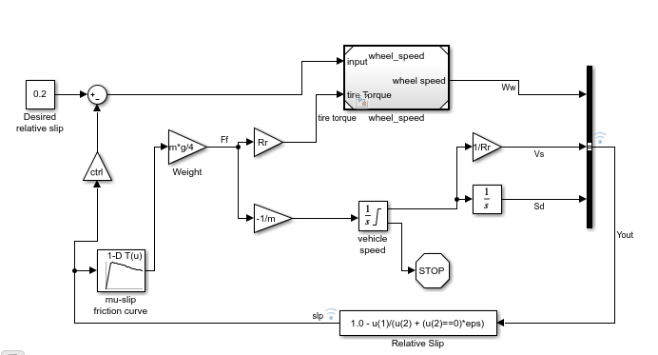

ABS Model

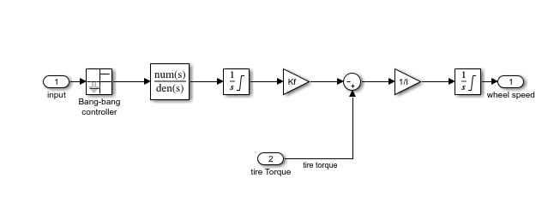

Model for wheel speed calculation

**Running the Simulation in ABS Mode:**

**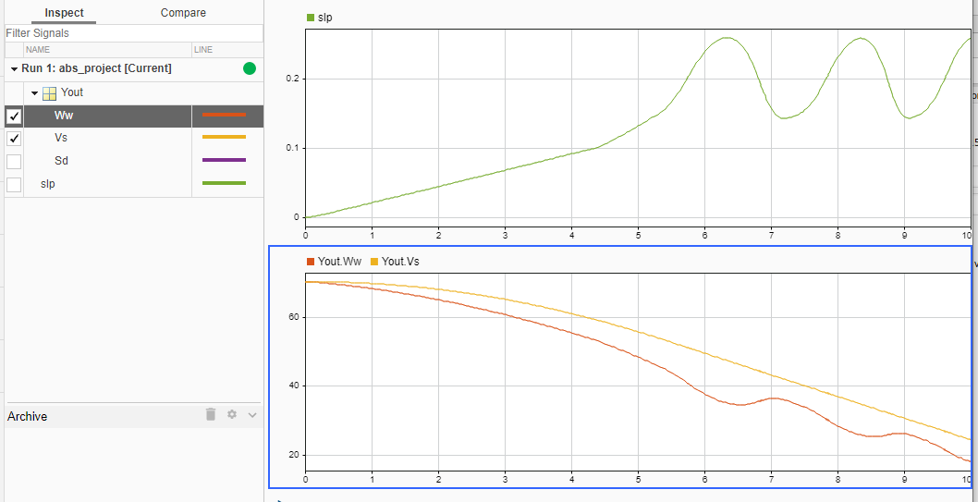**

In graph Yout Vs is vehicle speed and Yout Ww is wheel speed

### Running the Simulation Without ABS:

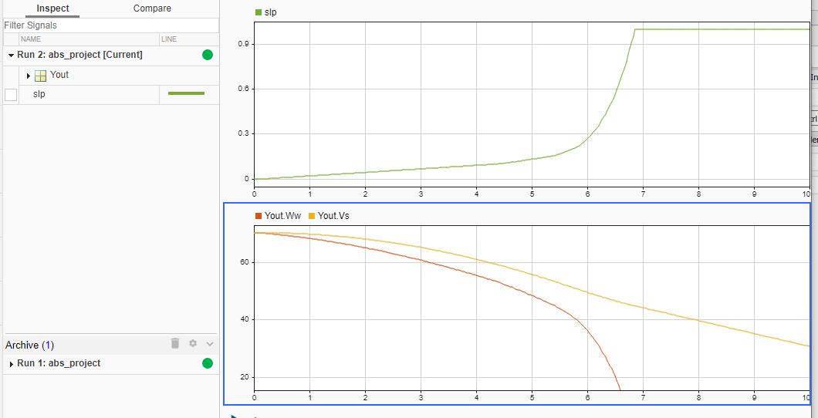

### Running the Simulation Without ABS