Project Documentation Report
Smart Inventory Management System (Java Terminal Application)
1. Project Overview & Problem Statement
Small retail businesses and local stores frequently rely on manual register books or informal record-keeping to track product inventories. This manual approach leads to significant challenges including inaccurate stock counts, difficulty locating items, unnoticed low-stock levels, and human error during billing. The Smart Inventory Management System is a robust, lightweight, command-line Java application built to digitize and automate core inventory operations seamlessly.
2. Key Features & Solution Architecture
The application offers a fully structured terminal user interface (TUI) with modular architecture:
- Product CRUD Operations: Add, view, edit, search, and delete products with unique system IDs.
- Stock Control: Real-time stock addition, reduction, and dynamic quantity adjustments.
- Automated Billing: Process sales transactions, compute total bills, and instantly update stock levels.
- Smart Reporting: Generate low-stock alerts, category-wise breakdowns, and financial inventory summaries.
- CSV Persistence: Automatic saving and retrieval of inventory data to local CSV storage files.
3. Technical Specifications & Java Concepts
- Object-Oriented Programming (OOP): Encapsulation for product attributes, domain modularity, and interface-driven persistence.
- Collections Framework: ArrayList and HashMap for fast data manipulation, lookups, and reporting.
- Exception Handling & Validation: Robust input sanitization preventing type mismatches and invalid menu selections.
- File I/O & Persistence: Custom file management handlers reading and writing CSV formats without third-party frameworks.
4. Execution Walkthrough & System Screenshots
Figure 1: Menu Interface & Adding a New Product (with Input Validation)
This view shows the terminal main menu, user selection (Option 1), robust category validation (handling non-numeric/invalid inputs), and success notification upon adding a new product ('snacks').
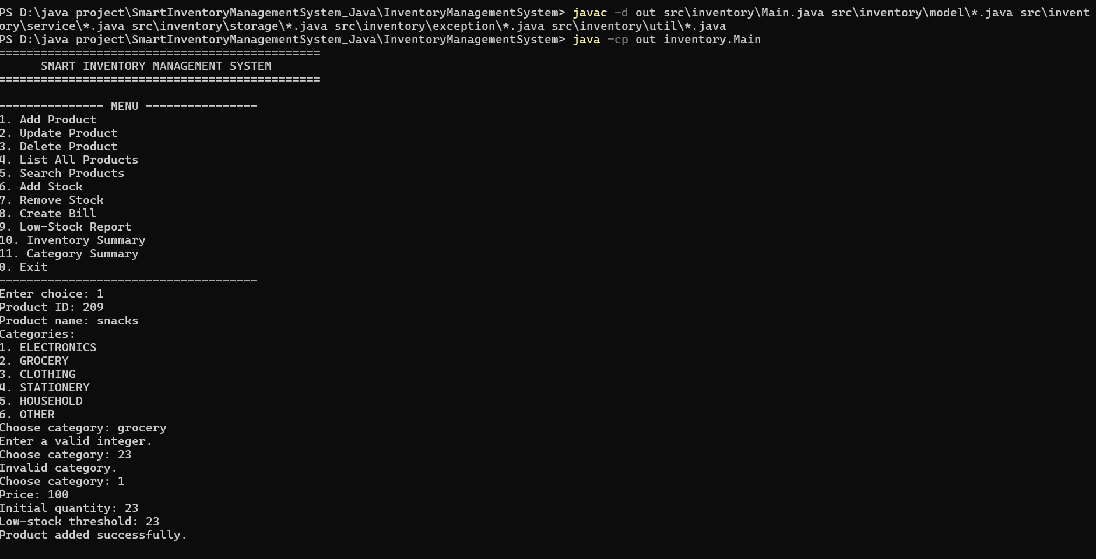
Figure 2: Complete Inventory Product Listing
Option 4 displays all active inventory items formatted in tabular form, showing Product ID, Name, Category, Price, Current Stock, and Low-Stock Threshold.
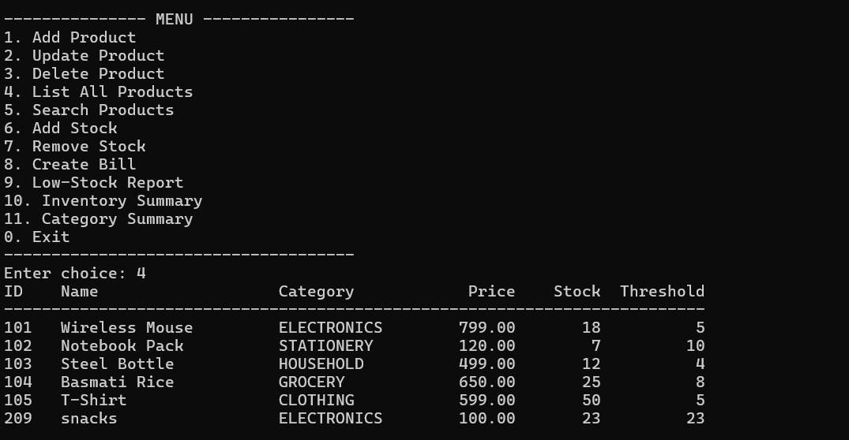
Figure 3: Updating Existing Product Details
Option 2 allows modifying attributes of existing items by Product ID, including category, price, and reorder thresholds.
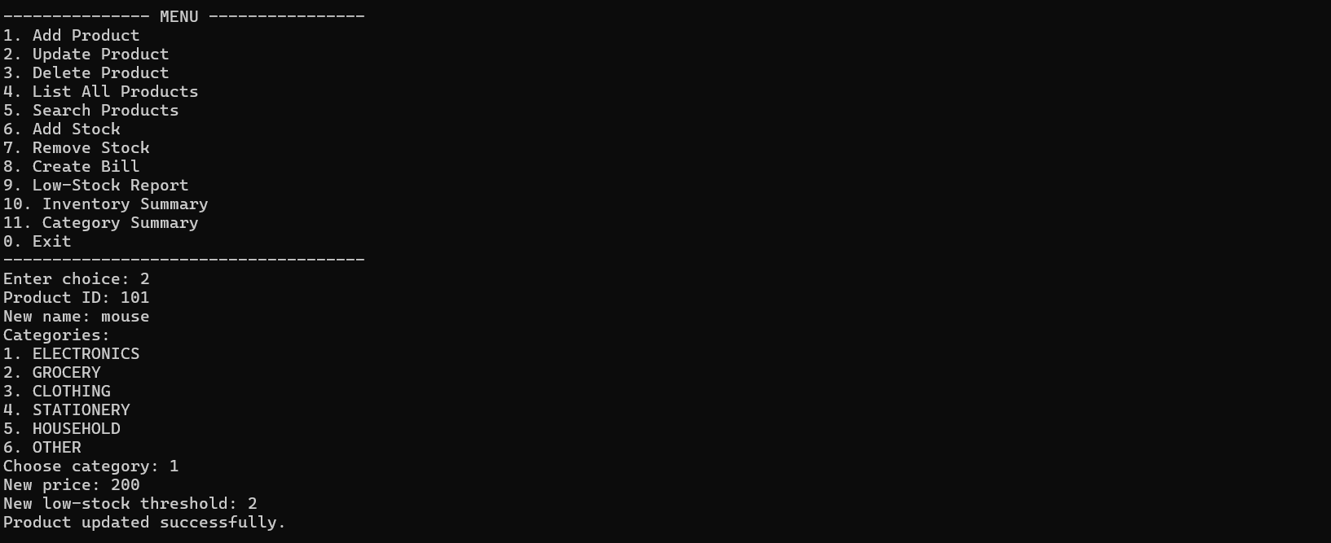
Figure 4: Deleting a Product Record
Option 3 handles item deletion by ID from the persistent repository with immediate confirmation.
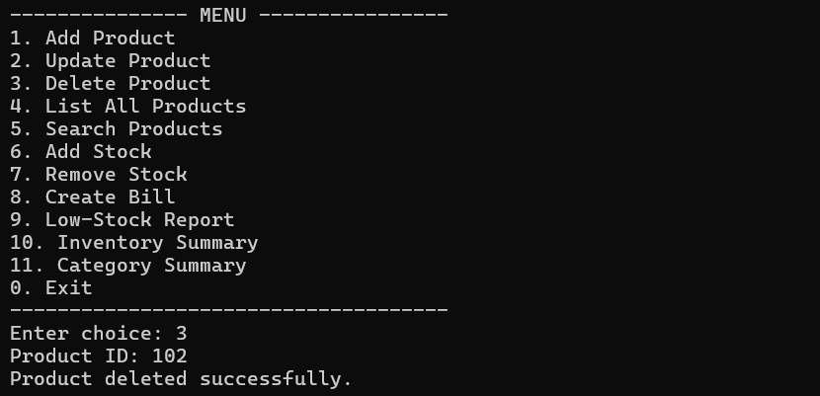
Figure 5: Searching Inventory by ID, Name, or Category
Option 5 allows quick dynamic lookup across inventory fields (e.g., searching by ID '101' yields item 'mouse').
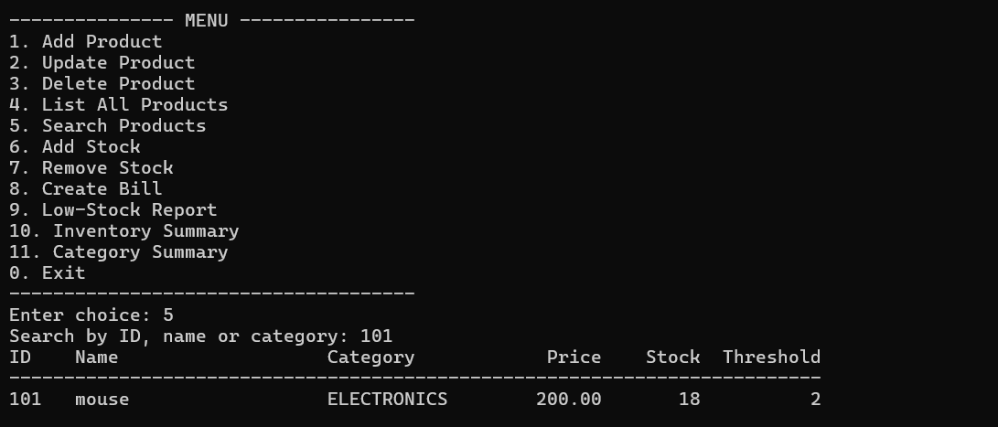
Figure 6: Automated Billing & Stock Reduction
Option 8 creates customer bills. Entering Product ID and quantity automatically generates a timestamped receipt and reduces available inventory.
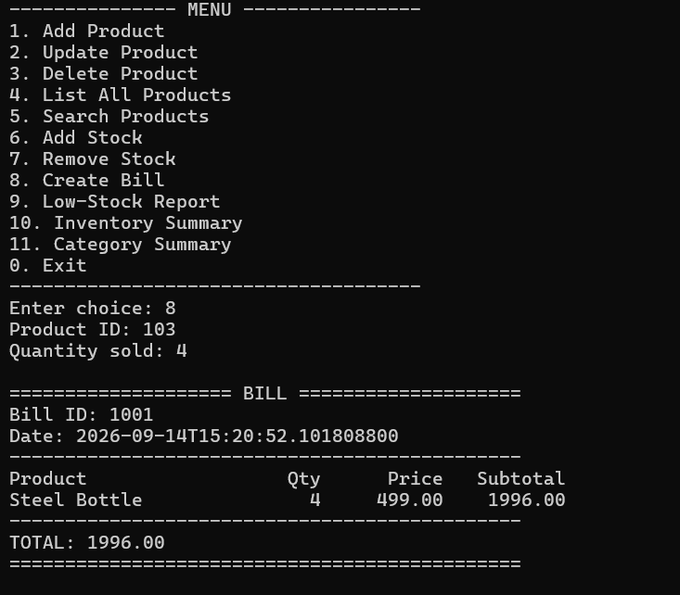
Figure 7: Executive Inventory Summary Report
Option 10 aggregates inventory statistics: unique product count, total units, overall valuation, and count of low-stock items.
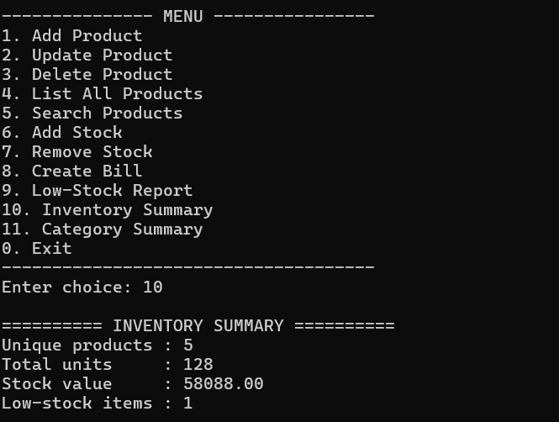
Figure 8: Category Breakdown Summary
Option 11 provides stock distribution metrics (product count & total units) across categories like Electronics, Grocery, and Clothing.
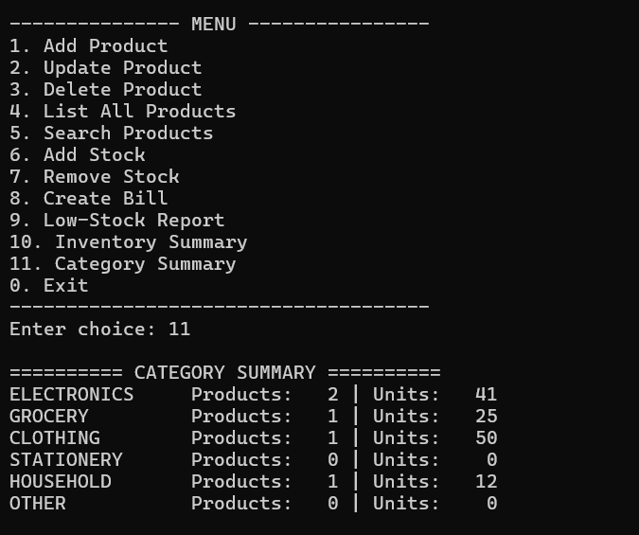

Figure 9: Low-Stock Alert Report
Option 9 isolates items whose stock has reached or dropped below their threshold, enabling timely reordering.
