## **\*\*\*\*\*\*\*\*\*\*\*\*\*\*\*\*\*\*\*\*\*\*\*\*\*\*\*\*\*\*\*\*\*\*\*\*\*\*\*\*\*\*\*\*\*\*\*\*\*\*\*\*\*\*\*\*\*\*\*\*\*\*\*\*\*\*\*\*\*\*\*\*\*\*\*\*\*\*\*\*\*\*\*\***

## **Questions: - Create Users S1 and S2 allow these 2 Users Websites.**

## **Wikipedia.org, Amazon.in, filpkart.com, myntra.com**

## **Block all other Websites.**

## Step1:- First we are creating two Users S1 and S2.

## Login in PFSense portal then go to the services, select Squid Proxy Server and click on users. redhat

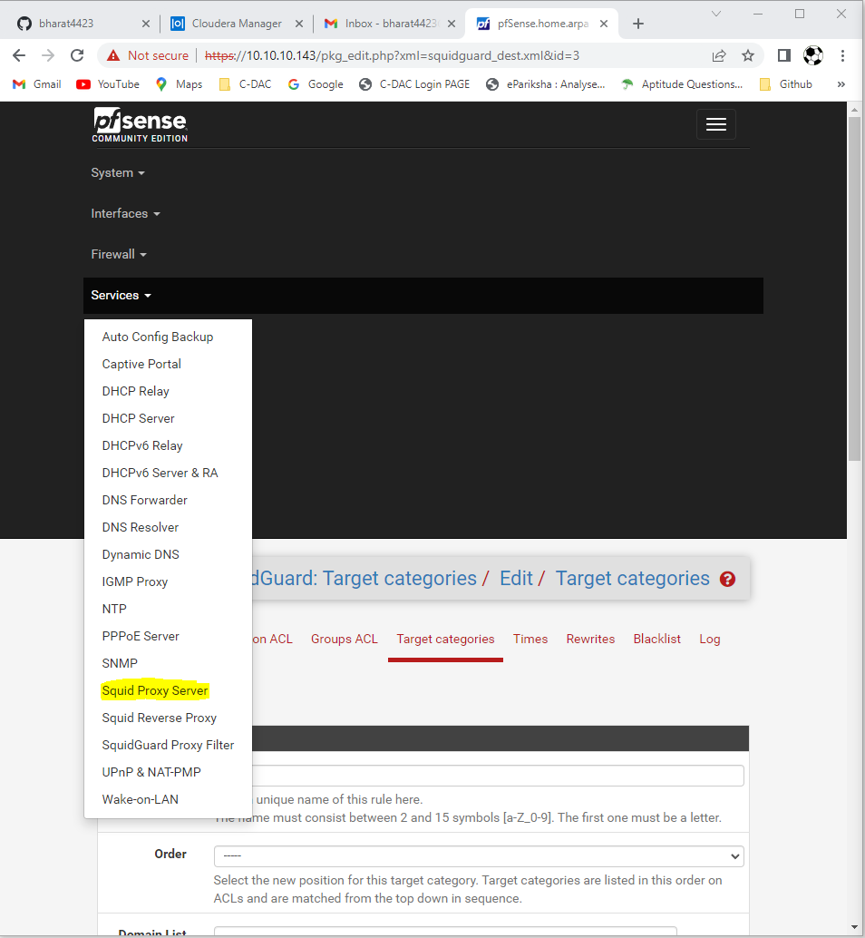

## Step 2: Create 2 users, S1 and S2.

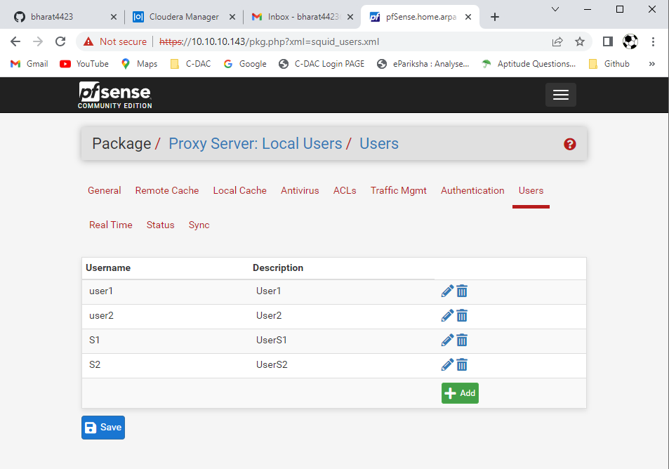

## Then go to general and restart service.

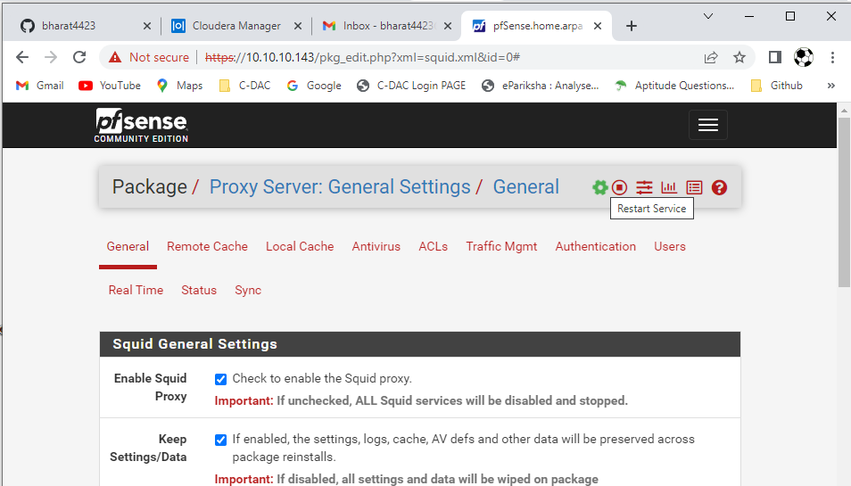

## Step3: After that required to go Services and SquidGuard Proxy Filter

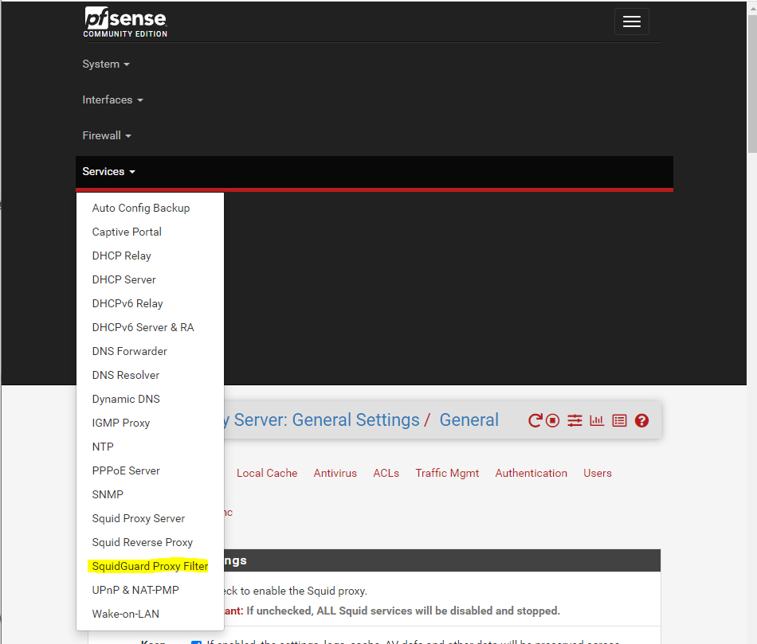

## Then go to Target categories and add new rule for user S1 and S2.

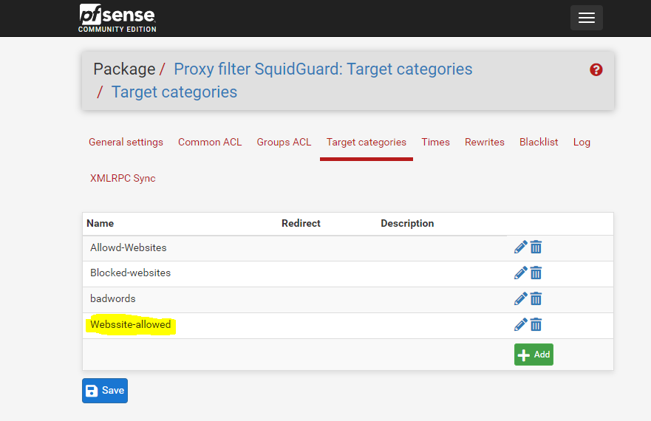

## After that go to the Groups ACL add Name.

## Example:-

## 1) Name: User_S1_and_S2_Access 2) Client (source):- ‘S1’ ‘S2’

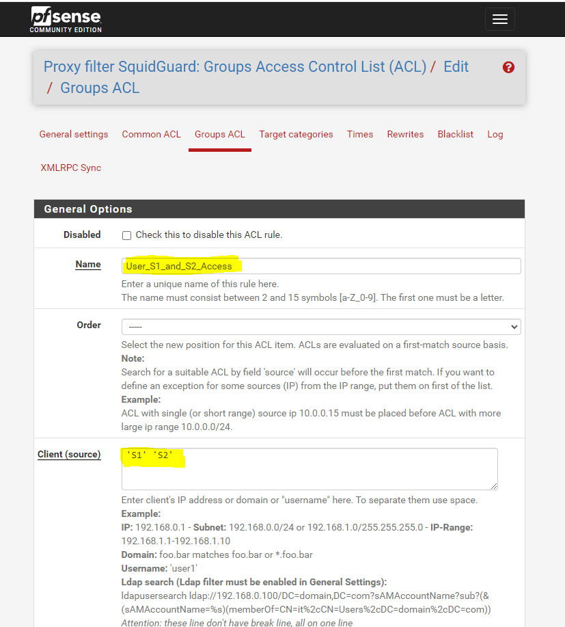

## Then click on Target Rules List.