**iOn nginx server**

Step 1 ➖ Add 2 Network Adapter (one **NAT** & second **HOST-ONLY**)

Step 2 :- Make ip up then make firewall, SELINUX disable by below commands

# systemctl stop firewalld

# systemctl disable firewalld

# setenfoce 0

# sed -i 's/^SELINUX=.*$/SELINUX=disabled/g' /etc/selinux/config

# su

Step 2 :- Install epel-release & then install nginx





Step 2 :- Go to the nginx.conf file by

# **cd /etc/nginx**

**On client** ➖

Step 3 :- Add the **HOST-ONLY** Network Adapter

Step 4 :- Here also make firewalld & SELINUX disable by

# systemctl stop firewalld

# systemctl disable firewalld

# setenfoce 0

# sed -i 's/^SELINUX=.*$/SELINUX=disabled/g' /etc/selinux/config

# su

Step 5 “- install the HTTPD service



Step 6 :- Make the index.html file for client

# cd /etc/www/html

# vim Index.html …….(Write any content which you want )

.....(Centos_Client_webpage)

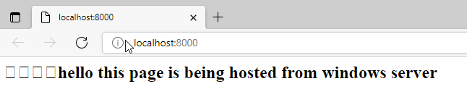.....(windows client web page)

**On nginx server**

Step 7 :- Check on Proxy server that the client ip is pinging or not or you can check with the curl

# ping <client_ip>

# curl http://<client_ip>

Step 8 ➖To host/Load balancer we write a rule in nginx.conf file

# vim nginx.conf

→ in this file we want to add the rule for load balancing as shown below

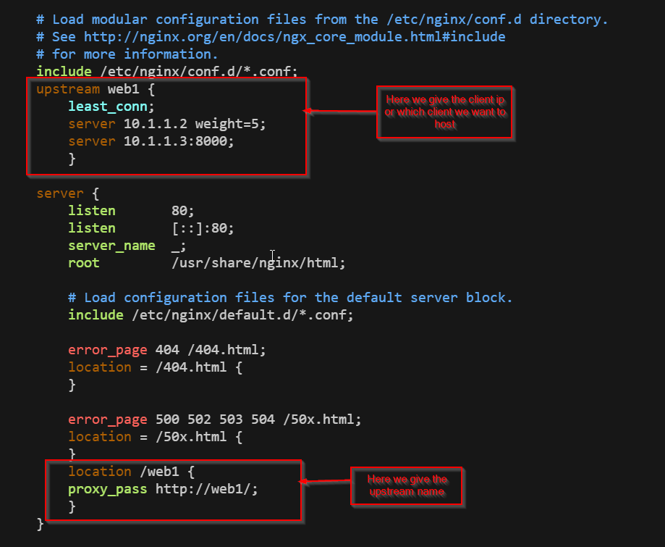

Step 9 :- After writing the rule we have to restart the nginx service & check that it is started or not by below commands

# systemctl restart nginx

# systemctl status nginx

Step 10 ➖ To see the web page go to **BASE MACHINE Browse**r & give

**<proxy_server_NAT_IP / upstream_name>**

**→** If you refresh the page it will show the next **Client Web Browser**

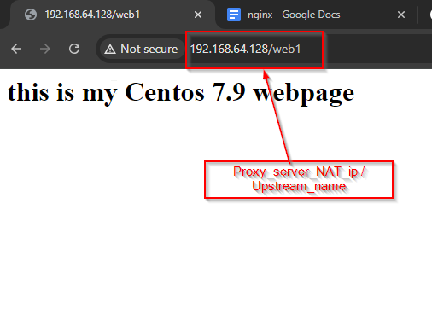

**→** After Refreshing the Page it is showing the next client web page

