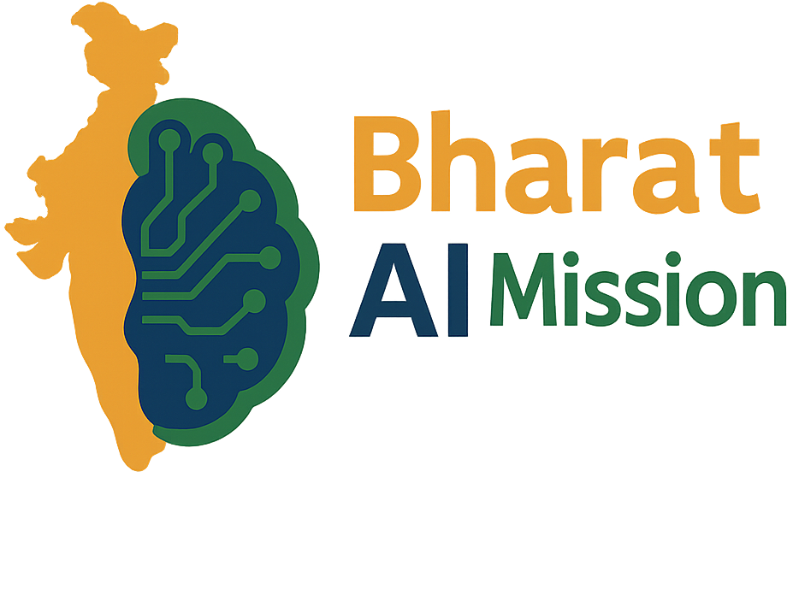
BHARAT AI MISSION • COMMUNITY CONTRIBUTOR SERIES

Bharat AI Commons

Contributor Handbook
Getting started with India’s open-source AI ecosystem

Document version | v1.0
Last updated | 29 October 2026
Document owner | Bharat AI Mission
Status | Initial branded release

Discover. Document. Evaluate. Enable.
Building shared foundations for Open Source AI in India.

1. Welcome
Bharat AI Commons is a community-oriented directory for discovering and contributing information about open-source AI resources relevant to India. It brings together datasets, models, language resources, benchmarks, tools, responsible-AI guidance and real-world use cases.
Bharat AI Mission is the community initiative behind this effort. The Commons is a resource and contribution platform; it does not automatically certify, endorse or independently validate every listed resource.

Our contribution principles
- Evidence first: Link to the original source or official model/dataset card.
- Respect rights: Public downloadability does not automatically mean an open licence.
- Be transparent: Distinguish verified facts from unknown details.
- Represent languages carefully: Record only language and state coverage supported by documentation.
- Make it useful: Provide context so others can evaluate and reuse the resource.

2. What can you contribute?
Area | Useful contributions | Evidence to capture
Datasets & language resources | Text, speech, translation, OCR, transliteration and instruction data | Original URL, maintainer, licence/terms, languages, modality, access conditions
Models | Indic-language and India-relevant models, checkpoints and model cards | Model card, intended use, languages, licence, limitations
Benchmarks | Evaluation sets, leaderboards, metrics and reproducible protocols | Methodology, dataset, metrics, languages, version and caveats
Tools & infrastructure | Annotation, data processing, inference, evaluation and language tools | Repository/docs, licence, status, requirements, maintainer
Responsible AI | Guidance on privacy, consent, safety, provenance, fairness and governance | Publisher, scope, date/version, jurisdiction, limitations
Use cases & initiatives | Documented deployments, pilots, community projects and public initiatives | Organisation, problem, source evidence, maturity, impact caveats

3. Before adding a resource
- Find the original publisher, repository, documentation or model/dataset card.
- Confirm that the resource exists and the link works.
- Check licence terms, access restrictions and attribution requirements.
- Record the name exactly as published.
- Record languages only when the source documents them.
- Do not infer state coverage from a language name or an organisation’s location.
- Capture version/date where available.
- Note limitations, intended use and known risks.
- Avoid duplicating an existing entry.
Important: Public availability is not the same as an open licence. If licensing is unclear, write “Not stated—verify with publisher” rather than guessing.

4. How to contribute through GitHub
Repository: https://github.com/bharataimission/bharat-ai-commons
The repository’s CONTRIBUTING.md and README.md are the source of truth for the current workflow and catalogue formats.

Beginner-friendly workflow
- Explore first. Read the README and contribution guide; check the relevant catalogue for duplicates.
- Choose the right category. Use the existing catalogue and its current column names.
- Add a small, evidenced entry. Keep descriptions factual and include the original source URL.
- Check formatting. Preserve CSV column order and quote values containing commas.
- Review your change. Check spelling, URLs, licences, language names and duplicates.
- Submit for review. Follow the repository’s accepted contribution method and explain your sources.
- Respond constructively. Maintainers may request clarification before merging.

If you are new to GitHub
A pull request is a proposed change for maintainers to review before it becomes part of the project. You do not need to be an AI researcher: link checking, documentation, metadata cleanup, translations, issue reporting and careful resource discovery are valuable contributions.

5. Recommended catalogue metadata
Field | Guidance
Name and category | Use the published name and the best-fitting Commons category.
Source URL | Prefer the official repository, publisher page, model/dataset card or documentation.
Licence / terms | Use the documented licence name/link; otherwise say it is not stated.
Language coverage | Include only language names or codes supported by source documentation.
Modality / task | Examples: text, speech, OCR, translation, ASR, TTS, embeddings, generation.
Maintainer / version | Record publisher, release/version or last-updated date where available.
Limitations / notes | Capture caveats, access requirements, evaluation limits and intended use.
Verification status | Use the project’s defined status vocabulary; never imply unperformed review or endorsement.

6. Responsible and safe contributions
Do not upload private, confidential or unlawfully obtained data. Do not publish secrets, access tokens or personal contact details without a legitimate reason and permission. For datasets involving people, check consent, privacy, collection context, data minimisation and publisher terms before recommending reuse.
For models and benchmarks, avoid overstating performance. Record the evaluation setup, test data, language coverage, version and known limitations where available. Scores from different benchmarks may not be directly comparable.
For geographic or language maps, show only associations documented by a trustworthy source. A resource supporting Marathi does not by itself establish coverage across every district of Maharashtra. Use “not specified” or “not verified” where appropriate.

7. How to write a useful entry

Illustrative template
- Resource name: [official published name]
- Category: Dataset / Model / Benchmark / Tool
- Source: [official URL]
- Licence: [exact licence, or “not stated”]
- Languages: [only those documented by publisher]
- What it does: One or two factual sentences
- Limitations: [documented constraints, or “not documented in source reviewed”]
- Checked on: [date source was checked]
Avoid: “Best model for all Indian languages,” “fully open” without licence evidence, invented performance numbers, inferred state coverage, unsupported adoption claims or third-party copies when the original source is available.

8. Community conduct and review
Be respectful, explain disagreements with evidence and welcome contributors with different experience levels. Follow CODE_OF_CONDUCT.md and CONTRIBUTING.md. Report broken links, incorrect metadata, licensing concerns and potentially harmful content through the project’s documented process.

9. First contribution checklist
☐ I found the original source and checked for duplicates.
☐ I recorded the licence accurately or marked it unknown.
☐ I only included documented languages, locations and performance claims.
☐ I noted limitations and access conditions where available.
☐ I followed the current catalogue schema and contribution instructions.
☐ I reviewed my change and explained my sources.

10. Useful links
- Bharat AI Mission: https://bharataimission.org
- Bharat AI Commons repository: https://github.com/bharataimission/bharat-ai-commons
- Contribution guide: https://github.com/bharataimission/bharat-ai-commons/blob/main/CONTRIBUTING.md
- Repository overview: https://github.com/bharataimission/bharat-ai-commons/blob/main/README.md
This is an introductory guide. Repository instructions, catalogue schemas, licence terms and source documentation take precedence where they differ. Review this handbook as the Commons evolves.

