1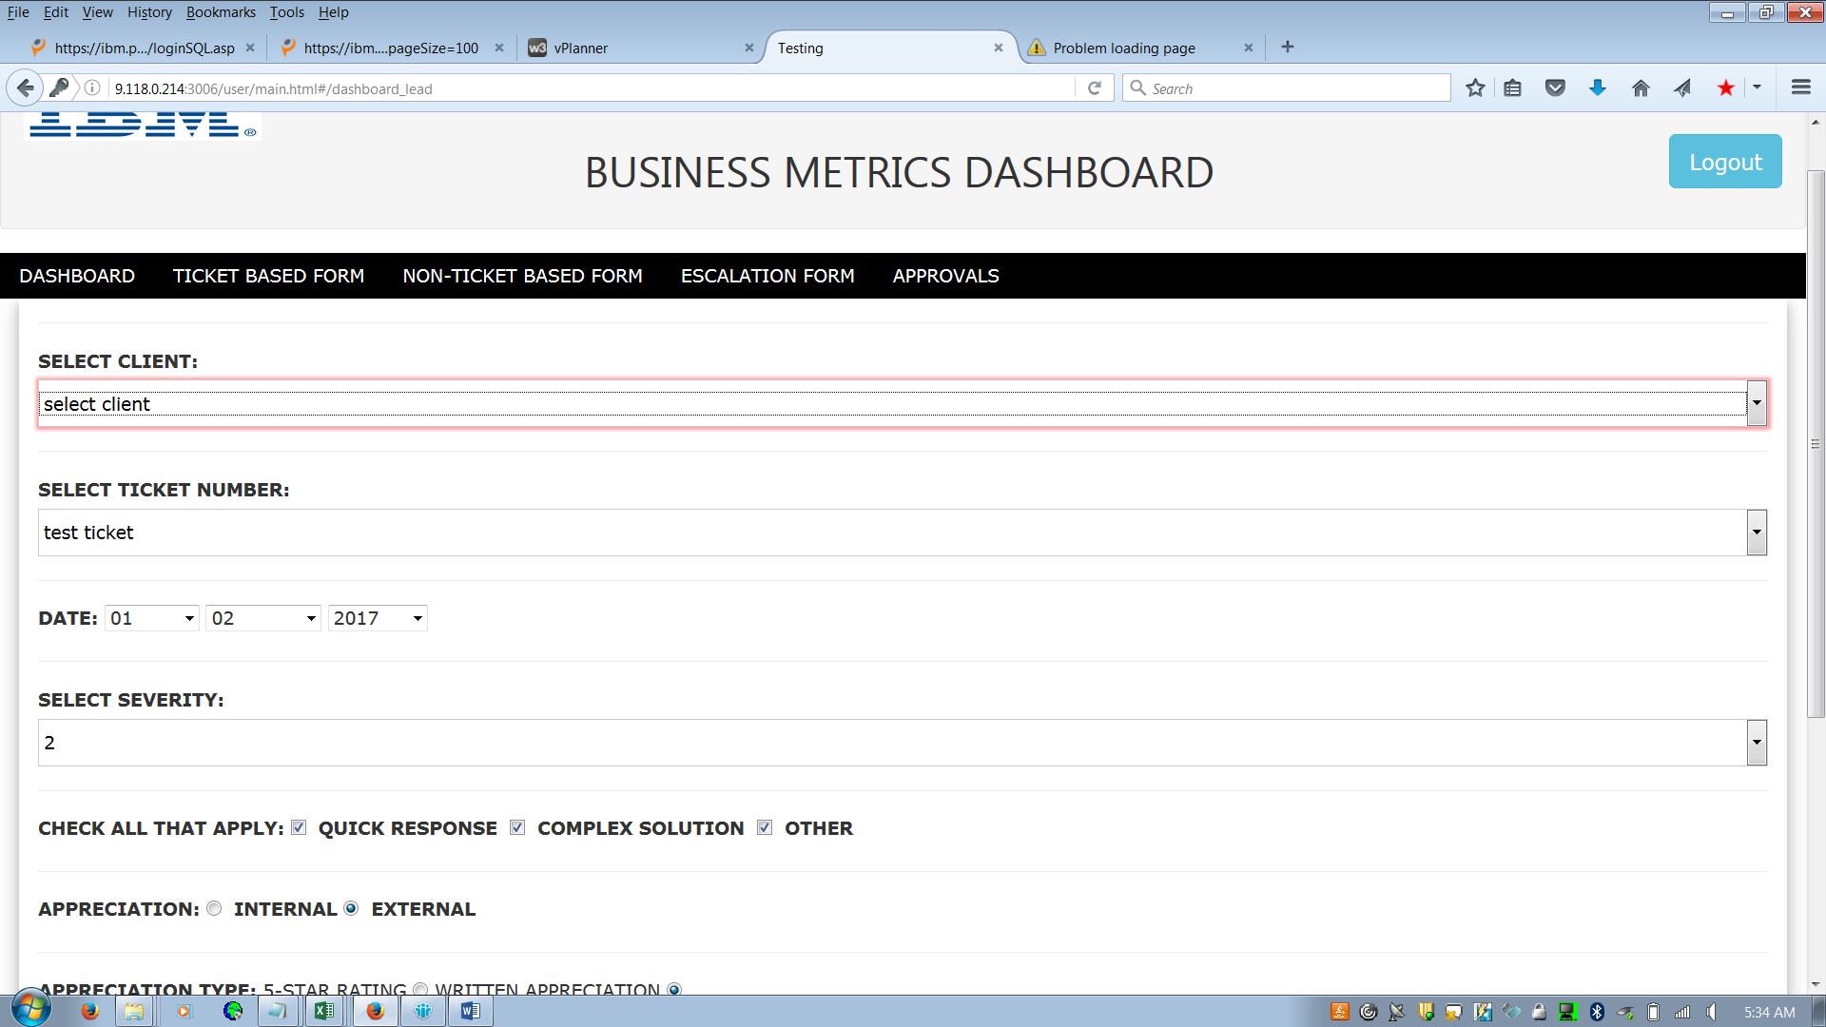

As client is not loaded so we are not able to submit appreciation/Escalation

2.

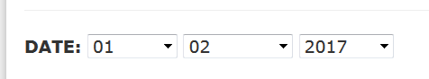

Can date field be changed like below

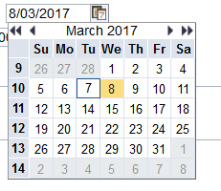

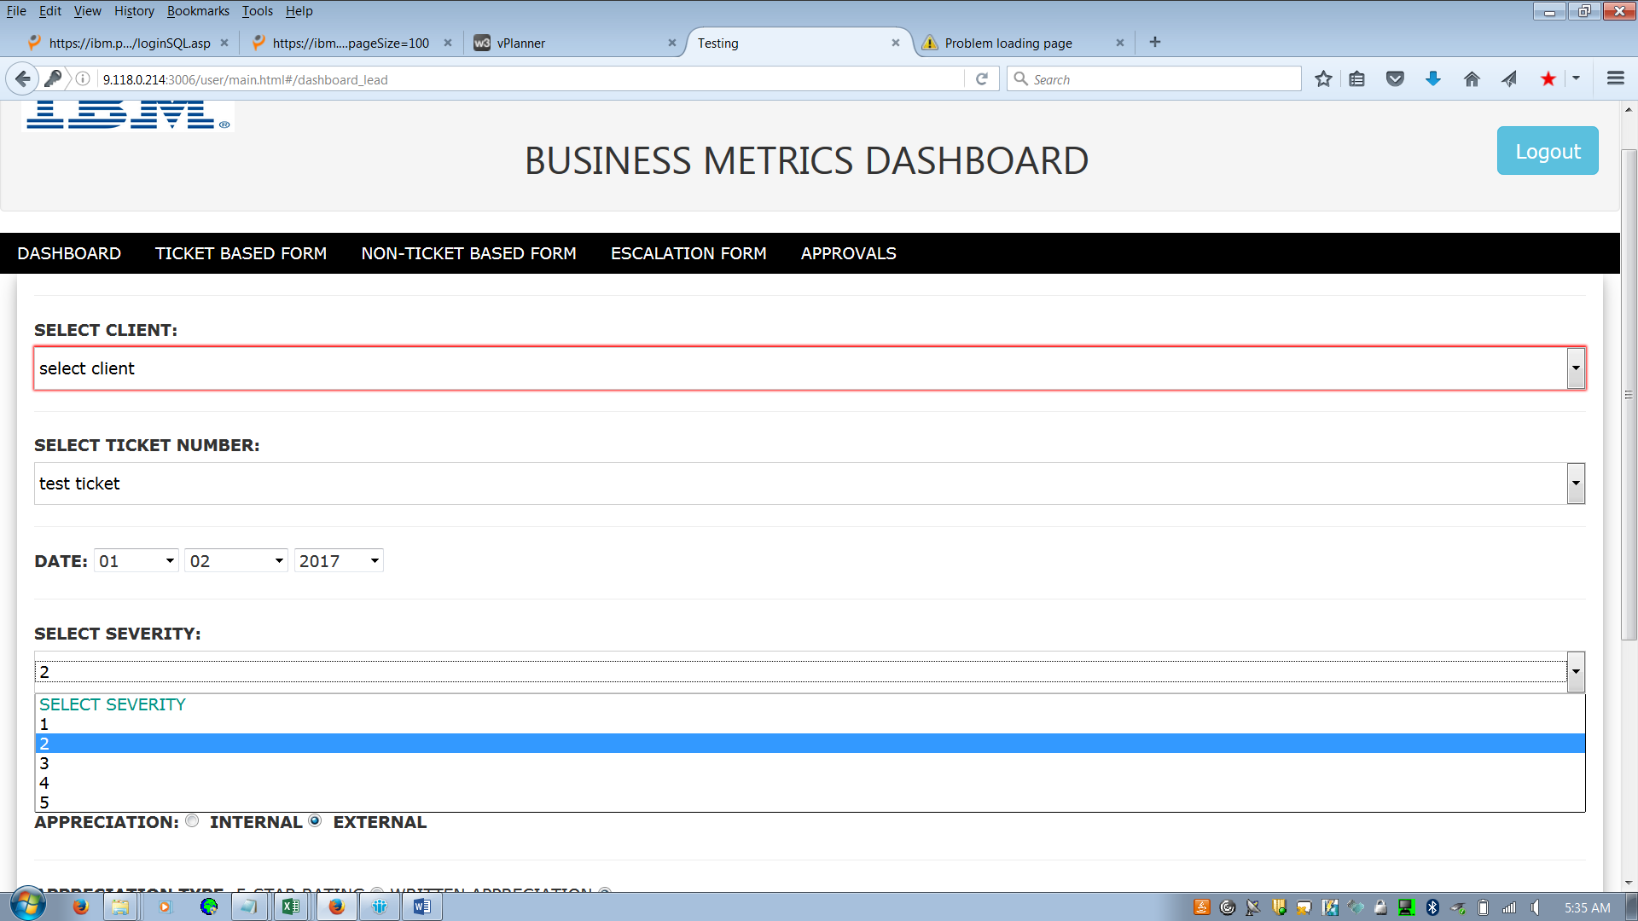

Severity must be from 1 to 4 only.

**Escalation Form**

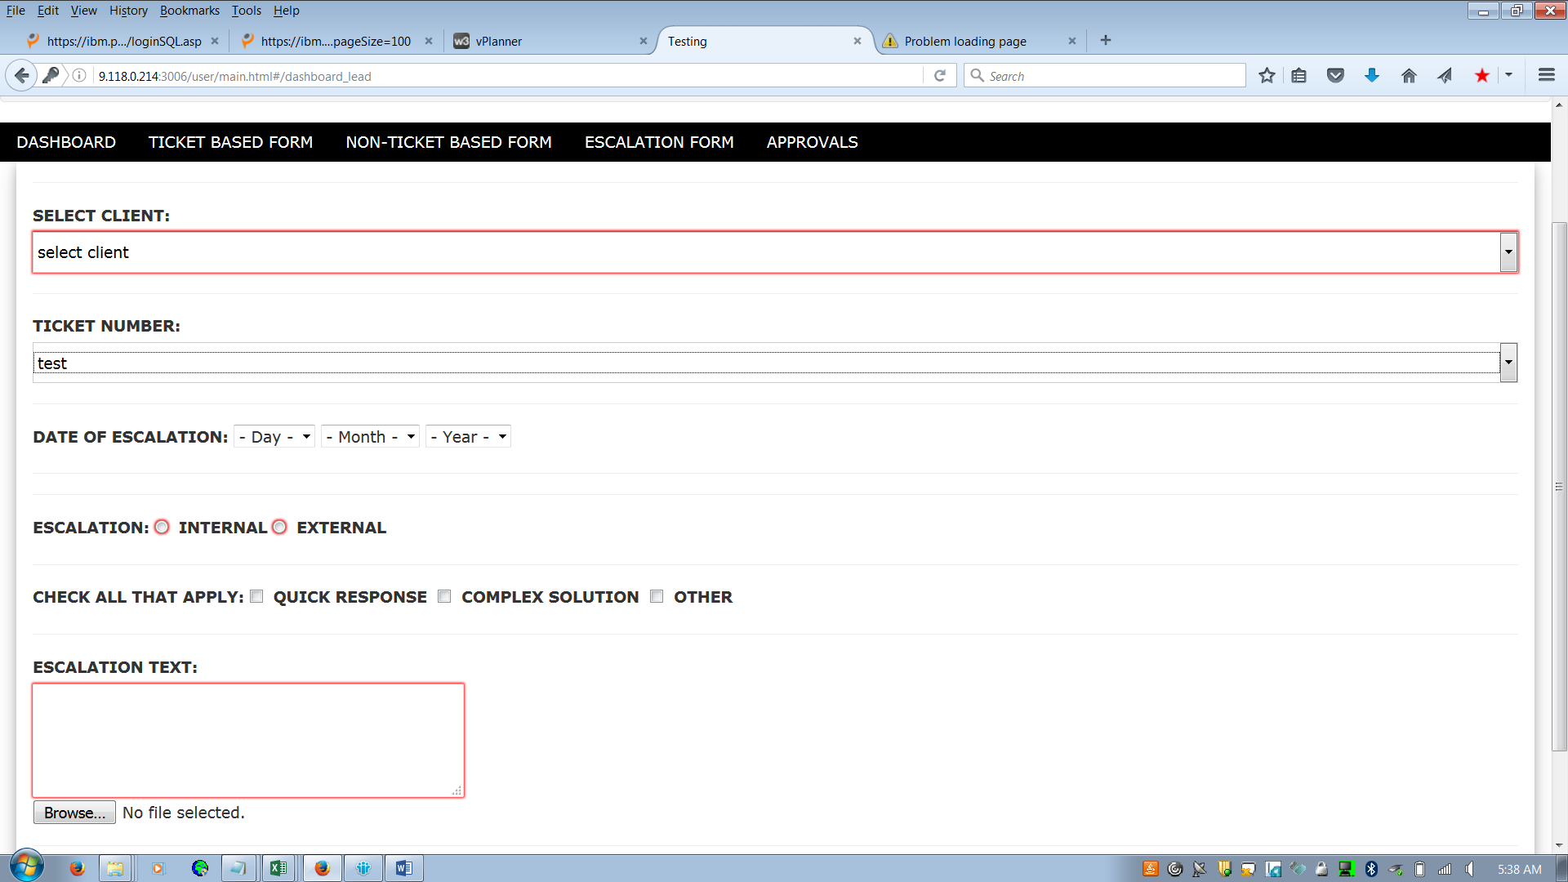

Escalations can be without ticket number also, so can we have Ticket number filed to be Optional for Escalations.



For escalation above is not required.

**Technical**

**Process** check boxes we can have instead of above.