**BMD Defect Tracking**

**Objective**

The objective of the application lies in the fact that the escalated defects are sometimes not enough to understand at what point the defect has risen. This leads to some problems when the fixes are being made, for example if someone is trying to fix a defect and we already know it would save a day’s time and make it easier.

**Modules**

1. **Login Page** – The basic IBM standard and LDAP authentication enabled login where anyone present in the groups allowed the access can enter the tool and use it.

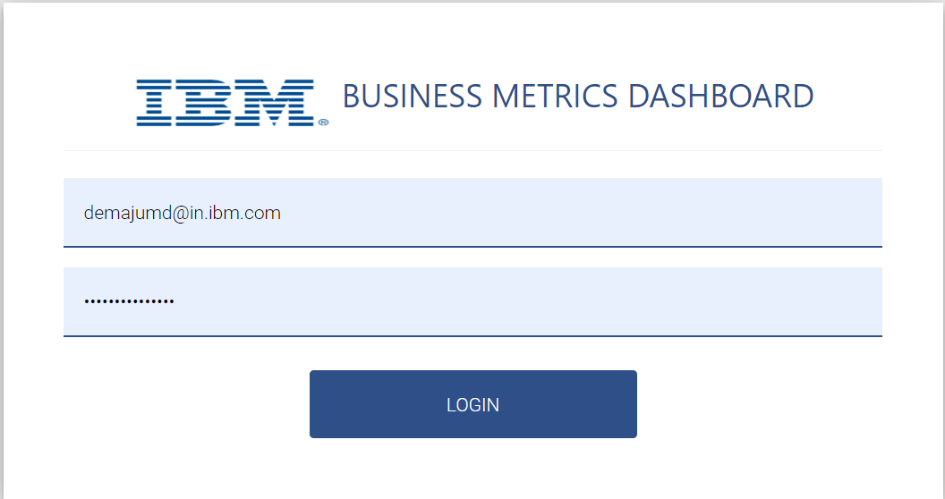

1. **Defect Management**– Consists of two sections Defect Log and Defect View.

* Defect Log – This section deals with the logging of a defect. There are various parameters which can be filled.

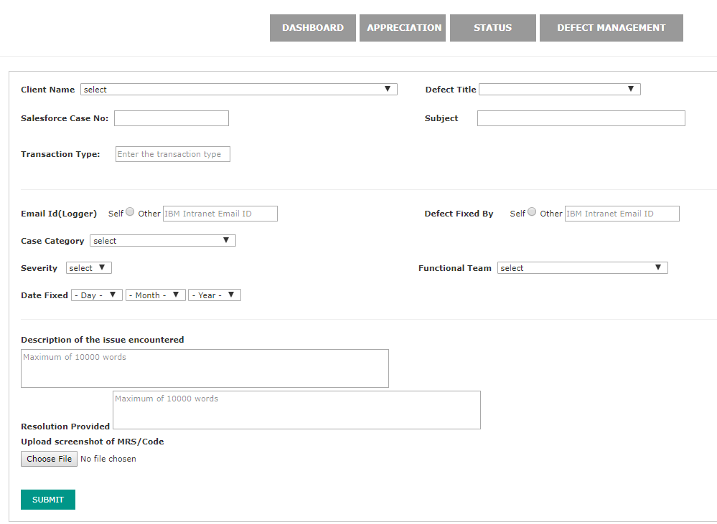

* Defect View – This section has a dropdown of clients, where client specific issues can be viewed, and each defect can be opened and seen. Also, there are two filters based on defects and based on Defect Title and Subject Search box.

