**SCBN Rule Validator**

**Objective**

The objective of the application is to extend an additional feature to the existing Sterling Rule Search Tool. The current tool was able to do a search by the Rule Name Only, making it less flexible for implementers.

The SCBN Rule Validator has been designed in such a way so that these shortcomings can be taken care of or rather a better flexible approach can be made. Apart from the extended searching capabilities the tool also takes care of an addition feature that is Rule Validation.

The Rule Validation is basically another interface where bad rules can be avoided (Discussed later) and user can first confirm whether a rule is suitable or not to be moved forward with, and only then move forward with the configurations.

**Modules**

1. **Login Page** – The basic IBM standard and LDAP authentication enabled login where anyone present in the groups allowed the access can enter the tool and use it.

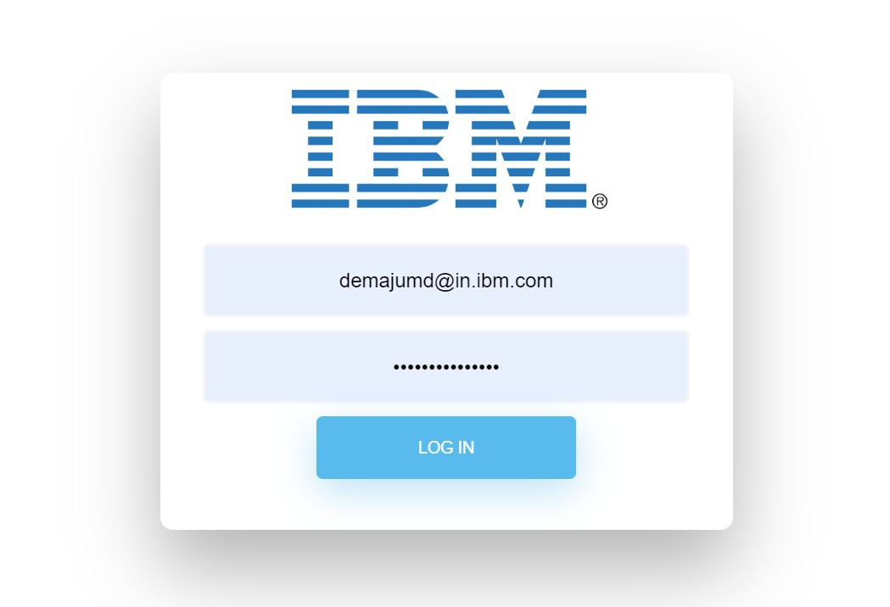

1. **The Home Page (Landing Page)** – This page manages the home landing of the application. There are basically three parts where you can visit

**Rule Search**

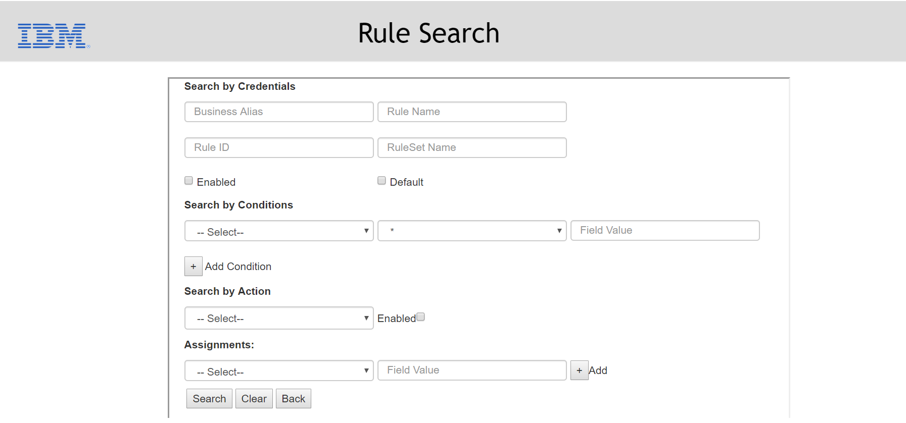

As seen in the picture this section contains of 9 Major fields and sub fields can be attached with the click of the add button.

The fields are:

**Business Alias** – The Client under which the rule is allotted

**Rule Name** – The Name of the Rule

**Rule Id** – The unique ID assigned to each rule

**Ruleset Name** – There are rule sets under which the rules are present. It takes care of those

**Default** – Checks whether a rule is set as default

**Enabled**- Checks whether a rule is Enabled

**Conditions** – The sets of conditions a rule follows while being mapped

**Actions/Assignments** – The action taken, and the assignments made after those conditions are met

**Action Enabled** – What is the current state of some action.

These provide a very extensible search tool and the user can mix up using all the present fields and thus knowing even some specific details the filters can be added.

**Rule Validator**

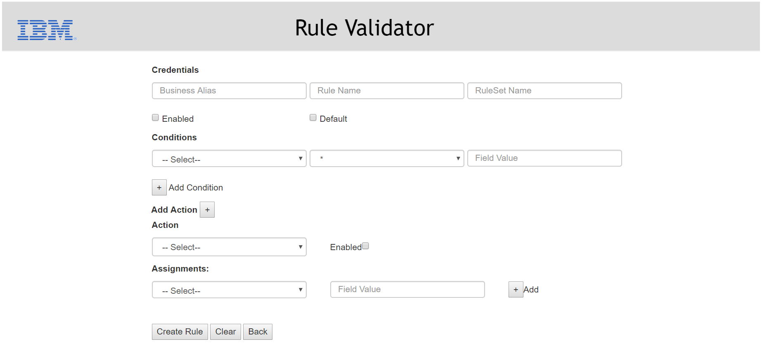

This part as seen is the Rule validator, given a similar interface as the Rule Search, basically it deals with the validation on Rules.

A Rule is said to be a Bad Rule if while being processed the Rule does not behave as expected causing unwanted scenarios like collision between two *Rules Having Same Name.* This can be a very serious harm to the Business and can affect up to a great margin.

The Validator therefore checks for some very important but basic constraints and you can put all the configurations you want her, and the popup makes u aware if a Rule is Bad or it is ready to be proceeded with.

The constraints being checked are:

* A rule should not have only ‘!=’ as condition operator.
* A rule if set as default should not have any conditions.
* A rule should have tracking action enabled only in a rule under "BPN_Receive*" ruleset.
* A rule if enabled and not default should have at least one condition.
* A rule is invalid if Rule(s) with same Name under the Same Business Alias Exist.

**Logout** – Gets you back to the Login screen.

**Other Modules**

**The Results Page** - After the search is made the page comes up with the results.

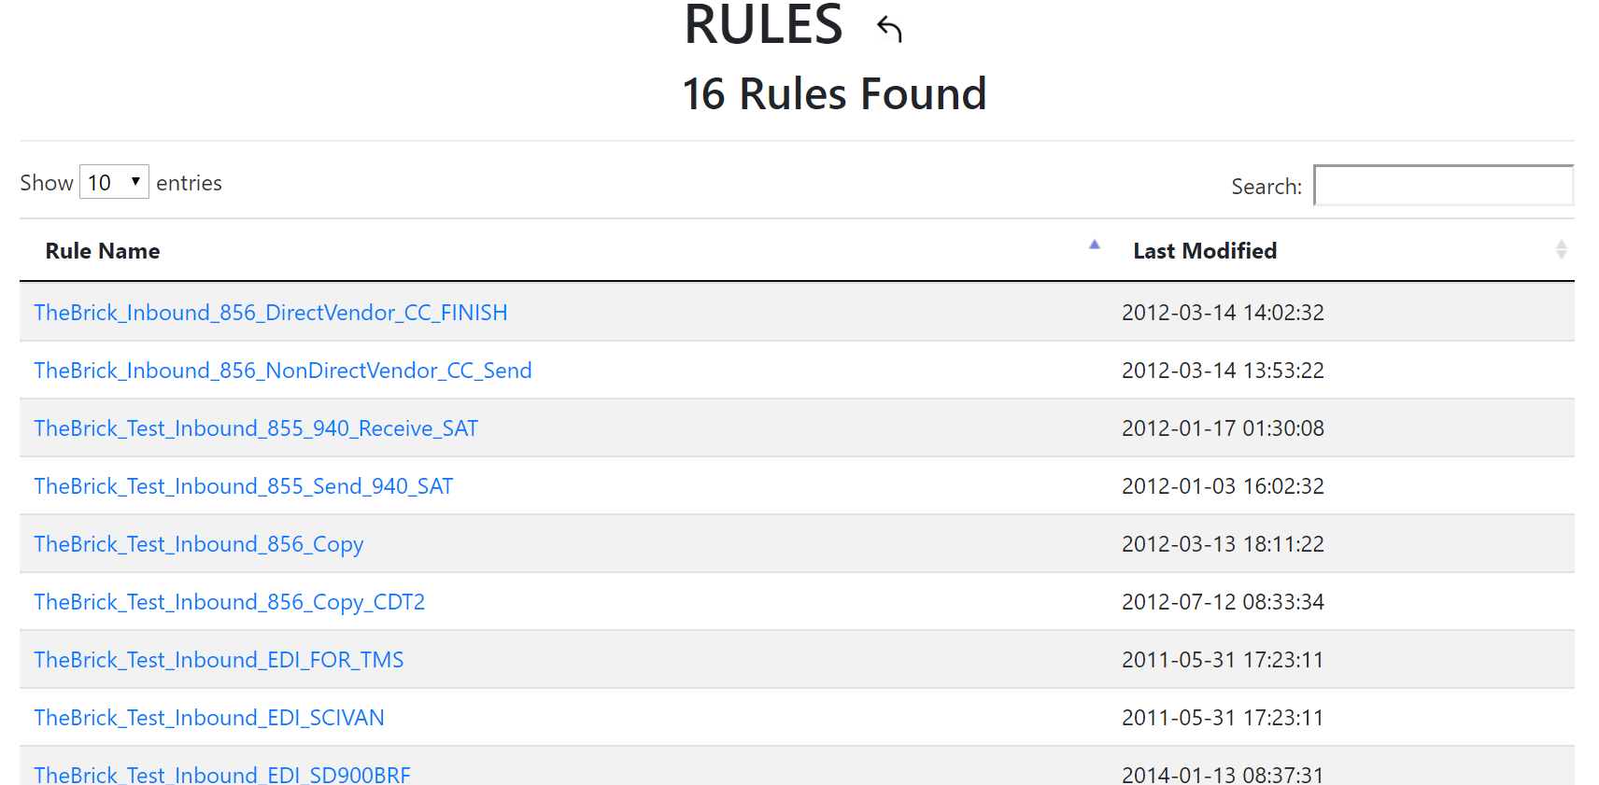

**The Configurations Page**

The internal configurations can be viewed once the rules are selected.

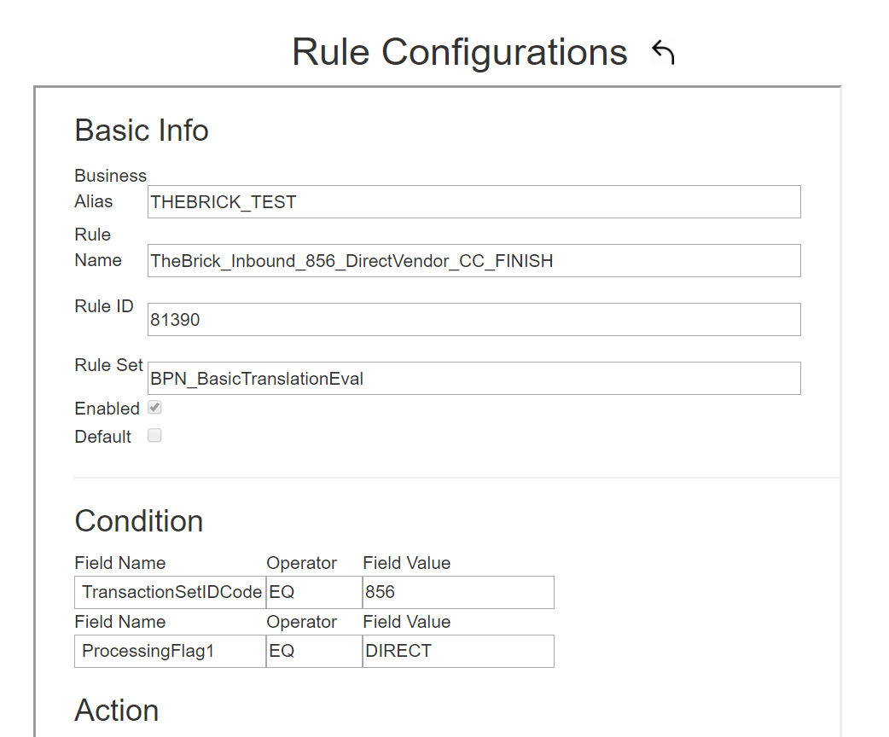

**Download Results**

The results can be downloaded in your local machine with a click of the button, with the the name Rule Results.

