**CS 5200 - Database Management Systems**

Project Proposal

Group Name: PatelSChawlaB

Group Members: Sachi Patel, Bharat Chawla

**Introduction:**

NPMS (Northeastern Parking Management System) is a smart, easy parking facility provided by Northeastern University, Boston. NPMS is a system which monitors an area continuously to transfer data and information on parking space availability with the use of different tools and software such as camera, sensors, and automatic gates. NPMS is a unique and an intelligent innovation of technology and humans which helps students, faculties, staff, and visitors to not only manage their parking spaces but also helps to achieve much faster and easier parking of vehicles saving time, fuel, and space.

**Database Description:**

The database contains information on the Northeastern Parking Management System to facilitate customers with open parking spots based on their permit types. Each parking garage has its unique id, name, address, number of blocks, is slot available, and is re-entry allowed.

A parking lot is divided into one or more blocks. Each block has block Id, block code, number of floors, and is block full or not. Each block can have more than one floor and each floor has floor id, floor number, number of slots, is floor full, is reserved for customers or not. Each floor has multiple slots and each slot contains slot unique id, and slot number.

Each customer can park at the garage based on their association with the permit type i.e. regular, one time, and prepaid. Each customer contains customer id, customer type, vehicle number, contact number, registration date, and has a permit or not. A regular customer will have only one permit and it consists of permit type id, permit type, cost, purchase date, start date, and end date. Regular customers need to scan their permit every time they enter and exit the parking garage and if it's a one time permit customer such as a visitor then required to scan their parking slip when they leave and enter the parking garage.

A customer can only make one reservation at a time and it keeps track of reservation unique id, start timestamp, and date. To track the number of open slots, reservation slips store information about customer’s entry and exit times. It also stores a penalty fee if a customer delays their exit, cost of the reservation, total cost, if a customer has paid for the permit which will allow them to re-enter the garage.

**User Interaction:**

The NPMS system helps students, faculties, staff, and visitors find vacant space in a parking garage, track vehicle entry/exit and processes online reservation to reserve the spot for a certain amount of time to make their parking experience simple and efficient. Additionally, the system also tracks any parking permits that customers have purchased.

**Why Does This Interest Us?**

Transportation is a crucial part of one’s everyday life, whether it includes starting the day off waiting for the train or driving by car. Many Northeastern students, including us, commute to campus every day to attend classes or additional events. One of our members commutes by car and not only has to deal with a large amount of traffic but also must drive around multiple levels of the garage to find a parking spot. Therefore, we decided to design a Northeastern Parking Management System Model where students and all facilities have access to the parking garage and a system which has access to various features such as easy pay, finding a vacant spot, and being able to track entry and exit time as well to provide real-time empty spots. In addition, they may reserve a spot for a certain period as well.

**Database languages:**

Software: MySQL Workbench

Language:

* MySQL to manage the database
* Python for command-line arguments to support CRUD operations.

**UML Diagram:**

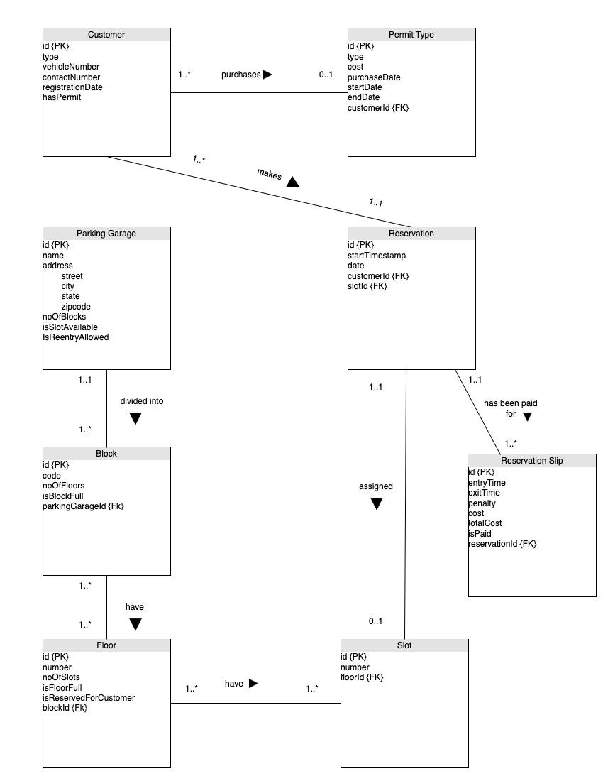

**Activity Diagram:**

