UHO
United Health Organization

Integration Technical Design Document

aws-sapi technical design

Project/Service Identifier: |  | aws system API
Prepared By: |  | Chinna Reddy
Document Version: |  | Version 1.0.0
Published Date: |  | 2021/08/12

Revision History

Version Number | Revision Date | Summary of Changes | Modified by
0.1 | 2021/08/12 | Initial document created | Chinna Reddy

Contributors

Name | Title
Chinna Reddy | Mulesoft Technical Architect

Distribution & Reviewers

Name | Title
Technical Reviewer | TBD
QA Reviewer | TBD
Architecture Reviewer | TBD
PM | TBD

Approvals

Interface ID | Interface Name | Approval Given On | Approver(s)
1 | upload-s3-document | TBD | TBD

Table of Contents

1 Introduction 1
1.1 Document Overview 1
1.1.1 Intended Audience 1
1.1.2 Structure 1
1.1.1 Related Documents 1
2 Technical Architecture 2
3 Services/APIs High level Specification 3
3.1 upload-s3-document : https://uho-{env}-aws-sapi/v1/document 3
3.1.1 Input and Output Definitions of API 3
3.1.2 Consumers 4
3.1.3 Technical details 4
3.1.4 Non Functional 4
3.1.5 Error Handling 5
3.1.6 Integration test cases 5
3.1.7 API Endpoint Details 5
4 API Policies, Access and Network Security - TBD 6
5 Open Issues 7
6 Appendix A – Interface details 8

Introduction

Document Overview

Intended Audience
This document is intended to be used by the integration developers, Integration support team, architects, and testers who will be designing, implementing, and maintaining these middleware services. This document is not intended to be used by the API consumers; API documentation is provided on the Anypoint platform.

Structure
This document contains an overview and depiction of all the services. Document includes detailed designs for each service, including intended API consumers, business rules, technical considerations, and result codes.

Related Documents
The following list provides links to related documents:

Document | Intended Use | Share point Link
Solution Architecture Document
Data Mapping document

Technical Architecture

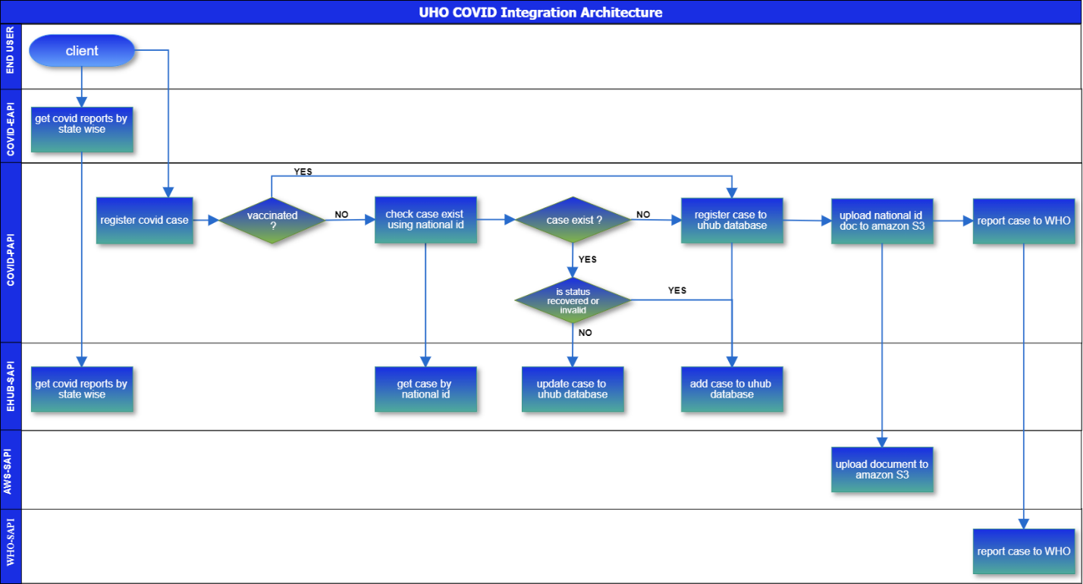

Services/APIs High level Specification

upload-s3-document : https://uho-{env}-aws-sapi/covid/v1/document

This is a POST based API allows COVID case document JSON payload as input then decodes using base 64 then uploads document to AWS S3 bucket and responds back 200, Success. On failure the API will respond back corresponding error code and message along with description.

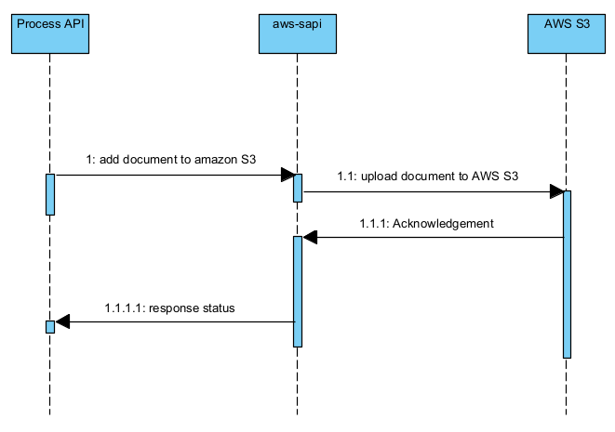

- The process API’s consumes aws-sapi.
  - The aws-sapi uploads document to amazon S3.
    - The amazon S3 responds back generated acknowledgement.
1.1.1.1 The aws-sapi API responds back client.

Input and Output Definitions of API

Input:
{
"bucketName":"uho-covid-docs",
"folderPath":"identity",
"fileName":"35653.png",
"document":"iVBORw0KGgoAAAANSUhEUgAAAOIAAACRCAYAAADepmS4AAAAAXNSR0IArs4c6QAAAARnQU1BAACxjw"
}

Output: 200, Success

{
"code": 200,
"message": "Success",
"description": "Document uploaded successfully",
"dateTime": "2021-07-29T05:58:02Z",
"transactionId": "44b32520-61ee-47b4-907d-fa15869f3c4d"
}

Mapping

Consumers

API Consumer | Description
Experience API’s / Process API’s |  | Experience API’s consumes amq-sapi services to upload documents to amazon S3.
Other UHO applications |  | UHO applications can consume amq-sapi services to upload documents to amazon S3.

Technical details

API Name | aws-sapi
Business Requirements | As mentioned in integration solution document
API Communication Type | REST
Interface Pattern | Request/Reply
Interface Definitions | RAML API Specification
Sample Request | JSON(Section 3.1.1)
Sample Response | JSON(Section 3.1.1)

Non Functional

Post Execution Notification Details | Data-Related Failures Handling:  Currently all the errors will be logged into logs with log4j.  Consumer API is responsible to log about error details.  Can be visible in runtime manager.  Technical Errors Handling:  Currently all the errors will be logged into logs with log4j.  Consumer API is responsible to log about error details.  Can be visible in runtime manager.
Process Log Audit Details | Audit & Logging:  Created Logs for the following  - Request message at entry point  - Request message at system call entry point  - Request message at system call entry point  - Request completed

Error Handling

No. | Type of Exception | Exception Handling
1 | Any technical issue | - API shall respond corresponding response message.  - API will record the error in logs.  - Runtime manager notifications will be configured - TBD  - Application Administrative team will be notified using an email notification service- TBD

Integration test cases

Description | Result
Successful case registration | 200 - Success
System connectivity failure (Database is down) | 503 - The (upstream) service is temporarily not available
Invalid JSON payload request | 400 – Bad request
Internal server error | 500 – Internal server error
API Kit Router errors | Global errors

API Endpoint Details

Requirement | Method | Details
Development | POST | https://uho-dev-aws-sapi/covid/v1/document
Test | POST | https://uho-test-aws-sapi/covid/v1/document
UAT | POST | https://uho-uat-aws-sapi/covid/v1/document
Production | POST | https://uho-prod-aws-sapi/covid/v1/document

API Policies, Access and Network Security

Define API policies to be configured / customized

Requirement | Details
Access to APIs - Authentication | client_id enforcement
API Policy | CORS should be enabled
Communication over API’s | x-transaction-id and correlation-id

Open Issues

No | Open Issues
1.0

Appendix A – Interface details

WSDLs
Exported RAMLs
Tables outlining data design

