**LAB EXAM**

**MS.Net Technologies**

**Total Marks: 20 Time: 2 hours**

**1. Write a program in C# Sharp to display the name of the days of the week using LINQ.**

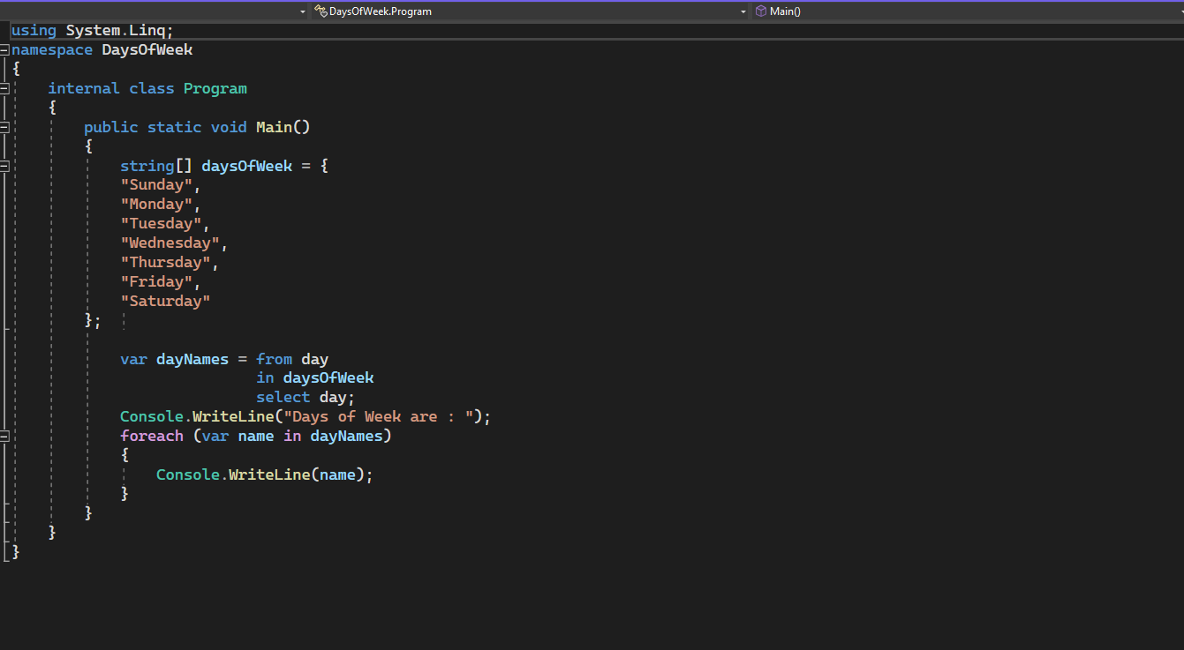

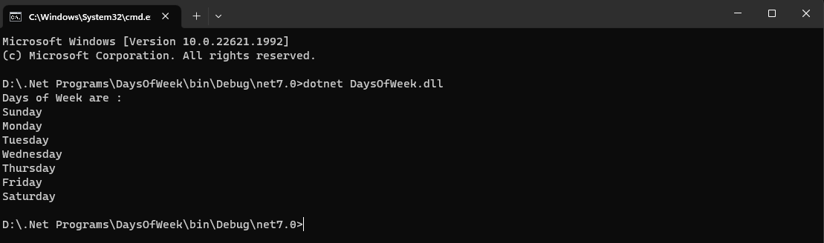

**2. Using ASP.Net Core, create an MVC project for a college with the following pages such as Home,**

**Employee, Student. Create functions such as Index, login and signup. Return the corresponding view**

**pages and display it in the browser.**

