Step 1:

Login to portal with following URL

<https://portal.azure.com/#home>

Step 2:

click on RGISQLDBBACKUP

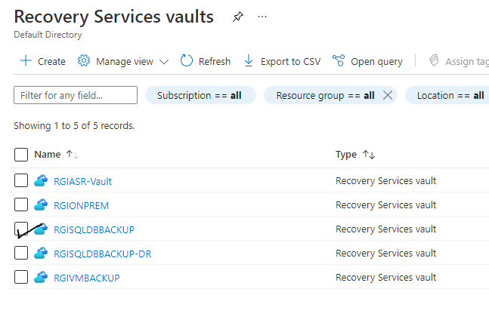

STEP 3:

Click on **BACKUP**

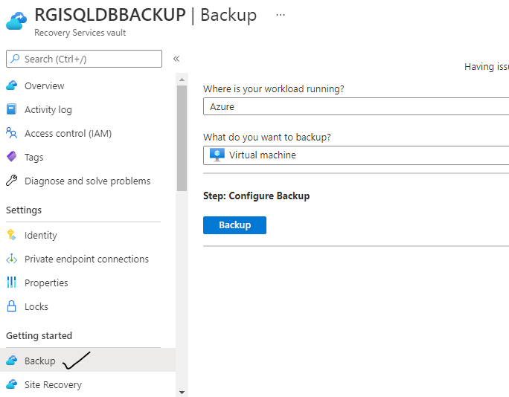

Step 4:

click on **SQLSERVER IN AZURE VM**

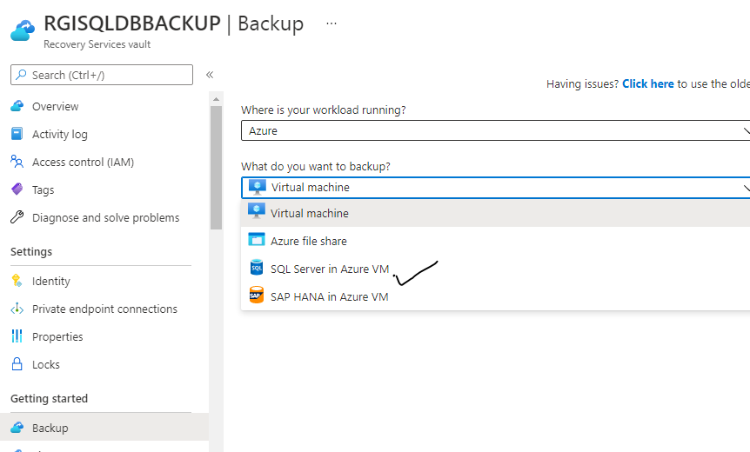

Step 5:

click on **START DISCOVERY**

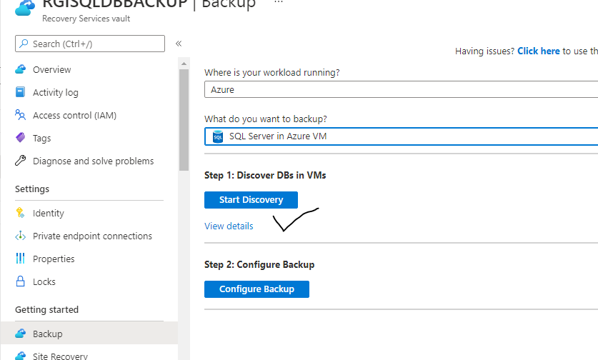

Step 6:

Select check box and and click discover db

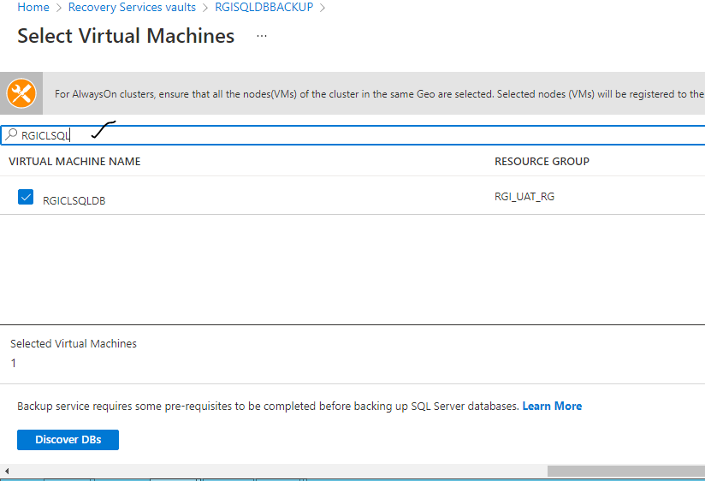

Step 7:

After deployment login is create server

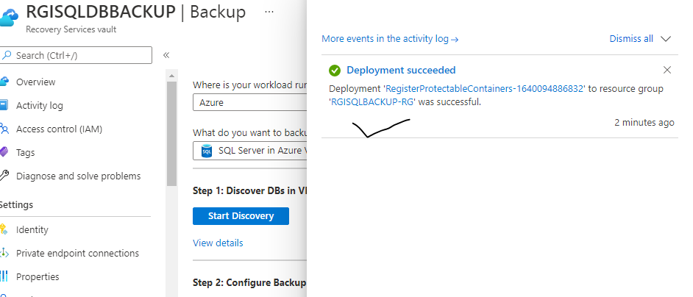

Step 8:

Create user NT SERVICE\AzureWLBackupPluginSvc in SQL Server with SA privileges if Azure Portal service has not created the same automatically.

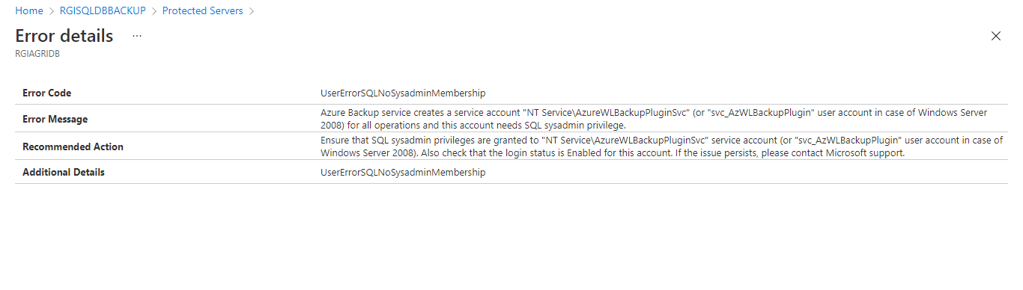

Step 9

see login is created and give rights sysadmin

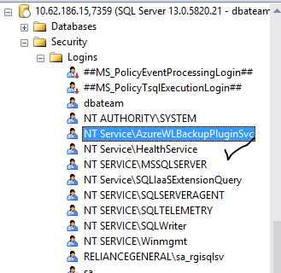

Step 10:

After deployment new server assign new backup policy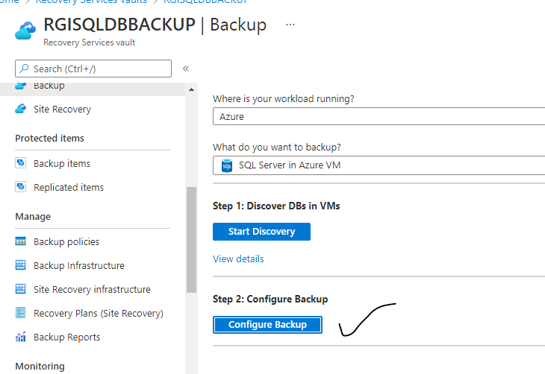

Step 11:

click on **Add button**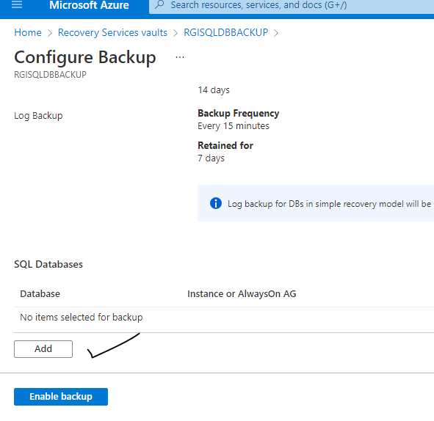

Step 12:

click on ok **button**

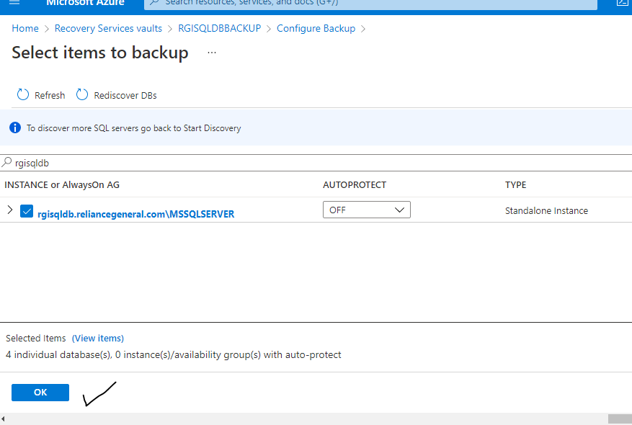

Step 13:

click on **ENABLE BACKUP**



