Step 1:

Login to portal with following URL

<https://portal.azure.com/#home>

Step 2:

Choose Recovery Services Vault

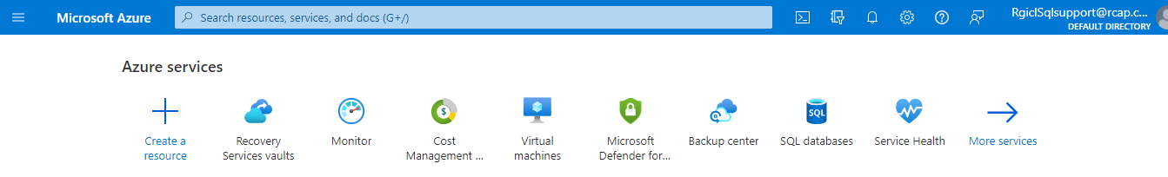

Step 3:

Choose vault **RGISQLDBBACKUP** for DC backup items: (**RGISQLDBBACKUP-DR** for DR backup items)

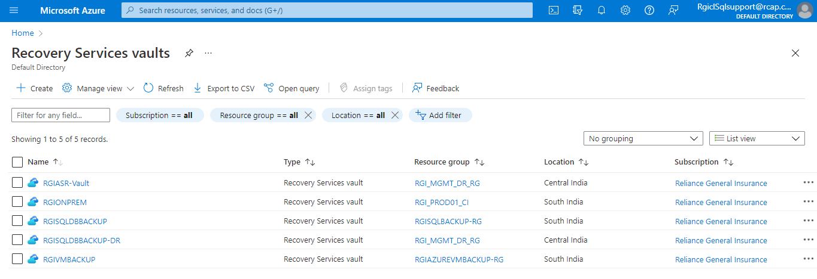

Step 4:

Select existing DB from backup items tab:

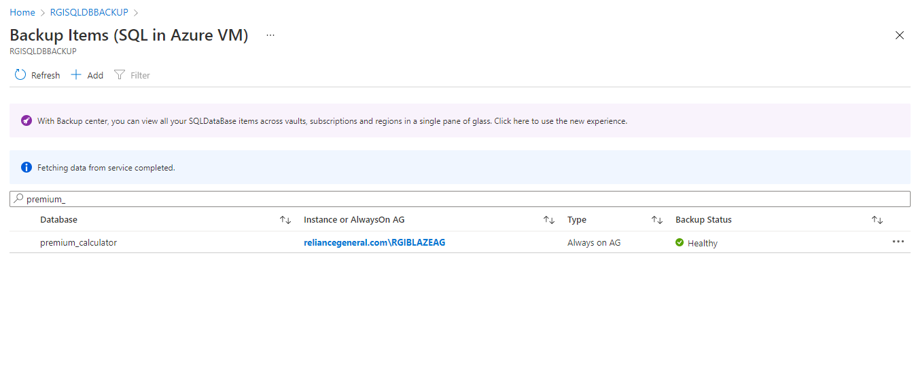

Step 5:

Change backup policy by choosing from the dropdown

