you can download the logscout tool from here: <http://aka.ms/get-sqllogscout>

 Considerations to run the logscout:

* The user than runs the logscout needs to be sysadmin on the instance and local administrator at server level at the same time.
* The logscout package will need to be located on a disk with at least 40 GB available.
* Please try to put the logscout folder on a disk not related to the OS or to the DB files.
* Please remember to collect the logscout from 20 minutes to 30 minutes while the issue is happening.

1. Unzip the folder on the selected folder and using CMD as administrator go to that location:

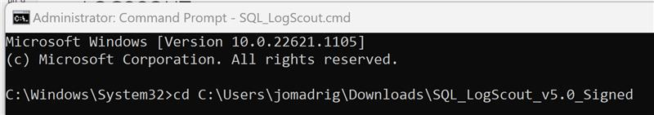

1. Run the command SQL_LogScout.cmd and when it asks you to run the software indicate "Always Run" by typing the letter A:

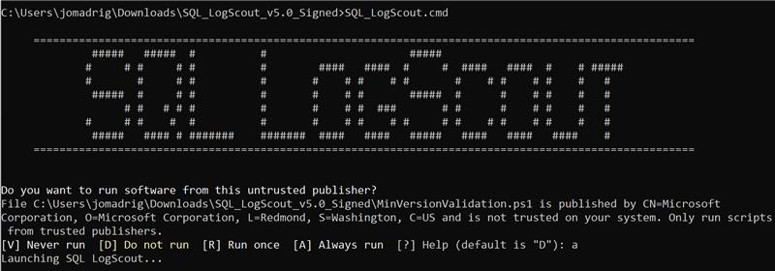

image

Type N to use the text interface

Type N do use the default directory this is the directory that the logscout was unzipped to.  Else you can specify where to put the logs

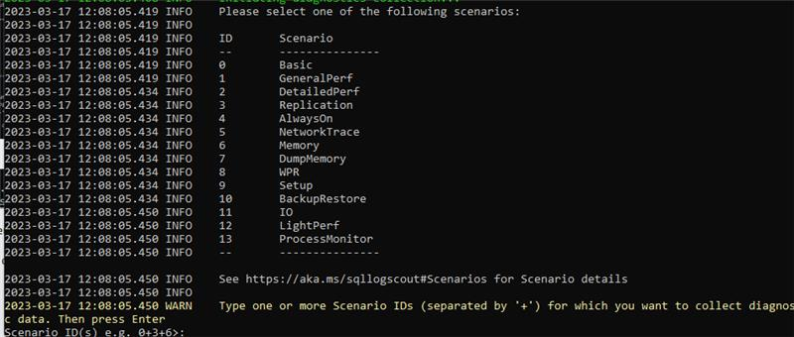Please Select 2 for the Detailed Perf collection

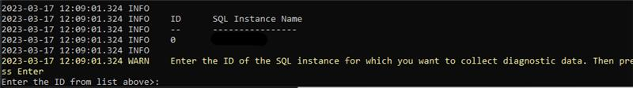

Enter the ID for the instance from the list displayed (server instance is redacted for these instructions)

**Reproduce the issue.**

1. Stop the collection when you are ready (by typing "stop" or "STOP")
2. Once finished, please zip the output folder that was created and upload it to the attachments.