LAB 1
Bandari Bharathkumar Reddy
University of Maryland Baltimore County

Presented to: Gina Scaldaferri
Date: 09-06-2021

Introduction
This lab focuses on how an incident responder performs live analysis of a system using basic Windows tools. The analysis is conducted on a suspicious executable file, LairNetPutty.exe, which was downloaded by an employee without obtaining consent or approval from the IT department. By performing this analysis, we aim to identify any potential risks associated with this application.

Background:
An employee at Tata Consultancy Services downloaded a software utility program, LairNetPutty.exe, without authorization from the company’s IT department. The IT department requested the incident response team to investigate this unknown software and determine the potential risk it poses to the organization. This report documents the findings of the incident response team and provides recommendations to mitigate the identified risks.

Analysis
1)Static Analysis:
Prior to Executing the application:
1)What utility can be run on the Windows VM to monitor processes running on the system?
Task Manager can be used to monitor processes running on a Windows virtual machine.
2)What utility can be run on the Windows VM to monitor network connections on the system?
The netstat command can be used to monitor active network connections.
3)What application could you run on Windows to capture network traffic from the system?
Wireshark is commonly used to capture and analyze network traffic.
4)What information can you gather about the application from reviewing it without any special tools?
Basic file properties such as file name, size, digital signature, and creation date can be reviewed.

The image below shows process monitoring using Task Manager.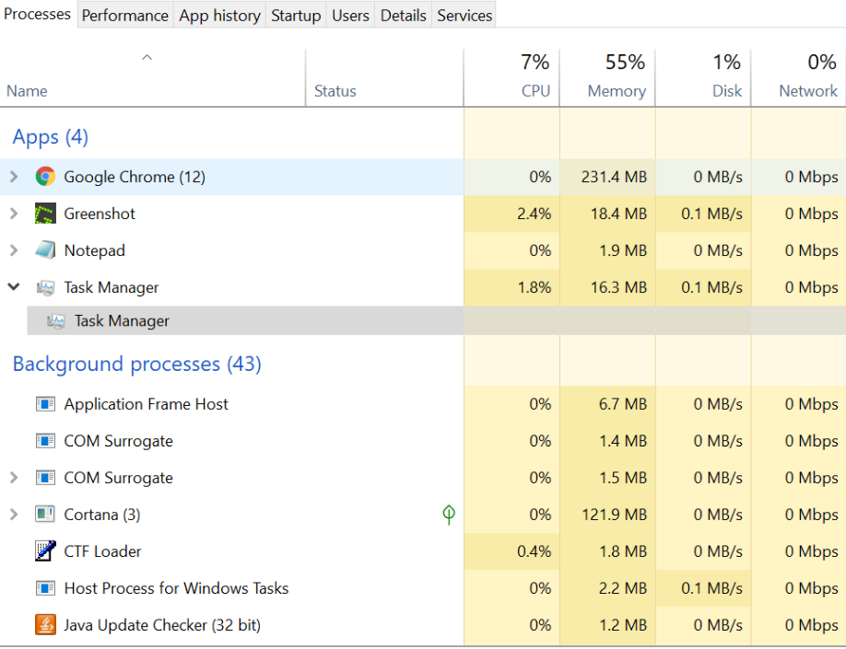
We used the netstat command to monitor network connections. At this stage, all observed connections appeared to be associated with Microsoft or Windows-owned services.
The below fig shows the established network connection.
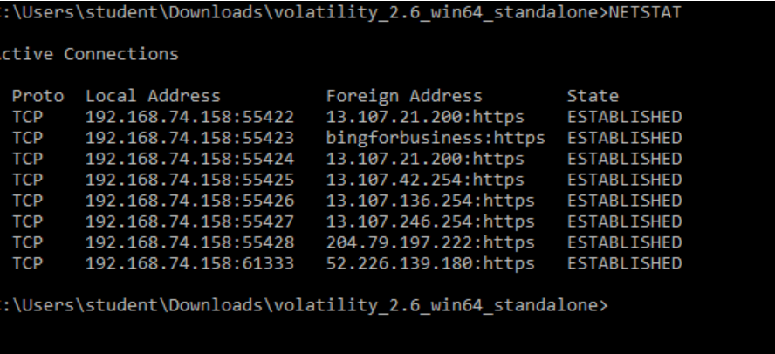

Wireshark was identified as one of the most effective tools for capturing and analyzing network traffic.
Using VirusTotal to analyze LairNetPutty.exe, we found that 60 out of 67 security vendors flagged the file as malicious. Several antivirus vendors classified the executable as a Trojan malware. Further research revealed that Trojan malware is often disguised as legitimate software and, once executed, can allow attackers to spy on users, steal sensitive data, or gain unauthorized backdoor access to the system.

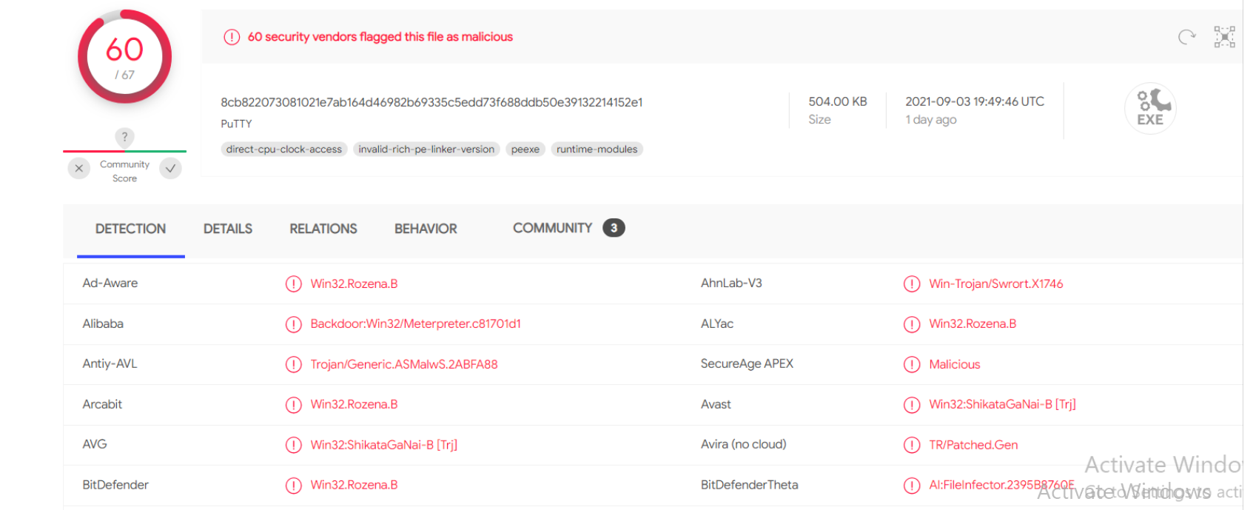

2) Dynamic Analysis
After launching LairNetPutty.exe, several suspicious behaviors were observed.
While monitoring the process using Task Manager, the application appeared to run normally; however, this does not rule out malicious activity occurring in the background.
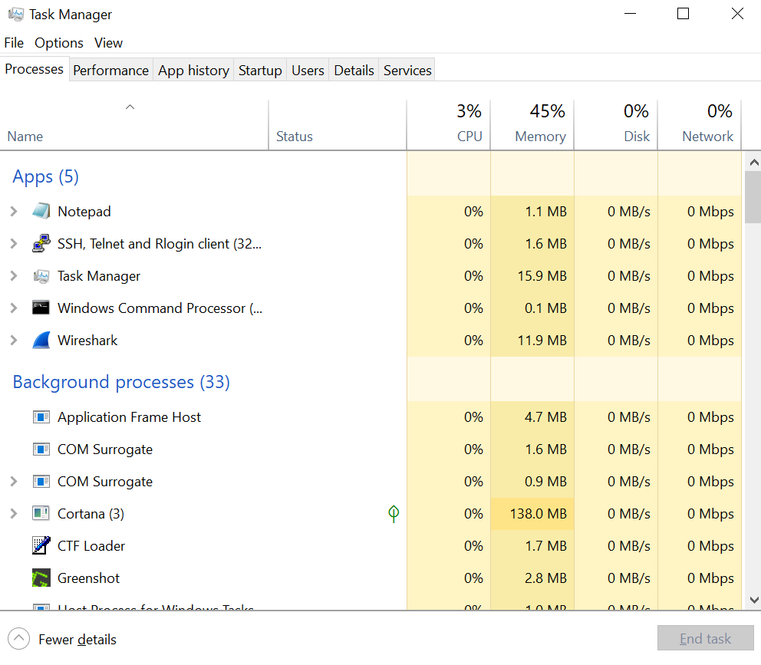
Using the netstat command after execution, we observed connections to multiple external IP addresses. Two IP addresses, 72.21.91.29 and 72.21.81.200—were identified as potentially malicious based on online threat intelligence sources and user reports.

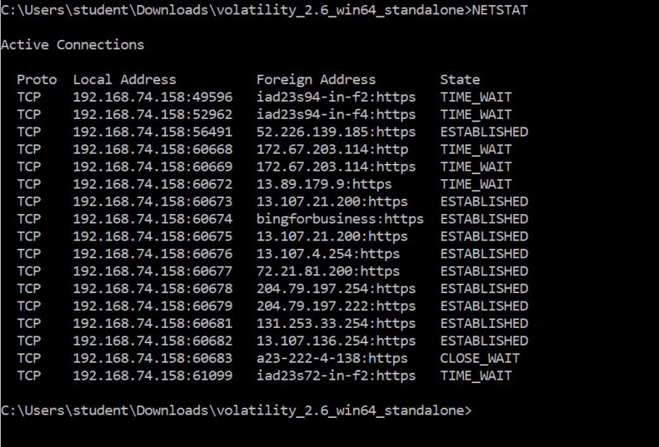

Several user comments indicated that 72.21.91.29 had been associated with suspicious or malicious activity. When this IP address was checked on VirusTotal, security vendors flagged it as malicious, while others marked it as clean. This suggests the IP address may belong to a legitimate service provider but could also be abused or misclassified due to dynamic IP allocation.
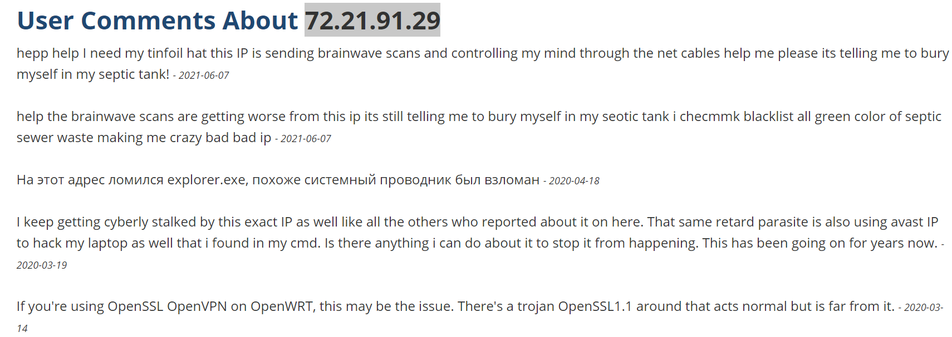
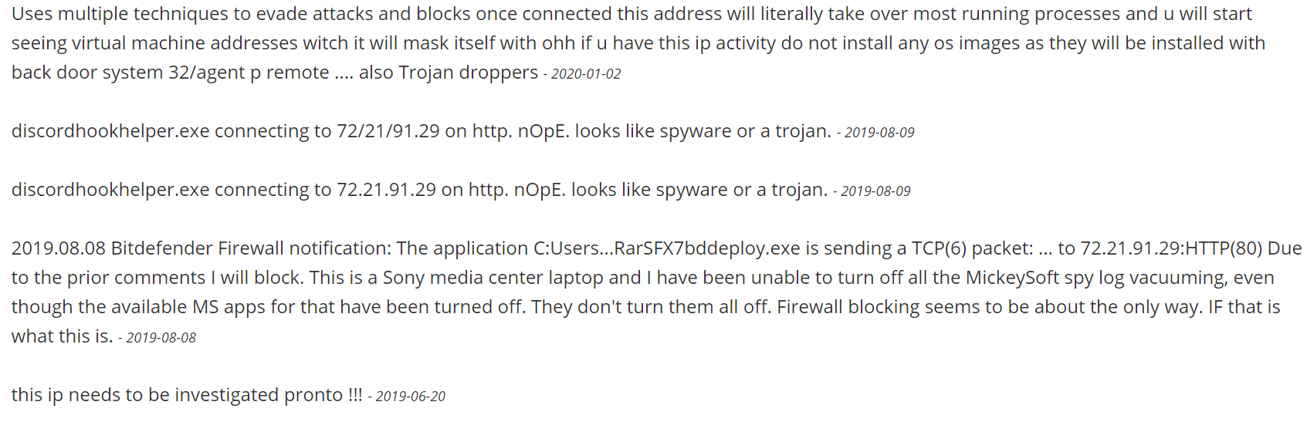After seeing these comments, I’ve uploaded this IP address into Virus Total and one security vendor marked it has Malware. I’ve researched thoroughly but didn’t find what type of malware it is. I’ve seen some other comments suggesting “It may be Verizon IP may be due to dynamic issues”.

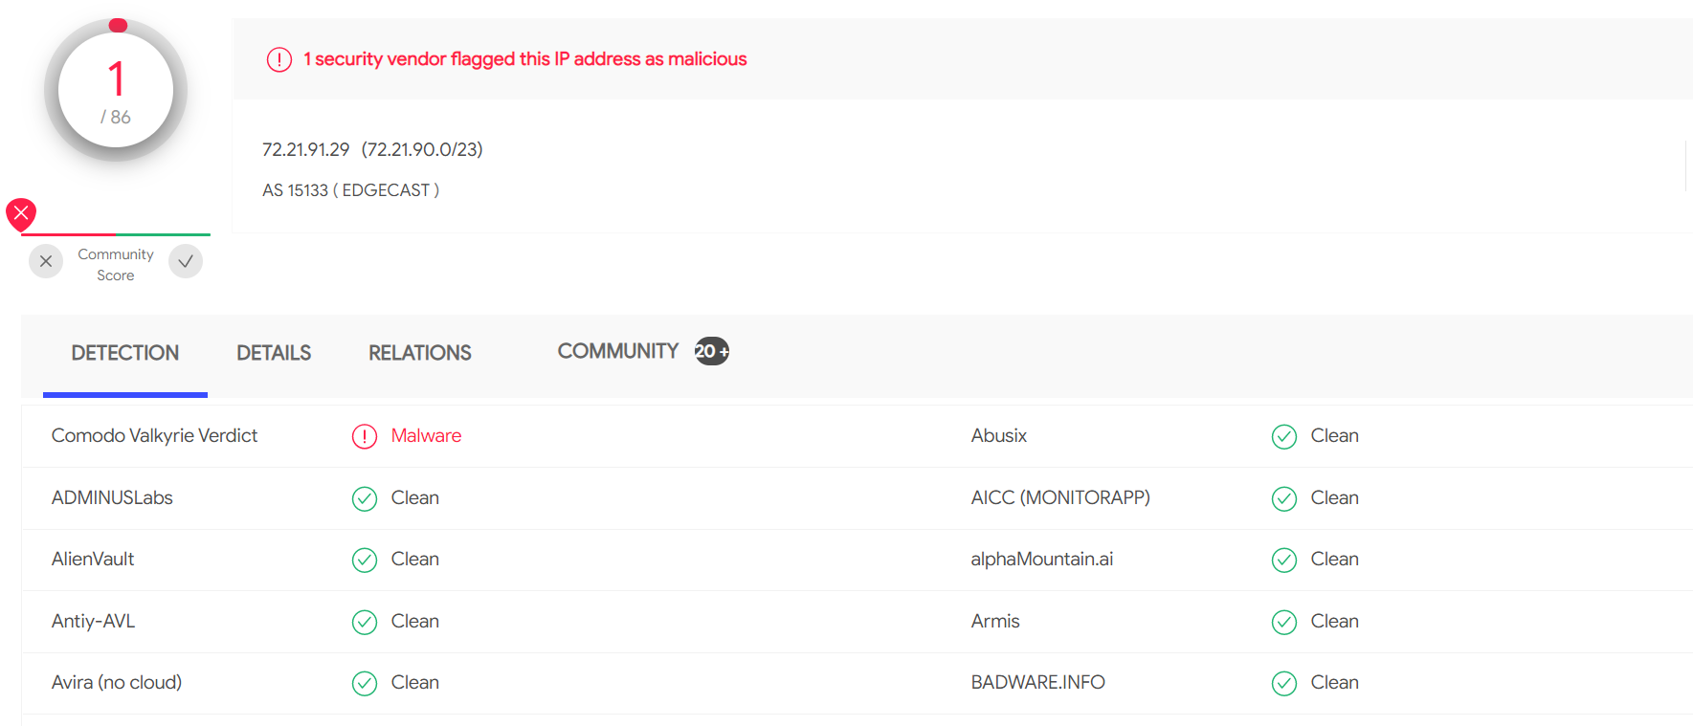

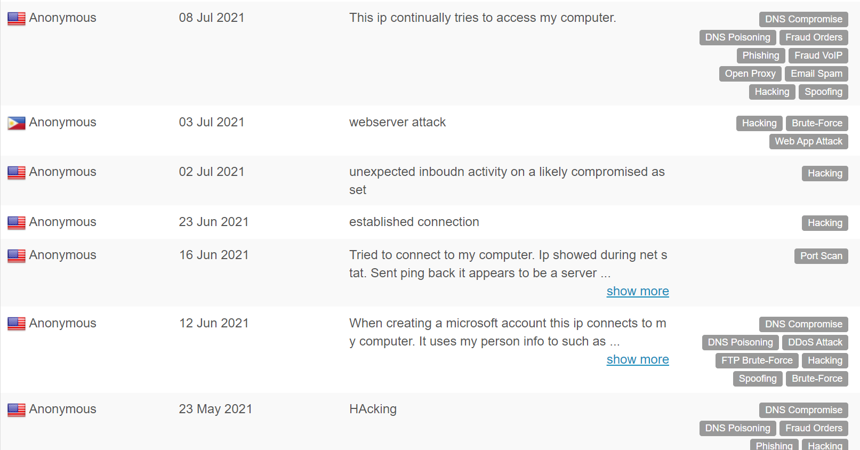
From the above pictures, we can see some users mention that this IP address is trying to get the system hacked and few researchers mentioned it as Trozen malware and trying to get the system access.
Network traffic captured using Wireshark showed multiple TCP packets marked as “Spurious Retransmission.” A spurious retransmission occurs when the sender retransmits a packet even though the receiver has already acknowledged it. This typically indicates network latency, packet delay, or retransmission timeout rather than direct malicious activity.
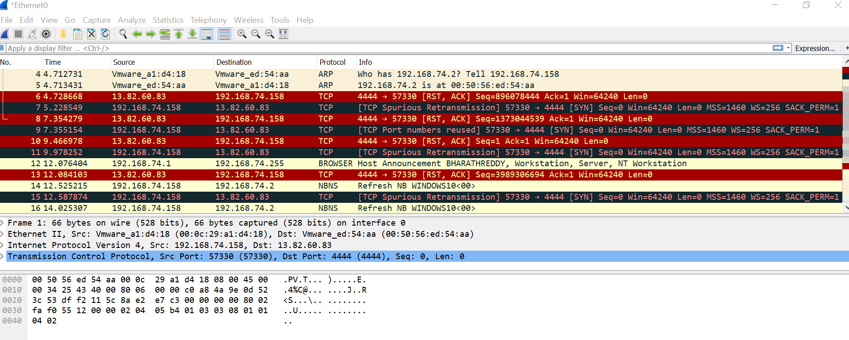
Spurious Retransmission is the retransmission in which the receiver acknowledges the packet but not before the sender retransmits the packet (If you’re seeing spurious retransmissions, it means that the sender thought packets were lost and sent them again, even though the receiver sent an acknowledge packet for it.
According to Wireshark documentation, a spurious retransmission is identified when the sequence number and segment length are less than the most recently acknowledged value. While occasional spurious retransmissions are normal, a large number of them may indicate underlying network issues.
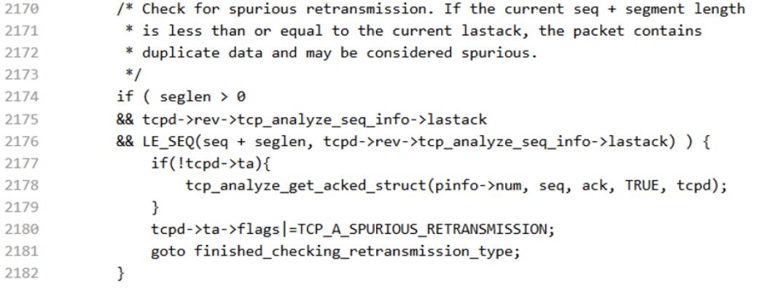
The above picture clarifies that a spurious retransmission contains a Sequence number + Length Value that is less than the most recently received ACK(Acknowledgement).
Sometimes due to Retransmission Timeout, the ACK packet will be sent again to the host. But if it is repeating then Wireshark will mark it has spurious retransmission. A few TCP spurious retransmission here and there are typically not a problem but, if it starts increasing then we need to find the root cause for this problem.
If you are experiencing packet loss - look for an infrastructure device as the most likely cause of dropped ACKs. You will likely find that you also have "Previous Segment(s) Not Captured" throughout your trace file as that infrastructure device is probably dropping data packets as well as the ACK packets.

Conclusions
This lab provided hands-on experience in performing live system analysis using basic Windows tools. I learned how to monitor system processes with Task Manager, analyze network connections using netstat, and capture network traffic using Wireshark.
I also gained practical experience using VirusTotal to analyze suspicious executables. Initially, I assumed LairNetPutty.exe was a legitimate variant of PuTTY; however, further investigation revealed it to be malicious.
Overall, this lab served as a strong introduction to digital forensics and incident response techniques.
Lastly, it’s a great way to start the digital Forensic learning.

References

Laura Chappell. Chappell University.
https://www.chappell-university.com/post/spurious-retransmissions-a-concern

Jasper(13/06/2013).Packet-Foo.com.
https://blog.packet-foo.com/2013/06/spurious-retransmissions/

Arwin Reprakash(10/04/2015).IT Blogtorials.
http://ithitman.blogspot.com/2015/04/what-are-tcp-spurious-retransmissions.html

Chris Greer(13/03/2017).Troubleshooting With Wireshark.
https://www.youtube.com/watch?v=cIxr8zosTBc

AbuseIPDB.
https://www.abuseipdb.com/check/72.21.81.200

WhatIsMyIPAddress.
https://whatismyipaddress.com/ip/72.21.91.29

Netstat.Microsoft.
https://docs.microsoft.com/en-us/windows-server/administration/windows-commands/netstat

VIRUSTOTAL.
https://www.virustotal.com/gui/home/upload

