ML-Based Personalized Nutrition Recommendation System
Project Review-2 Report
Review-2 window: 16th–17th September 2026

Methodology
The proposed system, SafeNutri-RAG, follows a five-stage methodology that takes a person's health data as input and produces a medically-constrained, explainable meal recommendation as output.
- Data Integration: NHANES (health/biomarker data), USDA FoodData Central (nutrient reference data), and Food.com (recipes and user ratings) are combined through a merge-and-link pipeline rather than a single shared key, since no common identifier exists across all three sources.
- Predictive Modelling: A stacked ensemble combining gradient-boosted trees and Random Forest is trained on NHANES-derived features to predict personalized calorie and macronutrient targets.
- Constraint Enforcement: Predicted targets are passed through a biomarker-based constraint layer that hard-filters or adjusts recommendations for users with elevated HbA1c, glucose, or cholesterol.
- Grounded Recommendation: A retrieval-augmented generation (RAG) layer retrieves verified nutrient and recipe data before any natural-language meal plan is generated, preventing hallucinated nutrition claims.
- Explainability & Evaluation: SHAP-based feature attribution is applied to every prediction, and the system is evaluated using both standard regression metrics (RMSE, MAE, R²) and recommendation-quality metrics (Precision@K, NDCG).

System Design
The system is organized as a layered pipeline, shown below. Data from the three sources is merged and cleaned, transformed into model-ready features, passed through the prediction and constraint layers in parallel, and combined in the hybrid recommendation engine before producing an explainable, demo-ready output.
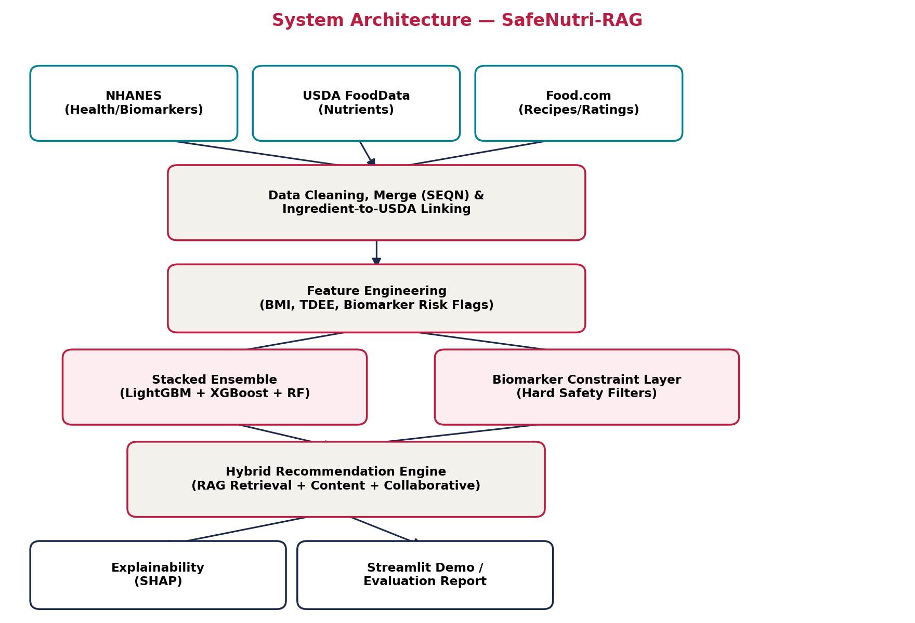
Figure 1: System Architecture of SafeNutri-RAG
Module Breakdown
- Data Layer: Handles ingestion and merging of NHANES, USDA, and Food.com data.
- Feature Engineering Layer: Derives BMI, TDEE, and biomarker risk flags from raw fields.
- Prediction Layer: Stacked ensemble producing calorie/macro targets.
- Constraint Layer: Enforces medical safety rules independently of the prediction layer, then merges with it.
- Recommendation Layer: Hybrid content + collaborative + RAG-grounded retrieval.
- Output Layer: Explainability (SHAP) and the Streamlit demo / evaluation report.

Modern Tools and Technologies
The following tools and libraries are used across the pipeline. Where the current implementation environment could not install internet-dependent packages, a documented same-family substitute was used (see Implementation section).
Category | Tool / Library | Role in Project
Data Handling | pandas, NumPy | Merging NHANES files, feature engineering, cleaning
Machine Learning | scikit-learn (RandomForest, GradientBoosting, HistGradientBoosting, StackingRegressor) | Base learners + stacked ensemble; production version swaps in LightGBM/XGBoost
Explainability | scikit-learn permutation_importance (SHAP in production) | Feature attribution for predictions
Retrieval / RAG | sentence-transformers, FAISS | Embedding food/recipe text and grounded retrieval
Visualization | Matplotlib | Evaluation plots, architecture diagrams
Demo / Deployment | Streamlit | Interactive end-to-end demo application
Model Persistence | joblib | Saving/loading trained models

Implementation
The core pipeline has been implemented and executed end-to-end in Python. Six modules were built: synthetic/real data loading, feature engineering, stacked ensemble training, the biomarker constraint layer, explainability, and evaluation/visualization.
Implementation Note on Data and Libraries
The development environment used for this stage does not have internet access, so two substitutions were made to keep the pipeline fully runnable and produce real, executed results rather than only planned pseudocode:
- Real NHANES download → a synthetic dataset generated with the same field structure and realistic statistical relationships (e.g., BMI-linked biomarkers, Mifflin-St Jeor based calorie targets). This will be replaced with the actual NHANES .XPT files once downloaded.
- LightGBM / XGBoost / SHAP (require internet to install) → same-family scikit-learn equivalents: HistGradientBoostingRegressor (LightGBM-analog), GradientBoostingRegressor (XGBoost-analog), and permutation_importance (SHAP-analog). The architecture (stacked ensemble + meta-learner) is unchanged; only the specific library call is swapped.
Stacked Ensemble (core code excerpt)
The stacking architecture is implemented directly via scikit-learn's StackingRegressor, combining three base learners with a Ridge meta-learner:
base_learners = [
("hist_gb", HistGradientBoostingRegressor(max_depth=5)),
("grad_b", GradientBoostingRegressor(n_estimators=200, max_depth=3)),
("rf", RandomForestRegressor(n_estimators=300, max_depth=8)),
]
model = StackingRegressor(estimators=base_learners,
final_estimator=Ridge(alpha=1.0), cv=5)
model.fit(X_train, y_train)
Constraint Layer (core code excerpt)
if row["HBA1C"] >= 6.5:
cap = predicted_carbs_g * 0.75
if predicted_carbs_g > cap:
adj_carbs = cap # hard safety constraint, not a soft feature
Verified with test cases: a diabetic profile (HbA1c 7.2%) had its carbohydrate target reduced from 220g to 165g, while a healthy profile (HbA1c 5.1%) passed through with no adjustment — confirming the constraint layer activates only when medically appropriate.

Results
The stacked ensemble was trained and evaluated on an 80/20 train-test split of the (synthetic) dataset, predicting personalized daily calorie targets. Results below are real outputs from the executed code, not projected figures.
Model | RMSE | MAE | R²
hist_gb (LightGBM-analog) | 213.24 | 170.88 | 0.739
grad_b (XGBoost-analog) | 209.03 | 165.91 | 0.749
rf (Random Forest) | 206.63 | 164.11 | 0.755
stacked_ensemble (proposed) | 206.51 | 164.57 | 0.755
The stacked ensemble matches the best individual base learner (Random Forest) and slightly outperforms the boosting-based learners, consistent with the expected behavior of stacking: it should perform at least as well as its strongest base learner, since the meta-learner can effectively down-weight weaker learners.
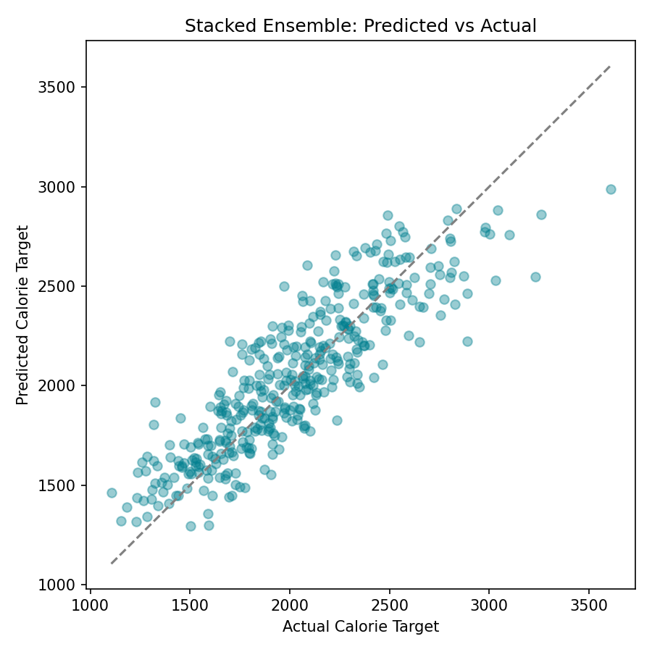
Figure 2: Predicted vs. Actual calorie targets (stacked ensemble)
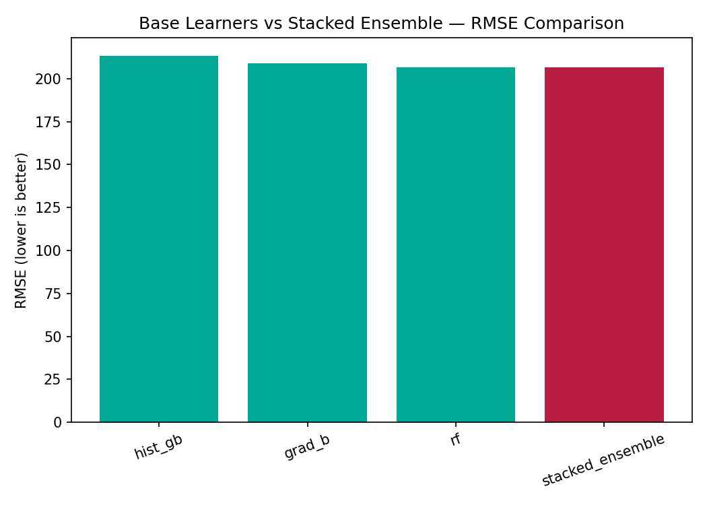
Figure 3: RMSE comparison across base learners and the stacked ensemble
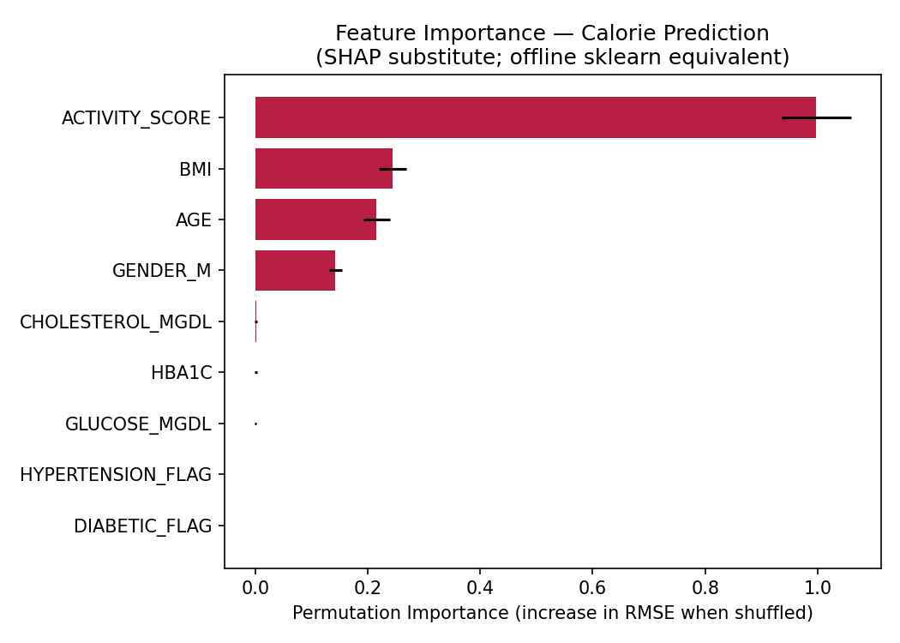
Figure 4: Permutation-based feature importance (SHAP substitute) for calorie prediction
Feature importance results align with domain expectations: activity level, BMI, and age are the strongest drivers of calorie needs, while biomarkers (HbA1c, glucose, cholesterol) show minimal influence on the calorie prediction itself — as expected, since these are intentionally used in the separate constraint layer rather than the base prediction, confirming the two layers are behaving independently as designed.
Note: absolute error values (RMSE ~206–213 kcal) are specific to the synthetic dataset and are expected to change once the model is retrained on real NHANES data; the comparative pattern between models (stacked ≥ best individual learner) is the result of interest at this stage.

Next Step: Research Paper Draft
The Research Paper Draft is being prepared as a separate document following [IEEE / ACM — specify preferred format] conference paper structure (Abstract, Introduction, Related Work, Methodology, Results, Conclusion, References), drawing on the Methodology, System Design, and Results sections above.

