Phase 0 – Inputs
- Define migration scope, access, tokens, and requirements.
- Generate key pair
- Generate SSH Key Pair
Use this command (with quotes around the email for safety):
Shell
ssh-keygen -t rsa -b 4096 -C "your_email@example.com"
Show more lines
  - -t rsa → RSA key type
  - -b 4096 → 4096-bit key for strong security
  - -C "your_email@example.com" → Adds a comment (usually your email)
Do NOT remove the quotes around the email; the second version without quotes can fail if the email contains special characters.

- Locate Generated Keys
  - Private key: ~/.ssh/id_rsa
  - Public key: ~/.ssh/id_rsa.pub

- Add Public Key to Authorized Hosts
Append the .pub key to the authorized_keys file on the target host:
Shell
cat ~/.ssh/id_rsa.pub >> ~/.ssh/authorized_keys
Show more lines
(Ensure correct permissions: chmod 600 ~/.ssh/authorized_keys)

- Add Public Key to Bitbucket Server
  - Go to Bitbucket Server → Personal Settings → SSH Keys
  - Paste the contents of id_rsa.pub

- Store Private Key in GitHub Actions Secret
  - Copy the contents of id_rsa (private key)
  - Add it to GitHub Actions Secrets as SSH_PRIVATE_KEY

- Save Secretes like (GH_PAT, SSH_USER, SSH_PRIVATE_KEY, BBS_TOKEN, BBS_USERNAME & BBS_PASSWORD)
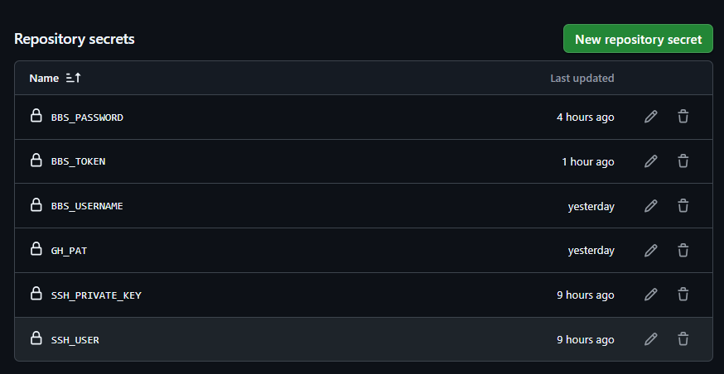
Phase 1 – Repo Inventory
- Collect repo metadata from BBS.
- Pipeline will Export to CSV and store as a pipeline artifact.
- Below is the GitHub Actions Workflow that will generate the repos.csv artifact which can be downloaded. Sample file given below.
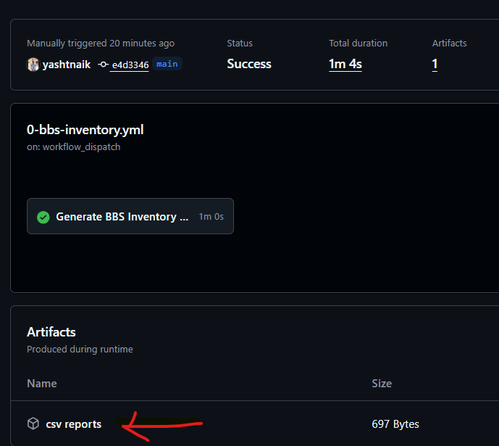
Note - BBS Inventory report works only with Admin password, even with full access PAT Token it fails to generate. Check observations below
Phase 2 – Pre-Validation
- Run checks for any blockers for migration. (Open PRs, Running Build pipelines, Release pipelines etc.)
- This will produce a per-repo report and gate migration based on blockers/warnings.
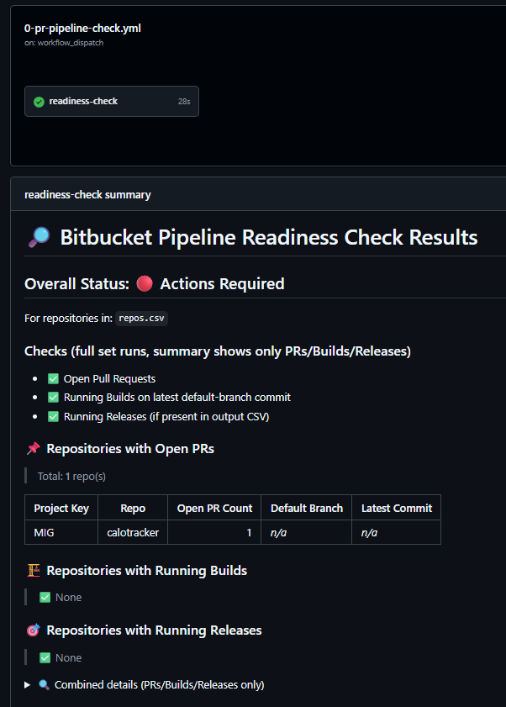
Phase 3 – Migration
- If pre validation goes well, trigger Migration workflow.
- Capture verbose logs and artifacts for each repo.
- Summary will show Successfully, failed etc repos, check the verbose logs in the artifact to identify the failure reason.
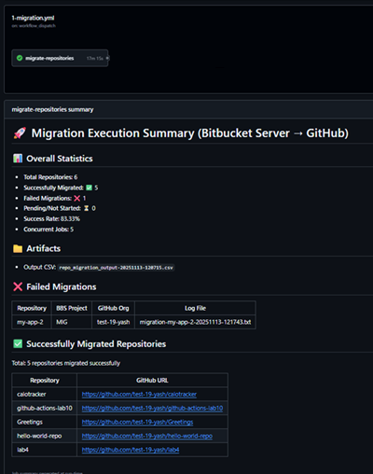
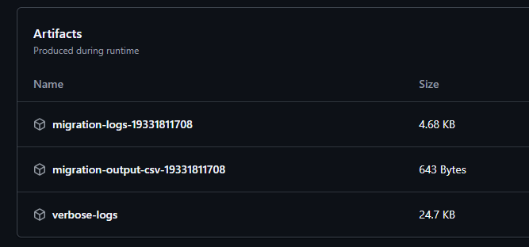
Phase 4 – Post-Validation
- Checks the SHA, Commit counts and branches
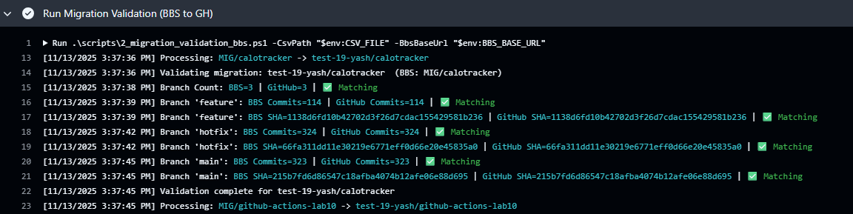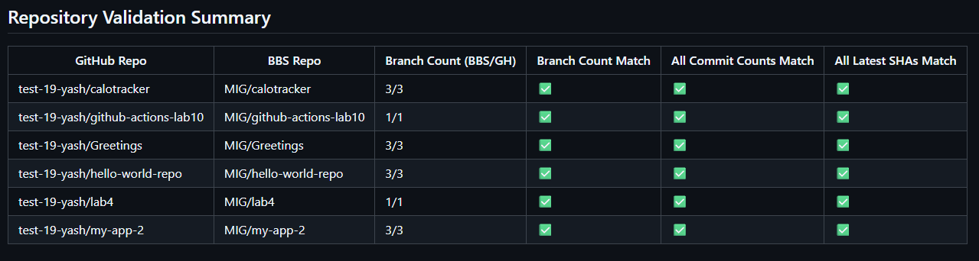
Phase 5: Mannequins reclaim.
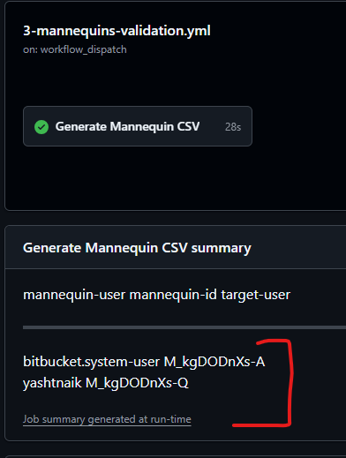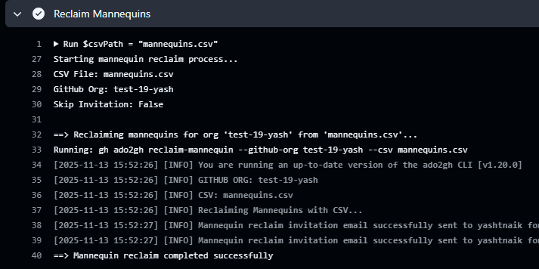

- Update the mannequins.csv and commit back to the repo.
- Then run the reclaim pipeline.

Observations/Note:
- Pipelines are not interconnected; it has the code for it but currently disable.
- BBS Inventory report works only with Admin password, even with full access PAT Token it fails to generate.
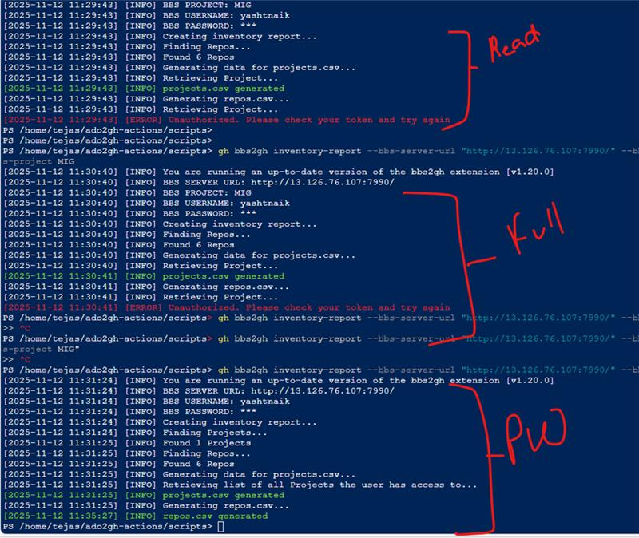

- Validation: BBS_PAT (recommended) — Bitbucket HTTP access token for REST API (Bearer). Create under Profile → HTTP access tokens with read permissions to enumerate PRs/branches/commits
- Repo link https://github.com/yashtnaik/bbs2gh-actions.git

