|  |
| --- |
|  |
| The Documentation |
| [Type the document subtitle] |
|  |
| **[Your Name]** |
| **[Pick the date]** |

[Type the abstract of the document here. The abstract is typically a short summary of the contents of the document. Type the abstract of the document here. The abstract is typically a short summary of the contents of the document.]

Table of Contents

[To update the table of contents, right click the message below and select Update Field (F9 on PC, ⌥⌘U on Mac).]

**No table of contents entries found.**

1. Pages
   1. Page Tree

Home  
 Dashboard  
Customer Management  
 Create a customer  
 Edit a Customer - Initial  
 Edit a Customer  
 Delete a Customer - Initial  
 Delete a Customer  
 Confirmation Popup  
Brand Management  
 Create a Brand - Initial  
 Create a Brand  
 Create a Brand - change default reasons  
 Create a Brand - With roles  
 Create a Brand- add role - popup  
 Create a Brand- add role - popup - change reasons  
 Edit a Brand - Initial  
 Edit a Brand  
 Delete a Brand - Initial  
 Delete a Brand  
 Confirmation Popup  
Location Management  
 Create a location  
 Edit a Location - Initial  
 Edit a Location  
 Delete a Location - Initial  
 Delete a Location  
 Confirmation Popup  
Beacon Management  
 Assign  
 Unassign  
 View and Search - Initial  
 View and Search - Result  
 View and Search - Status result  
 Assign Individual - Initial  
 Assign Individual - Both Unassigned  
 Assign Individual - Both Unassigned - Success - Popup  
 Assign Individual - Only beacon unassigned  
 Assign Individual - Only emplyee beacon unassigned  
Employee Management  
 Bulk upload - Initial  
 Bulk upload  
 Create Single - Initial  
 Create Single  
 Edit - Initial  
 Edit - Result  
 Edit  
 Delete confirm - popup  
 History - Initial  
 History - Result  
 History record  
Meimodo Tasks  
 Update Contact Details  
 Update About Us  
 Update Terms  
 Update Privacy Policy  
 Update Country List  
 Update Country List - Result  
 Update Country List - Save

* 1. Home
     1. User Interface

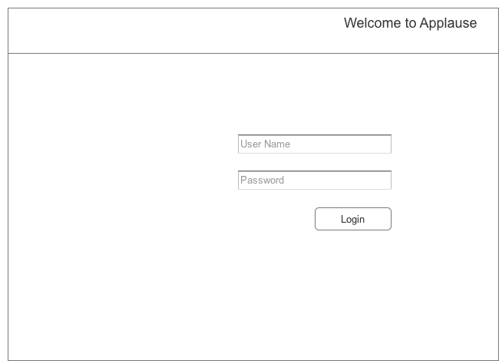

* 1. Dashboard
     1. User Interface

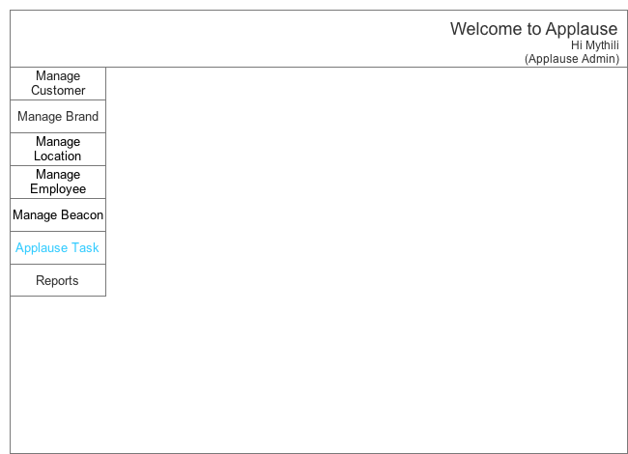

* 1. Create a customer
     1. User Interface

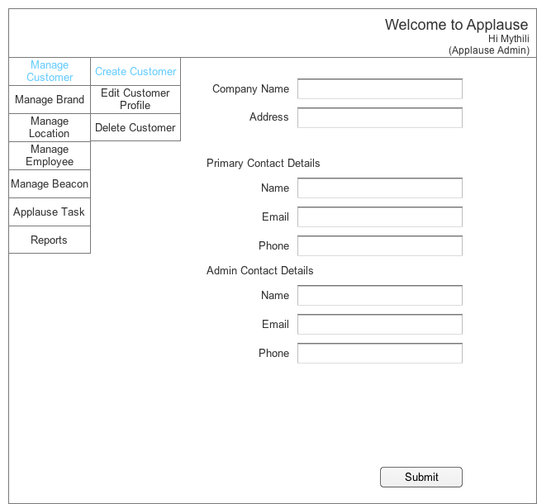

* 1. Edit a Customer - Initial
     1. User Interface

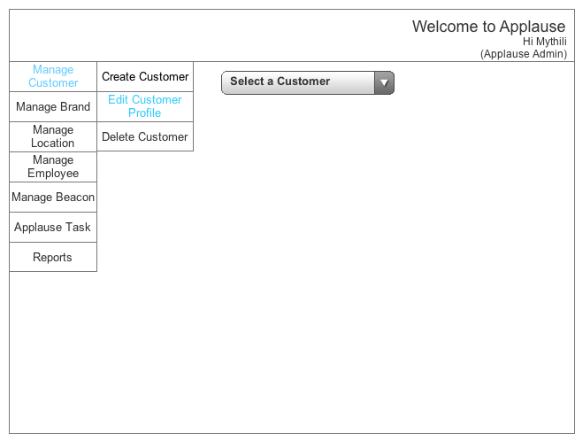

* 1. Edit a Customer
     1. User Interface

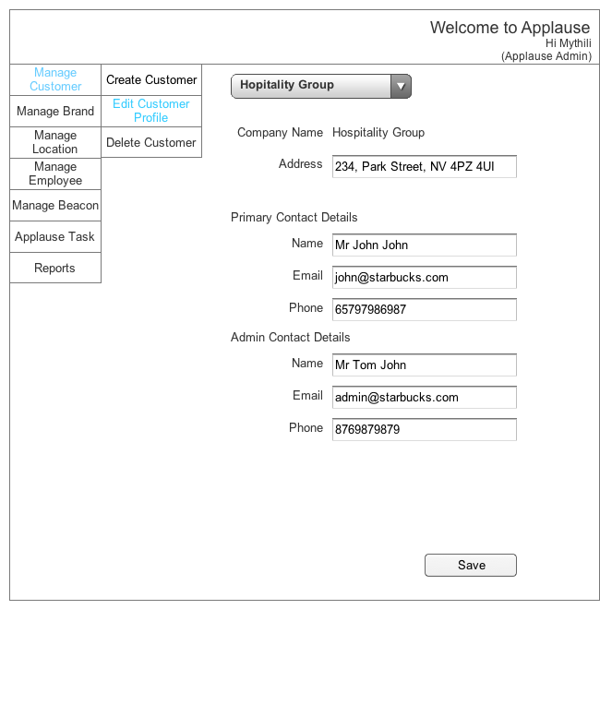

* 1. Delete a Customer - Initial
     1. User Interface

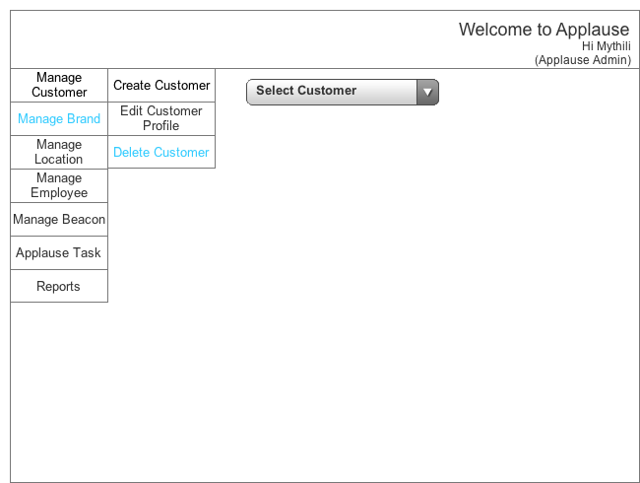

* 1. Delete a Customer
     1. User Interface

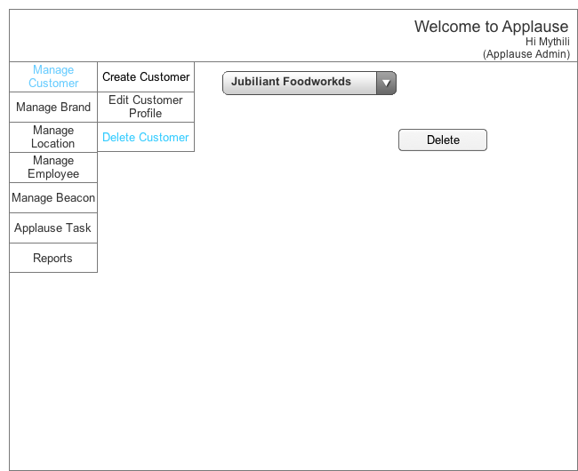

* 1. Confirmation Popup
     1. User Interface

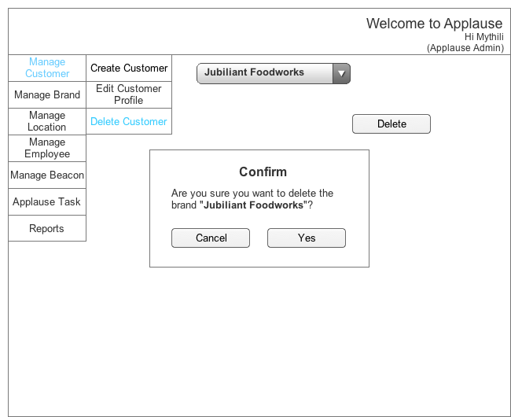

* 1. Create a Brand - Initial
     1. User Interface

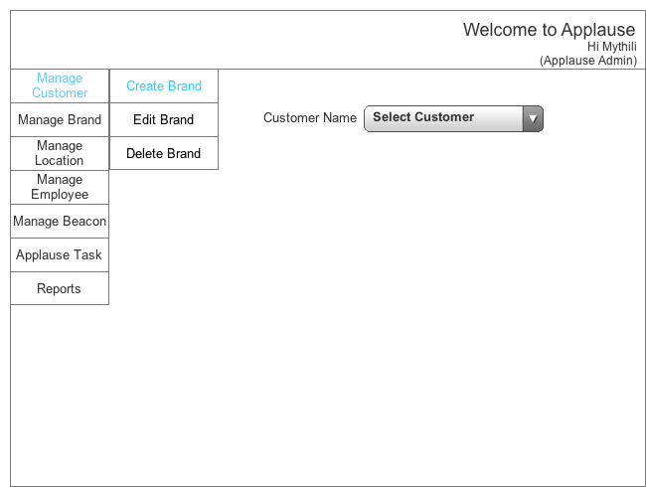

* 1. Create a Brand
     1. User Interface

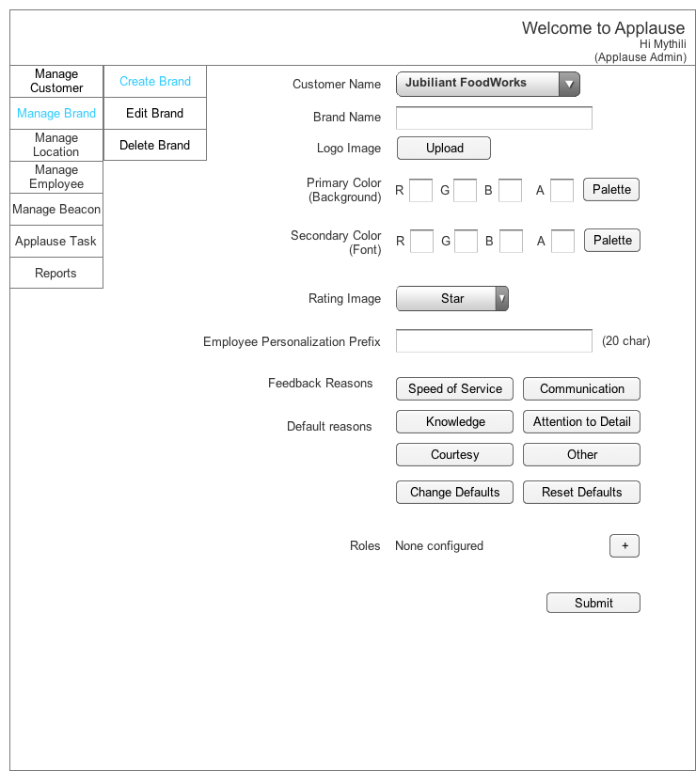

* 1. Create a Brand - change default reasons
     1. User Interface

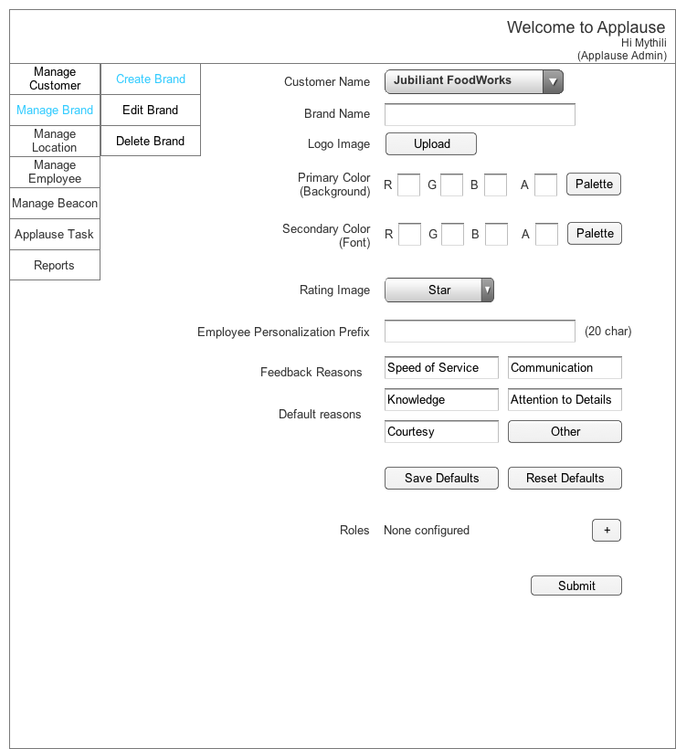

* 1. Create a Brand - With roles
     1. User Interface

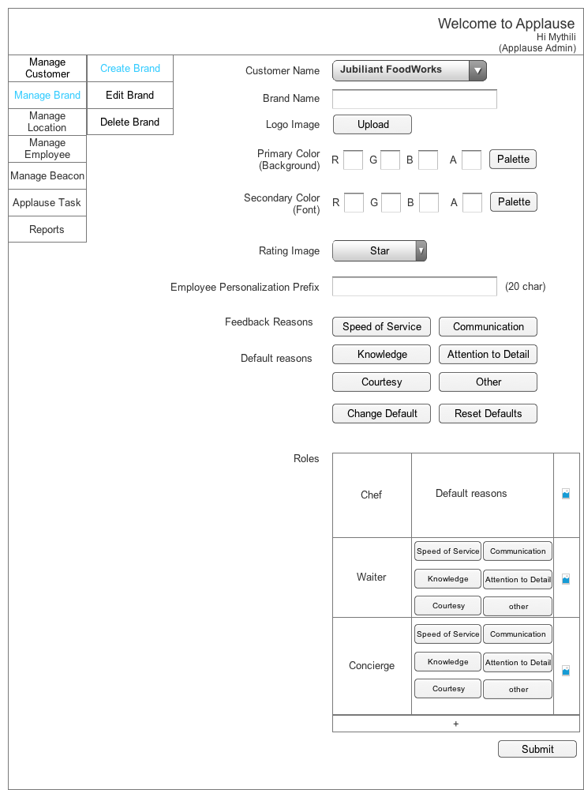

* 1. Create a Brand- add role - popup
     1. User Interface

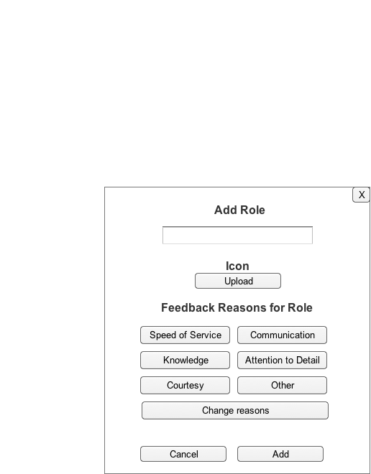

* 1. Create a Brand- add role - popup - change reasons
     1. User Interface

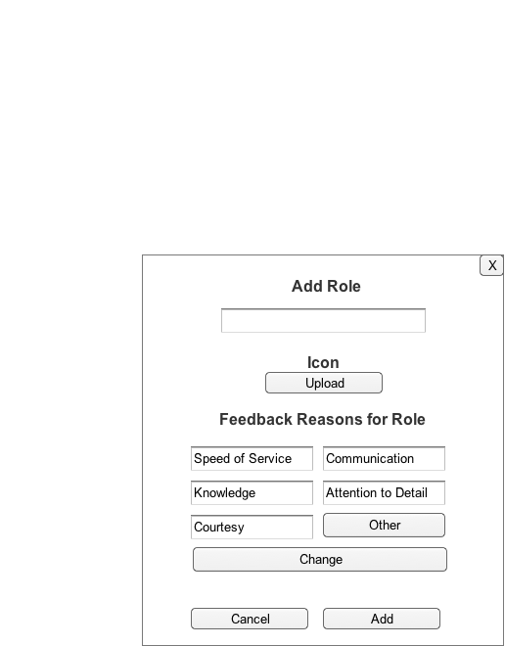

* 1. Edit a Brand - Initial
     1. User Interface

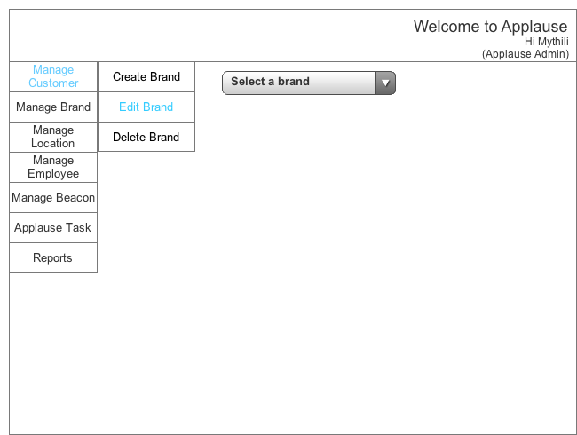

* 1. Edit a Brand
     1. User Interface

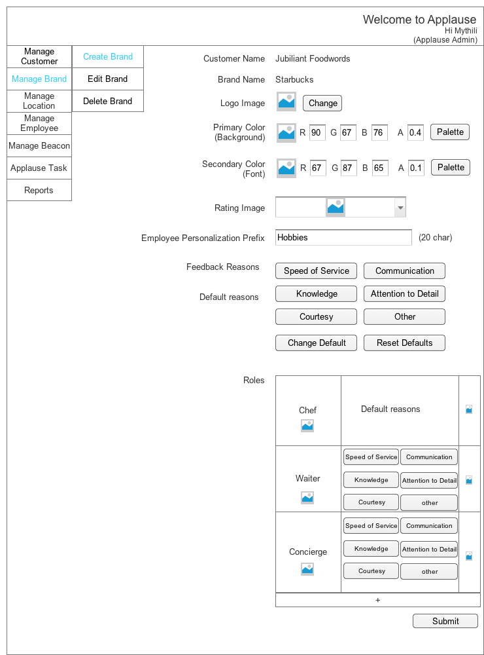

* 1. Delete a Brand - Initial
     1. User Interface

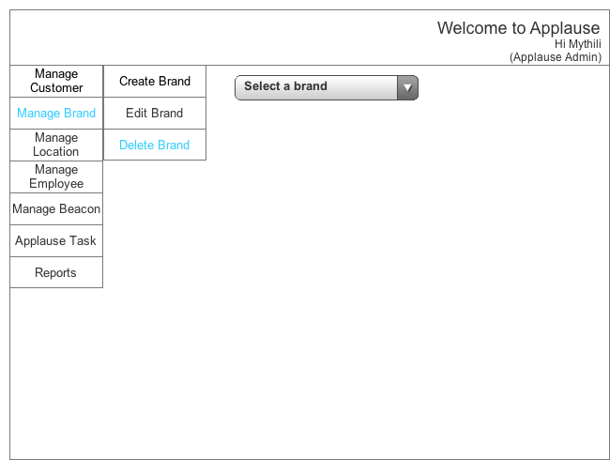

* 1. Delete a Brand
     1. User Interface

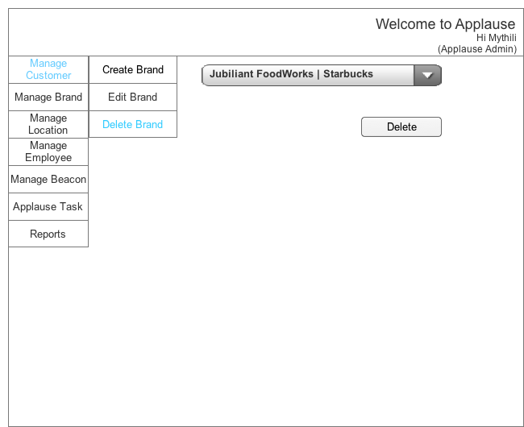

* 1. Confirmation Popup
     1. User Interface



* 1. Create a location
     1. User Interface

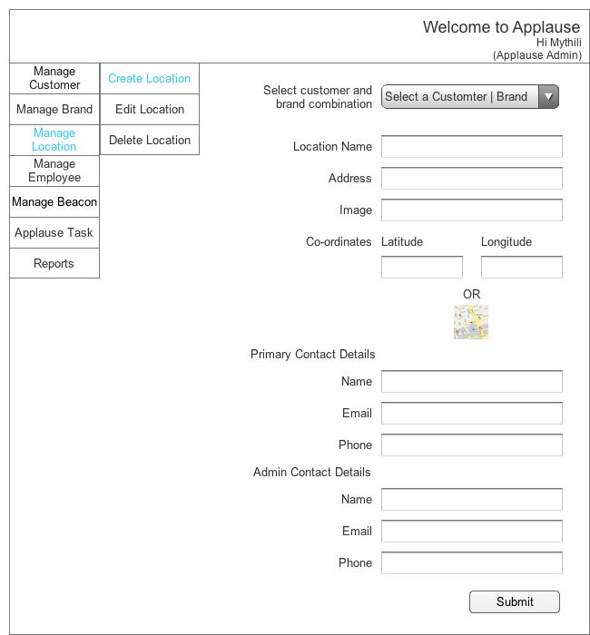

* 1. Edit a Location - Initial
     1. User Interface

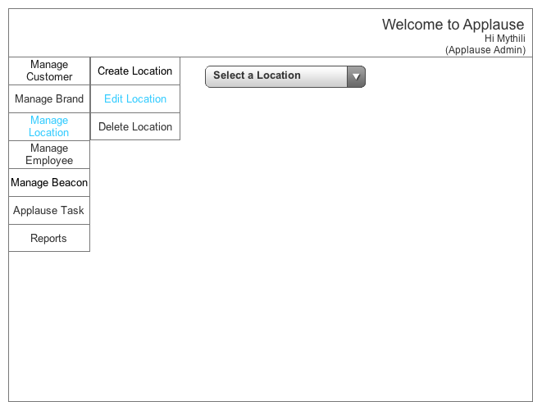

* 1. Edit a Location
     1. User Interface

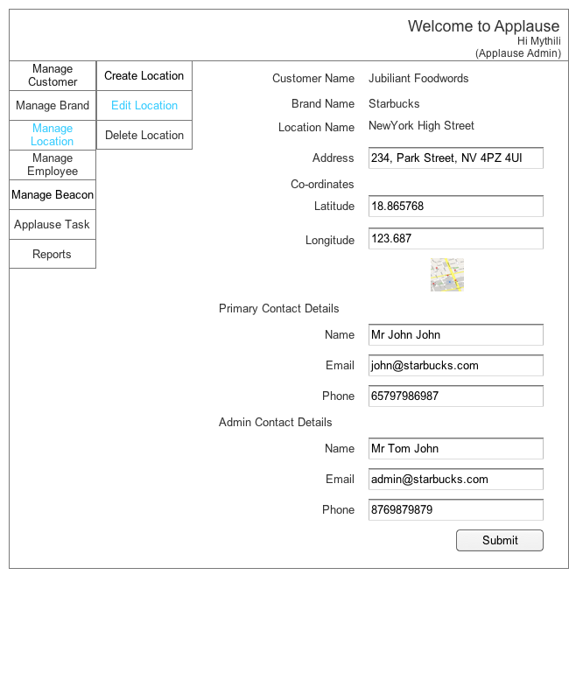

* 1. Delete a Location - Initial
     1. User Interface

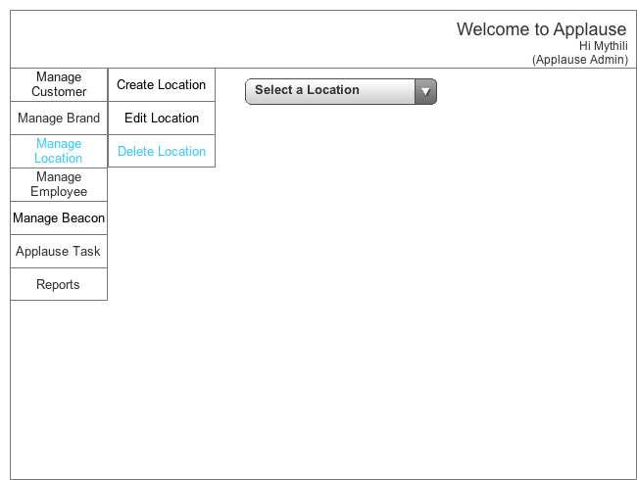

* 1. Delete a Location
     1. User Interface



* 1. Confirmation Popup
     1. User Interface



* 1. Assign
     1. User Interface

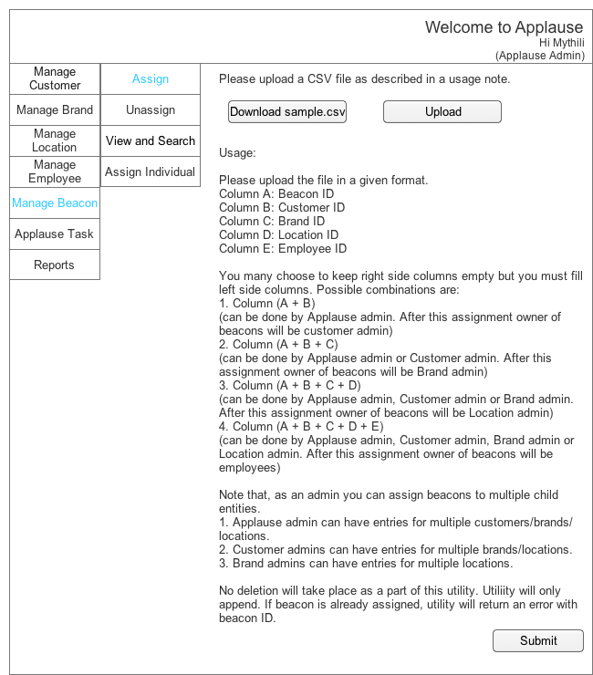

* 1. Unassign
     1. User Interface

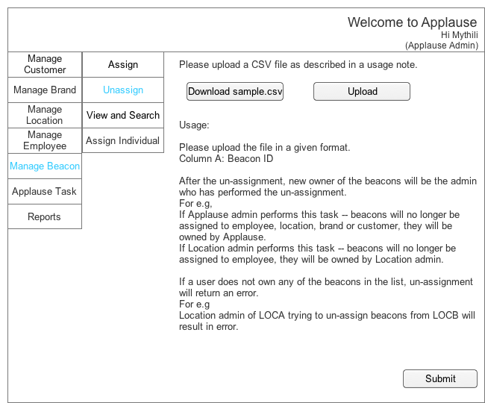

* 1. View and Search - Initial
     1. User Interface

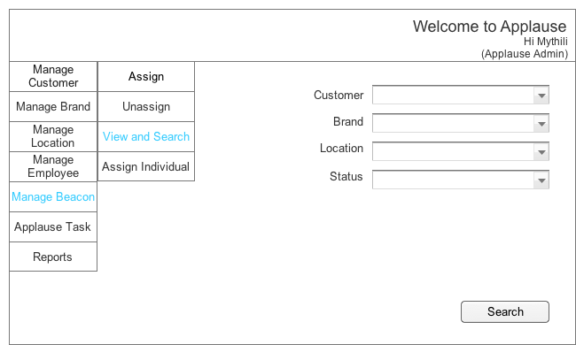

* 1. View and Search - Result
     1. User Interface

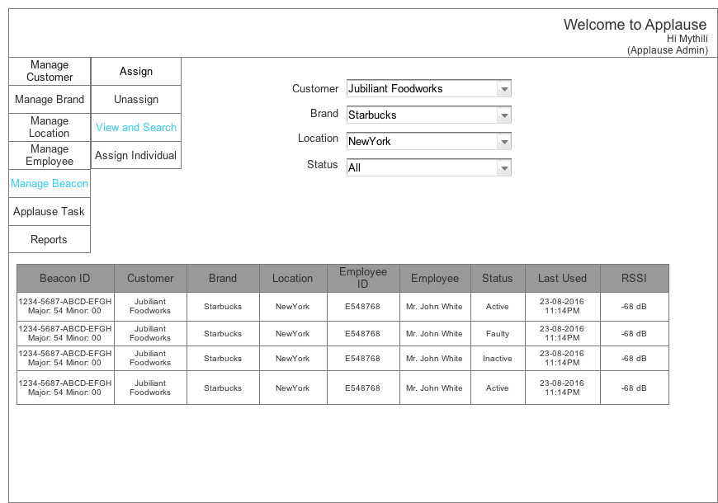

* 1. View and Search - Status result
     1. User Interface

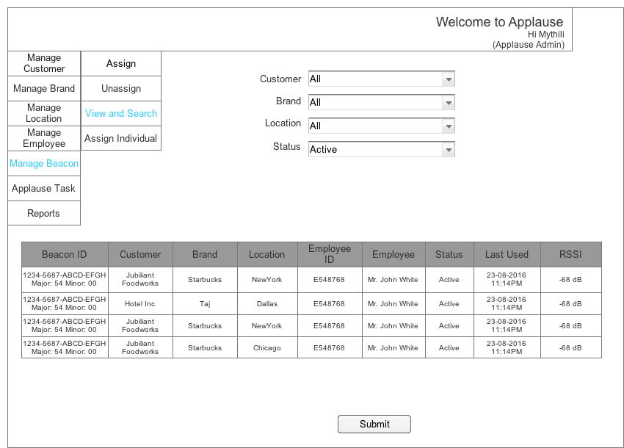

* 1. Assign Individual - Initial
     1. User Interface

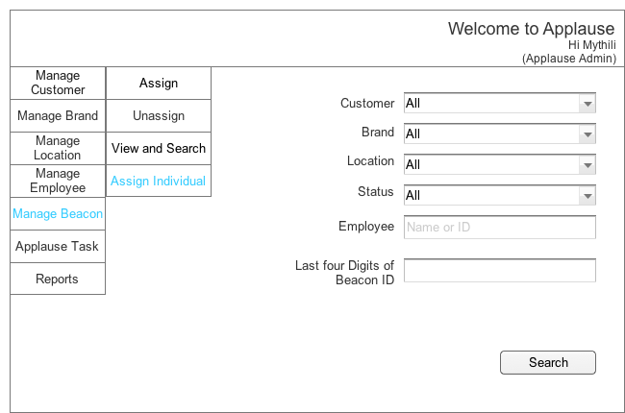

* 1. Assign Individual - Both Unassigned
     1. User Interface

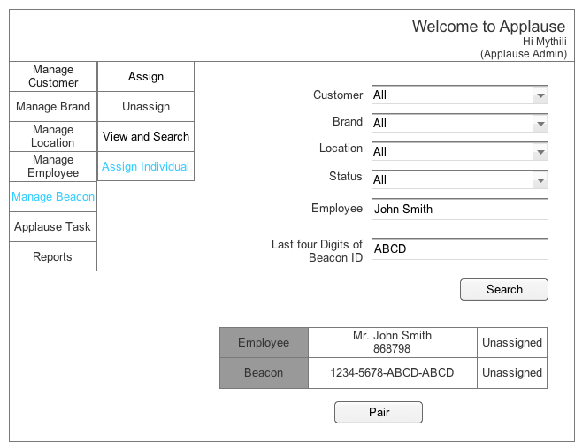

* 1. Assign Individual - Both Unassigned - Success - Popup
     1. User Interface

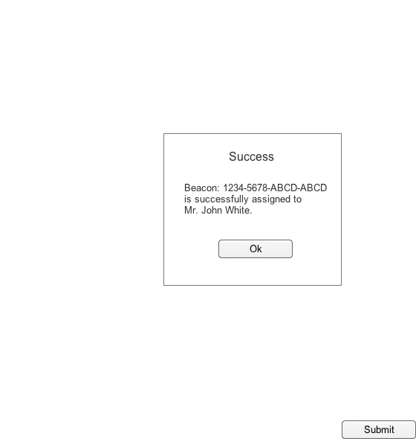

* 1. Assign Individual - Only beacon unassigned
     1. User Interface

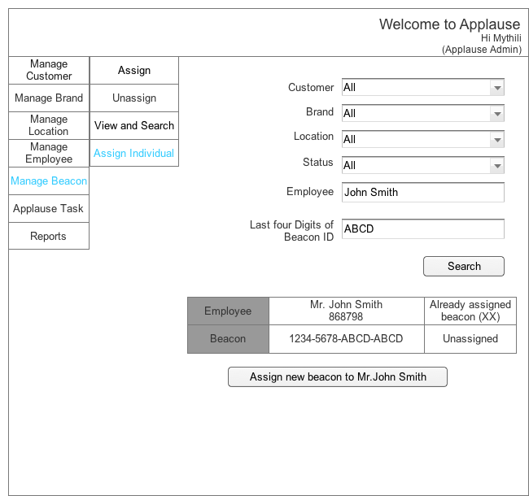

* 1. Assign Individual - Only emplyee beacon unassigned
     1. User Interface

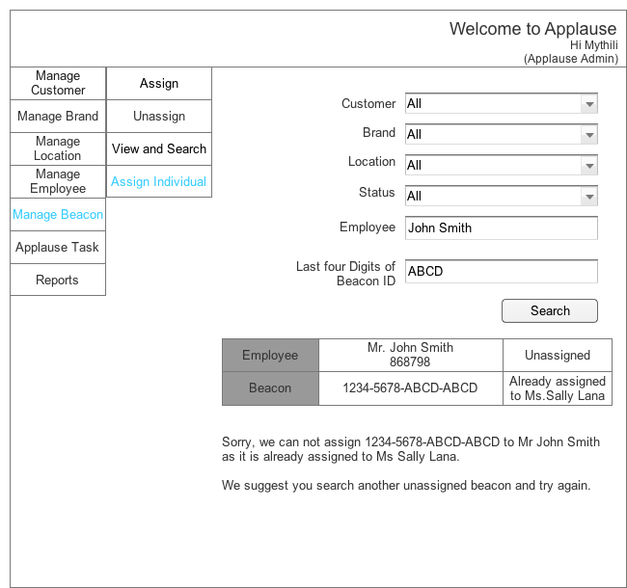

* 1. Bulk upload - Initial
     1. User Interface

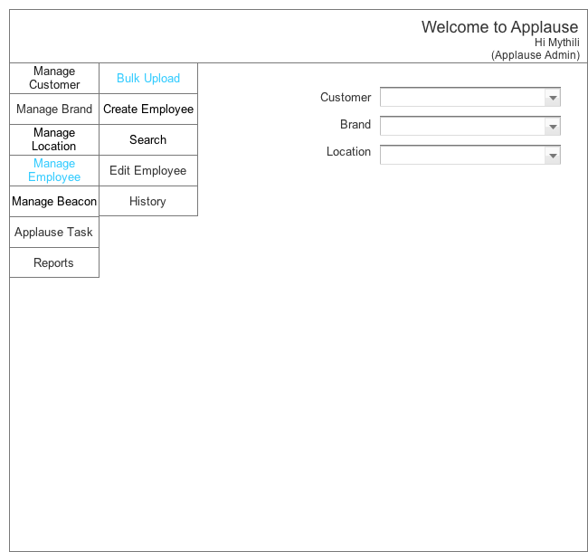

* 1. Bulk upload
     1. User Interface

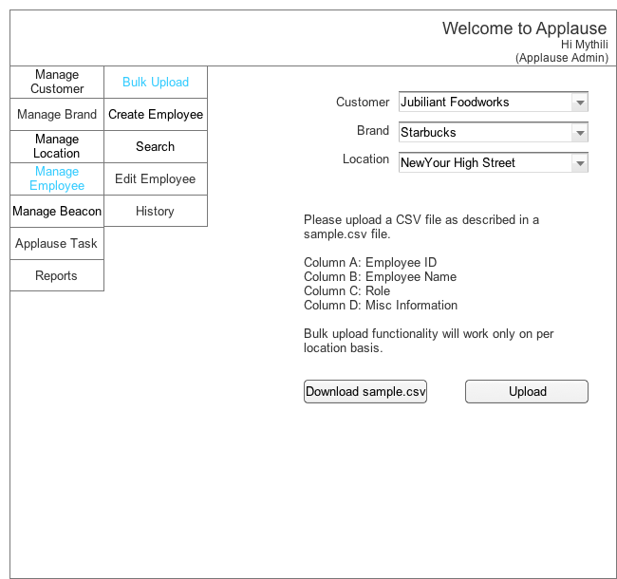

* 1. Create Single - Initial
     1. User Interface

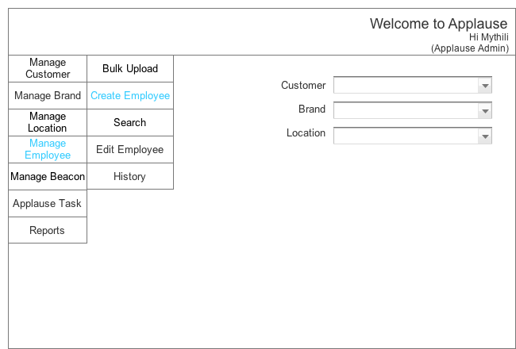

* 1. Create Single
     1. User Interface

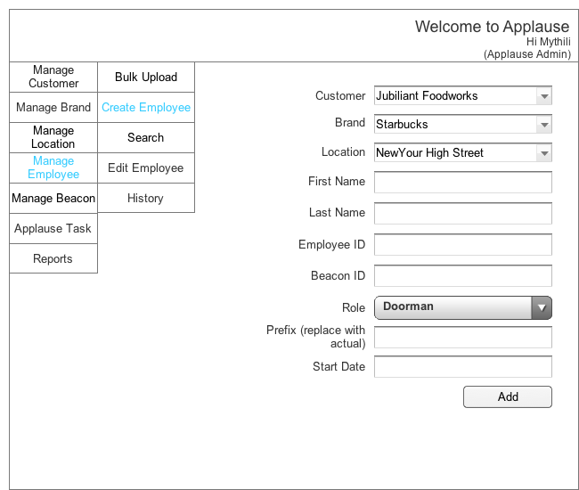

* 1. Edit - Initial
     1. User Interface

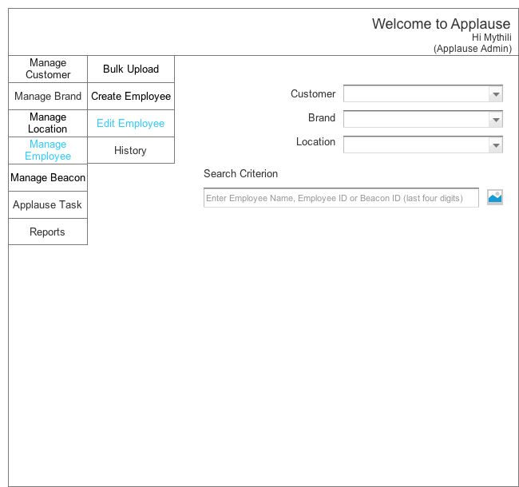

* 1. Edit - Result
     1. User Interface

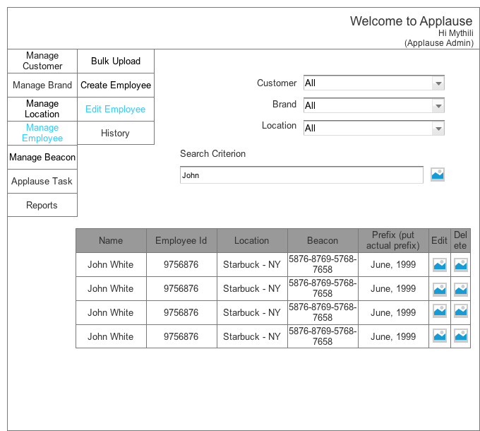

* 1. Edit
     1. User Interface

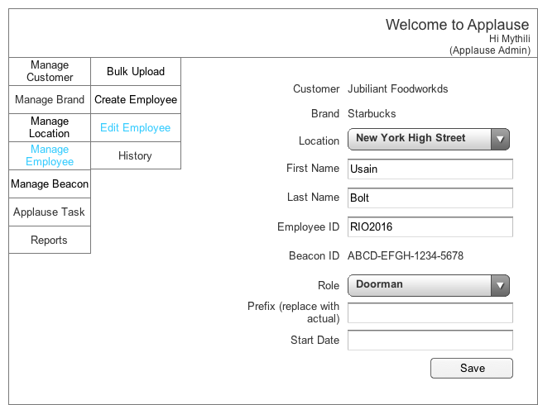

* 1. Delete confirm - popup
     1. User Interface

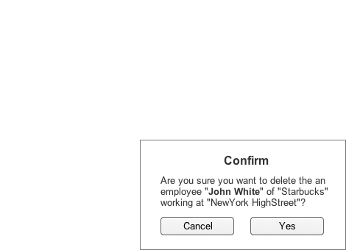

* 1. History - Initial
     1. User Interface

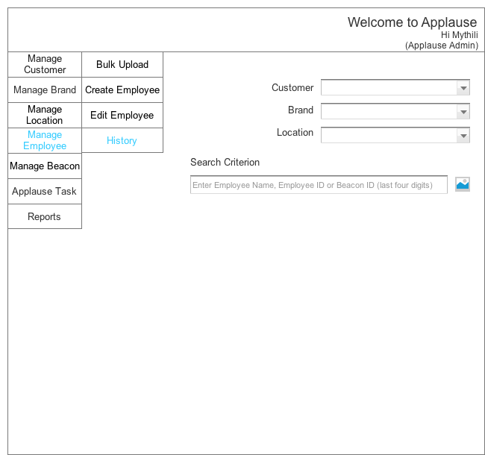

* 1. History - Result
     1. User Interface

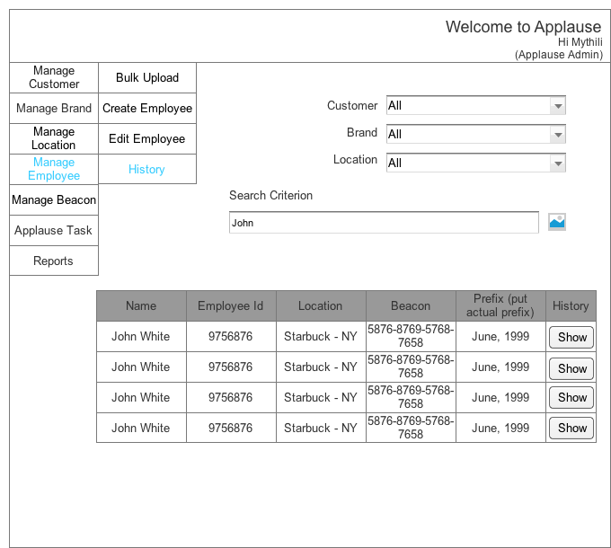

* 1. History record
     1. User Interface

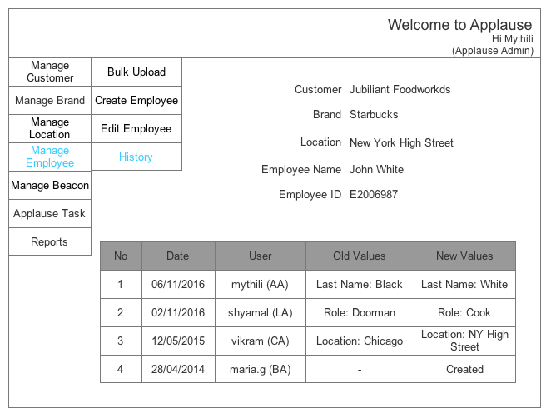

* 1. Update Contact Details
     1. User Interface

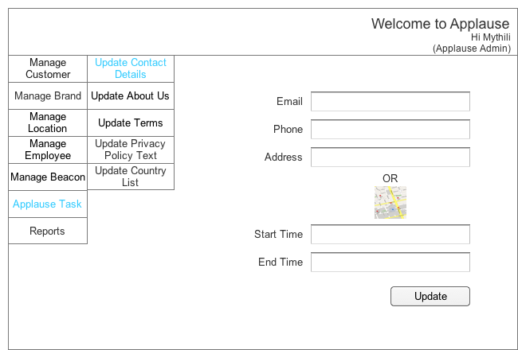

* 1. Update About Us
     1. User Interface

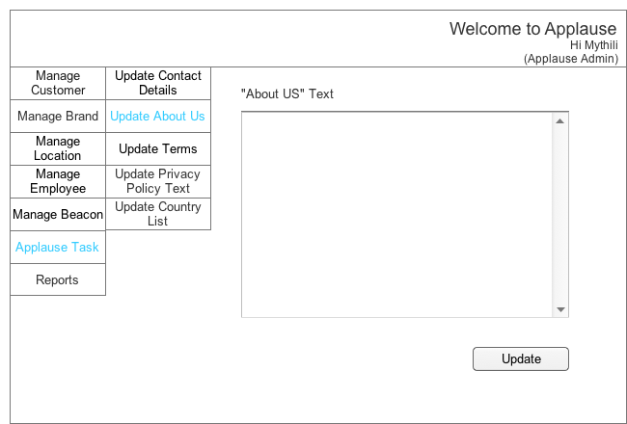

* 1. Update Terms
     1. User Interface

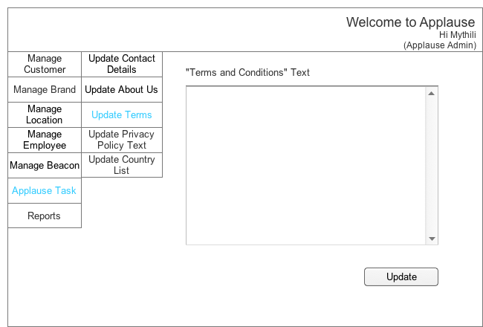

* 1. Update Privacy Policy
     1. User Interface

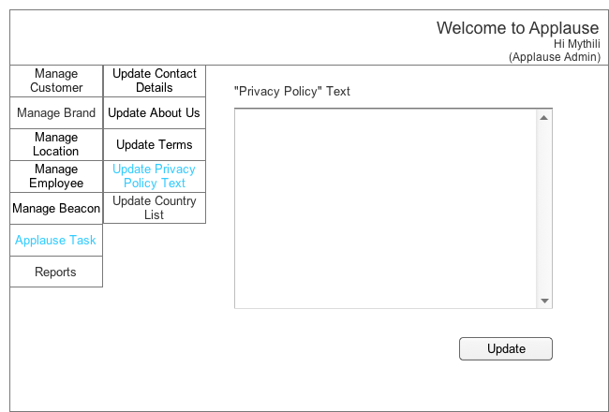

* 1. Update Country List
     1. User Interface

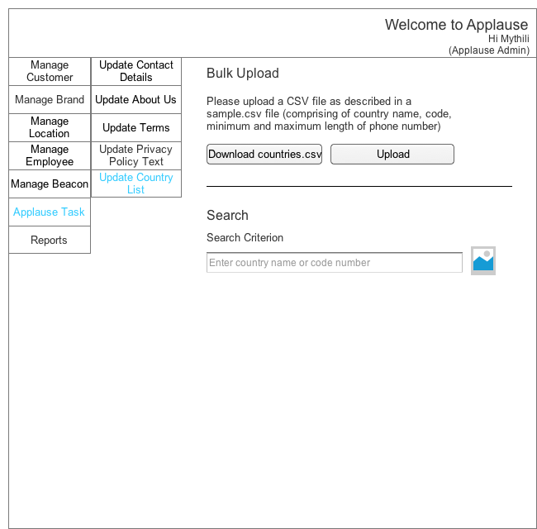

* 1. Update Country List - Result
     1. User Interface

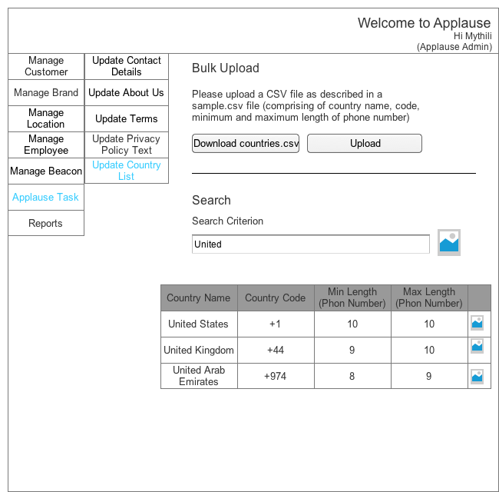

* 1. Update Country List - Save
     1. User Interface

