

A
Report on
Prakash: Smart Streetlight Maintenance and Decision Support System
Prepared For
Natural Language Processing (NLP)
Complex Engineering Problem (CEP) · SDG 11: Sustainable Cities and Communities
Team 6
SIES GRADUATE SCHOOL OF TECHNOLOGY NERUL,
NAVI MUMBAI 400706
ACADEMIC YEAR 2025-26

A
Report on
Prakash: Smart Streetlight Maintenance and Decision Support System
Prepared For
Natural Language Processing (NLP) · CEP
Submitted by: Team 6
Bharath Rathinasapabathy | 123A8012
Gregory | 123A8020
Harshwardhan Ahire | 123A8004
Department of Artificial Intelligence & Data Science
Under the guidance of
Dr. Vidya Keshwani
SIES GRADUATE SCHOOL OF TECHNOLOGY NERUL,
NAVI MUMBAI 400706
ACADEMIC YEAR 2025-26

Acknowledgement
We, Team 6, express our sincere gratitude to our guide, Dr. Vidya Keshwani, for the direction, feedback and encouragement she gave us throughout this project. Her suggestion to treat the work as a Complex Engineering Problem aligned with a Sustainable Development Goal pushed us to build a complete, usable system instead of a classroom prototype.
We thank the Department of Artificial Intelligence & Data Science and SIES Graduate School of Technology, Nerul, for the laboratory facilities and the academic environment that made this work possible. We also thank our classmates, whose questions during the interim presentation helped us sharpen the problem statement and the evaluation.
Finally, we acknowledge the open-source communities behind Python, scikit-learn, Flask, SQLite, Leaflet and Chart.js. Their tools allowed three students to build and test a full-stack, multilingual AI system on ordinary laptops.
Team 6

Abstract
Faulty streetlights reported by citizens are still handled manually in most Indian cities. A clerk reads each phone call, WhatsApp message, email or tweet, decides how urgent it is, tries to work out which pole is meant, and calls a technician. The result is delayed repairs, inefficient crew scheduling and unsafe dark roads. This report presents Prakash, an AI-driven streetlight maintenance and decision support system that automates this journey end to end.
Prakash accepts complaints from six channels (WhatsApp, SMS, email, X/Twitter, call-centre transcripts and a web portal) and processes every message with one Natural Language Processing pipeline: channel-specific text clean-up, language identification for English, Hindi, Marathi and Hinglish, fault classification into eight classes using TF-IDF word and character n-grams with logistic regression, named entity recognition for pole IDs, landmarks, roads, sectors, durations and fault phrases, and an explainable severity score from 0 to 100. The extracted location is geocoded, snapped to the nearest lamp in a GIS lamp register and checked against open tickets so that duplicate reports merge instead of creating extra work. Messages the system is unsure about are sent to a human review queue, and the operator's corrections are used to retrain the classifier.
On top of the NLP layer, Prakash identifies maintenance hotspots with DBSCAN clustering, predicts the probability that each lamp fails within 14 days with a gradient-boosted model, forecasts weekly fault counts with damped Holt smoothing, and builds crew routes with a priority-, skill- and shift-aware insertion heuristic improved by 2-opt and or-opt moves. A role-based web application (citizen, technician, admin) with live updates over server-sent events, alerts, a technician route view and a citizen tracking portal puts the results into use. The backend is written in Python with Flask and SQLite; the interface uses Leaflet and Chart.js.
On a held-out test of 480 paraphrased complaints that never appear in training, the classifier reaches 87.5% accuracy (macro-F1 0.875) against 42.7% for the keyword-rule baseline of our first prototype, and 91.7% on 24 hand-written messages. The failure-risk model reaches an AUC of 0.80, and on the demonstration data the route optimiser cuts total travel by about one third and reduces the average time to reach Critical and High jobs from 105 to 12 minutes. Because no public labelled streetlight-complaint corpus exists, the training complaints, lamp network and history are synthetic; the report states this limitation openly and describes how the system retrains on real data. The project supports SDG 11, in particular target 11.7 (safe public spaces), target 11.2 (safe transport systems) and target 11.3 (participatory urban planning).
Keywords: Natural Language Processing, text classification, named entity recognition, code-mixed text, GIS, DBSCAN, predictive maintenance, route optimisation, human-in-the-loop, SDG 11.
Table of Contents
Acknowledgement 1
Abstract 2
CHAPTER 1 Introduction 6
1.1 Background 6
1.2 Problem Statement 6
1.3 Motivation 7
1.4 Objectives 7
1.5 Alignment with SDG 11 7
1.6 Scope and Limitations 8
1.7 Organisation of the Report 8
CHAPTER 2 Literature Review and Technical Background 9
2.1 Citizen Complaint Systems 9
2.2 Text Classification 9
2.3 Named Entity Recognition and Geoparsing 9
2.4 Code-Mixed and Multilingual Text 10
2.5 Spatial Clustering for Hotspots 10
2.6 Predictive Maintenance and Forecasting 10
2.7 Vehicle Routing and Scheduling 10
2.8 Research Gap and Contribution 11
CHAPTER 3 Requirements and Problem Analysis 12
3.1 Stakeholders and Roles 12
3.2 Functional Requirements 12
3.3 Non-Functional Requirements 13
3.4 Use Cases 13
3.5 Why This Is a Complex Engineering Problem 14
CHAPTER 4 System Design 15
4.1 Architecture Overview 15
4.2 Layers and Responsibilities 15
4.3 Data Model 16
4.4 Ticket Life Cycle 16
4.5 API Design 17
4.6 Real-Time Updates 17
4.7 Security Design 17
4.8 Synthetic Data Generation 18
CHAPTER 5 NLP Methodology 19
5.1 Training and Test Data 19
5.2 Text Normalisation 19
5.3 Language Identification 20
5.4 Fault Classification 20
5.5 Named Entity Recognition 21
5.6 Severity Scoring 21
5.7 Geocoding and Lamp Matching 22
5.8 Duplicate Detection 23
5.9 Human-in-the-Loop Review 23
5.10 Automatic Multilingual Reply 23
5.11 Worked Example 23
CHAPTER 6 Predictive Analytics and Optimisation 25
6.1 Hotspot Detection with DBSCAN 25
6.2 Lamp Failure-Risk Model 25
6.3 Weekly Fault Forecast 25
6.4 Priority Score 26
6.5 Technician Scheduling 26
6.6 Alerts Engine 26
CHAPTER 7 Implementation 27
7.1 Tools and Technologies 27
7.2 Project Structure 27
7.3 User Interface 28
CHAPTER 8 Testing and Results 40
8.1 Test Strategy 40
8.2 Classifier Results 40
8.3 Effect of the Safety Rule and Review Threshold 41
8.4 Failure-Risk Model Results 41
8.5 Scheduling Results 42
8.6 Performance 42
8.7 Threats to Validity and Limitations 43
CHAPTER 9 Social Impact, Ethics and Sustainability 44
9.1 Expected Impact 44
9.2 Ethical Considerations 44
9.3 Sustainability 44
CHAPTER 10 Mapping to Course Outcomes, Programme Outcomes and Knowledge Profiles 45
10.1 Course Outcome Mapping 45
10.2 Programme Outcome Mapping 45
10.3 Knowledge Profile (WK) Mapping 46
CHAPTER 11 Conclusion and Future Scope 48
11.1 Conclusion 48
11.2 Future Scope 48
References 49
Appendix A: Running the Project 51
Appendix B: REST API Summary 52
Appendix C: Sample Complaints and Outputs 53

CHAPTER 1
Introduction

1.1 Background
Streetlights are among the most visible services a city provides, and among the most noticed when they fail. A dark road raises the risk of road accidents, theft and harassment, and it discourages people, especially women, children and older residents, from using public space after sunset. Yet maintaining a large network of lamps is a logistics problem. A mid-sized municipal ward can have tens of thousands of lamps, hundreds of complaints a week, and a handful of crews. Each complaint arrives in free text, in whichever language and through whichever channel the citizen finds convenient.
In practice, the work flow is largely manual. A complaint is read by a clerk, entered in a register, and handed to a supervisor who decides which crew goes where. Locations are described in words such as "near the school gate" or "opposite the temple" rather than coordinates, so crews waste time finding the right pole. Duplicate complaints about the same lamp create duplicate work orders, while a hanging live wire may wait in the same queue as a lamp that merely flickers. Crews are assigned by arrival order rather than by priority, certification or geography, so they criss-cross the city.
Recent advances in Natural Language Processing, geographic information systems (GIS) and machine learning make it possible to automate most of these decisions while keeping a human in control of the uncertain ones. This project, Prakash (Sanskrit and Hindi for "light"), explores how far a complete pipeline can go with techniques that students can implement, explain and test.

1.2 Problem Statement
Faulty streetlights reported by citizens are often processed manually, leading to delayed repairs, inefficient maintenance scheduling, and increased public safety concerns. Develop an AI-driven Smart Streetlight Maintenance and Decision Support System that integrates Natural Language Processing (NLP), Machine Learning, Geographic Information Systems (GIS) and predictive analytics to collect maintenance requests from multiple communication channels, automatically classify fault types, extract streetlight locations using Named Entity Recognition (NER), assess fault severity, identify maintenance hotspots, predict recurring failures based on historical data, optimise technician scheduling and resource allocation, and provide real-time dashboards with alerts to support efficient streetlight maintenance and improve public safety.

1.3 Motivation
- Safety. Hazards such as exposed wires and leaning poles must be identified in minutes, not days.
- Language diversity. Real complaints in Navi Mumbai arrive in English, Hindi, Marathi and in Hinglish (Hindi written in Roman script). A system limited to formal English would miss a large share of citizens.
- Unclear locations. A complaint is only useful if a crew can find the pole. Entity extraction and a lamp register turn words into coordinates.
- Wasted effort. Duplicate tickets, unprioritised queues and unplanned routes waste crew hours and fuel.
- Accountability. Citizens and auditors need to see why a ticket was rated critical and who fixed it and when.

1.4 Objectives
- Collect maintenance requests from multiple channels (WhatsApp, SMS, email, X/Twitter, call-centre transcripts, web portal, bulk upload) into a single queue.
- Classify the fault type automatically across English, Hindi, Marathi and Hinglish text.
- Extract pole IDs, landmarks, roads, sectors, durations and fault phrases using Named Entity Recognition, and convert them to a location on the map.
- Score severity from 0 to 100 with a visible, auditable explanation.
- Identify maintenance hotspots and recurring failure locations using spatial clustering.
- Predict which lamps are likely to fail next and forecast weekly fault volumes from historical data.
- Optimise technician scheduling under priority, skill-certification and shift-length constraints.
- Provide real-time dashboards and alerts for the control room, a route view for technicians and a tracking portal for citizens.
- Send uncertain cases to a human reviewer and learn from the corrections.

1.5 Alignment with SDG 11
Sustainable Development Goal 11 aims to "make cities and human settlements inclusive, safe, resilient and sustainable" [1]. Prakash contributes to three of its targets:
Table 1: SDG 11 targets addressed by the project
Target | Statement (summary) | Contribution of Prakash
11.7 | Provide universal access to safe, inclusive and accessible public spaces, in particular for women, children, older persons and persons with disabilities. | Faster repair of dark roads, priority points for women, students and elderly users in the severity score, public city map of lamp status.
11.2 | Provide access to safe, affordable, accessible and sustainable transport systems and improve road safety. | Hazard detection (leaning poles, exposed wires) goes to certified crews first; faster restoration of lighting on roads and junctions.
11.3 | Enhance inclusive and sustainable urbanization and capacity for participatory planning and management. | Citizens report in their own language, confirm existing faults, track progress and rate repairs; the city gets data on where infrastructure fails.

The project also supports SDG 9 (resilient infrastructure) through predictive maintenance, and SDG 7 (affordable and clean energy, target 7.3 on energy efficiency) because lamps that burn in daytime are detected as a separate fault class and cleared.

1.6 Scope and Limitations
In scope: multilingual complaint understanding, lamp matching, duplicate merging, hotspot detection, failure-risk prediction, weekly forecasting, skill-aware crew scheduling, role-based web application with live dashboard, alerts, citizen tracking and technician route.
Out of scope: live GPS tracking of crews, integration with a real municipal ticketing system or WhatsApp Business account, IoT sensors inside lamps, and production-scale deployment. Complaint text used for training, the lamp register and twelve weeks of maintenance history are synthetic, generated for this project, because no public labelled corpus of streetlight complaints exists. All reported accuracy figures therefore describe the pipeline on synthetic data and should not be read as real-world performance.

1.7 Organisation of the Report
Chapter 2 reviews related work and the techniques we build on. Chapter 3 analyses requirements and shows why the problem is a Complex Engineering Problem. Chapter 4 presents the system design. Chapters 5 and 6 describe the NLP pipeline and the predictive and optimisation modules in detail. Chapter 7 describes the implementation and the user interface. Chapter 8 reports testing and results. Chapter 9 discusses social impact, ethics and sustainability. Chapter 10 maps the work to course outcomes, programme outcomes and knowledge profiles. Chapter 11 concludes with future scope.

CHAPTER 2
Literature Review and Technical Background

2.1 Citizen Complaint Systems
Several civic reporting platforms already let residents report faulty infrastructure. FixMyStreet (mySociety) and SeeClickFix are widely used examples, and many municipalities run their own 311-style helplines and mobile apps. Their strength is easy intake and public visibility of reports. Most depend on structured form fields (category, pin on a map) filled in by the citizen, or on staff who read and categorise free text. Open 311 data sets such as the New York City 311 Service Requests [18] and the City of Chicago 311 Service Requests [19] contain street-light complaints and show how large the volumes are, but they are English-only and structured. Free-text, multilingual and code-mixed reports through chat channels are much less served, and that is the gap this project targets.

2.2 Text Classification
Classifying short complaints into a small set of fault types is a supervised text-classification task. A standard and strong baseline represents each message as a vector of TF-IDF weights [2] and trains a linear classifier such as logistic regression [20]. Term frequency rewards words that appear often in a message, and inverse document frequency down-weights words that appear in almost every message. Character n-gram features extend the idea to sub-word units, which makes the representation robust to spelling variation and to transliteration, both common in Indian-language chat messages.
Pre-trained transformer models such as BERT [10] and its smaller variant DistilBERT [11] give higher accuracy when enough labelled data and compute are available, and multilingual models such as MuRIL [12] are trained specifically on Indian languages and their transliterated forms. We chose the TF-IDF and logistic-regression route for this project because there is no labelled real data, training must finish in seconds on a laptop, and a linear model is transparent: the weight of each word in each decision can be shown to the operator. The pipeline is modular so a transformer can replace the classifier later.

2.3 Named Entity Recognition and Geoparsing
Named Entity Recognition (NER) finds and labels spans of text that refer to entities such as places or durations [4]. Approaches range from hand-written rules and gazetteers (lists of known names) to statistical sequence models and neural taggers. For complaints, the useful entities are domain-specific: pole identifiers, landmarks, roads, sectors, durations and fault phrases. With no annotated data, a hybrid of regular expressions and a gazetteer of local landmarks is the practical choice, and it is easy to extend. Geoparsing, the step of turning a recognised place name into coordinates, is done by gazetteer look-up; coordinates are then matched to the nearest asset using great-circle distance computed with the haversine formula [22].

2.4 Code-Mixed and Multilingual Text
Messages that mix Hindi and English, either in Devanagari or in Roman script ("Hinglish"), are routine in India. They break word-level tokenisers trained on a single language and produce many unseen spellings. Character n-grams, script detection, and training data that deliberately includes the mixed forms are lightweight ways to handle them. The system detects the language so that its automatic reply can be written in the citizen's own language.

2.5 Spatial Clustering for Hotspots
DBSCAN (Density-Based Spatial Clustering of Applications with Noise) [5] groups points that have at least a minimum number of neighbours within a given radius, and labels isolated points as noise. It needs no preset number of clusters and can find clusters of any shape, which suits faults that line up along a road because they share a feeder or a cable. Using the haversine metric makes the radius a real distance in metres.

2.6 Predictive Maintenance and Forecasting
Predictive maintenance estimates the probability that an asset fails within a horizon, using features such as age, past failures and operating conditions. Gradient-boosted decision trees [6] are a strong, widely used model for such tabular data and provide feature importance for explanation. For counts over time, exponential smoothing with a damped trend [7] is a simple, robust forecaster that works with short histories, and it supports prediction intervals from the spread of past errors.

2.7 Vehicle Routing and Scheduling
Assigning jobs to crews and ordering the visits is a Vehicle Routing Problem (VRP) with additional constraints [9]. Exact methods do not scale well, so practical systems use heuristics. Cheapest insertion builds routes by adding each job at the position that increases cost least, and local-search moves such as 2-opt [8] (reverse a segment of the route) and or-opt (move a job) improve them. Skill constraints (only certified crews handle live-wire hazards) and shift length are modelled as hard limits.

2.8 Research Gap and Contribution
Table 2: Gaps addressed by this work
Gap in existing practice | How Prakash addresses it
Reports need structured forms or manual reading | One NLP pipeline reads free text from six channels.
English-only processing | English, Hindi, Marathi and Hinglish handled by the same model and answered in the citizen's language.
Location lost in words | NER plus gazetteer, pole-ID look-up and GPS pins resolve a message to a specific lamp.
Duplicates and flat queues | Reports about one lamp merge and raise its priority; severity is explainable.
Reactive maintenance only | Failure-risk prediction and hotspot detection support preventive work orders.
Crews dispatched by arrival order | Skill-, priority- and distance-aware optimiser compared with a manual baseline.
AI decisions are opaque | Every decision shows the words, rules and points behind it; low confidence goes to a human, and corrections retrain the model.

CHAPTER 3
Requirements and Problem Analysis

3.1 Stakeholders and Roles
Table 3: Stakeholders and their needs
Role | Needs | What the system gives them
Citizen | Report a fault easily in their own language; know that it was received; know when it will be fixed. | Web portal with live AI preview, photo and GPS pin, voice input, duplicate warning, status timeline, notifications, rating.
Technician | A clear list of jobs in a sensible order, with location and parts. | Optimised route on a map, start and finish buttons with notes and parts, shift toggle, history.
Control-room admin | See what is happening now, decide what to do, and trust the AI. | Live dashboard, ticket drawer with explanation, review queue, alerts, scheduling, analytics, model metrics, user management, audit log.
City administration | Evidence of service quality and where infrastructure fails. | SLA compliance, resolution times, hotspots, forecasts, CSV export.

3.2 Functional Requirements
Table 4: Functional requirements
ID | Requirement | Module
FR1 | Accept complaints from WhatsApp, SMS, email, X/Twitter, call transcripts, web form and CSV import through a common ingest pipeline. | Ingest, webhooks
FR2 | Clean channel noise (signatures, quoted replies, hashtags, mentions, emojis, speech fillers). | NLP
FR3 | Detect language (English, Hindi, Marathi, Hinglish). | NLP
FR4 | Classify fault type into eight classes with a probability for each. | NLP
FR5 | Extract pole IDs, landmarks, roads, sectors, durations and fault phrases. | NLP (NER)
FR6 | Score severity from 0 to 100 and list the reason for each point. | NLP
FR7 | Geocode the location, snap to the nearest lamp, and merge duplicate reports. | GIS, services
FR8 | Send low-confidence or location-less tickets to a human review queue and store corrections. | Review, learning
FR9 | Cluster faulty lamps into hotspots and find 90-day repeat-failure zones. | Analytics
FR10 | Predict 14-day failure risk per lamp, with a rainfall what-if, and forecast weekly faults. | Analytics
FR11 | Build skill-aware, priority-aware routes; dispatch on one click; auto-dispatch critical faults. | Scheduler
FR12 | Show real-time dashboard, alerts, notifications and a citizen tracking timeline. | Frontend, SSE
FR13 | Role-based access for citizen, technician and admin; audit log of administrative actions. | Security
FR14 | Retrain the classifier from stored human corrections and report before/after accuracy. | Models

3.3 Non-Functional Requirements
- Usability: works on desktop and phone, light and dark themes, plain-language messages.
- Performance: live AI preview must respond in well under a second so it can run while the citizen types (measured mean 29 ms, Chapter 8).
- Explainability: each automated decision shows its evidence.
- Security and privacy: server-side role checks, hashed passwords, rate-limited login, escaped output, restricted uploads, minimal personal data.
- Reliability: a single command starts the system; the system works offline except for map background tiles.
- Maintainability: modular code (NLP, analytics, scheduler, services, API) with automated tests.

3.4 Use Cases
Table 5: Use cases by actor
Actor | Main use cases
Citizen | Register and sign in · report a fault · see live AI understanding · pin a location or use GPS · attach a photo · speak the complaint · confirm an existing fault ("me too") · track a ticket · rate a repair · view the city lamp map · read notifications.
Technician | Sign in · toggle shift · view optimised route · navigate to a job · start work · mark fixed with notes and parts · view history and rating.
Admin | Monitor dashboard · open a ticket · assign, correct, annotate, resolve or reject · review uncertain tickets · simulate channels · inspect hotspots and predictions · run and dispatch the optimiser · manage technicians and users · adjust SLA and thresholds · retrain the model · export data.

3.5 Why This Is a Complex Engineering Problem
The project was framed as a Complex Engineering Problem (CEP). the table below relates it to the usual attributes of such problems.
Table 6: Complex engineering problem attributes
Attribute | Evidence in this project
Depth of knowledge required | Needs NLP (representation, classification, NER), spatial analysis, machine learning, optimisation and web engineering together.
Conflicting requirements | Fast triage versus accuracy (human review threshold); urgent jobs first versus shortest travel; automation versus citizen trust and privacy.
Depth of analysis | No standard solution exists: model choice, features, severity design, dedupe rules and routing cost all needed analysis and experiments.
Familiarity of issues | Code-mixed Hinglish, vague locations and missing data are not covered by textbook NLP exercises.
Stakeholder involvement | Citizens, technicians, control-room staff and city administration have different, sometimes competing, needs.
Interdependence | Classification, location, severity, duplicates, hotspots, risk and scheduling feed each other; an error early in the pipeline propagates, which is why a review loop exists.

CHAPTER 4
System Design

4.1 Architecture Overview
Prakash follows a five-stage pipeline: Collect, Understand, Locate, Predict and Decide, Act. A Flask backend implements the stages as services over an SQLite database and exposes them through a REST API and a server-sent event stream. A single-page browser application renders three role-specific interfaces.
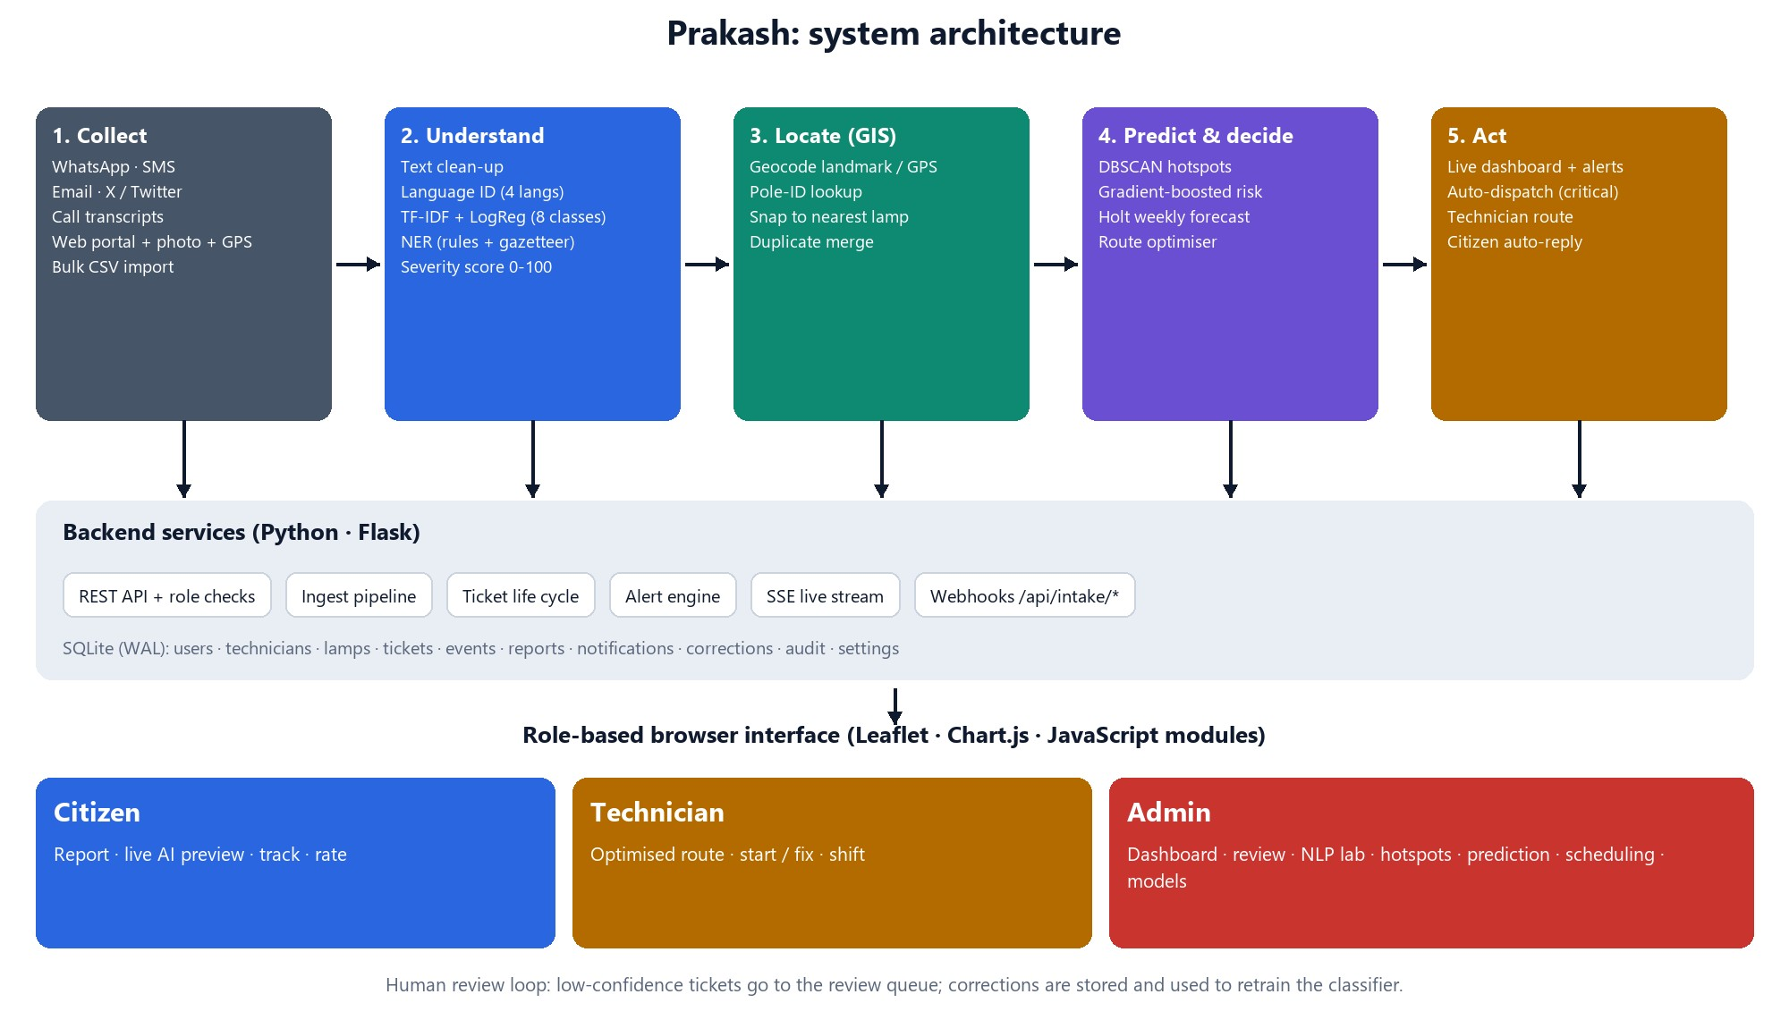
Figure 1: System architecture of Prakash

4.2 Layers and Responsibilities
Table 7: Layers of the system
Layer | Technology | Responsibility
Presentation | JavaScript modules, Leaflet, Chart.js, CSS | Role-based single-page app, maps, charts, live updates, responsive layout, themes.
API | Flask, signed-cookie sessions | REST endpoints, role checks, input validation, uploads, webhooks, SSE stream.
Services | Python modules | Ingest pipeline, duplicate handling, ticket life cycle, alerts, dashboard numbers, dispatch.
Intelligence | scikit-learn, NumPy | NLP pipeline, classifier, NER, severity, risk model, forecast, DBSCAN, scheduler.
Data | SQLite (WAL mode) | Users, technicians, lamps, tickets, events, reports, notifications, corrections, audit log, settings.

4.3 Data Model
Table 8: Main database tables
Table | Purpose and key fields
users | Account, role (citizen, technician, admin), password hash, active flag, last login.
technicians | Linked user, skills (HV-certified, bucket truck), base location, colour, shift status, capacity in minutes.
lamps | Lamp ID (for example SL-NER-021), coordinates, zone, age, supply-voltage variation, driver type, burning hours, pole condition, status.
tickets | Text, cleaned text, language, class, confidence, severity and reasons, entities, probabilities, location and lamp, status, SLA deadline, reporter, report count, technician, route order, ETA, resolution note, parts, rating.
ticket_events | Timeline of everything that happened to a ticket (who, what, when).
ticket_reports | Additional citizen reports merged into a ticket.
notifications | In-app messages for citizens and technicians.
corrections | Human-corrected labels, used to retrain the classifier.
alert_acks, audit, settings | Acknowledged alerts, administrative audit trail, configurable SLA hours and thresholds.

4.4 Ticket Life Cycle
A ticket enters as Received and is placed either in Open (confident classification and a usable location) or in Review (uncertain). An admin can release a reviewed ticket to Open, or reject it. Open tickets become Assigned when a technician is chosen, In progress when the technician starts, and Resolved when the job is fixed. Critical tickets are auto-dispatched to the nearest qualified technician. Duplicate reports never create a new ticket: they join the existing one and raise its priority.
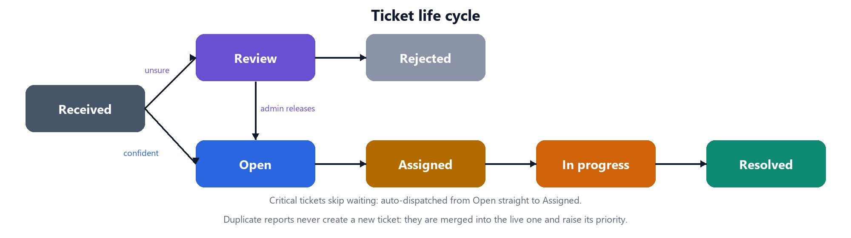
Figure 2: Ticket life cycle

4.5 API Design
The interface between browser and server is a set of JSON REST endpoints [13], grouped by role. A summary is given below; the complete list is in Appendix B.
Table 9: REST API groups
Group | Examples
Authentication | POST /api/auth/login, /register, /logout; GET /api/auth/me.
Citizen | POST /api/analyze (live AI preview), POST /api/tickets, GET /api/my/tickets, GET /api/nearby, POST /api/tickets/{id}/confirm and /rate, GET /api/city/map.
Technician | GET /api/tech/jobs, POST /api/tech/shift, POST /api/tech/jobs/{id}/start and /complete.
Admin | GET /api/admin/overview, /tickets, /hotspots, /predictions, /schedule, /analytics, /model, /alerts; POST /api/admin/schedule/dispatch, /model/retrain, /preventive.
Channels | POST /api/intake/{whatsapp, sms, email, twitter, call, web}, protected by an X-API-Key header or an admin session.
Live updates | GET /api/stream (server-sent events).

4.6 Real-Time Updates
Updates flow only from server to browser, so we use Server-Sent Events instead of WebSockets. When a ticket is created or changed, the server publishes an event. Admin connections receive every event with full detail; a citizen or technician receives only events about their own tickets, with reduced detail. The browser updates the feed, map, counters and charts without refreshing, shows red alerts for critical faults and raises notifications.

4.7 Security Design
- Authentication: passwords stored as salted hashes (Werkzeug); signed, HttpOnly, SameSite cookies; login attempts rate-limited.
- Authorisation: every API route checks the role on the server. A citizen sees their own tickets in full and only a public summary of others; a technician sees only assigned jobs. Automated tests verify these rules.
- Input handling: length limits, coordinates restricted to the service area, uploads limited to images up to a size limit and stored under random names, all output escaped before display.
- Webhooks: external channel calls need a shared API key.
- Auditability: administrative actions are written to an audit log; each ticket keeps its own event timeline.

4.8 Synthetic Data Generation
Because real data was not available, the project generates its own, in three parts. (1) Lamp network: 508 lamps in eight zones of Navi Mumbai (Airoli, Ghansoli, Vashi, Sanpada, Nerul, Seawoods, Belapur, Kharghar), laid out along road corridors and short roads through 12 landmarks and every railway station, using approximate real coordinates. Each lamp has age, supply-voltage variation, driver type, burning hours and pole condition. (2) History: twelve weeks of resolved tickets whose volume, fault mix and repair times follow realistic patterns; lamps that are older or have worse supply fail more often, so repeat offenders exist. All of it is generated through the real NLP pipeline, so the data is consistent with the models. (3) Complaint text: phrase banks in English, Hinglish, Hindi and Marathi combined with places, openers, closers, durations and random typos. Separate phrase banks are used for training and testing (Chapter 5).

CHAPTER 5
NLP Methodology
Every complaint, from any channel, passes through the same sequence of steps. This chapter describes each step, the algorithm behind it, and the design decisions.

5.1 Training and Test Data
The classifier distinguishes eight fault classes (listed in the table below). Complaints are composed from phrase banks, where each class has several phrasings in English, Hinglish, Hindi and Marathi. A complaint is built as opener + fault phrase + place + duration + closer, with random typos in about one fifth of messages. The training set contains 170 messages per class (1,360 in total). The test set contains 60 messages per class (480 in total) built from different phrasings that never occur in training, so that the score measures generalisation rather than memorisation. A third set of 24 hand-written, realistic messages (including examples from our first prototype) provides a sanity check. In addition, a keyword-rule classifier like the one in our first prototype is kept as a baseline.
Table 10: Fault classes
Class | Meaning | Typical repair | Crew skills needed
outage | Lamp not working | 30 min | standard
flicker | Flickering or intermittent | 25 min | standard
dayburn | Burning in daytime (timer or photocell) | 20 min | standard
hazard | Electrical or pole hazard (sparks, hanging wire, leaning pole) | 60 min | HV-certified
dim | Dim or weak light | 25 min | standard
vandal | Damaged or stolen fixture or cable | 45 min | standard
timer | Controller or timer fault | 35 min | standard
cluster | Multiple-light outage on a stretch | 75 min | HV + bucket truck

5.2 Text Normalisation
Each channel has its own kind of noise, so the first step cleans the text before any model sees it. The table below lists the operations; the list of fixes applied to a message is stored with the ticket and shown to the operator.
Table 11: Text normalisation by channel
Channel | Clean-up applied
Email | Remove header lines (From, To, Date), merge the subject into the body, drop quoted replies (lines beginning with ">") and everything after a signature marker ("--", "Regards", "Sent from my").
X / Twitter | Remove retweet markers and @mentions; split hashtags written in CamelCase into words (#NerulStreetlight becomes "Nerul Streetlight").
Call centre | Remove speech fillers such as "uh", "um", "you know".
All channels | Remove URLs and emojis, expand SMS shorthand (plz, pls, stn, nr, opp), collapse whitespace.

5.3 Language Identification
If a message contains Devanagari characters it is Hindi or Marathi, and the two are separated by counting marker words typical of each language (for example आहे, नाही, जवळ for Marathi and है, नहीं, के पास for Hindi). A message in Roman script that contains two or more common romanised Hindi words (hai, nahi, band, andhera, batti, paas and similar) is labelled Hinglish; otherwise it is English. The label drives the language of the automatic reply.

5.4 Fault Classification

Representation
The cleaned text is converted to a sparse vector by concatenating two TF-IDF representations: word unigrams and bigrams, and character n-grams of length 2 to 5 within word boundaries. Sub-linear term frequency is used. For a term t in a document d of a corpus of N documents, the weight is
tfidf(t, d) = (1 + log tf(t, d)) × log( (1 + N) / (1 + df(t)) ) + 1
and each vector is length-normalised. Character n-grams keep similar spellings close (batti and bati, flickring and flickering) and give useful features for Devanagari, which has no spaces inside words that a simple tokeniser can exploit.

Classifier
A multinomial logistic regression model (regularisation strength C = 12) maps the vector x to class probabilities with the softmax function:
P(y = k | x) = exp(w_k · x + b_k) / Σ_j exp(w_j · x + b_j)
The class with the highest probability is the prediction, and the full probability list is shown to the operator.

Explainability
For the predicted class k, the contribution of each word feature is its TF-IDF value multiplied by the corresponding weight w_k. The six largest positive contributions are shown as "words that drove this decision". For example, "flickering" and "on and off" drive the flicker decision, and "sparks" and "hanging from" drive hazard.

Safety rule
Missing an electrical hazard is far more costly than a false alarm. A deterministic safety rule therefore raises the probability of hazard to at least 0.55 whenever danger words (spark, live wire, exposed wire, electrocution, shock, short circuit, smoke, dangling, and Hindi and Marathi equivalents) appear, even if the statistical model preferred another class. This is reported in the interface as "safety rule applied".

5.5 Named Entity Recognition
The NER module combines regular expressions with a gazetteer of local places. It tags five entity types (see the table below). Overlapping matches are resolved by keeping the earliest and longest span, so "SIES College Nerul" becomes one landmark rather than three entities.
Table 12: Entity types
Entity | Meaning | Examples
POLE_ID | Pole identifier | SL-NER-021, pole no. 214
LOCATION | Area, sector or road name | Vashi, Sector 17, Palm Beach Road
LANDMARK | Named landmark, station or phrase after near/opposite/behind | SIES College, Vashi Station, the temple
DURATION | How long the fault has existed | since 3 days, for two weeks, 3 दिन से
FAULT | Fault phrase | flickering, not working, sparks, wire hanging, band hai, बंद

5.6 Severity Scoring
Severity is a transparent rule-weighted score rather than a learned one, so every point can be explained to a citizen or an auditor. The score starts from a base level for the fault class (outage 35, flicker 25, daytime burning 15, hazard 75, dim 18, vandalism 40, timer 30, multi-light outage 55) and adds points when evidence is found in the text (see the table below). The score is capped at 100 and mapped to a level: Critical (75 or more), High (55 to 74), Medium (30 to 54) and Low (below 30).
Table 13: Severity factors
Evidence | Points | Examples of cue words
Electrical-danger words (when the class is not already hazard) | +25 | spark, exposed, live wire, shock, smoke
High-footfall or critical place | +10 | school, college, hospital, station, bus stop, junction, market, temple
Public-safety concern | +12 | women, girls, unsafe, dangerous, accident, theft
Vulnerable road users | +4 | child, senior, elderly, patients, students
Night-time impact | +3 | night, evening, after dark, रात, अंधार
Unresolved 3 to 6 days / 7 days or more | +8 / +14 | since 5 days, for two weeks

The SLA deadline follows from the level: Critical 4 hours, High 12 hours, Medium 48 hours and Low 96 hours (configurable by the admin).

5.7 Geocoding and Lamp Matching
The location is resolved in order of trust. A GPS pin shared by the citizen is most reliable, followed by a pole ID found in the lamp register, a named landmark, a railway station, a sector within a zone, and finally a zone name alone (see the table below). The coordinates are then snapped to the nearest lamp using the haversine distance. Lamps that are already faulty are preferred, because a complaint is more likely to be about a lamp known to be failing.
Table 14: Location sources and confidence
Source of location | Confidence | Lamp search radius
GPS pin | 0.99 | 120 m
Pole ID in text | 0.98 | exact lamp
Landmark in gazetteer | 0.95 | 450 m
Station name | 0.93 | 450 m
Sector within a zone | 0.78 | 700 m
Zone name only | 0.72 | sent to review

5.8 Duplicate Detection
Before a ticket is created, the system looks for a live ticket for the same lamp. If the location was only approximate (confidence below 0.98), it also looks for a live ticket of the same fault class within 110 m. If a match is found, the new report is added to that ticket, its report count rises, and the citizen is told that the fault was already logged and that the priority has risen. Two reports with exact locations on different lamps stay separate, so that a row of failed lamps is not collapsed into one ticket.

5.9 Human-in-the-Loop Review
A ticket goes to the review queue instead of being processed automatically when no location can be extracted, when the location is too vague to choose a lamp, or when classifier confidence is below 55% (configurable). The operator confirms or corrects the fault type and chooses the lamp. Each correction is stored; pressing Retrain adds the corrections to the training data (repeated six times so that scarce examples carry weight) and refits the model. The interface then reports accuracy before and after.

5.10 Automatic Multilingual Reply
Every ticket creation returns a reply in the language detected. A confident ticket gets a confirmation with the reference number, priority and promised time; an unclear one asks for a landmark or a location pin; a duplicate says that the report was added to an existing ticket. The reply is stored with the ticket and, in a real deployment, would be sent through the same channel the complaint arrived on.

5.11 Worked Example
Table 15: Worked example through the pipeline
Step | Result for "Sparks coming from the pole near Vashi Station and a wire is hanging!"
Clean-up | No change needed.
Language | English.
Class | Electrical / pole hazard, probability above 0.95; words: pole, sparks, hanging from.
Entities | FAULT "Sparks", FAULT "wire is hanging", LANDMARK "Vashi Station".
Severity | Base level 75 for a hazard plus 10 for a high-footfall place (a railway station) gives 85, which is Critical.
Location | Landmark Vashi Station, confidence 0.95, snapped to lamp SL-VSH-046.
Decision | Open ticket with a 4-hour SLA, auto-dispatched to the nearest HV-certified technician, red alert to the control room, reply to the citizen.

CHAPTER 6
Predictive Analytics and Optimisation

6.1 Hotspot Detection with DBSCAN
Two kinds of hotspot are computed. Current hotspots are found by running DBSCAN with the haversine metric on the coordinates of lamps that are currently faulty, with a radius of 170 m and a minimum of three lamps. Each cluster is reported with its centre, radius, number of lamps and a probable cause (a feeder pillar or MCB trip when four or more lamps fail together). Repeat-failure hotspots apply DBSCAN to 90 days of complaint locations with a radius of 75 m and at least eight points; the recommended action is to replace the driver or re-cable the stretch rather than repeat spot repairs. Clusters of four or more lamps also raise an alert.

6.2 Lamp Failure-Risk Model
A gradient-boosted classifier [6] (140 trees of depth 3, learning rate 0.08, subsampling 0.85) estimates the probability that each lamp fails within 14 days. The features are lamp age, faults in the last 90 days (computed live from real tickets), supply-voltage variation, rainfall in the last seven days, driver type (magnetic ballast, electronic, LED), burning hours and pole condition. Because no real failure records exist, the model is trained on 6,000 synthetic lamp records generated from a logistic relationship plus noise; 4,500 are used for training and 1,500 for testing. The administrator can drag a rainfall slider to see how the risk of all 508 lamps changes. For each lamp the dominant driver is found by replacing each feature in turn with the fleet median and measuring how far the risk falls. Selected lamps can be turned into preventive work orders that join the scheduling queue.

6.3 Weekly Fault Forecast
Weekly complaint counts for the last twelve weeks are forecast six weeks ahead with Holt's linear method with a damped trend [7], [23]. With level l, trend b, smoothing constants α and β and damping φ, the recursions are:
l_t = α y_t + (1 − α)(l_{t−1} + φ b_{t−1})
b_t = β (l_t − l_{t−1}) + (1 − β) φ b_{t−1}
ŷ_{t+h} = l_t + (φ + φ² + … + φ^h) b_t
The parameters α, β and φ are chosen by grid search to minimise one-step-ahead squared error. The 80% prediction interval uses 1.28 times the standard deviation of past forecast errors, widened with the horizon. The mean absolute percentage error on the demonstration history is about 10%.

6.4 Priority Score
Ticket priority combines severity with time and citizen pressure:
priority = severity + min(25, 0.6 × hours open) + min(25, 2.2 × (12 − hours to SLA)) + min(15, 3 × (reports − 1))
The third term applies only when fewer than 12 hours remain before the SLA deadline. The formula makes old, nearly-overdue and widely reported faults rise in the queue even when their severity is moderate.

6.5 Technician Scheduling
Each on-shift technician has a base location, a set of skills and a shift capacity of 480 minutes. Hazard jobs require an HV-certified electrician; multi-light outages require HV certification and a bucket truck. Travel speed is taken as 24 km/h and the on-site time is the typical repair time of the fault class. The optimiser works as follows:
- Sort the open and unstarted tickets by priority, highest first.
- For each ticket, try every eligible technician and every position in their route (cheapest insertion), rejecting positions that exceed the shift capacity.
- Choose the insertion that increases the route cost least, where route cost = travel kilometres + 2.2 × Σ (priority/100 × hours until the job is reached). The cost rewards short routes and early arrival at urgent jobs.
- Improve each route with 2-opt (reverse a segment) [8] and or-opt (move one job) until no move lowers the cost.
- Jobs that fit no shift are deferred to the next shift.
A manual baseline models a busy dispatcher: oldest complaint first, nearest depot, visit in arrival order, skills not checked. The interface shows both plans side by side. A critical ticket bypasses the batch: it is assigned immediately to the nearest eligible technician and placed first in their route.

6.6 Alerts Engine
Alerts are recalculated from live data rather than stored: critical faults, tickets past their SLA, tickets within two hours of SLA, high-priority tickets unassigned for three hours, hotspots of four or more lamps, zones with high predicted failure risk, and the size of the review queue. Alerts can be acknowledged and critical ones are pushed to every admin screen as soon as the ticket is created.

CHAPTER 7
Implementation

7.1 Tools and Technologies
Table 16: Tools used
Area | Tool | Use in the project
Language | Python 3.13 | Backend, NLP, machine learning, optimisation, tests.
Web framework | Flask | REST API, sessions, static files, SSE.
Database | SQLite with WAL | Persistent storage, concurrent reads and writes.
Machine learning | scikit-learn [3], NumPy, SciPy | TF-IDF, logistic regression, gradient boosting, DBSCAN, metrics.
Maps | Leaflet, Esri street tiles | Lamp map, heat layer, hotspots, routes, pins.
Charts | Chart.js | Dashboard and analytics charts.
Front end | JavaScript modules, HTML, CSS | Single-page application without a build step.
Testing | pytest, Playwright | Automated tests; scripted screenshots and demo video.
Version control | Git, GitHub | https://github.com/bharath050305/prakash

7.2 Project Structure
Table 17: Project structure
Path | Contents
run.py | Starts the server (options: --reset, --host, --port).
backend/nlp.py | Normalisation, language ID, classifier, NER, severity, geocoding.
backend/training_data.py | Synthetic multilingual training and test complaints, hand-written check set.
backend/ml.py | Failure-risk model, forecast, DBSCAN hotspots.
backend/scheduler.py | Priority, route optimiser, manual baseline.
backend/services.py | Ingest pipeline, duplicates, ticket life cycle, alerts, dashboard statistics.
backend/app.py | REST API, roles, SSE, webhooks.
backend/db.py, seed.py, geo.py | Schema, demo data generator, city and lamp model.
frontend/ | Single-page app: core helpers, map helpers, pages for citizen, technician and admin.
tests/ | Unit tests and an end-to-end API check.

The code base has about 5,200 lines of Python and JavaScript (3,300 in the backend). The source is available at https://github.com/bharath050305/prakash.

7.3 User Interface
The interface was designed for clarity and for presentation. It has a light and a dark theme, a responsive layout that works on phones, a navigation sidebar that depends on the role, live indicators and toast messages. The following figures show the main screens as captured from the running application.

Sign-in
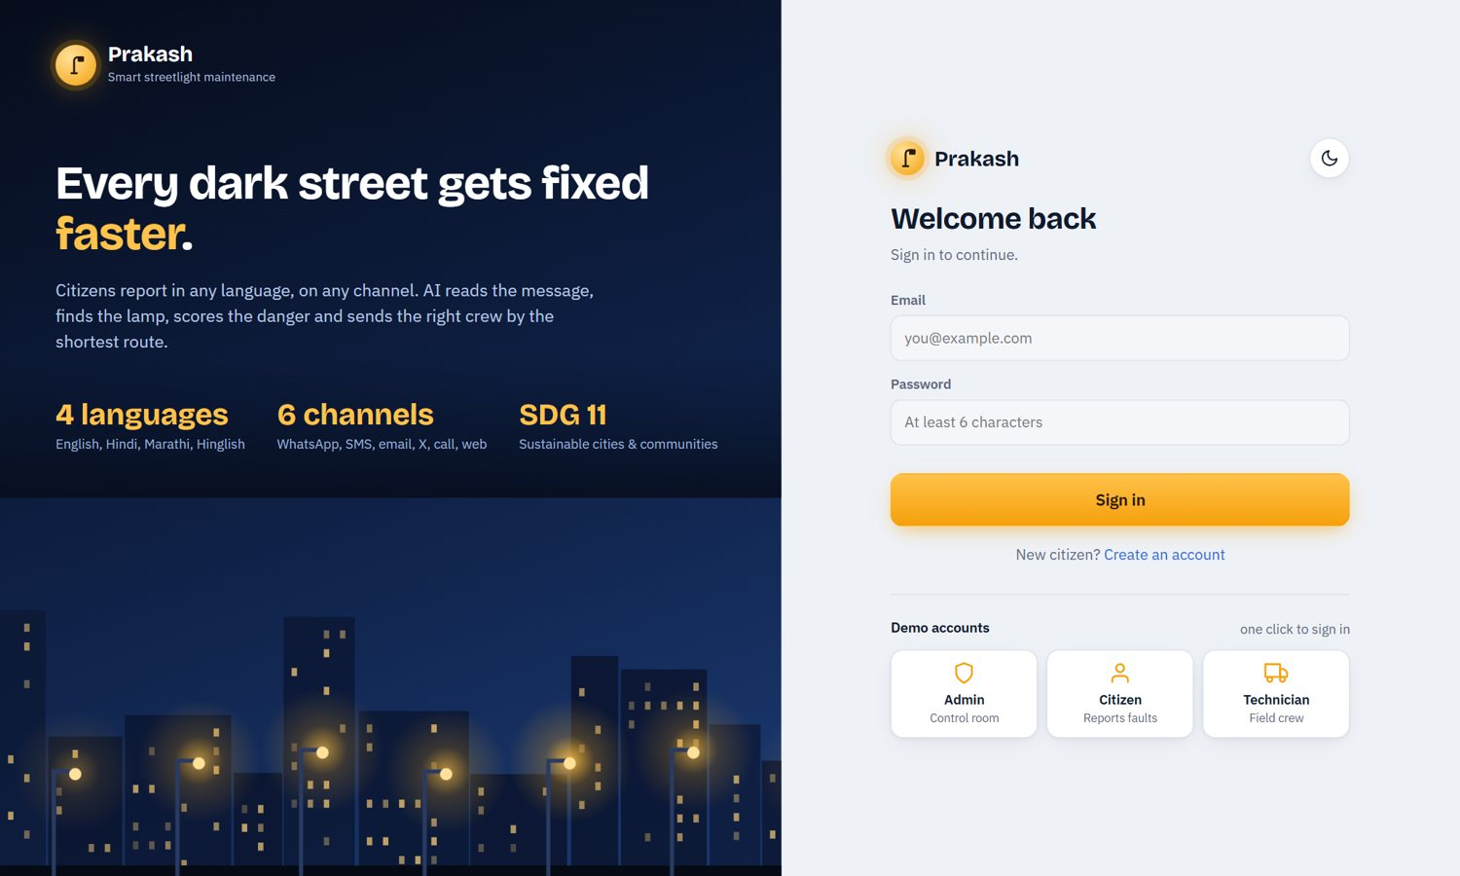
Figure 3: Sign-in page with one-click demonstration accounts for the three roles

Citizen screens
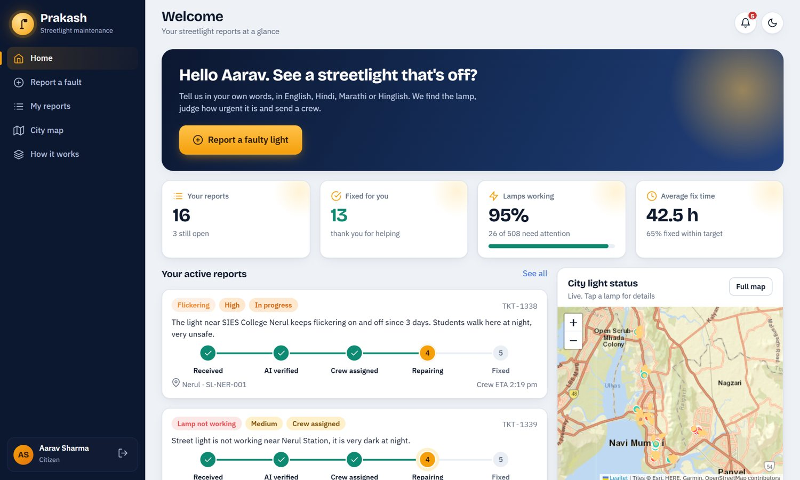
Figure 4: Citizen home: active reports with progress tracker and city lamp status
When a citizen types a complaint, the same pipeline used by the server runs on every pause in typing and shows the detected language, fault class, severity, extracted entities, matched lamp and expected fix time. Danger wording triggers a visible warning.
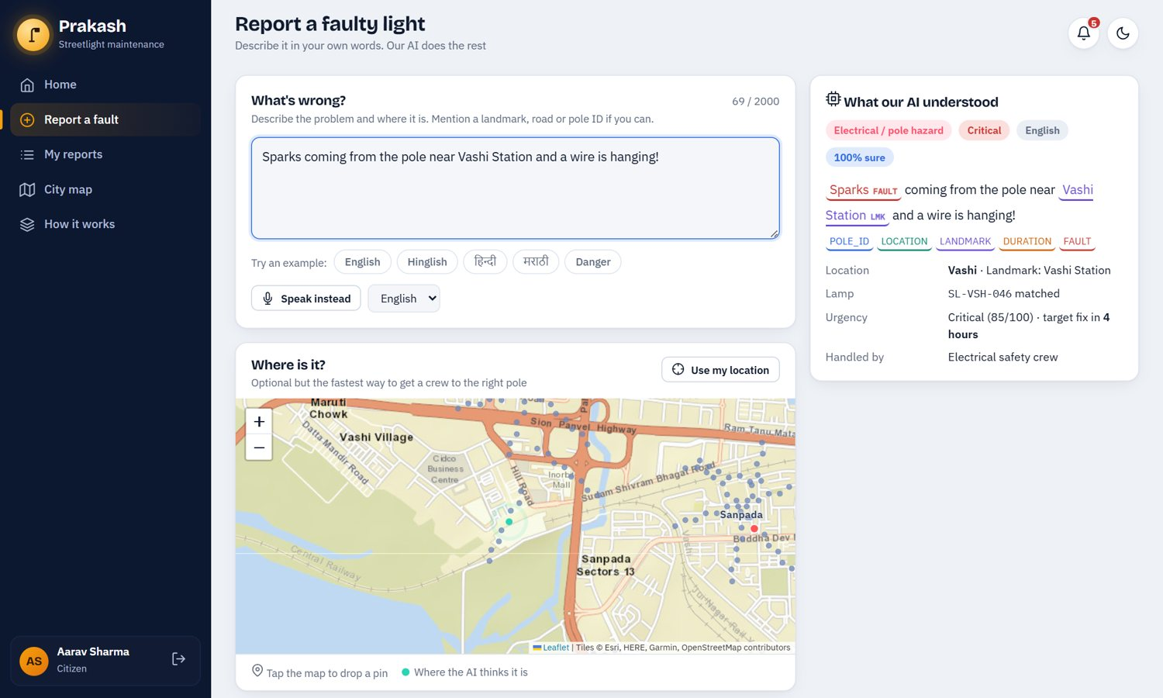
Figure 5: Report page with the live "what our AI understood" panel (English)
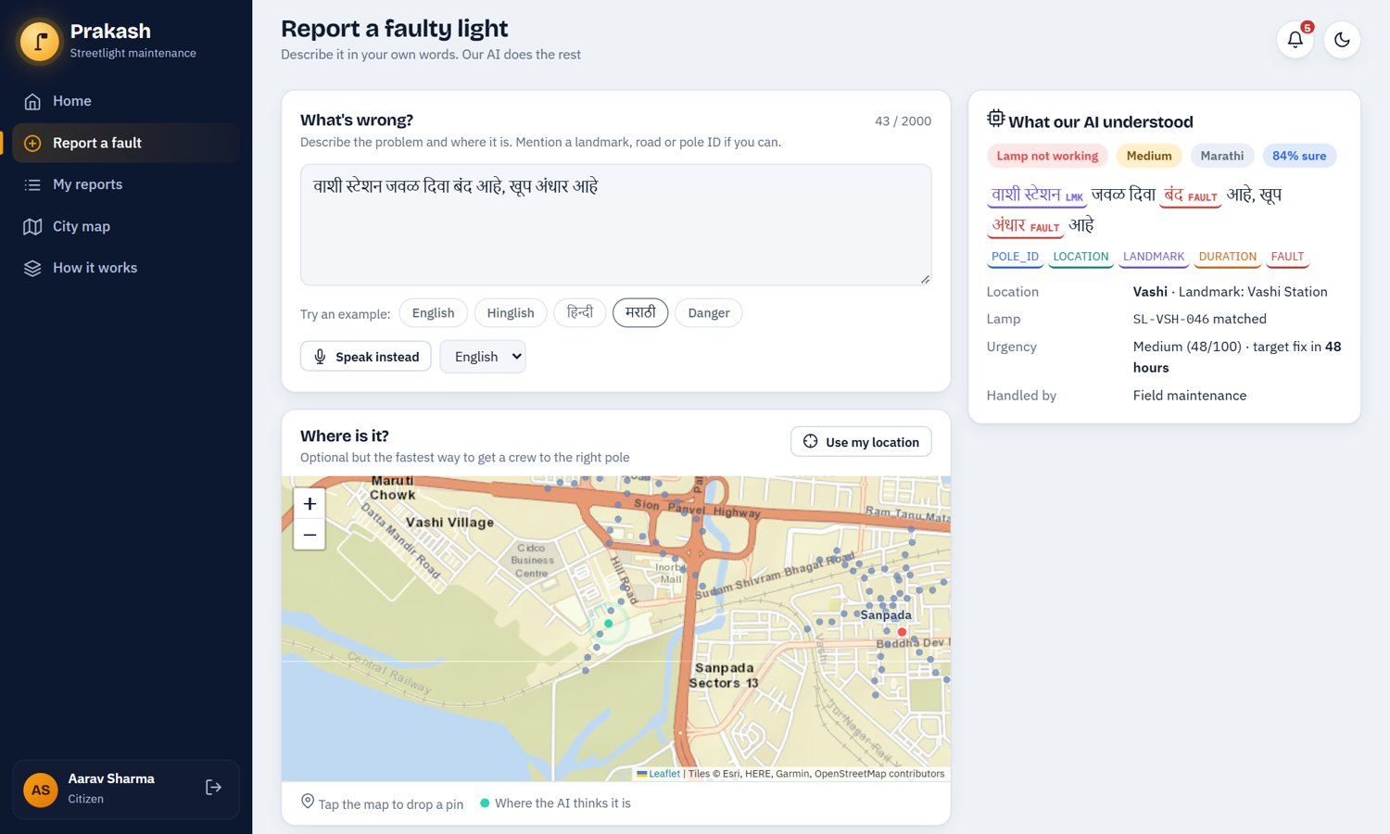
Figure 6: The same panel for a Hindi complaint, with the landmark and duplicate warning
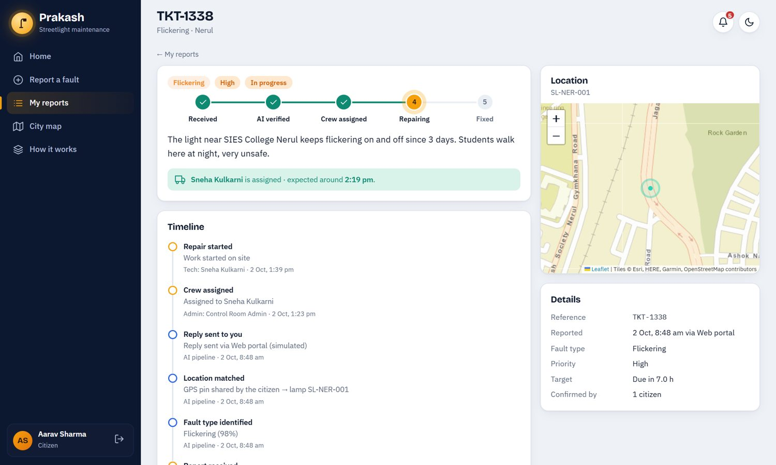
Figure 7: Citizen ticket tracking with progress stepper, timeline and location
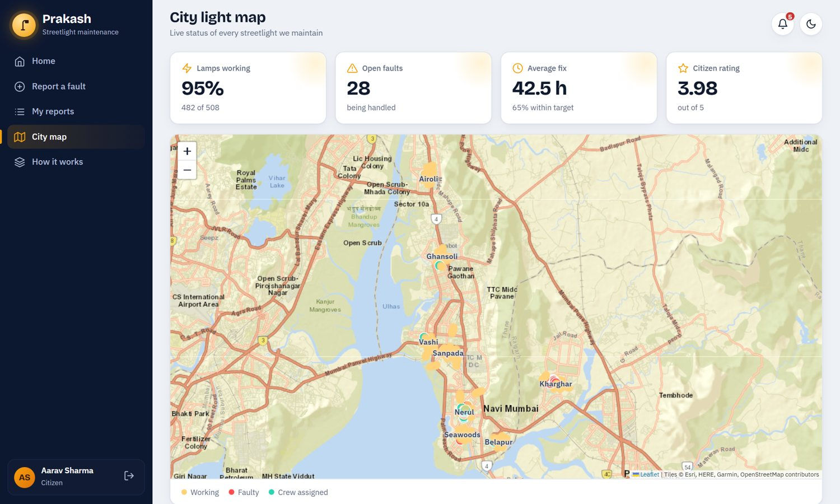
Figure 8: Public city map of lamp status

Admin screens
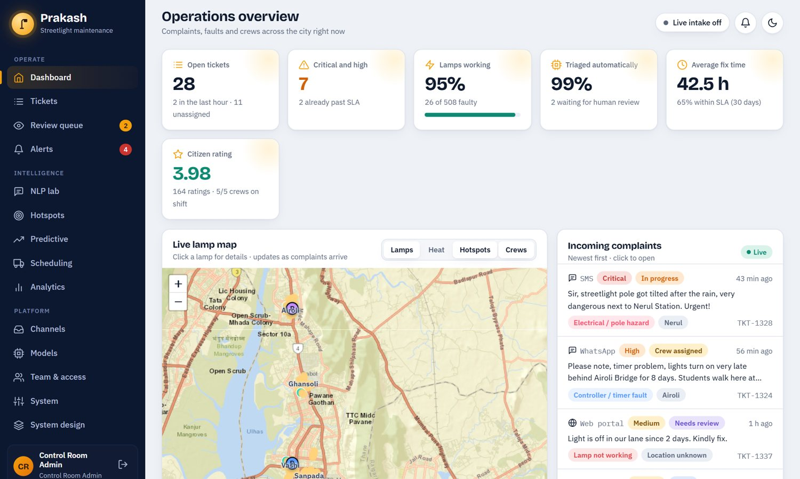
Figure 9: Admin dashboard with key indicators and live map
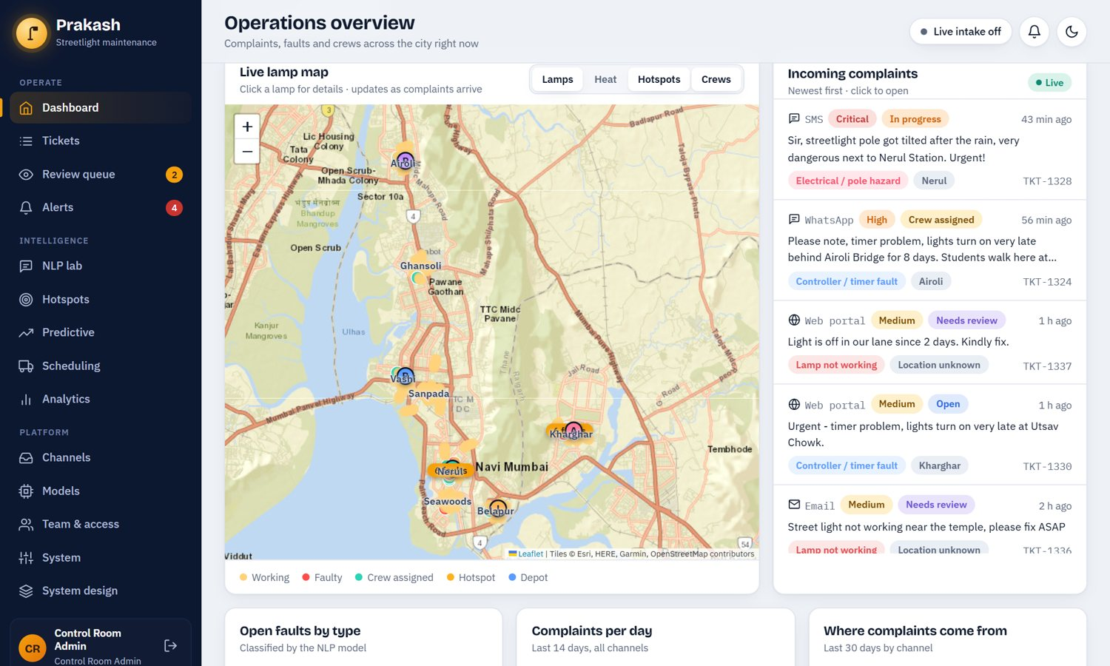
Figure 10: Live lamp map with hotspot clusters, and the live complaint feed
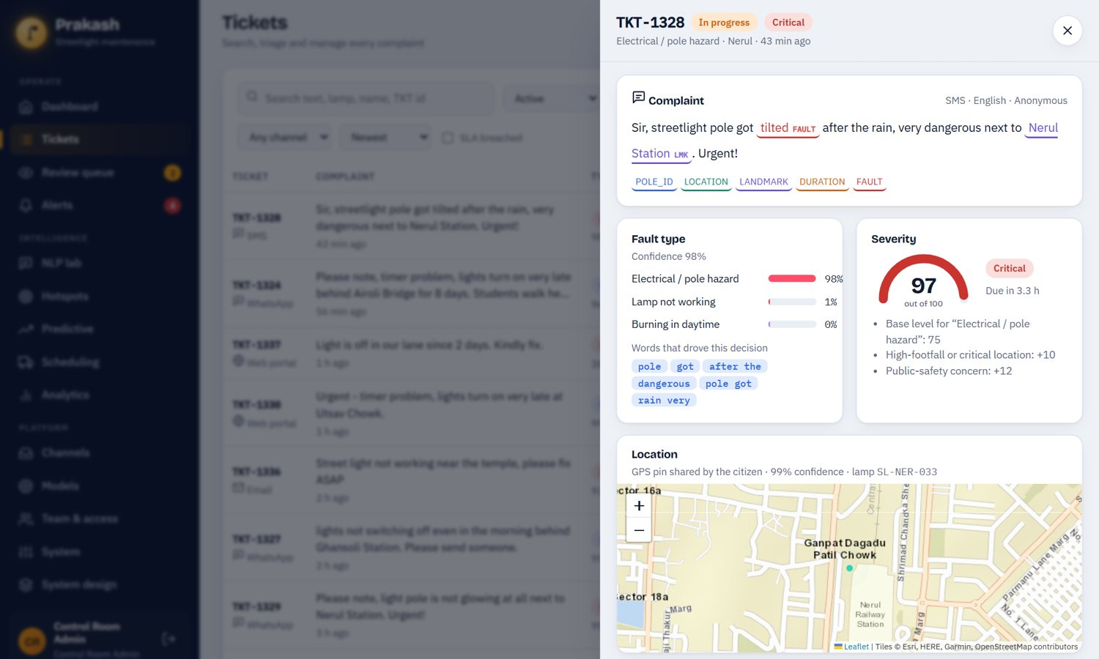
Figure 11: Ticket drawer: entities, class probabilities, severity explanation and location
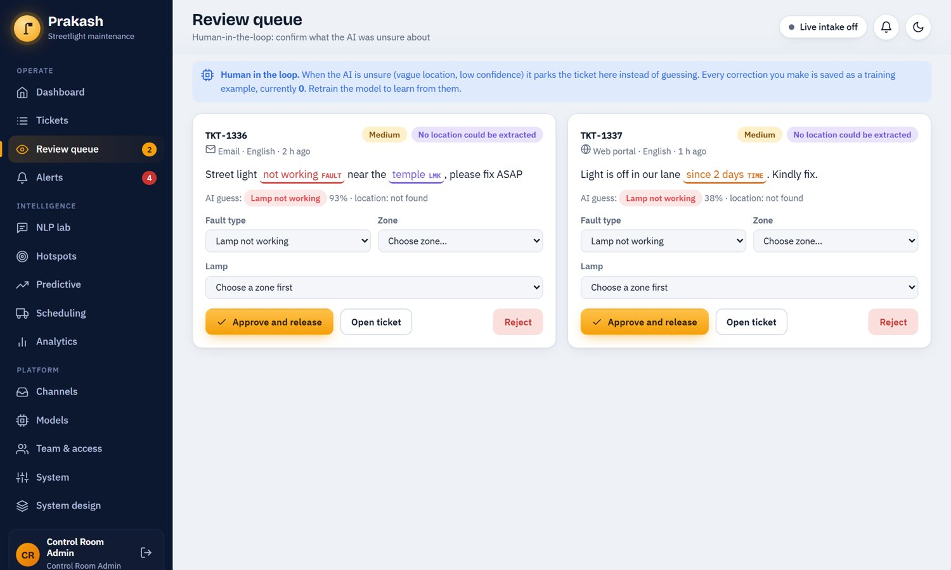
Figure 12: Review queue for uncertain tickets (human in the loop)
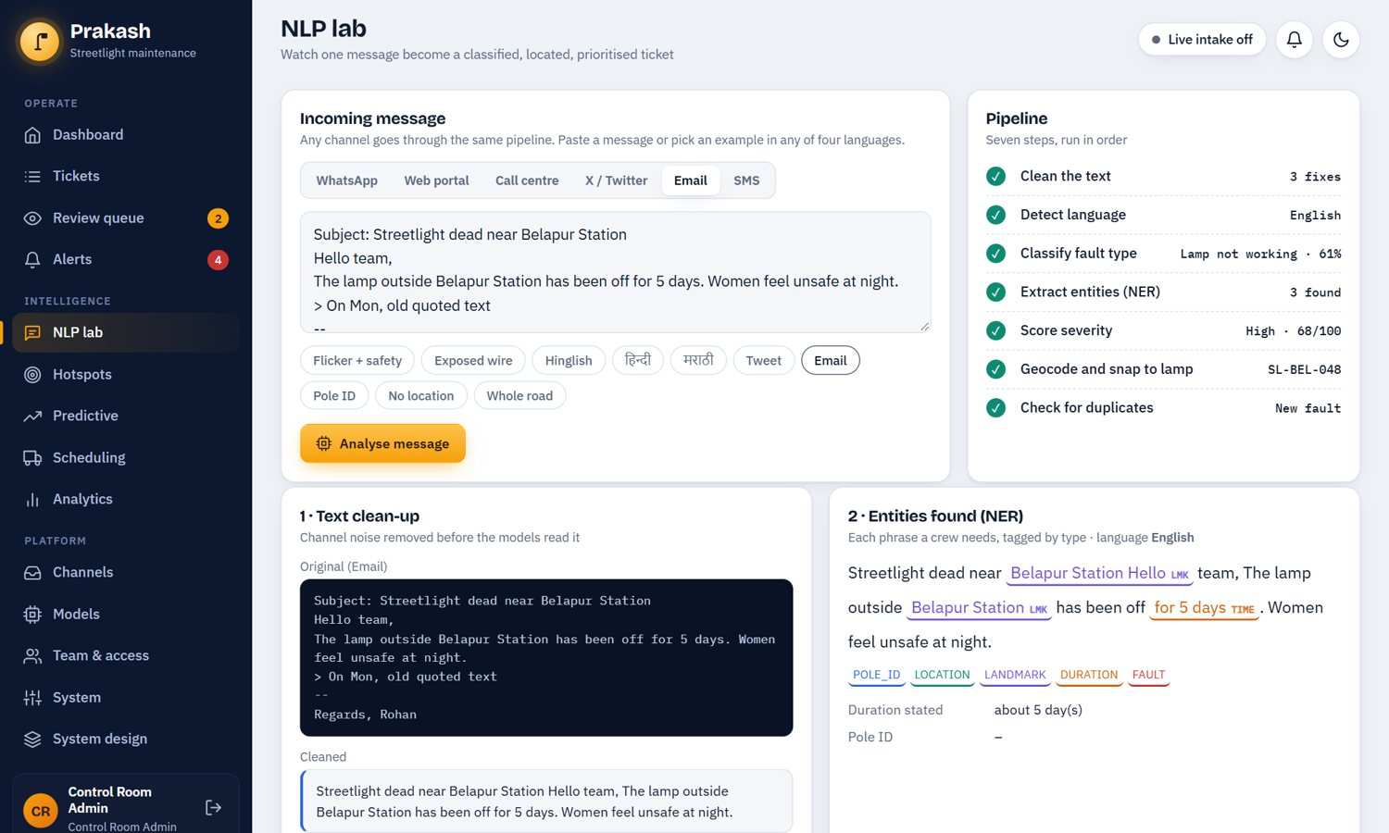
Figure 13: NLP lab: an email passes through seven pipeline steps
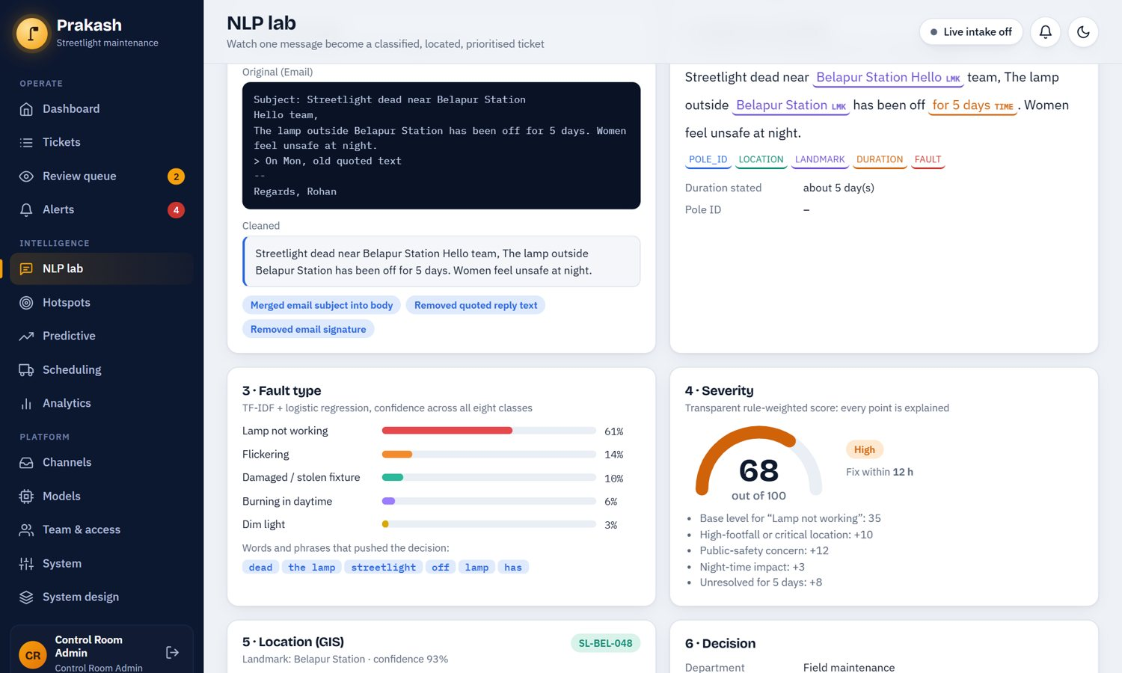
Figure 14: NLP lab: text clean-up and entity extraction for an email
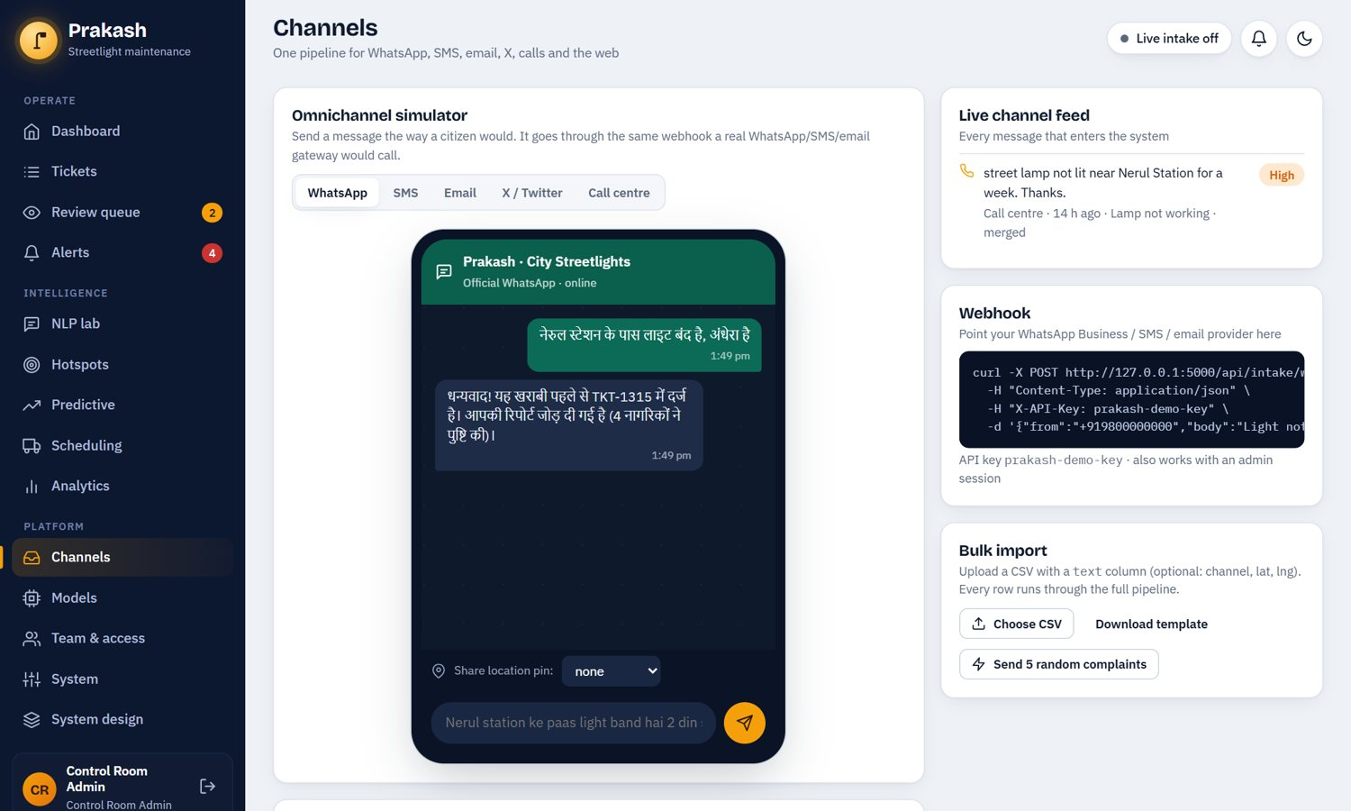
Figure 15: Omnichannel simulator: a Hindi WhatsApp message and the bot reply in Hindi
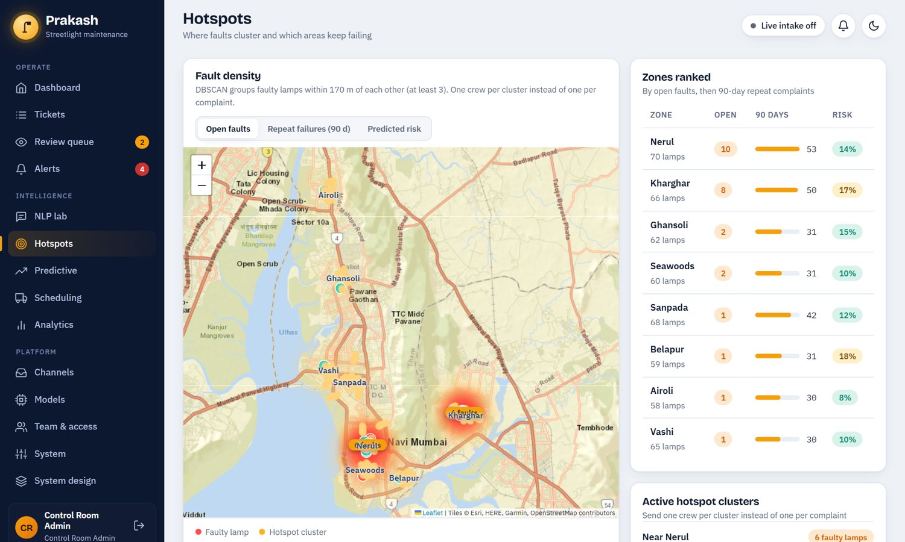
Figure 16: Hotspot analysis with ranked zones and cluster list
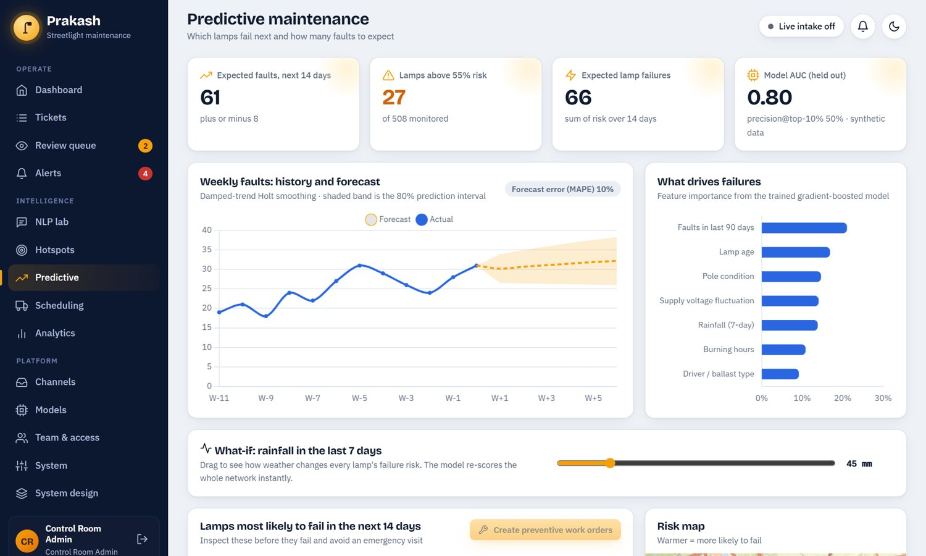
Figure 17: Predictive maintenance: forecast, feature importance and rainfall what-if
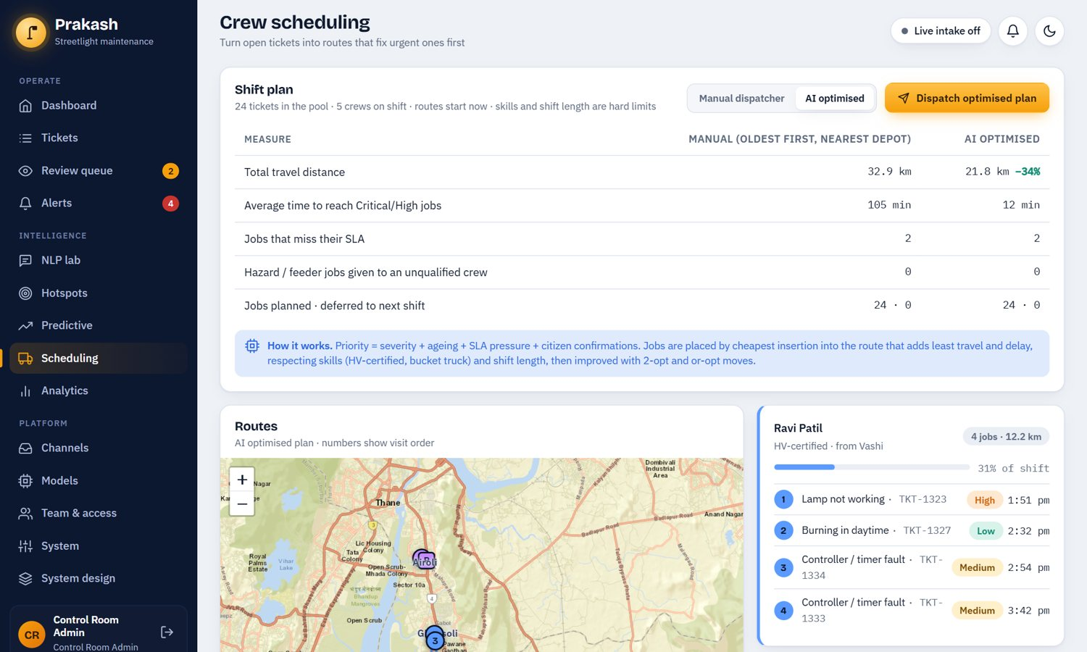
Figure 18: Crew scheduling: manual dispatcher compared with the optimiser
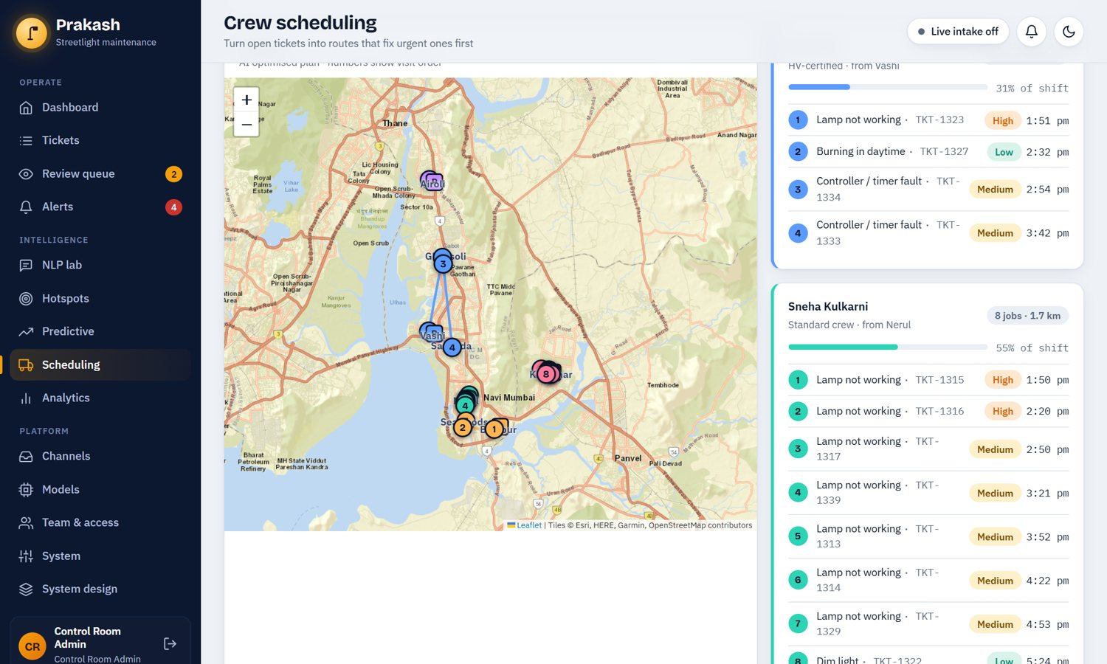
Figure 19: Optimised routes on the map with per-technician stop lists
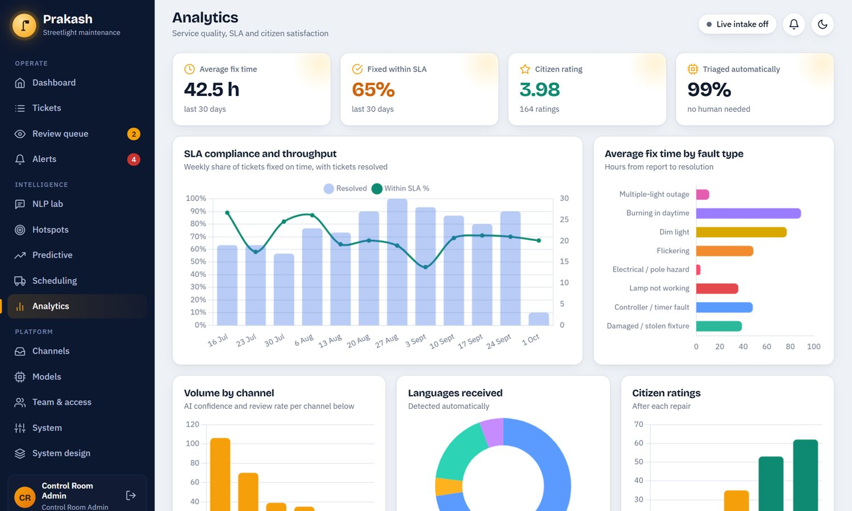
Figure 20: Analytics: SLA compliance and throughput
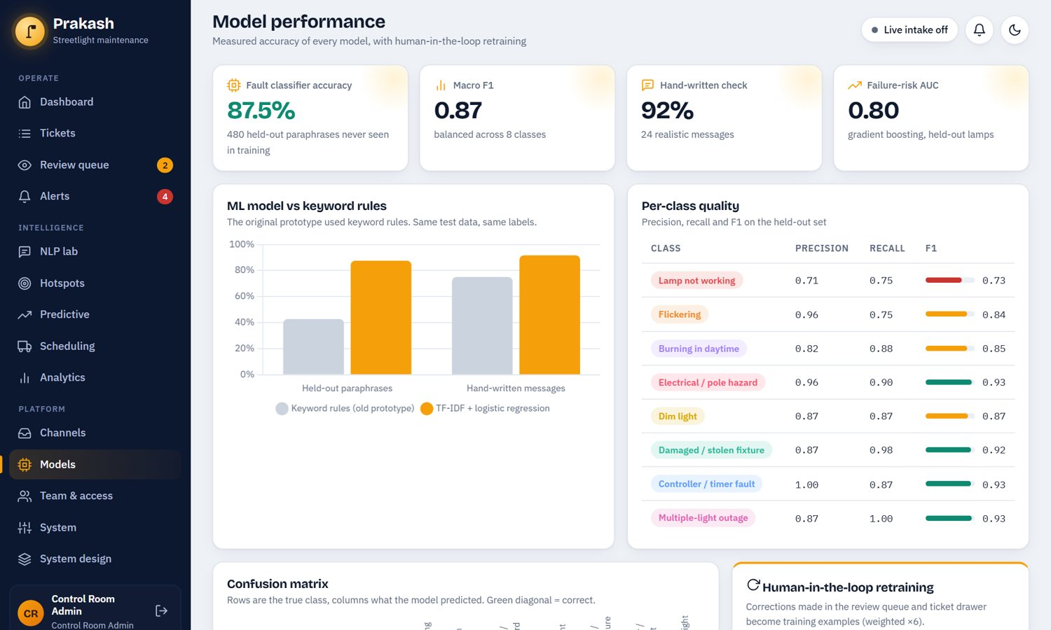
Figure 21: Model performance page: accuracy, baseline comparison and per-class quality
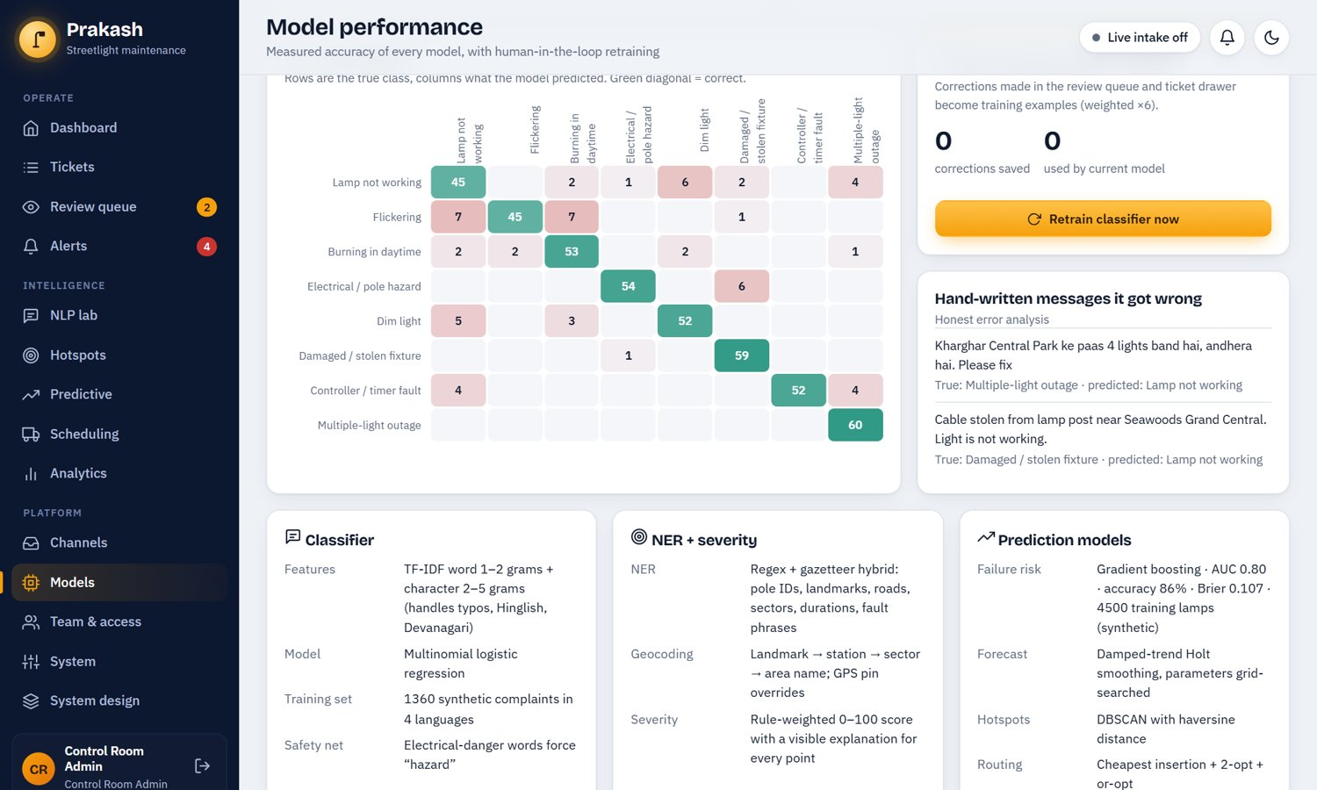
Figure 22: Confusion matrix and human-in-the-loop retraining

Technician screen
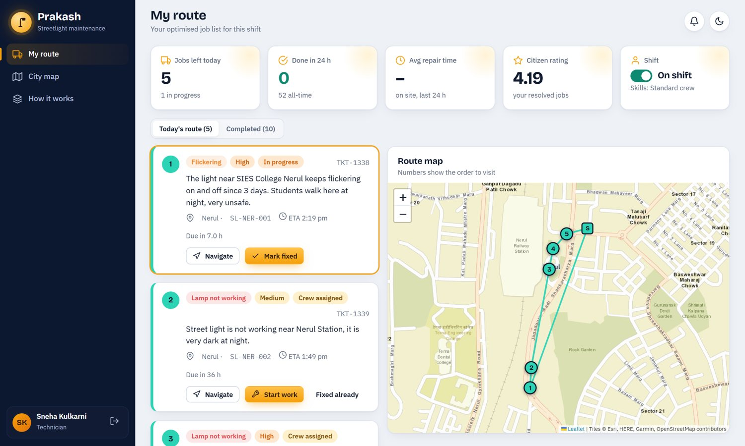
Figure 23: Technician route with numbered stops and job actions
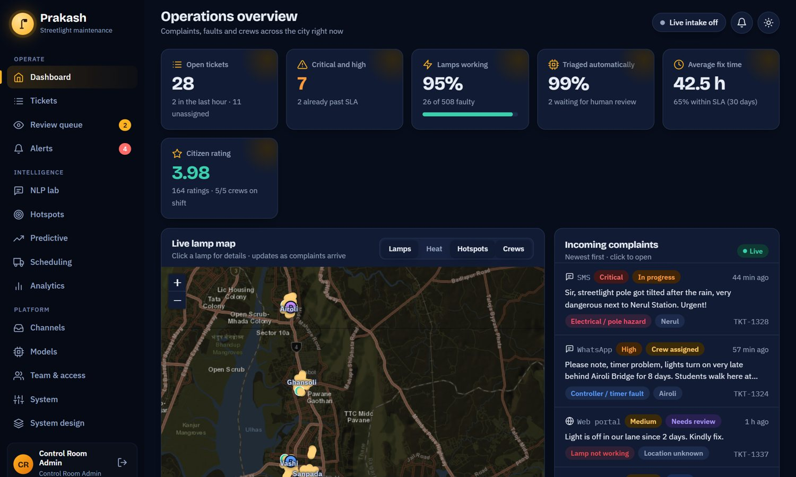
Figure 24: Dark theme of the admin dashboard

CHAPTER 8
Testing and Results

8.1 Test Strategy
Table 18: Automated tests
Level | Count | What is checked
Unit tests: NLP | 8 | Classifier metrics and margin over the baseline; language detection; electrical-danger safety rule; NER and geocoding; GPS override; channel clean-up; severity explanation adds up.
Unit tests: scheduler | 5 | Hazard jobs only to HV crews; cluster jobs need HV and bucket truck; capacity defers low-priority work; optimiser beats manual distance; off-shift crews ignored.
Service tests | 7 | Duplicate merge; review routing; exact-GPS reports on different lamps stay separate; lamp status through the life cycle; unqualified assignment rejected; risk and forecast; hotspots; review correction.
API tests | 4 | Role isolation; registration creates citizens only; citizens see only a public summary of others' tickets; webhook key check.
End-to-end API check | 40 checks | Login for three roles, role isolation, citizen flow, admin flow, dispatch, webhooks, technician flow.

All 24 unit tests and all 40 end-to-end checks pass on the final code.

8.2 Classifier Results
Table 19: Fault classifier results
Measure | Result | Data
Accuracy (TF-IDF + logistic regression) | 87.5% | 480 held-out paraphrases
Macro-F1 | 0.875 | same
Accuracy on hand-written messages | 91.7% (22 of 24) | 24 realistic messages
Keyword-rule baseline | 42.7% | 480 held-out paraphrases
Keyword-rule baseline | 75.0% | 24 hand-written messages

Table 20: Per-class precision, recall and F1 on the held-out set
Class | Precision | Recall | F1 | Comment
outage | 0.71 | 0.75 | 0.73 | Most generic wording; confused with dim and flicker
flicker | 0.96 | 0.75 | 0.84 | Some synonyms unseen in training
dayburn | 0.82 | 0.88 | 0.85
hazard | 0.96 | 0.90 | 0.93 | Safety rule helps recall
dim | 0.87 | 0.87 | 0.87
vandal | 0.87 | 0.98 | 0.92
timer | 1.00 | 0.87 | 0.93
cluster | 0.87 | 1.00 | 0.93

The weakest class is outage (F1 0.73) because "lamp not working" is the most generic description and other faults are sometimes described in similar words. The confusion matrix shown in Chapter 7 shows that errors are mainly between outage, dim and flickering, which are all minor faults, whereas the most dangerous class (hazard) is recognised with high precision. The hand-written check also exposes two errors, both involving descriptions that mix two faults (for example a stolen cable and "light is not working").

8.3 Effect of the Safety Rule and Review Threshold
The safety rule guarantees that danger words are routed as hazards. The 55% confidence threshold sends vague messages to a human. In the demonstration data this affects a small fraction of tickets (about 99% are triaged automatically with two or three waiting for review), which keeps operator effort low while limiting wrong automatic decisions.

8.4 Failure-Risk Model Results
Table 21: Failure-risk model results
Measure | Result | Data
AUC | 0.80 | 1,500 held-out synthetic lamps
Accuracy | 85.6% | same (failure base rate 15.4%)
Brier score | 0.107 | same
Precision in the top 10% of risk | 0.50 | same

Table 22: Feature importance of the failure-risk model
Feature | Importance
Faults in the last 90 days | 0.21
Lamp age | 0.17
Pole condition | 0.15
Supply-voltage variation | 0.14
Rainfall (7 days) | 0.14
Burning hours | 0.11
Driver / ballast type | 0.09

The model recovers the relationship used to generate the data, as expected; the AUC therefore shows that the pipeline and features work, not that the predictions are valid for real lamps. The forecast has a mean absolute percentage error of about 10% on the demonstration history.

8.5 Scheduling Results
On the demonstration data (24 open tickets, five technicians) the optimiser was compared with the manual baseline:
Table 23: Optimiser compared with the manual baseline
Measure | Manual dispatcher | Optimiser
Total travel distance | 32.9 km | 21.8 km (about 34% shorter)
Average time to reach Critical and High jobs | 105 min | 12 min
Hazard or feeder jobs given to an unqualified crew | 0 in this run (2 in other runs) | 0
Jobs planned / deferred | 24 / 0 | 24 / 0

The distance advantage depends on the situation. With extra hazard jobs that only HV-certified crews may take, the optimiser may travel as far as the baseline, but it still reaches urgent jobs much sooner and never violates skills. The automated end-to-end check therefore asserts a competitive distance and a shorter time to urgent jobs, not a fixed saving.

8.6 Performance
Table 24: Measured response times on a laptop (local server)
Operation | Mean time | Slowest of runs
Live AI preview (/api/analyze) | 29 ms | 32 ms
Dashboard numbers (/api/admin/overview) | 15 ms | 18 ms
Ticket list page (25 rows) | 17 ms | 21 ms
Both schedule plans (24 tickets, 5 technicians) | 37 ms | 41 ms
Failure-risk scores for 508 lamps with predictions page | 51 ms | 57 ms
Map data with risk and hotspots | 63 ms | 72 ms
Cold start (training both models and generating data) | about 7 s

8.7 Threats to Validity and Limitations
- Synthetic data. Complaint text, lamp register, history and ratings were generated, so accuracy numbers describe the pipeline, not real-world performance. Real messages are longer, noisier and more varied.
- Template-based test set. The held-out set uses different phrasings but the same generator style; the hand-written set is small (24).
- Model simplicity. TF-IDF with logistic regression cannot capture deep context or negation reliably. A transformer would likely perform better with real data.
- Rule-based NER and severity. They are transparent but limited to the gazetteer and rules written for this city.
- Simulated channels. The webhooks are real endpoints, but no WhatsApp Business or SMS provider was connected.
- Routing. Travel uses straight-line distance at a constant speed, not road-network times.
- Deployment. The demonstration uses a development web server and SQLite.

CHAPTER 9
Social Impact, Ethics and Sustainability

9.1 Expected Impact
- Faster repair of dangerous faults: hazards are classified within milliseconds, flagged as critical, and sent to the nearest certified crew, instead of waiting in a queue.
- Less wasted effort: merging duplicates and planning routes reduces repeat visits and kilometres driven.
- More inclusive reporting: citizens can write in Hindi, Marathi or Hinglish, and can speak instead of typing.
- Transparency: citizens see progress and rate repairs; administrators see SLA compliance and where infrastructure fails.
- Prevention: failure-risk prediction and hotspot analysis support planned replacement before failures happen.

9.2 Ethical Considerations
- Privacy and data protection. Only the data needed to handle a complaint is stored (name, optional phone, complaint, location). Access is limited by role. A real deployment must comply with India's Digital Personal Data Protection Act, 2023 [14], including consent, purpose limitation and retention limits.
- Human oversight. The system never silently guesses: uncertain tickets go to a human, every automated decision is explained, and an administrator can override any classification.
- Fairness across areas and languages. Severity depends on the content of a complaint, not on which neighbourhood it came from, but a model trained mostly on one language or area could serve others worse. Per-language and per-zone evaluation on real data is needed before deployment, and the language mix is already reported on the analytics page.
- Safety first. The deterministic danger rule favours false alarms over missed hazards.
- Accountability. Ticket timelines and an audit log record who did what and when.

9.3 Sustainability
Detecting lamps that burn during the day avoids wasted electricity. Predictive replacement of ageing ballast-type drivers supports the move to efficient LED fixtures. Shorter crew routes reduce fuel use and emissions. The software itself is lightweight: it trains and runs on a laptop, which keeps its own energy footprint small.

CHAPTER 10
Mapping to Course Outcomes, Programme Outcomes and Knowledge Profiles
This chapter relates the project to the outcomes of the NLP course and to the programme outcomes (PO) and knowledge profiles (WK) used for Complex Engineering Problems. Course-outcome numbers follow the order of topics in the course.

10.1 Course Outcome Mapping
Table 25: Course outcome mapping
CO | Outcome (summary) | Where it is demonstrated
CO1 | Apply text pre-processing and feature representation techniques (tokenisation, normalisation, TF-IDF, n-grams). | Chapter 5.2 to 5.4: channel clean-up, word and character n-gram TF-IDF.
CO2 | Apply language-modelling and classification techniques to text. | Chapter 5.4: logistic regression, probabilities, evaluation with precision, recall, F1.
CO3 | Apply sequence labelling and information extraction (NER). | Chapter 5.5 and 5.7: entity types, gazetteer, geocoding.
CO4 | Handle multilingual and code-mixed text, and compare approaches. | Chapter 5.3: Hindi, Marathi, Hinglish; comparison with the keyword baseline.
CO5 | Build, evaluate and present an NLP application addressing a real-world problem. | Chapters 4, 7, 8: full system, testing and results, demonstration.

10.2 Programme Outcome Mapping
Table 26: Programme outcome mapping
PO | Programme outcome | Evidence | Level
PO1 | Engineering knowledge | Applied mathematics (probability, TF-IDF, haversine, optimisation) and computing fundamentals. | High
PO2 | Problem analysis | Decomposed the problem statement into nine objectives and a five-stage pipeline (Chapters 1, 3). | High
PO3 | Design and development of solutions | Designed architecture, data model, algorithms and interfaces (Chapters 4 to 7). | High
PO4 | Investigation of complex problems | Experiments on held-out data, baseline comparison, error analysis (Chapter 8). | High
PO5 | Modern tool usage | scikit-learn, Flask, SQLite, Leaflet, Chart.js, Git, automated tests. | High
PO6 | The engineer and society | Public safety, inclusive reporting, SDG 11 (Chapters 1.5, 9). | High
PO7 | Environment and sustainability | Energy waste detection, shorter routes, preventive replacement (Chapter 9.3). | Medium
PO8 | Ethics | Privacy, human oversight, transparency, safety-first design (Chapter 9.2). | Medium
PO9 | Individual and team work | Three-member team with shared repository and review of each other's work. | Medium
PO10 | Communication | This report, presentation, narrated demo video, README and demo guide. | High
PO11 | Project management and finance | Phased plan from prototype to full system, version control, tests; no paid services needed. | Medium
PO12 | Life-long learning | Self-learning of NLP, geospatial clustering, forecasting and web engineering beyond the syllabus. | Medium

10.3 Knowledge Profile (WK) Mapping
Table 27: Knowledge profile mapping
WK | Knowledge profile | Evidence
WK2 | Mathematics, statistics and computer science | Probability and logistic regression, TF-IDF, DBSCAN, exponential smoothing, heuristic optimisation.
WK3 | Engineering fundamentals | Algorithms and data structures, databases, networking (REST, SSE).
WK4 | Specialist engineering knowledge | Natural language processing, machine learning, GIS and operations research.
WK5 | Engineering design | System architecture, data model, API and user-interface design.
WK6 | Engineering practice | Software engineering practice: testing, version control, security, deployment.
WK7 | Engineering in society | Municipal service delivery, public safety, SDG 11, citizen participation.
WK8 | Research literature | Use of published methods for TF-IDF, NER, DBSCAN, gradient boosting, Holt smoothing and routing (References).
WK9 | Ethics, inclusive behaviour and conduct | Privacy, fairness across languages, human oversight, honest reporting of limitations.

CHAPTER 11
Conclusion and Future Scope

11.1 Conclusion
This project set out to show that one pipeline can turn raw, multilingual streetlight complaints into classified, located, prioritised and scheduled repairs, while sending uncertain cases to a human. Prakash does this end to end. It reads complaints from six channels in English, Hindi, Marathi and Hinglish; classifies the fault with 87.5% accuracy on held-out wording; extracts entities and resolves them to a specific lamp; explains a severity score; merges duplicates; finds hotspots; predicts failures; and builds skill-aware routes that reach urgent jobs about nine times sooner than a manual baseline in our demonstration. It does this in a role-based web application with live updates, alerts, a citizen tracking portal and a technician route view, and it is tested by 24 automated tests and 40 end-to-end checks.
The work also made limits clear. Without real labelled data, accuracy figures describe the pipeline on synthetic complaints and must not be read as real-world performance. The value of the project is therefore the complete, explainable and testable system, and the human-in-the-loop mechanism that lets it learn from real operators once deployed.

11.2 Future Scope
- Collect and label 1,500 to 2,000 real complaints in English, Hinglish, Hindi and Marathi, and report per-language accuracy, F1 and confusion matrices.
- Replace or complement the classifier with DistilBERT [11] or MuRIL [12], and a trained NER model (for example spaCy) with entity-level F1.
- Train the failure-risk model on real maintenance records and weather data; compare gradient boosting with other tabular models.
- Use road-network travel times and an exact or metaheuristic VRP solver such as Google OR-Tools for scheduling.
- Connect a WhatsApp Business account and an SMS gateway to the existing webhooks; integrate with the municipal ticketing system and lamp register.
- Add image analysis of citizen photos (for example to confirm a hanging wire) and live crew GPS.
- Move to PostgreSQL with PostGIS, deploy behind HTTPS with a production server, and add a mobile app for technicians.

References
[1] United Nations, "Transforming our world: the 2030 Agenda for Sustainable Development," General Assembly resolution A/RES/70/1, 2015.
[2] G. Salton and C. Buckley, "Term-weighting approaches in automatic text retrieval," Information Processing & Management, vol. 24, no. 5, pp. 513-523, 1988.
[3] F. Pedregosa et al., "Scikit-learn: Machine learning in Python," Journal of Machine Learning Research, vol. 12, pp. 2825-2830, 2011.
[4] D. Nadeau and S. Sekine, "A survey of named entity recognition and classification," Lingvisticae Investigationes, vol. 30, no. 1, pp. 3-26, 2007.
[5] M. Ester, H.-P. Kriegel, J. Sander and X. Xu, "A density-based algorithm for discovering clusters in large spatial databases with noise," in Proc. 2nd Int. Conf. on Knowledge Discovery and Data Mining (KDD), pp. 226-231, 1996.
[6] J. H. Friedman, "Greedy function approximation: A gradient boosting machine," Annals of Statistics, vol. 29, no. 5, pp. 1189-1232, 2001.
[7] E. S. Gardner Jr. and E. McKenzie, "Forecasting trends in time series," Management Science, vol. 31, no. 10, pp. 1237-1246, 1985.
[8] G. A. Croes, "A method for solving traveling-salesman problems," Operations Research, vol. 6, no. 6, pp. 791-812, 1958.
[9] P. Toth and D. Vigo (eds.), Vehicle Routing: Problems, Methods, and Applications, 2nd ed. Philadelphia, PA: SIAM, 2014.
[10] J. Devlin, M.-W. Chang, K. Lee and K. Toutanova, "BERT: Pre-training of deep bidirectional transformers for language understanding," in Proc. NAACL-HLT, 2019.
[11] V. Sanh, L. Debut, J. Chaumond and T. Wolf, "DistilBERT, a distilled version of BERT: smaller, faster, cheaper and lighter," arXiv:1910.01108, 2019.
[12] S. Khanuja et al., "MuRIL: Multilingual representations for Indian languages," arXiv:2103.10730, 2021.
[13] R. T. Fielding, "Architectural styles and the design of network-based software architectures," Ph.D. dissertation, University of California, Irvine, 2000.
[14] Government of India, "The Digital Personal Data Protection Act, 2023."
[15] Flask documentation, Pallets Projects. https://flask.palletsprojects.com
[16] Leaflet: an open-source JavaScript library for interactive maps. https://leafletjs.com
[17] Chart.js documentation. https://www.chartjs.org
[18] City of New York, "311 Service Requests from 2010 to Present," NYC Open Data. https://opendata.cityofnewyork.us
[19] City of Chicago, "311 Service Requests," Chicago Data Portal. https://data.cityofchicago.org
[20] T. Hastie, R. Tibshirani and J. Friedman, The Elements of Statistical Learning, 2nd ed. New York: Springer, 2009.
[21] D. Jurafsky and J. H. Martin, Speech and Language Processing, 3rd ed. (draft), 2024.
[22] R. W. Sinnott, "Virtues of the haversine," Sky and Telescope, vol. 68, no. 2, p. 159, 1984.
[23] C. C. Holt, "Forecasting seasonals and trends by exponentially weighted moving averages," International Journal of Forecasting, vol. 20, no. 1, pp. 5-10, 2004.
[24] Prakash source code, GitHub repository. https://github.com/bharath050305/prakash

Appendix A: Running the Project
Source code: https://github.com/bharath050305/prakash
Requirements: Python 3.10 or later. Open a terminal in the project folder and run:
pip install -r requirements.txt
python run.py
Then open http://localhost:5000. The first start trains the models and generates demonstration data (about 7 seconds). The sign-in page offers one-click demonstration accounts for the Admin, Citizen and Technician roles.
Table 28: Commands
Command | Effect
python run.py --reset | Wipe the database and regenerate fresh demonstration data.
python run.py --host 0.0.0.0 | Allow phones on the same Wi-Fi to open the app.
python run.py --port 8080 | Use another port.
python -m pytest tests -q | Run the 24 automated tests.
python tests/smoke_api.py | Run the 40-check end-to-end API test against a running server.

Appendix B: REST API Summary
Table 29: REST API summary
Method | Endpoint | Purpose
POST | /api/auth/login, /register, /logout | Authentication
GET | /api/auth/me, /api/meta | Session and reference data
POST | /api/analyze | Run the NLP pipeline without creating a ticket
POST | /api/tickets | Create a ticket (citizen)
GET | /api/my/tickets, /api/tickets/{id} | Citizen ticket list and detail
POST | /api/tickets/{id}/confirm, /rate | Confirm an existing fault; rate a repair
GET | /api/nearby, /api/city/map | Nearby reports; public lamp map
GET | /api/notifications; POST /read | In-app notifications
GET | /api/stream | Server-sent events
GET | /api/tech/jobs; POST /shift, /jobs/{id}/start, /complete | Technician functions
GET | /api/admin/overview, /map, /tickets, /hotspots, /predictions, /schedule, /analytics, /alerts, /model | Admin dashboards and analytics
POST | /api/admin/tickets/{id}/assign, /status, /review, /note | Ticket management
POST | /api/admin/schedule/dispatch, /preventive, /model/retrain, /import, /reset | Dispatch, preventive work orders, retraining, bulk import, reset
GET/PUT | /api/admin/settings; GET /export/tickets.csv, /audit | Settings, export and audit log
POST | /api/intake/{whatsapp, sms, email, twitter, call, web} | Channel webhooks (API key or admin session)

Appendix C: Sample Complaints and Outputs
Table 30: Sample complaints and system outputs
Complaint (channel) | Language / class | Severity and location
"The light near SIES College Nerul keeps flickering on and off since 3 days. Students walk here at night, very unsafe." (WhatsApp) | English / flicker | High (62); landmark SIES College; duration 3 days
"Caller reports sparks and a wire hanging from the pole near Vashi Station!" (Call centre) | English / hazard (safety rule) | Critical (85); landmark Vashi Station
"Kharghar Central Park ke paas 4 lights band hai, andhera hai." (WhatsApp) | Hinglish / outage | Medium; landmark Kharghar Central Park
"नेरुल स्टेशन के पास स्ट्रीट लाइट बंद है, अंधेरा है" (WhatsApp) | Hindi / outage | Medium (48); Nerul Station
"SL-NER-021 not glowing near D Y Patil Stadium" (Web) | English / outage | Medium; pole ID SL-NER-021 matched
"Street light not working near the temple, please fix ASAP" (Email) | English / outage | No location: sent to human review

